Name:

Year and Section:

Subject:

1. Source Mac Address

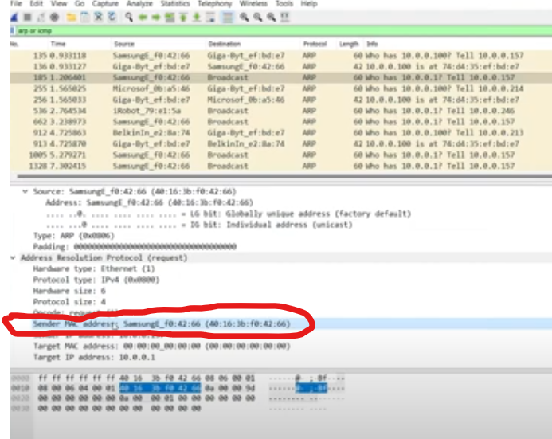

1. Destination Mac Address
2. Type
3. Data
4. FCS