1-6-23 2:23PM

1. The First 123 pogs is now in the game.
2. The POG script will now take the pog list length as the max.

1-13-23 10:53 AM

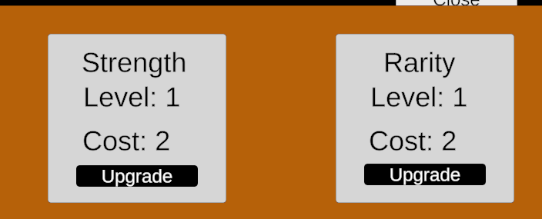

1. A new Store Tap
2. Strength upgrade have been added in and working as intended
3. Rarity Upgrade have been added in, it function still a WIP.
4. Both Level and Cost will increase per upgrade.
5. Added 4 more scripts “Rarity” “RarityUI” “Strength” “StrengthUI”