Cattle diet and winter plant growth effects on nitrogen losses from cattle urine patches

Journal: Nutrient Cycling in Agroecosystems

William D. Talbot^{a,}*, Brendon J. Malcolm^{b}, Keith C. Cameronª, Hong J. Diª, & David C. Whitehead^{c}
ªDepartment of Soil and Physical Sciences, Lincoln University, PO Box 85084, Lincoln 7647, Canterbury, New Zealand; ^{b}The New Zealand Institute for Plant and Food Research Ltd, Private Bag 4704, Christchurch, New Zealand; ^{c}Manaaki Whenua – Landcare Research, PO Box 69040, Lincoln 7640, Canterbury, New Zealand

Contact William D. Talbot william.talbot@lincolnuni.ac.nz

ORCID: William D. Talbot (0000-0003-2141-2728), Brendon J. Malcolm (0000-0002-2028-4579), Keith C. Cameron (0000-0002-7631-1636), Hong J. Di (0000-0002-6966-0299), & David C. Whitehead (0000-0002-9791-7493)

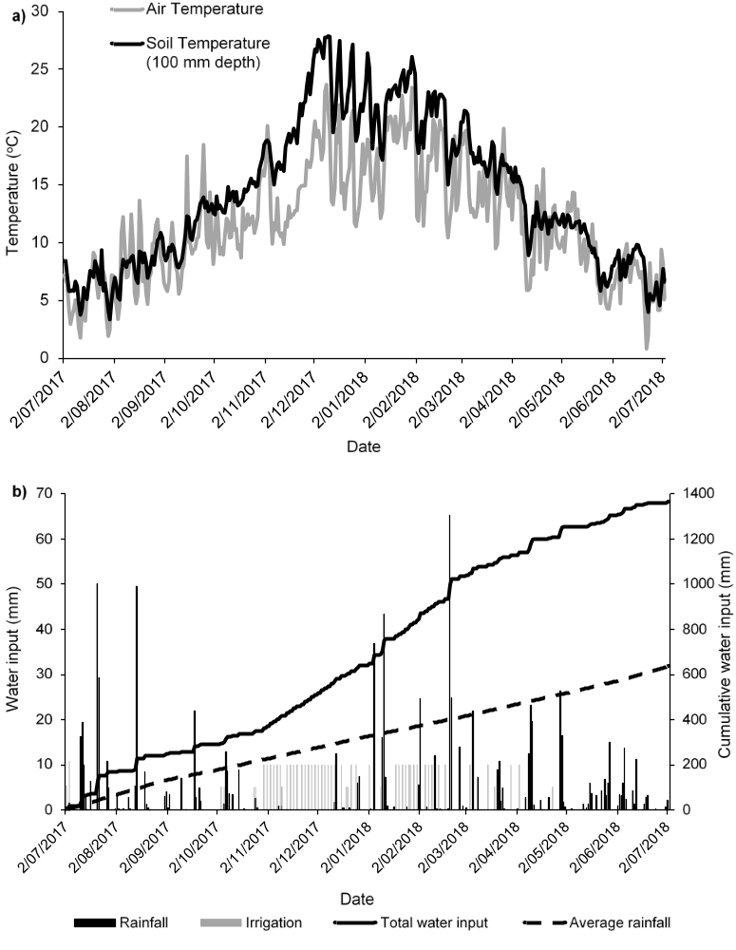
Supplementary online material. 1. a) Mean daily air temperature and soil temperature (100 mm depth), and b) daily rainfall, irrigation water inputs and cumulative water input over the experimental period (4 July 2017 - 3 July 2018), and long-term average rainfall data (1971-2000, Lincoln weather station 4881).

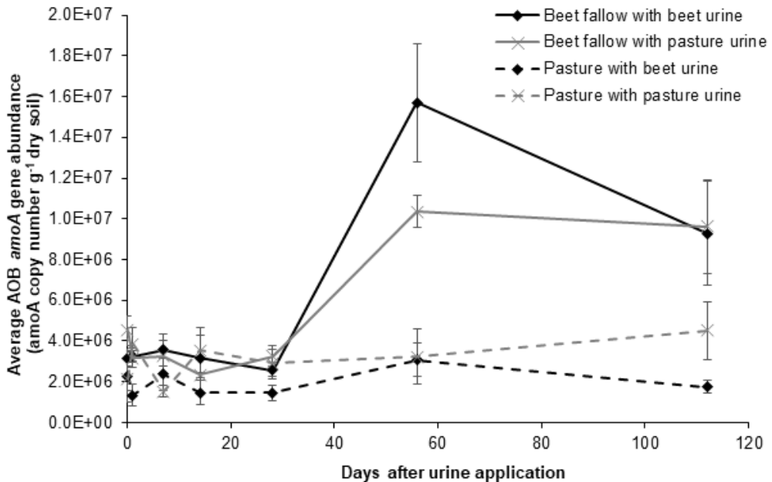
Supplementary online material. 2. The effect of urine type on soil ammonia oxidising bacteria (AOB) amoA gene copies over the first 112 days after urine application, beneath pasture. Day 0 is prior to urine application. Samples were taken from 0-100 mm depth in the soil profile. Error bars are standard error of the mean (n = 5).

