Part 1
The question: Can we build a model to predict the positivity index of Fasciola hepatica?

What is Fasciola hepatic? A parasitic worm which causes fasciolosis. This worm is transmitted by freshwater snails of the Lymnaea genus onto vegetation. This vegetaion is eaten by mammals and the worm gorws to maturity in the mammal. Where they lay eggs that are passed into freshwater in stool or urine. In the water they find a snail and the cycle begins anew.

In Brazil the two main identified intermediate hosts are:
1. Lymnaea columella: American Ribbed Fluke snail.
2. Lymnaea Viatrix: small to large air breathing freshwater snail aka pond snail

Summary of the Paper
The authors built a model using mulitiple linear regression to predict the positivity index of Fasciola hepatica. The model they fouind with the highest predictive ability was the one which used the indicator variables of the positivity index of the previous year, the average regional altitude and thr maximum winter temperature for the earlier year. The model predicted the positivity index by region. They further broke the model down to year on year prediction. Using the data on hand to try and predict past data as a means of testing its performance. In the end the model ranged between 48% to 66% predictive accuracy over the years 2003 – 2010.

Data generation process: The data come from cattle tested at slaughterhouses across 497 municipalities. Collected via harmonised sampling procedures (a methodology that ensures consistency and comparability across different sampling sites, measurement procedures, and time periods).
Testing was administered by the Brazilian Federal Meat Inspection Service. Presumably trained testers. Farm of origin is not recorded. Slaughter house not recorded. Inspector not recorded. We can assume some level of consistency due to harmonised sampling, but we can't be sure without the meta data.
Only inspected slaughterhouses are collected from, we know this for sure. Uninspected slaughterhouses are omitted. Year on year it is not known if the sampling method was to vary slaughterhouses or not. Therefore it is impossibnle to know if farmers are able to knowingly game the system to avoid detection. Nor is it possible to identify if a tester is adminisitering the tests under quality control practices. Nor is it possible to identify if the farm of origin is the primary source of the observed incidences of the diasease in the municipality. In short, there is no statistical data control practices at work on the data or the process which generated it. Instead, the data is averaged across the entire municipality. Which means the data is of low fidelity.
The positivity index is likewise a low fidelity measure. The PI value is the number infected divided by total slaughtered per city. 0% infection cities are included. Risk classification in bands <8%, 8-18% and >18% with 0% not permitted. Already the model will not be able to predict 0% infection as a possibility.

So the data is rough. Not all land is equal, not all municipalities are the same in size. Prevalence of species which have confied ranges (like snails) will be highly specific to even within a square kilometer. Given they cluster around freshwater ponds and bodies. All this is to say that the measure produced has neatly packaged within lots of uncertainty.

The model: the authors did log transformation to increase correllation. A log transform doesn't make sense practically because the PI is not a magnitude scale, and therefore the transform loses information. They do provide the reverse transform model however. Of course a log transform will increase correlation, distances get smaller, and so more data points will be closer. The disadvantage is that the outputs are unreadable without a reverse transforms. There are some issues with their methodolgy. The authors were chasing P values and high correlation. Not in and of itself bad practice, but perhaps here not entirely sensible.

In this paper the authors are primarily concerned with prediction. As such they omit a lot of information held in the data, forgoing description of the phenomena. This is most obvious in the omission of input data from 2008 and 2007, because the prior years were La Nina years which have wide variance in temperature and rainfall. This information would be useful because other variables may vary conditionally in their importance during such periods. In a sense, they dropped the outliers where the outliers were considered to be a whole subset of data which made the prediction less accurate.

This sort of data massaging is one way to get a model that is better at predicting the phenomenon within very narrow conditions. However, the real world isn't beholden to such conditions, and so the loss of the La Nina years perhaps would result in a less useful model for predictions. As mentioned earlier this is not entirely sensible in the context studied. A model which doesn't seek to understand the cause of a finanically impactful diasese which affects one of the largest industries in Brazil, while proposing to make policy changes is careless. Prediction is not enough for policy. Understanding the phenomenon is much more important because the long term, unforseen second order effects should be considered.

Part 2:The project plan:
For this project I will reanalyse the data and construct a model which seeks to understand the Fasciola phenomenon rather than predict it. The following questions will be answered:
- What is the prevalance of the diasese (PI) in each municipality conditional on La Nina (years omitted in study) versus years without La Nina?
  - The intervention here is presence of La Nina or not
- What is the causal model of fasciola based on the variable provided? How does a causal model compare to the predicitive model of the authors.
  - This question will be to attempt to construct the correct DAG and test it with the data on hand. It will invovle lots of model comparisons.
- Given a set of prior distributions informed by the causal model, can we create a predictive model that out performs that of the authors?
  - For this question I will attempt to use MCMC analysis to get 'true' prior distributions from the data itself.

Part 3: Exploratory Data Analysis

Part 4: A causal model, draft.
This parasite requires a snail to complete its life cycle. The range of this parasite is most of the world:
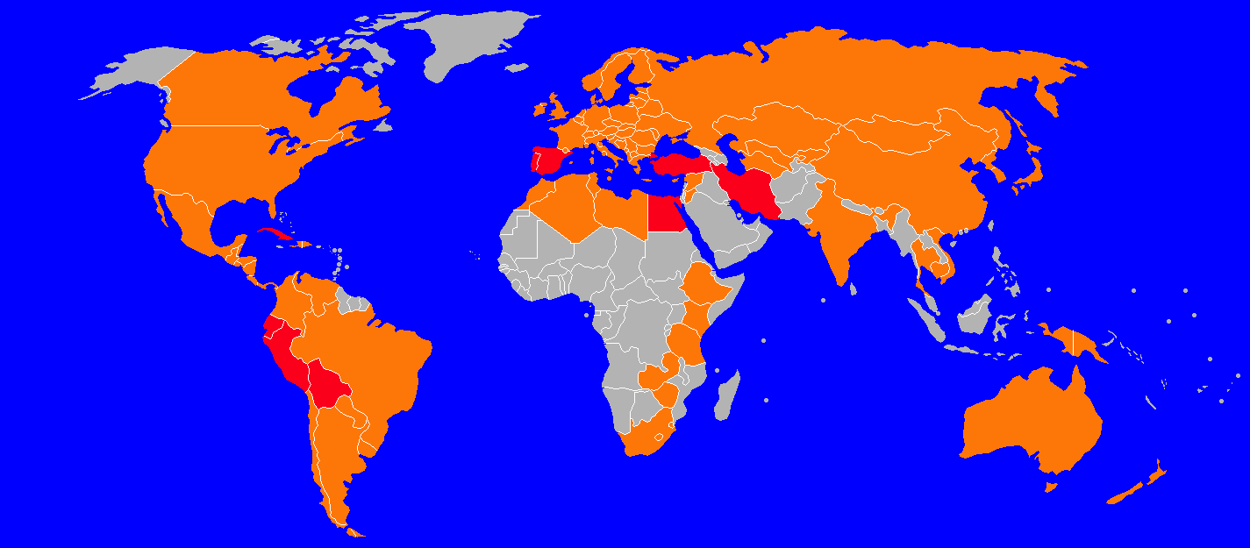
(red is high prevalance, orange is medium, grey is no prevalence).

By Canuckguy (talk) and many others (see File history)derivative work: Izzytr19 (talk) - BlankMap-World6.svg, CC BY-SA 4.0, https://commons.wikimedia.org/w/index.php?curid=47656153

Climate is an impact. We can see that where the geography is drier, there is less prevalence, though this isn't a strict rule as SE Asia isn't 'dry'.
The parasite and the snail host need moisture, a range of 10 – 25C in temperature and thus prevalence is linked to rainfall and temperature.
Mas-Coma, S. (September 2005). "Epidemiology of fascioliasis in human endemic areas". Journal of Helminthology. 79 (3): 207–216. doi:10.1079/joh2005296

Ingesting contaminated water or vegetation leads to infection. Obviously, the water and/or vegetation need to be infected. These could be co-local. But it there is high moiture the snails can travel over the ground further. So moisutre can influence vegetation infection levels.

Moghadami M, Mardani M. Fasciola hepatica: a cause of obstructive jaundice in an elderly man from Iran. Saudi J Gastroenterol. 2008 Oct;14(4):208-10. doi: 10.4103/1319-3767.43279. PMID: 19568541; PMCID: PMC2702927.

The Lymnaea snail, or pond snail, live in stagnant water sources rich in vegetation (it eats that) or in alluvial river valleys. And also artifical water bodies (probably because they are often stagnant OR have vegetaion around).
https://www.molluscs.at/gastropoda/index.html?/gastropoda/freshwater/lymnaea.html

They have also been found at high altitudes, 3800-4100 m. Therefore altitude will play a part, but not a large contributing factor. Probably.
https://www.researchgate.net/publication/11589119_Fasciola_hepatica_and_lymnaeld_snails_occurring_at_very_high_altitude_in_South_America

Rio Grande Do Sul has a mil climate, 18-43C with annual averages at 20C.Rain is about 1300 mm anually. There are about 1300k of water ways inland. It varies from sea level up wards. The land scape varies with mountains in the centre east, with west of the mountains being a plateau of good pasture. East is a wide coast zone with two large lagoons (no snails). There are a number of swampy lakes in the south near the penisulas (good for snails). One third of the state is a drainage basin. Behind Serra do Mar the plateau is also covered in moist forests. In the north earts are tropical moist evergreen forests. In the south east are the Pampas on the border with Uraguay (fertile, low grass land). In the south and east of the plateau are deciduous forests which are in nutrient poor, sandy soils.
Britannica, T. Editors of Encyclopaedia. "Rio Grande do Sul." Encyclopedia Britannica, July 16, 2024. https://www.britannica.com/place/Rio-Grande-do-Sul.

We can assume that we will get more prevalence in the south east where there are those stagnant lagoons and where the state borders Uraguay on the Pampas. A smattering in the centre where the plateau has some water, mostly centre south where the rivers drain. And perhaps some up in the north west where the moist forests are.

This study has some nice maps:

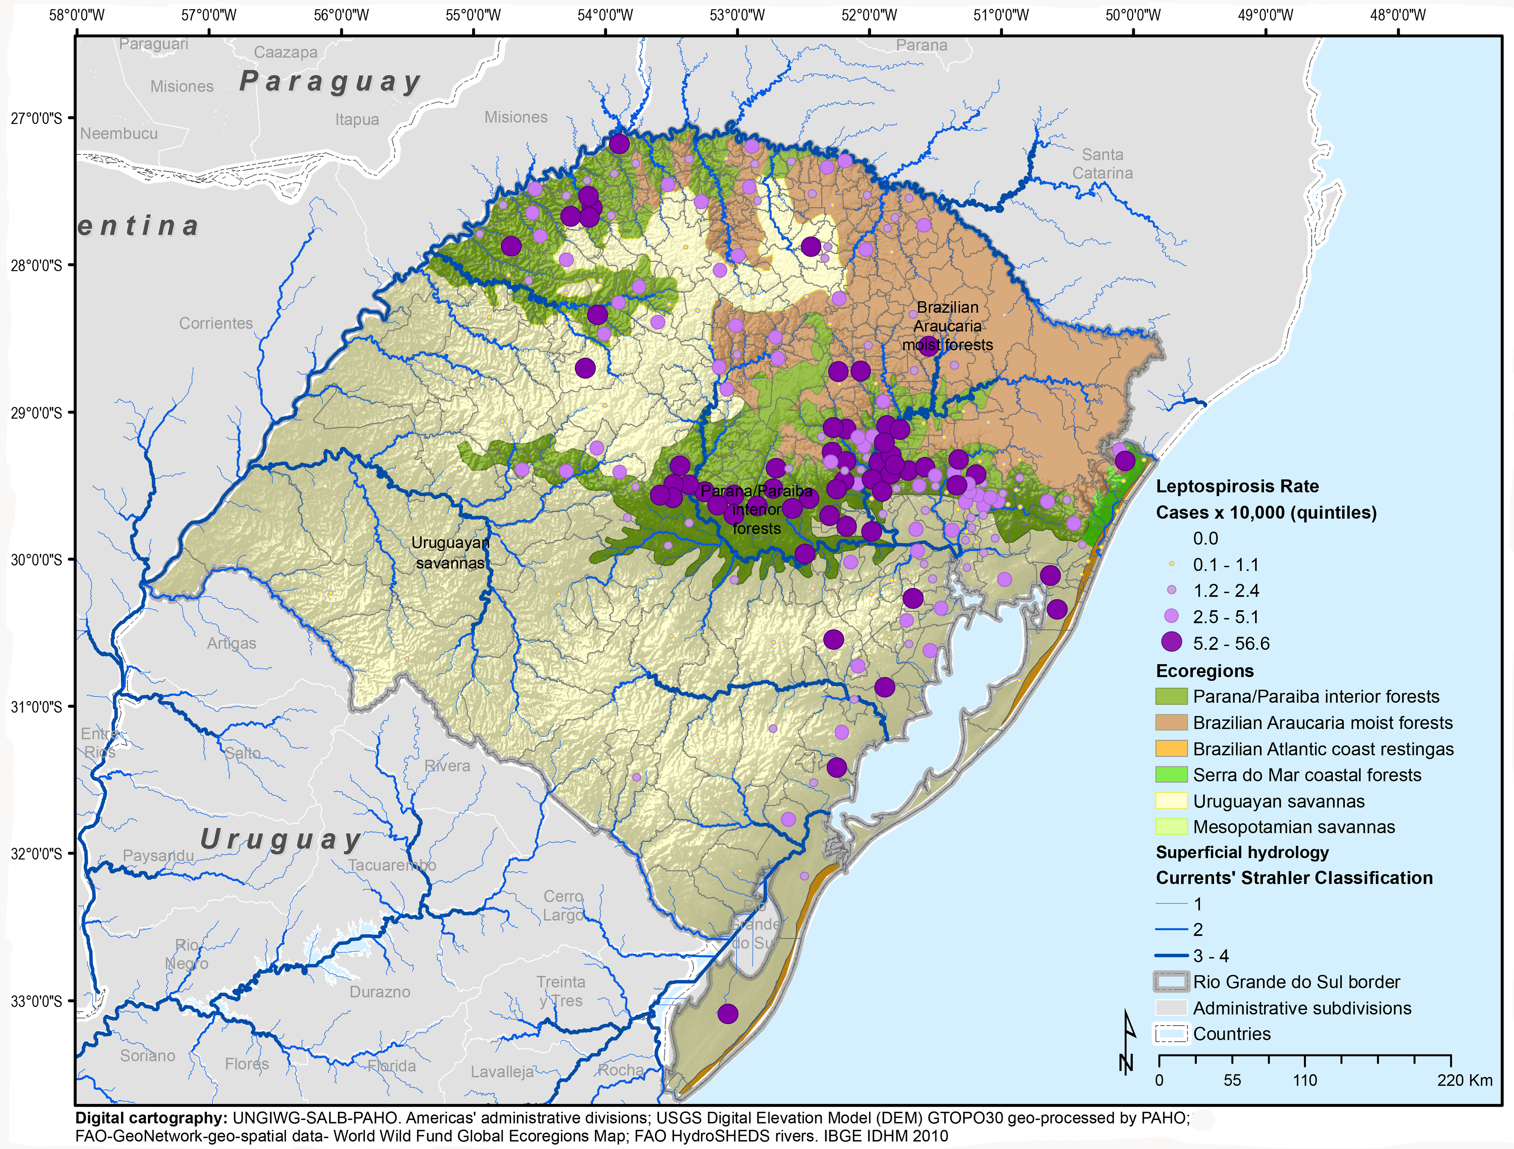
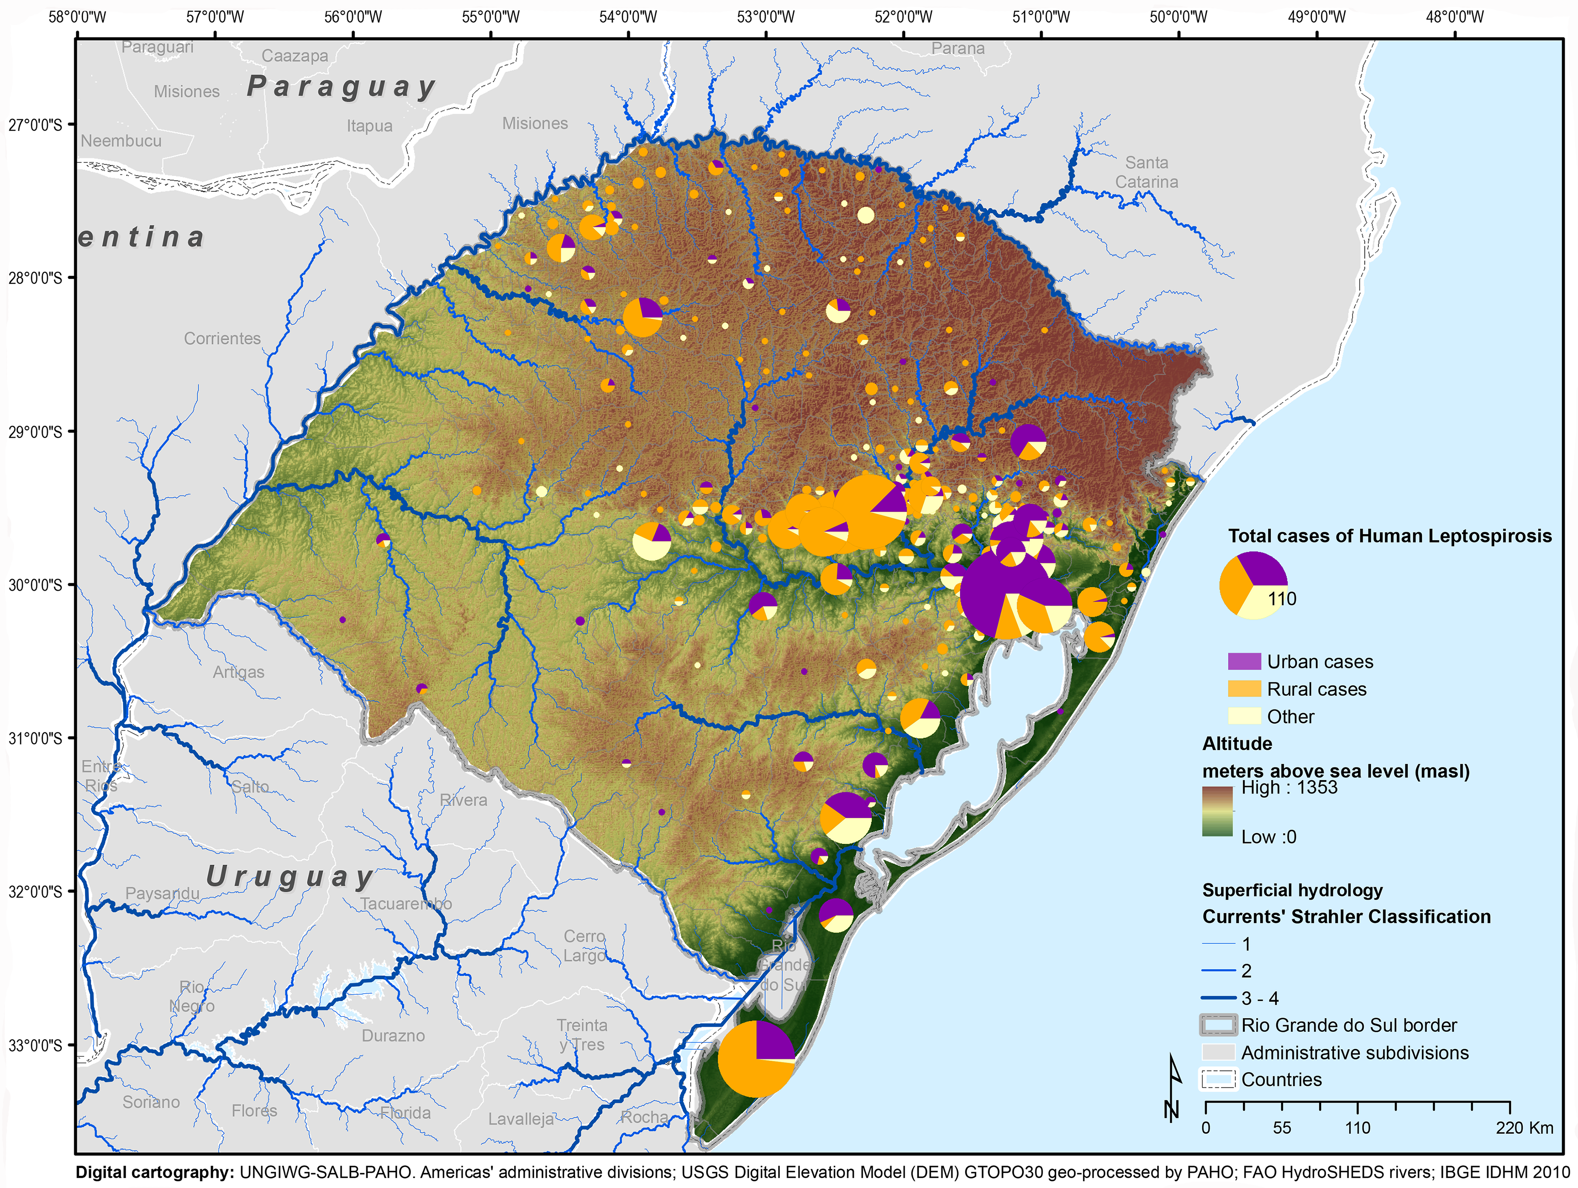
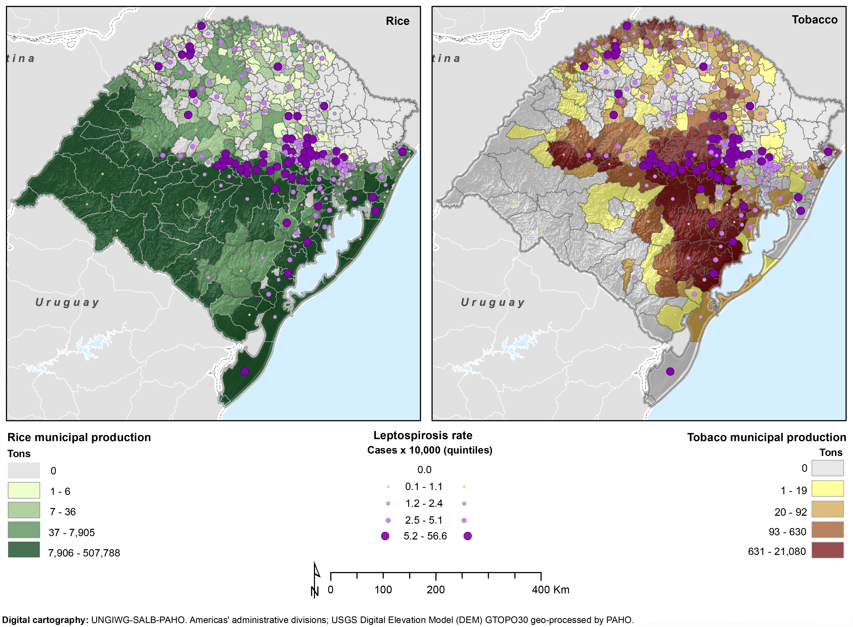
Maria Cristina Schneider ,
- Patricia Najera,
- Martha M. Pereira,
- Gustavo Machado,
- Celso B. dos Anjos,
- Rogério O. Rodrigues,
- Gabriela M. Cavagni,
- Claudia Muñoz-Zanzi,
- Luis G. Corbellini,
- Mariana Leone,
- Daniel F. Buss,
- Sylvain Aldighieri,
- Marcos A. Espinal

- Published: November 12, 2015
- https://doi.org/10.1371/journal.pntd.0004095

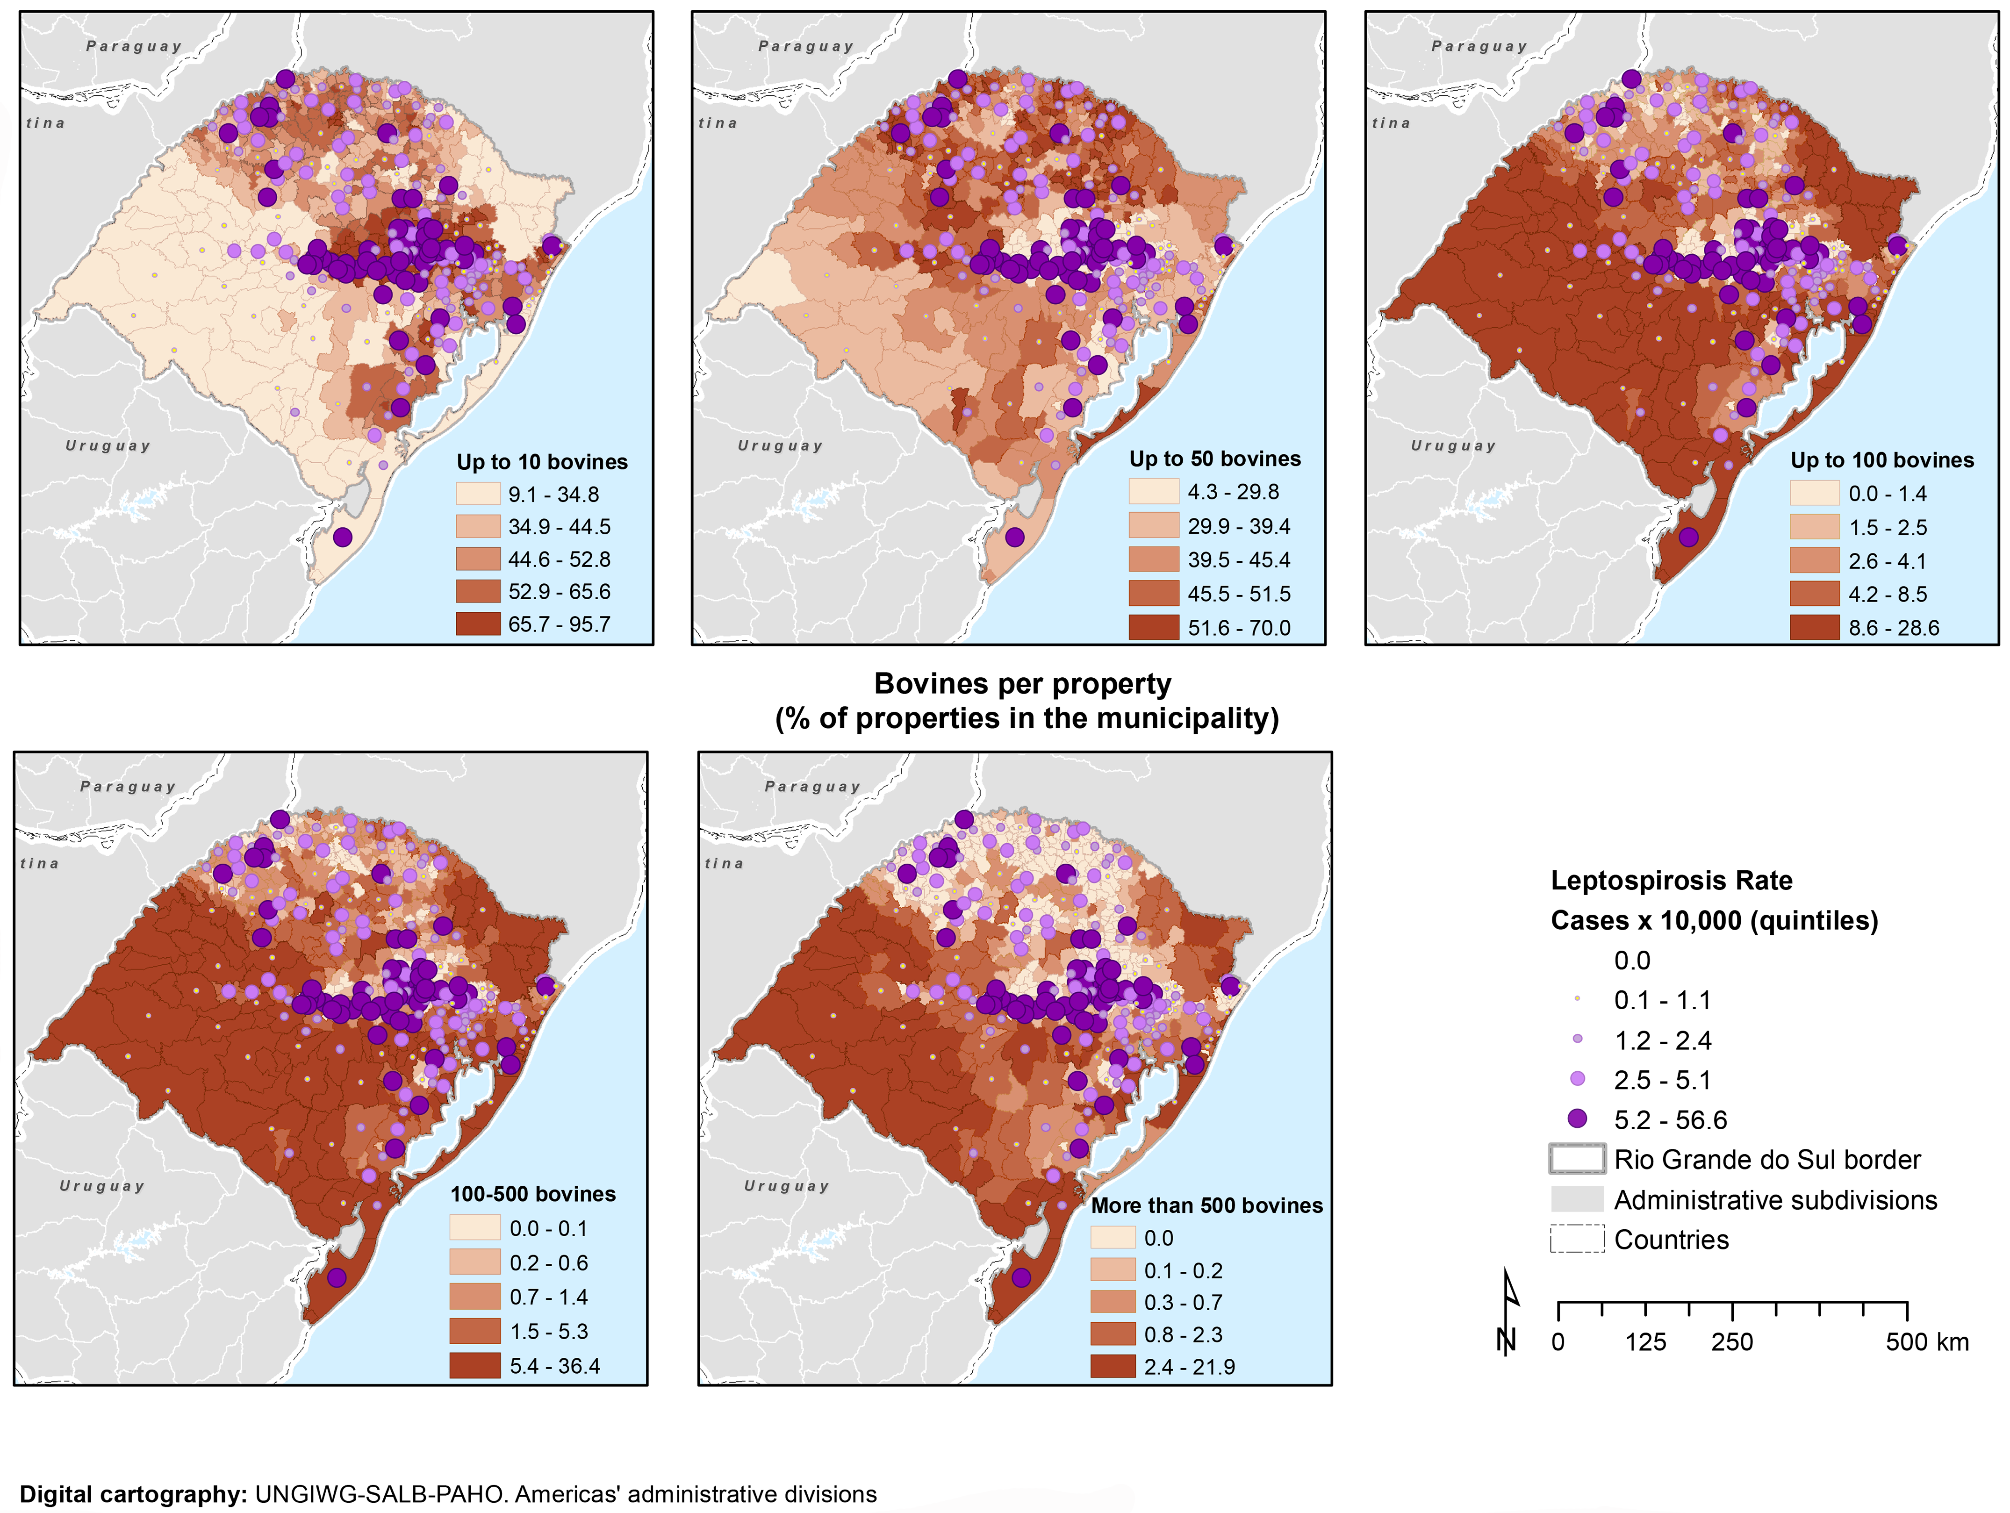

Here we see that places where there are more water, such as where there are lots of rice paddies (water and vegetation), lakes in the lowlands and moist forests. All places that the lymnaea snail likes.

We might expect low altitude to indicate infectious areas, but only because these areas also have lots of water. Slope would indicate run off.

So, what we could expect is that PI would be influenced by temperature, actual amout of water, actual amount of vegetation in a given year, and because this is a population growth problem, the previous year's population. Or PI as a proxy for that measure. This latter aspect is recursive if we control for year. To start, we won't use it.

