OFFICIAL PRODUCT DOCUMENTATION & VISUAL UI GUIDE
Tranche (Ambagan)
User Manual
A Complete Step-by-Step Visual Reference to Creating Paluwagan Groups, Executing Smart Split E-Contracts, Settling Round Contributions, and Monitoring Non-Custodial Multisig Vaults on the Stellar Network.
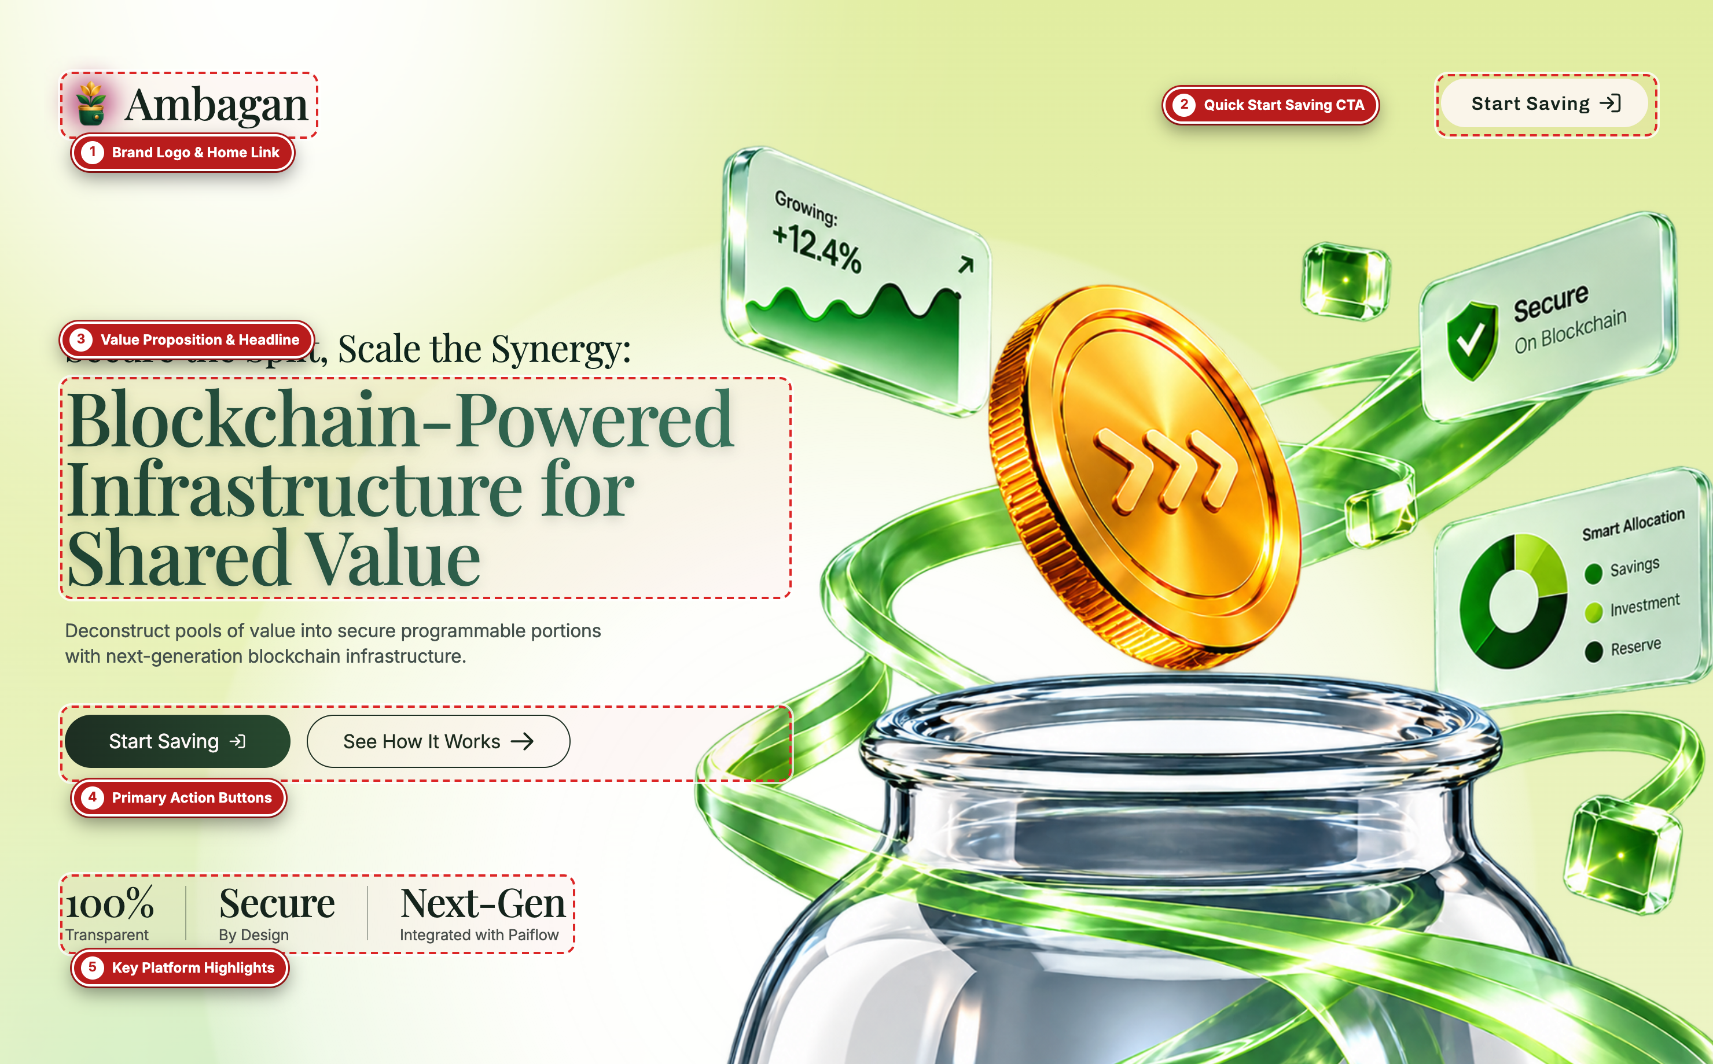

Application Name | Tranche / Ambagan (Non-Custodial Rotating Savings & Smart Split Platform)
Underlying Infrastructure | Next.js 14 App Router • Supabase Auth • Stellar Testnet (Soroban / Horizon) • Paiflow Split
Screenshot Capture Engine | Automated Playwright Chromium (Microsoft Edge 2x Retina Viewport + DOM Callout Injection)
Manual Version & Date | Version 1.0 • Generated October 2026

SECTION 01
Introduction & Core Concepts
Understanding how Tranche (Ambagan) modernizes traditional Filipino paluwagan (rotating savings) using non-custodial smart splits and cryptographic e-contracts.
Tranche (branded in-app as Ambagan) is a blockchain-powered rotating savings and credit association (ROSCA / Paluwagan) platform designed to eliminate organizer default risk, manual bookkeeping errors, and custodial lock-in. Instead of entrusting an individual treasurer to hold everyone's cash, Ambagan coordinates group agreements through legally binding electronic contracts (under Republic Act No. 8792) and settles funds directly on the Stellar Testnet via Paiflow's automated 3-way Smart Split protocol.
The 3-Way Smart Split Architecture (77% / 20% / 3%)
Allocation Bucket | Default Share | Functional Role in the Ambagan Lifecycle
1. Immediate Direct Release | 77.0% | Disbursed immediately upon round completion to the scheduled recipient's pre-configured payout destinations (e.g., landlord rent wallet, tuition account, or personal Stellar/GCash wallet).
2. Ambagan Multisig Vault | 20.0% | Locked in a non-custodial M-of-N Stellar multisig escrow vault. This reserve ensures the recipient continues contributing in future rounds and is released when the full group cycle completes.
3. Emergency Safety Fund | 3.0% | Contributed to a shared mutual liquidity buffer that protects the group against temporary payment delays or missed installments so scheduled payouts still settle on time.

Complete Visual Screen Index (17 Labeled Figures)
Figure | Screen / Modal Name | Route / Component
Figure 1 | Landing Page Hero & Value Proposition | / (components/hero.tsx)
Figure 2 | How Ambagan Works (3-Step Smart Split) | /#how (components/hero.tsx)
Figure 3 | Start Saving Here Onboarding Modal | / Modal (components/hero.tsx)
Figure 4 | Create Account (Sign Up) Page | /signup (components/signup-card.tsx)
Figure 5 | 6-Digit OTP Account Verification Page | /verify (components/verify-card.tsx)
Figure 6 | Welcome / Member & Organizer Login Page | /login (components/login-card.tsx)
Figure 7 | Main Purpose Cards Dashboard | /dashboard (components/dashboard.tsx)
Figure 8 | Create Ambagan (Purpose Saving Ledger Modal) | /dashboard Modal (components/ledger-modal.tsx)
Figure 9 | Rotating Savings Group Dashboard | /group (components/group-dashboard.tsx)
Figure 10 | E-Contract Workspace & Live Settlement Monitor | /contract Top (components/contract.tsx)
Figure 11 | Individual Addendum & Smart Split Rules | /contract Clauses 02–04 (components/contract.tsx)
Figure 12 | Mandatory Acknowledgments & Signatory Register | /contract Clauses 06–07 (components/contract.tsx)
Figure 13 | Interactive Electronic Signature Modal | /contract Modal (components/contract.tsx)
Figure 14 | Payment Portal — Select Payment Method | /pay?view=method (components/payment.tsx)
Figure 15 | Payment Portal — Payment Review & Authorization | /pay?view=review (components/payment.tsx)
Figure 16 | Payment Portal — Official Verified Receipt | /pay?view=receipt (components/payment.tsx)
Figure 17 | Profile Settings, Stellar Wallet & Security | /profile (components/profile-settings.tsx)

SECTION 02
Landing Page & Getting Started
Exploring the public landing page, understanding the non-custodial Smart Split flow, and launching the onboarding modal.
Figure 1: Landing Page Hero & Value Proposition
Application Route / View: GET / (app/page.tsx -> components/hero.tsx)
The Landing Page introduces visitors and prospective group organizers to Ambagan. It highlights how the platform automates shared savings splits and secures group funds via Stellar multisig vaults without holding user deposits in a centralized company wallet.
Figure 1 — Landing Page Hero & Value Proposition (Captured via Playwright with Visual Callout Labels)

Labeled Component Guide (Figure 1)
Label # | UI Component / Element | What It Does & How to Use It
#1 | Brand Logo & Home Link | Displays the Ambagan emblem and wordmark in the sticky top navigation bar. Clicking it returns the user to the top of the home page from any section.
#2 | Quick Start Saving CTA | Top-right navigation button ('Start saving') that immediately opens the 'Start saving here' onboarding modal from anywhere on the landing page.
#3 | Value Proposition & Headline | Communicates the core mission ('Save together. Split automatically.') along with the 'SIMPLE PALUWAGAN FOR REAL LIFE' category badge.
#4 | Primary Action Buttons | Contains two action buttons: 'Start saving' (opens the onboarding modal to Sign Up or Log In) and 'See how it works' (smooth-scrolls down to the 3-step architectural diagram).
#5 | Key Platform Highlights | Three quick-reference pills summarizing Ambagan's guarantees: '3 ways' (Immediate, Vault, Safety Fund), 'Shared' (Multisig group approval), and '0 custody' (Funds go straight to destinations).

Operational Tip: New users should click 'See how it works' (#4) first to understand the 77% / 20% / 3% split before creating an account.

Figure 2: How Ambagan Works (3-Step Smart Split Section)
Application Route / View: GET /#how (components/hero.tsx)
Scrolling to the '#how' anchor reveals the architectural walkthrough of Ambagan. It visually explains how member deposits are partitioned at the moment of payment and how the 20% multisig vault and 3% safety fund protect the entire group.
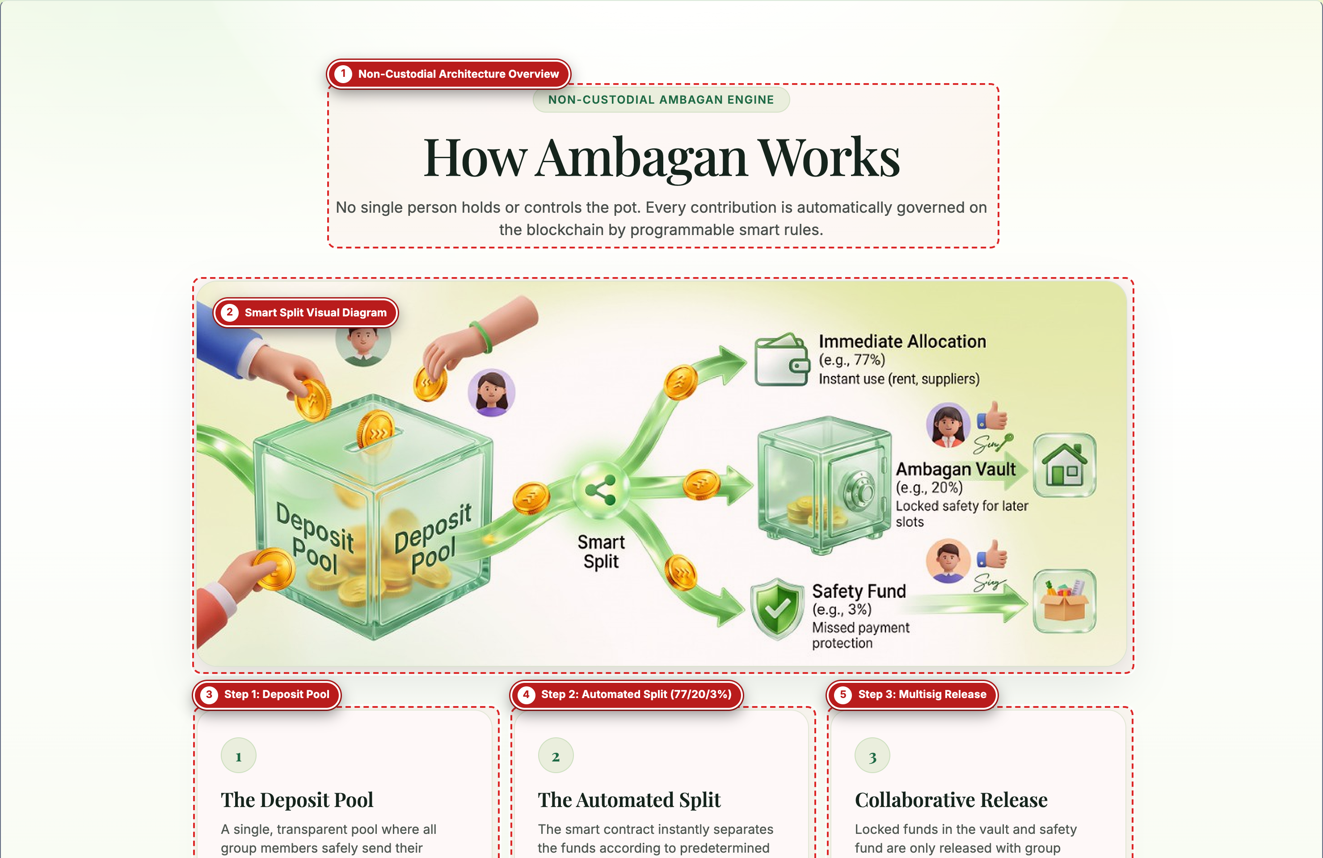
Figure 2 — How Ambagan Works (3-Step Smart Split Section) (Captured via Playwright with Visual Callout Labels)

Labeled Component Guide (Figure 2)
Label # | UI Component / Element | What It Does & How to Use It
#1 | Non-Custodial Architecture Overview | Section header explaining that Ambagan is non-custodial: deposits are split and routed directly to their final on-chain or provider destinations.
#2 | Smart Split Visual Diagram | Interactive visual illustration showing a single incoming Deposit Pool splitting into Immediate Allocation, Ambagan Vault, and Safety Fund.
#3 | Step 1: Deposit Pool | Explains that members contribute on a shared schedule (Weekly, Biweekly, or Monthly) with every deposit tracked against the active round.
#4 | Step 2: Automated Split (77/20/3%) | Details how Paiflow automatically divides each payout into three buckets: 77% immediate direct release, 20% locked multisig vault, and 3% mutual safety buffer.
#5 | Step 3: Multisig Release | Explains that the 20% vault reserve requires M-of-N group co-signatures on the Stellar network before unlocking, preventing early drop-offs.

Figure 3: Start Saving Here Onboarding Modal
Application Route / View: Landing Page Modal (Triggered via 'Start saving' button)
Clicking 'Start saving' on the Landing Page opens this modal dialog, which serves as the gateway for both new organizers/members registering an account and returning participants signing in.
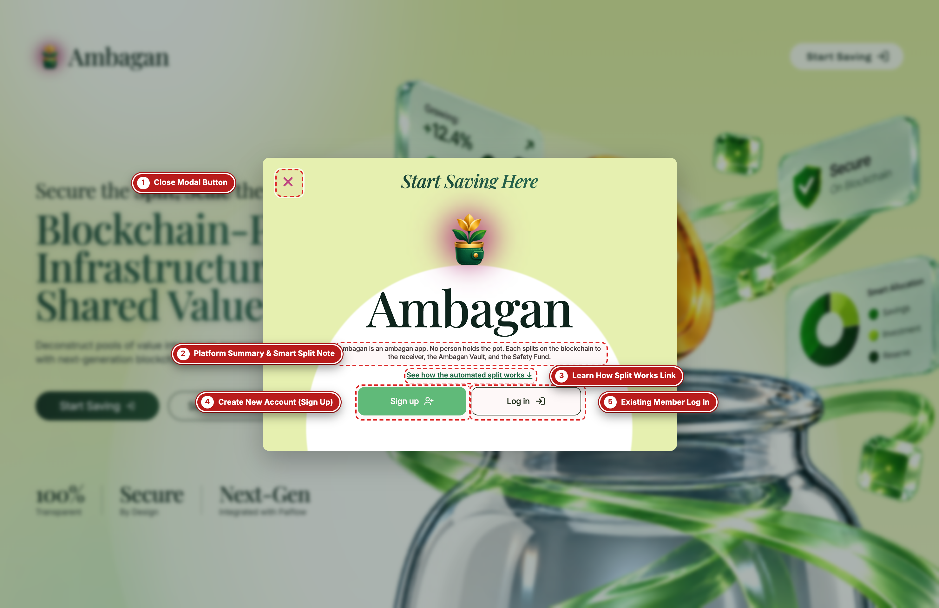
Figure 3 — Start Saving Here Onboarding Modal (Captured via Playwright with Visual Callout Labels)

Labeled Component Guide (Figure 3)
Label # | UI Component / Element | What It Does & How to Use It
#1 | Close Modal Button | Dismisses the onboarding modal (also triggered by pressing the Escape key or clicking the blurred backdrop).
#2 | Platform Summary & Smart Split Note | Concise explanation of how Ambagan splits deposits into immediate needs, a multisig group vault, and a small safety buffer.
#3 | Learn How Split Works Link | Closes the modal and scrolls smoothly to the 'How Ambagan Works' section (#how) if the user wants more detail before registering.
#4 | Create New Account (Sign Up) | Primary plum action button ('Sign Up') that routes new users to `/signup` to register their organizer or participant profile.
#5 | Existing Member Log In | Secondary action button ('Log In') that routes existing members directly to `/login`.

SECTION 03
Account Registration, OTP Verification & Login
Creating a new Ambagan account, completing 6-digit email OTP verification, and signing in with credentials or instant demo access.
Figure 4: Create Account (Sign Up) Page
Application Route / View: GET /signup (app/signup/page.tsx -> components/signup-card.tsx)
The Create Account screen allows new organizers and group members to register using their email address and a password (minimum 6 characters), or bypass manual registration during demonstrations using the one-click Google / Demo sign-in button.
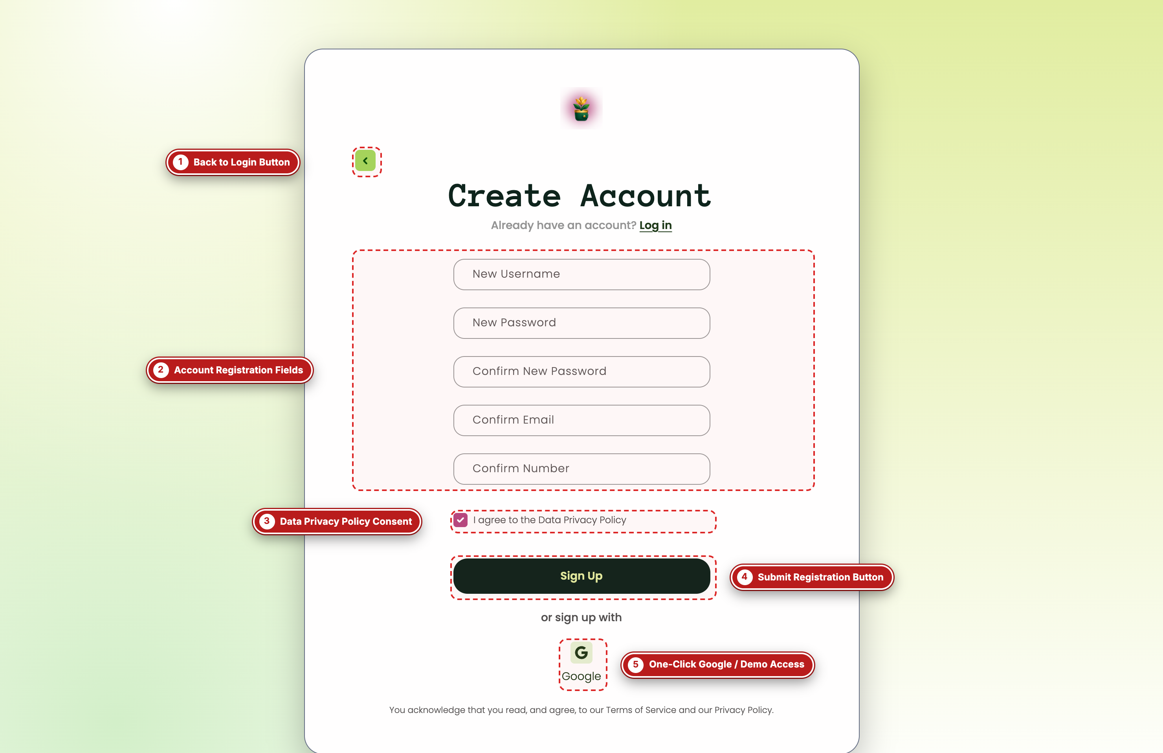
Figure 4 — Create Account (Sign Up) Page (Captured via Playwright with Visual Callout Labels)

Labeled Component Guide (Figure 4)
Label # | UI Component / Element | What It Does & How to Use It
#1 | Back to Login Button | Circular back arrow button that navigates back to `/login` if the user already has an account.
#2 | Account Registration Fields | Input fields for Username/Full Name, Email Address, Password (minimum 6 characters), and Confirm Password. The form validates password matching and minimum length before submission.
#3 | Data Privacy Policy Consent | Mandatory checkbox requiring the user to accept the Ambagan Privacy Policy before account creation is enabled.
#4 | Submit Registration Button | Submits the registration payload to `/api/auth/signup`, sets the signed `tranche_session` cookie, and redirects the user to `/verify` for OTP confirmation.
#5 | One-Click Google / Demo Access | Calls `/api/auth/demo` to provision or sign into a pre-configured demo organizer account and immediately enter `/dashboard`.

Operational Tip: In local or offline hackathon environments without live SMTP configured, clicking 'Continue with Google (Demo)' (#5) or using the Demo OTP button on the next screen provides instant full-featured access.

Figure 5: 6-Digit OTP Account Verification Page
Application Route / View: GET /verify (app/verify/page.tsx -> components/verify-card.tsx)
After submitting the Sign Up form, users are directed to `/verify` to confirm their email address by entering a 6-digit One-Time Password (OTP). The screen supports keyboard auto-advance, full 6-digit clipboard paste, and a built-in 'Demo OTP (123456)' auto-fill helper.
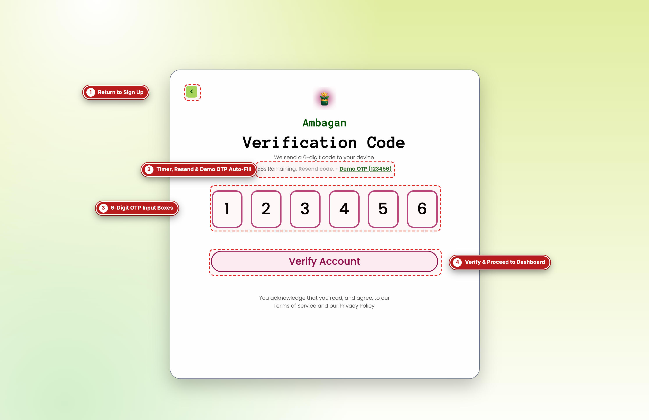
Figure 5 — 6-Digit OTP Account Verification Page (Captured via Playwright with Visual Callout Labels)

Labeled Component Guide (Figure 5)
Label # | UI Component / Element | What It Does & How to Use It
#1 | Return to Sign Up | Navigates back to `/signup` if the user needs to correct a mistyped email address.
#2 | Timer, Resend & Demo OTP Auto-Fill | Displays a 60-second countdown timer, a 'Resend Code' button (`POST /api/auth/resend-otp`), and a 'Demo OTP (123456)' button that automatically populates all 6 digits for testing.
#3 | 6-Digit OTP Input Boxes | Six individual numeric input slots that automatically advance focus as digits are typed and support pasting a 6-digit code directly from the clipboard.
#4 | Verify & Proceed to Dashboard | Validates the 6-digit code via `POST /api/auth/verify` and routes the authenticated user to `/dashboard`.

Figure 6: Welcome / Member & Organizer Login Page
Application Route / View: GET /login (app/login/page.tsx -> components/login-card.tsx)
Returning organizers and participants sign in at `/login`. If a participant received an emailed invite link or temporary password for a specific Ambagan group, they can also log in here or trigger a password reset.
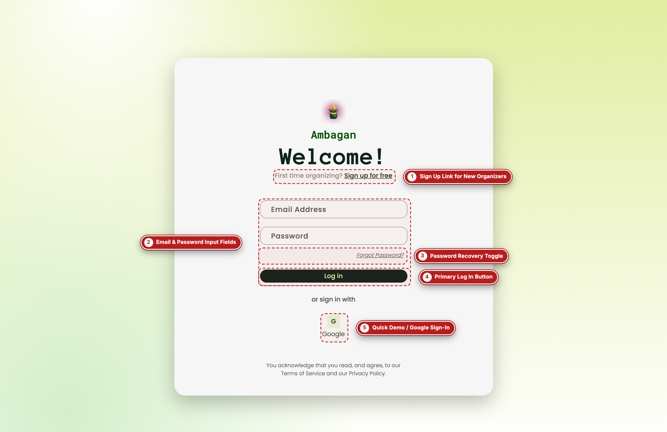
Figure 6 — Welcome / Member & Organizer Login Page (Captured via Playwright with Visual Callout Labels)

Labeled Component Guide (Figure 6)
Label # | UI Component / Element | What It Does & How to Use It
#1 | Sign Up Link for New Organizers | Direct link to `/signup` for users who do not yet have an Ambagan account.
#2 | Email & Password Input Fields | Standard credential inputs authenticated against `/api/auth/login`.
#3 | Password Recovery Toggle | 'Forget Password?' link that switches the card into Password Recovery mode, allowing users to request a reset link via `/api/auth/forgot-password`.
#4 | Primary Log In Button | Authenticates credentials, issues an HTTP-only HMAC-signed `tranche_session` cookie, and redirects to `/dashboard`.
#5 | Quick Demo / Google Sign-In | Provides one-click instant sign-in (`POST /api/auth/demo`) for evaluators and demo walkthroughs.

SECTION 04
Main Dashboard & Creating an Ambagan Group
Managing active savings groups from the Purpose Cards dashboard and configuring a new Ambagan ledger with automatic share splitting.
Figure 7: Main Purpose Cards Dashboard
Application Route / View: GET /dashboard (app/dashboard/page.tsx -> components/dashboard.tsx)
The Main Dashboard is the central command center after signing in. Each rotating savings group is displayed as a visual 'Purpose Card' showing its active round, remaining days until the deadline, member count, next scheduled payer, total pool goal, and per-cycle contribution.
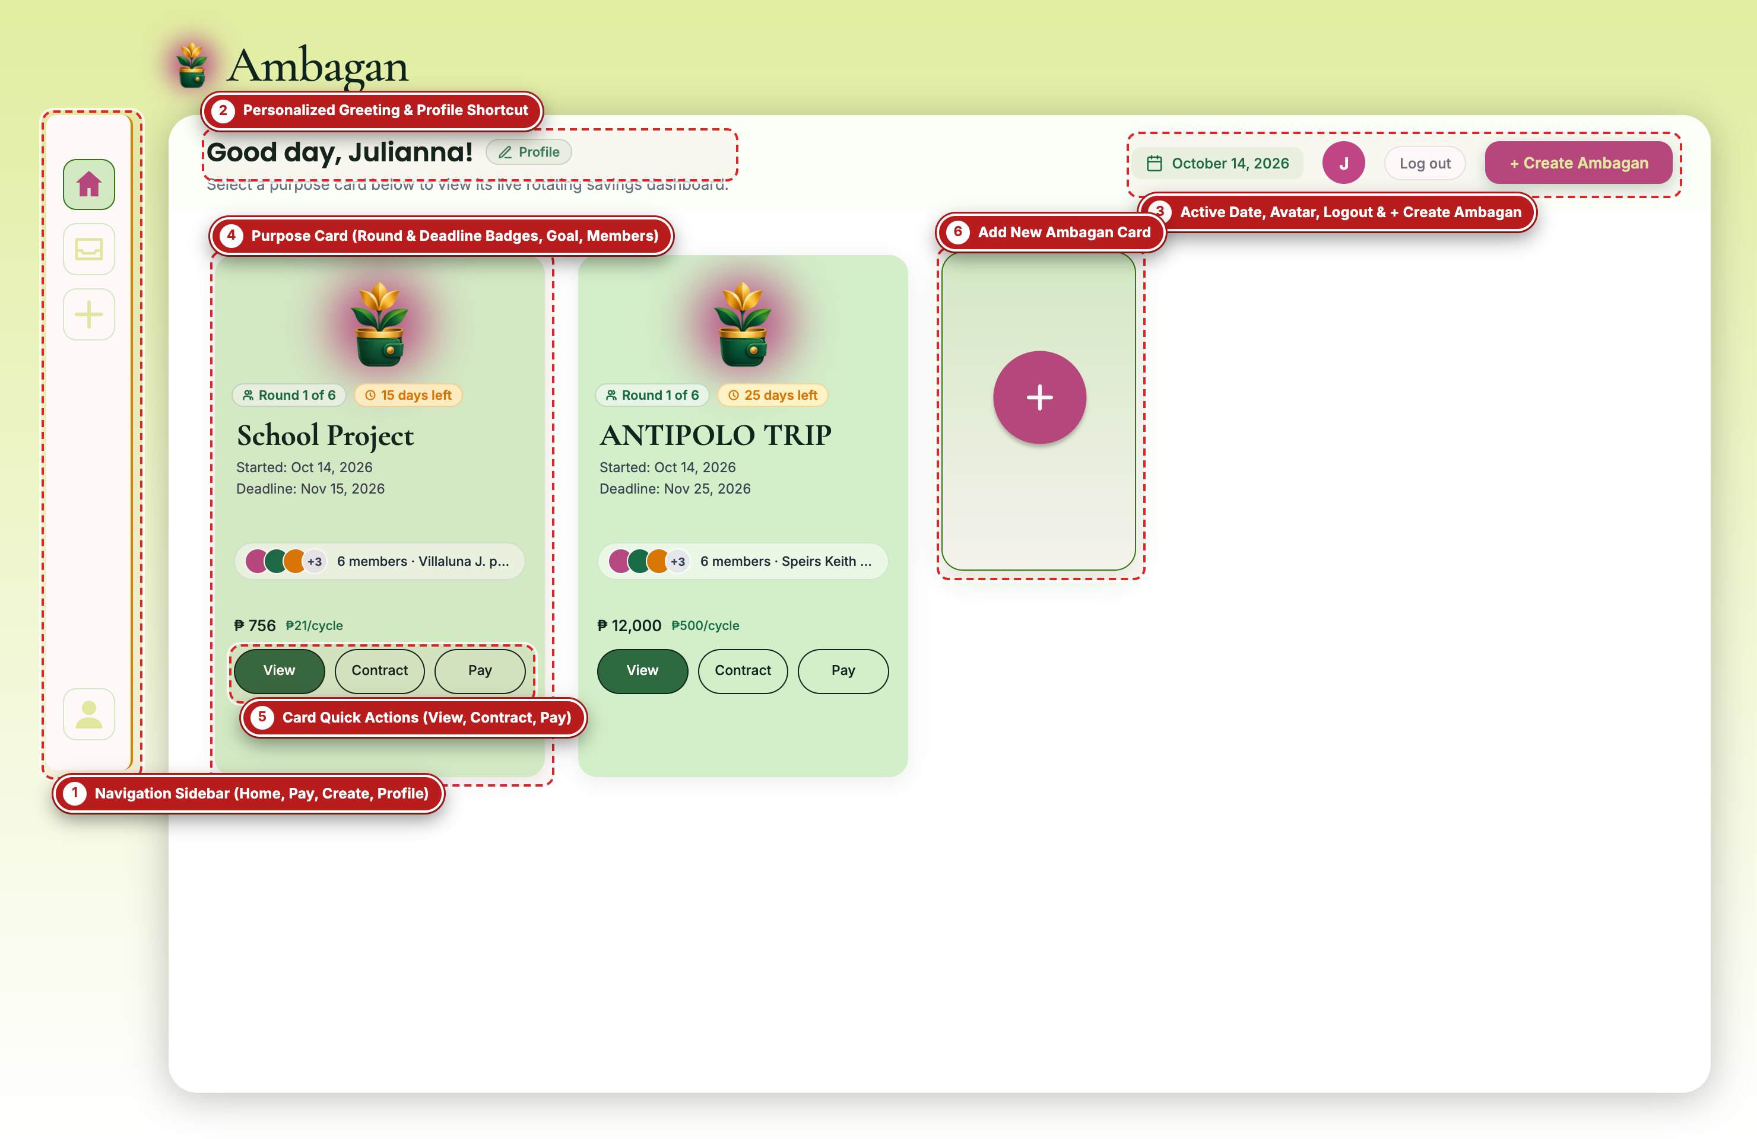
Figure 7 — Main Purpose Cards Dashboard (Captured via Playwright with Visual Callout Labels)

Labeled Component Guide (Figure 7)
Label # | UI Component / Element | What It Does & How to Use It
#1 | Navigation Sidebar (Home, Pay, Create, Profile) | Persistent left rail providing one-click access to the Dashboard Home (`/dashboard`), Payment Portal (`/pay`), Create Ambagan Modal (`+`), and Profile Settings (`/profile`).
#2 | Personalized Greeting & Profile Shortcut | Displays a personalized greeting ('Good day, Julianna!') alongside a quick 'Profile' pill that links directly to `/profile`.
#3 | Active Date, Avatar, Logout & + Create Ambagan | Top-right utility bar showing the current date badge, user avatar initial, 'Log out' button (`POST /api/auth/logout`), and the primary '+ Create Ambagan' button.
#4 | Purpose Card (Round & Deadline Badges, Goal, Members) | Summarizes a single Ambagan group (e.g., 'School Project' or 'ANTIPOLO TRIP'), including the current round ('Round 1 of 6'), countdown ('15 days left'), start/deadline dates, member avatars, total pool (₱756 or ₱12,000), and cycle contribution (₱21/cycle or ₱500/cycle).
#5 | Card Quick Actions (View, Contract, Pay) | Three dedicated action buttons on every card: 'View' opens the live Group Dashboard (`/group?plan=...`), 'Contract' opens the E-Contract workspace (`/contract?plan=...`), and 'Pay' launches the Payment Portal (`/pay?plan=...`).
#6 | Add New Ambagan Card | Large dashed '+' card at the end of the grid that opens the Create Ambagan modal when clicked.

Operational Tip: Any newly created Ambagan group saved via the Create Ambagan modal is persisted in browser storage (`ambagan_created_plans_v1`) and immediately appears as a new Purpose Card on this dashboard.

Figure 8: Create Ambagan Modal (Purpose Saving Ledger Setup)
Application Route / View: Dashboard Modal (components/ledger-modal.tsx)
Clicking '+ Create Ambagan' opens the Purpose Saving configuration modal. Here, the group organizer defines the savings purpose, sets the total shared target in Philippine Pesos (₱), invites recipients by email, selects the contract start and deadline dates, picks the contribution frequency, and affixes their organizer e-signature.
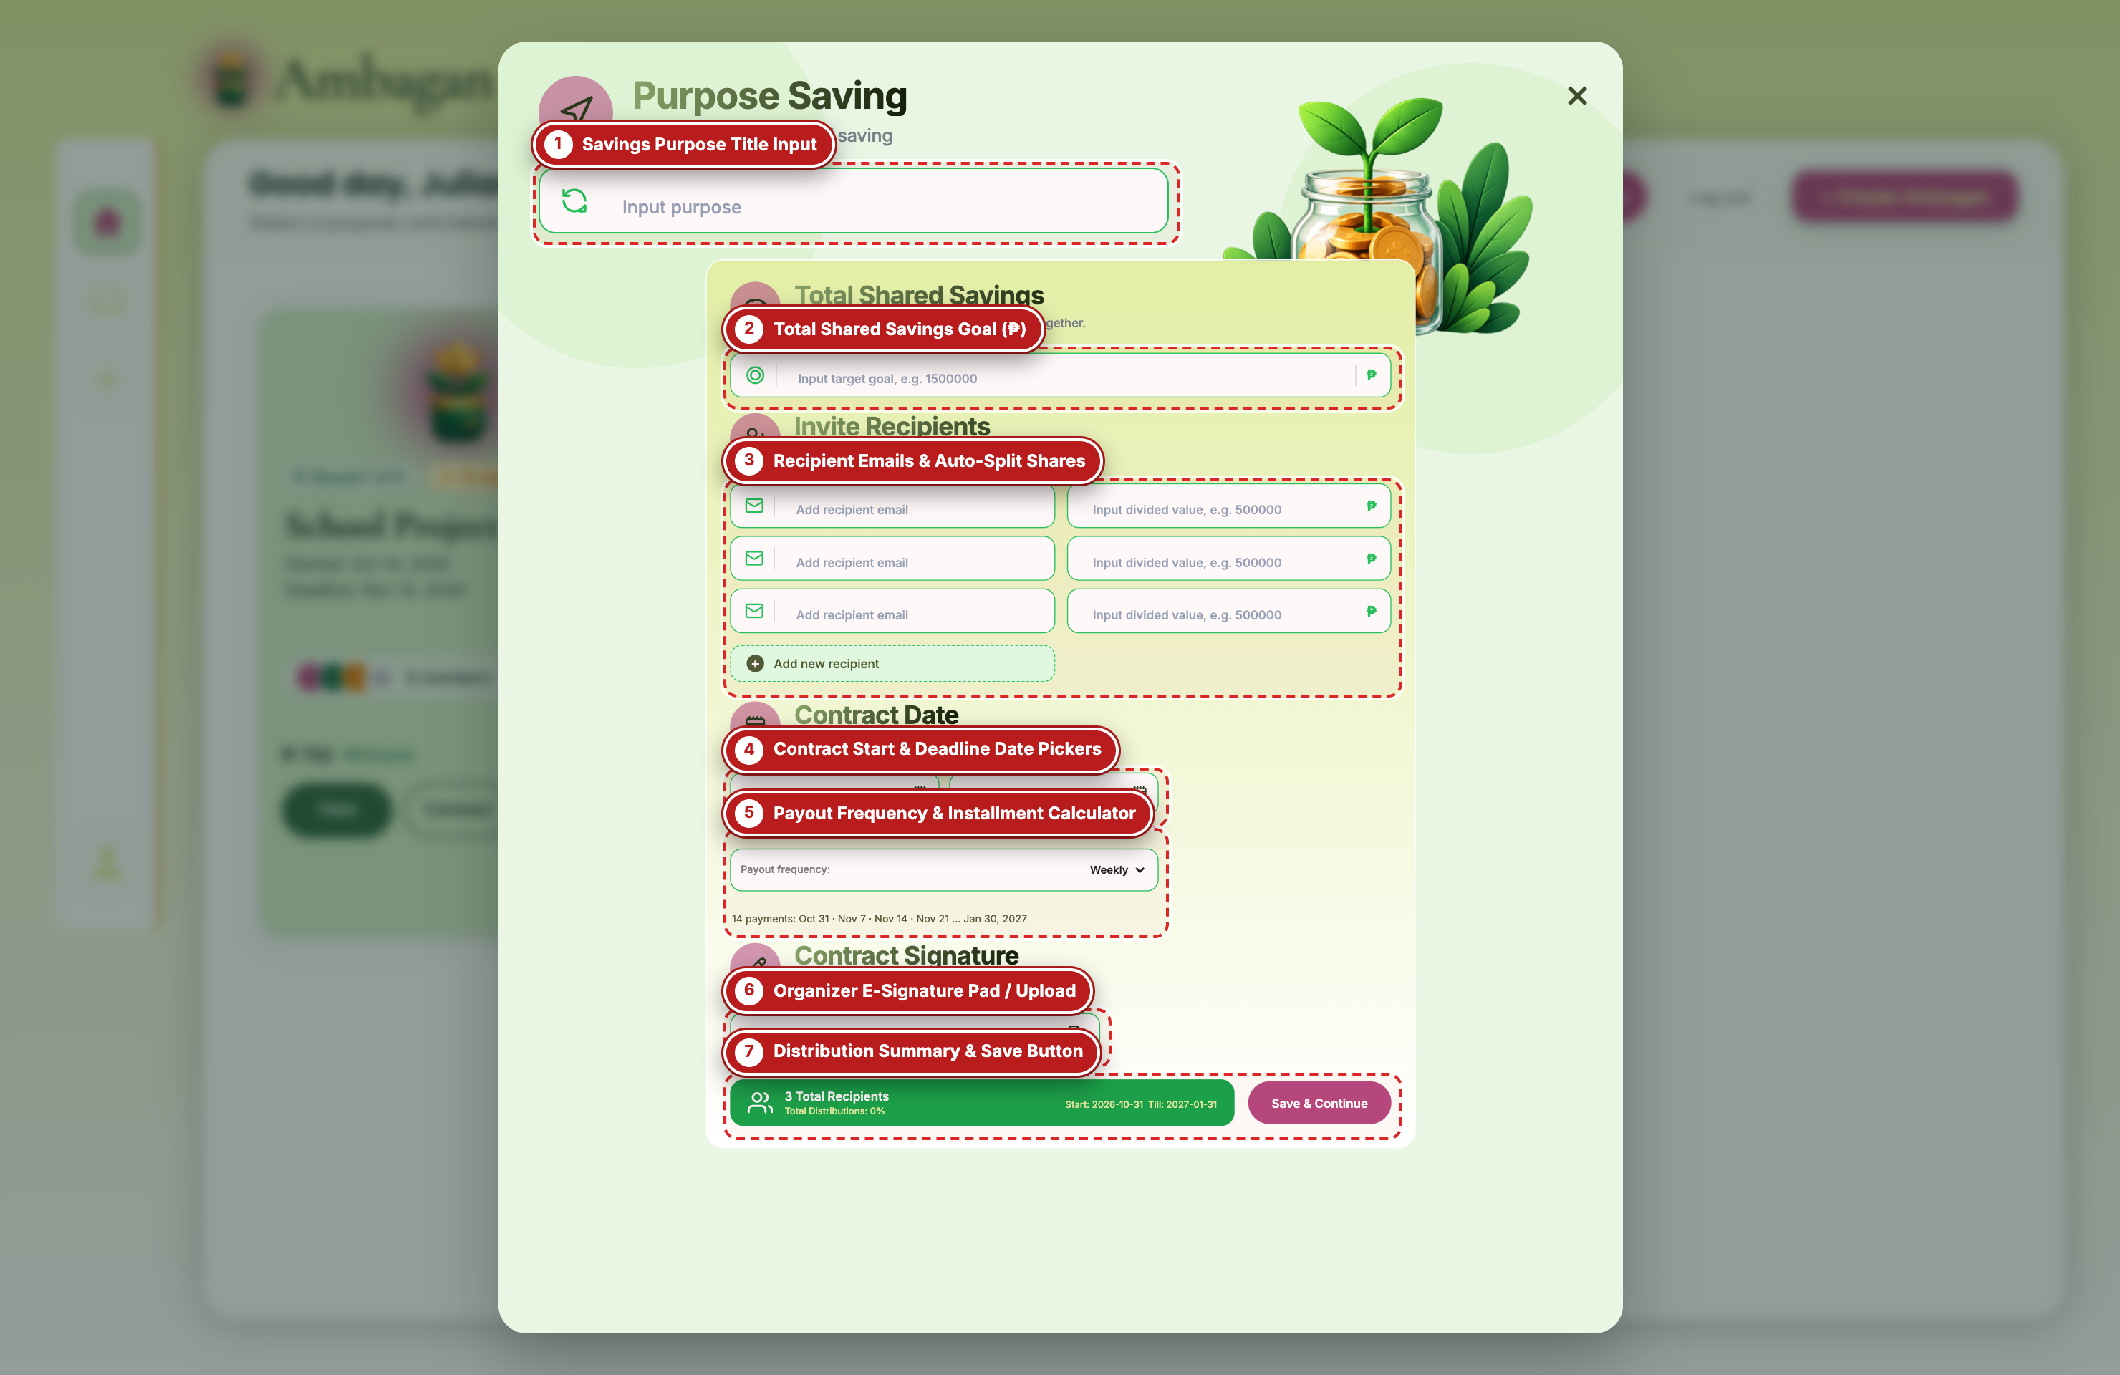
Figure 8 — Create Ambagan Modal (Purpose Saving Ledger Setup) (Captured via Playwright with Visual Callout Labels)

Labeled Component Guide (Figure 8)
Label # | UI Component / Element | What It Does & How to Use It
#1 | Savings Purpose Title Input | Text field where the organizer names the savings pool (e.g., 'Boracay Barkada Fund', 'Laptop Upgrade Pool', or 'School Project').
#2 | Total Shared Savings Goal (₱) | Numeric input for the total target pool amount in PHP. Entering or changing this value automatically divides the goal equally across all invited recipients unless custom shares are entered.
#3 | Recipient Emails & Auto-Split Shares | Dynamic list of group participants. For each member, the organizer enters their email address and divided payout value. Clicking '+ Add new recipient' adds more slots and automatically recalculates equal shares.
#4 | Contract Start & Deadline Date Pickers | Interactive calendar pickers defining when the rotating savings contract begins ('Start date') and when the final round concludes ('Deadline date').
#5 | Payout Frequency & Installment Calculator | Dropdown to choose 'Weekly', 'Biweekly (Every 2 weeks)', or 'Monthly' cadence. Below the dropdown, Ambagan automatically computes the exact number of payment cycles and previews the upcoming collection dates.
#6 | Organizer E-Signature Pad / Upload | Allows the organizer to either draw their handwritten signature on an interactive HTML5 canvas or upload an image file (PNG/JPG) to countersign the group creation.
#7 | Distribution Summary & Save Button | Live status bar displaying total recipients, percentage of pool allocated (must equal 100%), contract date span, and the 'Save & Continue' button, which creates the group and routes directly to `/contract`.

SECTION 05
Group Dashboard (Rotating Savings & On-Chain Monitor)
Tracking pool collections, Stellar Testnet settlement status, member slot rotation, and round-by-round payout history.
Figure 9: Rotating Savings Group Dashboard
Application Route / View: GET /group?plan=antipolo-trip (app/group/page.tsx -> components/group-dashboard.tsx)
Clicking 'View' on any Purpose Card opens the Group Dashboard. This screen provides full transparency for every participant: showing total pool value, next draw date, live workflow gate status (whether e-signatures are complete), Stellar Testnet connection status, a visual donut breakdown of funds, the member slot table, and a clickable round timeline.
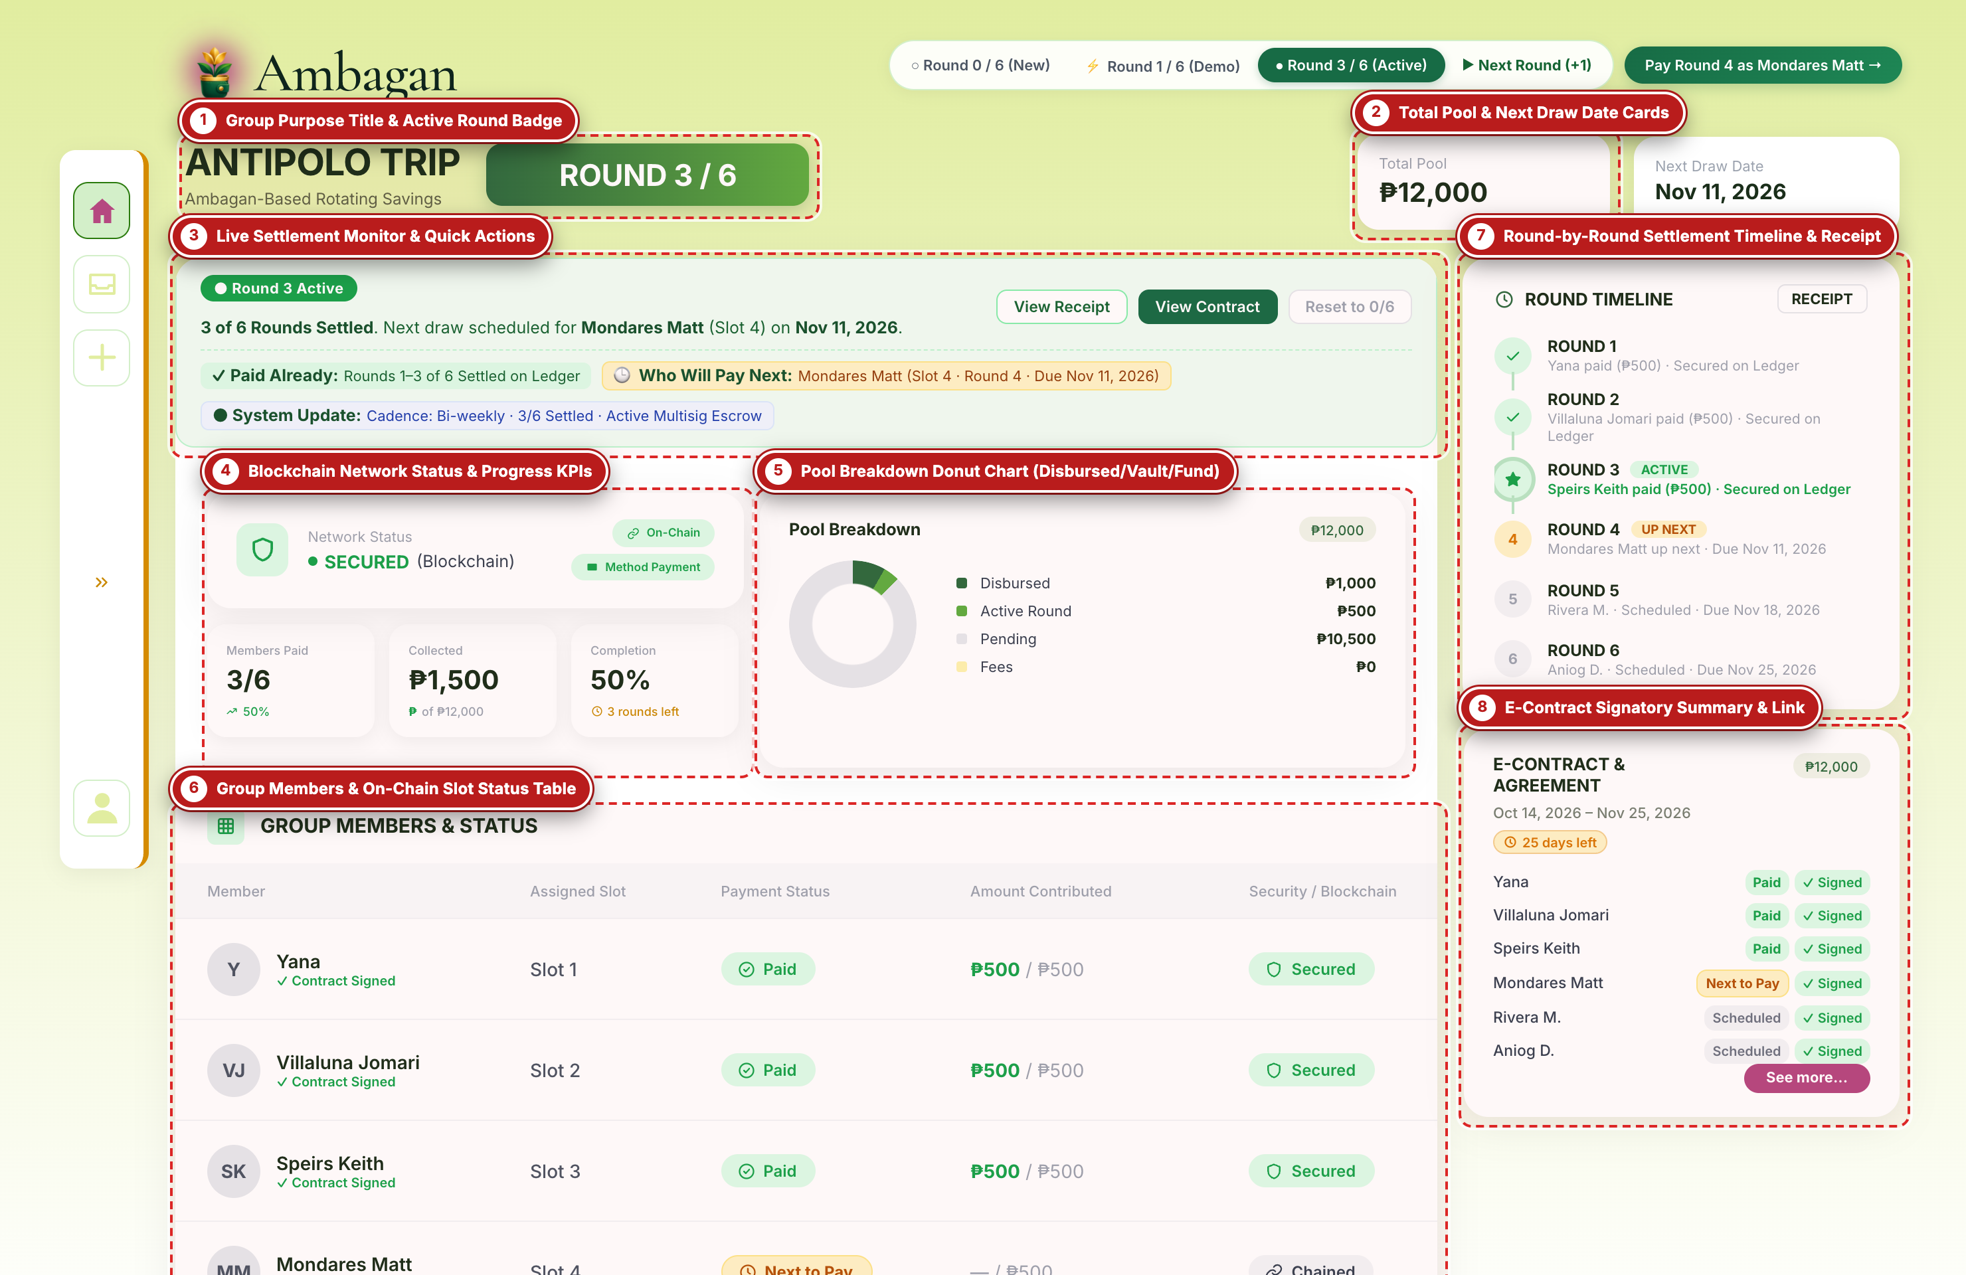
Figure 9 — Rotating Savings Group Dashboard (Captured via Playwright with Visual Callout Labels)

Labeled Component Guide (Figure 9)
Label # | UI Component / Element | What It Does & How to Use It
#1 | Group Purpose Title & Active Round Badge | Displays the active group name ('ANTIPOLO TRIP'), the current cycle pill ('Round 1 of 6'), and a 'My Groups' back button to return to `/dashboard`.
#2 | Total Pool & Next Draw Date Cards | High-visibility KPI cards showing the total pool target (₱12,000 across 6 members at ₱500/round) and the Next Draw Date along with the scheduled recipient and their truncated Stellar wallet address.
#3 | Live Settlement Monitor & Quick Actions | Real-time workflow banner indicating whether the pool is awaiting contract signatures or ready for round settlement, paired with 'Pay Contribution (₱500)' and 'View E-Contract' buttons.
#4 | Blockchain Network Status & Progress KPIs | Displays the live network indicator ('Stellar Testnet • Live'), total collected in the current round, remaining balance, and overall cycle progress bar.
#5 | Pool Breakdown Donut Chart (Disbursed/Vault/Fund) | SVG donut chart visualizing the exact PHP amounts and percentages allocated across Disbursed payouts, the Ambagan Multisig Vault, and the Safety Fund.
#6 | Group Members & On-Chain Slot Status Table | Lists every member in slot order (#1 through #6), their role, Stellar wallet address (`GCXR...JFUI`), round contribution amount, and live status badge ('Paid', 'Pending', or 'Scheduled').
#7 | Round-by-Round Settlement Timeline & Receipt | Chronological list of all 6 payout rounds. Completed rounds display a 'View Receipt' link that opens an on-chain settlement modal with the Stellar transaction hash and ledger number.
#8 | E-Contract Signatory Summary & Link | Compact summary card showing how many participants have signed the group agreement (e.g., '0 of 7 signatures recorded') with a button to open `/contract`.

SECTION 06
Individual E-Contract & Cryptographic E-Signature Portal
Reviewing legally binding paluwagan clauses, switching participant perspectives, verifying Smart Split rules, and executing R.A. 8792 electronic signatures.
Figure 10: E-Contract Workspace, Live Settlement Monitor & Perspective Switcher
Application Route / View: GET /contract?plan=antipolo-trip (app/contract/page.tsx -> components/contract.tsx)
The E-Contract page generates a customized, legally structured Shared Savings Contract for the group and each individual slot holder. The top section provides PDF export (`window.print()`), a live workflow gate tracker, simulated email credential dispatch cards for demo testing, and a Perspective Switcher.
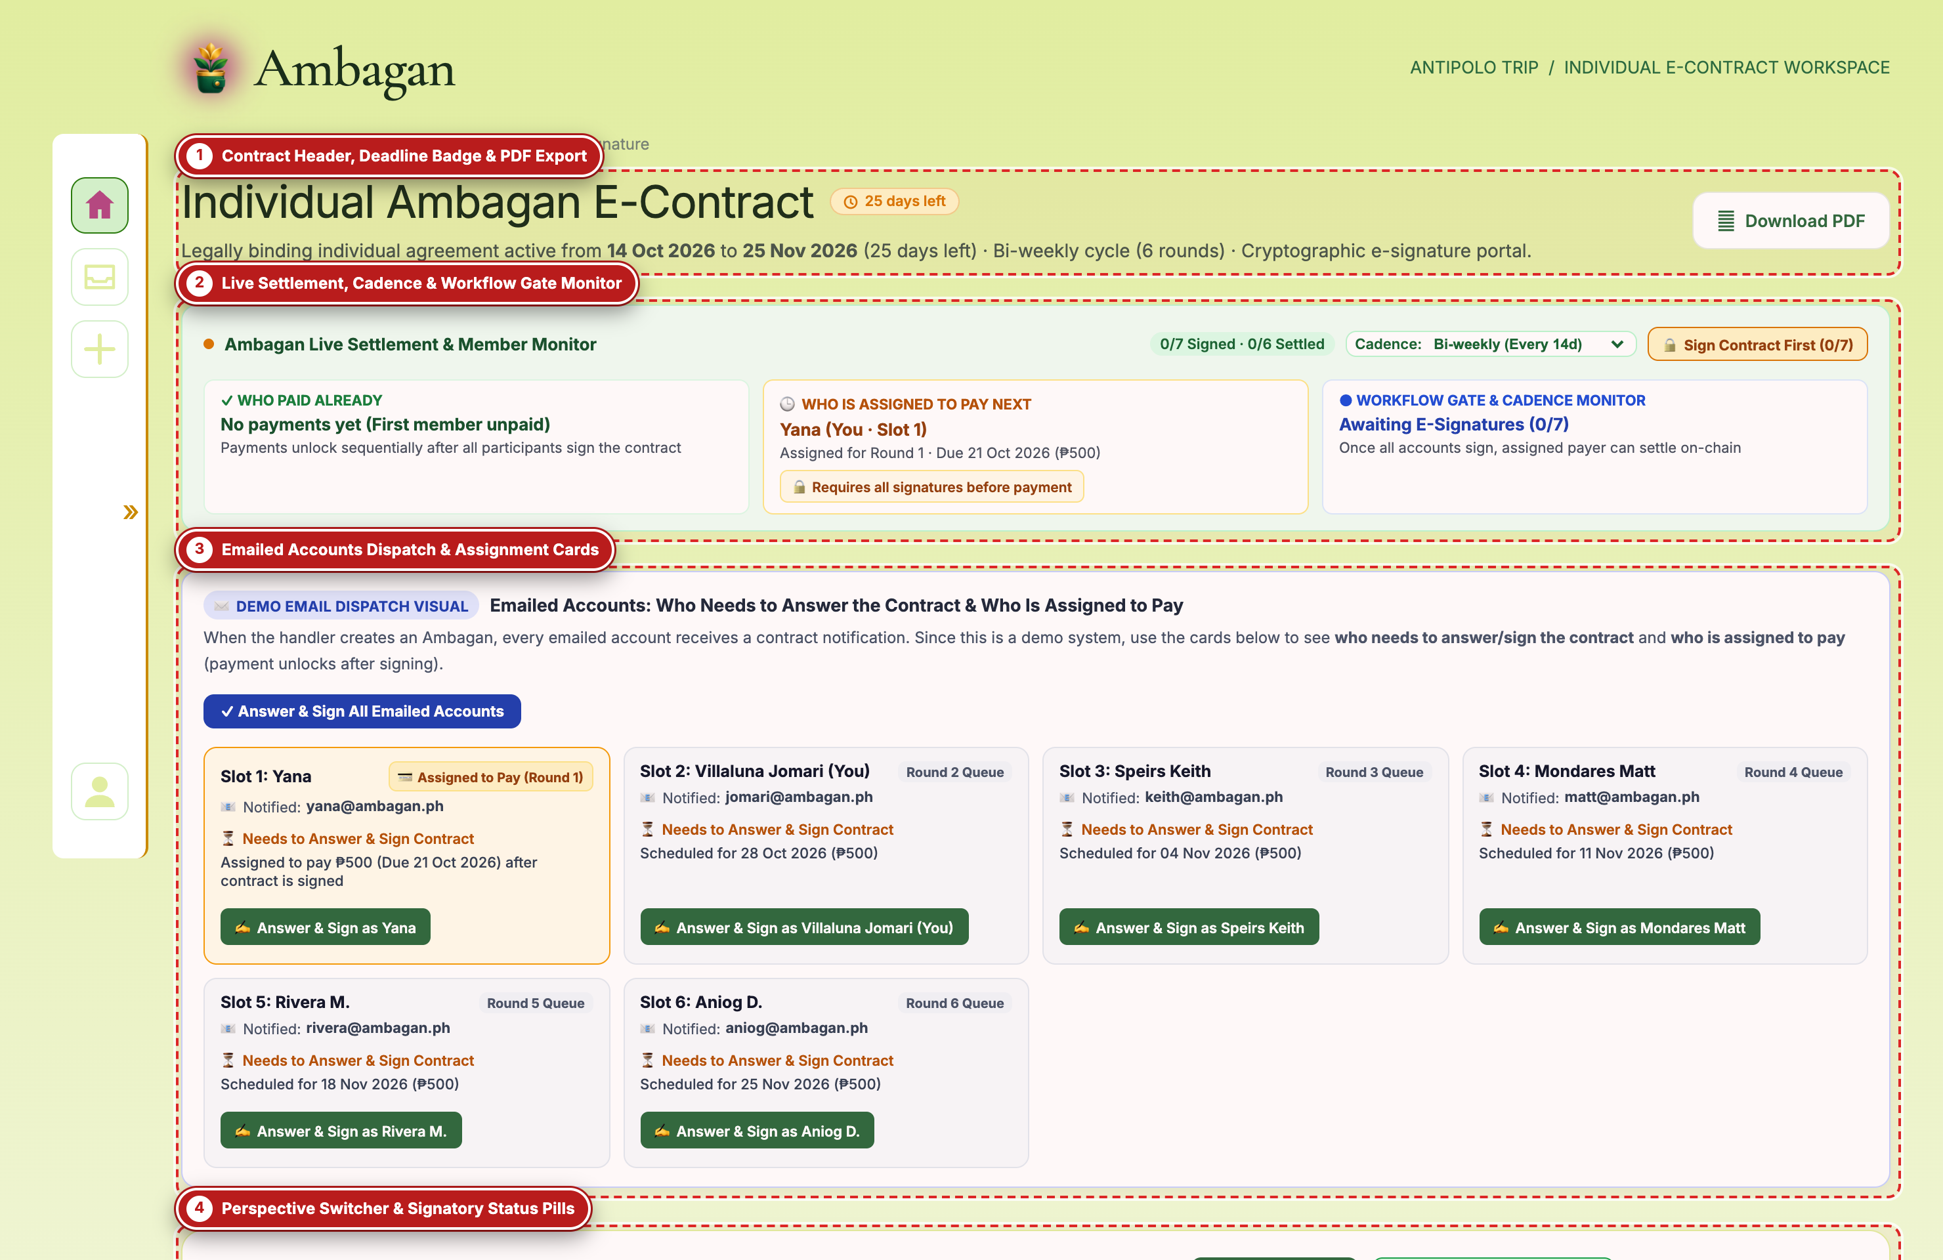
Figure 10 — E-Contract Workspace, Live Settlement Monitor & Perspective Switcher (Captured via Playwright with Visual Callout Labels)

Labeled Component Guide (Figure 10)
Label # | UI Component / Element | What It Does & How to Use It
#1 | Contract Header, Deadline Badge & PDF Export | Displays the group title, contract status badge ('Pending agreement'), remaining days badge, 'Save PDF' print button, and navigation links back to the Group Dashboard.
#2 | Live Settlement, Cadence & Workflow Gate Monitor | Tracks the 2-step activation gate: Step 1 requires all participants and the organizer to affix their e-signatures; Step 2 unlocks contribution payments in strict slot order (#1 -> #6).
#3 | Emailed Accounts Dispatch & Assignment Cards | Displays the credential dispatch cards sent to each invited email address (including temporary password and assigned payout round) and allows clicking any member card to preview their perspective.
#4 | Perspective Switcher & Signatory Status Pills | Interactive selector bar ('Viewing Individual Contract For:') allowing the user or evaluator to switch between any participant (e.g., Yana Slot #1, Villaluna Jomari Slot #2, or Organizer) to inspect and sign their specific addendum.

Operational Tip: In the Tranche workflow gate, contribution payments are locked until all required signatures (participants + organizer) are recorded on the E-Contract.

Figure 11: Individual Participant Addendum & Smart Split Partition Rules
Application Route / View: GET /contract#individual-contract (Clauses 02–04)
Scrolling down the E-Contract reveals Clause 02 (Individual Participant Addendum), which dynamically adapts to whichever participant is selected in the Perspective Switcher. It details their exact slot number, per-round obligation, scheduled payout round, 77%/20%/3% Smart Split partition, and Stellar payout addresses.
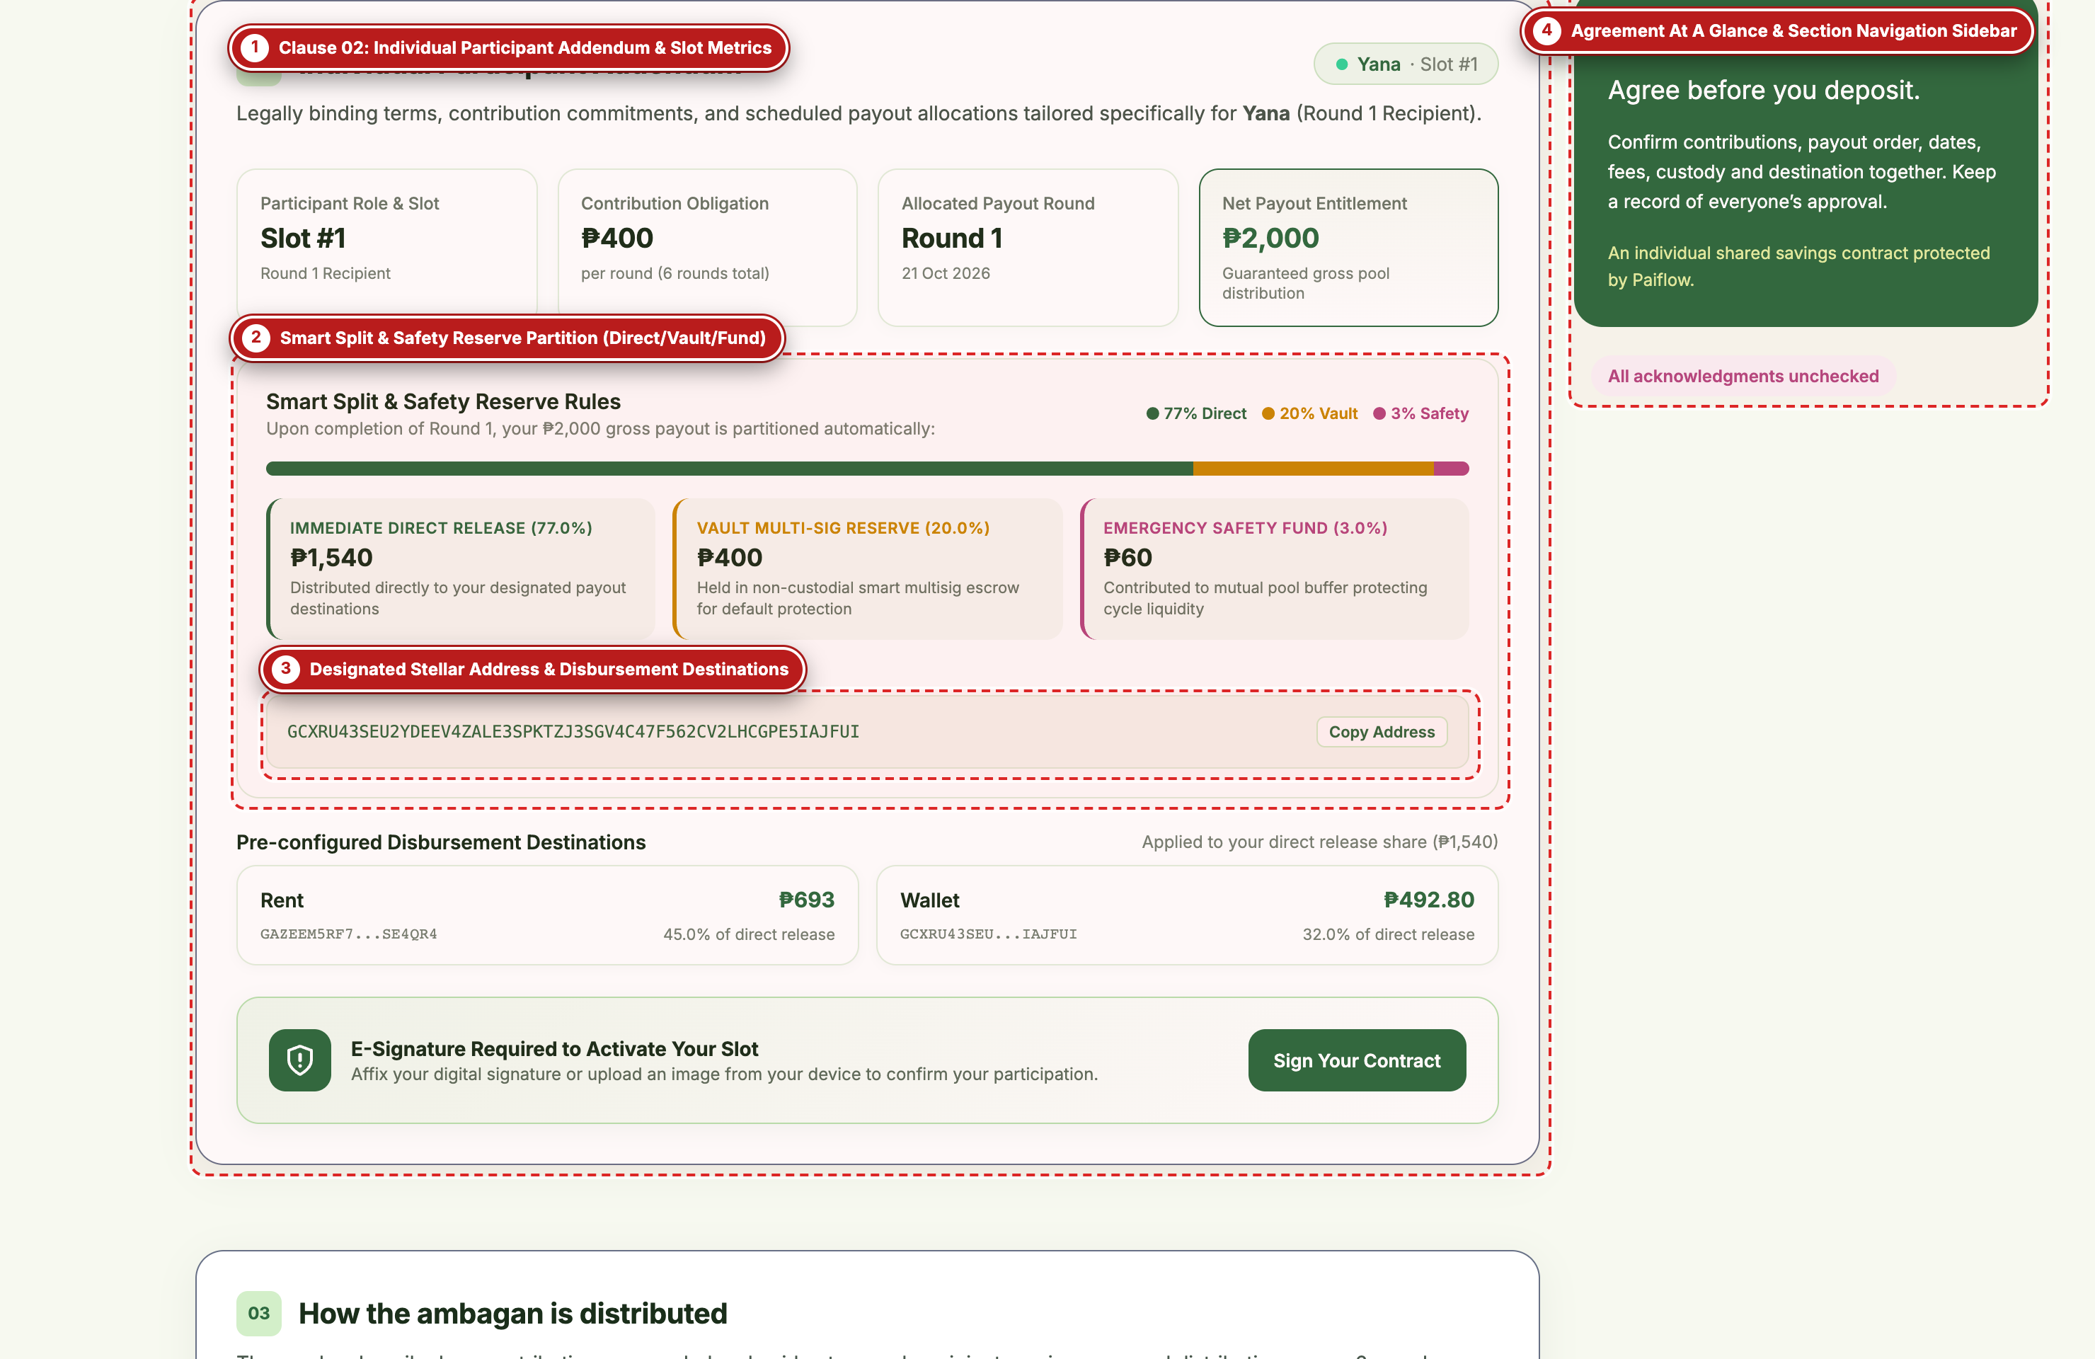
Figure 11 — Individual Participant Addendum & Smart Split Partition Rules (Captured via Playwright with Visual Callout Labels)

Labeled Component Guide (Figure 11)
Label # | UI Component / Element | What It Does & How to Use It
#1 | Clause 02: Individual Participant Addendum & Slot Metrics | Displays the selected member's binding metrics: Participant Role & Slot (e.g., Slot #1), Contribution Obligation (₱400/round), Allocated Payout Round (Round 1), and Net Payout Entitlement (₱2,000).
#2 | Smart Split & Safety Reserve Partition (Direct/Vault/Fund) | Visualizes the exact PHP breakdown of the member's gross payout: Immediate Direct Release (77.0% / ₱1,540), Vault Multi-Sig Reserve (20.0% / ₱400), and Emergency Safety Fund (3.0% / ₱60).
#3 | Designated Stellar Address & Disbursement Destinations | Shows the member's primary Stellar public key with a one-click 'Copy Address' button, followed by their pre-configured disbursement split (e.g., 45% to Rent, 32% to Personal Wallet).
#4 | Agreement At A Glance & Section Navigation Sidebar | Sticky right-hand summary panel showing pool totals, acknowledgment completion status, and quick-jump anchor links to Clauses 01 through 07.

Figure 12: Mandatory Acknowledgments & Cryptographic Signatory Register
Application Route / View: GET /contract#acks & #sign (Clauses 06–07)
At the bottom of the E-Contract are Clauses 06 and 07. Before a participant can affix their signature, they are presented with four mandatory risk and responsibility acknowledgments, followed by the live Signatory Register recording every member's signature image, timestamp, and verification badge.
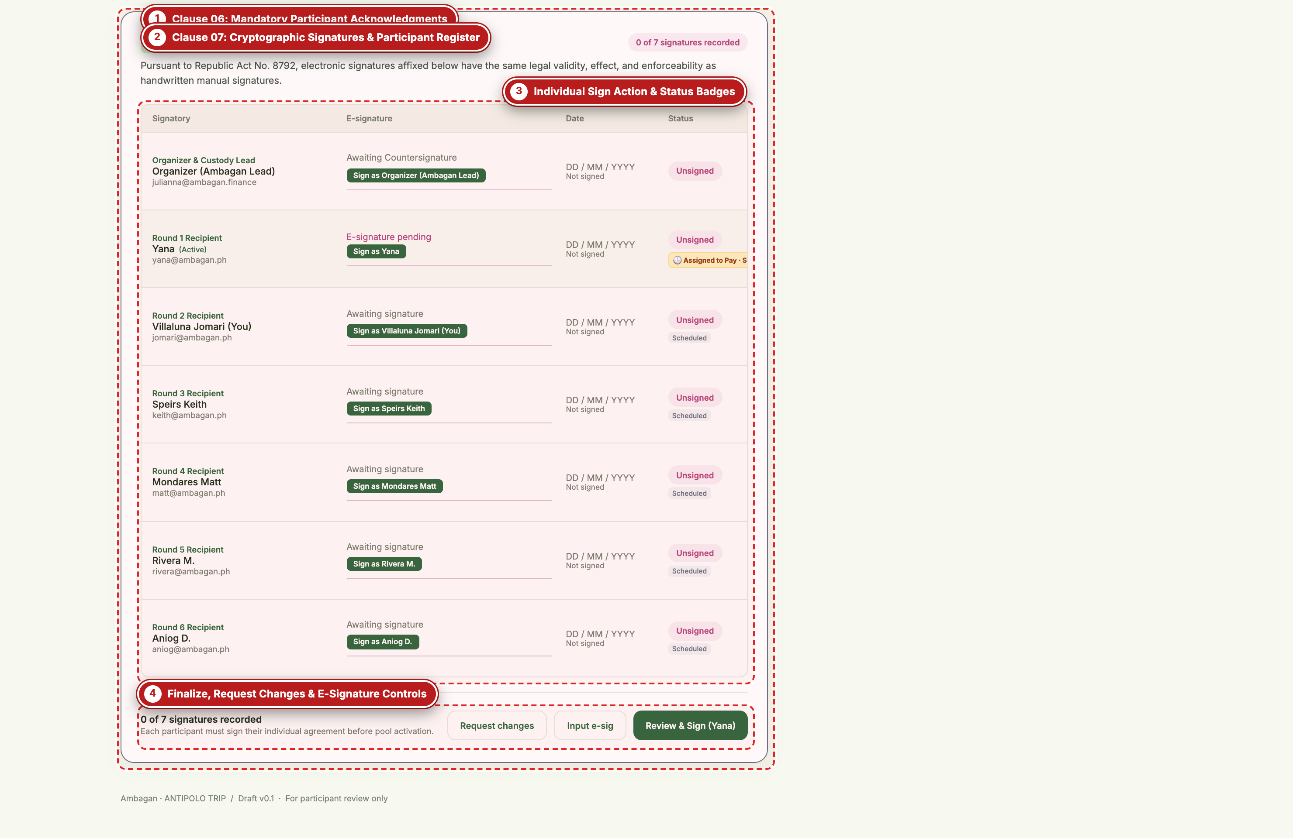
Figure 12 — Mandatory Acknowledgments & Cryptographic Signatory Register (Captured via Playwright with Visual Callout Labels)

Labeled Component Guide (Figure 12)
Label # | UI Component / Element | What It Does & How to Use It
#1 | Clause 06: Mandatory Participant Acknowledgments | Four individual checkboxes that each participant ticks to confirm they have read the pending terms, understand Ambagan is a shared savings arrangement (not an investment), accept crypto/provider risks, and agree to keep a signed copy.
#2 | Clause 07: Cryptographic Signatures & Participant Register | Header and live counter ('0 of 7 signatures recorded') citing legal enforceability under the Philippine Electronic Commerce Act of 2000 (Republic Act No. 8792).
#3 | Individual Sign Action & Status Badges | Interactive table listing the Organizer and all Round 1–6 Recipients. Each row displays either the rendered signature image and date or an active 'Sign as [Member Name]' button alongside their payment status badge.
#4 | Finalize, Request Changes & E-Signature Controls | Bottom action bar allowing the active participant to 'Request changes', open the signature pad ('Input e-sig'), or 'Review & Sign' their contract.

Figure 13: Interactive Electronic Signature Modal
Application Route / View: E-Contract Signature Modal (Triggered via 'Sign as ...' or 'Input e-sig')
Clicking any 'Sign as [Participant]' button opens the Affix Electronic Signature modal. Participants can either draw their signature using a mouse, stylus, or trackpad, or upload an existing signature image from their device.
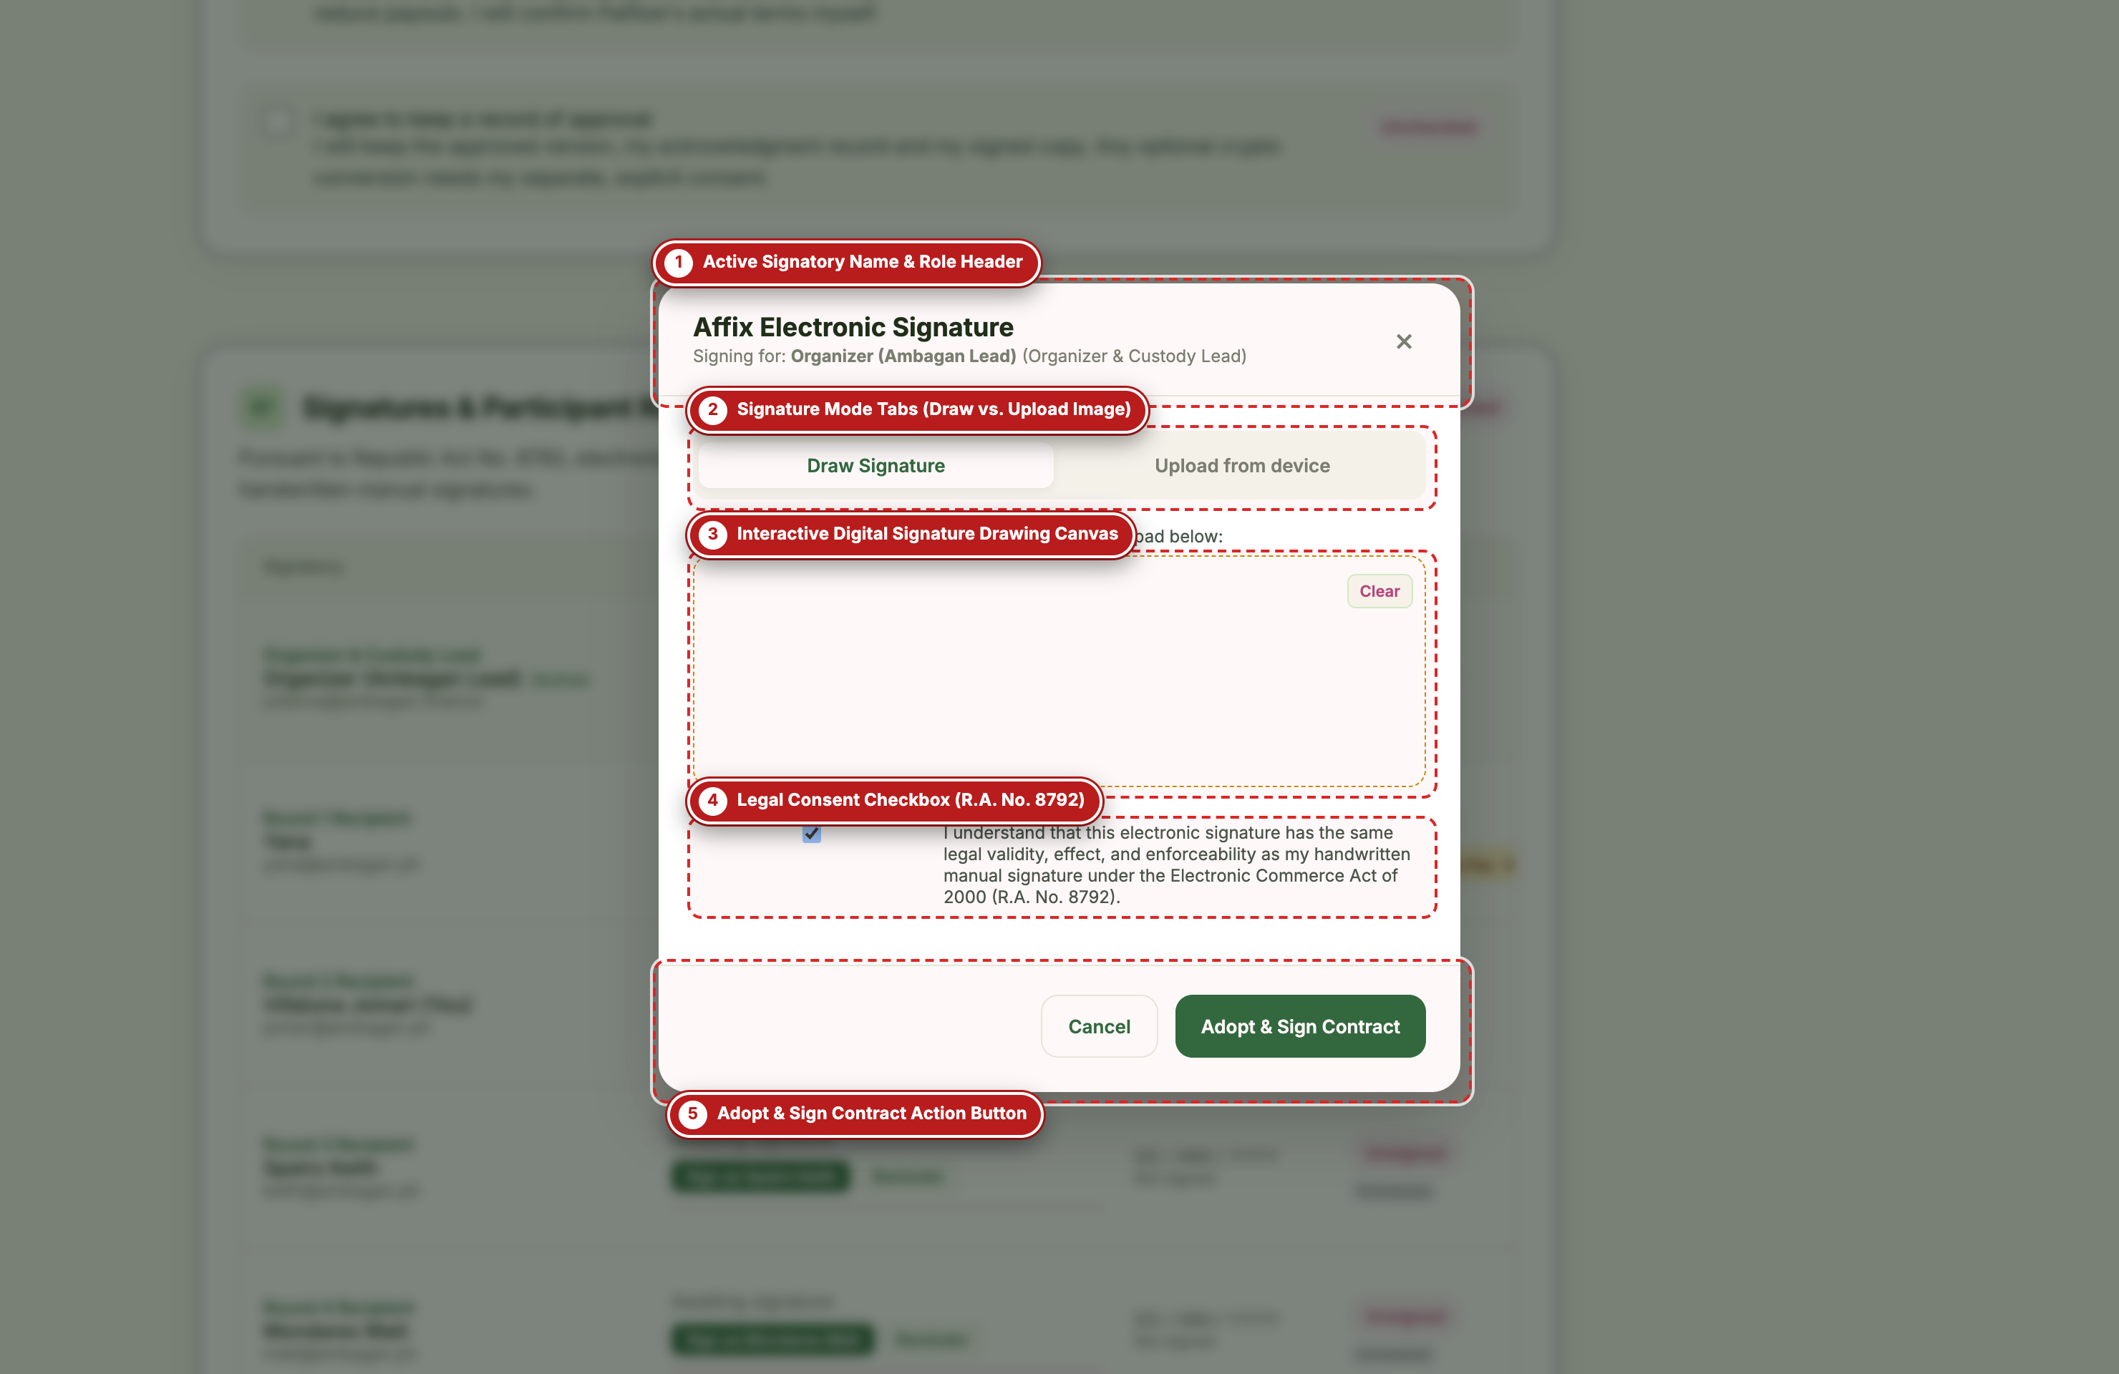
Figure 13 — Interactive Electronic Signature Modal (Captured via Playwright with Visual Callout Labels)

Labeled Component Guide (Figure 13)
Label # | UI Component / Element | What It Does & How to Use It
#1 | Active Signatory Name & Role Header | Confirms exactly which participant or organizer role is currently signing (e.g., 'Signing for: Organizer (Ambagan Lead)').
#2 | Signature Mode Tabs (Draw vs. Upload Image) | Segmented toggle allowing the signatory to switch between 'Draw Signature' (interactive canvas) and 'Upload from device' (PNG/JPG file picker).
#3 | Interactive Digital Signature Drawing Canvas | High-DPI HTML5 drawing pad with a 'Clear' button in the top-right corner to reset strokes if the user wants to redraw their signature.
#4 | Legal Consent Checkbox (R.A. No. 8792) | Mandatory legal attestation confirming that the electronic signature carries the same validity and effect as a handwritten signature under R.A. No. 8792.
#5 | Adopt & Sign Contract Action Button | Embeds the base64 signature graphic into the Signatory Register, timestamps the approval, updates the group's signature counter in real time, and persists the state across the app.

SECTION 07
Contribution Payment Portal & Official Receipts
Selecting a Philippine payment rail (GCash, Maya, Bank Transfer, or Cash), reviewing zero-fee breakdowns, authorizing settlement, and downloading tamper-evident receipts.
Figure 14: Payment Portal — Select Payment Method
Application Route / View: GET /pay?plan=school-project&view=method (app/pay/page.tsx -> components/payment.tsx)
The Payment Portal (`/pay`) uses a split-screen layout: the left panel summarizes the active group, amount due, due date, and round progress, while the right modal card steps the payer through selecting a payment rail, reviewing transaction details, and receiving a verified on-chain receipt.
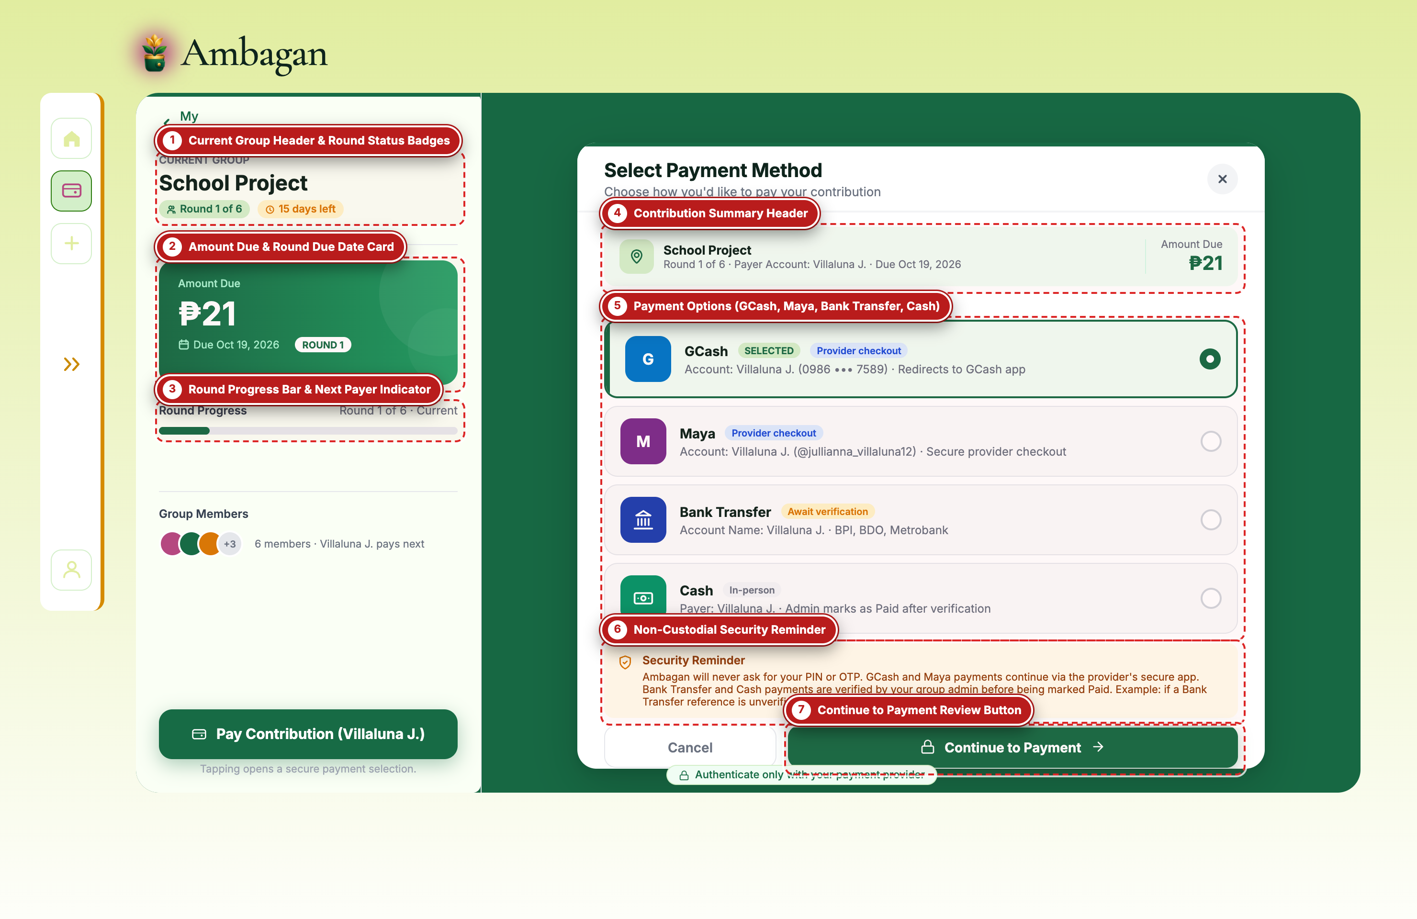
Figure 14 — Payment Portal — Select Payment Method (Captured via Playwright with Visual Callout Labels)

Labeled Component Guide (Figure 14)
Label # | UI Component / Element | What It Does & How to Use It
#1 | Current Group Header & Round Status Badges | Displays the group being paid ('School Project'), active round pill ('Round 1 of 6'), remaining days badge ('15 days left'), and a 'My Groups' link back to `/dashboard`.
#2 | Amount Due & Round Due Date Card | Highlights the exact contribution amount due for the current cycle (e.g., ₱21) and the round due date.
#3 | Round Progress Bar & Next Payer Indicator | Visual progress bar showing how many members have settled their current round contribution and who is next in line to pay.
#4 | Contribution Summary Header | Compact banner inside the payment modal confirming the group name, active round, payer account name, due date, and amount due.
#5 | Payment Options (GCash, Maya, Bank Transfer, Cash) | Interactive radio list of supported Philippine payment channels: GCash (instant provider checkout), Maya (instant provider checkout), Bank Transfer (BPI/BDO/Metrobank with admin verification), and Cash (in-person handoff).
#6 | Non-Custodial Security Reminder | Explains that Ambagan never asks for or stores user PINs or OTPs; digital wallet payments redirect to the provider's official checkout.
#7 | Continue to Payment Review Button | Proceeds to the itemized Payment Review screen (`view=review`) for the selected payment rail.

Figure 15: Payment Portal — Payment Review & Provider Authorization
Application Route / View: GET /pay?plan=school-project&view=review (components/payment.tsx)
Before any funds are settled, the Payment Review screen presents a complete, transparent breakdown of the payer slot, recipient pool, due date, contribution amount, and waived convenience fee (₱0.00).
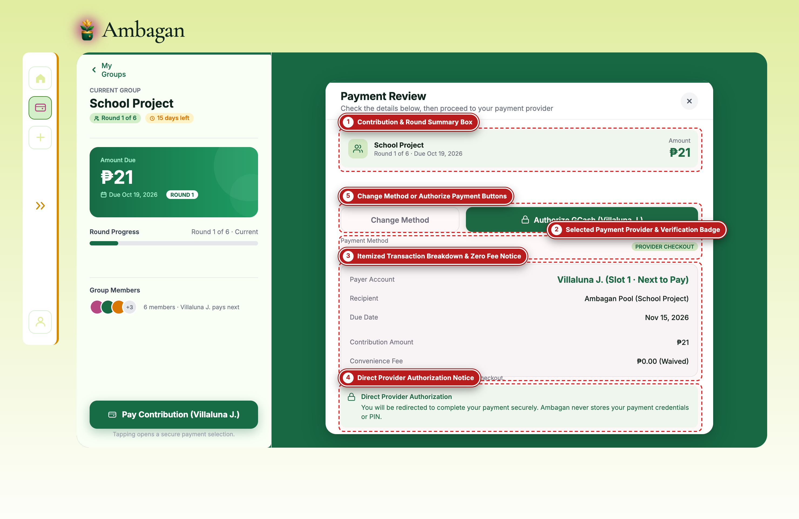
Figure 15 — Payment Portal — Payment Review & Provider Authorization (Captured via Playwright with Visual Callout Labels)

Labeled Component Guide (Figure 15)
Label # | UI Component / Element | What It Does & How to Use It
#1 | Contribution & Round Summary Box | Reconfirms the target group ('School Project'), round number, due date, and total amount to be authorized (₱21).
#2 | Selected Payment Provider & Verification Badge | Displays the chosen payment rail (e.g., GCash) and its settlement mode badge ('PROVIDER CHECKOUT' for instant digital rails or 'ADMIN VERIFICATION' for manual transfers).
#3 | Itemized Transaction Breakdown & Zero Fee Notice | Lists the Payer Account & Slot ('Villaluna J. • Slot 1'), Recipient ('Ambagan Pool'), Due Date, Contribution Amount, Convenience Fee ('₱0.00 Waived'), and Total to Pay.
#4 | Direct Provider Authorization Notice | Security assurance box confirming that authorization occurs directly with the payment provider and credentials are never stored by Ambagan.
#5 | Change Method or Authorize Payment Buttons | 'Change Method' returns to the payment rail selector; 'Authorize GCash' initiates the settlement transaction and advances the group ledger.

Figure 16: Payment Portal — Official Blockchain-Verified Payment Receipt
Application Route / View: GET /pay?plan=school-project&view=receipt (components/payment.tsx)
Once payment authorization succeeds, Ambagan records the contribution against the active round, advances the slot pointer to the next scheduled payer, and generates an official, downloadable Payment Receipt.
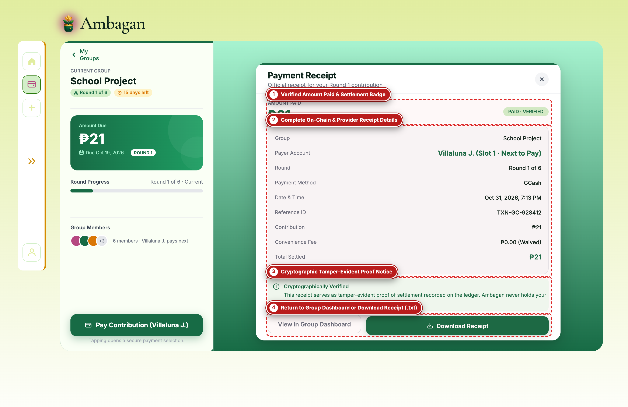
Figure 16 — Payment Portal — Official Blockchain-Verified Payment Receipt (Captured via Playwright with Visual Callout Labels)

Labeled Component Guide (Figure 16)
Label # | UI Component / Element | What It Does & How to Use It
#1 | Verified Amount Paid & Settlement Badge | Displays the settled contribution amount alongside a green 'PAID • VERIFIED' status badge.
#2 | Complete On-Chain & Provider Receipt Details | Itemizes the Group, Payer Account & Slot, Round, Payment Method, exact Date & Time timestamp, unique Reference ID (`TXN-GC-928412`), Contribution, Waived Fee, and Total Settled.
#3 | Cryptographic Tamper-Evident Proof Notice | Confirms that the receipt serves as tamper-evident proof of settlement recorded on the non-custodial group ledger.
#4 | Return to Group Dashboard or Download Receipt (.txt) | 'View in Group Dashboard' navigates to `/group` to see the updated pool progress; 'Download Receipt' generates and downloads a formatted `.txt` receipt file (`Ambagan-Receipt-TXN-....txt`) to the user's device.

SECTION 08
User Profile, Stellar Wallet & Security Settings
Managing personal account information, connecting or inspecting a Stellar Testnet wallet, configuring notifications, and updating security credentials.
Figure 17: Profile Settings, Stellar Testnet Wallet & Security Workspace
Application Route / View: GET /profile (app/profile/page.tsx -> components/profile-settings.tsx)
Accessible from the sidebar or top greeting pill on `/dashboard`, the Profile Settings page lets users customize their display name and avatar, verify their mobile number, manage their non-custodial Stellar Testnet wallet and XLM balance, link local payout rails (GCash/Maya), and update security or notification preferences.
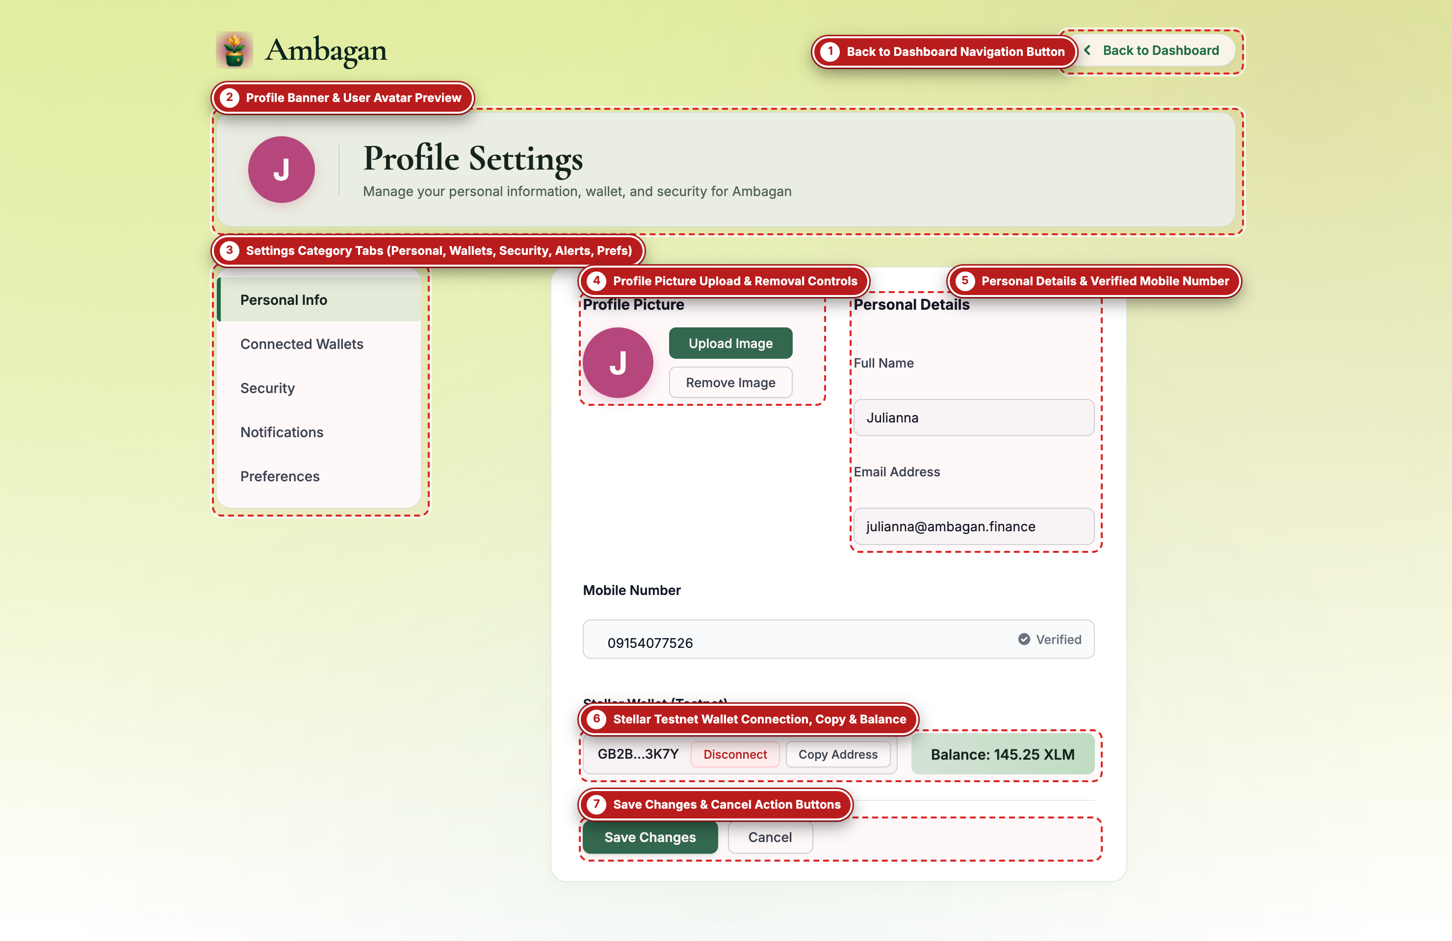
Figure 17 — Profile Settings, Stellar Testnet Wallet & Security Workspace (Captured via Playwright with Visual Callout Labels)

Labeled Component Guide (Figure 17)
Label # | UI Component / Element | What It Does & How to Use It
#1 | Back to Dashboard Navigation Button | Top-right pill button ('< Back to Dashboard') that returns the user to `/dashboard`.
#2 | Profile Banner & User Avatar Preview | Header card displaying the user's current avatar image (or initial badge) alongside the page title and subtitle.
#3 | Settings Category Tabs (Personal, Wallets, Security, Alerts, Prefs) | Left-hand category switcher offering five dedicated views: 'Personal Info', 'Connected Wallets' (Stellar + GCash/Maya), 'Security' (password update & 2FA toggle), 'Notifications' (email/SMS round alerts), and 'Preferences' (currency, language, and default split).
#4 | Profile Picture Upload & Removal Controls | Allows uploading a custom profile image (PNG/JPG/WebP up to 5 MB) with instant preview, or reverting to the default initial avatar.
#5 | Personal Details & Verified Mobile Number | Editable fields for Full Name, Email Address, and Philippine Mobile Number (with a 'Verified' status indicator).
#6 | Stellar Testnet Wallet Connection, Copy & Balance | Displays the connected Stellar Testnet public key (`GB2B...3K7Y`), a 'Disconnect' toggle, a one-click 'Copy Address' button, and the live testnet balance badge ('Balance: 145.25 XLM').
#7 | Save Changes & Cancel Action Buttons | 'Save Changes' persists updated profile fields and displays a confirmation toast; 'Cancel' discards unsaved edits and returns to `/dashboard`.

Operational Tip: Users can switch to the 'Connected Wallets' or 'Preferences' tab (#3) inside Profile Settings to customize their default Smart Split percentages (e.g., 70/25/5%) for future Ambagan groups they organize.

