NONPROVISIONAL UTILITY PATENT APPLICATION

Title of Invention: Systems and Methods for Runtime Trust-Based Authority Governance in Autonomous Systems with Neural Trust Inference and Tamper-Evident Audit

Applicant: The Wayfinder Trust
Inventor: Jonathan Luethke
Total Number of Drawing Sheets: 9
Total Number of Claims: See Claims section

FIELD OF THE INVENTION
[0001] The present invention relates to safety systems for autonomous and semi-autonomous machines, and more particularly to runtime supervision of learned or algorithmic controllers by enforcing bounded control authority based on measured divergence between expected and observed system behavior, neural trust inference with multi-head classification, controller-agnostic constraint enforcement, and cryptographically auditable governance decisions.
---

BACKGROUND OF THE INVENTION
[0002] Autonomous and AI-controlled systems are increasingly deployed in safety-critical domains such as vehicles, robotics, industrial automation, and algorithmic decision systems. These systems rely on controllers or learned models trained under assumptions about operating conditions. In practice, real-world conditions diverge from training data and internal models, leading to unsafe control outputs.
[0003] Existing approaches rely on:
- Offline validation
- Redundant perception
- Rule-based safety envelopes
- Static safety constraints
[0004] However, there is no general runtime mechanism that:
- Measures model-reality divergence,
- Infers trust in system behavior using both physics-based and neural methods,
- Enforces bounded authority through a controller-agnostic adapter, and
- Produces tamper-evident records of enforcement decisions.
[0005] Thus, unsafe actions may occur even when the controller is functioning nominally.

Distinction from Prior Art
[0006] The closest prior art, the Neural Simplex Architecture (Phan et al., 2019), employs binary switching between a high-performance neural controller and a verified baseline controller when a safety envelope is violated. This binary switching approach -- the system is either using the advanced controller or the baseline controller -- fundamentally differs from the present invention's continuous trust modulation. The present invention computes a continuous trust value from measured behavioral divergence and maps that continuous value to graduated authority levels via a monotonic non-increasing function. This enables proportional response: as trust decreases, control authority is progressively constrained through scaling, clamping, and eventually failsafe override, rather than abruptly switching controllers. The present invention also introduces neural multi-head trust inference producing multiple concurrent governance signals, a non-bypassable controller-agnostic enforcement adapter, and a tamper-evident cryptographic audit chain -- none of which are present in the Neural Simplex Architecture or its variants.
[0007] The Aegis Architecture (Mazzocchetti, 2026) provides cryptographic runtime governance with hash-chained audit logs, but operates in the AI agent policy compliance domain (governing text emissions), not physical actuation governance. Aegis has no divergence computation between expected and observed physical behavior, no continuous trust value computation, and no graduated authority levels.
[0008] While exponential decay functions are known in probabilistic trust models (El Salamouny et al., 2009), the present invention applies exponential decay specifically to governance of physical actuation authority -- computing trust from model-reality divergence observed in real-time sensor data, smoothing via EMA, and mapping the result to bounded control authority through a non-bypassable enforcement adapter. The mathematical decay function is a known building block; the governance application to actuation authority with neural inference and cryptographic audit is novel.

SUMMARY OF THE INVENTION
[0009] The invention provides a runtime supervisory governor that:
- Computes divergence between expected and observed system behavior,
- Infers a trust value through a multi-stage pipeline combining physics-based decay, temporal smoothing, and neural trust inference with multi-head classification,
- Maps said trust value to a bounded authority level using a monotonic non-increasing function,
- Enforces control commands through a non-bypassable, controller-agnostic enforcement adapter that applies declarative constraints without interpreting governance logic,
- Manages operating modes with deterministic transitions and authority-weighted recovery hysteresis, and
- Produces cryptographically verifiable audit artifacts describing each enforcement decision, forming a tamper-evident chain.
The invention operates independently of perception, planning, and control logic and does not generate commands of its own. Instead, it constrains or replaces commands from an upstream controller when unsafe conditions are detected.
A formal safety envelope is declared outside the learning system and enforced regardless of learned trust output.
---

BRIEF DESCRIPTION OF THE DRAWINGS
[0010] FIG. 1 is a system block diagram of a system for runtime governance of an autonomous system, showing the expectation interface (100), observation interface (102), divergence computation module (104), trust inference module (106) including the neural trust inference component (108), authority mapping module (110), mode management module (112), enforcement adapter (114), audit artifact generator (116), and tamper-evident audit chain (118).
[0011] FIG. 2 is a block diagram of the multi-stage trust evaluation pipeline within the trust inference module (106), showing computation from a divergence metric input (200) through a bounded decay function (202), exponential moving average smoothing (204), neural trust inference (206), composite trust value computation (208), safety envelope check (210), operational design domain checks (214), recovery hysteresis (216), and final trust signal assembly (218).
[0012] FIG. 3 is a block diagram of the neural trust inference component (108), showing the feature vector input (300), shared encoder (302), latent representation (304), and a plurality of output heads (306, 308, 310) producing a trust score (312) and classification signals indicating degraded (314) and unsafe (316) operating conditions.
[0013] FIG. 4 is a state machine diagram of the mode management module (112), showing the nominal mode (400), degraded mode (402), failsafe mode (404), and recovery dwell period (406) with trust-threshold-based transitions and recovery hysteresis.
[0014] FIG. 5 is a diagram of the authority mapping module (110), showing the permitted control authority as a monotonic non-increasing function (504) of the trust value, with the failsafe zone (506), degraded zone (508), and nominal zone (510) separated by configurable thresholds (512, 514).
[0015] FIG. 6 is a block diagram of the enforcement adapter (114), showing the control command input (600), the non-bypassable enforcement path (602), the constraint severity hierarchy comprising an advisory level (604), bounded scaling level (606), strict clamping level (608), and failsafe override level (610), the anti-amplification invariant check (612), and the enforced control command output (614).
[0016] FIG. 7 is a state machine diagram of the envelope recovery state machine, showing the inactive state (700), unsafe state (702), and recovering state (704) with transitions requiring configurable consecutive safe time steps (706).
[0017] FIG. 8 is a flowchart of the operational design domain boundary module (800), showing configurable bounds on system velocity (802), environmental conditions (804), sensor agreement (806), and operational parameters (808), with ODD boundary evaluation (810) leading to either continued operation within the declared operating domain (812) or ODD violation detection (814) forcing the trust value to unsafe (816) and triggering a mode transition (818).
[0018] FIG. 9 is a diagram of the tamper-evident audit chain, showing safety state records (900, 902, 904) at successive time steps, each containing the divergence metric (912), trust value (914), permitted control authority (916), and control command with enforced control command (918), linked by cryptographic hashes (906) of each safety state record to the prior safety state record hash (908), terminating in a root hash (910).
[0019] ---

DETAILED DESCRIPTION OF THE INVENTION
[0020] Referring to FIG. 1, a system for runtime governance of an autonomous or semi-autonomous system is shown. The system comprises an expectation interface (100) configured to receive expected system behavior generated by at least one controller or predictive model (120), and an observation interface (102) configured to receive observed system behavior from at least one sensor, estimator, or physical plant (122). A divergence computation module (104) computes a divergence metric between the expected system behavior and the observed system behavior.
[0021] The divergence metric is provided to a trust inference module (106), which computes a trust value based at least in part on the divergence metric. The trust inference module (106) includes a neural trust inference component (108), comprising a multi-layer network with a shared encoder and a plurality of output heads. The neural trust inference component (108) receives a feature vector derived from the divergence metric and contextual system state, and produces a trust score and at least one classification signal indicating a degraded or unsafe operating condition, which are used to modulate the trust value.
[0022] The trust value is provided to an authority mapping module (110), which computes a permitted control authority as a monotonic non-increasing function of the trust value. The trust value is also provided to a mode management module (112), which selects between a plurality of operating modes based on the trust value.
[0023] An enforcement adapter (114) receives the permitted control authority from the authority mapping module (110), the operating mode from the mode management module (112), and a control command from the upstream controller (120). The enforcement adapter (114) is non-bypassable such that all control commands pass through the enforcement adapter (114) prior to actuation, and prevents amplification of any control command. The enforcement adapter (114) produces an enforced control command that is applied to at least one actuator (124).
[0024] An audit artifact generator (116) produces, at each time step, a safety state record comprising at least the divergence metric, the trust value, the permitted control authority, the control command, and the enforced control command. The audit artifact generator (116) computes a cryptographic hash of each safety state record and links each safety state record to a cryptographic hash of a prior safety state record to form a tamper-evident audit chain (118).
[0025] Referring to FIG. 2, the multi-stage trust evaluation pipeline within the trust inference module (106) is shown. A divergence metric input (200) is processed through a bounded decay function to compute an instantaneous trust value (202). The instantaneous trust value (202) is smoothed by applying exponential moving average smoothing over a configurable temporal window to produce a smoothed trust value (204). The smoothed trust value (204) is modulated with a neural trust score (206) produced by the neural trust inference component (108) to produce a composite trust value (208).
[0026] The composite trust value (208) is then processed through a safety envelope check (210), physics threshold checks (212), operational design domain checks (214), and recovery hysteresis with a dwell counter (216). The final trust signal assembly (218) produces a trust value output (220) and operating mode flags indicating degraded or unsafe conditions (222).
[0027] Referring to FIG. 3, the neural trust inference component (108) is shown in detail. A feature vector (300) comprising a plurality of elements derived from at least the divergence metric, a measure of observed dynamics, a temporal measure of trust, and at least one contextual signal describing a physical operating condition is provided to a shared encoder (302) implemented as a multi-layer network. The shared encoder (302) produces a latent representation (304) that is fed to a plurality of output heads. A first output head (306) produces a trust score output (312). A second output head (308) produces a classification signal indicating a degraded operating condition (314). A third output head (310) produces a classification signal indicating an unsafe operating condition (316).
[0028] Referring to FIG. 4, the mode management module (112) implements a state machine with a plurality of operating modes comprising at least a nominal mode (400), a degraded mode (402), and a failsafe mode (404). Transitions between operating modes are deterministic for identical inputs. In the degraded mode (402), the enforcement adapter (114) scales the control command by a configurable authority factor. In the failsafe mode (404), the enforcement adapter (114) replaces the control command with a predetermined failsafe command. Recovery from the failsafe mode (404) to the nominal mode (400) requires a configurable dwell period (406) during which the trust value must remain above a recovery threshold, with the rate of recovery modulated by the current actuator authority level.
[0029] Referring to FIG. 5, the authority mapping module (110) maps the trust value to a permitted control authority using a monotonic non-increasing function (504). As the trust value decreases from the nominal zone (510) through the degraded zone (508) to the failsafe zone (506), the permitted control authority decreases correspondingly. The degradation threshold (514) marks the boundary between the nominal zone and the degraded zone. The failsafe threshold (512) marks the boundary between the degraded zone and the failsafe zone. Within each zone, the authority value is computed by linear interpolation.
[0030] Referring to FIG. 6, the enforcement adapter (114) is shown receiving a control command from an upstream controller (600). The enforcement adapter (602) is non-bypassable and applies constraints selected from a hierarchy of constraint severity levels. The hierarchy comprises at least an advisory level (604) producing no modification, a bounded scaling level (606), a strict clamping level (608), and a failsafe override level (610). The constraint of highest severity takes precedence when multiple constraints are applicable. An anti-amplification invariant check (612) ensures the enforcement adapter prevents amplification of any control command. The enforced control command (614) is output to the actuator, and a safety state record (616) is provided to the audit artifact generator (116).
[0031] Referring to FIG. 7, the envelope recovery state machine implements a formal safety envelope defining configurable bounds on allowable system behavior. The state machine transitions between an inactive state (700), an unsafe state (702), and a recovering state (704). Violation of the safety envelope forces the permitted control authority to a failsafe value in the unsafe state (702) regardless of the trust value. Recovery from the unsafe state (702) requires a configurable number of consecutive time steps (706) with no envelope violation before returning to the inactive state (700).
[0032] Referring to FIG. 8, the operational design domain boundary module (800) determines whether operation is within a declared operating domain. The operating domain is defined by configurable bounds on at least one of: system velocity (802), environmental conditions (804), sensor agreement (806), and operational parameters (808). An ODD boundary evaluation (810) determines whether all bounds are satisfied. If within bounds (812), normal operation continues. If any bound is violated, an ODD violation is detected (814), the trust value is forced to unsafe (816), and a mode transition is triggered (818).
[0033] Referring to FIG. 9, the tamper-evident audit chain is shown across multiple time steps. Each safety state record (900, 902, 904) comprises the divergence metric (912), the trust value (914), the permitted control authority (916), and the control command with the enforced control command (918). A cryptographic hash (906) is computed for each safety state record. Each safety state record is linked to the cryptographic hash of the prior safety state record (908) to form the tamper-evident audit chain. A root hash (910) represents the terminal cryptographic hash of the audit chain for a runtime session. Modification of any safety state record alters all subsequent cryptographic hashes in the chain, enabling post-event reconstruction of all governance decisions for certification, regulatory review, or forensic analysis.

System Architecture
[0034] The system comprises:
- An expectation interface and observation interface
- A divergence computation module
- A trust inference module with neural trust inference component
- An authority mapping module
- An enforcement adapter
- A mode management module
- A formal safety envelope with recovery state machine
- An operational design domain boundary module
- An audit artifact generator
Position in stack:
Perception -> Planning -> Control -> Governor (invention) -> Actuators
[0035] The invention receives:
- expected dynamics (from controller or predictive model)
- observed dynamics (from sensors or estimators)
- control commands (from upstream controller)
- contextual signals (physical operating conditions)
[0036] It outputs:
- bounded control commands
- operating mode state
- constraint enforcement records
- cryptographically chained audit records

Data Flow
- Expected behavior and observed behavior are received through the expectation and observation interfaces.
- Divergence metrics are computed from these inputs.
- The multi-stage trust evaluation pipeline processes divergence and contextual signals to produce a composite trust value.
- Authority is computed as a monotonic non-increasing function of trust.
- The enforcement adapter applies declarative constraints to incoming control commands.
- System mode is updated deterministically.
- A safety state record is generated, hashed, and chain-linked to a prior record.

Multi-Stage Trust Evaluation Pipeline
[0037] Trust is computed through a pipeline of stages, each executed at every time step:

Stage 1: Instantaneous Trust
[0038] Divergence between expected and observed behavior is processed through a bounded decay function. The decay function produces a trust value that decreases exponentially as divergence increases. A configurable decay rate controls the sensitivity. Normalization prevents noise-floor effects in low-divergence conditions.

Stage 2: Temporal Smoothing
[0039] The instantaneous trust value is smoothed using an exponential moving average over a configurable temporal window. This prevents transient disturbances from causing unnecessary mode transitions while ensuring that persistent divergence is captured.

Stage 3: Neural Trust Inference
[0040] A feature vector is constructed from the divergence metric and contextual system state. This feature vector is processed through a multi-layer neural network comprising a shared encoder and a plurality of output heads.
[0041] The shared encoder processes the feature vector through a series of nonlinear transformations with configurable width and depth. Each output head produces a distinct governance signal:
- A trust score bounded in a predefined range (via a squashing function)
- A classification signal indicating a degraded operating condition (raw classification output)
- A classification signal indicating an unsafe operating condition (raw classification output)
[0042] The neural trust inference component performs inference only. No online learning occurs during governance operation.

Stage 4: Trust Modulation
[0043] The smoothed trust value from Stage 2 is combined with the neural trust score from Stage 3 to produce a composite trust value.

Stage 5: Safety Envelope Check
[0044] A structural safety envelope state machine evaluates whether observable physical quantities exceed declared bounds. The state machine has three states:
- Inactive: No envelope violation detected.
- Unsafe: Physical quantities exceed bounds. Trust forced to minimum.
- Recovering: Physical quantities have returned to within bounds. Recovery requires a configurable number of consecutive safe time steps before returning to inactive.

Stage 6: Physics Threshold Checks
[0045] Observable quantities (divergence residuals, dynamic measurements) are compared against configurable thresholds. These thresholds define boundaries between nominal, degraded, and unsafe conditions.

Stage 7: Operational Design Domain Checks
[0046] The system verifies operation is within a declared operating domain defined by configurable bounds on system velocity, environmental conditions, sensor agreement, and operational parameters. Violations force trust to unsafe and trigger mode transitions.

Stage 8: Recovery Hysteresis
[0047] Recovery from failsafe requires a configurable dwell period. During recovery:
- The trust value is capped above the unsafe threshold by a configurable margin.
- The dwell counter increments at a rate modulated by the current actuator authority level. Authority-limited operation produces faster recovery progression.
- Recovery is aborted and the counter reset if unsafe conditions recur.
- Upon dwell completion, trust is released to a configurable recovery floor.
[0048] This mechanism prevents rapid oscillation at safety boundaries while allowing controlled return to nominal operation.

Stage 9: Final Signal Assembly
[0049] The composite trust value is clamped to the predefined range. Operating mode flags are set:
- Degraded: trust below the degraded threshold
- Unsafe: trust below the unsafe threshold, or was unsafe in the prior step and has not completed recovery

Neural Trust Inference Component -- Detailed Description
[0050] The neural trust inference component is a feedforward multi-layer network with the following architecture:
Input: A feature vector of configurable dimensionality. In one preferred embodiment, the feature vector contains elements derived from:
- Expected and observed dynamic measurements
- Divergence metrics
- Temporal trust measures
- Contextual physical signals (environmental conditions, system configuration, sensor agreement)
Shared Encoder: A series of linear transformations followed by nonlinear activations (rectified linear units in one embodiment). The encoder processes the raw feature vector into a latent representation suitable for multi-task governance classification.
Output Heads: A plurality of linear output heads, each producing a distinct governance signal from the shared encoder's latent representation:
- Trust head: Produces a trust score bounded in a predefined range via a squashing activation function.
- Degraded head: Produces a raw classification output. Values above a configurable threshold indicate a degraded operating condition.
- Unsafe head: Produces a raw classification output. Values above a configurable threshold indicate an unsafe operating condition.
Weight Storage: Weights may be serialized in a binary format comprising a format identifier, a parameter count, and contiguous parameter values. The format may apply scaling to output layer weights during serialization and inverse scaling during deserialization. Weights may also be loaded from standard model checkpoint formats.

Enforcement Adapter -- Detailed Description
[0051] The enforcement adapter is the critical boundary between the upstream controller and the governance system. It applies constraints to controller outputs without:
- Accessing or modifying controller internal logic
- Accessing or modifying controller internal state
- Interpreting why constraints exist
- Performing inference, learning, or control decisions

Constraint Severity Hierarchy
[0052] The enforcement adapter recognizes a hierarchy of constraint severity levels:
- No modification: Control commands pass through unchanged.
- Advisory: No modification to commands. The constraint is recorded in the audit trail for informational purposes.
- Bounded scaling: The control command is scaled by a configurable authority factor derived from a maximum scaling parameter. The output is clamped to the scaled limit.
- Strict clamping: The control command is clamped to a configurable maximum allowed value. If no explicit limit is provided, the command is replaced with a failsafe value (fail-closed behavior).
- Failsafe override: The control command is replaced with a predetermined failsafe value regardless of the requested command.

Anti-Amplification Invariant
[0053] The enforced magnitude of any command never exceeds the requested magnitude. After constraint application, if the enforced output exceeds the original request, the output reverts to the original request. This ensures the enforcement adapter can only attenuate or block, never amplify.

Multiple Constraint Resolution
[0054] When multiple constraints are applicable, the constraint of highest severity takes precedence. Resolution is deterministic and independent of constraint ordering.

Audit Export
[0055] Each enforcement decision is exported as an audit record containing the requested command, enforced command, whether constraint was applied, the severity level, and the resulting actuator scale factor.

Authority Mapping
[0056] Authority is computed as:
authority = f(trust)
[0057] Where f is a monotonic non-increasing function.
Properties:
- Lower trust implies lower authority
- Authority is bounded by safety thresholds
- Authority cannot exceed nominal control authority
- Authority at minimum trust equals zero (complete failsafe)
[0058] In one preferred embodiment, authority is mapped through configurable threshold boundaries defining nominal, degraded, and failsafe operating modes with corresponding authority levels.

Operating Modes and Recovery
[0059] The mode management module selects between operating modes:
- Nominal: Full authority. Trust above degraded threshold.
- Degraded: Reduced authority via bounded scaling. Trust below degraded but above failsafe threshold.
- Failsafe: Minimal authority via failsafe override. Trust below failsafe threshold.
[0060] Transitions are deterministic for identical inputs and state.
[0061] Recovery from failsafe requires:
- Physical conditions returning to within safe bounds.
- A configurable dwell period with trust above the recovery threshold.
- Modulated recovery rate based on actuator authority level.

Formal Safety Envelope
[0062] The system enforces a formal safety envelope defined by configurable bounds on allowable system behavior. The safety envelope is:
- declared outside of a learned model
- immutable at runtime
- enforced independently of the trust value
- cryptographically bound to the audit chain
[0063] Violation of the safety envelope forces the permitted control authority to a failsafe value regardless of trust output.
[0064] The safety envelope includes a recovery state machine with three states (inactive, unsafe, recovering) to prevent immediate return to full authority after transient violations.

Operational Design Domain (ODD) Handling
[0065] The system stores explicit ODD boundaries defining the declared operating domain. If ODD violation is detected:
- trust is forced to unsafe
- authority is reduced
- system enters degraded or failsafe mode
[0066] ODD bounds are declared independently of the learning system and are defined by configurable parameters.

Failsafe Behavior
[0067] Failsafe mode causes:
- minimal risk maneuver
- controlled deceleration
- or actuator neutralization
[0068] Failsafe is triggered by:
- trust below failsafe threshold
- safety envelope violation
- ODD violation
- internal fault
- timing violation

Determinism
[0069] The invention operates deterministically given identical inputs and state. No stochastic operations exist in the governance path. The invention does not perform online learning in the governance path. The invention does not generate autonomous control commands.

Audit and Evidence Integrity
[0070] The invention generates a safety record at each runtime step containing:
- divergence metrics
- trust values (instantaneous, smoothed, neural, composite)
- authority value
- operating mode
- constraint severity applied
- requested command
- enforced command
- actuator scale factor
- timestamp
[0071] Each safety record is serialized into a canonical representation and cryptographically hashed. The audit artifact generator produces cryptographically chained records such that:
- a hash is computed over the current safety state
- the hash of the previous safety record is included in the current record
- each record therefore commits to all prior records
[0072] The safety state hash and previous hash form a causal chain that is tamper-evident. Modification of any record alters all subsequent hashes. For each execution run, a root hash is produced representing the terminal hash of the chain.
[0073] This mechanism ensures:
- non-repudiation of safety decisions
- detection of post-run modification
- reproducibility of execution traces
- evidentiary integrity for certification, regulatory review, and forensic analysis

Enablement
[0074] A person skilled in control systems, robotics, or autonomous systems may implement the invention by:
- computing divergence between expected and observed behavior
- inferring trust using a multi-stage pipeline with physics-based decay, temporal smoothing, and neural inference
- mapping trust to authority using a monotonic non-increasing function
- enforcing bounded actuation through a controller-agnostic constraint adapter with a severity hierarchy
- generating cryptographically chained safety records
[0075] No specific controller, planner, perception system, or sensor type is required. The invention is model-agnostic and platform-independent. The enforcement adapter operates without knowledge of the upstream controller's implementation.

Example Embodiments

Vehicle Embodiment
[0076] In one embodiment, the invention is applied to a vehicle. Expected acceleration is compared with measured acceleration. If divergence increases, trust decreases. Authority is reduced. Throttle commands are bounded through the enforcement adapter. If divergence persists or envelope bounds are violated, failsafe mode commands braking. Each time step produces a hashed safety record chained to the prior record.

Robotic Embodiment
[0077] In another embodiment, the invention is applied to a robotic manipulator. Expected joint trajectories are compared with measured trajectories. The enforcement adapter limits joint torque or velocity based on trust-derived authority constraints.

Industrial Control Embodiment
[0078] In another embodiment, the invention is applied to an industrial machine. Expected process outputs are compared with measured outputs. The enforcement adapter limits control signals to industrial actuators.

Algorithmic Decision Embodiment
[0079] In another embodiment, the invention is applied to an algorithmic decision system. Expected behavior or risk metrics are compared with observed behavior. The enforcement adapter limits transaction volume, order execution, or decision scope.

CLAIMS
What is claimed is:

1. A system for runtime governance of an autonomous or semi-autonomous system, comprising: a) an expectation interface configured to receive expected system behavior generated by at least one controller, planner, or predictive model; b) an observation interface configured to receive observed system behavior from at least one sensor, estimator, or physical plant; c) a divergence computation module configured to compute a divergence metric between the expected system behavior and the observed system behavior; d) a trust inference module configured to compute a trust value based at least in part on the divergence metric, the trust value being bounded within a predefined range; e) a neural trust inference component within the trust inference module, the neural trust inference component comprising a multi-layer network with a shared encoder and a plurality of output heads, each output head producing a distinct governance signal, wherein at least one output head produces a trust score and at least one additional output head produces a classification signal indicating a degraded or unsafe operating condition; f) an authority mapping module configured to compute a permitted control authority as a monotonic non-increasing function of the trust value; g) an enforcement adapter configured to apply the permitted control authority to at least one control command from an upstream controller before the control command is applied to an actuator, wherein the enforcement adapter is non-bypassable such that all control commands pass through the enforcement adapter prior to actuation, and wherein the enforcement adapter prevents amplification of any control command; h) an audit artifact generator configured to produce, at each time step, a safety state record comprising at least the divergence metric, the trust value, the permitted control authority, the control command, and an enforced control command, and to compute a cryptographic hash of each safety state record and to link each safety state record to a cryptographic hash of a prior safety state record to form a tamper-evident audit chain; wherein the system operates independently of internal logic, parameters, or structure of the controller or predictive model, and wherein the enforcement adapter prevents actuation that exceeds the permitted control authority when the trust value indicates unsafe operation.
2. A method for runtime governance of an autonomous or semi-autonomous system, comprising: a) receiving expected system behavior from a controller or predictive model; b) receiving observed system behavior from at least one sensor or estimator; c) computing a divergence metric between the expected system behavior and the observed system behavior; d) computing an instantaneous trust value from the divergence metric using a bounded decay function; e) computing a smoothed trust value by applying temporal smoothing to the instantaneous trust value over a configurable window; f) computing a neural trust score by processing a feature vector derived from the divergence metric and contextual system state through a multi-layer network having a plurality of output heads; g) computing a composite trust value by combining the smoothed trust value and the neural trust score; h) mapping the composite trust value to a permitted control authority using a monotonic non-increasing function; i) enforcing the permitted control authority on at least one control command prior to actuation through a non-bypassable enforcement path that prevents amplification of said control command, thereby producing an enforced control command; j) generating a cryptographic hash of a safety state comprising at least the divergence metric, the composite trust value, the permitted control authority, and the enforced control command; and k) linking the cryptographic hash to a hash of a prior safety state record to form a tamper-evident audit chain; wherein the method operates independently of internal structure of the controller or predictive model.
3. A non-transitory computer-readable medium storing instructions that, when executed by at least one processor, cause the at least one processor to perform operations comprising: a) computing a divergence metric between expected system behavior received from a controller and observed system behavior received from at least one sensor; b) computing a trust value from the divergence metric using a bounded decay function and temporal smoothing; c) processing a feature vector through a neural trust inference component having a shared encoder and a plurality of output heads to produce a trust score and at least one classification signal indicating an operating condition; d) computing a permitted control authority as a monotonic non-increasing function of the trust value; e) enforcing the permitted control authority on at least one control command through a non-bypassable enforcement path that prevents amplification; f) generating a tamper-evident audit chain by cryptographically hashing each safety state record and linking each hash to a hash of a prior safety state record; and g) selecting an operating mode from a plurality of operating modes based on the trust value, and transitioning between operating modes deterministically.
4. The system of claim 1, wherein the trust inference module computes the trust value through a multi-stage pipeline comprising: computing an instantaneous trust value from the divergence metric using a bounded decay function; computing a smoothed trust value by applying exponential moving average smoothing over a configurable temporal window; and modulating the smoothed trust value with a neural trust score produced by the neural trust inference component.
5. The system of claim 4, wherein the bounded decay function produces a trust value that decreases exponentially as the divergence metric increases, with a configurable decay rate.
6. The system of claim 1, wherein the trust inference module is configured to reduce the trust value when the divergence metric persists above a configurable threshold over multiple consecutive time steps.
7. The system of claim 1, wherein the neural trust inference component receives a feature vector comprising a plurality of elements derived from at least: the divergence metric, a measure of observed dynamics, a temporal measure of trust, and at least one contextual signal describing a physical operating condition.
8. The system of claim 1, further comprising a mode management module configured to select between a plurality of operating modes based on the trust value, the plurality of operating modes comprising at least a nominal mode, a degraded mode, and a failsafe mode, wherein transitions between operating modes are deterministic for identical inputs.
9. The system of claim 8, wherein in the degraded mode, the enforcement adapter scales the control command by a configurable authority factor, and in the failsafe mode, the enforcement adapter replaces the control command with a predetermined failsafe command.
10. The system of claim 1, wherein the enforcement adapter applies a constraint selected from a hierarchy of constraint severity levels, the hierarchy comprising at least an advisory level producing no modification, a bounded scaling level, a strict clamping level, and a failsafe override level, wherein the constraint of highest severity takes precedence when multiple constraints are applicable.
11. The system of claim 1, wherein the enforcement adapter is configured to receive declarative constraints specifying severity, maximum scaling factors, and maximum allowed values, and to enforce said constraints without interpreting the trust value or governance logic that produced them.
12. The system of claim 11, wherein the enforcement adapter applies constraints to control commands generated by any upstream controller without requiring modification of the controller's internal logic, state, or execution semantics.
13. The system of claim 1, further comprising a formal safety envelope defining configurable bounds on allowable system behavior, wherein the safety envelope is declared independently of any learned model, is immutable during runtime operation, and is enforced regardless of the trust value.
14. The system of claim 13, wherein violation of the safety envelope forces the permitted control authority to a failsafe value regardless of the trust value.
15. The system of claim 13, wherein the safety envelope parameters are cryptographically bound to the tamper-evident audit chain.
16. The system of claim 13, further comprising an envelope recovery state machine configured to transition between an inactive state, an unsafe state, and a recovering state, wherein recovery from the unsafe state requires a configurable number of consecutive time steps with no envelope violation before returning to the inactive state.
17. The system of claim 8, wherein recovery from the failsafe mode to the nominal mode requires a configurable dwell period during which the trust value must remain above a recovery threshold, and wherein a rate of recovery is modulated by a current actuator authority level.
18. The system of claim 1, further comprising an operational design domain boundary module configured to determine whether operation is within a declared operating domain, the operating domain being defined by configurable bounds on at least one of: system velocity, environmental conditions, sensor agreement, and operational parameters.
19. The system of claim 18, wherein violation of the declared operating domain forces the trust value to an unsafe value and triggers a mode transition.
20. The system of claim 1, wherein the audit artifact generator produces a root hash representing a terminal cryptographic hash of the tamper-evident audit chain for a runtime session.
21. The system of claim 1, wherein modification of any safety state record in the tamper-evident audit chain alters all subsequent cryptographic hashes in the tamper-evident audit chain.
22. The system of claim 1, wherein the safety state records in the tamper-evident audit chain enable post-event reconstruction of all governance decisions for certification, regulatory review, or forensic analysis.
23. The system of claim 1, wherein the system operates deterministically such that identical inputs and state produce identical trust values, authority constraints, and enforcement decisions.
24. The system of claim 1, wherein the system does not perform online learning in a governance path of the system.
25. The system of claim 1, wherein the system does not generate autonomous control commands.

ABSTRACT
A runtime supervisory governor for autonomous systems computes divergence between expected and observed system behavior, infers trust through a multi-stage pipeline comprising physics-based decay, temporal smoothing, and neural inference using a multi-layer network with a shared encoder and a plurality of output heads producing distinct governance signals. Trust is mapped to bounded control authority via a monotonic non-increasing function. A non-bypassable enforcement adapter applies declarative constraints to actuator commands through a severity hierarchy without modifying controller logic, preventing amplification of requested commands. The system includes a formal safety envelope enforced independently of trust inference, an operational design domain boundary module, deterministic mode management with recovery hysteresis, and a cryptographic audit chain producing tamper-evident records of all governance decisions. The governor operates independently of perception, planning, and control modules, does not generate commands, and does not perform online learning. --- Classification: CONFIDENTIAL -- Internal / NDA Use Only Applicant: The Wayfinder...

DRAWINGS
Total Number of Drawing Sheets: 9

FIG. 1
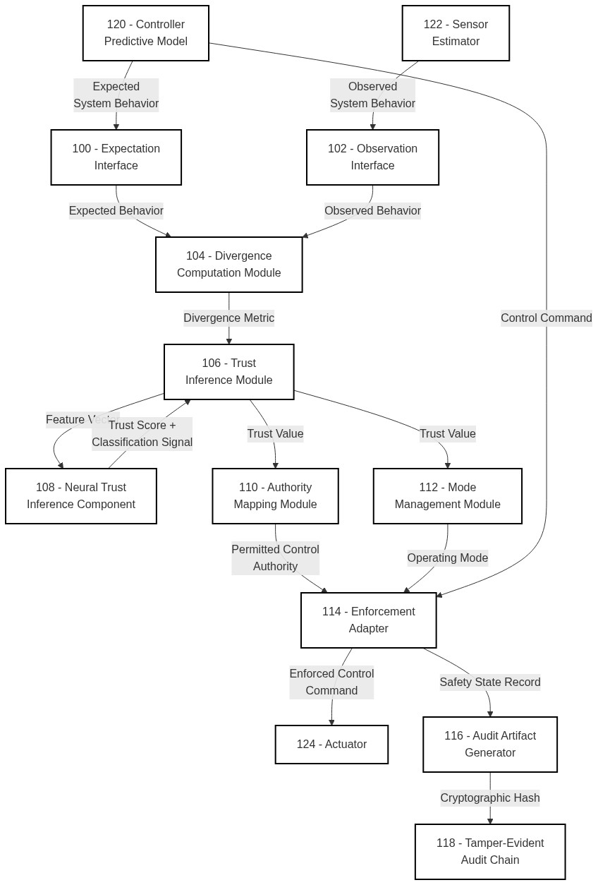

FIG. 2

FIG. 3
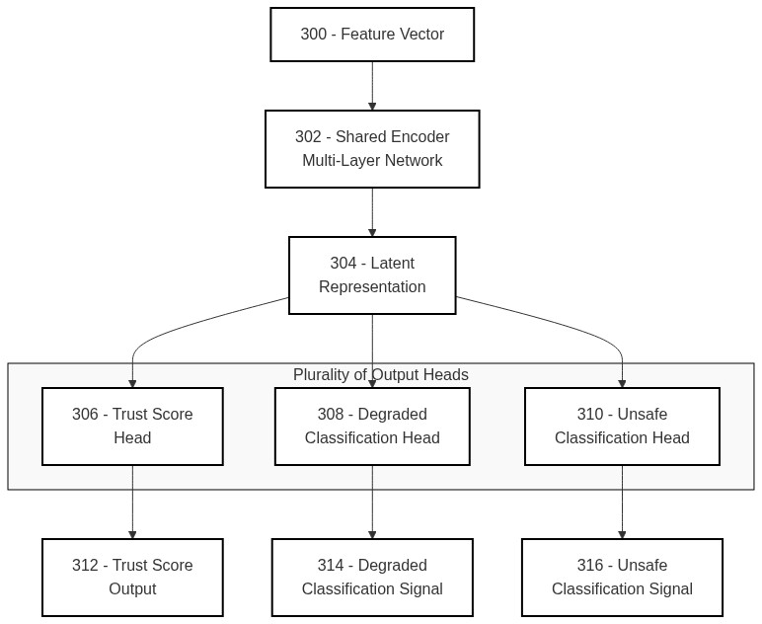

FIG. 4
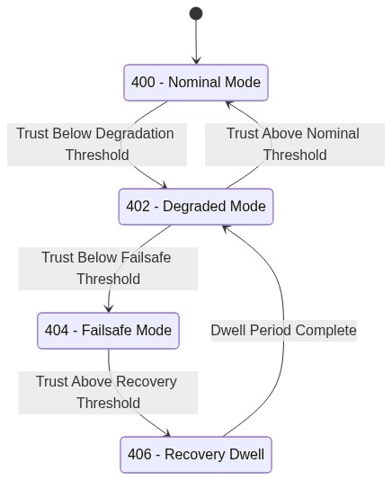

FIG. 5
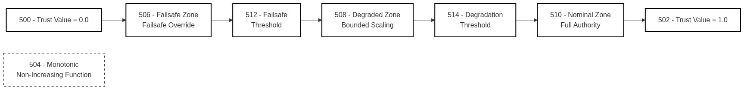

FIG. 6
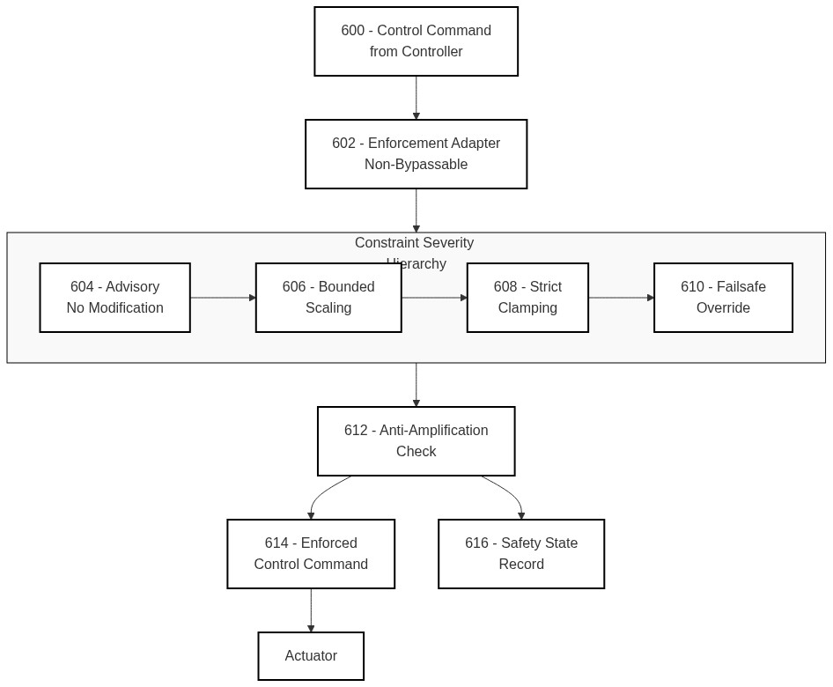

FIG. 7
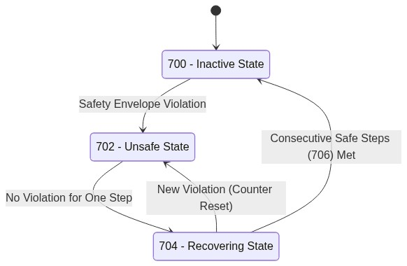

FIG. 8
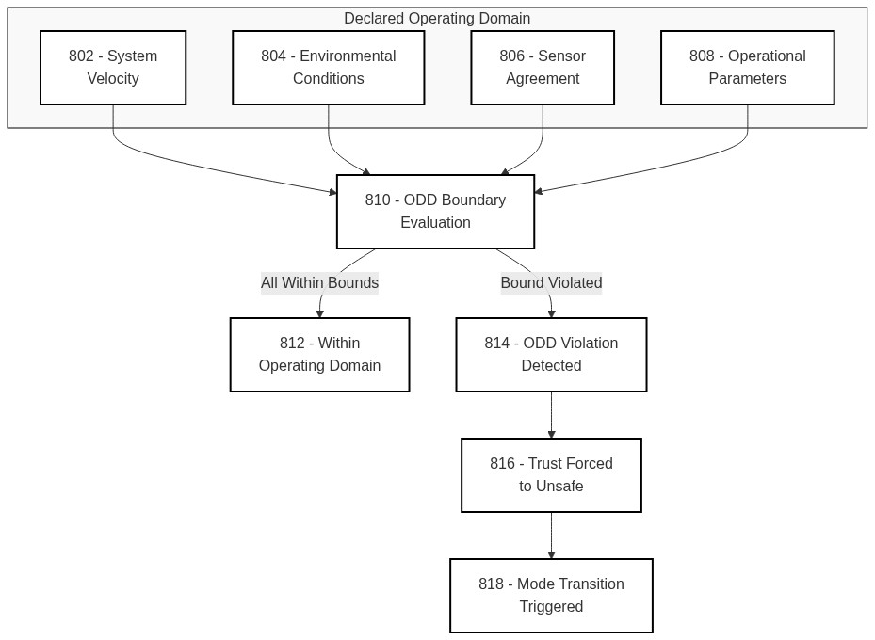

FIG. 9
