NONPROVISIONAL UTILITY PATENT APPLICATION

Title of Invention: Runtime Trust-Based Governance System for Safety-Critical Adaptive Systems

Applicant: The Wayfinder Trust
Inventor: Jonathan Luethke
Total Number of Drawing Sheets: 8
Total Number of Claims: See Claims section

CROSS-REFERENCE TO RELATED APPLICATIONS
[0001] This application is related to the following co-pending provisional applications filed by the same applicant:
- Patent Family A: "Runtime Trust-Based Authority Governor for Safety-Critical Autonomous Systems" -- governs actuation-level output constraints; complementary to the present invention which governs learning and adaptation constraints.
- Patent Family D: "Cross-Subsystem Governance Coordination via Trust-Weighted Mesh Protocol" -- coordinates governance signals across multiple subsystems, each of which may employ the governance system of the present invention.
- Patent Family F: "Cognitive Memory Governance" -- applies the governance architecture of the present invention to memory formation and retrieval in cognitive systems.
- Patent Family G: "Agent Swarm Governance" -- applies the governance architecture of the present invention to multi-agent coordination.
The present invention provides the core governance pipeline that Families D, F, and G extend to their respective domains. Family A provides a complementary governance layer operating at the actuation level rather than the adaptation level.
---

FIELD OF THE INVENTION
[0002] The present invention relates to safety systems for adaptive and learning-enabled systems, and more particularly to a runtime supervisory governor that bounds the authority of adaptive processes based on measured divergence between validated and current system behavior. The invention further relates to predictive trust projection using divergence trend extrapolation with crisis memory matching, asymmetric trust dynamics where trust decays faster than it recovers, linear interpolation of authority constraints to eliminate discontinuities at phase boundaries, two-layer rollback of both governance state and domain-specific state, domain-agnostic governance via an abstract adapter interface, and cryptographically auditable enforcement of safety constraints.
The domain of application includes, but is not limited to, autonomous vehicles, robotic systems, adaptive control systems, model fine-tuning pipelines, multi-agent systems, cognitive architectures, and any system in which operational parameters are modified during operation and the consequences of unbounded modification pose safety risks.
---

BACKGROUND OF THE INVENTION
[0003] Adaptive and learning-enabled systems modify their internal parameters during operation. Techniques including online learning, continual adaptation, fine-tuning, and reinforcement learning allow deployed models to adjust behavior based on new data at runtime. This adaptability introduces a fundamental tension: the same mechanism that enables improvement also enables divergence from validated behavior.
[0004] Existing approaches to managing adaptation safety include:
- (a) Offline validation: updates tested before deployment; cannot address runtime divergence.
- (b) Manual review: operators inspect changes; does not scale to continuous adaptation.
- (c) Static constraints: fixed bounds on modification rate or parameter magnitude; not responsive to post-update behavior.
- (d) Post-hoc testing: evaluation after update; detects problems only after they have occurred with no mechanism for real-time prevention or rollback.
[0005] No prior art provides a general runtime mechanism that simultaneously:
- (i) Measures behavioral divergence introduced by an operational modification across multiple configurable axes;
- (ii) Infers a scalar trust value from divergence via a deterministic computation;
- (iii) Projects trust forward in time using divergence trend extrapolation;
- (iv) Matches current divergence patterns against stored crisis records to identify recurring failures;
- (v) Maps trust to a bounded authority constraint with linear interpolation between phases;
- (vi) Enforces the authority bound before modifications reach the governed system;
- (vii) Triggers deterministic two-layer rollback to a known-good state; and
- (viii) Produces tamper-evident, cryptographically chain-linked audit records.

SUMMARY OF THE INVENTION
[0006] The invention is a runtime supervisory governance system, hereinafter the assured learning governor, operating as an independent interposition layer between an adaptive process and the system state it seeks to modify. The governor implements a six-stage pipeline: OBSERVE, ASSESS, ANTICIPATE, MODULATE, ENFORCE, and AUDIT (see FIG. 1).
The governor:
- (a) Observes divergence across a configurable number of measurement axes via a domain adapter interface (see FIG. 2). Each axis quantifies deviation between current state and a validated reference state along a respective dimension. A temporal axis may be computed internally from the rate of change of the combined divergence.
- (b) Assesses trust by computing a trust value via an exponential decay function applied to combined divergence, smoothed by an exponential moving average. Trust is bounded within [0, 1] and exhibits asymmetric dynamics: trust decays faster than it recovers, with a configurable decay-to-recovery ratio (see FIG. 2).
- (c) Anticipates future trust degradation by projecting trust forward using divergence trend extrapolation, and by matching the current divergence signature against crisis records stored in a Bayesian crisis memory bank using a vector similarity function such as cosine similarity. When projected trust approaches the rollback threshold or a matching crisis pattern is detected, authority is constrained preemptively (see FIG. 3).
- (d) Modulates authority by mapping trust to a scaling factor via linear interpolation between phase-specific authority levels. Authority transitions smoothly between phases without discontinuous jumps. Authority is bounded within [0, 1]: the system can only attenuate or block; it never amplifies (see FIG. 4).
- (e) Enforces authority by applying the scaling factor to proposed operational modifications. When trust falls below a rollback threshold, a two-layer rollback restores both internal governance state and domain-specific external state to a prior validated snapshot (see FIG. 5).
- (f) Audits every governance decision by recording it in a tamper-evident chain of collision-resistant cryptographic hashes, where each record's hash includes the hash of the preceding record (see FIG. 6).
The governor operates independently of the adaptive process under governance. It does not modify the adaptive process's internal algorithm, objective function, or optimization strategy. It acts solely on proposed operational modifications and on observable divergence metrics. The governor achieves domain-agnostic operation through an abstract domain adapter interface: different domains provide concrete adapter implementations without modification to the governance logic.
---

BRIEF DESCRIPTION OF THE DRAWINGS
[0007] FIG. 1 is a block diagram illustrating the six-module governance system architecture comprising the observation module (102), assessment module (104), anticipation module (106), modulation module (108), enforcement module (110), and audit module (112), interconnected via the domain adapter interface (100).
[0008] FIG. 2 is a data flow diagram illustrating the trust computation flow from a plurality of divergence measurement axes (200, 202, 204) through a weighted aggregate (208), an exponential decay function (212), and an exponential moving average function (216) to produce a smoothed trust value (218).
[0009] FIG. 3 is a block diagram illustrating the anticipation module, including divergence trend extrapolation (302) for computing a projected trust value (306) and vector similarity function (310) for matching against crisis divergence signatures (313) stored in the crisis memory bank (312).
[0010] FIG. 4 is a schematic diagram illustrating the trust-to-authority linear interpolation across the nominal phase (410), constrained phase (406), frozen phase (404), and rollback phase (402), with a scaling factor (414) bounded within the closed interval from zero to one.
[0011] FIG. 5 is a block diagram illustrating the two-layer rollback mechanism comprising a first layer for internal governance state (502) and a second layer for domain-specific external state (504), with an immutable deep copy stack (514) and rollback execution (518).
[0012] FIG. 6 is a schematic diagram illustrating the tamper-evident audit chain structure, showing governance records (602, 604, 606) linked by collision-resistant cryptographic hashes from a genesis hash (600) to a session root hash (608).
[0013] FIG. 7 is a state diagram illustrating the phase state machine with deterministic transitions between the nominal phase (700), constrained phase (702), frozen phase (704), and rollback phase (706), governed by configurable phase thresholds (708, 710) and a configurable rollback threshold (712).
[0014] FIG. 8 is a block diagram illustrating the domain adapter interface (800) as an abstract interface comprising a divergence computation method (802), a state capture method (804), and a state restoration method (806), with multiple concrete implementations (816, 818, 820).

DETAILED DESCRIPTION OF THE INVENTION
[0015] Referring to FIG. 1, a computing system for runtime governance of adaptive learning systems comprises six modules arranged in a pipeline. The domain adapter interface (100) receives divergence measurements from a governed adaptive learning system (118) and provides them to the observation module (102). The observation module (102) receives, from the domain adapter interface (100), a plurality of divergence measurements across a configurable number of measurement axes. The assessment module (104) computes a combined divergence value as a weighted aggregate of the plurality of divergence measurements and computes a trust value by applying an exponential decay function to said combined divergence value. The anticipation module (106) projects the trust value forward over a configurable number of future evaluation steps using divergence trend extrapolation and compares the projected trust value against crisis records stored in a crisis memory bank using a vector similarity function. The modulation module (108) maps the trust value to an authority constraint (116) via linear interpolation between phase-specific authority levels defined by configurable phase thresholds. The enforcement module (110) applies the authority constraint (116) to proposed operational modifications (114) and, when the trust value falls below a configurable rollback threshold, restores both an internal governance state and a domain-specific external state to a prior validated snapshot (122). The audit module (112) produces a governance record at each governance evaluation step and generates a tamper-evident chain (120) by computing a collision-resistant cryptographic hash of each governance record together with the cryptographic hash of the immediately preceding governance record.
[0016] Referring to FIG. 2, the trust computation flow comprises two stages within the observation module (102) and the assessment module (104). A plurality of divergence measurement axes, including divergence measurement axis 1 (200), divergence measurement axis 2 (202), divergence measurement axis N (204), and a temporal axis (206), feed into a weighted aggregate (208) to produce a combined divergence value (210). The combined divergence value (210) passes into the exponential decay function (212) which produces a raw trust value (214). The raw trust value (214) passes into the exponential moving average function (216) which produces a smoothed trust value (218). The smoothed trust value (218) passes through an optional post-trust adjustment callback (220) that can only decrease or maintain the trust value, producing the trust value output (222) bounded within a closed interval from zero to one.
[0017] Referring to FIG. 3, the anticipation module comprises two parallel subsystems: trust projection and crisis pattern matching. The combined divergence value history (300) feeds into the divergence trend extrapolation (302), which computes a projected divergence value (304). The projected divergence value (304) is used to compute the projected trust value (306) by applying the exponential decay function to the extrapolated divergence value. Separately, the current divergence measurement vector (308) is compared against crisis divergence signatures (313) stored in the crisis memory bank (312) using the vector similarity function (310). When a crisis pattern match (314) is identified, a post-crisis probation period (316) is entered. Both the projected trust value (306) and the post-crisis probation period (316) feed into the preemptive authority constraint (318), which constrains authority when the projected trust value falls within a configurable proximity of the rollback threshold.
[0018] Referring to FIG. 4, the modulation module maps the trust value to an authority constraint via linear interpolation between phase-specific authority levels. At trust value zero (400), the system enters the rollback phase (402), where no operational modifications are permitted. Above the configurable rollback threshold, the system enters the frozen phase (404), which prohibits all operational modifications. Above the next configurable phase threshold, the constrained phase (406) permits reduced authority. The phase-specific authority level (408) is computed via linear interpolation within each phase. The nominal phase (410) permits full operational authority at trust value one (412). The scaling factor (414) is bounded within a closed interval from zero to one such that the system can only attenuate or block proposed modifications and cannot amplify them.
[0019] Referring to FIG. 5, the two-layer rollback mechanism comprises a snapshot capture (500) that stores two independent layers. The first layer (502) stores snapshots of internal governance state including divergence history (506), trust state (508), and evaluation step count (510). The second layer (504) stores snapshots of domain-specific external state captured via the domain adapter interface state capture (512). Both layers are stored as an immutable deep copy stack (514). When a configurable rollback threshold trigger (516) is met, the rollback execution (518) restores the internal governance state (520) and the domain-specific external state (522) independently to their prior validated conditions.
[0020] Referring to FIG. 6, the tamper-evident audit chain comprises a sequence of governance records linked by collision-resistant cryptographic hashes. The genesis hash (600) serves as the initial hash value. Each governance record, including governance record 1 (602), governance record 2 (604), and governance record N (606), includes its data and a cryptographic hash computed from the record contents together with the cryptographic hash of the preceding governance record (624). Each governance record comprises at least a timestamp (610), a domain identifier (612), a combined divergence value (614), a trust value (616), a phase classification (618), an authority constraint (620), and a governance action identifier (622). The session root hash (608) represents the final cryptographic hash of the tamper-evident chain for a complete governance session. Modification of any governance record, such as a modified governance record (626), invalidates the cryptographic hash of that record and all subsequent records (628), thereby rendering any tampering detectable by recomputation of the hash chain.
[0021] Referring to FIG. 7, the phase state machine comprises four phases with deterministic transitions. The nominal phase (700) permits full operational authority. When the trust value falls below the configurable phase threshold (708), the system transitions to the constrained phase (702), which permits reduced authority. When the trust value falls below the frozen threshold (710), the system transitions to the frozen phase (704), which prohibits all operational modifications. When the trust value falls below the configurable rollback threshold (712), the system transitions to the rollback phase (706), triggering restoration of a prior validated state. Transitions between phases are deterministic functions of the trust value and the configurable phase thresholds.
[0022] Referring to FIG. 8, the domain adapter interface (800) is an abstract interface that enables the governance system to operate identically across different domains. The domain adapter interface (800) comprises a divergence computation method (802) that accepts domain-specific parameters (808) and returns divergence measurements per axis (810) for each configured measurement axis. A state capture method (804) returns a serializable snapshot (812) of domain-specific state. A state restoration method (806) accepts a previously captured snapshot and restores domain-specific state to the restored domain state (814). Multiple concrete implementations, including concrete implementation A (816), concrete implementation B (818), and concrete implementation N (820), substitute different domain-specific logic without modification to the governance system.

4. SYSTEM ARCHITECTURE
[0023] The governor comprises six functional modules plus a domain adapter interface:
- Observation Module (Divergence Monitor) -- N-axis divergence detection
- Assessment Module (Trust Module) -- Trust computation via exponential decay with EMA smoothing
- Anticipation Module (Trust Horizon) -- Predictive trust projection with crisis memory
- Modulation Module (Authority Gate) -- Authority mapping with linear interpolation
- Enforcement Module (Rollback Controller) -- Two-layer freeze and rollback management
- Audit Module (Audit Logger) -- Tamper-evident cryptographic hash chain
Domain Adapter Interface: Abstract interface that domain-specific implementations must satisfy, comprising: a divergence computation method, a state capture method, a state restoration method, a version accessor, and an authority application method. The governance system interacts with the governed domain exclusively through this interface.
Architectural position (see FIG. 1):
Adaptive Process -> [OBSERVE -> ASSESS -> ANTICIPATE -> MODULATE -> ENFORCE -> AUDIT] -> Governed State
Domain Adapter Interface
[0024] The adaptive process proposes state modifications. The governor evaluates divergence, computes trust, projects future trust, determines authority, scales or blocks the modifications, and logs the governance decision. Only modifications passing through the enforcement module reach governed state.

4.1 Observation Module (Divergence Monitor)
[0025] Receives divergence measurements from the domain adapter across N configurable named axes. Computes:
- Domain-specific axes: provided by the adapter (e.g., resource utilization, performance drift, signal deviation).
- Temporal axis: computed internally from exponentially-weighted first differences of the combined divergence history, capturing the rate of change of divergence.
- Combined divergence: configurable weighted aggregate of all axis values.
[0026] The observation module is a pure computation with no side effects on the governed domain. Configuration is explicit and frozen at deployment time. See FIG. 2 for the divergence computation flow.

4.2 Assessment Module (Trust Module)
[0027] Computes scalar trust in [0, 1]:
raw_trust = f(exp(-gain * combined_divergence))
smoothed_trust = alpha * raw_trust + (1 - alpha) * prev_smoothed_trust
[0028] Trust decreases as divergence increases. Trust exhibits asymmetric dynamics: the effective decay rate when divergence increases is configurable to be higher than the effective recovery rate when divergence decreases. This asymmetry reflects the principle that trust is harder to rebuild than to lose. Trust may be further adjusted by a configurable post-trust callback for domain-specific criteria.
[0029] See FIG. 2 for the complete trust computation flow.

4.3 Anticipation Module (Trust Horizon)
[0030] Projects trust forward using divergence trend extrapolation (see FIG. 3):
- Divergence Trend: Maintains an exponentially-smoothed slope of the combined divergence over successive evaluation steps. Extrapolates divergence forward by a configurable number of steps.
- Projected Trust: Computes what trust would be at the extrapolated divergence level. Only projects in the worsening direction; if divergence is stable or improving, returns current trust.
- Crisis Memory (Bayesian Prior): Maintains a bounded append-only ledger of past trust crises. Each crisis record stores the divergence signature (values across all axes), combined divergence, minimum trust reached, trust drop magnitude, interval since prior crisis, and action taken. Crisis records are linked via cryptographic hashes to form a tamper-evident crisis ledger.
- Crisis Pattern Matching: Computes a vector similarity measure (such as cosine similarity) between the current divergence vector and each stored crisis divergence signature. When similarity exceeds a configurable threshold, the system recognizes a recurring failure pattern.
- Adaptive Recovery Rate: Replaces a fixed recovery rate with a function of crisis severity and recurrence. Deep trust drops and frequently recurring patterns produce slower recovery. A post-crisis probation period further constrains authority for a configurable number of evaluation steps.
- Authority Multiplier: Exposes a multiplier in [0, 1] that the authority gate applies on top of its normal output. The multiplier gradually reduces authority as projected trust approaches the rollback threshold. The multiplier only constrains; it never amplifies.

4.4 Modulation Module (Authority Gate)
[0031] Maps trust to concrete authority bounds using linear interpolation within each phase (see FIG. 4):
[0032] Within each phase, authority interpolates linearly between the adjacent lower phase bounds and the current phase bounds:
- Top phase: linear interpolation between second-phase bounds and top-phase bounds.
- Middle phases: linear interpolation between next-lower-phase bounds and current-phase bounds.
- Lowest defined phase: fixed at lowest-phase bounds.
- Below all phases: fixed at zero-authority bounds.
[0033] This linear interpolation eliminates discontinuous jumps at phase boundaries, providing smooth authority transitions as trust varies.
[0034] Invariants:
- (a) Authority is bounded within [0, 1].
- (b) Authority is monotonically non-increasing with trust loss.
- (c) No amplification: authority never exceeds one.
- (d) Zero authority when frozen: no operational modifications permitted.
[0035] Thresholds are configurable at deployment, fixed during operation, and serialized in the audit chain.

4.5 Enforcement Module (Rollback Controller)
[0036] Manages validated state snapshots and executes two-layer rollback (see FIG. 5):
Two layers:
- Layer 1 (Governance State): Internal governor module state including divergence history, trust exponential moving average, and evaluation step count.
- Layer 2 (Domain State): Domain-specific external state captured via the domain adapter interface (e.g., capital positions, memory counts, agent registrations).
[0037] Both layers are deep-copied at validation time to ensure snapshot immutability. Both layers are restored independently during rollback.
Rollback triggers:
- Trust falls below the configurable rollback threshold.
- Trust has been in the frozen action for more than a configurable number of consecutive evaluation steps.
Post-rollback: The system continues on frozen state. Proposed modifications are scaled by zero and have no effect until trust recovers.

4.6 Audit Module (Audit Logger)
[0038] Produces tamper-evident records of each governance decision (see FIG. 6):
- Record Structure: timestamp, domain identifier, version, individual divergence axis values, combined divergence, trust score, phase classification, authority constraint, governance action, notes, preceding record hash, and domain-specific context.
- Hash: Each record is hashed using a collision-resistant cryptographic hash function applied to a canonical serialization of the record.
- Chain: Each record's hash is computed over the record contents together with the hash of the immediately preceding record, forming a sequential chain. The first record in the chain links to a declared genesis hash.
- Session Root Hash: The final hash value of the chain uniquely identifies the complete sequence of governance decisions for the session.
- Tamper Evidence: Modification of any record invalidates the hash of that record and all subsequent hashes in the chain, rendering any tampering detectable by recomputation from the genesis hash.
- Evidence Binding: The audit chain includes hashes of the governance configuration and domain adapter configuration at session start.

5. DATA FLOW
[0039] Per governance evaluation step (see FIG. 1):
- Domain adapter provides divergence measurements across configured axes.
- Observation module computes temporal divergence from internal history and produces the combined divergence.
- Assessment module computes raw trust via exponential decay, applies EMA smoothing, and classifies the operational phase.
- Anticipation module updates divergence trend, projects trust forward, checks for crisis pattern matches, and computes an authority multiplier.
- Enforcement module checks whether a rollback or freeze is required based on trust and consecutive frozen steps.
- Modulation module computes authority from trust via linear interpolation between phase-specific levels; the anticipation module's authority multiplier is applied.
- Enforcement module applies the final authority constraint via the domain adapter.
- Audit module generates a record, computes its hash, and appends it to the chain.

6. TRUST COMPUTATION (see FIG. 2)
raw_trust = f(exp(-gain * combined_divergence))
smoothed_trust = alpha * raw_trust + (1 - alpha) * prev_smoothed_trust
- Trust bounded [0, 1].
- Value 1.0 indicates zero divergence.
- Value approaching 0.0 indicates divergence exceeding the gain sensitivity range.
- Trust exhibits asymmetric dynamics: it decays faster than it recovers, with a configurable asymmetric decay-to-recovery ratio. This reflects the principle that trust, once lost, requires sustained low-divergence operation to rebuild.
- Trust may be overridden to an unsafe level by operational boundary violations.
- An optional post-trust callback allows domain-specific adjustments (e.g., recovery boost after consecutive low-stress evaluation steps).

7. AUTHORITY MAPPING (see FIG. 4)
[0040] The modulation module maps trust to authority using a configurable set of phase thresholds. Within each phase, authority interpolates linearly between the current phase bounds and the adjacent lower phase bounds. This eliminates discontinuities at phase boundaries.
[0041] Phase structure (see FIG. 7 for the phase state machine):
- Phase 1 (highest trust): Full operational authority. Authority at upper bound.
- Phase 2 (intermediate trust): Reduced operational authority. Authority linearly interpolated.
- Phase 3 (low trust): Frozen. Authority at zero. No operational modifications permitted.
- Below Phase 3: Rollback triggered.
[0042] The modulation module also applies the anticipation module's authority multiplier. Since both the authority and the multiplier are in [0, 1], the result is in [0, 1] and can only further constrain authority.
[0043] Invariants:
- (a) Monotonic non-increasing: decreased trust never increases authority.
- (b) Bounded: authority always in [0, 1].
- (c) No amplification: authority never exceeds 1.0.
- (d) Zero authority at frozen: no modifications permitted.
- (e) Rollback below threshold: enforcement module activated; authority = 0.

8. ENFORCEMENT (see FIG. 5)
enforced_modification = authority_scale * proposed_modification
[0044] Invariants:
- (a) No amplification: magnitude of enforced modification is at most the magnitude of proposed modification, elementwise.
- (b) No bypass: all proposed modifications pass through the enforcement module.
- (c) Deterministic: same trust and same proposed modification produce the same enforcement.

9. PHASE MANAGEMENT (see FIG. 7)
[0045] Phases are defined as a finite ordered set with configurable trust thresholds. Examples:
- Nominal: Trust at or above the highest configured threshold. Full authority.
- Constrained: Trust between the highest and a lower configured threshold. Reduced authority.
- Frozen: Trust below the frozen threshold. Zero authority. No modifications applied.
[0046] Transitions are deterministic, determined solely by the trust value and declared thresholds. The phase state machine includes hysteresis: the threshold for exiting a degraded phase may differ from the threshold for entering it, preventing oscillation at phase boundaries.

10. ROLLBACK BEHAVIOR (see FIG. 5)
- Trigger: Trust below rollback threshold (configurable), or consecutive frozen steps exceeding a configurable limit.
- Two-Layer Snapshot: At validation time, the system stores a deep-copy snapshot of (a) internal governance state and (b) domain-specific state captured via the domain adapter.
- Procedure: (a) Governance state restored from snapshot Layer 1; (b) domain state restored from snapshot Layer 2 via domain adapter; (c) rollback event recorded in audit chain; (d) system continues on frozen state.
- Post-Rollback: Proposed modifications are scaled by zero. The system operates on the restored state until trust recovers.
- Snapshot Bound: The number of retained snapshots is bounded by a configurable maximum. Oldest snapshots are evicted when the limit is exceeded.

11. TRUST HORIZON: PREDICTIVE GOVERNANCE (see FIG. 3)
[0047] The trust horizon module provides predictive governance capabilities:

11.1 Divergence Trend Projection
[0048] The module maintains an exponentially-smoothed slope of the combined divergence. When the slope is positive (divergence worsening), it extrapolates divergence forward by a configurable number of steps and computes what the trust value would be at the extrapolated divergence level. This enables preemptive authority reduction before actual trust reaches the danger zone.

11.2 Crisis Memory Bank (Bayesian Prior)
[0049] The crisis memory bank is a bounded, append-only ledger of past trust crises. Each crisis record includes:
- Divergence signature: the divergence values across all axes at the time of the crisis.
- Combined divergence at the crisis point.
- Minimum trust reached.
- Trust drop magnitude (pre-crisis trust minus minimum trust).
- Elapsed evaluation ticks since the preceding crisis.
- Action taken (rollback or freeze).
- A cryptographic hash linking to the preceding crisis record.
[0050] The bank identifies recurring failure patterns by computing a vector similarity measure (such as cosine similarity) between the current divergence vector and each stored crisis signature. When similarity exceeds a configurable threshold, the system recognizes the pattern and adjusts recovery behavior accordingly.

11.3 Adaptive Recovery Rate
[0051] Recovery rate is modulated by crisis severity and recurrence:
- Deeper trust drops produce slower recovery.
- More frequent recurrences of similar divergence patterns produce slower recovery.
- A post-crisis probation period further limits authority for a configurable number of evaluation steps.
- The recovery rate has a configurable floor to prevent indefinite stagnation.

12. DOMAIN ADAPTER INTERFACE
[0052] The governance system achieves domain-agnostic operation through an abstract domain adapter interface. The interface comprises:
- Divergence Computation: A method accepting domain-specific parameters and returning divergence measurements for each configured axis.
- State Capture: A method returning a serializable snapshot of domain-specific state.
- State Restoration: A method accepting a previously captured snapshot and restoring domain-specific state.
- Version Accessor: A method returning a current version identifier.
- Authority Application: A method accepting the computed authority bounds and the governance action and applying them to the governed domain.
[0053] Different domains provide concrete implementations of this interface. The governance logic remains identical across all domains.

13. AUDIT AND TAMPER EVIDENCE (see FIG. 6)
- Record Structure: timestamp, domain identifier, version, divergence axes, combined divergence, raw trust, smoothed trust, phase, authority scale, authority bounds, governance action, notes, preceding record hash, domain-specific context.
- Hash: H_n = hash(canonical_bytes(record_n)), using a collision-resistant cryptographic hash function.
- Chain: C_n = hash(C_{n-1} || H_n), where C_0 is a declared session genesis hash.
- Session Root Hash: The final chain value uniquely identifies the governance history.
- Tamper Evidence: Modification to any record invalidates all subsequent chain values and the session root hash.
- Evidence Binding: The audit chain includes hashes of the governance configuration, domain adapter configuration, and safety envelope bounds at session start.
- Export: The complete audit chain is exportable as a structured document for external verification and compliance.

14. DETERMINISM
- (a) Fixed computation: identical inputs produce identical outputs.
- (b) No stochastic operations in the governance path.
- (c) No adaptive algorithms in the governance path: governance parameters are fixed at deployment.
- (d) Reproducibility: the same sequence of divergence inputs and configuration produces the same sequence of governance decisions, audit records, and chain hashes.
- (e) The governance system itself does not learn or adapt. It constrains adaptation in other components.

15. FORMAL SAFETY ENVELOPE
[0054] Fixed numeric bounds constraining operations independently of trust:
- (a) Authority ceiling: fixed at 1.0; no configuration can exceed.
- (b) Modification magnitude ceiling: fixed upper bound on the magnitude of any operational modification; clipped before authority scale is applied.
- (c) Divergence ceiling: if combined divergence exceeds the ceiling, operations are immediately frozen regardless of trust.
- (d) Rollback threshold floor: minimum rollback threshold ensuring rollback is always available.
[0055] The envelope is defined outside the governed system. It is serialized, hashed, and included in the audit chain at session start. It is enforced independently of trust: even maximum trust does not override envelope bounds.

CLAIMS
What is claimed is:

1. A computing system for runtime governance of adaptive learning systems, comprising: a processor; and a non-transitory computer-readable memory storing instructions that, when executed by the processor, implement: a) an observation module configured to receive, from a domain adapter interface, a plurality of divergence measurements across a configurable number of measurement axes, wherein each axis quantifies deviation between a current operational state and a validated reference state along a respective dimension; b) an assessment module configured to compute a combined divergence value as a weighted aggregate of the plurality of divergence measurements and to compute a trust value by applying an exponential decay function to said combined divergence value, the trust value being smoothed by an exponential moving average function, wherein the trust value is bounded within a closed interval from zero to one; c) an anticipation module configured to project the trust value forward over a configurable number of future evaluation steps using divergence trend extrapolation to produce a projected trust value, and to compare the projected trust value against crisis records stored in a crisis memory bank using a vector similarity function to identify recurring failure patterns; d) a modulation module configured to map the trust value to an authority constraint via linear interpolation between phase-specific authority levels defined by configurable phase thresholds, wherein the authority constraint determines a scaling factor applied to proposed operational modifications, and wherein the scaling factor is bounded within a closed interval from zero to one such that the system can only attenuate or block proposed modifications and cannot amplify them; e) an enforcement module configured to apply the authority constraint to proposed operational modifications and, when the trust value falls below a configurable rollback threshold, to restore both an internal governance state and a domain-specific external state to a prior validated snapshot; and f) an audit module configured to produce, at each governance evaluation step, a governance record comprising at least the combined divergence value, the trust value, the authority constraint, and a governance action, and to generate a tamper-evident chain by computing a collision-resistant cryptographic hash of each governance record together with a cryptographic hash of an immediately preceding governance record; wherein the system governs operational modifications independently of any specific domain implementation through said domain adapter interface, and wherein the enforcement module prevents unbounded or unsafe modifications when the trust value indicates unsafe conditions.
2. A method for governing an adaptive system at runtime, the method comprising: a) observing, via a domain adapter interface, a plurality of divergence measurements across a configurable number of measurement axes, wherein each axis quantifies deviation between a current operational state and a validated reference state along a respective dimension; b) computing a combined divergence value as a weighted aggregate of the plurality of divergence measurements; c) computing a trust value by applying an exponential decay function to said combined divergence value, wherein the trust value is produced by a formula: raw trust equals the exponential function of the negative product of a configurable decay gain and the combined divergence value, smoothed trust equals the product of an exponential moving average coefficient and the raw trust, plus the product of one minus said coefficient and a prior smoothed trust value, and wherein the resulting trust value is clamped to a closed interval from zero to one; d) projecting the trust value forward over a configurable number of future evaluation steps by extrapolating a divergence trend, and comparing the projected trust trajectory against crisis records stored in a crisis memory bank to identify recurring failure patterns; e) mapping the trust value to an authority constraint via linear interpolation between phase-specific authority levels, wherein the authority constraint determines a scaling factor bounded within a closed interval from zero to one; f) applying the authority constraint to proposed operational modifications such that no proposed modification is amplified beyond its original magnitude; g) when the trust value falls below a configurable rollback threshold, restoring both an internal governance state and a domain-specific external state to a prior validated snapshot; and h) recording each governance decision in a tamper-evident chain by computing a collision-resistant cryptographic hash of each governance record together with a cryptographic hash of an immediately preceding governance record.
3. A non-transitory computer-readable medium storing instructions that, when executed by a processor, cause the processor to: a) receive, from a domain adapter interface, a plurality of divergence measurements across a configurable number of measurement axes, wherein each axis quantifies deviation between a current operational state and a validated reference state along a respective dimension; b) compute a combined divergence value as a weighted aggregate of the plurality of divergence measurements; c) compute a trust value by applying an exponential decay function to said combined divergence value, the trust value being smoothed by an exponential moving average function, wherein the trust value is bounded within a closed interval from zero to one; d) project the trust value forward over a configurable number of future evaluation steps using divergence trend extrapolation to produce a projected trust value, and compare the projected trust value against crisis records stored in a crisis memory bank using a vector similarity function; e) map the trust value to an authority constraint via linear interpolation between phase-specific authority levels defined by configurable phase thresholds, the authority constraint determining a scaling factor bounded within a closed interval from zero to one; f) apply the authority constraint to proposed operational modifications such that no proposed modification is amplified; g) when the trust value falls below a configurable rollback threshold, restore both an internal governance state and a domain-specific external state to a prior validated snapshot; and h) record each governance decision in a tamper-evident chain by computing a collision-resistant cryptographic hash of each governance record together with a cryptographic hash of an immediately preceding governance record.
4. The system of claim 1, wherein the observation module monitors divergence across N configurable measurement axes, wherein N is an integer greater than or equal to two, and wherein the measurement axes include at least a resource-utilization axis and a performance axis, and may further include a temporal axis computed from a rate of change of the combined divergence value over a sliding window of prior evaluation steps.
5. The system of claim 4, wherein each measurement axis has an associated configurable weight, and the combined divergence value is computed as a weighted sum of the individual axis values, and wherein the temporal axis value is computed using exponentially-weighted first differences of the combined divergence history.
6. The method of claim 2, wherein the plurality of divergence measurements includes a temporal divergence computed as an exponentially-weighted rate of change of the combined divergence value, such that positive temporal divergence indicates worsening conditions and negative temporal divergence indicates improving conditions.
7. The system of claim 1, wherein the trust value exhibits asymmetric dynamics such that trust decays at a first rate when divergence increases and recovers at a second rate when divergence decreases, and wherein the ratio of the first rate to the second rate is a configurable asymmetric decay-to-recovery ratio greater than one.
8. The method of claim 2, wherein the exponential moving average coefficient is selected to preserve a consistent effective time constant across different observation intervals, such that a governance behavior of the system is invariant to a frequency at which an evaluation step is invoked.
9. The system of claim 1, wherein the assessment module is further configured to receive a post-trust adjustment from a configurable callback function that modifies the smoothed trust value based on domain-specific criteria, wherein said callback function can only decrease or maintain the trust value and cannot increase it beyond the smoothed value.
10. The system of claim 1, wherein the anticipation module computes a projected trust value by: a) maintaining an exponentially-smoothed slope of the combined divergence value over successive evaluation steps; b) extrapolating the combined divergence value forward by a configurable number of steps using said slope; and c) computing the projected trust value by applying the exponential decay function to the extrapolated divergence value; wherein the anticipation module constrains authority preemptively when the projected trust value falls within a configurable proximity of the rollback threshold, and wherein the anticipation module only constrains and never amplifies authority.
11. The system of claim 1, wherein the crisis memory bank stores a bounded number of crisis records, each crisis record comprising a divergence signature capturing the divergence measurement values across all axes at a time of a governance crisis, a minimum trust value reached during the governance crisis, a trust drop magnitude, and an elapsed interval since a preceding crisis, and wherein each crisis record is linked to the preceding crisis record via a collision-resistant cryptographic hash to form a tamper-evident crisis ledger.
12. The system of claim 11, wherein the anticipation module identifies recurring failure patterns by computing a vector similarity measure between a current divergence measurement vector and each stored crisis divergence signature, and wherein a match is identified when the similarity measure exceeds a configurable similarity threshold.
13. The method of claim 2, further comprising entering a post-crisis probation period following each governance crisis, during which the authority constraint is reduced by a configurable factor, and wherein a duration of the post-crisis probation period is a function of both a severity of the governance crisis and a number of similar prior crises identified via the vector similarity function.
14. The system of claim 1, wherein the modulation module maps the trust value to authority via linear interpolation within each phase, such that authority transitions smoothly and continuously between adjacent phase-specific authority levels without discontinuous jumps at phase boundaries.
15. The system of claim 1, further comprising a phase management component configured to maintain a current operational phase selected from a finite ordered set of phases, wherein each phase is associated with a trust threshold and a set of authority bounds, and wherein transitions between phases are deterministic functions of the trust value and the configurable phase thresholds.
16. The system of claim 15, wherein the finite ordered set of phases comprises at least a nominal phase permitting full operational authority, a constrained phase permitting reduced authority, a frozen phase prohibiting all operational modifications, and a rollback phase triggering restoration of a prior validated state.
17. The system of claim 1, wherein the enforcement module maintains a two-layer rollback mechanism comprising: a) a first layer storing snapshots of internal governance state including divergence history, trust state, and evaluation step count; and b) a second layer storing snapshots of domain-specific external state captured via the domain adapter interface; wherein both layers are restored independently during a rollback operation, and wherein snapshots are immutable deep copies of the respective state at the time of validation.
18. The method of claim 2, wherein a rollback is triggered when any of the following conditions is met: the trust value falls below the configurable rollback threshold, or the trust value has remained in a frozen state for more than a configurable number of consecutive evaluation steps.
19. The system of claim 1, wherein the domain adapter interface is an abstract interface comprising: a) a divergence computation method that accepts domain-specific parameters and returns divergence measurements for each configured measurement axis; b) a state capture method that returns a serializable snapshot of domain-specific state; and c) a state restoration method that accepts a previously captured snapshot and restores domain-specific state to a captured condition; wherein the governance system operates identically across different domains by substituting different concrete implementations of said domain adapter interface without modification to the governance logic.
20. The system of claim 1, wherein each governance record in the tamper-evident chain includes at least: a timestamp, a domain identifier, individual divergence axis values, the combined divergence value, the trust value, a phase classification, the authority constraint, a governance action identifier, and a cryptographic hash of an immediately preceding governance record.
21. The system of claim 20, wherein modification of any governance record invalidates the cryptographic hash of that record and all subsequent records in the chain, thereby rendering any tampering detectable by recomputation of the hash chain from a declared genesis hash.
22. The system of claim 20, further comprising a session root hash representing a final cryptographic hash of the tamper-evident chain for a complete governance session, wherein the session root hash uniquely identifies a complete sequence of governance decisions.
23. The method of claim 2, wherein the governance records are sufficient to enable deterministic replay of all governance decisions, including reconstruction of a sequence of divergence values, trust values, authority constraints, and governance actions for any governance session.
24. The system of claim 1, further comprising a recovery mechanism configured to automatically increase the trust value after a configurable number of consecutive evaluation steps during which the combined divergence value remains below a configurable low-stress threshold, wherein a rate of trust recovery is modulated by a severity and a recurrence of prior crises stored in the crisis memory bank.
25. The system of claim 1, further comprising an emergency override mechanism configured to force the trust value to a minimum level and transition the system to a frozen phase when the combined divergence value exceeds a configurable emergency ceiling, regardless of a current trust value.
26. The system of claim 1, wherein the computing system is further configured to operate in conjunction with a separate runtime actuation governance system that governs how outputs of a governed model are applied to downstream actuators, wherein the computing system constrains how internal parameters of the governed model are modified and the separate runtime actuation governance system constrains how the governed model's outputs are applied, and wherein the computing system and the separate runtime actuation governance system operate as independent but complementary layers. A computing system, method, and computer-readable medium for runtime governance of adaptive systems. The system observes divergence across configurable measurement axes via a domain adapter interface, computes trust via an exponential decay function with exponential moving average smoothing, projects trust forward using divergence trend extrapolation with crisis memory matching, maps trust to authority constraints via linear interpolation between phase-specific levels, and enforces bounded operational modifications through a two-layer rollback mechanism. All governance decisions are recorded in a tamper-evident cryptographically chained audit trail. The system governs operational modifications independently of any specific domain implementation, providing algorithm-agnostic safety constraints on adaptive system behavior.

ABSTRACT
A computing system, method, and computer-readable medium for runtime governance of adaptive systems. The system observes divergence across configurable measurement axes via a domain adapter interface, computes trust via an exponential decay function with exponential moving average smoothing, projects trust forward using divergence trend extrapolation with crisis memory matching, maps trust to authority constraints via linear interpolation between phase-specific levels, and enforces bounded operational modifications through a two-layer rollback mechanism. All governance decisions are recorded in a tamper-evident cryptographically chained audit trail. The system governs operational modifications independently of any specific domain implementation, providing algorithm-agnostic safety constraints.
---
Classification: CONFIDENTIAL -- Internal / NDA Use Only
Applicant: The Wayfinder Trust

DRAWINGS
Total Number of Drawing Sheets: 8

FIG. 1
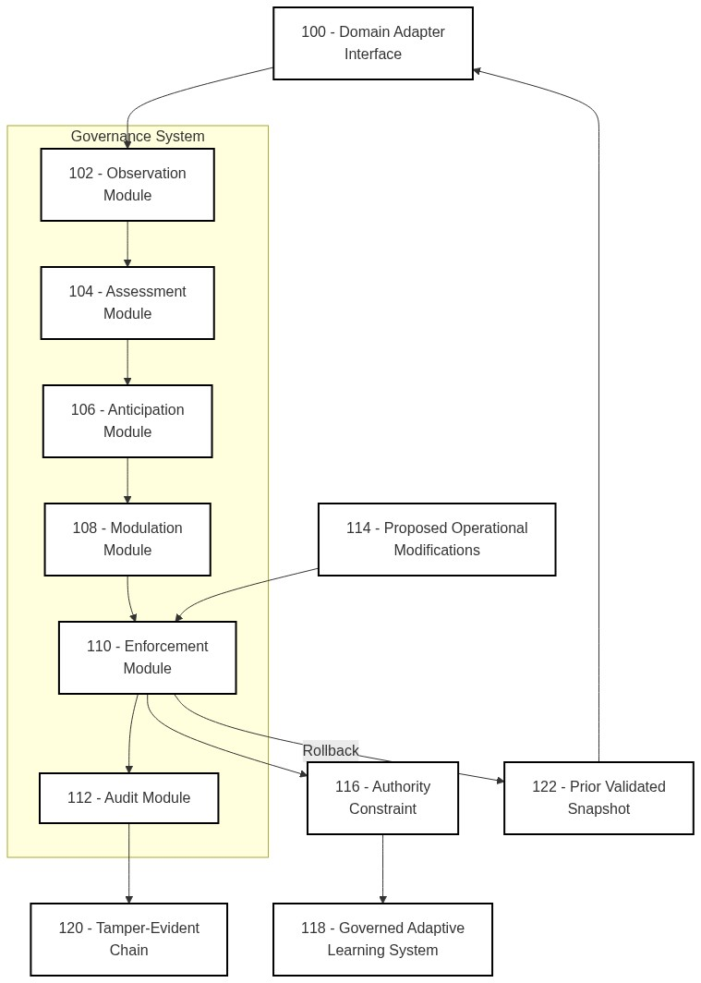

FIG. 2
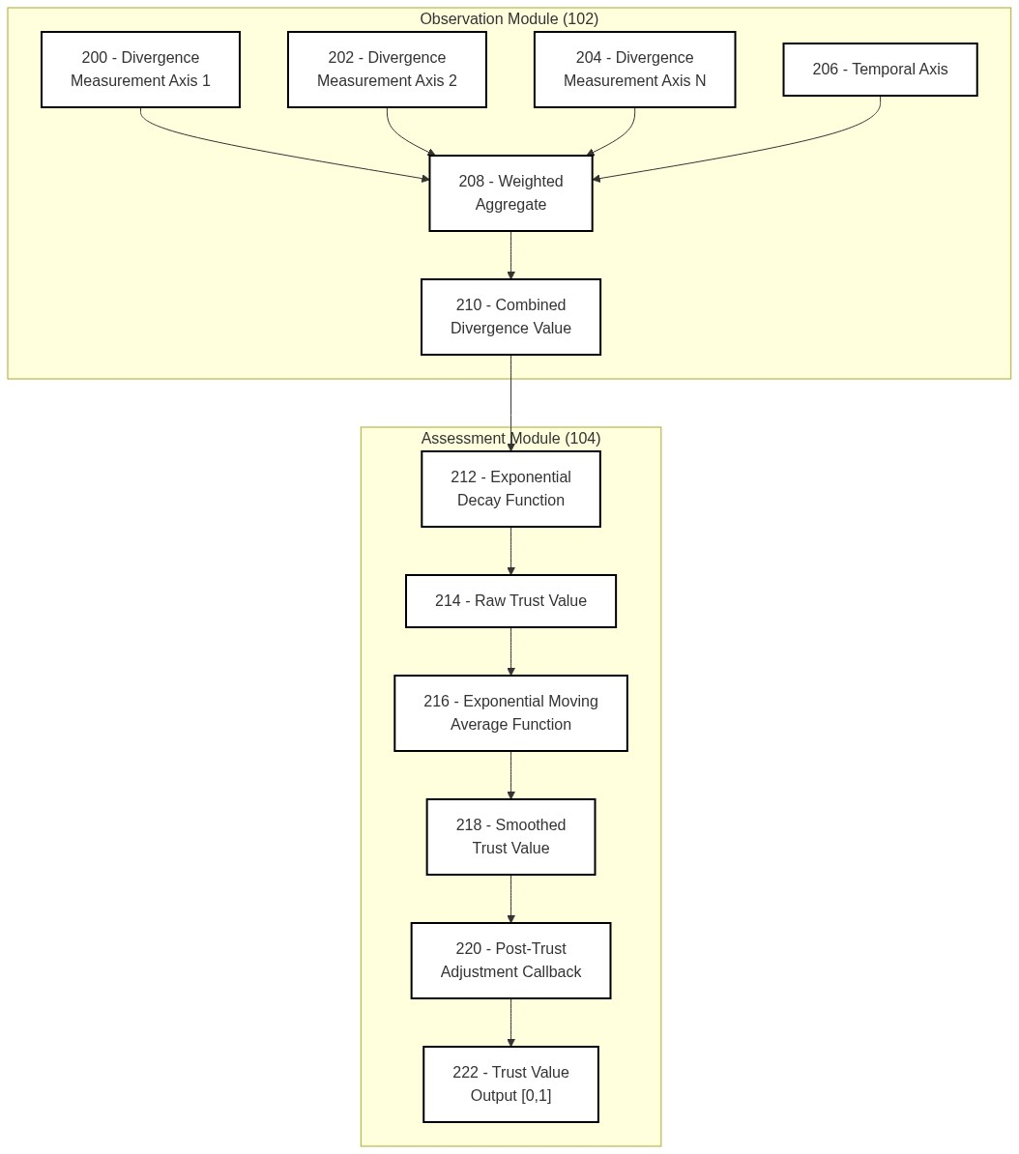

FIG. 3
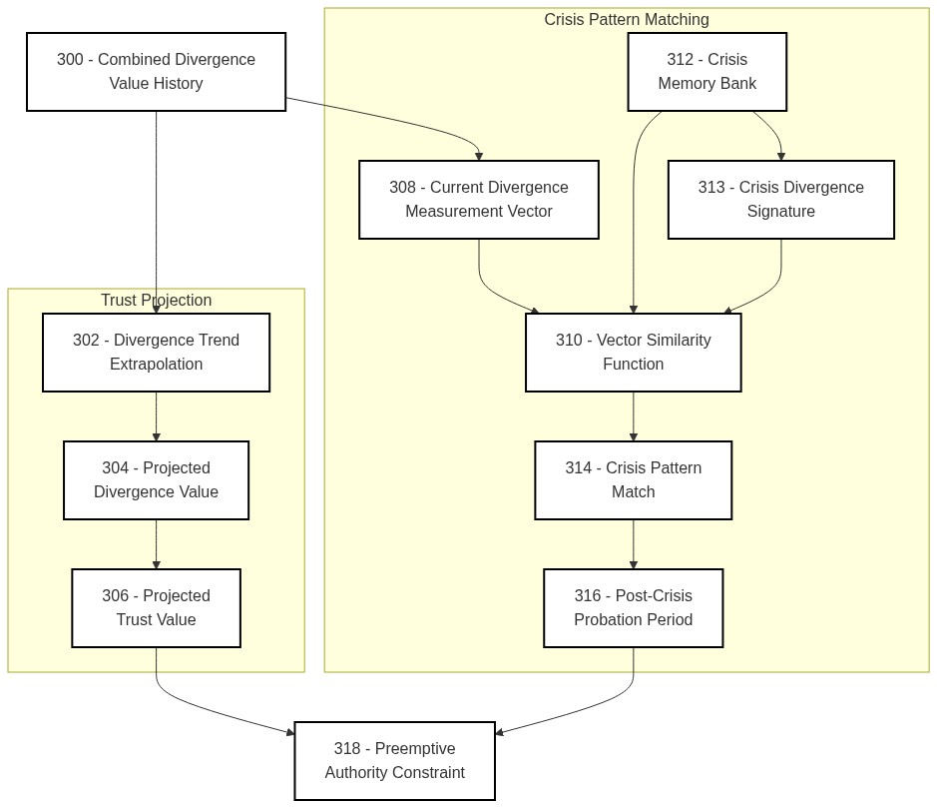

FIG. 4
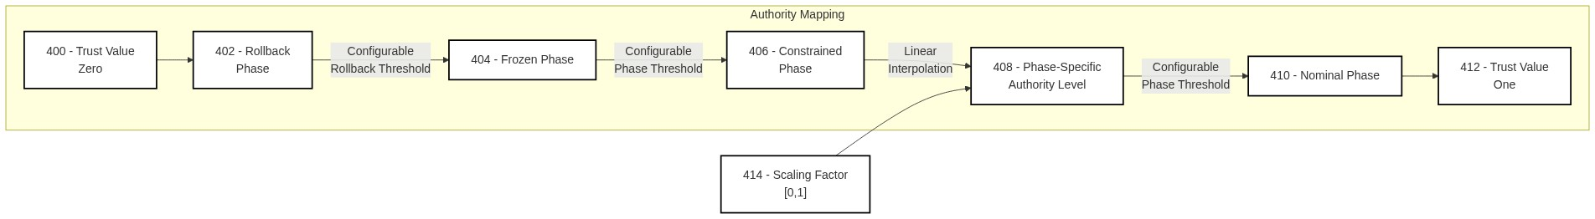

FIG. 5
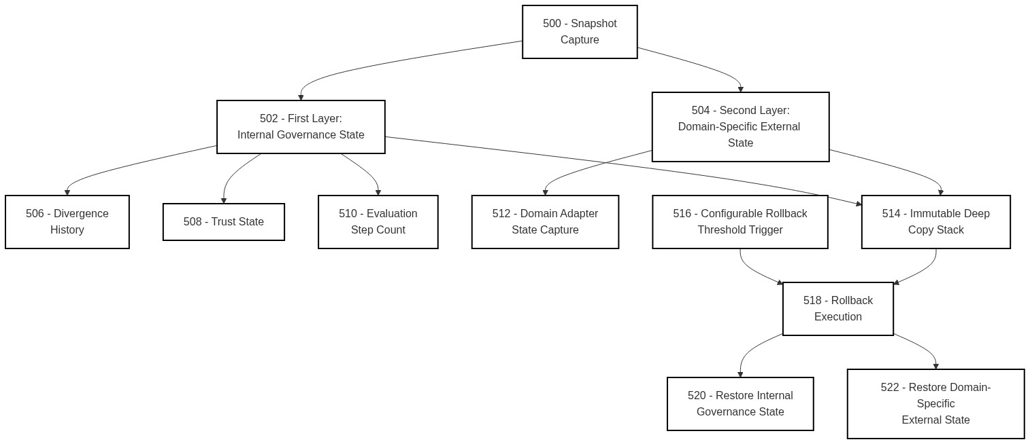

FIG. 6
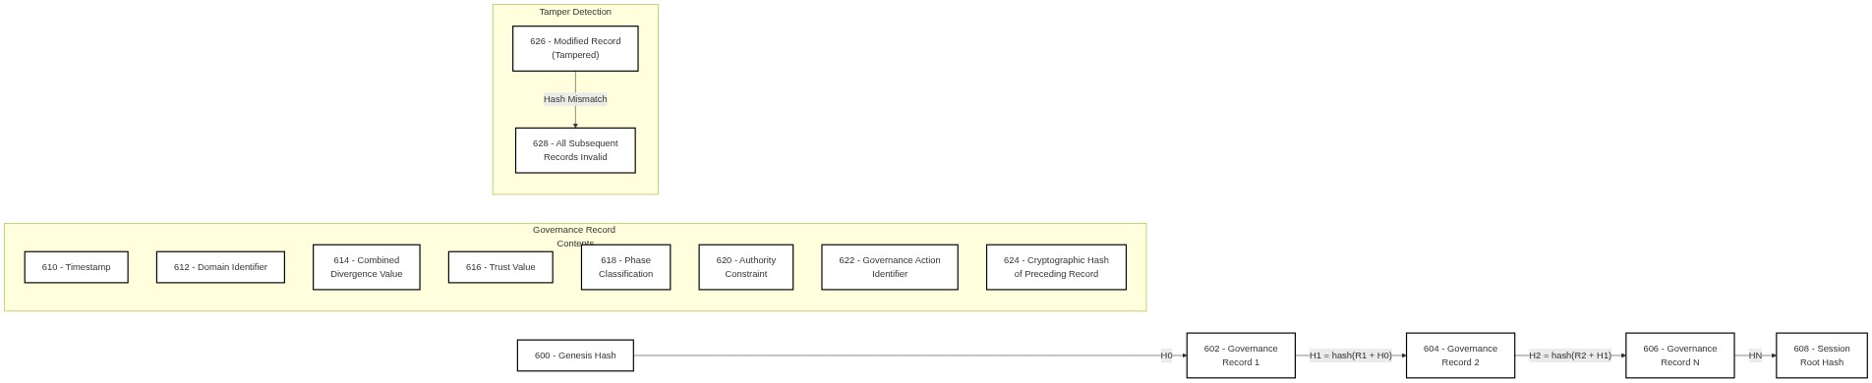

FIG. 7
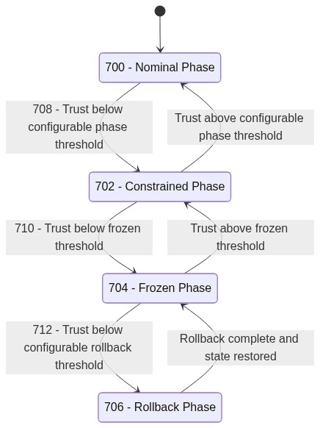

FIG. 8
