NONPROVISIONAL UTILITY PATENT APPLICATION

Title of Invention: Systems and Methods for Trust-Weighted Byzantine Fault Tolerant Consensus, Decentralized Skill Validation, and Governed Skill Interoperability in Multi-Agent Computing Networks

Applicant: The Wayfinder Trust
Inventor: Jonathan Luethke
Total Number of Drawing Sheets: 12
Total Number of Claims: See Claims section

CROSS-REFERENCE TO RELATED APPLICATIONS
[0001] This application is related to the following patent families, the disclosures of which are incorporated herein by reference in their entirety:
- Family A: "Runtime Actuation Governance Using Neural Trust Inference" (NeuroPRIN)
- Family B: "Assured Learning Governor with Exponential Decay Trust Computation" (ALG) -- The trust computation of the present invention directly implements the ALG exponential decay trust function in a decentralized network context.
- Family C: "AI-Native Operating System with Cognitive Memory Filesystem" (NeurOS/NeuroFS) -- The skill graduation pipeline of the present invention extends the autonomous skill generation system of Family C to a network context.
- Family D: "Cross-Subsystem Governance Coordination in Heterogeneous Autonomous Computing Environments" (Bridges)
- Family E: "Cross-Domain Resonance Analysis Using Coupled Oscillator Models" (Applied Energetics)
- Family G: "Production-Backed Digital Currency with Federation Governance" (Terra Unita)
The present invention adapts the trust computation methods of Family B and the skill graduation methods of Family C to a decentralized peer-to-peer network, adding novel consensus, validation, and interoperability mechanisms.
---

FIELD OF THE INVENTION
[0002] The present invention relates generally to decentralized computing networks for autonomous agent interoperability, and more particularly to systems and methods for: (1) achieving Byzantine fault tolerant consensus using trust-derived voting power rather than economic stake; (2) validating computational skills across heterogeneous agent platforms using shadow execution with domain competence gating; (3) resolving validation disputes through deterministic arbitrator selection; (4) enabling cross-platform skill interoperability through a universal skill format with platform-specific adapters; (5) automated software defect correction through multi-candidate fix generation with tournament-based selection in isolated sandboxes; (6) composing multiple skills into executable directed acyclic graph pipelines with topological execution ordering; (7) incentivizing real-world human activities through trust-verified proof-of-living token rewards; and (8) persisting skill execution state across invocations for incremental and resumable execution.
---

BACKGROUND OF THE INVENTION
[0003] The proliferation of autonomous computing agents (including large language model-based agents, rule-based agents, and hybrid architectures) has created a fragmented ecosystem in which each agent platform maintains its own proprietary skill format, validation methodology, and quality assessment framework. Skills developed for one agent platform cannot be used by another, creating redundant development effort and preventing the emergence of a shared knowledge economy.
[0004] Several technical problems prevent the creation of a decentralized skill marketplace:

Problem 1: Consensus Without Economic Stake
[0005] Existing decentralized consensus mechanisms (e.g., proof-of-work, proof-of-stake, delegated proof-of-stake) derive validator authority from economic resources: computational power or staked tokens. In a skill validation network, the relevant authority is not financial but competence-based. A validator should have authority proportional to its demonstrated trustworthiness in accurately validating skills, not proportional to its token holdings.
[0006] No existing consensus mechanism derives Byzantine fault tolerant voting power from a trust score computed via exponential decay of behavioral divergence with exponential moving average smoothing. Existing reputation systems (e.g., those used in e-commerce platforms) use simple aggregate metrics (average ratings, number of reviews) that are trivially manipulated via Sybil attacks and do not provide the mathematical properties needed for BFT consensus.

Problem 2: Cross-Platform Skill Validation
[0007] Validating that a computational skill produces correct results is straightforward when the validator uses the same platform as the publisher. However, when the publisher uses one agent platform and the validator uses another, output comparison becomes non-trivial because different platforms produce semantically equivalent but textually different outputs. Furthermore, a validator with no expertise in the skill's domain cannot meaningfully assess output quality.
[0008] No existing system combines: (a) sandboxed shadow execution of skills against reference outputs; (b) multi-metric similarity scoring that accounts for semantic equivalence; (c) domain competence gating that restricts validation to qualified validators; and (d) deterministic dispute resolution that prevents attacker-chosen arbitrators.

Problem 3: Trust Manipulation (Sybil Attacks)
[0009] In any decentralized trust system, an attacker can create multiple identities (Sybil nodes) that attest to each other's trustworthiness, artificially inflating trust scores. Existing anti-Sybil mechanisms in blockchain systems rely on economic barriers (staking) or social graphs. A trust-based system requires anti-Sybil mechanisms specifically designed for attestation-based trust.

Problem 4: Skill Format Fragmentation
[0010] Each major agent platform uses a different format for defining agent capabilities: some use structured markup, others use natural language descriptions, others use executable code with metadata. There is no universal skill format that can be consumed by any agent platform, and no governed pipeline for publishing, validating, and distributing skills across platforms.

Problem 5: On-Chain Trust Computation
[0011] Computing trust scores on a distributed ledger is constrained by the computational limitations of smart contract execution environments. Floating-point arithmetic is unavailable, recursive computations are gas-expensive, and the exponential function is not natively supported. No existing on-chain implementation provides exponential decay trust computation with EMA smoothing, weighted median aggregation, and attestation cooldown in a gas-efficient manner.
[0012] There exists a need for a comprehensive system that: (a) implements BFT consensus using trust-derived voting power; (b) validates skills across heterogeneous agent platforms using domain-gated shadow execution; (c) resists Sybil attacks through attestation-specific heuristics; (d) provides a universal skill format with platform adapters; and (e) implements trust computation on a distributed ledger using fixed-point arithmetic.

SUMMARY OF THE INVENTION
[0013] The present invention provides a decentralized skill validation and distribution network with five integrated subsystems.
**Trust-Weighted BFT Consensus**: A Byzantine fault tolerant consensus engine where voting power derives from trust scores computed via exponential decay of behavioral divergence with EMA smoothing, rather than economic stake. Validator eligibility requires demonstrated competence (minimum epochs active, minimum skills contributed, minimum trust level). Individual validator weight is capped at a configurable fraction of total network weight to prevent concentration of authority.
**Network Trust Module**: A peer-to-peer trust computation system that adapts the ALG exponential decay trust function to a decentralized context. Trust in an attestation is weighted by trust in the attester (web of trust). Attestation cooldowns prevent rapid-fire trust inflation. Phase classification assigns peers to tiers (validator, participant, probation, excluded) based on trust thresholds.
**Shadow Validation Protocol**: A network-level skill validation system using sandboxed shadow execution. Validators execute submitted skills against test cases and compare outputs to reference outputs using a multi-metric similarity score. Domain competence gating ensures validators have demonstrated expertise in the skill's domain. Deterministic dispute resolution selects arbitrators by cryptographic hash to prevent adversarial arbitrator selection.
**Universal Skill Format with Platform Adapters**: A packaging format that encapsulates skill definitions, test cases, metadata, and validation proofs in a self-contained archive. Platform-specific adapters translate the universal format into each agent platform's native format for installation and execution.
**On-Chain Trust Oracle**: A distributed ledger smart contract that implements trust attestation, exponential decay computation using fixed-point Taylor series approximation, EMA smoothing, weighted median aggregation, and attestation cooldown in a gas-efficient manner.
**Verified Fix Engine**: A multi-candidate fix generation and selection system that provisions isolated sandbox copies of a codebase, applies competing fix candidates, executes tests in parallel across sandboxes, scores candidates on a weighted composite metric (pass rate improvement, confidence, minimality, regression absence), and selects the optimal fix through tournament ranking with consensus measurement.
**Skill Composition Engine**: A DAG-based pipeline system that chains multiple skills into composite executable workflows, resolving execution order via topological sort, merging upstream outputs into downstream inputs, supporting parallel execution of independent branches, and enabling export of composed chains as new publishable skills.
**Life Rewards Module**: A proof-of-living incentive system that mints tokens for verified real-world human activities across multiple categories, using trust-weighted peer attestation for verification, with anti-gaming mechanisms including daily caps, diminishing returns, diversity bonuses, and streak rewards, and bridging digital skill economies with physical economic activity through a unified token system.
**Persistent Skill State Store**: A file-based state persistence system enabling cross-session skill execution continuity, with phase-level completion tracking, accumulated data persistence, run history archival, and incremental execution support.
---

BRIEF DESCRIPTION OF THE DRAWINGS
[0014] FIG. 1 is a block diagram illustrating the system architecture for decentralized skill validation and distribution in a multi-agent computing network, showing the network trust module (102), consensus engine (104), skill validation engine (106), skill packaging module (108), on-chain contract layer (110), and multi-agent computing network (122).
[0015] FIG. 2 is a pipeline diagram illustrating the network trust computation process, showing shadow execution attestation (200), behavioral divergence computation (204), exponential decay function (206), web-of-trust dampening (210), EMA smoothing (214), attestation cooldown (217), and trust phase classification (218) into validator (220), participant (222), probation (224), and excluded (226) phases.
[0016] FIG. 3 is a block diagram illustrating trust-weighted Byzantine fault tolerant consensus, showing validator selection (300) with trust score threshold gate (302), network participation duration gate (304), skill contribution volume gate (306), and domain competence gate (307), block proposer selection (308) via cryptographic hash of epoch seed and slot (309), and block consensus phases (310) including propose (312), prevote (314), precommit (316), and commit (318) with supermajority fraction gate (324).
[0017] FIG. 4 is a flowchart illustrating the sandboxed shadow execution validation protocol, showing domain competence gate (402), sandboxed shadow execution (406), multi-metric similarity function (412) with word-level set overlap (416) and word-pair sequence overlap (418), validation proof generation (420), and skill graduation (426).
[0018] FIG. 5 is a sequence diagram illustrating dispute resolution via deterministic cryptographic arbitrator selection, showing the challenger (500), dispute resolution module (502), arbitrators (504, 506, 508), original validator (510), deterministic cryptographic selection (512), and majority vote resolution (514).
[0019] FIG. 6 is a pipeline diagram illustrating the on-chain trust oracle contract, showing attestation input (600), epoch-based attestation cooldown (602), fixed-size ring buffer (606), exponential decay via polynomial approximation in fixed-point (608), weighted median aggregation (612), and on-chain mathematical library (616).
[0020] FIG. 7 is a block diagram illustrating universal skill packaging and platform adaptation, showing the self-contained skill archive (700) comprising skill metadata (702), skill definition (704), executable implementation (706), test cases (708), reference outputs (710), validation proofs (712), and cryptographic signatures (714), with platform adapters (720, 722, 724) for translation to heterogeneous agent platforms (728).
[0021] FIG. 8 is a block diagram illustrating Sybil resistance mechanisms, showing diminishing returns filter (802), age-based weight decay (804), temporal clustering detection (806), and collusion ring detection (808) with graph analysis of attestation patterns (830).
[0022] FIG. 9 is a flowchart illustrating the verified fix engine, showing detected software defect (900), candidate fix generation (902), isolated sandbox provisioning (906), automated test execution per sandbox (918), composite score computation (920), consensus measurement (932), and verification proof (938).
[0023] FIG. 10 is a block diagram illustrating the skill composition engine and directed acyclic graph execution, showing a directed acyclic graph of skill steps (1000), topological sort of dependency graph (1010), parallel execution of independent steps (1018), phase filter (1024), chain validation module (1027), and publishable skill archive export (1030) with usage fee distribution (1036).
[0024] FIG. 11 is a block diagram illustrating the life rewards module and proof of living protocol, showing activity categories (1100) including physical activity (1102), knowledge acquisition (1104), creative production (1106), knowledge transfer (1108), community service (1110), and physical goods production (1112), with peer attestation (1120), anti-gaming mechanisms (1128), and unified token economy (1140).
[0025] FIG. 12 is a block diagram illustrating the skill state store and persistent execution state, showing per-skill identity namespace (1200), run lifecycle (1208), phase completion records (1216), accumulated data store (1226), and incremental execution of uncompleted phases (1236).

DETAILED DESCRIPTION OF THE INVENTION
[0026] Referring to FIG. 1, the system architecture for decentralized skill validation and distribution in a multi-agent computing network is shown. The decentralized skill validation system (100) comprises four principal modules: a network trust module (102) configured to compute per-peer trust scores using exponential decay of behavioral divergence observed during sandboxed skill validation, a consensus engine (104) configured to implement Byzantine fault tolerant consensus with voting power derived from trust scores, a skill validation engine (106) configured to validate computational skills through sandboxed shadow execution against reference outputs using a multi-metric similarity function, and a skill packaging module (108) configured to encapsulate skills in a self-contained archive and translate the archive to platform-specific formats via platform adapters. The on-chain contract layer (110) comprises a node registry (112), trust oracle contract (114), skill registry (116), validation registry (118), and governance contract (120). The multi-agent computing network (122) comprises a plurality of peers (124, 126, 128) that interact with the system through attestations and skill submissions.
[0027] Referring to FIG. 2, the network trust computation pipeline is shown. A shadow execution attestation (200) produces similarity scores (202) from which behavioral divergence (204) is computed as one minus the mean similarity across validation runs. The exponential decay function (206) computes a raw trust score (208) from the behavioral divergence. The web-of-trust dampening module (210) interpolates between the raw trust score and a configurable neutral value (213) based on the attester trust score (212), such that attestations from peers with low trust scores are dampened toward the neutral value. EMA smoothing (214) produces a per-peer trust score (216). An attestation cooldown (217) prevents repeated attestations from the same attester-subject pair within a configurable time period. Trust phase classification (218) classifies per-peer trust scores into a validator phase (220), participant phase (222), probation phase (224), and excluded phase (226) using configurable thresholds.
[0028] Referring to FIG. 3, the trust-weighted Byzantine fault tolerant consensus protocol is shown. Validator selection (300) applies a trust score threshold gate (302), a network participation duration gate (304), a skill contribution volume gate (306), and a domain competence gate (307) to select eligible validators. A block proposer selection module (308) selects a block proposer for each slot by computing a cryptographic hash of an epoch seed concatenated with the slot number (309) and performing weighted selection among validators. The block consensus phases (310) advance through propose (312), prevote (314), precommit (316), and commit (318) phases. Each validator's trust-derived voting weight (320) is capped at a configurable maximum fraction via the weight cap (322). The supermajority fraction gate (324) requires agreement from validators holding at least a configurable supermajority fraction of total trust-derived weight before advancing from prevote to precommit and from precommit to commit.
[0029] Referring to FIG. 4, the sandboxed shadow execution validation protocol is shown. Upon skill submission (400), a domain competence gate (402) restricts validation eligibility to peers that have demonstrated expertise in the skill's domain by having contributed or validated at least a configurable number of skills in that domain. Eligible validators perform sandboxed shadow execution (406) producing actual outputs (408) that are compared against reference outputs (410) using a multi-metric similarity function (412). The similarity metrics (414) comprise a word-level set overlap metric (416) measuring output content coverage and a word-pair sequence overlap metric (418) measuring output structural ordering, with configurable weights (419). The result produces a validation proof (420). The system checks whether a configurable minimum number of validation proofs from distinct validators (422) has been achieved and whether a configurable minimum passing fraction (425) of those proofs indicate passing results before granting skill graduation (426).
[0030] Referring to FIG. 5, the dispute resolution process via deterministic cryptographic arbitrator selection is shown. A challenger (500) initiates a dispute with the dispute resolution module (502). The module performs deterministic cryptographic selection (512) of a configurable number of arbitrators (504, 506, 508) from the validator set, excluding the challenger and the original validator (510). Each arbitrator independently evaluates the disputed validation. The dispute resolution module resolves the dispute by majority vote (514) among the selected arbitrators and updates the trust scores of both the challenger (516) and the original validator (518).
[0031] Referring to FIG. 6, the on-chain trust oracle contract is shown. Attestation input (600) is first checked against an epoch-based attestation cooldown (602), rejecting duplicate attestations (604) within the cooldown period. Accepted attestations are stored in a fixed-size ring buffer (606) per target node. Exponential decay is computed using a polynomial approximation in fixed-point arithmetic (608) with a precision constant of at least a configurable minimum precision. Fixed-point EMA smoothing (610) is applied, followed by weighted median aggregation (612) where weights are reporter trust levels. The weighted median finds the value at the cumulative weight midpoint, providing resistance to manipulation by requiring an attacker to control more than half the total weight, producing an on-chain trust score (614). The on-chain mathematical library (616) provides supporting fixed-point implementations of square root via iterative approximation (618), binary logarithm via binary decomposition (620), and fixed-point EMA function (621).
[0032] Referring to FIG. 7, the universal skill packaging and platform adaptation system is shown. The self-contained skill archive (700) comprises skill metadata (702), skill definition (704), executable implementation (706), test cases (708), reference outputs (710), validation proofs (712), and cryptographic signatures (714). Platform detection (716) determines the target platform and selects an appropriate platform adapter (718). The structured markup adapter (720), natural language adapter (722), and executable code adapter (724) each convert skill definitions to their respective platform-specific formats. Platform-specific format translation (726) delivers the translated skill to the heterogeneous agent platform (728).
[0033] Referring to FIG. 8, the Sybil resistance mechanisms are shown. An attestation stream (800) passes through four sequential filters. The diminishing returns filter (802) tracks same attester-subject pair count (812) and applies a decay factor (814) to reduce the influence of repeated attestations from the same pair. Age-based weight decay (804) examines node age (818) and applies weight reduction (820) for new nodes. Temporal clustering detection (806) performs burst detection (824) and computes a coordination score (826) to identify suspiciously coordinated attestation timing. Collusion ring detection (808) applies graph analysis of attestation patterns (830) to identify ring structures (832). The attestation stream that survives all filters produces a validated trust score (834).
[0034] Referring to FIG. 9, the verified fix engine is shown. Upon detecting a software defect (900), the engine generates a plurality of candidate fixes (902). A pre-fix baseline test execution (904) establishes a reference pass rate. Isolated sandbox provisioning (906) creates independent sandbox copies (908) including sandbox 1 (910), sandbox 2 (912), and sandbox N (914), wherein each sandbox is independent such that modifications applied within one sandbox cannot affect any other sandbox or the original codebase. Each candidate fix is applied to its respective sandbox (916) and automated tests are executed independently in each sandbox (918). Composite score computation (920) computes a weighted combination of test pass rate improvement (924) relative to the pre-fix baseline, fix confidence (926), code minimality measured as an inverse function of the number of modified lines (928), and regression absence (930). Consensus measurement (932) computes a consensus score based on the fraction of candidates modifying the same files or functions. The highest-scoring candidate is selected (934) and applied to the original codebase (936). A verification proof (938) records a before-and-after comparison. If the highest-scoring candidate does not achieve full test passage, the engine iterates through candidates in descending score order (940), rolling back any candidate that does not improve the test pass rate.
[0035] Referring to FIG. 10, the skill composition engine and directed acyclic graph execution are shown. A directed acyclic graph of skill steps (1000) comprises step A referencing skill 1 (1002), step B referencing skill 2 (1004), step C referencing skill 3 (1006), and step D referencing skill 4 (1008), with dependency edges between steps. Topological sort of the dependency graph (1010) resolves the execution order (1012). Step A executes first (1014), and its output data is merged into the input context (1016) of downstream steps. Steps B and C, sharing no mutual dependencies, execute in parallel (1018). A phase filter (1024) restricts execution to a subset of the referenced skill's execution phases when only certain outputs are needed by downstream steps. Downstream context merge (1020) combines outputs before step D executes (1022). The chain validation module (1027) detects circular dependencies via cycle detection (1028) and references to missing or unresolved skills (1029) prior to execution. Composite skill export (1026) produces a publishable skill archive (1030) comprising constituent skill references (1032), dependency relationships (1034), and usage fee distribution proportional to each constituent skill creator's contribution (1036).
[0036] Referring to FIG. 11, the life rewards module and proof of living protocol are shown. The life rewards module is configured to mint tokens in response to verified real-world human activities across a plurality of activity categories (1100) including physical activity (1102), knowledge acquisition (1104), creative production (1106), knowledge transfer (1108), community service (1110), and physical goods production (1112). An activity proof submission (1114) is checked against a trust score threshold gate (1116), rejecting submissions from peers below a configurable minimum trust threshold (1118). Peer attestation (1120) requires a configurable minimum number of attestations from peers whose trust scores exceed a configurable minimum, with self-attestation prohibited. Upon meeting the configurable minimum attestations check (1122), the activity is verified (1126). Anti-gaming mechanisms (1128) include maximum activities per category per time period (1130), diminishing returns via exponential decay function (1132) wherein successive activities yield progressively reduced rewards, cross-category diversity bonuses (1134) for engaging in activities across a configurable minimum number of distinct categories, and streak bonus multipliers (1136) for consecutive periods of activity. Verified activities produce token minting (1138) into a unified token economy (1140) wherein tokens earned through verified physical activities may be spent to acquire computational skills in the skill marketplace (1142), and tokens earned through skill creation may fund physical production rewards (1144).
[0037] Referring to FIG. 12, the skill state store and persistent execution state are shown. A per-skill identity namespace (1200) contains state metadata (1202), accumulated data files (1204), and a chronological run history (1206). The run lifecycle (1208) proceeds from start (1210) through phase execution (1212) to completion or failure (1214). Phase completion records (1216) track each phase name (1218), completion status (1220), output data (1222), and duration (1224). The accumulated data store (1226) persists key-value pairs (1228) with update timestamps (1230) that survive across invocations. A subsequent invocation loads previous state (1232), enabling partial resumption (1234) of a previously interrupted execution and incremental execution of only uncompleted phases (1236), such that completed phases are not re-executed.

DETAILED DESCRIPTION OF PREFERRED EMBODIMENTS

1. System Architecture Overview
[0038] Referring to FIG. 1, the decentralized skill network 100 comprises an off-chain protocol layer 110 and an on-chain contract layer 120. The off-chain layer includes the trust computation module 111, the consensus engine 112, the skill validation engine 113, and the skill packaging and adaptation engine 114. The on-chain layer includes a node registry contract 121, a trust oracle contract 122, a skill registry contract 123, a validation registry contract 124, and a governance contract 125.
[0039] Peers in the network operate nodes that participate in trust attestation, skill validation, consensus, and skill publication. Each node maintains a local copy of the trust state and synchronizes with the on-chain contracts for persistence and finality.

2. Network Trust Module
[0040] Referring to FIG. 2, the network trust module 111 computes per-peer trust scores using the following mechanism.
[0041] Trust Attestation: The atomic trust signal is a trust attestation: a signed declaration by one peer (the attester) about the validation outcome of a skill submitted by another peer (the subject). Each attestation contains the attester identifier, subject identifier, skill hash, outcome classification, shadow execution similarity scores, epoch number, timestamp, and a cryptographic signature.
[0042] Divergence Computation: The attestation's divergence is computed from the shadow execution similarity scores:
[0043] divergence = 1 - mean(similarity_scores)
[0044] A perfect validation (all shadow runs match reference) has divergence 0. A complete failure has divergence 1.
[0045] Exponential Decay Trust: The raw trust signal is computed as:
[0046] raw_trust = exp(-decay_gain * divergence)
[0047] where decay_gain is a configurable parameter. This function produces trust near 1.0 for low divergence and trust near 0.0 for high divergence, with a smooth exponential transition.
[0048] Web of Trust Weighting: The raw trust signal is weighted by the attester's own trust score, dampening signals from low-trust peers toward a neutral value:
[0049] weighted_trust = attester_trust raw_trust + (1 - attester_trust) neutral_value
[0050] This creates a web of trust: attestations from highly trusted peers have more impact than attestations from untrusted peers.
[0051] EMA Smoothing: The peer's trust score is updated using exponential moving average:
[0052] trust_new = alpha weighted_trust + (1 - alpha) trust_previous
[0053] where alpha is a configurable smoothing factor.
[0054] Attestation Cooldown: To prevent rapid-fire trust inflation, a configurable cooldown period is enforced between attestations from the same attester-subject pair. Attestations submitted before the cooldown expires are ignored.
[0055] Phase Classification: Trust scores are classified into phases using configurable thresholds:
- Validator phase: trust >= a first configurable threshold (highest tier)
- Participant phase: trust >= a second configurable threshold
- Probation phase: trust >= a third configurable threshold
- Excluded phase: trust below all thresholds

3. Trust-Weighted BFT Consensus
[0056] Referring to FIG. 3, the consensus engine 112 implements a round-based BFT protocol with trust-derived voting power.
[0057] Block Lifecycle: Each block passes through four phases: PROPOSE, PREVOTE, PRECOMMIT, COMMIT.
[0058] Validator Selection: At the start of each epoch, the consensus engine selects validators from all registered peers based on:
- Trust score at or above a configurable participation threshold
- Minimum number of epochs active in the network
- Minimum number of skills contributed (published or validated)
[0059] Each validator's voting weight is computed from its trust-derived consensus weight, capped at a configurable maximum fraction of total network weight to prevent any single validator from dominating consensus.
[0060] Leader Selection: For each block slot within an epoch, a block proposer (leader) is selected deterministically by computing a cryptographic hash of (epoch_seed + slot_number) and using weighted selection among the validator set. The epoch seed is itself a cryptographic hash of the epoch number and the set of validator identifiers, ensuring determinism and resistance to manipulation.
[0061] Supermajority Requirement: Both prevote and precommit phases require agreement from validators holding at least two-thirds of the total trust-derived weight. The two-thirds threshold provides Byzantine fault tolerance: the network can tolerate up to one-third of total weight controlled by adversarial validators.
[0062] Prevote Phase: After a leader proposes a block, validators submit prevotes for the proposed block hash. When prevotes from validators holding at least two-thirds of total weight agree on a block hash, the slot advances to the precommit phase. Duplicate votes from the same validator are rejected.
[0063] Precommit Phase: Validators submit precommits for the block hash. When precommits from validators holding at least two-thirds of total weight agree, the block is committed. The committed block hash is recorded and the slot enters the COMMIT state.

4. Shadow Validation Protocol
[0064] Referring to FIG. 4, the skill validation engine 113 implements network-level skill validation through sandboxed shadow execution.
[0065] Skill Submission: A skill publisher submits a skill package containing: the skill hash (cryptographic digest of the skill code), publisher identifier, domain tags, test cases (input-output pairs), and reference outputs (expected outputs for the test cases).
[0066] Validator Assignment: The network selects validators with demonstrated domain competence. Domain competence is determined by a domain competence gate that requires:
- At least a first configurable number of published skills in the domain, OR
- At least a second configurable number of validated skills in the domain
[0067] This prevents validators from attesting on domains they do not understand, which would produce noisy trust signals.
[0068] Shadow Execution: Each assigned validator executes the submitted skill in a sandboxed environment against the test cases and obtains actual outputs. The validator records a hash of the execution environment to ensure comparable environments.
[0069] Similarity Scoring: Each actual output is compared to the corresponding reference output using a multi-metric similarity function:
[0070] similarity = w1 jaccard_similarity(output, reference) + w2 bigram_overlap(output, reference)
[0071] where w1 and w2 are configurable weights (w1 + w2 = 1), jaccard_similarity computes the Jaccard index of word sets, and bigram_overlap computes the ratio of shared word bigrams to total unique bigrams.
[0072] Validation Proof: The validator produces a validation proof containing: validator identifier, skill hash, publisher identifier, run count, pass count (runs exceeding the similarity threshold), individual similarity scores, execution hashes, environment hash, timestamp, and cryptographic signature.
[0073] Graduation: A skill graduates when it accumulates a configurable minimum number of validation proofs from distinct validators, and a configurable minimum fraction of those proofs indicate passing results. Graduated skills are eligible for publication to the on-chain registry.

5. Dispute Resolution
[0074] Referring to FIG. 5, when a peer disagrees with a validation result, they may open a dispute. The dispute resolution mechanism operates as follows:
- The challenger identifies the skill hash and the original validator whose result is disputed.
- The system selects a configurable number of arbitrators (in a preferred embodiment, three) from the validator set, excluding the challenger and the original validator.
- Arbitrator selection is deterministic: a cryptographic hash of (skill_hash + challenger_id) is used as a seed, and candidates are sorted by their hash distance from the seed. This prevents the challenger from selecting friendly arbitrators.
- Each arbitrator independently evaluates the dispute and submits a vote to uphold or overturn the original validation.
- The dispute is resolved by majority vote (e.g., 2 of 3 arbitrators must agree).
- The resolution affects the trust scores of both the original validator and the challenger.

6. On-Chain Trust Oracle
[0075] Referring to FIG. 6, the on-chain trust oracle contract 122 implements trust attestation and aggregation on the distributed ledger.
[0076] Attestation Storage: Attestations are stored in a fixed-size ring buffer (in a preferred embodiment, the most recent 50 attestations per target node). Each attestation contains the reporter node identifier, trust score, reporter weight, and block number.
[0077] Epoch-Based Cooldown: Each reporter can submit at most one attestation per target per epoch. The epoch is computed from the block number divided by a configurable blocks-per-epoch constant.
[0078] Exponential Decay: The on-chain contract implements exponential decay using a Taylor series approximation:
[0079] exp(-x) ≈ 1 - x + x^2/2! - x^3/3! + x^4/4! - x^5/5! + x^6/6!
[0080] computed using fixed-point arithmetic with a configurable precision constant (in a preferred embodiment, 10^18 as the unit). The approximation is accurate within a configurable tolerance for the operational range.
[0081] EMA Smoothing: The on-chain EMA is computed as:
[0082] result = (alpha newValue + (WAD - alpha) prevValue) / WAD
[0083] where WAD is the fixed-point precision constant.
[0084] Weighted Median Aggregation: Trust scores are aggregated using a weighted median where weights are the reporter's stake or trust level. The ring buffer contents are sorted by value, and the median is found at the cumulative weight midpoint. This provides Sybil resistance because a single attacker must control more than half the total weight to manipulate the median.
[0085] Additional Mathematical Functions: The on-chain library provides fixed-point implementations of square root (Babylonian method) and binary logarithm (binary decomposition with 64-iteration fractional precision), used by the governance contract for computing voting power.

7. Universal Skill Format and Platform Adapters
[0086] Referring to FIG. 7, the skill packaging engine 114 encapsulates skills in a universal format comprising:
- Skill metadata (name, version, domain tags, author, license)
- Skill definition (natural language description, input/output schema)
- Executable implementation (platform-agnostic representation)
- Test cases and reference outputs
- Validation proofs (accumulated from the network)
- Cryptographic hashes and signatures
[0087] Platform-specific adapters translate the universal format into each target platform's native format:
- For platforms using structured markup: the adapter converts skill definitions to the platform's markup schema.
- For platforms using natural language instructions: the adapter renders the skill as a natural language prompt with embedded tool definitions.
- For platforms using executable code: the adapter generates platform-specific code from the universal representation.
[0088] Each adapter supports install and uninstall operations, enabling skills to be added to and removed from any supported agent platform.

8. Sybil Resistance Mechanisms
[0089] In a preferred embodiment, the system employs multiple heuristics to detect and mitigate Sybil attacks on the trust system:
- Diminishing returns: Repeated attestations from the same attester-subject pair yield diminishing trust impact. In one embodiment, the first attestation has full weight, the second has half weight, and subsequent attestations have a configurable minimum weight.
- Age decay: Attestations from very new nodes carry reduced weight, increasing over time as the node establishes a history.
- Temporal clustering detection: Bursts of attestations within a short time window from multiple nodes are flagged as potentially coordinated.
- Collusion ring detection: Graph analysis of attestation patterns identifies clusters of nodes that exclusively attest for each other and do not participate in the broader network.

9. Verified Fix Engine with Tournament Selection
[0090] Referring to FIG. 9, the system further comprises a verified fix engine 115 that generates, tests, and selects optimal software fixes through a competitive tournament process.
[0091] Defect Detection and Analysis: Upon receiving a codebase containing one or more software defects, the engine scans the codebase to identify language, test framework, and test invocation command. The engine executes the existing test suite to establish a pre-fix baseline, recording total test count, passing test count, and specific failure details. Error parsing extracts structured error information including error type, location, and stack trace. Root cause analysis determines the likely cause and affected files.
[0092] Multi-Candidate Fix Generation: Rather than generating a single fix, the engine generates a configurable plurality of candidate fixes (in a preferred embodiment, five candidates). Each candidate represents an independent attempt to resolve the detected defects, potentially using different approaches or targeting different root causes.
[0093] Sandbox Isolation: For each candidate fix, the engine provisions an independent sandbox by creating an ephemeral copy of the codebase in a temporary directory. Non-essential directories (version control metadata, dependency caches, virtual environments, build caches) are excluded from the copy to minimize resource consumption. Each sandbox is fully isolated: modifications applied within one sandbox cannot affect any other sandbox or the original codebase. Sandboxes are automatically cleaned up upon tournament completion regardless of outcome.
[0094] Parallel Tournament Execution: Each candidate fix is applied to its respective sandbox. The test suite is then executed in each sandbox. When parallel execution is enabled (the default), all sandboxes are tested concurrently using a thread pool, significantly reducing total tournament duration. When parallel execution is disabled, sandboxes are tested sequentially.
[0095] Composite Scoring Formula: Each candidate is scored using a weighted linear combination of four metrics:
- Test pass rate improvement (configurable weight, in a preferred embodiment 50%): Measures the ratio of newly passing tests to previously failing tests. A candidate that converts all failures to passes scores 1.0 on this metric.
- Fix confidence (configurable weight, in a preferred embodiment 20%): Derived from the automated analysis of the proposed changes, reflecting how well the fix addresses the identified root cause.
- Code minimality (configurable weight, in a preferred embodiment 15%): Computed as a decreasing function of the total number of modified lines. Fewer changes yield a higher score, rewarding targeted fixes over broad modifications.
- No-regression penalty (configurable weight, in a preferred embodiment 15%): Measures the fraction of previously passing tests that remain passing. Any test that was passing before the fix but fails after incurs a regression penalty.
[0096] Consensus Measurement: The engine computes a consensus score by analyzing how many candidates modified the same files. If, for example, four of five candidates all modified the same function, the consensus score is 0.80, indicating high confidence that the fix location has been correctly identified. Low consensus suggests that candidates are exploring different hypotheses about the defect location.
[0097] Winner Selection and Verification: Candidates are ranked by composite score. The highest-scoring candidate is selected as the winner, provided its score is positive. The winning fix is then applied to the original (non-sandbox) codebase, and the test suite is executed one final time as verification. If this final verification shows a regression (lower pass rate than the pre-fix baseline), the fix is rolled back and the next candidate is tried.
[0098] Before-and-After Proof: The engine produces a verifiable before-and-after comparison record comprising: total test count before, pass rate before, total test count after, pass rate after, specific errors resolved, tournament duration, number of candidates tested, consensus score, and the winning candidate's composite score breakdown.
[0099] Multi-Attempt Iteration: If the highest-scoring candidate does not achieve full test passage, the engine may iterate through subsequent candidates in descending score order, up to a configurable maximum number of attempts.

10. Skill Composition Engine
[0100] Referring to FIG. 10, the system further comprises a skill composition engine 116 that composes multiple skills into executable directed acyclic graph (DAG) pipelines.
[0101] Chain Definition: A skill chain is defined as a directed acyclic graph where each node (step) references a named skill and may declare dependencies on one or more upstream steps via their aliases. Each step has a unique alias within the chain for reference by downstream steps.
[0102] Dependency Resolution via Topological Sort: Before execution, the engine resolves the execution order via Kahn's algorithm for topological sort. This ensures that every step executes only after all of its upstream dependencies have completed. If the dependency graph contains a cycle, execution is rejected with a diagnostic message identifying the circular dependency path.
[0103] Data Flow and Context Merging: When a step completes, its output data is made available to all downstream steps that declare a dependency on it. Downstream steps receive a merged context comprising the initial input context, the outputs of all upstream dependencies, and any step-specific configuration overrides. In a preferred embodiment, later outputs overwrite earlier ones on key conflicts, and each upstream step's output is also available under its alias key.
[0104] Parallel Execution: Steps that share no mutual dependencies may be executed concurrently. In a preferred embodiment, the engine identifies independent branches of the DAG and executes them in parallel, merging results before proceeding to downstream steps.
[0105] Phase Filtering: Each step may optionally specify a phase filter that restricts execution to a subset of the referenced skill's execution phases. This enables partial skill execution when only certain outputs are needed by downstream steps, reducing computational cost.
[0106] Chain Validation: Before execution, the engine validates the chain for structural errors including: missing steps (no steps defined), unresolved dependency references (a step depends on an alias that does not exist), circular dependencies (detected via topological sort failure and confirmed via depth-first search cycle detection), and duplicate step aliases.
[0107] Composite Skill Export: A composed chain may be exported as a new publishable skill archive (skillpack). The exported archive contains: a manifest listing all constituent skills and their execution order; the full chain definition with dependency edges; and a description document. The composite skill references its constituent skills, enabling the system to distribute usage fees among all constituent skill creators when the composite skill is consumed.
[0108] Visual Representation: The engine provides a textual visualization of the chain DAG showing the tree structure of dependencies, enabling inspection of the execution plan before running.

11. Life Protocol -- Proof of Living
[0109] Referring to FIG. 11, the system further comprises a life rewards module 130 that mints tokens in response to verified real-world human activities.
[0110] Activity Categories: The module defines a plurality of activity categories, in a preferred embodiment including at least: physical activity (bodily movement and exercise), knowledge acquisition (learning new skills or completing educational activities), creative production (building or creating tangible outputs), knowledge transfer (teaching or mentoring others), community service (contributing to community welfare), and physical goods production (producing tangible goods, bridging to physical economic activity).
[0111] Proof Submission: A registered node submits a proof of activity containing: the activity category, a cryptographic hash of the proof data (which may include sensor readings, completion certificates, peer observations, or other evidence), and the submitter's identity. The module computes a base reward amount with diminishing returns applied for successive activities within the same category on the same day.
[0112] Peer Attestation Verification: Each submitted proof enters a pending state and requires attestation from peers. Only peers whose trust scores (as computed by the network trust module) exceed a configurable minimum threshold may attest. Self-attestation is prohibited. Each proof requires a configurable minimum number of attestations (which may vary by category) before the reward is minted. Proofs that do not receive sufficient attestations within a configurable attestation window expire without reward.
[0113] Anti-Gaming Mechanisms: The module employs multiple mechanisms to prevent gaming:
- Daily activity limits: A configurable maximum number of reward-eligible activities per category per day, beyond which no further proofs are accepted.
- Diminishing returns: Each successive activity within the same category on the same day yields a progressively reduced reward, computed by iteratively applying a configurable decay factor to the base reward.
- Cross-category diversity bonus: When a user engages in activities across a configurable minimum number of distinct categories within a single day, all rewards for that day are multiplied by a configurable diversity bonus factor.
- Streak bonuses: Consecutive days of activity yield increasing reward multipliers. In a preferred embodiment, the multiplier increases linearly between tier thresholds (no bonus below a first threshold, increasing to a second multiplier at a second threshold, a third multiplier at a third threshold, capped at a maximum multiplier above a fourth threshold).
- Global daily emission cap: A governance-adjustable ceiling on total tokens minted via the life rewards module per day, preventing runaway inflation regardless of individual activity volume.
[0114] Unified Token Economy: The life rewards module mints tokens using the same token contract as the skill marketplace. This means tokens earned through physical activities (walking, learning, teaching) can be spent to acquire computational skills, and tokens earned through skill creation and validation can fund physical production rewards. This bridges digital skill economies and physical economic activity within a single token system.
[0115] Governance: Category configurations (base reward, daily cap, minimum attestations, active status) are adjustable by governance. The global daily emission cap and attestation window duration are also governance-adjustable.

12. Persistent Skill State Store
[0116] Referring to FIG. 12, the system further comprises a skill state store 117 that persists execution state between skill invocations.
[0117] State Organization: Each skill receives its own namespace in a file-based storage backend organized by skill identity. The store maintains: the current state (run count, first and last execution timestamps, accumulated data), a history of past runs, and key-value accumulated data that persists across invocations.
[0118] Run Lifecycle: A skill execution run progresses through a defined lifecycle: start (recording the execution pattern and start timestamp), phase recording (recording the completion status, output data, and duration of each execution phase), and completion (recording the final status and archiving the run to history).
[0119] Phase-Level State Tracking: Within each run, the store records the completion status, output data, timestamp, and duration of each individual execution phase. This enables: determining which phases have already completed in a prior invocation; resuming execution from the last completed phase rather than re-executing the entire skill; and incrementally building on prior results across sessions.
[0120] Accumulated Data Persistence: The store provides a key-value mechanism for persisting arbitrary data across runs. Skills can save intermediate results, cached computations, or accumulated context under named keys, and load them in subsequent invocations. This enables skills that build progressively richer context over multiple executions.
[0121] Run History and Audit: Completed runs are archived with timestamps, enabling auditing of skill execution history. The store provides access to recent run history for a configurable number of past runs.
[0122] Security: Skill names used as filesystem paths are sanitized to prevent path traversal attacks. Directory separators, parent directory references, null bytes, and leading dots are stripped. The resolved storage path is verified to reside within the designated base directory.

13. Block Structure
[0123] In a preferred embodiment, each block in the chain contains:
- Block header: block number, epoch number, timestamp, parent block hash, state root hash, transactions Merkle root
- Transactions: skill publications, trust attestations, validation proofs, governance proposals
- State commitments: updated trust scores, skill registry entries, validation statuses
[0124] The state root hash enables light clients to verify the current state without processing the full chain.

CLAIMS
What is claimed is:

1. A system for decentralized skill validation and distribution in a multi-agent computing network, the system comprising: a) a network trust module configured to compute per-peer trust scores using exponential decay of behavioral divergence observed during sandboxed skill validation, with exponential moving average smoothing, wherein trust in an attestation is weighted by a trust score of an attesting peer and dampened toward a configurable neutral value based on the attesting peer's trust score to form a web of trust with attestation cooldowns preventing repeated attestations from an attester-subject pair within a configurable time period; b) a consensus engine configured to implement Byzantine fault tolerant consensus with voting power derived from the trust scores computed by the network trust module rather than from economic stake or computational power, wherein the consensus engine requires agreement from peers holding at least a configurable supermajority fraction of total trust-derived weight; c) a skill validation engine configured to validate computational skills through sandboxed shadow execution against reference outputs using a multi-metric similarity function, wherein a domain competence gate restricts validation eligibility to peers that have demonstrated expertise in a skill's domain by having contributed or validated at least a configurable number of skills in that domain; and d) a skill packaging module configured to encapsulate skills in a self-contained archive comprising executable implementation, test cases, reference outputs, validation proofs, and cryptographic signatures, and to translate the archive to platform-specific formats via platform adapters for consumption by heterogeneous agent platforms; wherein the combination of trust derived from shadow execution behavioral divergence, domain competence gating of validators, web-of-trust dampening with attestation cooldowns, and universal skill packaging with validation proofs provides a meritocratic validation protocol that does not rely on economic stake for authority.
2. A method for achieving Byzantine fault tolerant consensus in a decentralized computing network using trust-derived voting power, the method comprising: a) computing, for each peer in the network, a trust score using exponential decay of behavioral divergence observed during sandboxed shadow execution of computational skills, with exponential moving average smoothing, wherein each trust observation is dampened toward a configurable neutral value based on a trust score of a peer providing the observation, and wherein attestation cooldowns prevent repeated attestations from an attester-subject pair within a configurable time period; b) selecting validators for a consensus epoch based on trust score, duration of network participation, and volume of skill contributions, wherein validator eligibility further requires demonstrated domain competence in a skill's domain; c) computing each validator's voting weight from its trust score; d) for each block slot within an epoch, selecting a block proposer by computing a cryptographic hash of an epoch seed concatenated with a slot number and performing weighted selection among validators; e) advancing block consensus through propose, prevote, and precommit phases, each requiring agreement from validators holding at least a configurable supermajority fraction of total trust-derived weight; and f) committing a block when a precommit supermajority is achieved; wherein voting power is derived entirely from trust earned through skill validation performance rather than from economic stake or computational power.
3. A non-transitory computer-readable medium storing instructions that, when executed by one or more processors, cause the one or more processors to perform operations comprising: a) maintaining per-peer trust scores in a decentralized network using exponential decay of behavioral divergence observed during sandboxed shadow execution of computational skills, with exponential moving average smoothing and web-of-trust weighting wherein attestation influence is dampened toward a neutral value based on attester trust, with attestation cooldowns preventing repeated attestations from an attester-subject pair within a configurable time period; b) implementing Byzantine fault tolerant consensus with voting power derived from trust scores earned through skill validation performance rather than from economic stake, and configurable supermajority requirements; c) validating computational skills through sandboxed shadow execution with domain competence gating requiring demonstrated expertise and multi-metric similarity scoring; and d) resolving validation disputes through deterministic cryptographic selection of arbitrators from a validator set, excluding disputing parties.
4. The system of Claim 1, wherein the network trust module computes a raw trust value using an exponential decay function applied to a divergence, where the divergence is computed from shadow execution similarity scores as one minus a mean similarity across validation runs.
5. The system of Claim 1, wherein a web-of-trust weighting computes weighted trust by interpolating between a raw trust value and the configurable neutral value based on the attesting peer's trust score, such that attestations from peers with low trust scores are dampened toward the configurable neutral value.
6. The system of Claim 1, wherein the network trust module enforces an attestation cooldown period between attestations from a given attester-subject pair, rejecting attestations submitted before the cooldown expires.
7. The system of Claim 1, wherein the network trust module classifies peer trust scores into a plurality of trust phases using configurable thresholds, including at least a validator phase, a participant phase, a probation phase, and an excluded phase.
8. The system of Claim 1, wherein each validator's voting weight is subject to a cap equal to a configurable maximum fraction of total network trust-derived weight, and wherein the cap is dynamically adjusted based on a number of active validators to prevent any single validator from exceeding a configurable influence ceiling regardless of its accumulated trust score.
9. The system of Claim 1, wherein the consensus engine selects a block proposer for each slot using a deterministic function of a cryptographic hash of an epoch seed concatenated with a slot number, with weighted selection proportional to trust-derived voting weights.
10. The system of Claim 1, wherein the skill validation engine employs the domain competence gate that requires validators to have demonstrated expertise in a domain of a skill under validation by having contributed at least a configurable number of skills in that domain or validated at least a configurable number of skills in that domain.
11. The system of Claim 1, wherein the multi-metric similarity function used in shadow execution validation computes a weighted combination of a word-level set overlap metric measuring output content coverage and a word-pair sequence overlap metric measuring output structural ordering, with configurable weights, and wherein a similarity score determines the behavioral divergence input to the trust computation of Claim 1.
12. The system of Claim 1, further comprising a dispute resolution module configured to select a configurable number of arbitrators from a validator set using deterministic cryptographic hash-based selection that excludes a challenger and an original validator, and to resolve disputes by majority vote among the selected arbitrators.
13. The system of Claim 1, further comprising an on-chain trust oracle contract configured to: i) store attestations in a fixed-size ring buffer per target node; ii) enforce epoch-based attestation cooldowns; iii) compute exponential decay using a polynomial approximation in fixed-point arithmetic; and iv) aggregate trust scores using a weighted median where weights are reporter trust levels.
14. The system of Claim 13, wherein the on-chain trust oracle contract computes exponential decay using a polynomial approximation of configurable order in fixed-point arithmetic with a precision constant of at least a configurable minimum precision.
15. The system of Claim 13, wherein a weighted median aggregation sorts attestation values and finds a value at a cumulative weight midpoint, providing resistance to manipulation by requiring an attacker to control more than half the total weight.
16. The system of Claim 1, further comprising Sybil resistance mechanisms including at least two of: diminishing returns for repeated attestations from an attester-subject pair; age-based weight decay for new nodes; temporal clustering detection; and collusion ring detection via graph analysis of attestation patterns.
17. The system of Claim 1, wherein the skill packaging module encapsulates skills in the self-contained archive comprising skill metadata, a skill definition, executable implementation, test cases, reference outputs, validation proofs, and cryptographic signatures.
18. The system of Claim 1, wherein the platform adapters translate a universal skill format to platform-specific formats by converting skill definitions to structured markup, natural language instructions, or executable code depending on a target platform's native format.
19. The method of Claim 2, wherein the epoch seed is computed as a cryptographic hash of an epoch number and a set of validator identifiers, and wherein the epoch seed is used both for deterministic block proposer selection and for deterministic arbitrator selection in dispute resolution, ensuring reproducible governance decisions across all network participants.
20. The method of Claim 2, further comprising computing a validation proof for a skill by executing the skill in a sandboxed environment against test cases, comparing outputs to reference outputs using a multi-metric similarity function, and recording a run count, a pass count, similarity scores, execution hashes, and an environment hash.
21. The method of Claim 2, further comprising graduating a skill when it accumulates a configurable minimum number of validation proofs from distinct validators and a configurable minimum fraction of those proofs indicate passing results.
22. The system of Claim 13, further comprising an on-chain mathematical library providing fixed-point implementations of exponential moving average, square root via iterative approximation, and binary logarithm via binary decomposition.
23. The system of Claim 1, further comprising a verified fix engine configured to: a) generate a plurality of candidate fixes for a detected software defect; b) provision an isolated sandbox copy of a codebase for each candidate fix, wherein each sandbox is independent such that modifications applied within one sandbox cannot affect any other sandbox or the original codebase; c) apply each candidate fix to its respective sandbox; d) execute automated tests in each sandbox independently; e) compute a composite score for each candidate based on a weighted combination of test pass rate improvement relative to a pre-fix baseline, fix confidence, code minimality measured as an inverse function of a number of modified lines, and absence of test regressions; and f) select a highest-scoring candidate as a verified fix and apply the selected fix to the original codebase.
24. The system of Claim 23, wherein the composite score is computed as a weighted linear combination of: a test improvement component measuring a ratio of newly passing tests to previously failing tests; a confidence component derived from automated analysis of proposed changes; a minimality component computed as a decreasing function of a total number of modified lines such that fewer changes yield a higher score; and a regression penalty component measuring a fraction of previously passing tests that remain passing, wherein each component weight is configurable.
25. The system of Claim 23, wherein provisioning each sandbox comprises creating a copy of the codebase in an ephemeral directory with automatic exclusion of non-essential artifacts, and wherein all sandboxes are automatically removed upon completion of a tournament regardless of outcome.
26. The system of Claim 23, further comprising a consensus measurement module configured to compute a consensus score based on a fraction of candidate fixes that modify same files or same functions as a plurality candidate, wherein a higher consensus score indicates higher confidence in an identified fix location.
27. The system of Claim 23, further comprising a verification proof module configured to execute an automated test suite both before any fix is applied and after a winning fix is applied to the original codebase, and to produce a verifiable before-and-after comparison record comprising a total test count, a pass rate, and specific errors resolved.
28. The system of Claim 23, wherein if the highest-scoring candidate does not achieve full test passage, the verified fix engine iterates through candidates in descending score order, applying and verifying each in turn, up to a configurable maximum number of attempts, and rolling back any candidate that does not improve a test pass rate relative to the pre-fix baseline.
29. The system of Claim 1, further comprising a skill composition engine configured to: a) accept a directed acyclic graph of skill steps with dependency edges, wherein each step references a skill and may declare dependencies on one or more upstream steps; b) resolve an execution order via topological sort of the dependency graph; c) execute skills in the resolved execution order, merging output data from each completed upstream step into an input context of each downstream step; and d) support parallel execution of steps that share no mutual dependencies.
30. The system of Claim 29, wherein the skill composition engine is further configured to export a composed skill chain as a new publishable skill archive, wherein a composite skill archive references its constituent skills and their dependency relationships, and wherein the system distributes usage fees among all constituent skill creators in proportion to their contribution to the composite chain.
31. The system of Claim 29, wherein each step in the directed acyclic graph may specify a phase filter restricting execution to a subset of the referenced skill's execution phases, enabling partial skill execution when only certain outputs are needed by downstream steps.
32. The system of Claim 29, further comprising a chain validation module configured to detect, prior to execution: circular dependencies via cycle detection in the dependency graph; references to missing or unresolved skills; and duplicate step identifiers, and further configured to generate a visual representation of an execution graph for inspection.
33. The system of Claim 1, further comprising a life rewards module configured to mint tokens in a token economy of the skill marketplace in response to verified real-world human activities, across a plurality of activity categories including at least physical activity, knowledge acquisition, creative production, knowledge transfer, community service, and physical goods production.
34. The system of Claim 33, wherein verification of a submitted activity proof requires a configurable minimum number of attestations from peers whose trust scores exceed a configurable minimum trust threshold, and wherein self-attestation is prohibited.
35. The system of Claim 33, further comprising anti-gaming mechanisms including at least two of: a configurable maximum number of reward-eligible activities per category per time period; diminishing returns wherein successive activities within a time period yield progressively reduced rewards computed via an exponential decay function; cross-category diversity bonuses wherein engaging in activities across a configurable minimum number of distinct categories within a time period yields a multiplied reward; and streak bonuses wherein consecutive time periods of activity yield increasing reward multipliers up to a configurable ceiling.
36. The system of Claim 33, wherein the life rewards module mints tokens in the token economy and using a same token contract as the skill marketplace, such that tokens earned through verified physical activities may be spent to acquire computational skills, and tokens earned through skill creation and validation may be used to fund physical production rewards, thereby bridging digital and physical economic activity within a unified token economy.
37. The system of Claim 1, further comprising a skill state store configured to persist execution state between skill invocations using a file-based storage backend organized by skill identity, wherein persisted state includes phase completion records, accumulated data that survives across invocations, and a chronological run history, such that a subsequent invocation of the same skill can load previous state and resume or build upon prior results.
38. The system of Claim 37, wherein the skill state store tracks a completion status, output data, and a duration of each execution phase within a skill run, enabling partial resumption of a previously interrupted execution and incremental execution across sessions wherein only uncompleted phases are re-executed.

ABSTRACT
A system and method for decentralized skill validation and distribution in multi-agent computing networks. The system implements Byzantine fault tolerant consensus using trust-derived voting power computed via exponential decay of behavioral divergence with EMA smoothing, replacing economic stake as the basis for validator authority. Skills are validated through sandboxed shadow execution against reference outputs using multi-metric similarity scoring, with domain competence gating restricting validation to qualified peers. A web-of-trust mechanism weights attestations by attester credibility. Dispute resolution uses deterministic cryptographic arbitrator selection. An on-chain trust oracle implements exponential decay via Taylor series in fixed-point arithmetic with weighted median aggregation. A universal skill format with platform-specific adapters enables cross-platform skill interoperability. The system resists Sybil attacks through attestation cooldowns, diminishing returns, and collusion detection. A verified fix engine generates multiple candidate fixes, tests each in isolated sandboxes, scores candidates on a weighted composite metric, and selects the optimal fix through tournament...

DRAWINGS
Total Number of Drawing Sheets: 12

FIG. 1
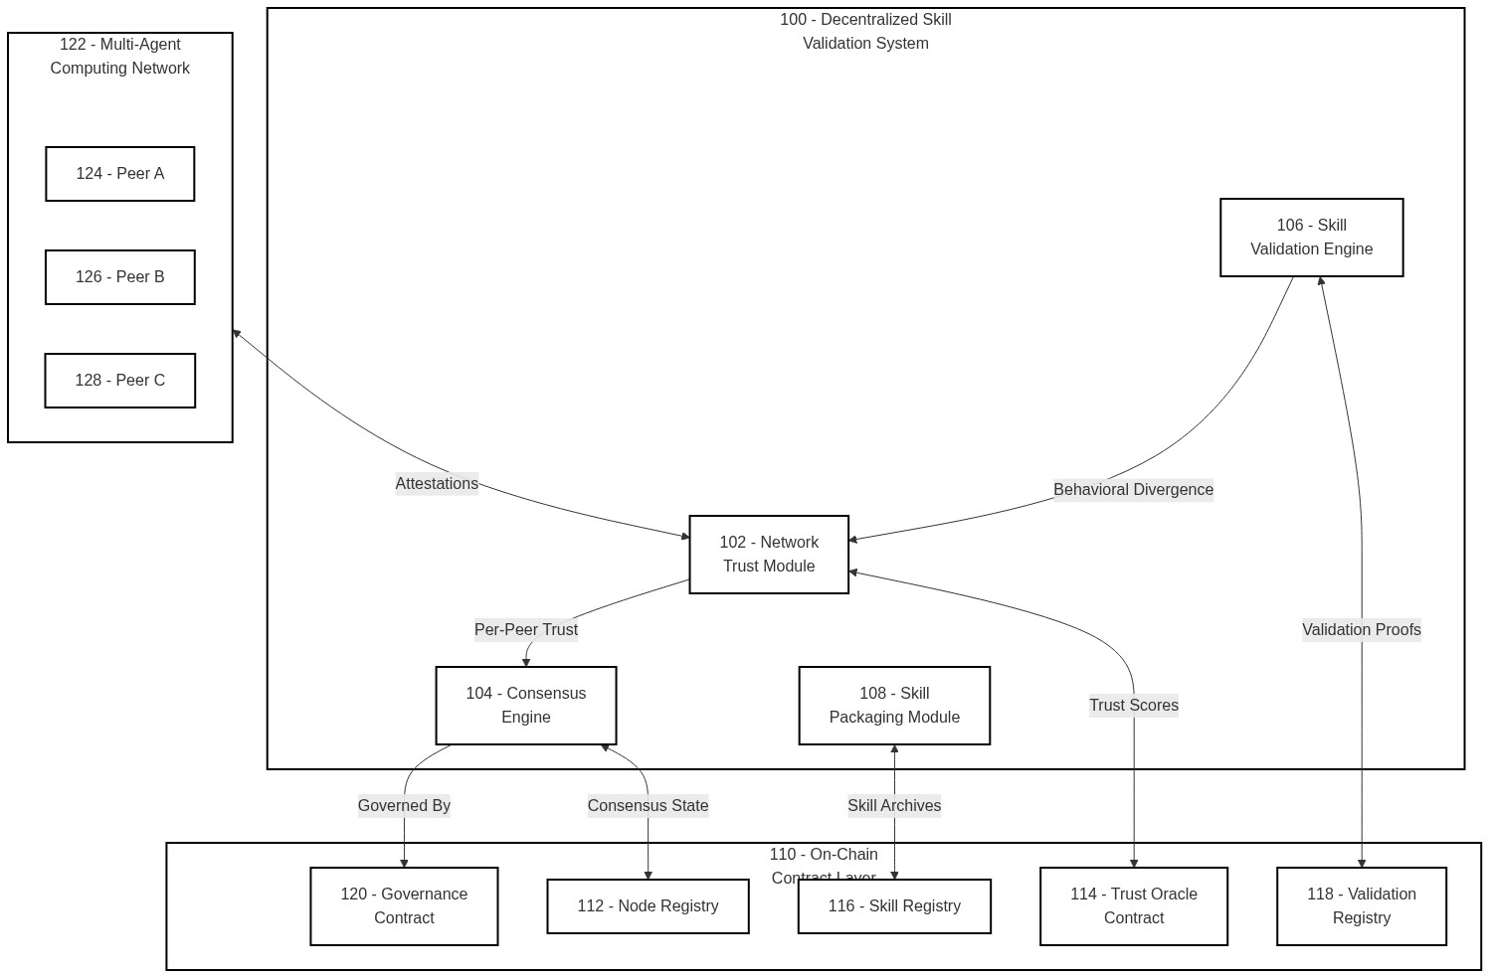

FIG. 2
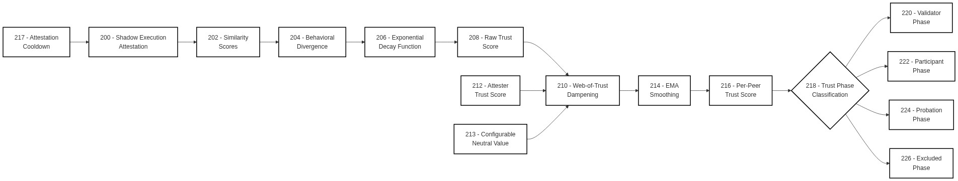

FIG. 3
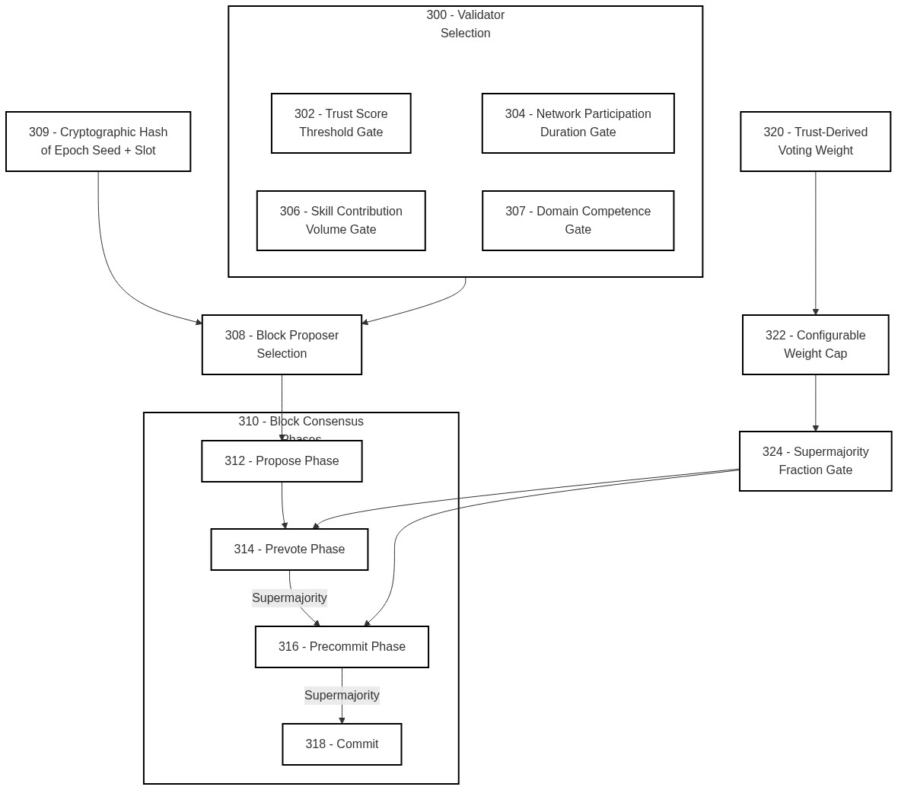

FIG. 4
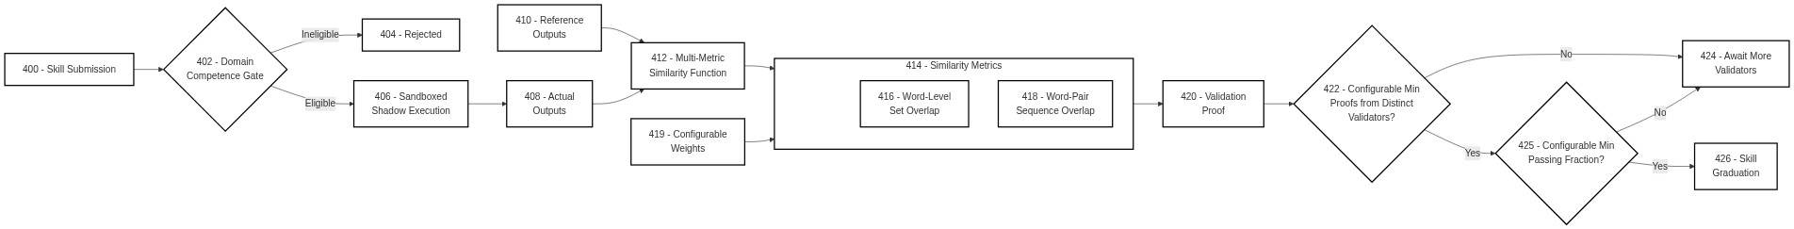

FIG. 5
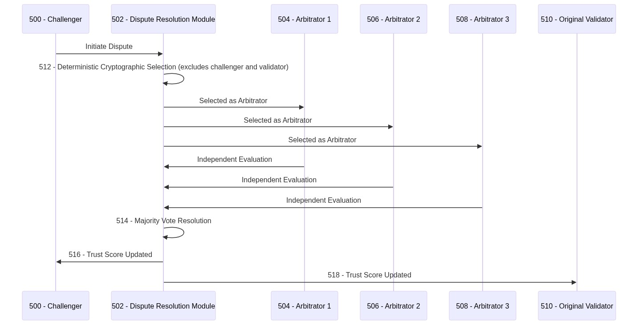

FIG. 6
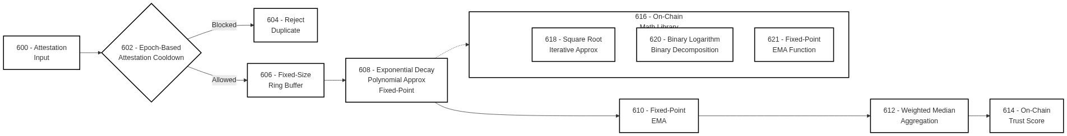

FIG. 7
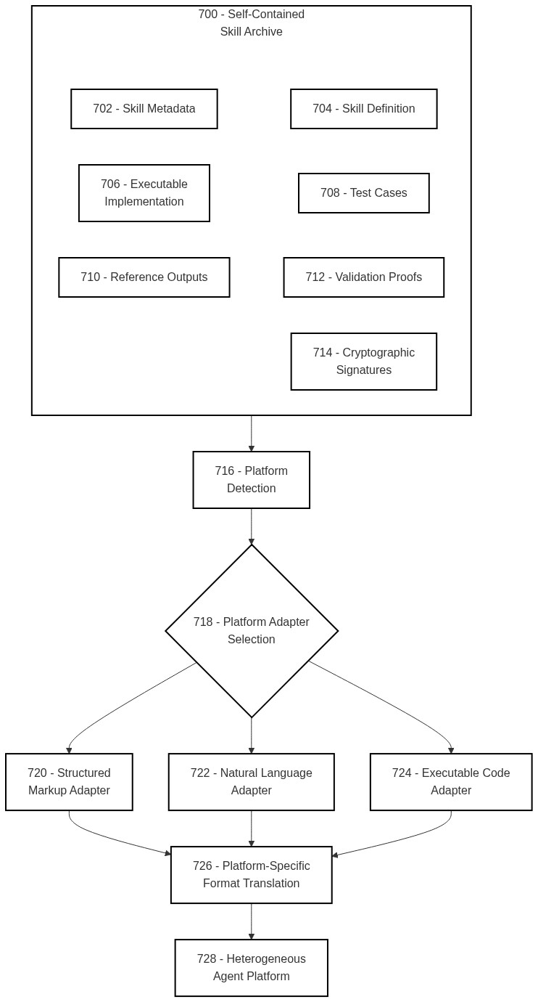

FIG. 8
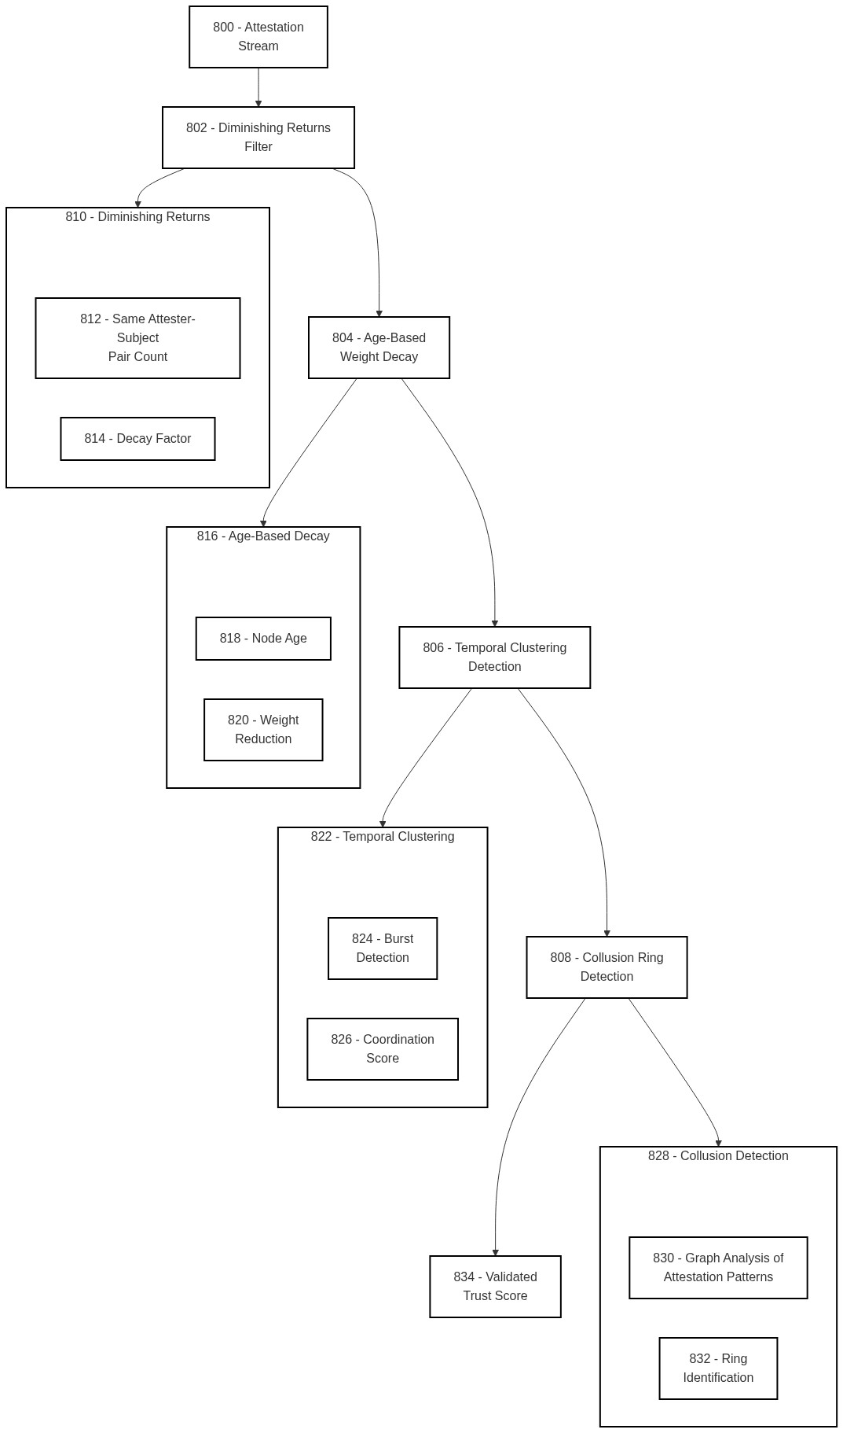

FIG. 9
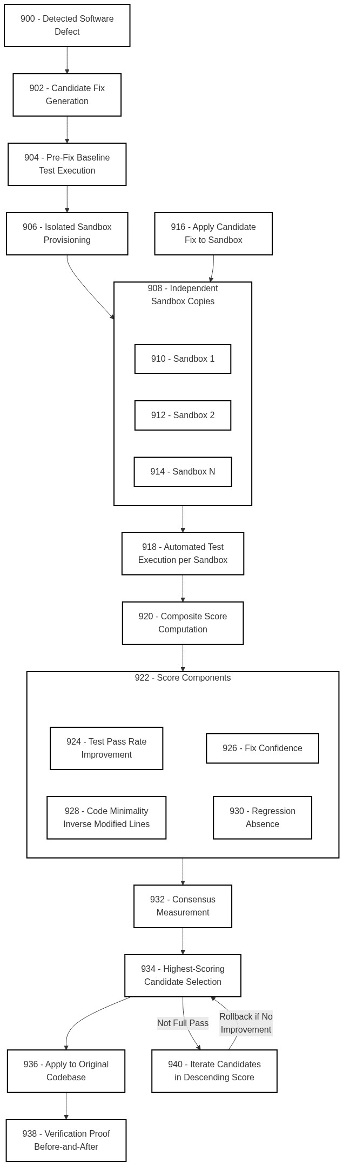

FIG. 10
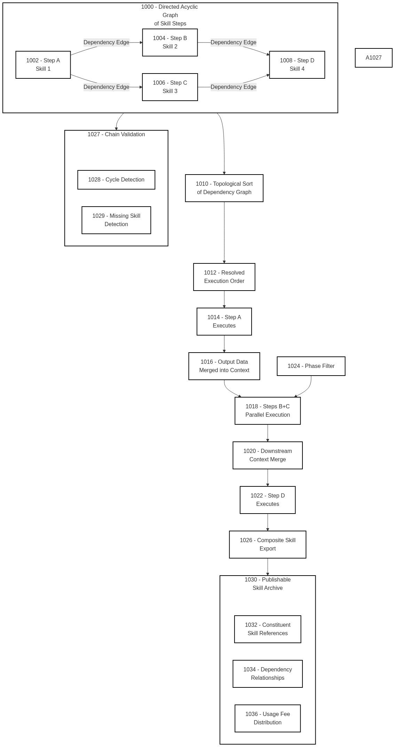

FIG. 11
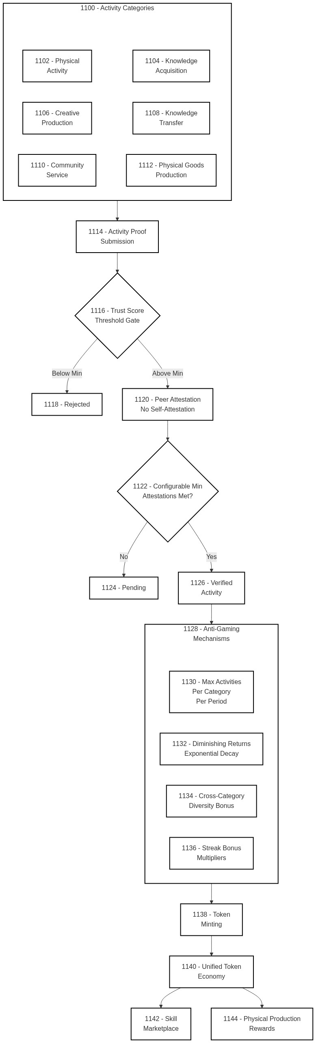

FIG. 12
