**Rainbow Dungeon**

**-The Bloody Cute Dungeon Crawler-**

Created by,

Eric Ellingson, Jacob Braun, Jonathan Lukasik, Stephen Hoffmann

**Table of Contents:__________________________________________________Page Number**

***General Description……………………………………………………………………………………………..…….3***

a.Concept……………………………………………………………………………………………………...3

b.Theme…………………………………………………………………………………………….……..…...3

***Player*………………………………………………………………………………………………....………………....**3

a. Description………………………………………………………………………………………………….3

b. Concept Art…………………………………………………………………………………..……………..4

c. Example Powers…………………………………………………………………………………………...4

d. Controls……………………………………………………………………………….…………………….5

e. Skills…………………………………………………………………………………………...……………6

f. Level System/Progression System……………………………………………………....………………6

***Enemies…………………………………………………………………………………………………..*……………..**6

a. Enemy Goals……………………………………………………………………………………………….6

b. General Enemies…………………………………………………………………………..……………….7

c. Bosses………………………………………………………………………………………..……………..8

d. Concept Art…………………………………………………………………………………………………9

***AI Control System*……………………………………………………………………………………....…………….**9

a. General Overview…...………………………………………………………………………..……………9

b. Attack Styles………………………………………………………………………………………………10

c. Progression Charts………………………………………………….…………………………..……….10

***Store………………………………………………………………………………………………………*…………….**10

a. Weapons…………………………………………………………………………………………………..11

b. Special Weapons…………………………………………………………………………………………11

***Dungeon Creation*……………………………………………………………………………………....…………...**12

a. Description…………………………………………………………………………………....…………..12

b. Level Examples………………………………………………………………………………..………….13

***Loot……………………………………………………………………………………………………….*…………….**13

a. Item Overview………………………………………………………………………………….…………13

b. Drop Table………………………………………………………………………………………………...14

c. Loot Progression………………………………………………………………………………………….14

d. Examples………………………………………………………………………………………………….14

***Sounds……………………………………………………………………………………………………*…………....**16

a.Effects…………………………………………………………………………………………..………….16

b.Music………………………………………………………………………………………………………..16

***Mechanics………………………………………………………………………………………………..*……………**16

a.Player physics………………………………………………………………………………….………….16

b.Enemy Spawn Controller……………………………………………………………………...…………17

c.Loot Spawn Controller...…………………………………………………………………….……………17

d.Inventory Controller…………………………………………………………………………….…………18

**User Interface………………………………………………………………………………………………………….**18

a. Description………………………………………………………………………………………………...18

b. Diagram…………………………………………………………………………………………………….19

**Team Overview…………………………………………………………………………………………….………….**19

**General Description**

***Concept***

Inspired by dungeon crawling games such as “Binding of Isaac” and “Gauntlet”, this 3D, third person action game pits the player against countless floors of challenging enemies and bosses while discovering unique powerups such as a Instruction Manual that insults you at how terrible you are playing this game to a Twenty Sided Dice that rerolls all of your items to completely new ones to constantly evolve how the player fights. It offers insane replayability as two playthroughs are never exactly alike, each floor being randomly generated in this dungeon crawling adventure.

***Theme***

This game takes a huge spin off from the regular fantasy genre many games are associated with, with a theme based around the cute and cuddly facing off against the powers of demons. You play as one such demon set out in this violent, teddy bear slaughtering, fairy murdering, and flower up ripping crusade.

**Player**

***Description***

The player’s appearance is something that will change several times over the course of a playthrough of this game. This change occurs by certain items or powerups, with the overall goal of making the character most badass as possible by the end. At the start of a game the player will start as a small, cute demon, something not very threatening. This demon appearance will become more and more menacing as the player progresses, turning into something you would expect out of a minion from hell.

***Concept Art***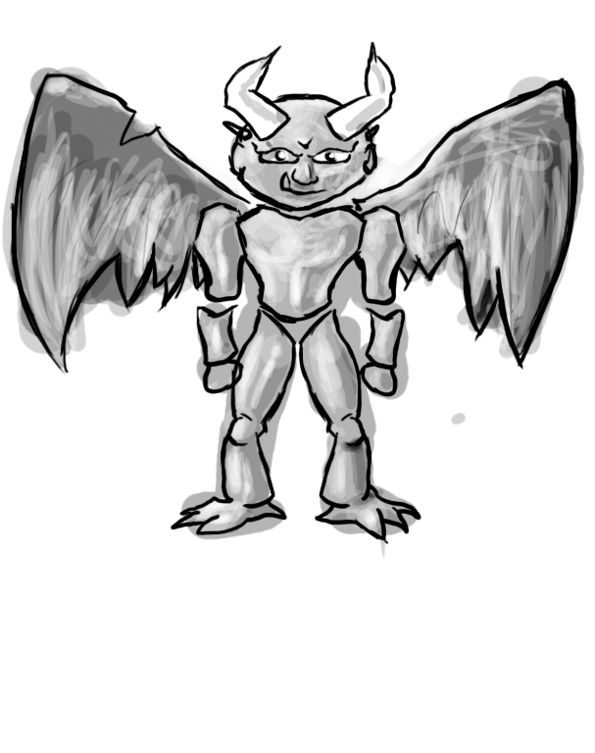

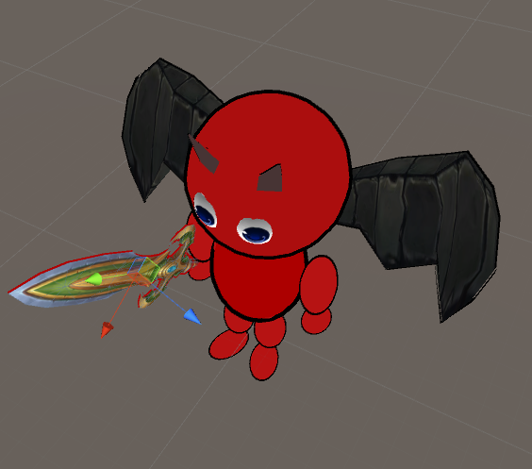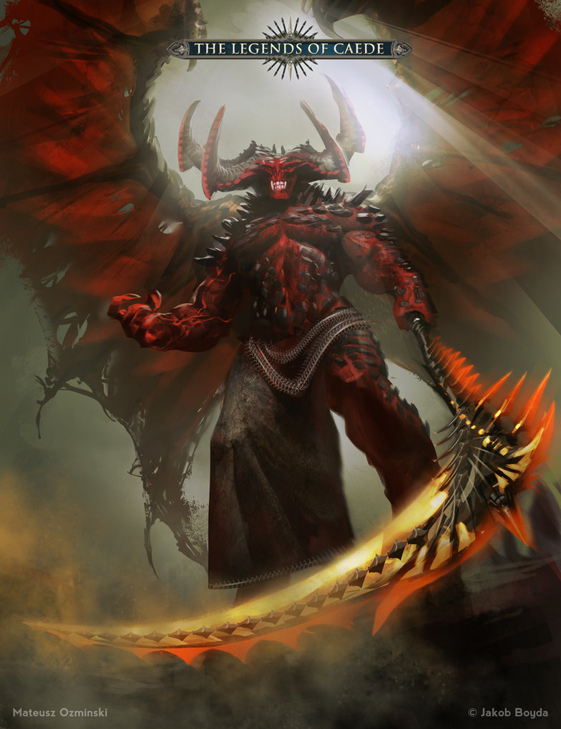

***Example Powers***

Below is a list of abilities granted to the player through various means while playing through the game. Some of these powers come from different items or are effects of said items. Others come in the form of spells that will be added to the player’s equipped spells.

* Powershield
  + The Power Shield provides a damage barrier for the player, absorbing a set amount of damage before shutting off. Higher upgrades of the power shield allow for damage reflection, as well as increasing the total amount absorbed by the shield.
* Curse
  + Transforms enemy into ally temporarily. Allied enemy will turn on his former companions. Ally turns back into enemy at the end of curse. Higher levels of the ability increase duration of curse, boost ally damage, and at highest levels kill ally at the end of duration.
* Traps
  + Allows the player to place down traps, marking a tile of ground on the current map as damaging to enemies, dealing damage, slowing, and weakening them. Upgrades increase the efficacy and size of the trap, affecting multiple tiles and enemies. Traps last until player leaves the room.
* Aoe
  + Area of effect attack, player charges attack and deals damage to any enemy within x amount of distance. Upgrades increase damage, distance, and reduce charge time to unleash attack.

***Controls***

The basic movement of the player will consist of basic WASD directional movement. We will be using numbers one through ten to control the use of abilities and useable items the player collects during the game. Because of this, we will limit the amount of useable skills to ten. There will be a basic attack ability controlled by the mouse’s left click and does not take up one of the player ten useable abilities.



***Skills***

Most skills and abilities will come from the items the player finds in their playthrough. All players start with a basic melee attack, which can be charged to deal extra damage at the cost of time. This charge up drains a small amount from the stamina bar. The player will obtain various useful items such as traps and bombs, different weapons like swords and daggers, and even the chance at magical abilities.

The player will possess four different stats: Health, Stamina, Mana, and Luck. Health dictates how much damage the player can take before they die. Stamina dictates melee oriented fightings like the charge up attack. Mana is in charge of managing magic, and the player will be unable to cast any magical skills if this depletes. Both stamina and mana will regenerate slowly over time, but this regeneration rate can be increased or decreased by various items. The player’s luck will determine a variety of things, such as how many items they can expect to find, and the effectiveness of items with a random chance associated with it.

***Level System/Progression System***

The game has a basic experience and level up system. The player starts at level one, and will go up a level once enough experience has been obtained. There is no cap of how high the player can level up, but it does take more and more experience to level up as your level increases. each time the player levels up they will be awarded a small boost to one of the four main stats, health, mana, stamina, or luck, decided by the player in a separate level up menu.

Experience is obtained is several different ways. The primary way of obtaining experience is by killing monsters and bosses, the stronger the enemy rewarding more experience. Experience can also be granted from certain items the player can obtain as well as from the in game shop.

As the player progresses in levels, their appearance will change to make themselves look stronger. At levels 10 and 20, the player’s appearance will evolve.

**Enemies**

***Enemy Goals***

Challenge to overcome adversities by using a variety of attacking methods which include melee, magic, range, AOE, traps, poison.

***General Enemies***

Following our theme of cute and cuddly, many enemies you face have very adorable outward appearances. Below is a list of some examples you can expect to face as well as a brief description of how they will try to make the player suffer.

* Bunnies - These little balls of white fluff hide a great bloodthirst ready to jump onto their victims, biting with large, vicious teeth.
* Fairies - While being the more innocent of enemies, these spellcasters will harass the player with a variety of control oriented abilities.
* Kittens - Luring the player in as they sit and look cute, they will pounce at the first chance they get, looking for a fresh kill.
* Unicorns - Fast creatures with the intense desire to charge at you, either impaling the player on a unicorn’s horn or trampling over your body.
* Baby Turtles - Slow moving, high health creatures, that while easily avoidable, will bite at the player if they get too close dealing a large amount of damage.
* Flower Creatures - Blending into the scenery, sometimes flowers and various plants will spring to life, assaulting the player with leaves, vines, and all things plant related.
* Cupid's/Little Angels - Powerful ranged attackers experts with the bow and arrow quickly flying away when they sense danger.
* Teddy Bears - A common stuffed animal magically brought to life, but given a need to kill. They often wield simple weapons such as daggers and swords.
* Dolls - A child’s doll magically brought to life. They now wander aimlessly, searching for their lost child and will stop at nothing to fine them.
* Little Clouds - Fluffy and wearing a huge smile, these loot filled clouds float around helplessly, unable to do much as they die and explode with items.

* Possessed Teddy Bear - Demonically empowered teddy bears

***Bosses***

* Fairy Queen - Renowned for her beauty and grace, the fairy queen is one of the most loving and peaceful creatures in all the realms.
* Archangel - One of the most holy beings in existence, the archangel is a fearsome foe.
* Cupid - The god of love and desire. Fires arrows of love that deal serious damage to the player. Can summon flying cherubs to attack the player.
* Rooted Flower - Gigantic sentient plant. It’s root system allows it to attack and entangle the player through the ground, while it’s rose thorn whips viciously flay anyone who comes near.

|  |  |  |  |
| --- | --- | --- | --- |
| Boss Name | Health | Attack Style | Unique Loot |
| Fairy Queen | 1000 | Has a wide arrange of spells at her disposal. Her magic is near endless from multiple styles. She also has the ability to summon forth her subjects to attack the player. | Magic Tomes |
| Archangel | 1250 | Has an extremely high defense level and relentlessly charges the player with swords infused with divine magic. | Angel’s Wings  Holy Water Balloons |
| Cupid | 750 | WIll always stay at ranged, disengaging if brought to melee range of the player. | Cupid’s Heart  Cupid’s Bow |
| Rooted Flower | 900 | Immobile but summons swarms of hostile plant life such as thorns, roots that erupt from the ground, and poisonous gas. | Four Leaf Clover |

***Concept Art***

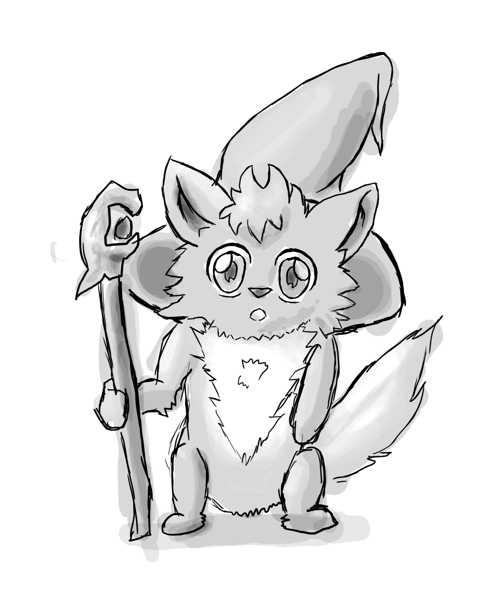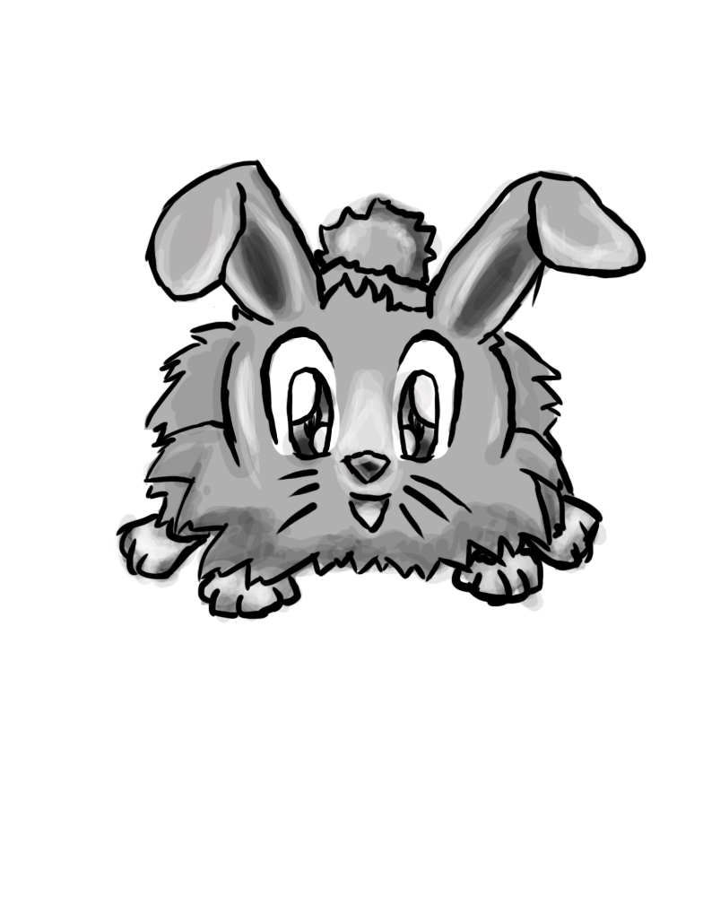

**AI Control System**

***General Overview***

Most enemies follow a simplistic goal of simply wanting to kill the player. They use their prefered style of attack, such as a melee style enemy using a sword. Higher level enemies and boss level enemies will follow a more advanced AI, such as using a variety of skills based on their current situation.

***Attack Styles***

In general, there is two styles of enemies: melee and ranged. Melee enemies will try to find the most direct route to the player, charging in as best they are able. Basic melee enemies will not possess much beyond this, and can be easily dispatched by kiting them around a room and using ranged attacks. Ranged enemies will be trying to keep their maximum distance from you at all times, becoming difficult to confront but not as scary of an enemy comparatively. Starting a few levels in, some enemies will inherit from both ranged and melee styles, usually affected by their available abilities.

Each boss will follow their own unique AI, usually involving scripts based on various situations. They all possess different abilities and attack styles an example being a boss charging at you, gaining more speed the longer they are charging, and then leaping back to disengage from the player once they make contact to make use of a ranged ability in combination with their charge ability.

***Progression Charts***

**Store:**

Sells 5 classes of each weapon type.

* Weapon varieties:
  + Regular - Normal class of weapon. Available to replace lost or currently unfound weapons
  + Fire - Adds damage to base weapon strike, may spread to adjacent enemies
  + Ice - Cumulative slow to enemies struck by ice weapon.
  + Electric - Moderate chance of stun with each strike
  + Sharp - Adds bleeding effect to strike. Deals damage over time.
* Buy consumables
  + Potions, health / energy
  + Ammunition for ranged weapons (arrows / javelins)
* Upgrades possibly
  + Random power up available for purchase, rolls on same drop table as other rooms, so almost anything is possible. Usually expensive.
  + Player uses a monster drop to teleport to store.
  + Can sell stuff for currency (souls)
  + Buy level, expensive.

***Weapons***

* Swords
  + Base weapon for the main character. Swings in an arc in front of the player character. Average base damage, average range of attack, average swing speed.
* Bow
  + Secondary weapon pickup for player. Fires directly forward. Lower base damage, but faster firing speed. Hold down secondary attack button to charge shot, dealing more damage and increasing width of attack.
* Spear
  + Secondary weapon pickup for player. Wider attack line compared to bow, but slower firing speed. High base damage, but cannot be charged.

***Special Weapons***

* Flame Sword
  + Advanced weapon pickup available for player. Wider arc of attack compared to regular sword. Slightly greater base damage, with a small chance to set enemy on fire, dealing damage over time. Average swing speed.
* Freeze Sword
  + Freezes enemies temporarily
* Dark Bow
  + Does damage over time, like poison.
* Explosion Spear
  + Causes explosion impact dealing massive damage with a change to blow the enemy into pieces
* Lighting blade
  + Chain damage with up to 3 enemies
* Rail Action Crossbow,
  + High impact damage that rips through enemies allowing multi kills with one shot.

**Level Design**

***Description***

At the start of the game and at the end of each level, the next level of the dungeon is generated. A variety of different pre constructed rooms are connected together. Afterwards doors, enemies, and enemy spawners are added to finish the level. This is all done before the player is actually put into the dungeon. This is done so the dungeon flows smoothly and removing the load time between each room as you would commonly find in many other games. Each level in the dungeon will be between ten and twenty rooms in size with a boss at the end of each level.

***Level Examples***



**Loot**

***Item overview***

Items are divided into 4 distinct categories: Consumables, which consist of health, energy, and other attribute boosting / restoring potions, and bombs. Consumables are stored in the inventory when picked up, and are used by pressing the assigned key. Weapons, which are upgrades and additional attack modes available to the player, such as swords, axes, bows, javelins, and magical abilities. Currency, called Souls, is dropped from most enemies which can be spent at shops to buy most common items, and select rare items. Miscellaneous items, such as familiars which follow the player around providing passive bonuses (or penalties) and other passive equippable items that provide new abilities. In addition there will be a boss loot table, items from the previous 4 categories with boosted effects only available from select bosses.

***Drop table***

Most enemies share a universal loot table of items that can drop when defeated. More powerful items will have a lower chance of dropping, but theoretically any item can drop from any enemy (minus boss items). Stronger enemies have a better chance of dropping more and better loot. Finally, bosses have inherit the universal boss table, with an additional boosted chance of dropping specific boss loot, which is much more powerful (and rare).

***Loot progression***

Loot is completely based on weights on a hidden loot table. Most items will be on one table, each having their own weights of how likely you are to receive that particular item when an item drops. This loot table will be attached to all enemies and bosses in the game. These weights however are modified by the player’s luck stat, with stronger items having a better chance of dropping with a high luck value and vice versa with having a very low luck value, more items with negative effects will drop. If the player is lucky enough, then they can obtain very strong items very early on although unlikely.

Bosses add to the general loot table with unique items only available from that boss. These items have a much greater weight on the loot table then any other item. In practice, the player will receive these unique items more often than items off the general loot table, but the chance still exists for the opposite to happen.

***Examples***

Below is a list of ideas of a variety of items that can appear in the game.

* Instruction Manual - Literally just tells you how to play the game while telling you you are shit at playing the game, can’t get rid of it. Messages (usually insulting) pop up randomly or by doing certain action (Killing monster, opening doors, etc.)
* D20 - rerolls all items you have on you to a new random item based on the player’s luck.
* The Stuffed Teddy Bear - A stuffed teddy bear of one of your kills (from a teddy bear), enrages other teddy bears at this sight, making you take more dmg and deal more damage to teddy bears, and yes, you the player are cuddling it till you get rid of it.
* Four Leaf Clover - GREATLY increases your luck.
* Happy Sun Sticker - Makes you feel happy, increasing your health.
* Teleporter - Randomly moves you to another location on the same level.
* Unicorn’s Head - Helmet (An actual unicorn’s head) that allows you to charge an enemy.
* Cupid’s Heart - Ripped from Cupid himself (as a boss drop?), heals you fully.
* Cupid’s Bow and Arrow - Ranged bow, or increases your current ranged weapon dmg/range.
* Bombs - Because who doesn’t want to violently explode everything cute and adorable?
* Dead Cat - Drag it behind you, gaining an extra life.
* Dessert - Massive ice cream sundae treat, healing you.
* Deal with the Devil - Sacrifices health for increased power.
* Angel’s Wings - Torn from an Angel, lets you temporarily fly/hover.
* Chest of loot- Awards one item from the general loot table
* Holy water balloons - Balloons filled with holy water, damaging everything hit, including you, and leaves a puddle of holy water on the ground.
* Dunce Cap - A classic dunce cap, demoralizing the player and reducing damage done.

* Ritual Binding - A demonic ritual that resets the player back to level one, and removing all stats gained by leveling up. However for every level removed in this way, an item will be awarded to the player from the general loot table.
* Lego Blocks - As soon as this item is obtain, it fills several rooms with damaging spikes. All enemies and the player are affected by this.
* Nerf Sword - Grants the player a foam sword, reducing player damage significantly
* Butter Fingers - All items such as Bombs and Holy Water Balloons that the player is holid are instantly dropped and activated.
* Karma - As long as the player is holding this item, the player takes more damage from attacks the more enemies they have killed.
* Conscience - Familiar follows player around, healing everything around it slowly, enemies included.
* Evil Twin - A enemy identical to the player, stats, health, abilities, is spawned in the room. This enemy inversely mimics the player’s key input.
* Anime eyes - Temporarily blinds the player, severely reducing visibility.

**Sounds**

***Sound Effects***

The goal is to create enough sound effects that cover all player actions such as move, attack, and take damage. This also goes for the enemies. There will also be special sound effects to players teleporting to store, and special weapons, and possibly taunts.

***Music***

The will be a Menu track, and a couple background tracks for the levels, and a boss track, death track. The goal will be to have cheerful upbeat background music.

**Mechanics**

***Player physics***

General movement will be accomplished using x,z transform manipulation using speed and time as the variables .

Collisions will go off two collision boxes.

a.Hitbox: Hitbox will be used to detect damage from enemies and stop movement when colliding with walls.

b.Attack Box: This will be used to deal damage to enemies and will only be activate when the player is actively engaged in an attack.

Animations: The base animations will consist of Idle, Move, Attacks, Spells, and teleport.

Using Unity’s Crossfade the animation will automatically smooth together.

***Enemy Spawn Controller***

When each room is created the spawn controller will general a number of random enemies from an array using an indicated range of numbers. Depending on the floor level, high level monsters will have a chance to spawn.

***Loot Spawn Controller***

Upon enemy death the Loot Spawn Script class will be called which contains an array with all the items upon it. The script will basically choose a drop based on rarity and player luck. The bosses will inherit this Script and include an additional variety of boss drops.

***Inventory Controller***



**User Interface**

***Description***

The UI will consist of a sizable health and mana bar, Level Counter, Soul Counter, Pause Button, Hotbar for inventory to correspond to the number keys to use. The hot key will also have a swap function to reorder the keys. In addition, if a player has a store teleport a clickable UI button will become available to activate the spell.

The pause/menu button will as bring up the players equipable inventory screen to allow changes in equipment. Along with this will be a restart, and quit button.

***UI DIAGRAM***



**Team Overview**

**Eric:** Will be assisting in the creation of game levels and overall balance of the game. Will assist where needed in the creation of items, powers, and enemies.

**Jonathan:** Will be primarily responsible for the animation of the game. Will also assist in the production of models and programming of the game. All the animations and models will be created using Maya.

**Jacob:** Will primarily be responsible for quality testing of art assets, balance, and testing of the game. Will also be keeping record of revisions, additions, and bugs as the game is developed.

**Stephen Hoffmann:** Will create nearly all the Art, Models, and sound tracks for the game. Will be assisting programmers, and help with animation. Will be using tools like Maya, Photoshop, Sonar Music Suite, and Unity to complete goals.