Problem Statement:
Design a scheduling system for a university similar to LeopardWeb. The system will allow students, faculty, and an admin (such as the registrar) to add courses, search for courses, print schedules, etc.
Requirements Engineering
- Feasibility Study:
- Does the technology exist needed to create the system – yes. We need classes and objects, a database, and a graphical user interface.
- Does it fit in the budget? – Yes.

Conclusion: The project is feasible, and we can continue.

- Requirements Elicitation
- We have examined past systems such as the existing LeopardWeb. From this, the requirements are:
  - Database of users: the system should work for 100 students, 10 instructors, and 1 admin, however, we will test with fewer.
  - Database of courses: this will contain information such as the CRN, course name, times, and instructor.
  - Three types of users:
    - Student – can register, can see available courses and their own schedule.
    - Instructor – can see available courses and their own course roster.
    - Admin – can see everything, can edit courses/users/schedules.
  - The system should include multiple semesters, print-out of schedule, scheduling preferences.
  - The system as a whole and all components must be tested thoroughly.
- Specification from users/customers:
  - The base class of the system is user with:
    - Attributes: first name, last name, and ID#
    - Methods: set function for each attribute, and a function to print all info for the object
  - There will be three derived classes:
    - All derived classes must contain any additional attributes and appropriate set/get functions.
    - Student – the student class will have functions that allow them to search courses, add/drop courses, and print their schedule.
    - Instructor – the instructor class will have functions that allow them to print their schedule, print their class list, and search for courses.
    - Admin – the admin class will have function that allow them to add courses to the system, remove courses from the system, add/remove users, add/remove students from a course, search and print rosters and courses.

- Requirements Specifications
- All users should be able to login to LeopardWeb with their username and password and see their information.
  - Set users first name using data from database table.
  - Set users last name using data from database table.
  - Set user ID# using data from database table.
  - Set academic profession based on database information.
  - Display all user info to the user on the GUI.
- All students should be able to view courses and manage which courses they want to take.
  - Search the course catalog for a specific course.
  - Add a course to their course schedule.
  - Remove a course from their course schedule.
  - Print their course schedule on the software.
- All Instructors should be able to view the list of classes they are teaching, their weekly schedule, and they should be able to browse the course catalog.
  - Search the course catalog for a specific course.
  - Display the list of classes they are teaching on the GUI.
  - Display their weekly schedule on the GUI.
- All admins should be able to manage everything about the system.
  - Add new courses to the course catalog in the system.
  - Remove courses from the system’s course catalog.
  - Add new users to the system database.
  - Remove users from the system database.
  - Add a student to a course in the catalog.
  - Remove a student from a course in the catalog.
  - Search the course catalog for the roster of a course.
  - Search the course catalog for a specific course.
  - Print out the roster for a specific course.
  - Print out all courses in the course catalog.
Design and Implementation
- Architectural Design – high-level components: classes and objects, functions, database, and Graphic User Interface.
- Interface Design – The user login information will have the program assign the user into one of the classes. Based on the class the user is in, they will be able to use different functions. Each class will pull from information from the database. Queries will be used to access the database and pull information from it.
- Component Design – Classes: user class (base class); derived classes: student, instructor, and admin. User Interface will be graphical, will have dropdowns and search boxes to input and search for information.
- Database Design

Users Table – first name, last name, WIT ID, occupation

Courses Table – Instructor, Course #, name, Department, Section #

Software Validation
- Component Testing – test the individual components as they are being built.
- System Testing – Test the system after each individual component after they are integrated.
- Acceptance Testing – Test the final system with “real” data.

Software Evolution
Modify the system based on changing user needs over time or any bugs found.

Waterfall Model
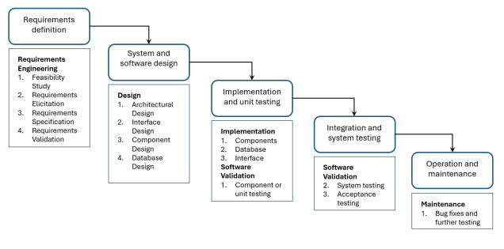
Incremental Model

1st Version – Create the classes, objects, and functions, and make sure they are properly functioning. (Week 1)

2nd Version – Create the database and make sure all classes, objects, and classes can access and query the database to get relevant information. (Week 2 – 3)

3rd Version – Design the GUI for the program and integrate the code into it. At the end of Week 8 the GUI should be complete and functional. (Week 4 – 8)

4th Version – Test the code to make sure all requirements are satisfied, and no bugs are occurring. Add in any additional requirements decided upon by the group. (Week 9 – 11)

Final Version – Resolve any bugs that occur during beta testing and make sure any additional features added are functioning properly. (Week 12 – 14)

Integrate and Configure Model
Integrate an API so that the program would be able to send an Instructors schedule to their outlook.
- Integrate Microsoft Graph Python SDK into Python so that is has the capabilities to send emails
- Python has a local library called smtplib which can also be used to access outlook to send emails.
  - Requires POP/IMAP/SMTP to be enabled in Outlook

Part 2:
GitHub Repo Link: https://github.com/Jmachado2005/LeopardWeb-Assignment-APC

Comments:

