Justino Almazan

Alberto Espinoza

ECE 366

Project 4 MIPS simulator

Fall 2018

Here is proof that the 1st sample works:

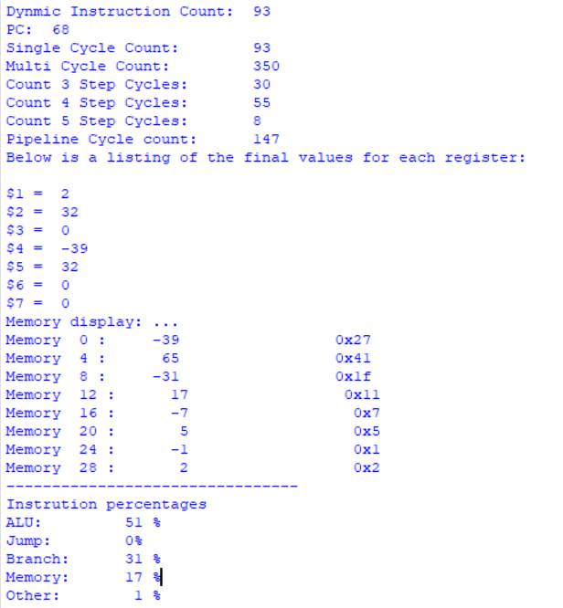

Here is proof that the 2nd sample works:

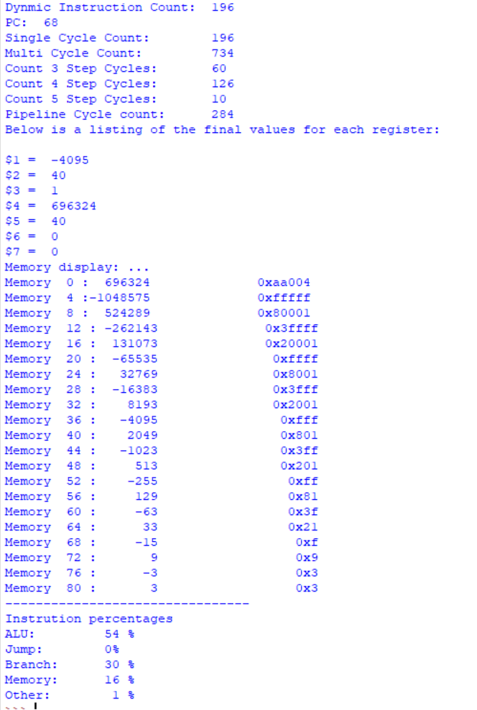

Here is proof that the 3rd sample works:

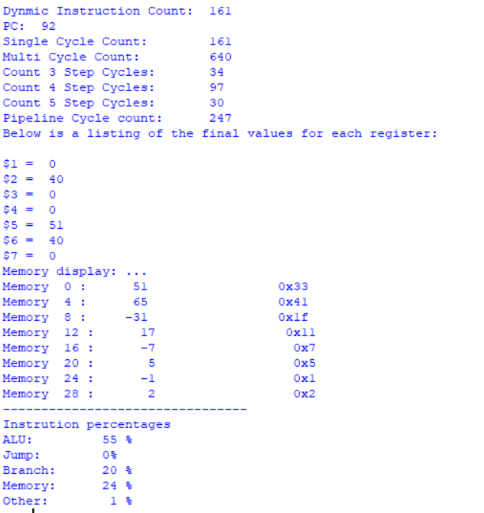

Here is proof that the 4th sample works:

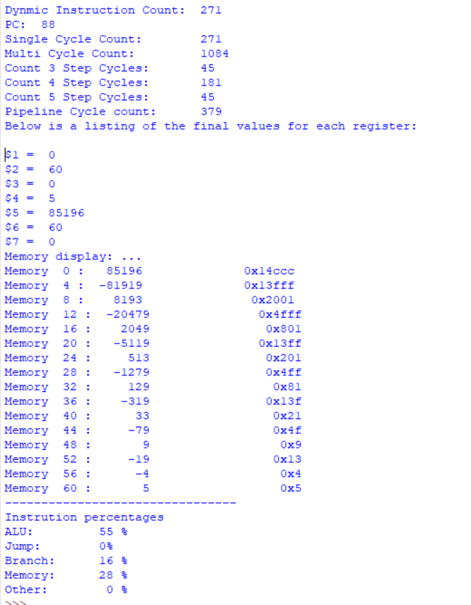

An image of some instruction by instruction info that was important in helping us debug:

