**Homework Assignment #3 - Math 290.2**

**Group Members**:

* James Mancuso
* Christian G.
* Michael Velez

1. Individual write-ups uploaded to google sheets.

create table qcmath290.public."2018_Yellow_Taxi_Trip_Data_gz"(

"vendorID" bigint,

"tpep_pickup_datetime" varchar,

"tpep_dropoff_datetime" varchar,

"passenger_count" bigint,

"trip_distance" float8,

"PULocationID" bigint,

"DOLocationID" bigint,

"ratecodeID" bigint,

"store_and_fwd_flag" varchar,

"payment_type" bigint,

"fare_amount" float8,

"extra" float8,

"mta_tax" float8,

"improvement_surcharge" float8,

"tip_amount" float8,

"tolls_amount" float8,

"total_amount" float8);

copy yellow_taxi_trip_data(

vendorid,

tpep_pickup_datetime,

tpep_dropoff_datetime,

passenger_count,

trip_distance,

ratecodeid,

store_and_fwd_flag,

pulocationid,

dolocationid,

payment_type,

fare_amount,

extra,

mta_tax,

tip_amount,

tolls_amount,

improvement_surcharge,

total_amount)

from program 'cmd /c "type D:\Downloads\2018_Yellow_Taxi_Trip_Data.csv"' delimiter ',' csv header;

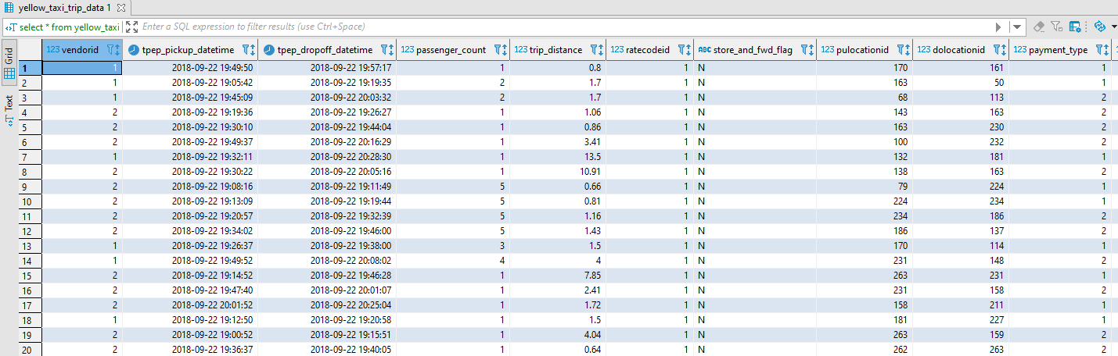

select count(*) as observation_count from yellow_taxi_trip_data yttd

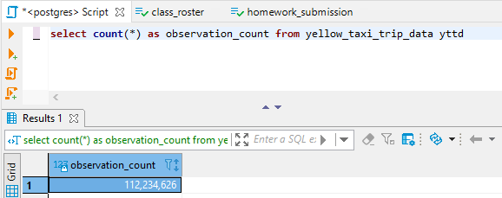

select count(distinct "vendorid") from yellow_taxi_trip_data yttd

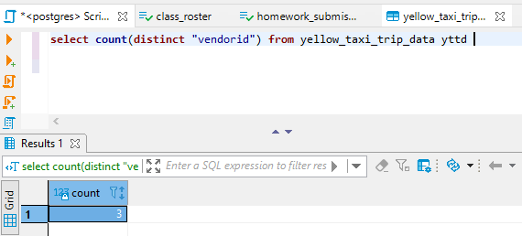

* This would **not** be a good candidate for a primary key because there are 3 unique values within the attribute of a dataset that contains over 112 million tuples.