Texture analysis data summary:
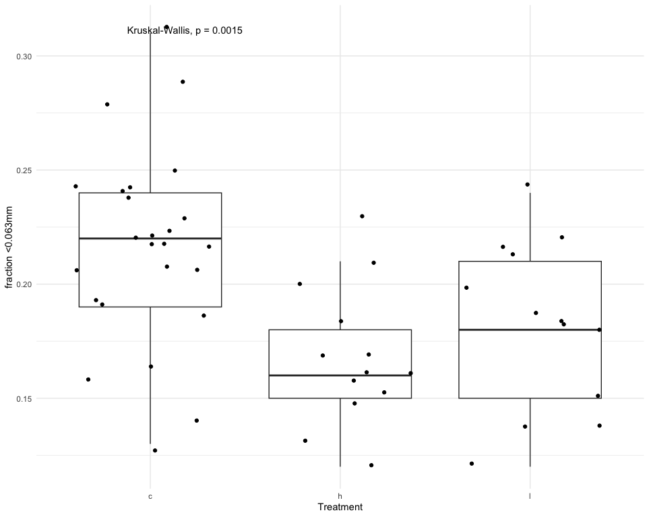
Using the Kruskal-Wallis test, control treatments contained a significantly (p=.0015) higher fraction of fine sediments (<0.063mm) than treatments with high or low P/A. This could be due to the high mobility of larger sediments (shell fragments) found on top layer of control plots. See below.

No significant difference between treatment types for fraction of sediment sizes ranging 0.063mm to 2mm. See below.
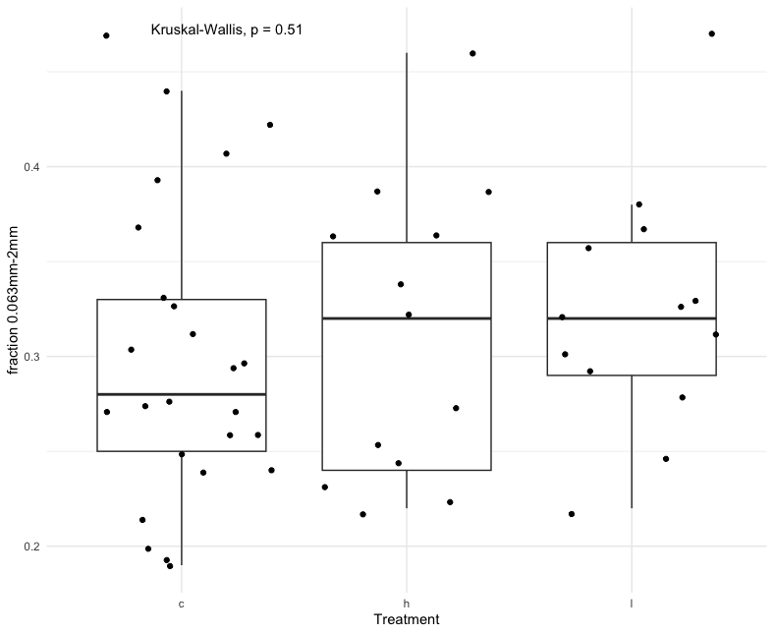
High and low P/A treatments contained a significantly higher (p=0.017) fraction of sediments/shell fragments ranging from 2mm to 6mm than controls. Possibly due to oysters attenuating waves and allowing for accretion and trapping of shell fragments in this size class. See below.
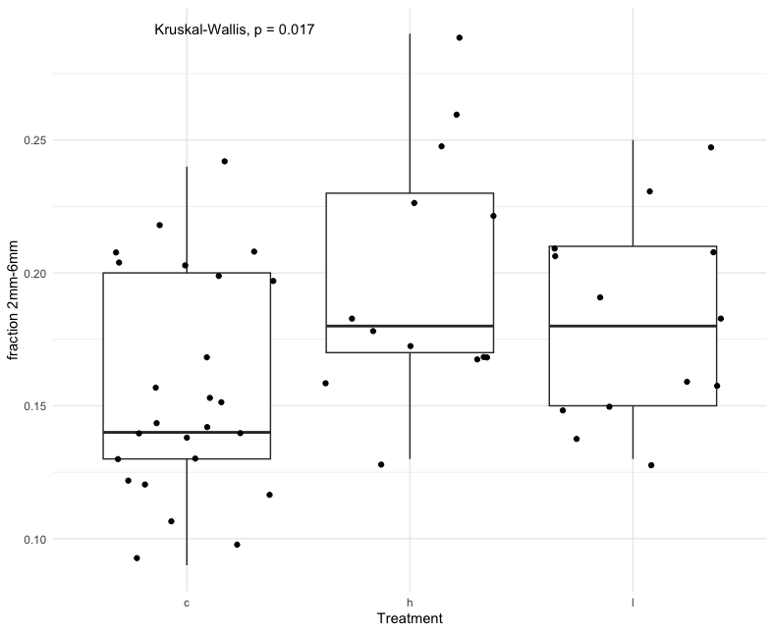
No significant difference between treatment types for fraction of sediments larger than 6mm. See below.
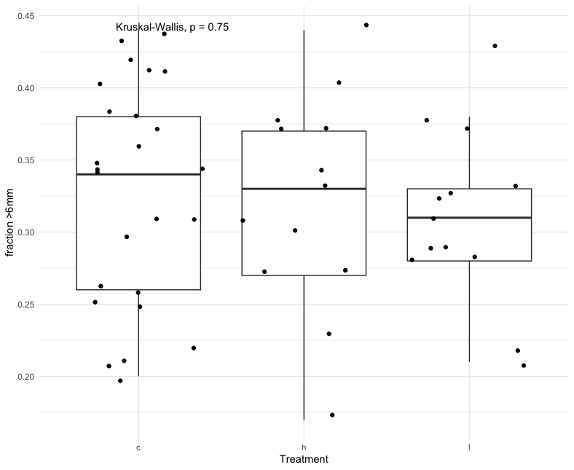

Isotopic analysis data summary:
Control treatment contained a borderline significantly higher (p=0.044) fraction of total organic carbon TOC. See below.
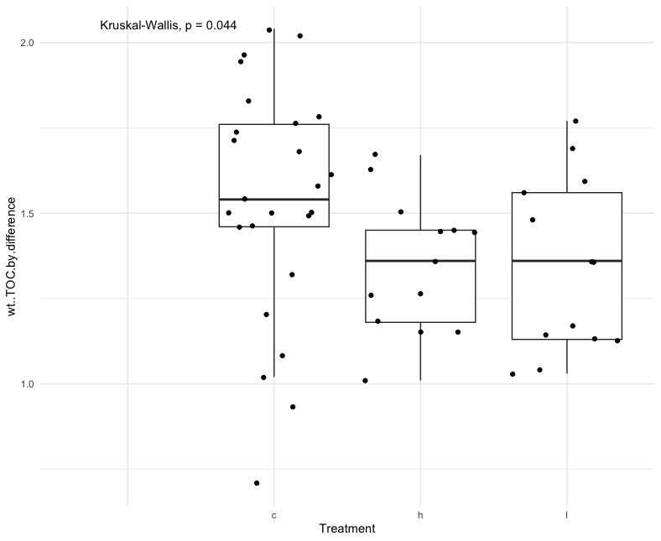
No significant difference between treatments for total inorganic carbon TIC. See below.
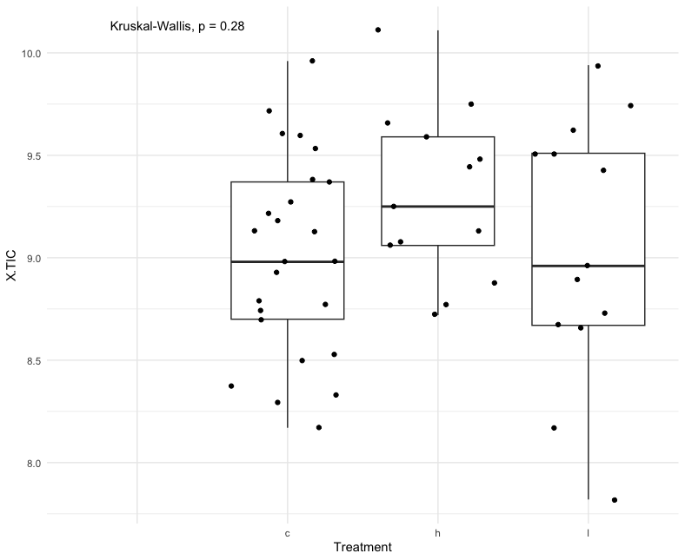

No significant difference between treatments for total inorganic carbon CaCO₃. See below.
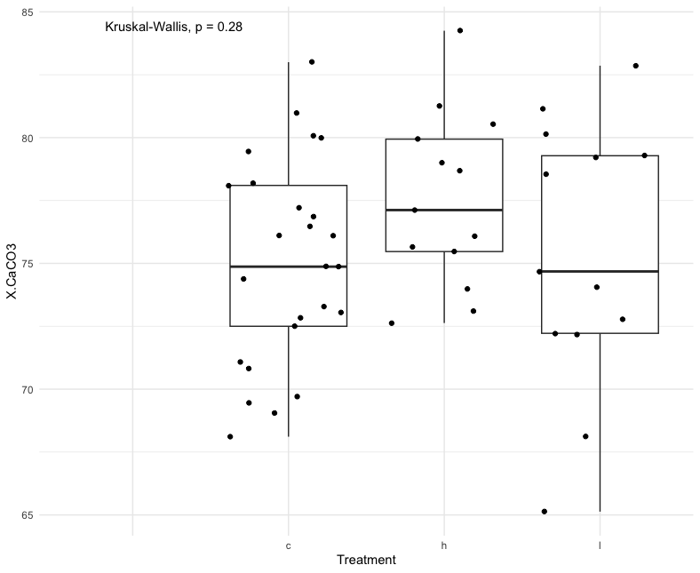
No significant difference between treatments for total nitrogen N. See below.

