Texture analysis data summary:
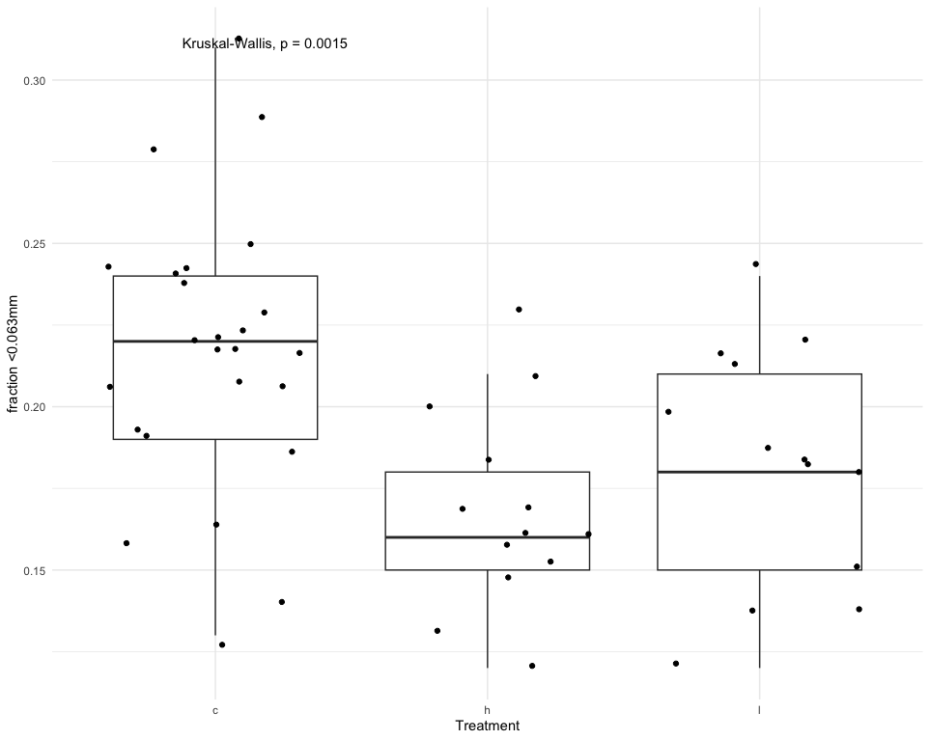
Using the Kruskal-Wallis test, control treatments (C) correlate with a significantly (p=.0015) higher fraction of fine sediments (<0.063mm) than treatments with high (H) or low (L) heterogeneity. See below.

No significant difference between treatment types for fraction of sediment sizes ranging 0.063mm to 2mm.
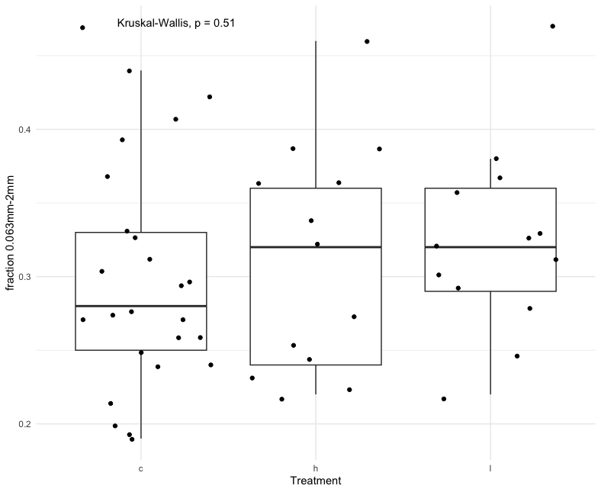
H and L treatments correlate with a significantly higher (p=0.017) fraction of sediments/shell fragments ranging from 2mm to 6mm than controls.
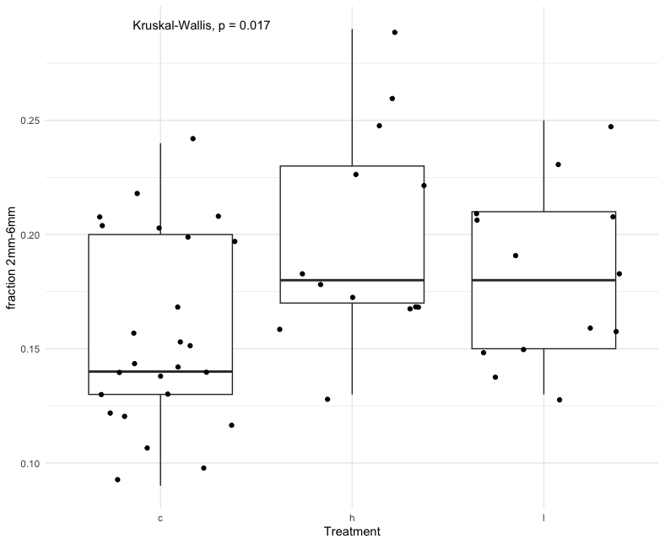
No significant difference between treatment types for fraction of sediments larger than 6mm. See below.
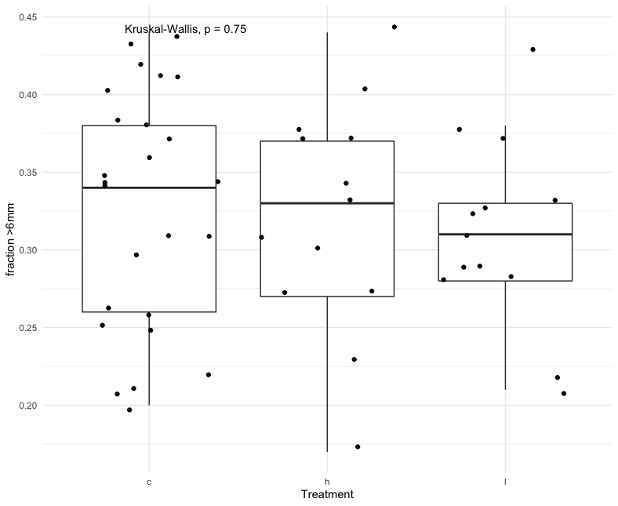

Mass spec analysis data summary:
Control treatments are correlated with a “borderline” significantly higher (p=0.044) fraction of total organic carbon TOC. See below.
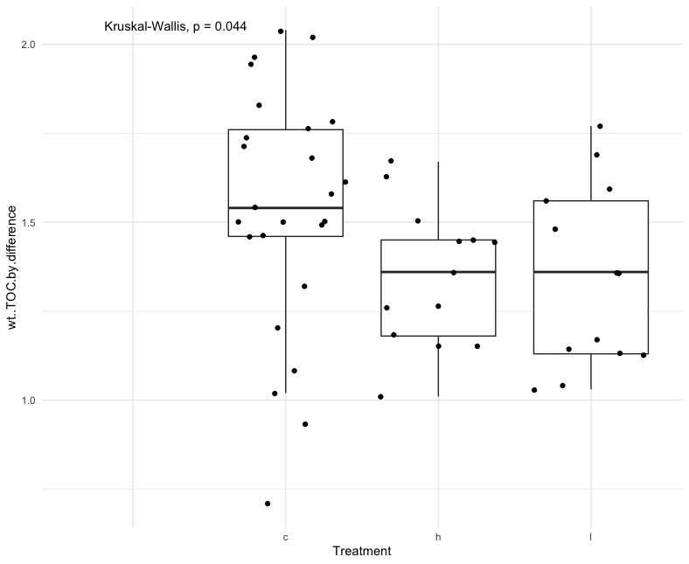
No significant difference between treatments for total inorganic carbon TIC. See below.
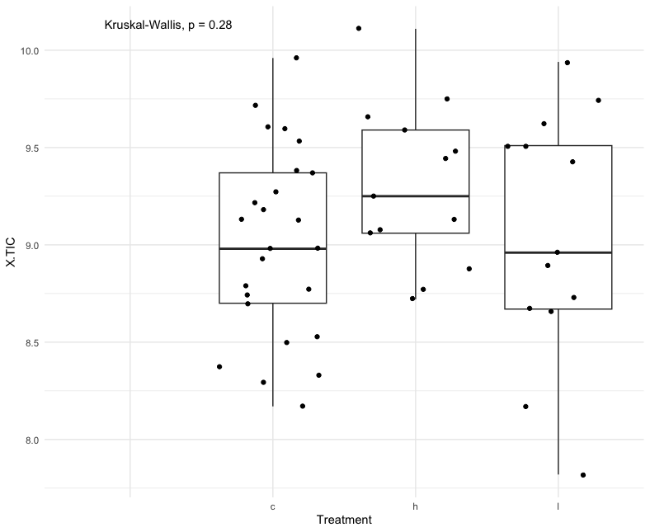

No significant difference between treatments for CaCO₃. See below.
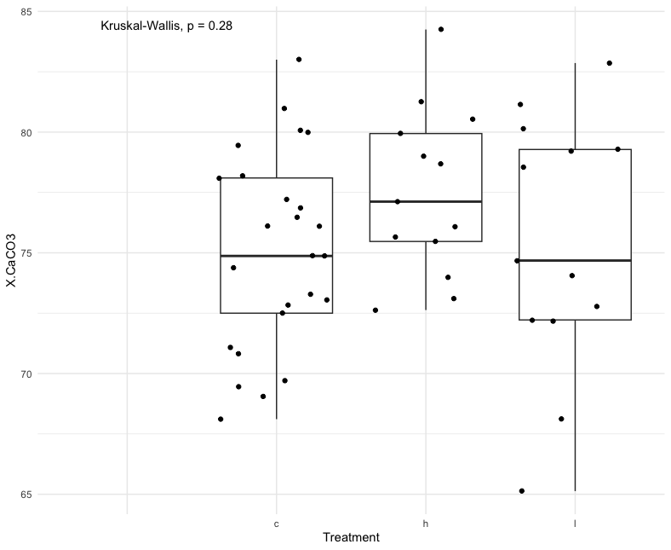
No significant difference between treatments for total nitrogen N. See below.

