Module 3 Assignment Jeremy Mastrodomenico
- Select a Dataset:
  - Choose a small, accessible dataset on a topic you’re interested in. It could be about topics like climate data, health statistics, tech trends, or sports. Ensure that the dataset has a few columns for interactivity (e.g., categories, dates, numerical values).
  - You can find datasets on Kaggle, data.gov, or other public sources.
- Set Up Streamlit and Load Your Dataset:
  - Install Streamlit and load your dataset into a Streamlit app. Start by displaying the dataset in a simple, readable format using Streamlit’s st.write() or st.dataframe() functions.
  - Include introductory text describing the dataset and its purpose to give users context.
- Add Basic Interactive Features:
  - Leverage Streamlit’s interactive components to help users interact with the data. Consider using dropdown menus, sliders, or checkboxes to enhance the exploration experience. Incorporate at least two interactive features in your app. For example:
    - Dropdown Menu: Allow users to filter the data by selecting specific categories or variables.
    - Slider: Enable filtering based on a numerical range, such as dates or score limits.
    - Checkbox: Provide toggles to show or hide certain data features or subsets.
Use ChatGPT if you need assistance learning how to implement these interactive features effectively.
- Enhance the User Experience:
  - Structure your app in a way that guides users through the interaction:
    - Begin with an introduction to the dataset and its purpose.
    - Follow with the data exploration features, clearly organized and easy to navigate.
    - Conclude with summary statistics, key insights, or visualizations to provide useful feedback from the interaction.
    - Use headings and instructions to make each step intuitive, and place guidance next to the interactive elements to clarify their functionality.
- Reflect on ChatGPT’s Assistance and Design Choices:
  - Write 1–2 sentences on how you used ChatGPT to help with specific Streamlit components. Did it suggest helpful widgets or layout ideas?
  - Write another 2–3 sentences on why you chose the specific interactive elements and how they make the data more accessible or useful to the user.

- Dataset - https://www.kaggle.com/datasets/abhishek14398/salary-dataset-simple-linear-regression

- Streamlit app - https://module3py.streamlit.app/
Screenshot:
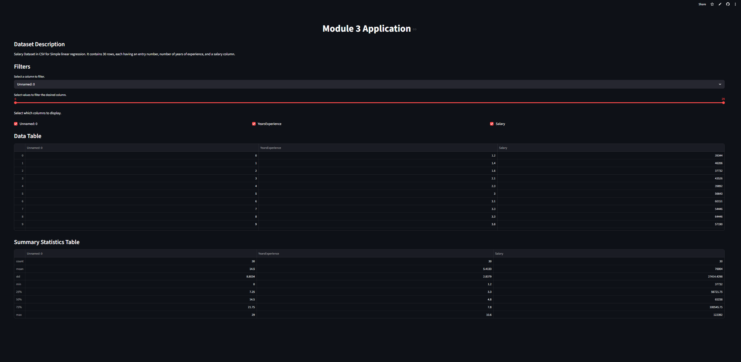
*I shrank my chrome view to 50% capture the whole app in one snippet*

- Features -
  - Dropdown menu – select column with which to filter values
  - Slider – enables numerical filtering based on column selected in dropdown menu
  - Checkbox – toggles the ability to view certain columns in the data table view

- User Experience –
The dataset is automatically attached to the web app, and the dataset is given a description at the top immediately following the title. Next are the data filtering options (dropdown, slider, checkboxes) available to the user. Lastly the unaltered data table and summary statistics tables appear in descending order on the page. Each component has its own title and each filter has a short description of its functionality.

- ChatGPT Assitance –
  - Streamlit Assitance –
I utilized ChatGPT to help structure & format the web-app components & sync the filter functionality to both tables. One optimization that was suggested was to use float() instead of int() for the slider to improve precision. Another optimization given was to use a multiselect rather than checkboxes for the data table filtering but I found this solution to be more difficult for the user but an easier implementation.

  - Interactive Elements –
    - Dropdown – I chose the dropdown as it is one of the most common, most intuitive, interactive filters available. In this case, the dropdown indicates which column is to be filtered.
    - Slider – I chose the slider as it works nicely with the dropdown selection and is an easy, visual way to manipulate the respective data ranges of each column.
    - Checkboxes – I chose the checkboxes as they are probably the most intuitive filter in the web-app, enabling the user to toggle the view of a column with as few clicks as possible.

