BirdCLEF+ 2025: Identifying Species in Rainforest Soundscapes
Member 1, Member 2, Member 3, Member 4
College of Computing and Data Science, Nanyang Technological University, Singapore
TODO: full names and NTU e-mails before hand-in

Abstract
We tackle the BirdCLEF+ 2025 Kaggle competition: predict which of 206 species are calling in each 5-second window of 1-minute rainforest soundscapes. Starting from an EfficientNet-B0 spectrogram baseline (public leaderboard 0.717), we test four changes that each target one difficulty found in the data: random crops (weak labels), soundscape noise and mixup (domain shift), secondary labels (label noise) and focal loss (class imbalance). Random crops give the largest single gain (+0.035). Combining crops, noise/mixup and secondary labels into baseline v2 reaches 0.763 public and 0.789 private (+0.046 and +0.090). Remove-one ablations show that secondary labels matter most once combined, while focal loss does not help. Local validation AUC predicts leaderboard scores poorly. TODO: final method and final score of the whole team.
Baseline Improvements (Member 1)
TODO: This file holds Member 1's ablation section only. Merge it into the main report after ‘Baseline Results’ (Methodology and Experiments sections). The Introduction, data analysis and baseline sections are in AAAI_baseline_draft.docx on the baseline-findings branch.
The baseline (EfficientNet-B0 on the first 5 s of each clip, primary label only, binary cross-entropy, no augmentation) scores 0.973 on local validation but only 0.717 on the public leaderboard, and it overfits after epoch 7. Our data analysis found four difficulties: weak labels, domain shift, label noise and class imbalance. We test one targeted change for each, first on its own and then combined, to measure how much each one is worth.
Whole-Clip Spectrogram Pipeline
The baseline caches only the first 5 s of each clip, so it cannot sample other parts of a recording. We therefore precompute log-mel spectrograms of the whole clip (up to 30 s, padded to at least 5 s) once, with the same settings as the baseline (128 mel bands, FFT 2048, hop 512, 50–14,000 Hz). They are stored as 8-bit integers over a 120 dB range: 35.6 million frames (4.6 GB) for 28,564 clips. When a 5 s window is cut out at training time, it is normalised exactly as at inference (decibels relative to the window maximum, 80 dB range, scaled to [0, 1]). A check on 50 random windows against spectrograms computed directly from audio gave a 99th-percentile error of 0.005. We also store spectrograms of 1,000 unlabelled 60 s training soundscapes to use as background noise. With the same settings as the baseline, the new pipeline reaches a validation AUC of 0.971 (baseline 0.973), so it does not change results by itself, and a training run takes about 16 minutes on a Kaggle T4 GPU instead of 32.
The Four Changes
• Random crop (weak labels). Instead of always the first 5 s, each training sample is a random 5 s window from the whole clip, so the model sees every part of the recording.
• Soundscape noise and mixup (domain shift). With probability 0.5, a random 5 s window of an unlabelled soundscape is added on the power scale at −20 to −3 dB relative to the clip. With probability 0.5, two samples are then mixed (Beta(0.4, 0.4) weights) and the target is the element-wise maximum of their labels (Zhang et al. 2018).
• Secondary labels (label noise). Species listed as secondary get a soft target of 0.5 instead of 0, so the model is not punished for hearing background species.
• Focal loss (class imbalance). Binary cross-entropy is replaced with focal loss, γ = 2 (Lin et al. 2017), which down-weights easy examples.
Experimental Setup
Everything else is kept fixed: EfficientNet-B0 pretrained on ImageNet, AdamW (learning rate 1e-3) with a one-cycle schedule, batch size 64, 15 epochs, and the same stratified 80/20 split (seed 42). The epoch with the best validation AUC is kept. Validation always uses the first 5 s of each hold-out clip and the primary label only, so validation scores are comparable across runs. One training notebook holds all code, and each experiment only changes a set of switches. Every model is scored with the unchanged baseline inference notebook on CPU. We run two ablation designs: (1) baseline plus one change, and (2) baseline v2 (all changes that helped) minus one change.
Ablation Results
Single Changes
Table 1 and Figure 1 add one change at a time to the baseline. Random crops give the largest gain (+0.035 public, +0.055 private): many 5 s windows at the start of a clip contain no call, and sampling the whole clip fixes this. Noise/mixup (+0.016) and secondary labels (+0.012) help less but clearly, and both help more on the leaderboard than on local validation, which is expected because they target the soundscape test data, not the clean hold-out clips. Focal loss does not help (−0.012 public, +0.011 private).

Experiment | Val AUC | Public | Private | Δ public
Baseline | 0.973 | 0.717 | 0.699 | –
+ random crop | 0.982 | 0.752 | 0.754 | +0.035
+ noise / mixup | 0.975 | 0.732 | 0.733 | +0.016
+ secondary labels | 0.969 | 0.729 | 0.733 | +0.012
+ focal loss | 0.973 | 0.705 | 0.710 | −0.012
v2 (crop + noise + sec.) | 0.977 | 0.763 | 0.789 | +0.046
Table 1: Adding one change to the baseline. Val AUC is the best-epoch local validation score; public and private are Kaggle leaderboard scores.
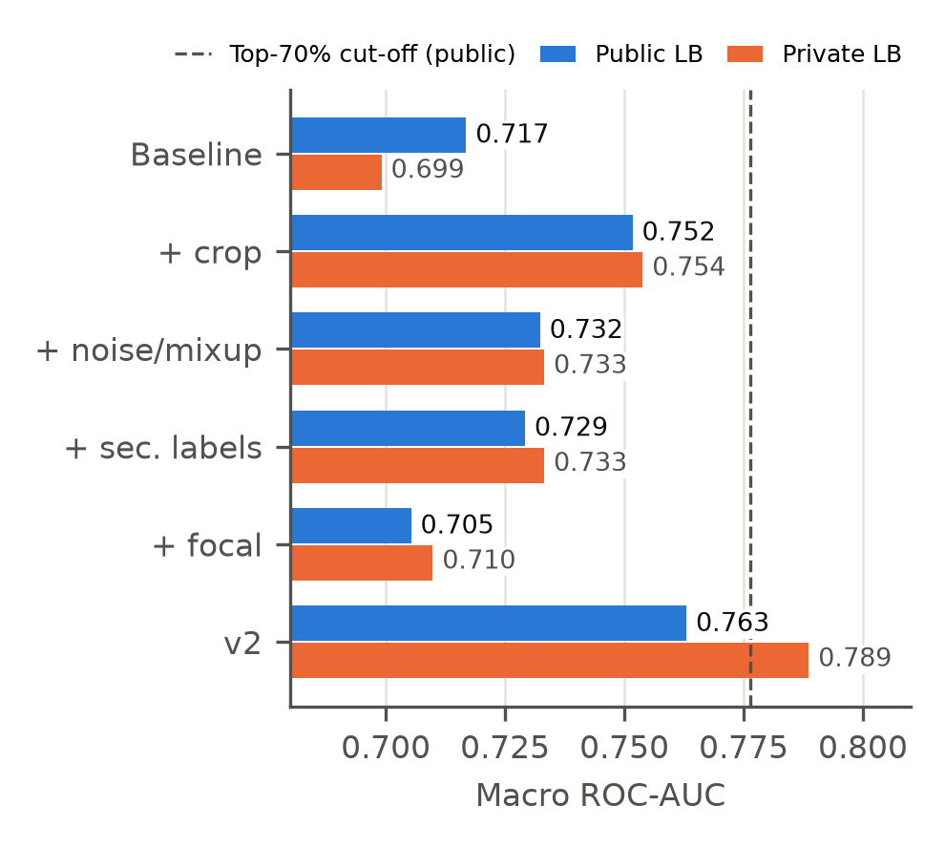
Figure 1: Public and private leaderboard scores when one change is added to the baseline. The dashed line is the public top-70% grading cut-off (0.776).
Training Behaviour
Figure 2 shows the validation curves. Like the baseline, the secondary-label and focal-loss runs peak early (epochs 5–7) and then overfit. Random crops and noise/mixup act as data augmentation: their curves still rise at epoch 15 and do not fall, because the model sees a different window or noise each epoch. Focal loss learns fastest but also overfits fastest.
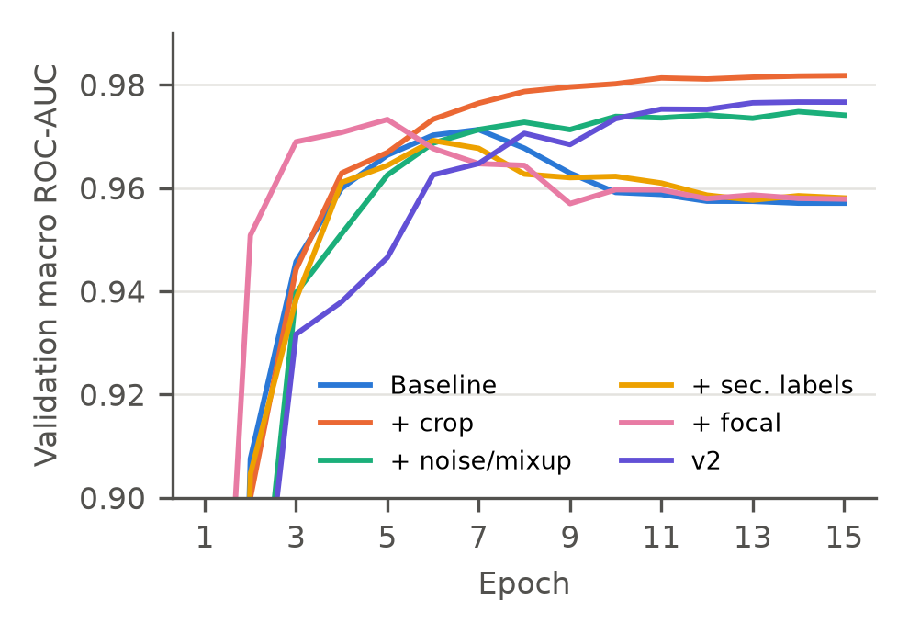
Figure 2: Validation macro ROC-AUC per epoch. Crop, noise/mixup and v2 keep improving; the others overfit after about epoch 7.
Combined Model and Remove-One Ablation
Baseline v2 combines the three changes that improved the public score. It scores 0.763 public and 0.789 private, the best of all runs, but is still 0.014 below the top-70% public cut-off. Table 2 and Figure 3 remove one change from v2 at a time. Removing secondary labels costs the most (−0.026 public), much more than the +0.012 they gave alone, so they work better together with the other changes. A likely reason is that random crops often contain background species rather than the primary one, and secondary labels give those windows correct targets. Removing crops costs −0.010. Removing noise/mixup slightly raises the public score (+0.004) but lowers the private score by 0.028, so we keep it. Adding focal loss to v2 again lowers the public score (−0.020).

Experiment | Val AUC | Public | Private | Δ public
v2 | 0.977 | 0.763 | 0.789 | –
v2 − random crop | 0.974 | 0.753 | 0.772 | −0.010
v2 − noise / mixup | 0.981 | 0.767 | 0.760 | +0.004
v2 − secondary labels | 0.979 | 0.737 | 0.772 | −0.026
v2 + focal loss | 0.978 | 0.743 | 0.782 | −0.020
Table 2: Removing one change from baseline v2 (or adding focal loss). Δ is relative to v2.
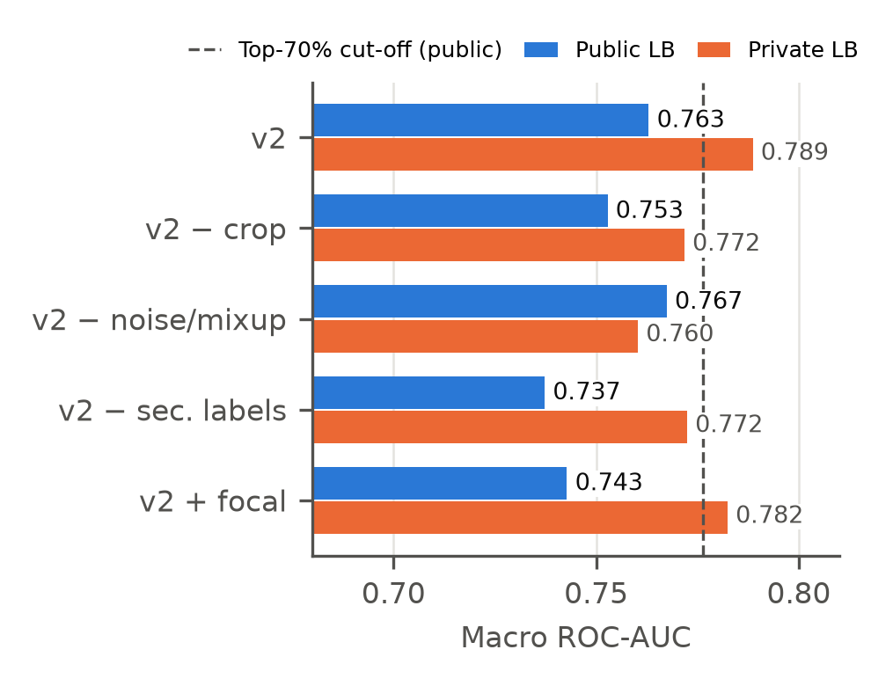
Figure 3: Leaderboard scores of the remove-one ablations of baseline v2.
Discussion of the Ablations
Local Validation Does Not Predict the Leaderboard
Figure 4 plots local validation AUC against the public score. The two are only weakly related: v2 without noise has the highest validation AUC of the v2 runs but the lowest private score, and secondary labels lower validation AUC but raise the leaderboard score. Our hold-out clips are clean recordings like the training data, so they cannot measure robustness to soundscape noise. Model choice must therefore be made on the leaderboard, or on a validation set built from labelled soundscapes.
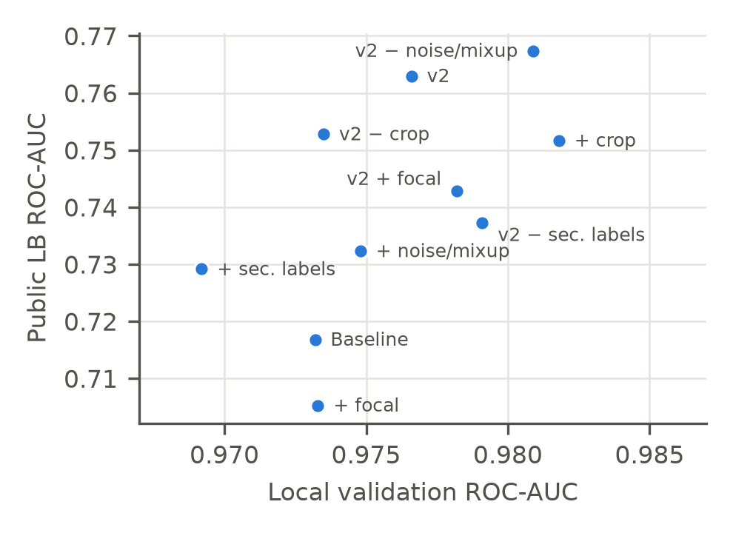
Figure 4: Local validation AUC against public leaderboard AUC for all ten runs.
Public and Private Scores Disagree
The public leaderboard uses only part of the test set, so small differences are noisy. For example, v2 without secondary labels scores 0.026 below v2 on the public set but only 0.016 below on the private set, and v2 without noise flips sign. We therefore treat public differences under about 0.01 as inconclusive and report both scores.
Limitations
Each configuration was trained once with one seed, so we cannot give error bars. The noise soundscapes are unlabelled and may contain real calls, which then become wrong negatives. Crops of short clips are often mostly padding. The image-classification model also scores each 5 s window on its own and cannot use context from neighbouring windows. These are the motivations for the sound-event-detection model, pseudo-labelling of soundscapes and ensembling in the following sections.
TODO: link to Members 2–4's sections (SED model, pseudo-labelling, ensemble) once they are written.
Contributions
Member 1: whole-clip spectrogram pipeline, the four baseline improvements, ten ablation runs with leaderboard submissions, baseline v2 for the team, and this section.
References
Cornell Lab of Ornithology; LifeCLEF; and Kaggle. 2025. BirdCLEF+ 2025. https://www.kaggle.com/competitions/birdclef-2025. Accessed: 2026-11-07.
Lin, T.-Y.; Goyal, P.; Girshick, R.; He, K.; and Dollár, P. 2017. Focal Loss for Dense Object Detection. In Proceedings of the IEEE International Conference on Computer Vision, 2980–2988.
Tan, M.; and Le, Q. V. 2019. EfficientNet: Rethinking Model Scaling for Convolutional Neural Networks. In Proceedings of the 36th International Conference on Machine Learning, 6105–6114.
Zhang, H.; Cisse, M.; Dauphin, Y. N.; and Lopez-Paz, D. 2018. mixup: Beyond Empirical Risk Minimization. In International Conference on Learning Representations.

Copyright © 2025, Association for the Advancement of Artificial Intelligence (www.aaai.org). All rights reserved.

