BirdCLEF+ 2025: Identifying Species in Rainforest Soundscapes
Member 1, Member 2, Member 3, Member 4
College of Computing and Data Science, Nanyang Technological University, Singapore
TODO: full names and NTU e-mails before hand-in

Abstract
We tackle the BirdCLEF+ 2025 Kaggle competition: given 1-minute audio recordings from El Silencio Natural Reserve, Colombia, predict which of 206 species (birds, amphibians, mammals and insects) are calling in each 5-second window. Our exploratory analysis identifies four difficulties: severe class imbalance, weak recording-level labels, a domain shift between clean training clips and noisy test soundscapes, and incomplete labels for background species. As a baseline we convert audio to log-mel spectrograms and fine-tune an ImageNet-pretrained EfficientNet-B0. It reaches a macro ROC-AUC of 0.973 on held-out training clips but only 0.717 on the public leaderboard, which confirms the domain shift. TODO: final method, final public/private score and ranking, and the main ablation findings.
Introduction
Passive acoustic monitoring lets ecologists survey biodiversity at scale by leaving recorders in the field, but the hours of audio they produce are far too much to label by hand. The BirdCLEF+ 2025 competition (Cornell Lab of Ornithology et al. 2025) asks for a model that, for every 5-second window of a 1-minute soundscape recorded in El Silencio Natural Reserve (Colombia), outputs a probability for each of 206 species of birds, amphibians, mammals and insects.
The metric is the macro-averaged ROC-AUC over species, skipping species with no positive window in the test set. Every species therefore counts equally, however rare it is. The task is also a code competition: the submission is a Kaggle notebook that must run on CPU only, with internet disabled, in at most 90 minutes. This budget limits the size and number of models we can use at test time.
This report first analyses the data and identifies four difficulties (class imbalance, weak labels, domain shift and label noise), then describes a spectrogram-CNN baseline and its leaderboard score, which later experiments build on.
TODO: summary of what we did and its novelty (SED model, ablations, pseudo-labelling, ensemble); final score, rank and relative ranking with leaderboard screenshots; one-line contribution of each member.
Data and Exploratory Analysis
The labelled training set (train_audio) contains 28,564 recordings, mostly from the citizen-science archives Xeno-canto and iNaturalist, each tagged with one primary species and optionally some secondary species. The organisers also provide 9,726 unlabelled 1-minute soundscapes (train_soundscapes) from the same recorders as the hidden test set. All audio is 32 kHz mono. Table 1 summarises the data.

Statistic | Value
Labelled training clips | 28,564
Species | 206
Aves / Amphibia / Insecta / Mammalia | 146 / 34 / 17 / 9
Clips per species (min / median / max) | 2 / 80 / 990
Species with ≤ 5 / ≤ 20 clips | 30 / 55
Clips with secondary labels | 9.3% (mean 1.48)
Median clip duration | 20.5 s
Clips shorter than 5 s | 8.1%
Unrated clips (rating 0) | ≈ 8,000
Unlabelled 60 s soundscapes | 9,726
Table 1: Summary statistics of the BirdCLEF+ 2025 training data.
Finding 1: Severe Class Imbalance
The most common species has 990 clips, while 30 species have five or fewer (Figure 1). Birds dominate both the species list and the clip count; insects and mammals together have only a few hundred clips (Figure 2). Because the metric is macro-averaged, the rare classes weigh as much as the common ones, so methods that help rare classes, such as focal loss, class-balanced sampling and pseudo-labels, should pay off.
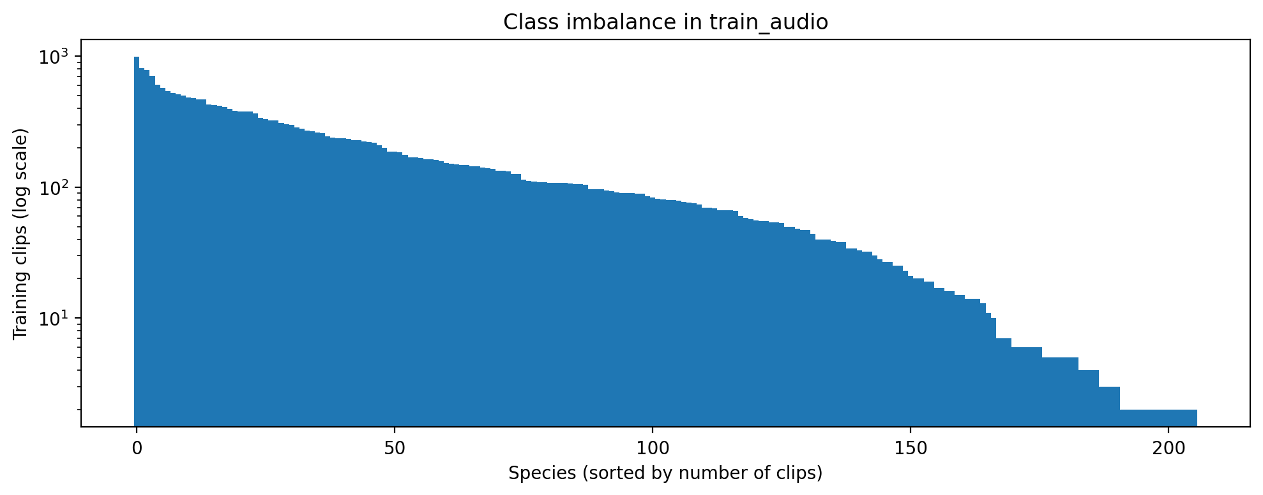
Figure 1: Number of training clips per species, sorted. The long tail of rare species is the main challenge for a macro-averaged metric.
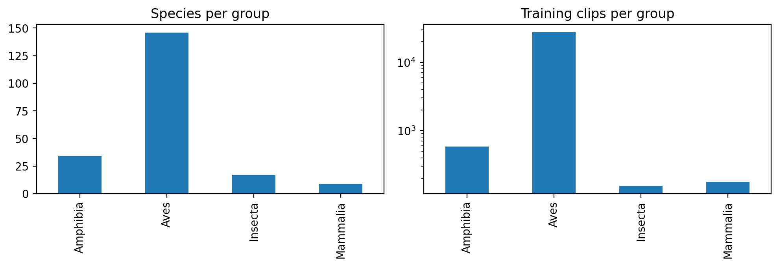
Figure 2: Species and clip counts per taxonomic class.
Finding 2: Weak Labels
Each training file carries one label for the whole recording, whose median length is about 20 s (Figure 3), but the animal may call for only a few seconds of it. We must predict per 5 s window, so a fixed 5 s crop, as in our baseline, can show the model windows that contain only background noise but are labelled as a species.
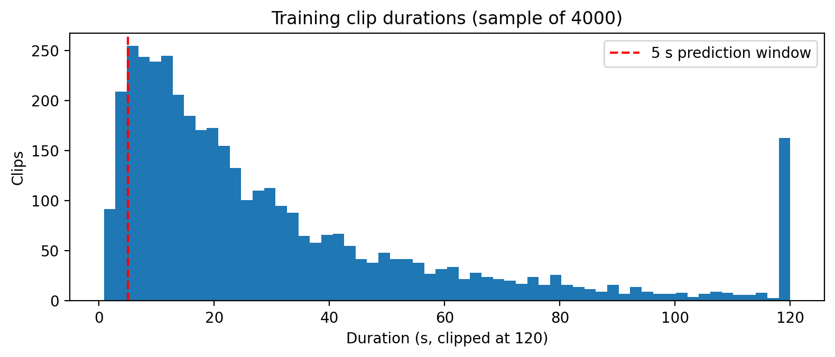
Figure 3: Distribution of training clip durations. Most clips are much longer than the 5 s prediction window.
Finding 3: Domain Shift
Training clips are mostly focused recordings in which the target animal is loud and close. The test soundscapes are continuous 60 s recordings from fixed recorders with rain, insects, overlapping calls and distant sources (Figures 4 and 5). The unlabelled soundscapes come from the same recorders as the test set, which makes them valuable for semi-supervised learning such as pseudo-labelling.
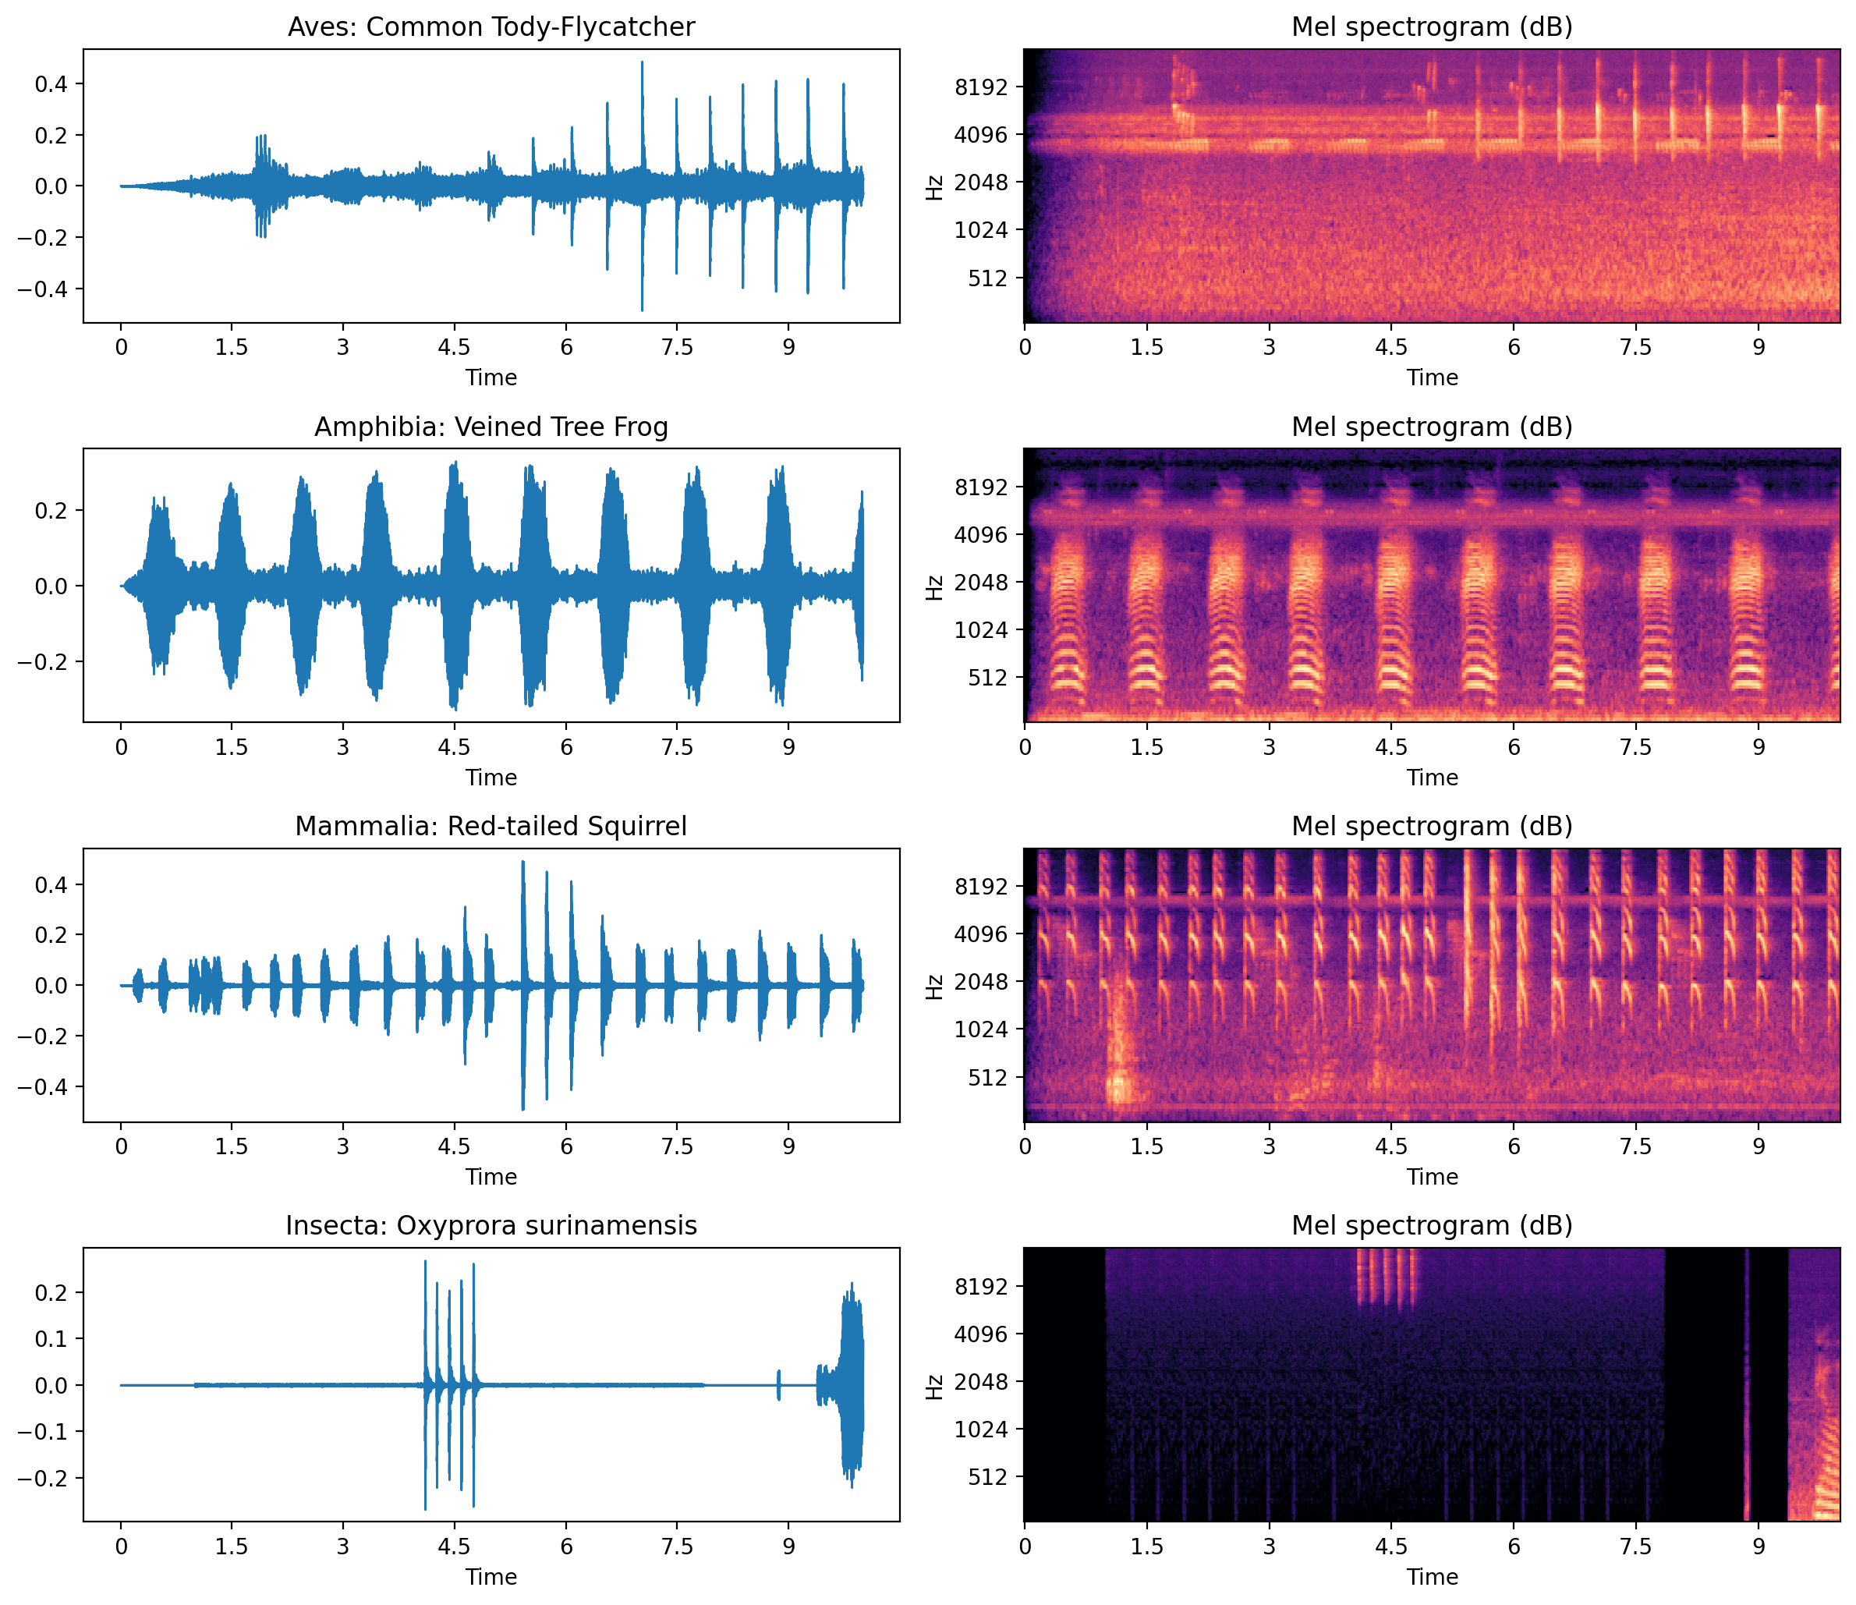
Figure 4: Log-mel spectrograms of example training clips. Calls are clean and prominent compared with the test soundscapes.
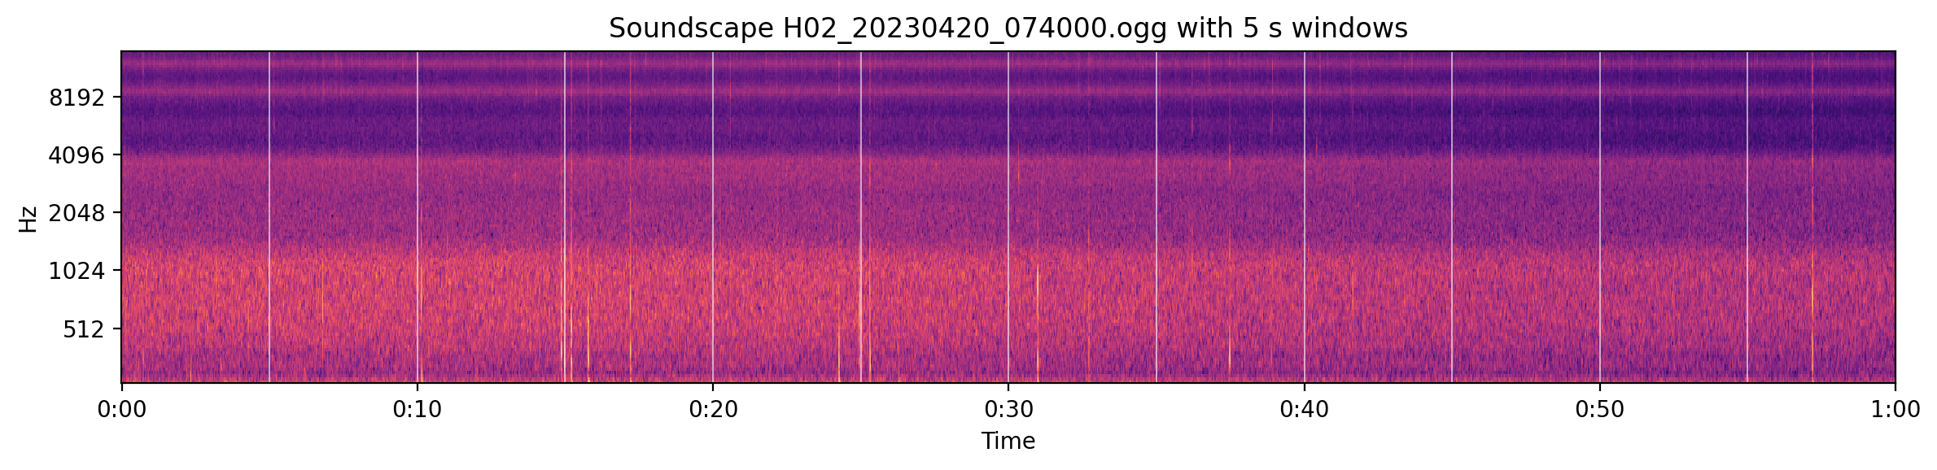
Figure 5: A 60 s unlabelled soundscape split into the twelve 5 s windows that must be scored. Background noise is continuous.
Finding 4: Label Noise and Quality
Background species are mostly unlabelled: only 9.3% of clips list secondary species. Clip quality also varies (Figure 6). Most rated clips score 4–5 out of 5, but about 8,000 clips are unrated, so filtering on quality has to be done with care.
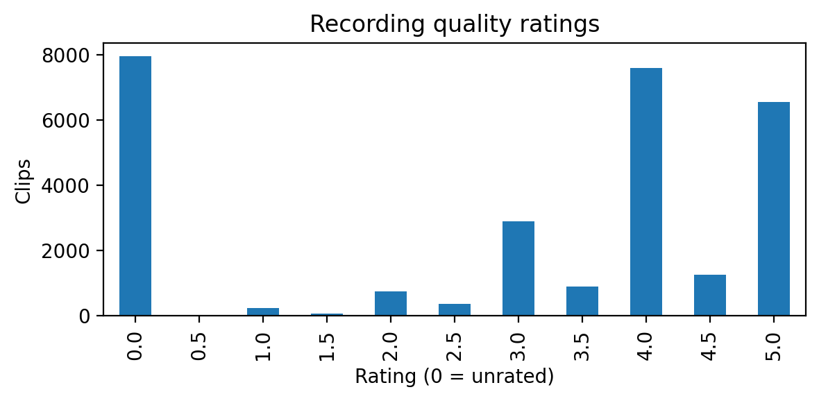
Figure 6: Distribution of user quality ratings (0 = unrated).
Baseline Method
Our baseline treats species identification as multi-label image classification on spectrograms, which is a common starting point for bird-sound recognition.
Preprocessing
We take the first 5 s of each clip (zero-padded if shorter) and convert it to a 128-band log-mel spectrogram (FFT size 2048, hop 512, 50–14,000 Hz) with librosa (McFee et al. 2015). Power is converted to decibels relative to the maximum (80 dB range) and scaled to [0, 1]. The spectrograms are computed once and cached in memory in float16 (about 2.3 GB); this step takes about 17 of the 32 minutes of a training run.
Model and Training
We fine-tune EfficientNet-B0 (Tan and Le 2019), pretrained on ImageNet (Deng et al. 2009), from the timm library (Wightman 2019), with one input channel and 206 sigmoid outputs. Training uses the primary label only, binary cross-entropy loss, AdamW (Loshchilov and Hutter 2019; learning rate 1e-3, weight decay 1e-2) with a one-cycle schedule (Smith and Topin 2019), batch size 64, 15 epochs and mixed precision on a Kaggle T4 GPU (about 57 s per epoch). No data augmentation is used. We validate on a stratified 80/20 hold-out split and keep the epoch with the best macro ROC-AUC, computed over the species present in the hold-out set, as in the competition metric.
Inference
Each test soundscape is cut into twelve 5 s windows, converted with the same mel settings, and scored on CPU. In a dry run on 20 soundscapes (240 windows), spectrogram extraction took 33 s and the forward pass 8 s on 4 CPU cores, about 2 s per soundscape. The full test set is therefore expected to take about 25 minutes, well within the 90-minute limit.
Baseline Results
Training Curve
Table 2 and Figure 7 show the training curve. Validation AUC peaks at 0.973 at epoch 7 and then falls to 0.960 while the training loss keeps decreasing towards zero, which is a clear sign of overfitting: with no augmentation and a fixed crop, the model memorises the training spectrograms. This motivates the augmentation and cropping ablations.

Epoch | Train loss | Val loss | Val AUC
1 | 0.1364 | 0.0278 | 0.592
2 | 0.0219 | 0.0180 | 0.903
4 | 0.0108 | 0.0120 | 0.967
7 (best) | 0.0047 | 0.0101 | 0.973
10 | 0.0007 | 0.0110 | 0.963
15 | 0.0001 | 0.0115 | 0.960
Table 2: Baseline training curve (validation macro ROC-AUC on the 20% hold-out). The epoch-7 model is kept.
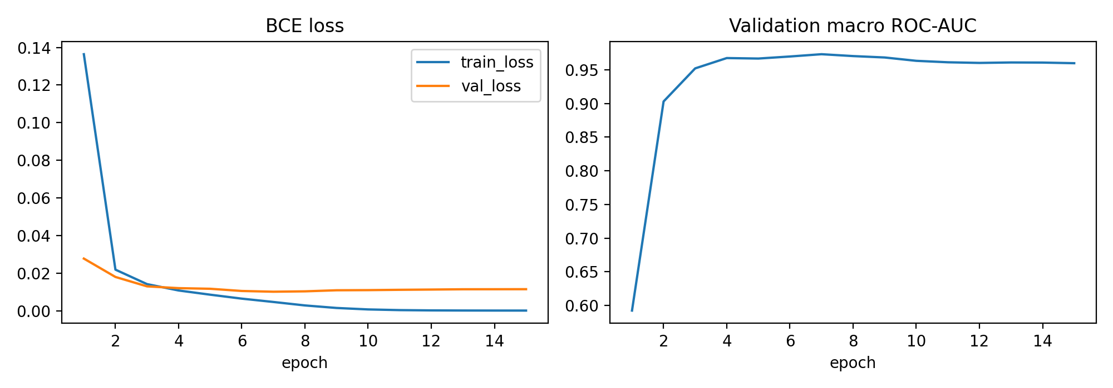
Figure 7: Baseline training and validation loss (left) and validation macro ROC-AUC (right).
Leaderboard Score
The baseline scores 0.71681 on the public leaderboard (0.69908 private), about rank 1600 of 2032 teams, a relative ranking of about 79% (Table 3, Figures 8 and 9). The gap between the local validation score (0.973) and the leaderboard (0.717) is large because the hold-out clips come from the same clean distribution as the training data, whereas the test set is noisy soundscapes. Local validation therefore overstates performance, and we rely on the leaderboard to judge how well a model generalises to soundscapes.

Model | Val AUC | Public | Private
Baseline (EffNet-B0, first 5 s) | 0.973 | 0.717 | 0.699
Top 70% cut-off | – | 0.776 | –
Top 50% cut-off | – | 0.810 | –
Top 30% cut-off | – | 0.873 | –
Top 10% cut-off | – | 0.881 | –
Best public score | – | 0.934 | –
Table 3: Baseline score against the public leaderboard band cut-offs used for grading.
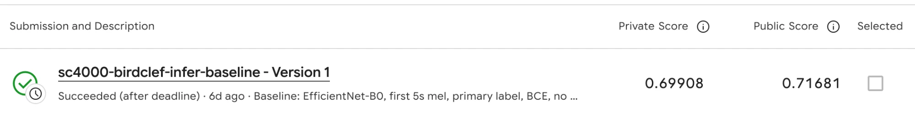
Figure 8: Kaggle submission of the baseline inference notebook: 0.71681 public, 0.69908 private.
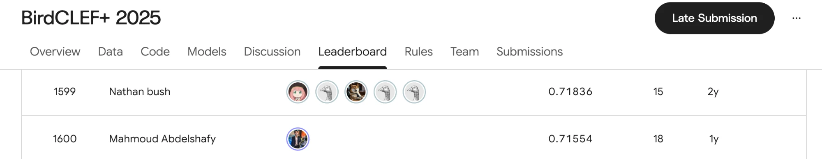
Figure 9: Public leaderboard around our score. 0.71681 falls between rank 1599 (0.71836) and rank 1600 (0.71554), so the baseline sits at about rank 1600 of 2032.
Methodology
TODO: proposed solution in detail: SED model on 20 s chunks, Bird-MAE pilot, pseudo-labelling, ensemble, CPU speed-ups (Members 2, 3, 4).
Experiments and Results
TODO: ablation table (baseline, each change alone, baseline v2) with text discussion (Member 1); SED, pseudo-label and ensemble results; CPU timing table.

Experiment | Val AUC | Public LB
Baseline (first 5 s, BCE, no aug.) | 0.973 | 0.717
+ random 5 s crops | TODO | TODO
+ soundscape noise and mixup | TODO | TODO
+ secondary labels | TODO | TODO
+ focal loss | TODO | TODO
Baseline v2 (combined) | TODO | TODO
Table 4: Ablation study (to be completed). Each row adds one component to the baseline on its own.
Discussion
TODO: which change helped most and why; rare-class vs common-class AUC; inference time of each model; limitations and future work.
Conclusion
TODO: significance of the work and the most important findings.
Contributions
Member 1: repository and Kaggle workflow, exploratory data analysis and figures, baseline training and inference notebooks, first leaderboard submission, draft of the introduction and data sections.
TODO: Members 2–4, and Member 1's later work.
References
Cornell Lab of Ornithology; LifeCLEF; and Kaggle. 2025. BirdCLEF+ 2025. https://www.kaggle.com/competitions/birdclef-2025. Accessed: 2026-11-07.
Deng, J.; Dong, W.; Socher, R.; Li, L.-J.; Li, K.; and Fei-Fei, L. 2009. ImageNet: A Large-Scale Hierarchical Image Database. In Proceedings of the IEEE Conference on Computer Vision and Pattern Recognition, 248–255.
Loshchilov, I.; and Hutter, F. 2019. Decoupled Weight Decay Regularization. In International Conference on Learning Representations.
McFee, B.; Raffel, C.; Liang, D.; Ellis, D. P. W.; McVicar, M.; Battenberg, E.; and Nieto, O. 2015. librosa: Audio and Music Signal Analysis in Python. In Proceedings of the 14th Python in Science Conference, 18–25.
Smith, L. N.; and Topin, N. 2019. Super-Convergence: Very Fast Training of Neural Networks Using Large Learning Rates. In Artificial Intelligence and Machine Learning for Multi-Domain Operations Applications, volume 11006. SPIE.
Tan, M.; and Le, Q. V. 2019. EfficientNet: Rethinking Model Scaling for Convolutional Neural Networks. In Proceedings of the 36th International Conference on Machine Learning, 6105–6114.
Wightman, R. 2019. PyTorch Image Models. https://github.com/huggingface/pytorch-image-models. Accessed: 2026-11-07.
TODO: add the 1st-place write-up and any other write-ups or papers the team used (required by the course).

Copyright © 2025, Association for the Advancement of Artificial Intelligence (www.aaai.org). All rights reserved.

