Plots:

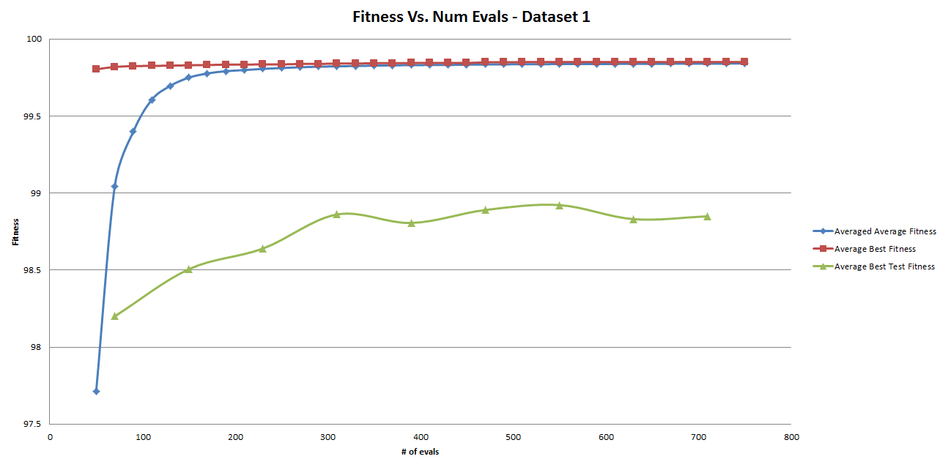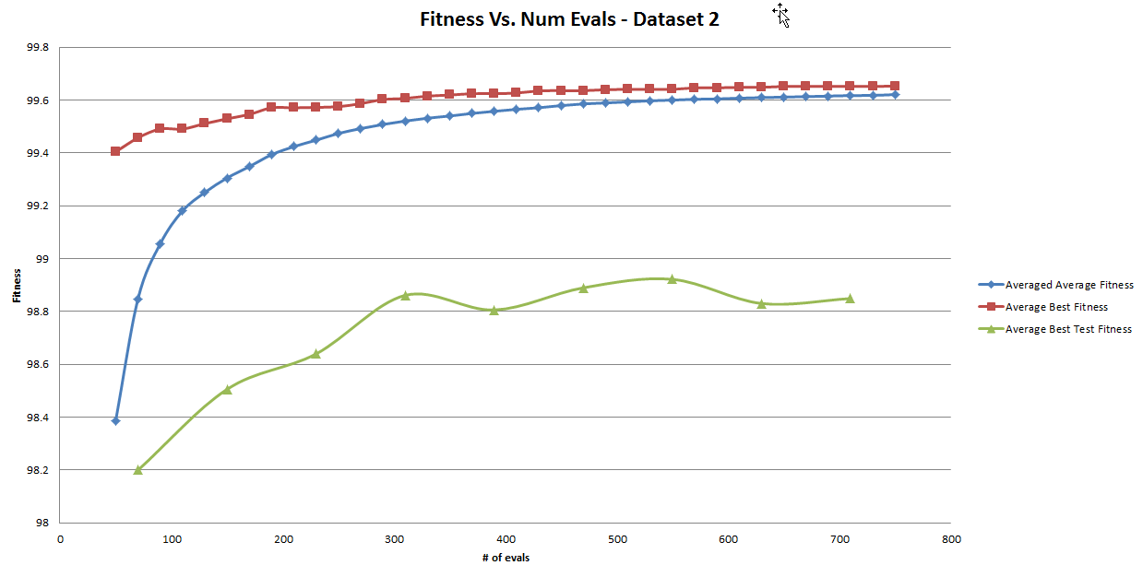

Statistical Analysis:

After running my EA on dataset 1, I gathered my top test set fitness score from each run and compared them to my best random search scores. The scores are listed below

|  |  |
| --- | --- |
| Random Search - 5 best | EA - 5 best |
| 98.3767 | 98.5967 |
| 98.44 | 99.15 |
| 98.6233 | 98.8633 |
| 98.5033 | 98.61 |
| 98.46 | 99.0267 |

After performing an F-test on the above data, I came to the conclusion that I should use a T-test assuming *unequal* variances. I came to this conclusion by using the statistics flowchart on Dr. T’s website. |mean(var1)| < |mean(var2)| and F < F-critical, therefore I assumed unequal variances.

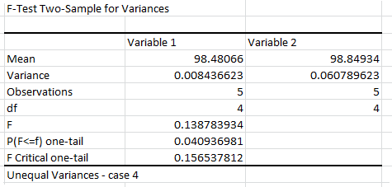

After assuming unequal variance, I then performed a T-test with the assumption of unequal variance. Once again following the instructions on the flowchart, I concluded that the null hypothesis (the difference in the means is indeed zero) was false and that the variable with the better mean does indeed indicate a statistically-better algorithm. Since the higher mean belongs to variable2, I concluded that my EA (which variable 2 represents) is better than random search.

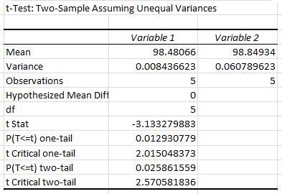

Dataset 2:

After running my EA on dataset 1, I gathered my top test set fitness score from each run and compared them to my best random search scores. The scores are listed below

|  |  |
| --- | --- |
| Random Search - 5 best | EA - 5 best |
| 98.3767 | 98.5967 |
| 98.44 | 99.15 |
| 98.6233 | 98.8633 |
| 98.5033 | 98.61 |
| 98.46 | 99.0267 |

After performing an F-test on the above data, I came to the conclusion that I should use a T-test assuming *unequal* variances. I came to this conclusion by using the statistics flowchart on Dr. T’s website. |mean(var1)| < |mean(var2)| and F < F-critical, therefore I assumed unequal variances.

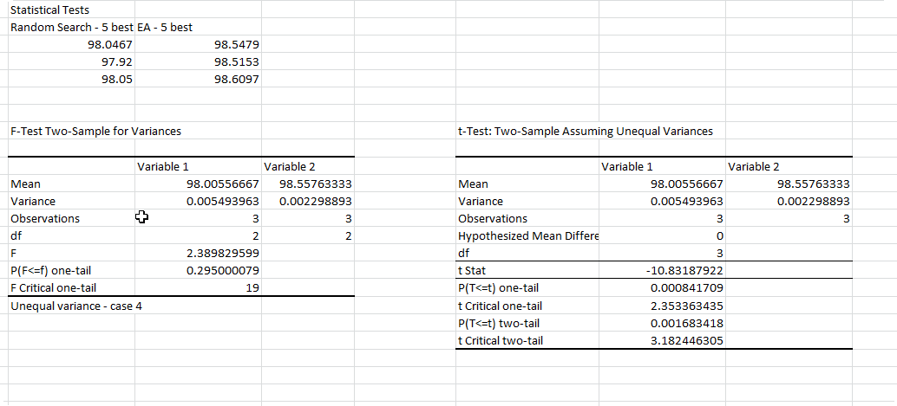

After assuming unequal variance, I then performed a T-test with the assumption of unequal variance. Once again following the instructions on the flowchart, I concluded that the null hypothesis (the difference in the means is indeed zero) was false and that the variable with the better mean does indeed indicate a statistically-better algorithm. Since the higher mean belongs to variable2, I concluded that my EA (which variable 2 represents) is better than random search.