**Screenshots Pre-Layout**

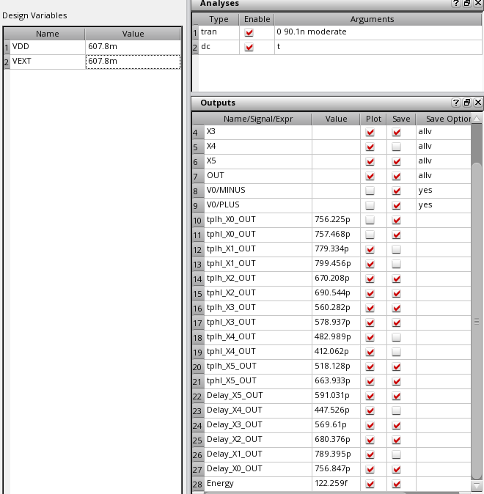

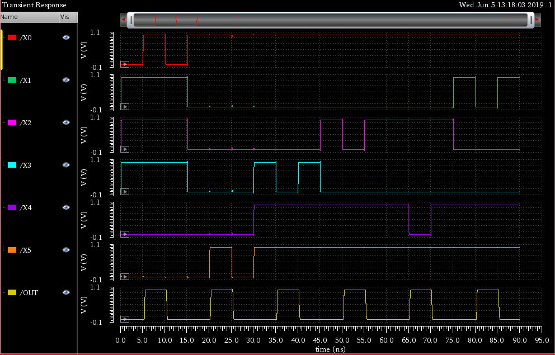

**Screenshots Post Layout**

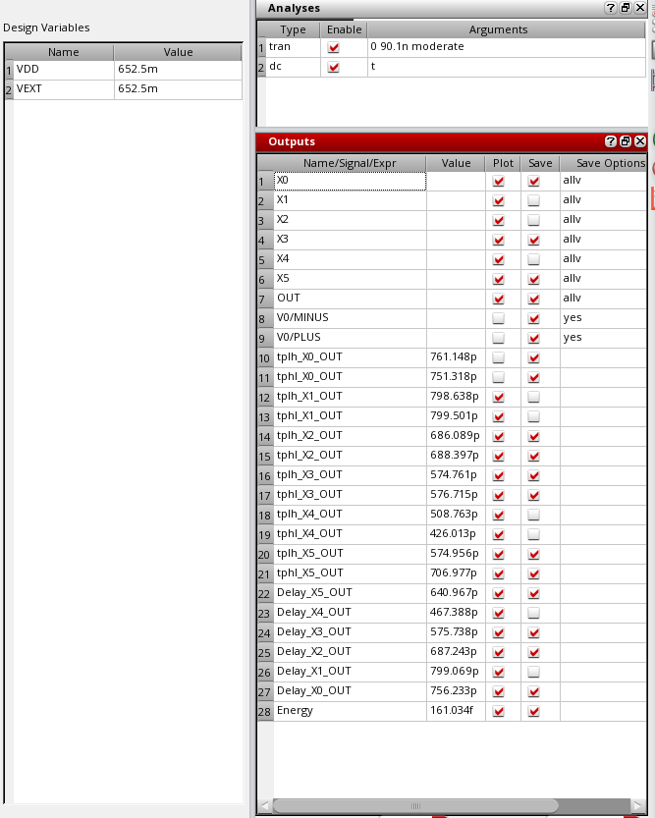

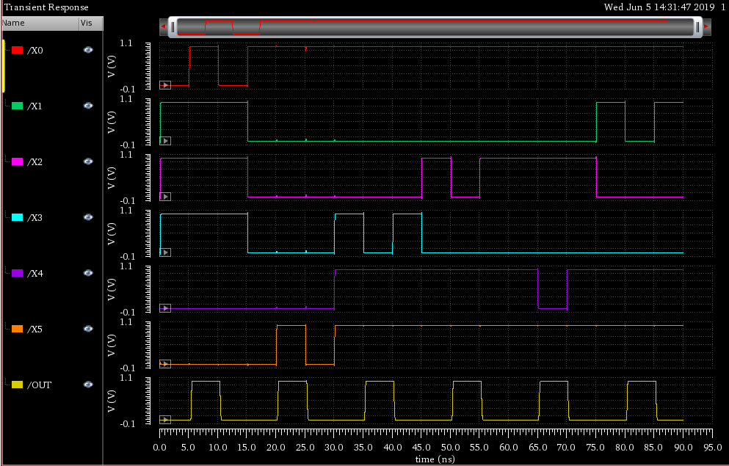

**Layout Verification**

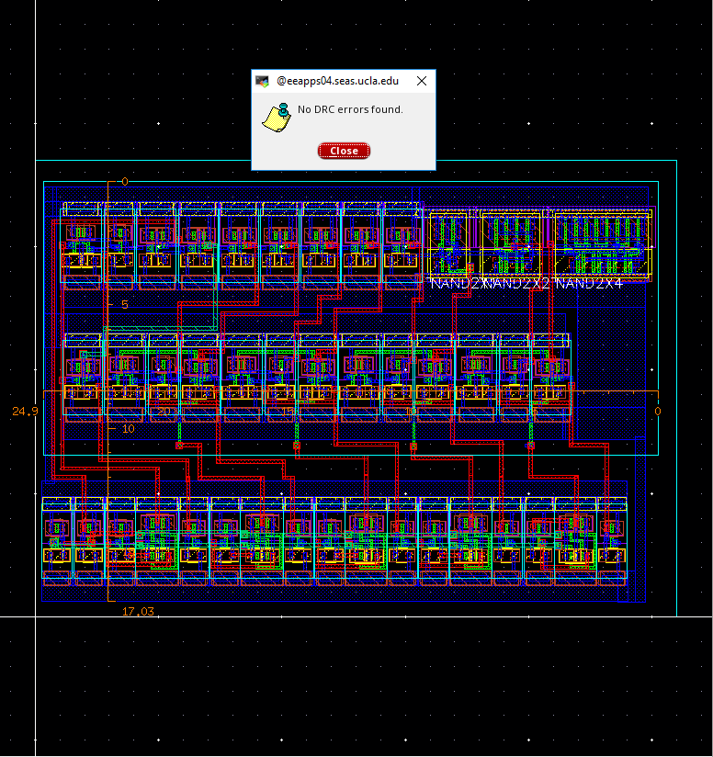

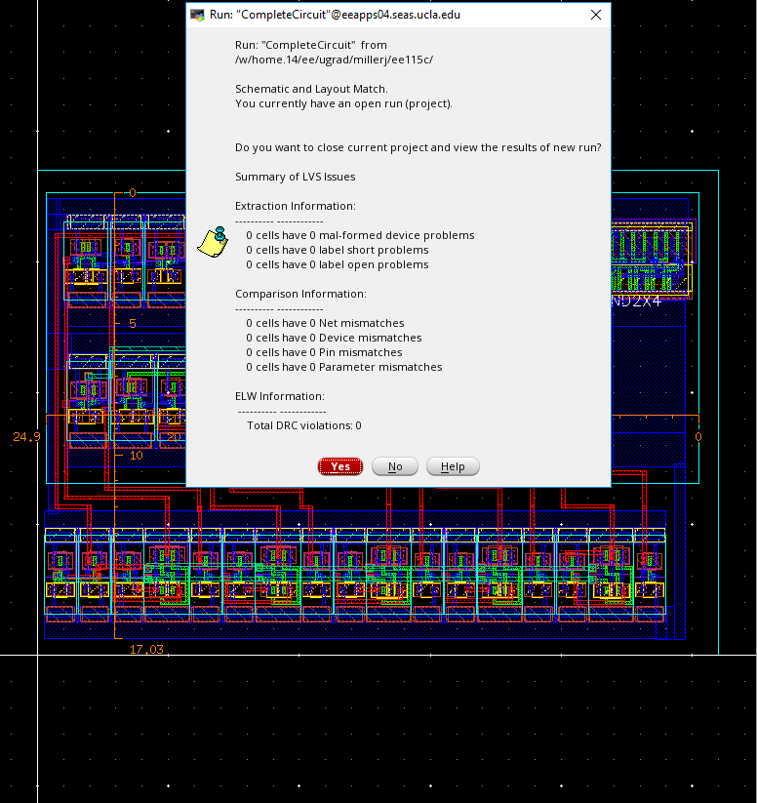

**Work Division**

Alexander:

Built schematic view for AdderModule, Built and tested carry Bypass Adder to compare with CLA, designed layout for PTL Mux half sized NAND, NOR, Inverter, as well as layout for Adder Module.

Joseph:

Designed circuit used for schematic, sized schematic, built schematic view for Inverting Stage, designed layout for Inverting Stage and Abs_Value_Detector.