**Lab 4: IoT**

Josh Miller || Apr 10, 2022

**Part 1:**

Below are the clock and data oscilloscope captures for both clockwise and counter clockwise rotation of a rotary encoder:

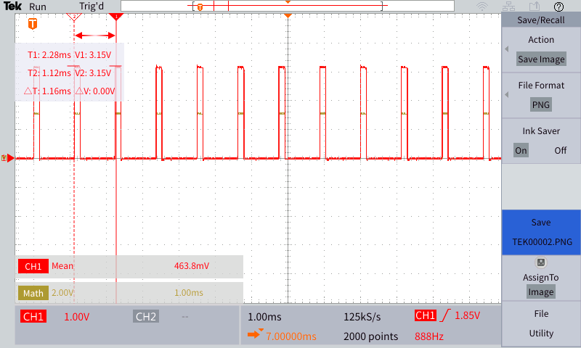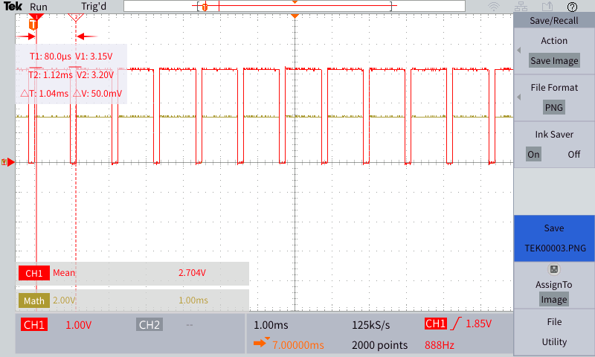

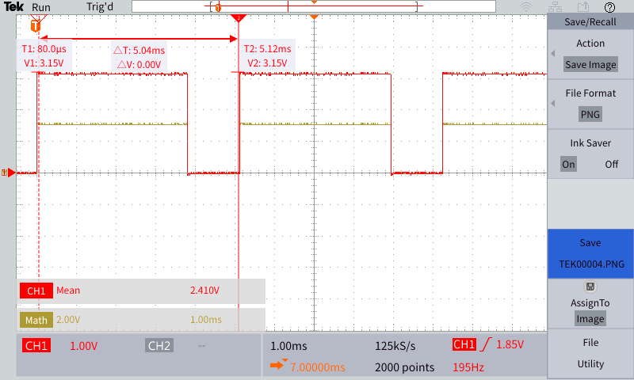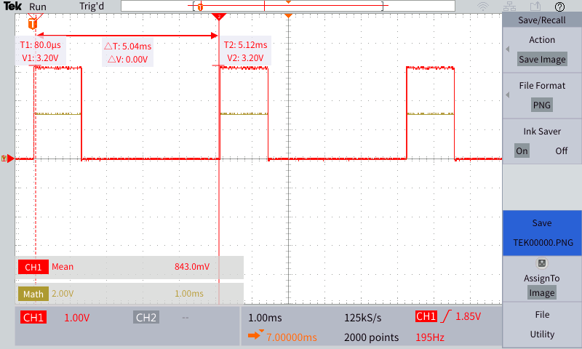

**Part 2:**

Video Demo attached to submission

**Part 3:**

Below are oscilloscope captures of I2C connections acknowledging ACK or not:

**Part 4:**

Code for custom symbols on LCD Display shown below:

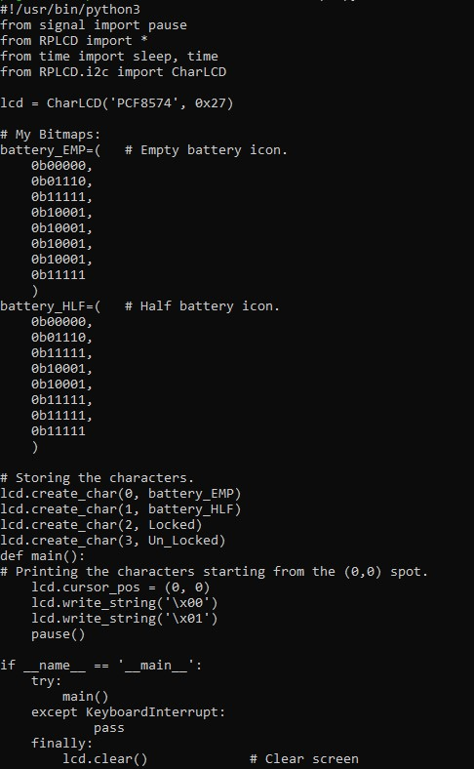

Video demo (not mine but Abhinavs) will be attached to submission.

**Part 5:**

The code for this section became quite long so it will be attached via .txt file in the submission as well as a video demonstration.

**Critical Reflection:**

This lab encompassed a lot of topics I had never seen/heard of before. Oscilloscopes, rotary encoders, LCD displays, RFID scanners and the DHT-11 sensor all being new topics (in a technical sense). Therefore there is a lot to reflect on and the quantity is what I would like to reflect on, while I understand the purpose behind exposure to these simple machines the lab seemed to bite off more than was necessary. Problems were encountered at every stage which was expected however part 5 of this lab could have been a lab on its own. I understand that part 5 ties into the next two labs however I don’t believe it entirely necessary as the broker system addressed in lab 5 could be demonstrated using the created symbols from part 4 just as well as a menu. The parts of this lab I liked involved the RFID scanner as its role in security is very evident as well as the symbols created in part 4 as that had always been a personal interest.