# Launch to the Milky Way – My Special Place in the Database

Don’t forget to record data and observations as you work through this activity. All of the questions and reminders from the activity are listed in order below.

1. Which star and constellation did you choose as your starting point for this activity? What are the coordinates (RA and Dec) of your bright star?

Andromeda - Alpheratz, (2.10, 29.09)

1. Use a star wheel to answer the following questions. Is this constellation visible at this time of year from your location? If not, choose a month when it is visible. Name the rise and set time for your constellation and its location in the sky when it is at its highest point.
   1. Month when your target(s) are visible

August-October

* 1. Rise time

11:58 pm

* 1. Set time

5:38 am

* 1. General location of the constellation when it appears highest in the sky

North

1. After you scanned the area around your bright star, choose an interesting field of view as your Special Place in the database. Why did you choose this location? What are its coordinates? Paste in a screen shot of your location, if you can.

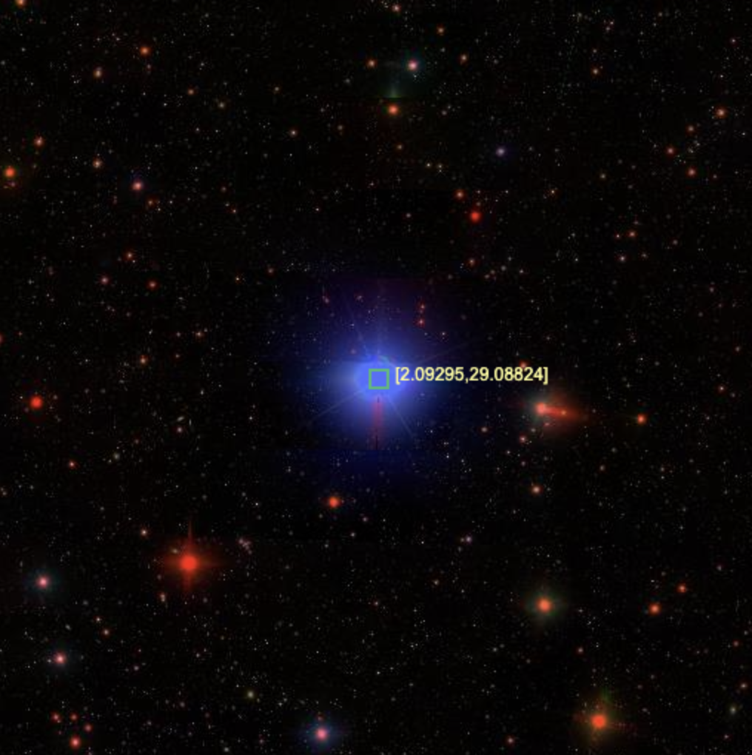 Shows a lot of stars

1. Create a collection of objects in the area around your starting place in the NoteBook tool. Choose a method for saving your NoteBook and describe it below.

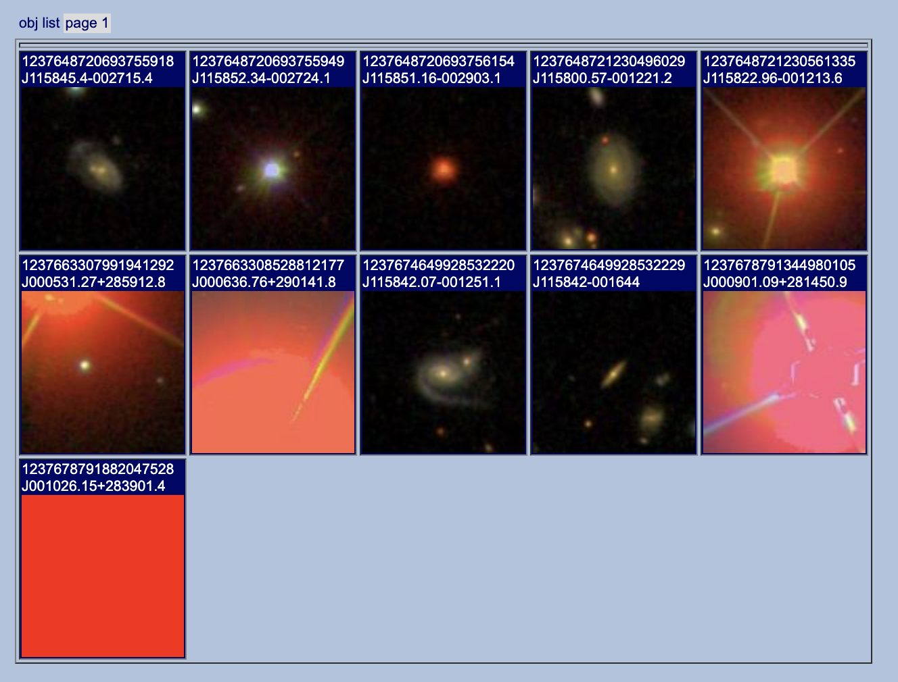

1. List three different tools available to you from NoteBook. Why might you want to use each?

Export as CSV is useful because I can export the data about the stars in a simple format and upload to imglist is useful because it lets me see all the images of the stars.

1. After observing the objects in your Special Place in the database, record any interesting patterns you notice and record any questions you have.

Many of the stars around it were red.