Inventory & Point-of-Sale System for a Small Café
Final Project Report — Software Engineering 1
Student | [Your full name]
Student number / section | [Student number] · [Section]
Instructor | [Instructor's name]
Submitted | [Date of submission]
System version described | v0.21.2 (23 October 2026)
Source code | https://github.com/JmlAsync/inventory-pos-system
Video presentation | [Link to the recorded video]

Contents
About this report 6
Tools and assistance 6
1. Introduction 7
1.1 The problem 7
1.2 What the system does 7
1.3 Objectives 7
1.4 Scope 7
1.5 Who uses it 8
1.6 Technology 8
1.7 Glossary 8
2. A tour of the system 10
3. Software process model (item 1) 20
3.1 The model I chose: incremental development 20
3.2 How each increment was built 20
3.3 Why incremental, and not the other two? 21
4. Feature stories (item 2) 22
F1 — Viewing the product list (v0.3.0) 22
F2 — Adding a new product (v0.4.0) 22
F3 — Editing a product (v0.5.0) 22
F4 — Deleting a product (v0.5.0) 22
F5 — Logging in and out (v0.6.0) 22
F6 — Admin and cashier permissions (v0.7.0) 22
F7 — Processing a sale (v0.8.0, fixed in v0.8.1) 23
F8 — Low-stock warning (v0.9.0, fixed in v0.9.1–v0.9.2) 23
F9 — Sales report (v0.10.0, fixed in v0.10.1–v0.10.2) 23
F10 — Profile picture (v0.12.0) 23
F11 — A modern look with light and dark themes (v0.13.0) 23
F12 — Account safety (v0.13.1–v0.13.5) 24
F13 — Product pictures and a tap-to-add menu (v0.14.0–v0.14.4) 24
F14 — Paying by GCash (v0.15.0) 24
F15 — Hot / Iced and add-ons (v0.16.0–v0.16.1, wording v0.17.2) 24
F16 — Ingredients and recipes (v0.17.0–v0.17.1) 24
F17 — Finding and updating an ingredient quickly (v0.18.0–v0.18.2) 24
F18 — Changing the system safely (v0.19.0) 25
F19 — Serving a queue quickly (v0.20.0–v0.20.1) 25
F20 — A calmer, roomier screen (v0.21.0–v0.21.2) 25
5. Test cases (item 3) 26
5.1 How the system was tested 26
5.2 F1 — View product list 26
5.3 F2 — Add product 27
5.4 F3 — Edit product 27
5.5 F4 — Delete product 28
5.6 F5 — Log in / log out 28
5.7 F6 — Role-based access (Admin vs. Cashier) 29
5.8 F7 — Process sale (v0.8.0, v0.8.1) 29
5.9 Patches v0.8.2–v0.8.6 — robustness of the sale flow and forms 31
5.10 F8 — Low-stock warning (v0.9.0, v0.9.1, v0.9.2) 32
5.11 F9 — Sales report (v0.10.0, v0.10.1, v0.10.2) 33
5.12 Demo data (v0.11.0, v0.11.1, v0.11.2) 33
5.13 F10 — Profile picture (v0.12.0) 34
5.14 F11 — Modern theme (v0.13.0) 35
5.15 F12 — Security patches (v0.13.1–v0.13.5) 36
5.16 F13 — Product pictures and café menu (v0.14.0–v0.14.3) 37
5.17 F14 — Payment method (v0.15.0) 39
5.18 F15 — Sizes and add-ons (v0.16.0, v0.16.1) 40
5.19 F16 — Ingredients and recipes (v0.17.0, v0.17.1) 41
5.20 F17 — Ingredients page redesign (v0.17.4, v0.18.0, v0.18.1) 42
5.21 F18 — Project rules and automated tests (v0.19.0) 44
5.22 Security audit patches (v0.19.3) 45
5.23 Offline pages (v0.19.4) 45
5.24 F19 — New Sale redesign (v0.20.0) 46
5.25 F20 — Cozy layout and foldable sidebar (v0.21.0) 48
5.26 Last open defects closed (v0.20.2–v0.20.4) 49
5.27 Test summary 50
6. Requirements (items 4–10) 52
6.1 Requirements definition: user and system requirements (item 4, Lecture 4 p. 7) 52
6.2 Nonfunctional requirements (item 5, Lecture 4 p. 18) 53
6.3 Nonfunctional requirements metrics (item 6, Lecture 4 p. 21) 53
6.4 Requirements of each part (item 7, Lecture 4 p. 39) 54
6.5 Structured requirements (item 8, Lecture 4 p. 42–43) 55
6.6 Tabular computation (item 9, Lecture 4 p. 45) 57
6.7 Detailed scenarios (item 10, Lecture 4 p. 62–63) 59
7. System models (items 11–25) 61
7.1 Context model (item 12, Lecture 5 p. 10) 61
7.2 Process model (item 13, Lecture 5 p. 12) 62
7.3 Use case diagrams (items 11 and 14, Lecture 4 p. 65 and Lecture 5 p. 15) 62
7.4 Tabular use case descriptions (item 15, Lecture 5 p. 16) 67
7.5 Each actor's use cases (item 16, Lecture 5 p. 17) 71
7.6 Sequence diagrams (item 17, Lecture 5 p. 19–20) 73
7.7 Class associations and class model (items 18 and 19, Lecture 5 p. 23–25) 81
7.8 Generalization hierarchy (item 20, Lecture 5 p. 30–31) 83
7.9 Aggregation (item 21, Lecture 5 p. 33) 84
7.10 Activity model (item 22, Lecture 5 p. 36) 85
7.11 Application process (item 23, Lecture 5 p. 37) 86
7.12 State diagrams (item 24, Lecture 5 p. 40) 86
7.13 Structured forms of states (item 25, Lecture 5 p. 41–42) 88
8. Architecture and design (items 26–30) 91
8.1 Software architecture (item 26, Lecture 6 p. 42 and 49) 91
8.2 System context (item 27, Lecture 7 p. 9) 93
8.3 High-level architecture (item 28, Lecture 7 p. 13) 93
8.4 Object classes (item 29, Lecture 7 p. 19) 94
8.5 Detailed usage scenario (item 30, Lecture 8 p. 53) 95
9. Dependability and security (items 31–39) 96
9.1 Reliability terminology (item 31, Lecture 11 p. 25) 96
9.2 Safety terminology (item 32, Lecture 11 p. 35) 96
9.3 Security terminology (item 33, Lecture 11 p. 42) 97
9.4 Vulnerability avoidance techniques (item 34, Lecture 11 p. 45) 97
9.5 Risk classification (item 35, Lecture 12 p. 15) 98
9.6 Software fault tree (item 36, Lecture 12 p. 18) 99
9.7 Safety requirements (item 37, Lecture 12 p. 23) 99
9.8 Functional reliability requirements (item 38, Lecture 12 p. 39) 100
9.9 Threat and control analysis (item 39, Lecture 12 p. 46) 100
10. Defects, lessons learned and known limitations 102
10.1 Defects found and fixed 102
10.2 Lessons learned 108
10.3 Security audit and security review 108
10.4 Known limitations 109
11. Conclusion 111
Appendix A. Version history 112
Appendix B. Automated test suite 116
Appendix C. Where each Section B item is answered 118
Appendix D. Running the system 120

About this report
This report describes the Inventory & POS System from the first idea to the version I am submitting. It follows the order of the items in Section B of the final project instructions, so each item can be found quickly. The table in Appendix C lists every item and the section that answers it.
The chapters build on each other:
- Chapters 1–2 explain what the system is and show it working.
- Chapters 3–5 cover how I built it (the process model), what each feature does (stories) and how I tested it.
- Chapters 6–9 are the engineering models: requirements, UML system models, architecture, and dependability and security.
- Chapter 10 lists every defect I found and fixed, what I learned from them, and what the system still cannot do.
- Chapter 11 closes the report. The appendices hold the full version history, the automated test suite and the instructions for running the system.
A few conventions are used throughout. Versions are written as vX.Y.Z and match the Git tags in the repository. Features are numbered F1–F20, use cases UC-01–UC-15, test cases TC-… and defects DEF-01–DEF-60, so any one of them can be traced from the requirement to the code to the test. In the test tables, ✅ means the test passed and ❌→✅ means it failed first, the defect was fixed, and it passed afterwards.

Tools and assistance
I built the first versions (v0.1.0 to v0.8.1) myself. From then on I decided what each version should do, tried each one in the running app, and found several of the defects in Chapter 10 by hand. Because of the time pressure of finals week, I used an AI coding assistant (Claude, by Anthropic) for a large part of the implementation from v0.8.2 onwards, for writing the automated tests and for drawing the UML diagrams from the code. Every change still went through the same process as my own code: its own branch, a pull request, the automated checks, my review, and a version tag. The project rules in AGENTS.md were written so that anyone changing the code, person or AI assistant, has to follow the same security and data rules. Where a test or screenshot was produced with the assistant, the result is reported exactly as it came out.

1. Introduction

1.1 The problem
Small cafés in the Philippines often run on a notebook, a calculator and memory. The owner knows roughly how much milk is left, the cashier works out the change in their head, and at closing time someone adds up the day's sales by hand. This works until it doesn't: a drink is promised and the oat milk has run out, the drawer is ₱200 short and nobody can say which sale it was, or two people sell the last slice of cake at the same time.
I started this project as a simple inventory list for a general store. Midway through, a café owner showed interest in it, so from v0.14.0 the system was shaped around what a café actually needs: drinks sold Hot or Iced, add-ons such as oat milk or an extra shot, GCash payments, and ingredient stock that goes down with every cup sold.

1.2 What the system does
The Inventory & POS System is a web application that runs on the café's own laptop. Staff open it in a browser, and it works without an internet connection.
- At the counter, a cashier taps drinks and pastries into a basket, adjusts servings and add-ons, takes cash or GCash, and prints a receipt. The change is worked out automatically, and the system refuses to sell anything that is no longer in stock.
- Behind the counter, the owner (admin) keeps the menu, prices and pictures up to date, sets up servings and add-ons, records ingredients and recipes, adds deliveries, counts the shelves, and reads the sales report.
- Throughout the day, the system warns staff when a product or ingredient is running low, and keeps a history of every ingredient change so a missing amount can be explained.

1.3 Objectives
- Record every sale correctly, with the right total, change and receipt, and never sell more than is in stock.
- Keep product and ingredient stock accurate without manual counting after each sale.
- Give the owner a clear daily picture: revenue (cash and GCash), number of sales and best sellers.
- Keep the data safe: only the right people can change prices or see reports, and passwords are never stored.
- Be quick and easy at a busy counter, on a laptop or a phone, in a light or dark theme.

1.4 Scope
In scope: products, pictures and categories; servings and add-ons; ingredients, recipes and stock history; sales with cash or GCash; receipts; low-stock warnings; a sales report; two roles (admin and cashier); account safety (login limit, password change, sessions that can be ended).
Out of scope: online ordering, accounting, payroll, refunds and voids, discounts, and anything required of an official BIR-registered cash register. The receipts this system prints are order slips for the shop's own records, not official sales invoices (see 10.4).

1.5 Who uses it
An actor is anyone outside the system who interacts with it.
Actor | Who they are | What they can do
Visitor | Anyone who opens the site without logging in | See the home page, go to the login page, switch the light or dark theme
User (general) | Any logged-in person. Admin and Cashier are both kinds of User | Log in and out, see Home with today's numbers, view products, make sales and open receipts, change their picture and password
Admin | The café owner or manager | Everything a User can do, plus manage products, servings and add-ons, ingredients and recipes, restocks and counts, and view the sales report
Cashier | Counter staff | Everything a User can do. Any admin page answers 403 Forbidden, even if the address is typed in by hand

Admin and Cashier are drawn as kinds of User because they share most of their abilities. This matches the code: there is one User table, and its role column decides what each person may do.

1.6 Technology
Part | Choice | Why
Language | Python 3.11+ (developed on 3.11, checked on 3.13) | Readable for a beginner, and the language of the course
Web framework | Flask 3.1 with Flask-Login and Flask-SQLAlchemy | Small, well documented, easy to follow from request to page
Database | SQLite, one file (instance/inventory.db) | Nothing to install; enough for one shop
Pages | Jinja2 templates, Bootstrap 5.3.3, Bootstrap Icons, the Inter font | Clean layout that works on phones; all stored locally so nothing loads from the internet
Version control | Git and GitHub, one branch and pull request per version | Every change can be reviewed, tested and traced
Tests | Python's standard library only (tests/) | Anyone can run them with one command

1.7 Glossary
- POS (Point of Sale): the counter where a customer pays, and the software used there.
- SKU (Stock Keeping Unit): a short unique code for each product, such as HC-001.
- Serving / add-on: a serving is the one choice every drink needs (Hot or Iced, or a size); an add-on is an optional extra with its own price (Oat Milk +₱40).
- Recipe: what one product, serving or add-on uses up (18 g of beans, 160 ml of milk…).
- CRUD: Create, Read, Update, Delete, the four basic operations on stored data.
- Hashing: turning a password into a scrambled value that cannot be turned back. The system stores only the hash.
- Role-based access control: each user has a role (admin or cashier) that decides what they may do.
- Transaction: a group of database changes that are saved together or not at all.

2. A tour of the system
The screenshots below were taken on v0.21.2 with the generic demo menu (python seed_demo_data.py). The café's own menu, prices and photos are used only on my laptop for the live demo and are never published.
Logging in. Every page except the home page and this one needs a login. After five wrong passwords for a username, that computer has to wait five minutes.
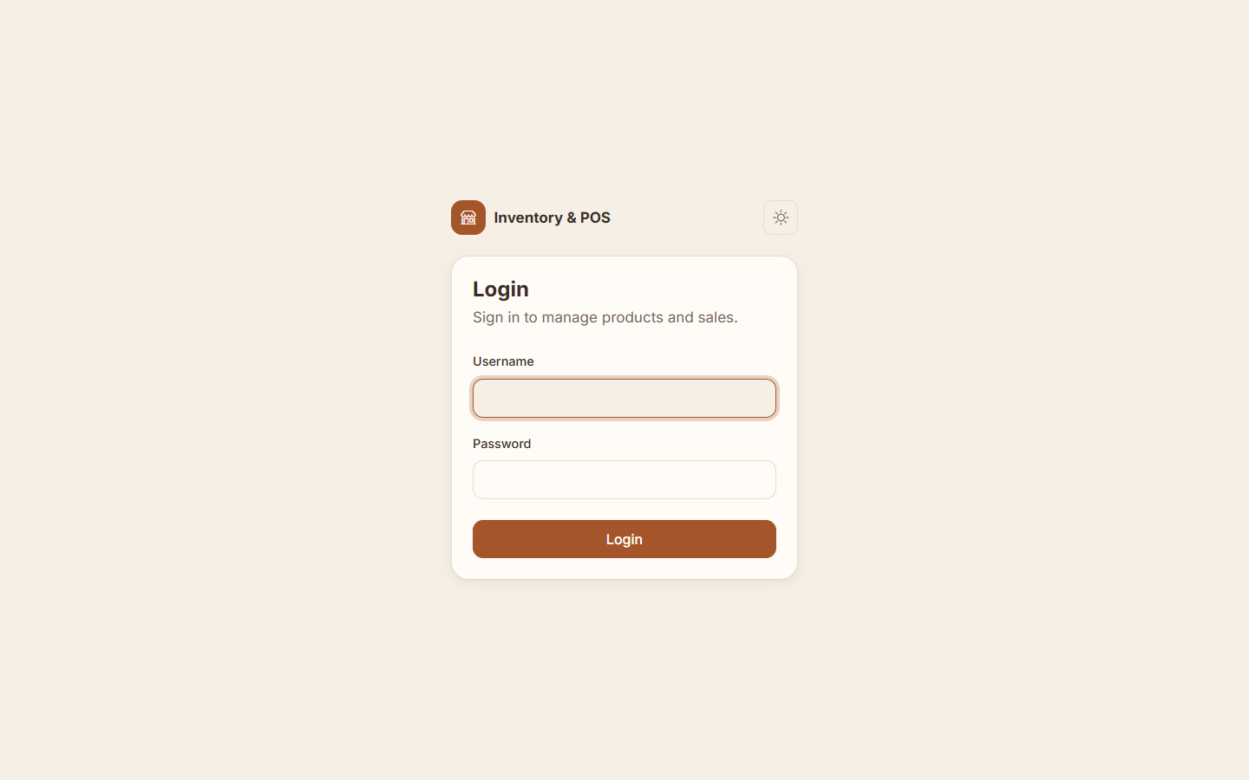
Home. The owner sees today's numbers at a glance and a warning when an ingredient is running low. The sidebar lists only the pages this user is allowed to open.
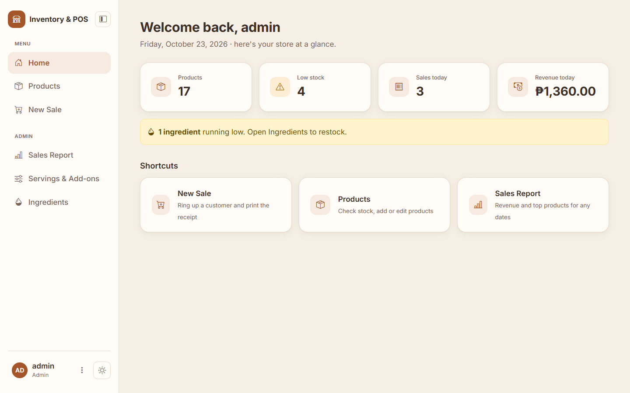
New Sale. This is the screen a cashier uses all day. Each tile has one button per serving (here 12oz and 16oz; the café itself uses Hot and Iced), and a bar showing how many more can be made from the ingredients on hand. Tapping a basket line opens it to change the serving and add-ons; here the Cafe Latte has Oat Milk. Quick-cash buttons fill in the amount received, and the change appears immediately.
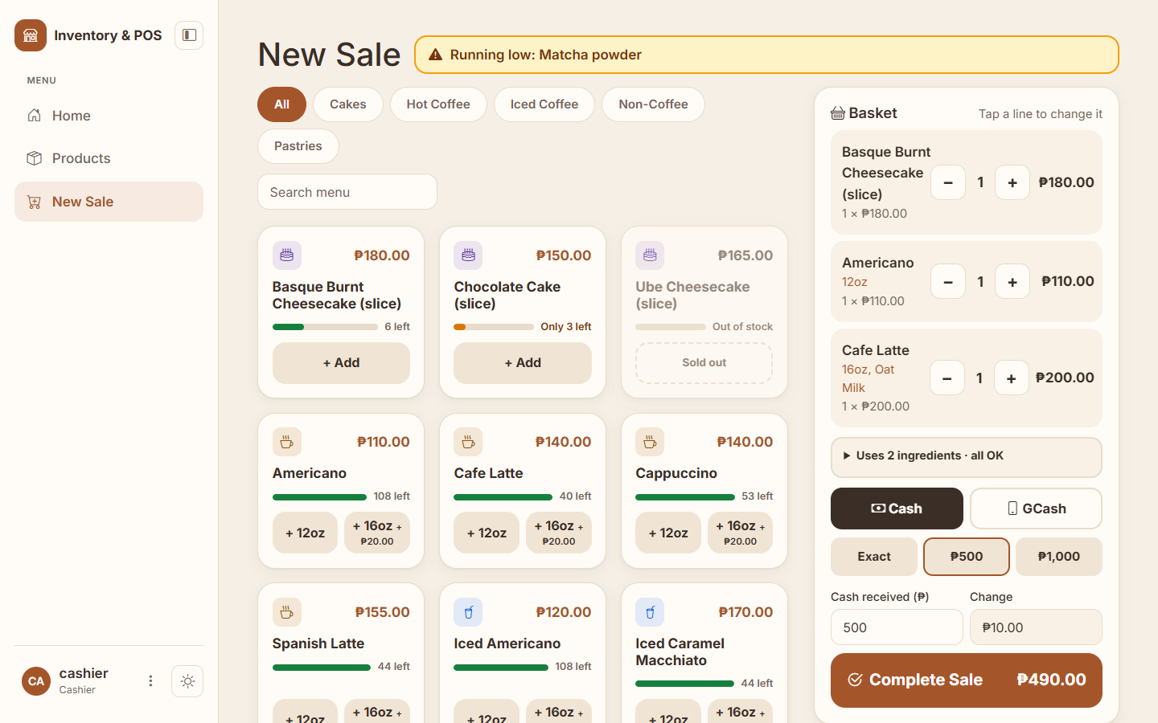
Receipt. The receipt keeps its own copy of each item's name, options and price, so it never changes, even if the menu does later. Printing hides the sidebar and buttons.
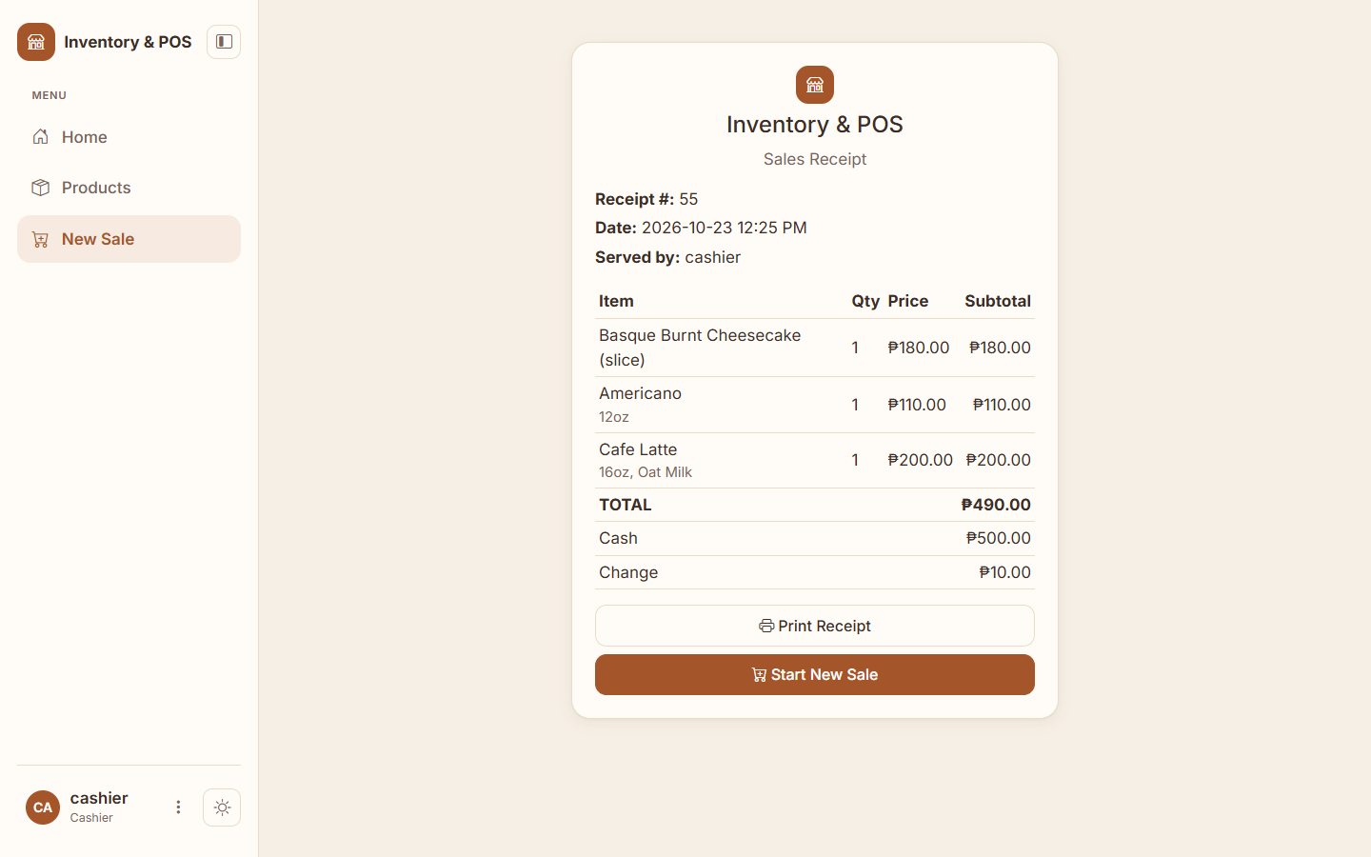
Products. The admin manages the menu here. Drinks show how many can still be made ("can make"), and a box at the top lists everything with five or fewer left.
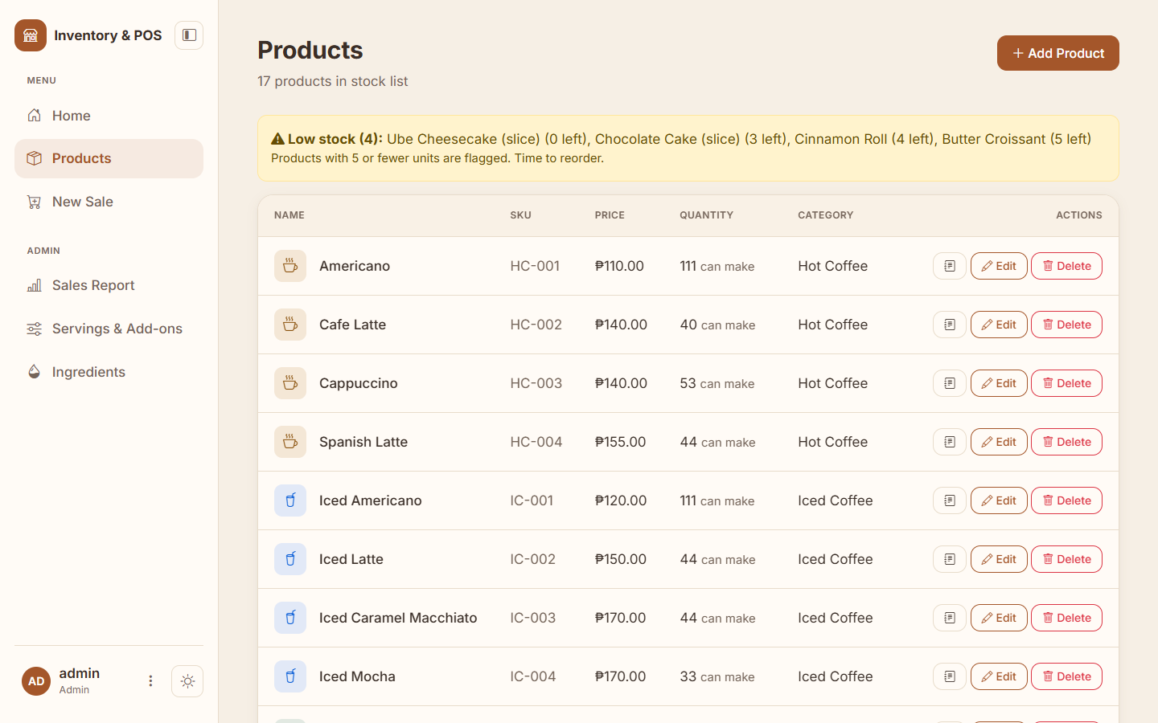
Ingredients. Ingredients are grouped, searchable and shown with a stock bar and a mark at the warning level. Needs attention always comes first. Update opens a small window for a delivery (Restock) or a shelf count.
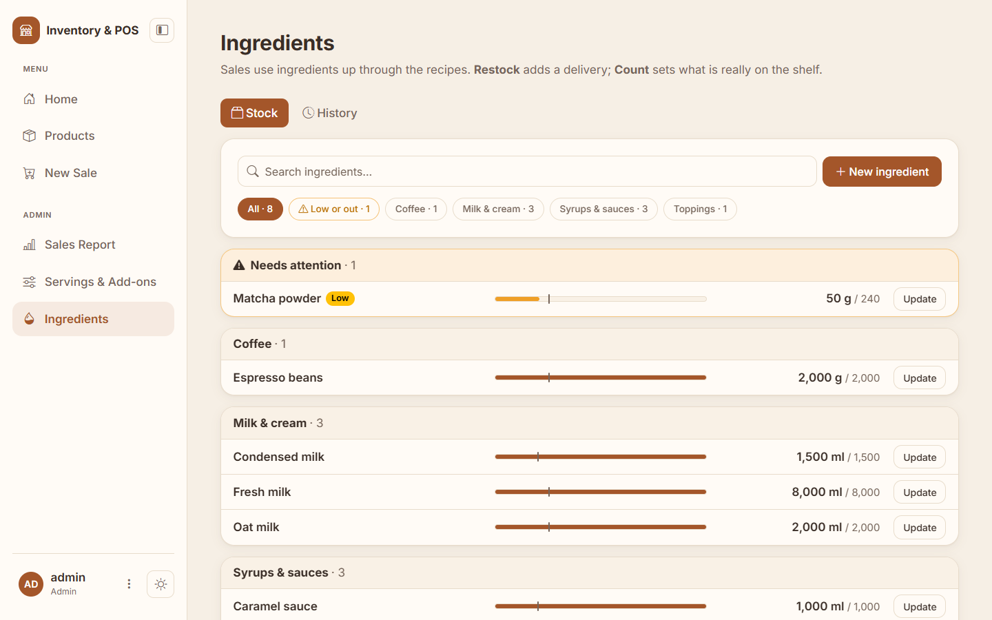
Servings & Add-ons. The admin decides which servings and extras exist, their prices, and whether they are on offer right now.
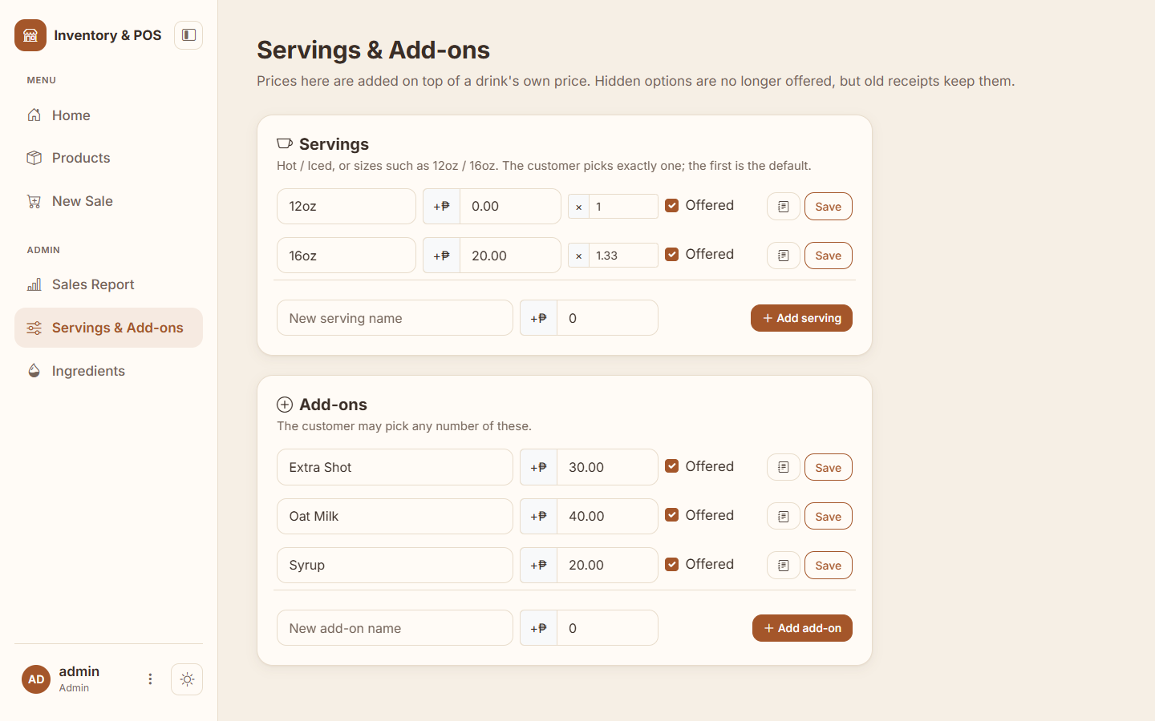
Sales Report. Revenue for any range of dates, split into cash and GCash, with the top five products and a link to every receipt.
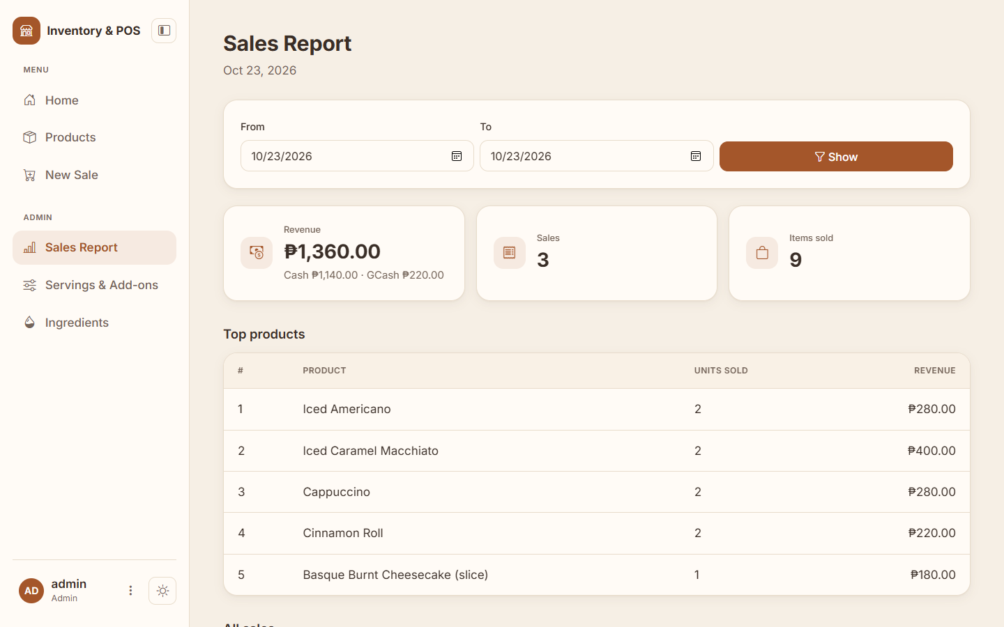
What a cashier sees on an admin page. Hiding a button is not enough, so the server itself refuses.
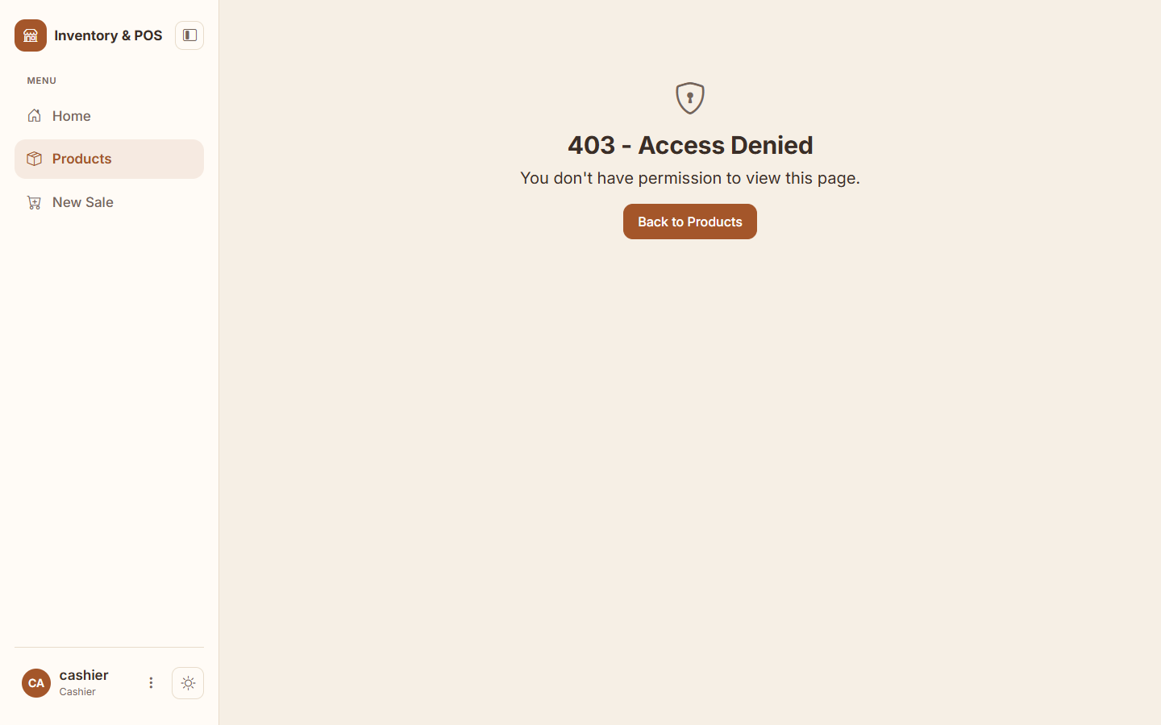
Dark theme and folded sidebar. For evening shifts there is a dark theme, and on wide screens the sidebar folds into a strip of icons to give the menu more room. Both choices are remembered by the browser.
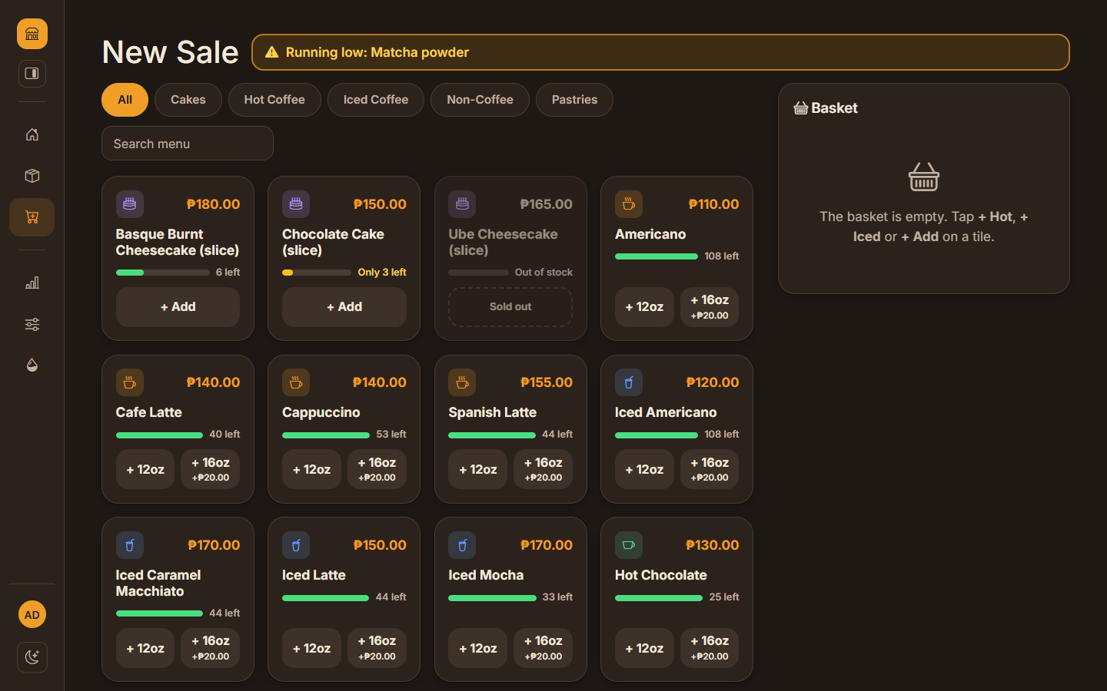
On a phone. The same pages work at phone width; the sidebar slides in from the ☰ button.
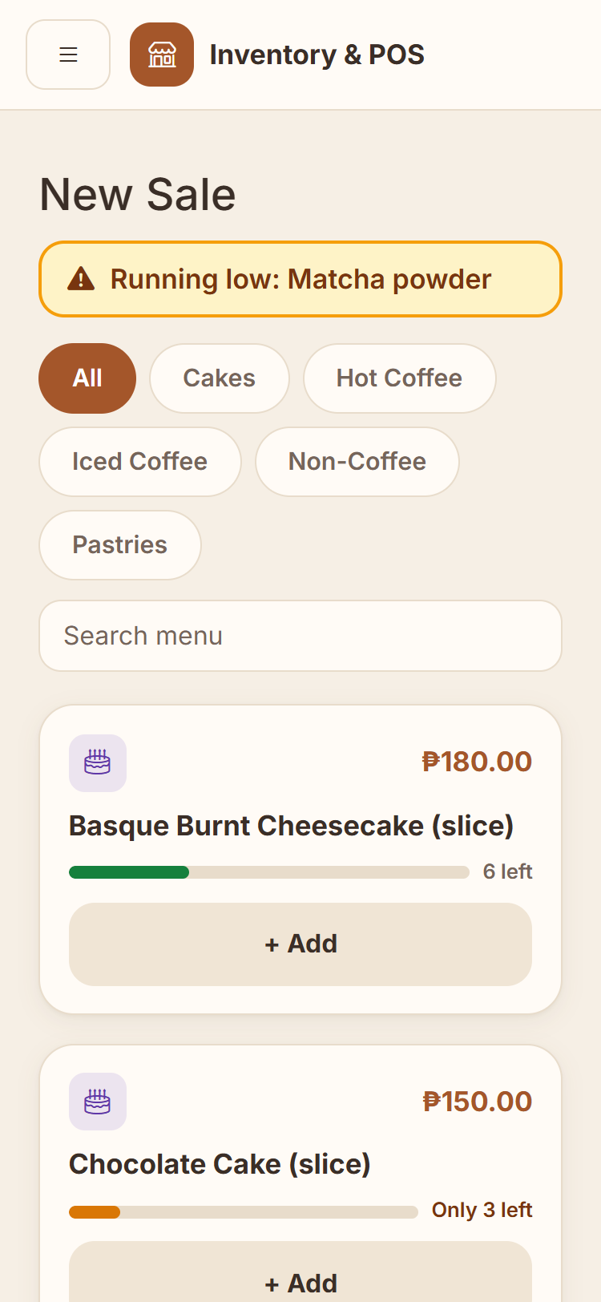

3. Software process model (item 1)

3.1 The model I chose: incremental development
In incremental development a system is built and delivered as a series of small working versions called increments. Each one adds a piece of functionality to the last, and each one can be run, shown and tested. Specification, development and testing overlap instead of happening once, in a fixed order, and what I learned from one increment shaped the next.
That is exactly how this project grew. Every Git tag is one increment, and every increment produced a version that runs:
Increments | What they added
v0.1.0 – v0.7.0 | The foundation: a Flask app, the product table, the product list, add / edit / delete, login and logout, then admin and cashier roles
v0.7.1 | First fixes found by testing: duplicate SKUs, negative prices, empty names, the peso sign
v0.8.0 – v0.8.6 | Sales: basket, cash and change, stock deduction and printable receipts, then five patches that made the sale safe when two tills sell at once and when strange input arrives
v0.9.0 – v0.11.2 | Low-stock warnings, the sales report and demo data, each followed by small patches
v0.12.0 – v0.13.5 | Profile pictures, the modern look with a light and dark theme, then five security patches (secret key, CSRF tokens, login limit, security headers, password change)
v0.14.0 – v0.18.2 | The café: product pictures and a tap-to-add menu, GCash, servings and add-ons, ingredients and recipes, and a redesigned Ingredients page
v0.19.0 – v0.19.4 | Project rules and automated tests on every pull request, a security audit and its patches, and pages that work without internet
v0.20.0 – v0.20.6 | The counter redesign (one-tap tiles, changes on the basket line, quick cash), then the last open defects: SKU capitals, sessions that can be ended, one receipt per basket, return to the requested page after login
v0.21.0 – v0.21.2 | A warmer, roomier look with a foldable sidebar, and a final layout audit of every page

The full list, with dates, commits and pull request numbers, is in Appendix A.

3.2 How each increment was built
Each increment followed the same small cycle:
- Decide what the increment should do, written as a user story (Chapter 4).
- Branch: create feature/<name> for a feature or fix/<name> for a defect.
- Build and test on that branch. From v0.19.0, python tests/run_tests.py checks the project rules and runs every test file in a throw-away copy of the project.
- Pull request on GitHub with three headings: Problem, Change, Testing. GitHub runs the same tests and shows a green tick or a red cross.
- Merge and tag with an annotated tag (git tag -a v0.20.4 -m "…"), so every version can be found again.
- Update this report: the version history, the story, the test cases and any defect found.
I also followed a stabilization rule: when a version has a known defect, it is fixed as a patch (v0.9.1, v0.9.2…) before the next feature starts. This is why most features are followed by one or two patch versions. I broke the rule once on purpose: the counter redesign (v0.20.0) went ahead of three small open defects because I wanted the new counter screen finished first, and those defects were fixed straight after it in v0.20.2–v0.20.4.

3.3 Why incremental, and not the other two?
Model | Why it was or wasn't chosen
Waterfall | Waterfall needs every requirement fixed and signed off before coding starts, and nothing works until the end. I started this project as a beginner, so I could not predict every requirement or how hard each part would be, and the café's needs only appeared halfway through. A mistake found late in a waterfall project is also expensive to fix. Not chosen.
Reuse-oriented | This model builds a system mainly by configuring existing products, for example adapting an off-the-shelf POS. The project has to be my own work, and a system assembled from an existing product would not show that. Not chosen as the main model.
Incremental | It let me learn step by step, always have a working version to show, test each small piece properly, and tag each increment in Git. If time had run out, there would still have been a working system with the most important features. Chosen.

Reuse still plays a part. The system builds on well-known components (Flask, Flask-Login, SQLAlchemy, Bootstrap) like almost every modern project. Sommerville points out that real projects usually combine models, so the honest description is an incremental process that reuses standard framework components.
Weaknesses I saw. The structure can degrade as increments pile up: all routes still live in one app.py file, which was a deliberate choice for the course but is now about 1,600 lines. Progress is also harder to measure against a fixed plan. The project rules (AGENTS.md) and the automated contract check were my answer to the first problem: they stop a later change from quietly removing a protection an earlier increment added.

4. Feature stories (item 2)
Each story follows Sommerville's narrative style: a realistic situation, what the person does, and what the system does in return. The characters are Maria, who owns the café and is the admin, and Jun, her cashier. The version in brackets is where the feature was built.

F1 — Viewing the product list (v0.3.0)
Jun arrives for his morning shift. A customer asks whether there are still croissants. Jun logs in on the counter laptop and opens Products. The system shows every product with its picture, name, SKU, price, how many are in stock and its category. He finds Butter Croissant, sees that 5 are left, and tells the customer.

F2 — Adding a new product (v0.4.0)
The café starts selling cinnamon rolls. Maria logs in and opens Products, where she sees an Add Product button that cashiers don't have. She fills in the name, an SKU (PA-003), the price ₱110.00, the quantity 12 and the category Pastries, and clicks Add Product. The roll appears in the list. Had she reused an SKU, left the name empty or typed a negative price, the form would have come back with a message and nothing would have been saved.

F3 — Editing a product (v0.5.0)
The supplier raises the price of cheesecake. Maria clicks Edit next to it; the form opens already filled in. She changes the price and, after counting the display case, the quantity, then clicks Save Changes. If she changes her mind, Cancel takes her back without saving.

F4 — Deleting a product (v0.5.0)
A seasonal drink that never sold is taken off the menu. Maria clicks Delete, and the browser asks "Delete this product?" to protect against a slip of the finger. She confirms and it disappears. A product that has already been sold cannot be deleted; the system suggests setting its quantity to 0 instead, so old receipts and reports stay correct (v0.10.2).

F5 — Logging in and out (v0.6.0)
Jun types his username and password. The first time he mistypes the password, and the system says "Invalid username or password" without saying which of the two was wrong, so a stranger can't find out which usernames exist. On the second try he is in, and his name and role appear in the sidebar. At the end of his shift he clicks Log out. Anyone who tries to open a page afterwards is sent to the login page, and after logging in they land on the page they first asked for (v0.20.6).

F6 — Admin and cashier permissions (v0.7.0)
Maria wants Jun to sell and look up products, but not change prices. When Jun logs in, the product list shows no Add, Edit or Delete buttons, and the sidebar has no Sales Report, Servings & Add-ons or Ingredients. Curious, he types /products/add into the address bar. The system answers with a 403 – Access Denied page. The check happens on the server, so hiding the buttons is not the only protection.

F7 — Processing a sale (v0.8.0, fixed in v0.8.1)
A customer brings two pastries and a bottle of water to the counter. Jun opens New Sale and adds them to the basket. The basket shows each line's subtotal and the total, and the menu now shows fewer available, because the ones in the basket are spoken for. The customer hands over ₱500; as Jun types it in, the change appears. He clicks Complete Sale. The system checks once more that everything is still in stock, saves the sale, lowers the stock, empties the basket and shows a receipt with the receipt number, date and time, who served, every item, the total, the cash and the change. Print Receipt prints only the receipt. Had the cash been too little, or had another till just sold the last pastry, the system would have refused with a clear message and saved nothing.

F8 — Low-stock warning (v0.9.0, fixed in v0.9.1–v0.9.2)
When Maria opens Products in the morning, a yellow box at the top says "Low stock (4): Ube Cheesecake (0 left), Chocolate Cake (3 left), Cinnamon Roll (4 left), Butter Croissant (5 left)". In the table, the cheesecake has a red Out of stock badge and the others a yellow Low badge. Jun sees the same box, so he can warn her before a customer asks. On a week with dozens of low items, the box shows the five most urgent and says "and 30 more", so the table stays visible (v0.9.1).

F9 — Sales report (v0.10.0, fixed in v0.10.1–v0.10.2)
At closing time Maria clicks Sales Report. Today's report shows the revenue, the number of sales and the items sold, then the top five products and every sale with a link to its receipt. To compare the week she picks a From and To date and clicks Show. She renamed a drink on Wednesday, but the report still counts it as one product (v0.10.1).

F10 — Profile picture (v0.12.0)
Jun logs in for the first time and sees a round badge with his initials at the bottom of the sidebar. He clicks it, chooses Change picture, and uploads a photo from his phone. The circle now shows his photo on every page. When he tries a GIF, the system says it only accepts PNG, JPG or WebP; a 5 MB photo gets "That picture is too big. The limit is 2 MB." Remove picture brings back his initials.

F11 — A modern look with light and dark themes (v0.13.0)
Maria opens the system and finds a sidebar on the left with the pages she may use, the current one highlighted. Home shows today's numbers and shortcuts. In the evening the café lights are dim, so she taps the sun icon beside her name: it becomes a moon and the screen turns dark. Tomorrow it opens dark again, because her browser remembers. A receipt printed from the dark theme is still black on white. On her phone, the sidebar hides behind a ☰ button.

F12 — Account safety (v0.13.1–v0.13.5)
On her first day Maria opens her avatar menu, chooses Change password, and replaces the demo password. A password shorter than 8 characters, or the same as her username, is refused. Later someone at the counter tries to guess her password: after five wrong tries the page says "Too many failed attempts. Please wait 5 minutes and try again.", even if the sixth guess is right. Behind the scenes every form carries a hidden security token, so another website can't make her browser change anything, and the key that protects her login is no longer in the published code.

F13 — Product pictures and a tap-to-add menu (v0.14.0–v0.14.4)
Maria adds a photo to each pastry; products without one show a coloured icon (a hot cup, an iced cup, a pastry, a cake). At the counter, Jun now sees the menu as tiles grouped by category. He taps Pastries, then a croissant twice; each tap adds one, and the Pastries filter stays selected (v0.14.2). On his phone, a bar at the bottom shows "2 items · ₱190.00 — Pay" and jumps to the basket (v0.14.3).

F14 — Paying by GCash (v0.15.0)
A customer orders a latte and a croffle (₱340.00) and wants to pay by GCash. Jun taps GCash: the cash boxes disappear and a box asks for the reference number. The customer pays in the app and shows the confirmation; Jun types the 13-digit reference, checks the amount and completes the sale. The receipt says Paid by GCash with the reference. A reference that was already used is refused and the earlier receipt is named. At closing, the report shows cash (what should be in the drawer) and GCash separately.

F15 — Hot / Iced and add-ons (v0.16.0–v0.16.1, wording v0.17.2)
Maria sets up the servings, Hot and Iced, and the café's extras (Extra Shot +₱30, Oat Milk +₱40, Syrup +₱20) on the Servings & Add-ons page. The Iced serving has its own recipe: 150 g of ice and an iced cup. A latte with Oat Milk appears in the basket as Cafe Latte — Iced, Oat Milk, separate from a plain Hot latte, and the receipt keeps the options and the price paid even if the add-on price changes later.

F16 — Ingredients and recipes (v0.17.0–v0.17.1)
Maria enters what is in the stock room (espresso beans 3,000 g, fresh milk 10,000 ml, oat milk 2,000 ml…) and a recipe for each product: one latte uses 18 g of beans and 160 ml of milk; Oat Milk swaps the fresh milk for oat milk. The menu now shows how many of each drink can still be made. When the oat milk runs low, Home warns her. When a delivery arrives she clicks Restock, and after counting the fridge at night she uses Count. Every change (each sale, delivery and count) appears in the ingredient history with who did it and which receipt it belongs to.

F17 — Finding and updating an ingredient quickly (v0.18.0–v0.18.2)
On Saturday morning the milk delivery arrives. Maria opens Ingredients: Needs attention comes first, then one card per group (Coffee, Milk & cream, Syrups & sauces, Toppings…). Each row has a bar showing how full the shelf is, with a mark at the warning level. She types "oat", clicks Update on Oat milk, taps Fill up to full and Add to stock. The page comes back to the same row with her search still there (v0.18.1). Later she opens History and filters it to see last night's count.

F18 — Changing the system safely (v0.19.0)
A classmate, or an AI coding assistant, is asked to add a new button. Before writing any code they read AGENTS.md, which lists the rules already decided: every admin page needs the admin check, every form needs the security token, stock may only be subtracted with a safe conditional update, no new packages without approval, and every change needs a test. When they finish they run python tests/run_tests.py; it checks those rules and runs every test in a throw-away copy of the project, so the café's real database is never touched. GitHub runs the same checks on their pull request before anyone merges it.

F19 — Serving a queue quickly (v0.20.0–v0.20.1)
It is 3 PM and six customers are waiting. Jun taps + Iced on the Cafe Latte tile: one iced latte is in the basket, with no window to close. The next customer wants oat milk, so he taps that line in the basket; it opens in place, he taps Oat Milk and Done. A second croffle is one tap on +. Each tile shows a bar and how many are left, so he can see that only three iced drinks are possible (the iced cups are low) and that the Matcha tile is greyed out with "Out of Matcha powder". The customer hands over ₱500: Jun taps ₱500, sees the change, and taps the big Complete Sale button. If the laptop is slow and he taps it twice, only one receipt is made (v0.20.4).

F20 — A calmer, roomier screen (v0.21.0–v0.21.2)
Maria works long shifts at the counter, and the old white-and-teal screen felt cramped and cold. She now sees a warm cream page (espresso brown at night) with bigger text and more space between the tiles. When she wants the whole width for the menu she taps the small fold icon beside the system name: the sidebar shrinks to a strip of icons (hovering shows each name) and stays that way the next time she opens the app. On a phone nothing changes; the menu still slides in from the left.

5. Test cases (item 3)

5.1 How the system was tested
Sommerville's test case description gives, for each feature, the input, the tests to run and the expected output. Each feature below starts with that summary where it helps, followed by a table of individual test cases with the expected and the actual result.
The tests were run in several ways, because no single method catches everything:
- Automated tests with Flask's test client. The test client sends requests to the app the way a browser would, but from a script, on a fresh database every time. Since v0.19.0 these tests live in the tests/ folder and run with one command (Appendix B).
- Attack tests. Every security weakness was attacked on the old version first (a forged cookie, a form without its token, 200 password guesses) and attacked again after the fix.
- Race tests on a real multi-threaded server: up to 20 "cashiers" press Complete Sale at the same moment.
- Browser tests in Chromium: clicking, typing, the change preview, light and dark themes, printing, and phone width, each time also checking for JavaScript errors.
- Hand testing by me in the running app, including a seven-round attack drill on 13 October 2026. Several defects in Chapter 10 were found this way.
- Regression testing. After every version, all earlier tests were run again, and a version was only published when everything passed.
The first features (F1–F6) were tested on 3 October 2026 against v0.7.0, while the shop was still a general store, so their test data uses items such as Coke 1.5L and Instant Noodles. Later tests use the café menu.
Reading the HTTP codes: 200 = page shown · 302 = sent to another page · 400 = request refused · 403 = forbidden · 404 = not found · 405 = method not allowed · 429 = too many attempts · 500 = the server crashed.

5.2 F1 — View product list
Input: a request to open /products, with or without being logged in. Tests: 1. Open the page while logged out. 2. Open it while logged in. 3. Check that every saved product appears with all five fields. Output: logged out → redirect to the login page; logged in → table of all products.
ID | Precondition | Steps / input | Expected result | Actual result | Pass?
TC-1.1 | Not logged in | Open /products | Redirect to /login | 302 → /login?next=/products | ✅
TC-1.2 | Logged in as admin, product "Coke 1.5L" exists | Open /products | Table shows Coke 1.5L, BEV-001, price, quantity, category | All fields shown | ✅
TC-1.3 | Not logged in | Open / (home) | Home page loads | 200, home page shown | ✅

5.3 F2 — Add product
Input: name (text, required), SKU (text, required, must be unique), price (decimal number), quantity (whole number), category (optional text). Tests: 1. All fields valid. 2. Category left empty. 3. SKU already used. 4. Price not a number. 5. Negative price or quantity. 6. Empty name. Output: valid input → product saved and shown in the list; invalid input → a clear error message and nothing saved.
ID | Precondition | Steps / input | Expected result | Actual result | Pass?
TC-2.1 | Logged in as admin | Coke 1.5L, BEV-001, 75.50, 24, Beverages | Saved; redirect to list; shown as 75.50 | Saved, redirect, shown | ✅
TC-2.2 | Admin | Noodles, FD-001, 15, 10, (no category) | Saved with empty category | Saved | ✅
TC-2.3 | Admin, BEV-001 already exists | Dup, BEV-001, 1, 1 | Error message "SKU already exists"; nothing saved | 500 server crash (database unique-constraint error not handled) (also confirmed by hand: IntegrityError) · v0.7.1: red message, nothing saved (confirmed by hand) | ❌→✅ DEF-01
TC-2.4 | Admin | price = abc (sent without the browser's check) | Error message; nothing saved | 500 server crash · v0.7.1: error message, nothing saved | ❌→✅ DEF-02
TC-2.5 | Admin | price = -5, quantity = -3 | Rejected: price and quantity cannot be negative | Accepted and saved with negative values (negative price also confirmed by hand) · v0.7.1: rejected by browser (min="0") and by server | ❌→✅ DEF-03
TC-2.6 | Admin | name = (empty), sent without the browser's check | Rejected: name required | Accepted; product saved with no name · v0.7.1: rejected with message | ❌→✅ DEF-04

Why "sent without the browser's check"? The form's HTML has required and type="number", so a normal browser stops you before sending. But anyone can bypass the browser (with developer tools or a script), so the server must check again. This is called server-side validation, and it is a standard security rule: never trust input from the client.

5.4 F3 — Edit product
Input: a product ID in the address (/products/edit/<id>) and the same fields as F2. Tests: 1. Form opens pre-filled. 2. Valid change is saved. 3. Product ID doesn't exist. 4. SKU changed to one another product uses. Output: changes saved and shown; a missing product gives "not found"; a duplicate SKU gives a clear error.
ID | Precondition | Steps / input | Expected result | Actual result | Pass?
TC-3.1 | Admin, product 1 exists | Open /products/edit/1 | Form pre-filled with current values | Pre-filled | ✅
TC-3.2 | Admin | Change price 75.50 → 80, quantity 24 → 20, save | Saved; list shows new values | Saved (80.0, 20) | ✅
TC-3.3 | Admin | Open /products/edit/999 | 404 Not Found | 404 | ✅
TC-3.4 | Admin, FD-001 belongs to another product | Change product 1's SKU to FD-001 | Error "SKU already exists" | 500 server crash · v0.7.1: error message, nothing changed | ❌→✅ DEF-01

5.5 F4 — Delete product
Input: a product ID, sent with a POST request (the Delete button). Tests: 1. Delete an existing product. 2. Delete a product that doesn't exist. 3. Try to delete with a plain link visit (GET) instead of the button. Output: product removed; missing ID → 404; GET → refused.
ID | Precondition | Steps / input | Expected result | Actual result | Pass?
TC-4.1 | Admin, product 2 exists | Click Delete on product 2, confirm | Removed from database and list | Removed | ✅
TC-4.2 | Admin | POST /products/delete/999 | 404 | 404 | ✅
TC-4.3 | Admin | Visit /products/delete/2 as a normal link (GET) | Refused (deleting through a link is unsafe) | 405 Method Not Allowed | ✅
TC-4.4 | Admin | Click Delete, then Cancel in the pop-up | Product kept | Browser test on v0.21.2 (2026-10-23): pop-up "Delete this product?", Cancel chosen; all 17 products still listed | ✅

Why does TC-4.3 matter? If deleting worked through a simple link, a web crawler or a malicious link in an email could delete products just by visiting it. Requiring POST (a form submission) prevents that.

5.6 F5 — Log in / log out
Input: username and password. Tests: 1. Correct details. 2. Wrong password. 3. Username that doesn't exist. 4. Username in different capitals. 5. Logout. 6. Protected page after logout. 7. Passwords are not stored in plain text. Output: correct → logged in and sent to Products; wrong → the same general error message; logout → protected pages locked again.
ID | Precondition | Steps / input | Expected result | Actual result | Pass?
TC-5.1 | Users exist | admin / admin123 | Redirect to Products; navbar shows "admin (admin)" | As expected | ✅
TC-5.2 | — | admin / wrong | "Invalid username or password" | Shown | ✅
TC-5.3 | — | ghost / x | Same message as TC-5.2 (doesn't reveal which part was wrong) | Same message | ✅
TC-5.4 | — | ADMIN / admin123 | Design decision: usernames are case-sensitive → rejected | Rejected | ✅
TC-5.5 | Logged in | Click Logout | Logged out; redirect to home | 302 → / | ✅
TC-5.6 | Just logged out | Open /products | Redirect to login | 302 → /login | ✅
TC-5.7 | Users created | Look at the password_hash column in the database | A hash, not the real password | Stored as scrypt:32768:8:1$… hash | ✅
TC-5.8 | Not logged in | Open /products/add → log in | After login, return to the page originally requested | v0.7.1–v0.20.5: always goes to /products (the next value is ignored) · v0.20.6: returns to the requested page; test_login_next.py also checks that other-website links are ignored (TC-24.1–24.4) | ❌→✅ DEF-06

5.7 F6 — Role-based access (Admin vs. Cashier)
Input: a logged-in user with role admin or cashier, requesting product-management pages. Tests: 1. Cashier sees no management buttons. 2. Cashier types each admin address directly. 3. Cashier sends a hidden form submission. 4. Admin keeps full access. Output: cashier → view only, every admin action refused with 403; admin → full access.
ID | Precondition | Steps / input | Expected result | Actual result | Pass?
TC-6.1 | Logged in as cashier | Open /products | No Add button; "View only" instead of Edit/Delete | As expected (also checked by hand) | ✅
TC-6.2 | Cashier | Type /products/add in the address bar | 403 Access Denied page | 403 page (also checked by hand) | ✅
TC-6.3 | Cashier | Open /products/edit/1 | 403 | 403 | ✅
TC-6.4 | Cashier | Send a POST to /products/add with product data | 403; nothing saved | 403 | ✅
TC-6.5 | Cashier | Send a POST to /products/delete/1 | 403; product still exists | 403; product still exists | ✅
TC-6.6 | Logged in as admin | Add / edit / delete | All allowed | Allowed (also checked by hand) | ✅

5.8 F7 — Process sale (v0.8.0, v0.8.1)
Input: products and quantities added to a basket; cash received from the customer. Tests: 1. Building the basket (adding, merging, removing). 2. Stock limits, including what is already in the basket. 3. Invalid quantities and products. 4. Cash checks. 5. Completing a sale and its effect on stock. 6. Receipts, including old ones. 7. Who can sell, and basket privacy. Output: valid sale → saved, stock reduced, receipt shown; anything invalid → clear message and nothing saved.
How these were run. On 2026-10-08 against the code tagged v0.8.0 (1343236) using the Flask test client, plus a real browser (Chromium) for the JavaScript change preview; v0.8.1 (538ce09) was re-tested the same day, including on a copy of the real database. Cases marked (by hand) were also confirmed by me in the running app.
ID | Precondition | Steps / input | Expected result | Actual result | Pass?
TC-7.1 | Not logged in | Open /sales/new | Redirect to login | 302 → /login | ✅
TC-7.2 | Cashier; Coke ₱75.50, Noodles ₱15 | Add Coke × 2, Noodles × 3 | Two lines; total ₱271.50 | As expected (by hand: Sample Item × 1 + A × 2 = ₱26.19, screenshot S2) | ✅
TC-7.3 | Coke × 2 in basket | Add Coke × 1 again | One line, × 3 (not two lines) | One line, × 3 | ✅
TC-7.4 | Noodles: 10 in stock | Add 3 → look at dropdown; add the other 7 | "7 available"; then Noodles leaves the dropdown; database stock stays 10 until the sale is completed | As expected (by hand: A 39 / Sample Item 38 before; 37 / 37 available with A × 2 and Sample Item × 1 in the basket, screenshots S3–S4) | ✅ (DEF-10)
TC-7.5 | Coke: 5 in stock, 3 in basket | Add Coke × 3 | "only 2 more can be added"; basket unchanged | As expected (by hand: "Not enough stock for A: only 39 more can be added.", screenshot S5) | ✅
TC-7.6 | Cashier | Quantity 0, −2, abc | "Quantity must be a whole number of at least 1." | As expected | ✅
TC-7.7 | Cashier | No product chosen; product ID 999 | "Please choose a product." | As expected | ✅
TC-7.8 | Soap: 0 in stock | Look at dropdown; send a hand-made request for Soap × 1 | Not listed; request refused | Not listed; "only 0 more can be added" | ✅
TC-7.9 | Two lines in basket | Remove one | Line gone; total updates | As expected | ✅
TC-7.10 | Empty basket | Complete Sale | "The basket is empty." | As expected | ✅
TC-7.11 | Basket total ₱226.50 | Cash ₱200; abc; nothing | "Cash received must be a number of at least ₱226.50."; no sale saved | As expected; 0 sales saved | ✅
TC-7.12 | Noodles × 3 in basket; stock then lowered to 2 elsewhere | Complete Sale | "…no longer has enough stock"; nothing saved, no stock changed | As expected | ✅
TC-7.13 | Basket Coke × 3 (₱226.50), Coke stock 5 | Cash ₱500 → Complete Sale | Receipt: number, date, "Served by", items, total ₱226.50, cash ₱500.00, change ₱273.50; Coke stock 5 → 2; basket emptied | As expected (by hand: receipt #4 ₱12.40, ₱500 cash → ₱487.60 change; receipt #6 ₱3.10, ₱10 cash → ₱6.90 change; A's stock 39 → 37 after receipts #6 and #7, screenshots S8, S1) | ✅
TC-7.14 | Basket ₱15.00 | Cash exactly ₱15 | Change ₱0.00 | Change ₱0.00 | ✅
TC-7.15 | Logged in as admin | Complete a sale | Allowed; "Served by: admin" | As expected | ✅
TC-7.16 | Receipt for Coke at ₱75.50 exists | Change Coke's price, then delete Coke; reopen receipt | Receipt still shows "Coke 1.5L" at ₱75.50 | As expected (since v0.10.2 a sold product can no longer be deleted; the receipt keeps the name and price from the time of sale after a rename or price change) | ✅
TC-7.17 | Items in basket | Logout → log in as another user → New Sale | Basket empty | Empty | ✅ (DEF-09)
TC-7.18 | Two browsers logged in | Add items in one | Other browser's basket unaffected | Unaffected | ✅
TC-7.19 | Basket ₱151.00 (browser) | Type cash 100, then 200 | Change box: "Not enough cash", then ₱49.00 | As expected; no script errors (by hand: ₱3.10 total, cash 2 → "Not enough cash", cash 10 → ₱6.90, screenshots S6–S7) | ✅
TC-7.20 | Receipt open | Print Receipt → print preview | Only the receipt; no navbar or buttons | (by hand, 2026-10-08) Print preview of receipt #7 shows only the receipt card: no navigation bar, no Print/New Sale buttons (screenshot S9) | ✅
TC-7.21 | Receipt #1–#3, made before cash was recorded | Open the receipt | No misleading cash amount | v0.8.0: "Cash ₱0.00 / Change ₱0.00" · v0.8.1: "Cash and change not recorded…"; #4 unchanged (checked on a copy of the real database) | ❌→✅ DEF-12
TC-7.22 | Logged in | /sales/999; visit /sales/complete as a link (GET) | 404; 405 | 404; 405 | ✅
TC-7.23 | Database from before v0.8.0's cash columns | Complete Sale | Sale saved | Crash "table sale has no column named cash_received" (by hand) → fixed by adding the columns; sale then saved | ❌→✅ DEF-11

Hand-test screenshots (v0.8.0, 2026-10-08, logged in as cashier)
# | Test | Screenshot
S1 | TC-7.13: Products page after receipts #6 and #7, stock of A reduced to 37 | !Products page with reduced stock
S2 | TC-7.2: basket with two lines and total ₱26.19 | !Basket with two lines
S3 | TC-7.4: dropdown before adding to the basket (A 39, Sample Item 38 available) | !Dropdown before basket
S4 | TC-7.4: dropdown with items in the basket (both 37 available) | !Dropdown showing available stock
S5 | TC-7.5: adding more than is available is refused | !Not enough stock message
S6 | TC-7.19: live change preview, ₱10 cash → ₱6.90 change | !Change preview
S7 | TC-7.19: cash lower than the total → "Not enough cash" | !Not enough cash
S8 | TC-7.13: receipt #6 with cash and change | !Receipt with cash and change
S9 | TC-7.20: print preview shows only the receipt | !Print preview
S10 | TC-7.21 (v0.8.1): a receipt made before cash tracking says "Cash and change not recorded" | !Old receipt: not recorded

5.9 Patches v0.8.2–v0.8.6 — robustness of the sale flow and forms
Found by the v0.8.x stabilization phase (design review, exploratory and fuzz testing). Run on 2026-10-09 with the Flask test client, a real threaded server for the stress test, and the previous version for the "before" column.
ID | Steps / input | Expected result | Before the fix | After the fix | Pass?
TC-7.24 | 1 left; another sale takes it between this sale's check and save; this sale continues | Refused; stock 0 | Both sales saved; DB stock 0 but really −1 (oversold) | Refused with message; stock 0 | ❌→✅ v0.8.2
TC-7.25 | 10 left; another sale of 3 lands mid-sale; this sale buys 5 | Both saved; stock 2 | DB says 5, really 2 (lost update) | Stock 2 | ❌→✅ v0.8.2
TC-7.26 | 20 cashiers press Complete Sale at the same moment; 5 in stock | Exactly 5 sold | 20 sold, DB showed 2 left | 5 sold, 15 refused, stock 0, no errors | ❌→✅ v0.8.2
TC-7.27 | Basket Bread × 2 + Milk × 1; Milk sells out mid-sale | Whole sale refused; Bread stock unchanged | Bread deducted, Milk oversold | Refused; Bread still 5; basket kept | ❌→✅ v0.8.2
TC-7.28 | Cash nan, inf, -inf, 1e308, 1000000.01 | Refused with message | nan crashed (500); inf/1e308 saved | All refused; 1000000 accepted | ❌→✅ v0.8.3
TC-2.7 | Price nan, inf, 1e400, 1000000.01; quantity 1000001 or 99999999999999999999 | Refused with message | nan and huge quantity crashed; inf saved | All refused; exactly 1,000,000 accepted | ❌→✅ v0.8.3
TC-7.29 | /sales/99999999999999999999, /products/edit/…, delete, add to basket with that id | 404 / "Please choose a product" | Server crash (500) | 404 / message; cashier still gets 403 first | ❌→✅ v0.8.4
TC-7.30 | Admin deletes a product that is in a cashier's basket; cashier refreshes or clicks Complete Sale | Product taken out, sale can finish | Basket stuck: hidden line, Complete Sale always failed | Removed with a note; total updated; sale completes | ❌→✅ v0.8.5
TC-2.8 | Name of 101 characters; SKU or category of 51 | Refused with message | 5,000-character name saved | Refused; exactly 100/50/50 accepted | ❌→✅ v0.8.6
TC-7.31 | Fuzz: 14 odd inputs (empty, spaces, abc, nan, huge, full-width digits, <script>, SQL text, 5,000 characters) on every form and address | No crash; nothing invalid stored | — | 0 crashes; <script> shown as text; SQL text stored as plain text (no SQL injection) | ✅

5.10 F8 — Low-stock warning (v0.9.0, v0.9.1, v0.9.2)
ID | Precondition | Steps / input | Expected result | Actual result | Pass?
TC-8.1 | Product with 0 | Open Products | Red "Out of stock" badge; listed first in the box | As expected | ✅
TC-8.2 | Product with exactly 5 | Open Products | Yellow "Low" badge; in the box (5 counts as low) | As expected | ✅
TC-8.3 | Product with 6 | Open Products | No badge; not in the box | As expected | ✅
TC-8.4 | Logged in as cashier | Open Products | Same box and badges | As expected | ✅
TC-8.5 | Product with 6 | Sell 1 through New Sale | It appears in the box ("5 left") | As expected | ✅
TC-8.6 | All low products restocked above 5 | Open Products | No box at all | As expected | ✅
TC-8.7 | Empty product list; product added with 3; low product deleted | Open Products | No crash; new product flagged; deleted one gone | As expected | ✅
TC-8.8 | 40 products, 35 of them low, long names | Open Products | Box stays readable; table visible | v0.9.0: ~4,500-character box filled the screen · v0.9.1: 5 names (shortened) + "and 30 more" | ❌→✅ DEF-18
TC-8.9 | Product without category | Open Products | Empty cell or dash | v0.9.0: word "None" · v0.9.2: dash | ❌→✅ DEF-19

5.11 F9 — Sales report (v0.10.0, v0.10.1, v0.10.2)
ID | Precondition | Steps / input | Expected result | Actual result | Pass?
TC-9.1 | Cashier / visitor | Open /reports/sales | 403 / login page; cashier has no navbar link | As expected | ✅
TC-9.2 | Sales today at 00:01 and now; one at 23:59 yesterday | Report for today | Only today's two counted (revenue, sales, items) | ₱231.00, 2 sales, 10 items | ✅
TC-9.3 | Same data | Report for yesterday only; 4-day range | Correct totals | ₱755.00 / 1 sale; ₱1,061.50 / 4 sales | ✅
TC-9.4 | Same data | To date before From date | Dates swapped automatically | Same result as correct order | ✅
TC-9.5 | — | Dates 2026-13-45, 2026-02-30, 1999-12-31, 2101-01-01, 9999-12-31 | Message; today's report | Message + today (the 9999 date crashed before release: DEF-24) | ✅
TC-9.6 | No sales in period | Report for 2020 | ₱0.00, 0 sales, "No sales in this period." | As expected | ✅
TC-9.7 | Bread sold 4; Cola sold 3, renamed "Cola 1.5L", sold 2 more | Top products | Cola 1.5L first with 5 units | v0.10.0: "Cola" 3 and "Cola 1.5L" 2 separately; Bread wrongly #1 · v0.10.1: one row, 5 units, #1 | ❌→✅ DEF-20
TC-9.8 | Product with sales history | Admin clicks Delete | Refused with message; product kept | v0.10.0: deleted; its id could be reused by a new product that "inherits" the sales · v0.10.2: refused, message shown once | ❌→✅ DEF-21
TC-9.9 | Product never sold | Admin clicks Delete | Deleted | Deleted | ✅
TC-9.10 | Bread's sales exist; Bread deleted (before v0.10.2) | Report | Its sales still counted | ₱120.00 kept | ✅

5.12 Demo data (v0.11.0, v0.11.1, v0.11.2)
ID | Steps / input | Expected result | Actual result | Pass?
TC-10.1 | Fresh database → python seed_demo_data.py | 15 products, 2 users, past sales; 4 low products | 15 products, 27 sales over 7 days (₱6,904.50), 4 low | ✅
TC-10.2 | Run it a second time | Nothing added twice | "(sales already exist…)" | ✅
TC-10.3 | Sales report for the demo week | Receipt numbers increase with time | v0.11.0: #25 at 9:27 AM after #23 at 6:13 PM · v0.11.1: in time order | ❌→✅ DEF-22
TC-10.4 | Any amount ≥ ₱1,000 (report, receipt, products, change preview, messages) | Thousands separator | v0.11.1: ₱6904.50 · v0.11.2: ₱6,904.50 | ❌→✅ DEF-23

5.13 F10 — Profile picture (v0.12.0)
ID | Precondition | Steps / input | Expected result | Actual result | Pass?
TC-11.1 | User without a picture | Open any page | Circle with initials (admin → AD) and the avatar menu | As expected | ✅
TC-11.2 | Logged in | Upload a PNG | Circle shows the picture; file saved under a random name | user1_<random>.png saved and shown | ✅
TC-11.3 | Picture already set | Upload a JPG | New picture shown; old file deleted | As expected | ✅
TC-11.4 | Picture set | Click Remove picture | Initials again; file deleted | As expected | ✅
TC-11.5 | Logged in | Upload a text file renamed to .png | Refused: "isn't a PNG, JPG or WebP picture" | Refused (the file's first bytes are checked, not its name) | ✅
TC-11.6 | Logged in | Upload a GIF | Refused with the same message | Refused | ✅
TC-11.7 | Logged in | Upload a 3 MB file | "That picture is too big. The limit is 2 MB."; no crash | As expected | ✅
TC-11.8 | Database from v0.11.2 (no avatar column) | Start the app | Column added automatically; old sales still work | Added by upgrade_database(); cash sale OK | ✅
TC-11.9 | Picture file deleted from the server by hand | Open any page | Initials instead of a broken image | As expected | ✅
TC-11.10 | Logged in | Open /profile/remove in the address bar (GET) | 405, picture kept | 405 | ✅
TC-11.11 | Visitor | Open /profile | Login page | As expected | ✅

Screenshots: profile picture (v0.12.0)
# | Test | Screenshot
S11 | TC-11.1: no picture yet, initials "AD"; the avatar menu with Change picture, Change password, Log out | !Avatar menu
S12 | TC-11.5: a text file named .png is refused | !Not a picture
S13 | TC-11.2: picture uploaded and shown in a circle (page and sidebar) | !Profile picture

5.14 F11 — Modern theme (v0.13.0)
ID | Precondition | Steps / input | Expected result | Actual result | Pass?
TC-12.1 | Admin | Open Products, then Add Product | Sidebar highlights Products on both pages | As expected | ✅
TC-12.2 | Cashier | Look at the sidebar | No Sales Report link | As expected | ✅
TC-12.3 | Any page | Click Dark mode, then reload | Dark theme with amber accent; still dark after reload | As expected | ✅
TC-12.4 | Dark mode | Print a receipt | Printout in light colours, no sidebar; dark again after printing | As expected | ✅
TC-12.5 | Window 390 px wide (phone) | Open Home, tap ☰ | Top bar with menu button; sidebar slides in | As expected | ✅
TC-12.6 | Font server slow or unreachable | New Sale: type the cash received | Change preview updates | v0.13.0 draft: stuck at ₱0.00 · released v0.13.0: updates | ❌→✅ DEF-25
TC-12.7 | Demo data | Admin opens Home | Products 15, Low stock 4, today's sales and revenue match the report for today | As expected | ✅
TC-12.8 | Visitor | Open /products | Login page with a styled "Please log in" message | v0.11.2: message shown as plain text · v0.13.0: blue info box | ❌→✅ DEF-26
TC-12.9 | All earlier tests | Run the full regression suite | Everything still passes | All 10 suites + 17 avatar checks pass | ✅
TC-12.10 | Light theme, logged in | Look at the bottom of the sidebar; hover the icon; click it; reload | Only a sun icon (no words) beside the user's name, tooltip "Switch to dark mode"; after the click a moon and "Switch to light mode"; still dark after reload | v0.19.0: a wide button with the words "Dark mode" · v0.19.1: as expected | ✅
TC-12.11 | Login page and phone (390 px) | Look at the switch; tap it | Same icon rule (sun = light, moon = dark), 40 × 40 px, works on the phone menu | As expected | ✅
TC-12.12 | Screen reader user | Read the switch's label | "Switch to dark mode" / "Switch to light mode" (the icon alone would say nothing) | As expected | ✅
TC-12.13 | Logged in (100 %, 110 %, 125 % text size; phone) | Open the avatar menu | Every line fits inside the menu, "Signed in as Admin" on one line | v0.19.1: "Change picture" and "Change password" ran past the menu's right edge (menu squeezed to 167 px) · v0.19.2: fits at every size (209 px at 100 %) | ❌→✅ DEF-46

Screenshots: modern theme (v0.13.0)
# | Test | Screenshot
S14 | TC-12.3 / TC-12.7: Home in the light theme with today's numbers and the low-ingredient warning | !Home, light
S15 | TC-12.3: the same page in the dark theme | !Home, dark
S16 | TC-12.4: printing a receipt from dark mode gives a light page without the sidebar | !Print from dark
S17 | TC-12.5: phone (390 px), the sidebar slides in from the menu button | !Phone menu
S18 | TC-12.8: "Please log in" as a blue info box | !Login message
S43 | TC-12.10 (v0.19.1): the switch beside the user's name, sun in the light theme (left, with its hover border) and moon in the dark theme (right) | !Theme icon
S44 | TC-12.11 (v0.19.1): the same icon on the login page and in the phone menu | !Login and phone
S45 | TC-12.13: avatar menu in v0.19.1 (left: words run past the edge), v0.19.2 (middle) and v0.19.2 with 125 % text (right) | !Avatar menu width

5.15 F12 — Security patches (v0.13.1–v0.13.5)
Each row is an attack or misuse tried on purpose (on the code published as v0.13.0), then again after the fix.
ID | Attack / input | Expected result | Actual result | Pass?
TC-13.1 | Build a login cookie with the secret key published on GitHub, open the Sales Report | Refused | v0.13.0: Sales Report opened as admin with no password · v0.13.1: sent to the login page | ❌→✅ DEF-07
TC-13.2 | Restart the app | Same secret key (users stay logged in); instance/ ignored by git; SECRET_KEY environment variable wins | As expected | ✅
TC-13.3 | Logged in as admin, send "Add product" without the hidden token / with a wrong token | Refused (400), nothing added | v0.13.0: product added · v0.13.2: 400 "This form has expired", nothing added | ❌→✅ DEF-08
TC-13.4 | Every POST form on Products, New Sale, Profile, Add, Edit | Each carries a token | All forms counted: tokens = forms | ✅
TC-13.5 | Open /logout as a link (GET) | Not allowed (405); logout only by button | v0.13.0: logged out · v0.13.2: 405 | ❌→✅ DEF-28
TC-13.6 | Session cookie | HttpOnly and SameSite=Lax | As expected | ✅
TC-13.7 | 200 wrong passwords for admin, then the right one | Locked after 5 tries | v0.13.0: right password accepted after 200 guesses · v0.13.3: 6th try → 429 "Too many failed attempts" | ❌→✅ DEF-27
TC-13.8 | Locked cashier; admin logs in from elsewhere / 4 wrong then right / wait 5 minutes | Other accounts unaffected; 4 wrong still OK; lock ends | As expected | ✅
TC-13.9 | Page headers | X-Frame-Options: DENY, X-Content-Type-Options: nosniff, Referrer-Policy: same-origin | v0.13.0: none · v0.13.4: all three | ❌→✅ DEF-29
TC-13.10 | Start with python app.py | Debug console off unless FLASK_DEBUG=1 | v0.13.0: debug=True · v0.13.4: off | ❌→✅ DEF-30
TC-13.11 | Change password: wrong current / not matching / same as username / shorter than 8 | Refused with a message each | As expected | ✅
TC-13.12 | Change password correctly, then log in with old and new | Old refused, new works | As expected | ✅ (DEF-31 fixed)
TC-13.13 | Log in with admin' OR '1'='1 (SQL injection) | Refused | Refused (SQLAlchemy sends input as data) | ✅
TC-13.14 | Product named <script>alert(1)</script> (XSS) | Shown as text | Shown as text (Jinja escapes it) | ✅

Screenshots: security patches (v0.13.2–v0.13.5)
# | Test | Screenshot
S19 | TC-13.3: a form sent without its security token is refused ("This form has expired") | !Form without token
S20 | TC-13.7: after 5 wrong passwords the login waits 5 minutes | !Too many attempts
S21 | TC-13.11: a new password shorter than 8 characters is refused by the server (the browser's own check was switched off for this test) | !Password too short

5.16 F13 — Product pictures and café menu (v0.14.0–v0.14.3)
ID | Precondition | Steps / input | Expected result | Actual result | Pass?
TC-14.1 | Database from v0.13 (no image column) | Start the app | Column added automatically | Added | ✅
TC-14.2 | Admin | Add a product with a PNG | Saved under a random name in static/products/; shown in the list | As expected | ✅
TC-14.3 | Admin | Add with a text file named .png / a GIF on edit | Refused with a message; nothing saved | As expected | ✅
TC-14.4 | Admin | Add with no file | Allowed; icon tile shown | As expected | ✅
TC-14.5 | Products named Iced Latte, Butter Croissant, Chocolate Cake, Americano, Hot Chocolate, Bottled Water | Look at the icons | Iced cup, pastry, cake, hot cup, cup, box | As expected | ✅
TC-14.6 | Product with a picture | Edit without a file / with a JPG / tick "Remove the picture" | Kept / replaced (old file deleted) / removed (file deleted) | As expected | ✅
TC-14.7 | Admin | 3 MB picture on Add Product | Back to Add Product with "too big" | Draft: sent to the profile page · v0.14.0: back to the form | ❌→✅ (fixed before release)
TC-14.8 | Product never sold / with sales | Delete it | Picture deleted / product and picture kept | As expected | ✅
TC-14.9 | Picture file missing, or name set to ../../app.py | Show the product; delete it | Icon tile; app.py untouched | As expected | ✅
TC-14.10 | Duplicate SKU + new picture on Edit | Save | Error; no stray picture file | As expected | ✅
TC-14.11 | Café demo data | New Sale | One tile per product in stock; sold-out Ube Cheesecake not shown; category buttons | As expected | ✅
TC-14.12 | New Sale | Tap a tile | 1 added; "left" count goes down | As expected | ✅
TC-14.13 | Product name of 100 letters without spaces | New Sale and Products | Wraps inside its tile / cell | v0.14.0: spilled over the basket · v0.14.1: wraps | ❌→✅ DEF-32
TC-14.14 | Menu with drinks and pastries | Look at the order; tap a pastry while "Pastries" is chosen | Grouped by category; Pastries still chosen | v0.14.1: A–Z mixed, filter reset to All after each tap · v0.14.2: as expected | ❌→✅ DEF-33, DEF-34
TC-14.15 | Phone (390 px), 2 items in basket | Look at the screen; tap the bar | Bar "2 items · ₱130.00 — Pay"; jumps to Complete Sale | v0.14.2: basket only after scrolling past the whole menu · v0.14.3: as expected | ❌→✅ DEF-35
TC-14.16 | Phone, basket table | Read the names | Normal names on one line | v0.14.1–v0.14.2: "Ensaymada" one letter per line · v0.14.3: fixed | ❌→✅ DEF-36
TC-14.17 | seed_demo_data.py --fresh at 3:30 PM | Run it | Old database renamed as a backup; 22 café items; sales for 7 days + today until 3:30 PM only; receipt numbers in time order | As expected (today: 4 sales, 7:09 AM–2:32 PM) | ✅
TC-14.18 | All earlier tests | Full regression (10 suites + avatar + security + pictures) | Everything passes | As expected | ✅
TC-14.19 | Window 992–1360 px wide, 3 items in the basket | Look at the basket | Remove (×) button visible on every line | v0.14.3: cut off at the right edge · v0.14.4: visible at 390, 768, 992, 1100, 1199, 1200 and 1360 px | ❌→✅ DEF-37

Screenshots: product pictures and menu (v0.14.0–v0.14.3)
# | Test | Screenshot
S22 | TC-14.2: adding a product with a picture | !Add product with picture
S23 | TC-14.11: New Sale menu: picture or icon tiles, category buttons, "left" counts | !Menu tiles
S24 | TC-14.13 (v0.14.1): a 100-letter name wraps inside its tile | !Long name wraps
S25 | TC-14.15 (v0.14.3): phone basket bar "2 items · ₱175.00 — Pay" | !Phone basket bar

5.17 F14 — Payment method (v0.15.0)
ID | Precondition | Steps / input | Expected result | Actual result | Pass?
TC-15.1 | Database from v0.14 | Start the app | payment_method, payment_reference and a unique index added; old sales count as cash | As expected | ✅
TC-15.2 | Basket ₱360 | Pay cash ₱400 (old form, no method sent) | Cash, change ₱40 | As expected | ✅
TC-15.3 | Basket ₱360 | GCash, reference 1234 567 890123 | Saved as 13 digits, cash = total, change 0, stock deducted | As expected | ✅
TC-15.4 | GCash sale | Open the receipt | "Paid by GCash" + reference, no Change line | As expected | ✅
TC-15.5 | Basket | GCash references: 12 digits, 14 digits, letters, Arabic digits, empty | Refused, nothing saved, stock unchanged | As expected (5 cases) | ✅
TC-15.6 | Reference already used | GCash with the same reference | Refused, names the earlier receipt | As expected | ✅
TC-15.7 | Two sales with the same reference at the same moment | Save both | Database refuses the second (unique index) | As expected | ✅
TC-15.8 | Basket | Method card (not offered) | Refused | As expected | ✅
TC-15.9 | Sales of both kinds | Sales Report | Revenue split "Cash ₱… · GCash ₱…"; Paid by column | As expected | ✅
TC-15.10 | Browser | Tap GCash, then Cash | Cash boxes hide/show; empty reference blocked by the browser; change preview still works | As expected | ✅

Screenshots: payment method (v0.15.0)
# | Test | Screenshot
S26 | TC-15.10: GCash chosen: the cash boxes are replaced by the 13-digit reference | !GCash payment
S27 | TC-15.4: receipt "Paid by GCash" with the reference, options under each drink | !GCash receipt
S28 | TC-15.9: Sales Report revenue split "Cash ₱… · GCash ₱…" and a Paid by column | !Report cash and GCash

5.18 F15 — Sizes and add-ons (v0.16.0, v0.16.1)
ID | Precondition | Steps / input | Expected result | Actual result | Pass?
TC-16.1 | Database from v0.15 | Start the app | menu_option table, has_options, options columns added | As expected | ✅
TC-16.2 | Admin | Add sizes and add-ons; duplicate name, negative/nan price, 51-char name, unknown kind | Saved / each refused with a message | As expected | ✅
TC-16.3 | Cashier | Open or post to Sizes & Add-ons | 403 | 403 | ✅
TC-16.4 | Honey Latte ₱180 | 2 × 16oz + Oat Milk + Espresso | One line, ₱270.00 each, ₱540.00 | As expected | ✅
TC-16.5 | Same choice ticked in another order | Add | Joins the same line | As expected | ✅
TC-16.6 | 3 in stock, 2 in basket (any sizes) | Add 2 more | Refused: only 1 more | As expected | ✅
TC-16.7 | — | Size id of an add-on, unknown size, size as add-on, non-number add-on | Refused | As expected | ✅
TC-16.8 | List form (no size sent) / croffle with options sent | Add | Default size at base price / options ignored | As expected | ✅
TC-16.9 | Two lines of one product | Remove one line | Only that line removed | As expected | ✅
TC-16.10 | Basket with options | Complete; then raise the add-on price | Receipt keeps options + price paid; stock reduced by all lines; report counts the product once | As expected | ✅
TC-16.11 | Line in basket | Admin unticks "sizes and add-ons" on that product | Line taken out with a message | v0.16.0: sold as "16oz" at the size price · v0.16.1: taken out | ❌→✅ DEF-38
TC-16.13 | Servings Hot and Iced (₱0); Iced recipe: 150 g ice + 1 iced cup | Iced Honey Latte + Oat Milk, and a Hot Mocha; complete | ₱220.00 and ₱190.00; ice −150 g, iced cups −1, hot cups −1, oat milk −180 ml, fresh milk unchanged | As expected (v0.17.2) | ✅
TC-16.14 | Café menu | Look at the tiles and the drink window | Tiles say "Hot / Iced · add-ons"; window says "Serving"; admin page "Servings & Add-ons" | v0.16.0–v0.17.1: "Size" · v0.17.2: as expected | ❌→✅ DEF-41
TC-16.12 | 6 add-ons with 50-character names | Complete the sale | Options text fits the 200-character column | v0.16.0: 316 characters saved · v0.16.1: shortened with "…" | ❌→✅ DEF-39

Screenshots: servings and add-ons (v0.16.0–v0.17.2)
# | Test | Screenshot
S29 | TC-16.13: the drink window: Iced + Oat Milk, live price ₱180.00 | !Drink window
S30 | TC-16.13: basket lines "Iced, Oat Milk" and "Hot" with their own prices | !Basket with options
S31 | TC-16.14 (v0.17.2): the Servings & Add-ons page with Hot / Iced and the upgrades | !Servings and add-ons

5.19 F16 — Ingredients and recipes (v0.17.0, v0.17.1)
ID | Precondition | Steps / input | Expected result | Actual result | Pass?
TC-17.1 | Admin | Add ingredients; duplicate name, unit kg, negative warn-at | Saved / refused | As expected | ✅
TC-17.2 | Ingredient | Restock +1000; restock 0, -5, nan, abc, 1e12 | Added and written in the history / refused | As expected | ✅
TC-17.3 | Cream 400 ml | Count = 380 | Set to 380, history shows -20 | As expected | ✅
TC-17.4 | Recipes | Product: negative amount, same ingredient twice / add-on: negative amount | Refused, refused / allowed (replaces milk) | As expected | ✅
TC-17.5 | Milk 1,000 ml; Honey Latte uses 180 ml | Products list and New Sale | "5 can make", Low badge; tile "5 left" | As expected | ✅
TC-17.6 | 2 × 16oz (scale 1.5) in the basket | New Sale | "2 left" (460 ml ÷ 180) | As expected | ✅
TC-17.7 | Not enough milk for 2 more | Add | Message names the ingredient and amounts | "Not enough Fresh milk … 1,080 ml, only 1,000 ml on hand" | ✅
TC-17.8 | Basket: 2 × 16oz, 1 × Oat Milk, 1 croffle | Complete | Milk 460, oat 1,820, beans 928, cream 220; croffle 3 → 2; history lines linked to the receipt | As expected | ✅
TC-17.9 | Milk drops to 100 ml before checkout | Complete | Refused, nothing saved | As expected | ✅
TC-17.10 | Another till uses up every ingredient between the check and the save | Complete | Whole sale cancelled, croffle stock restored | As expected | ✅
TC-17.11 | 20 cashiers sell a latte at the same moment, milk for 5 | Complete all | Exactly 5 sold, milk 0, never negative, history adds up | 5 completed, 15 refused, 0 errors | ✅
TC-17.12 | Cashier | Ingredients / recipe pages; another recipe's line; unknown kind | 403 / 404 / 404 | As expected | ✅
TC-17.13 | Product with a recipe, never sold | Delete it, then add a new product (SQLite reuses the id) | New product has no recipe | v0.17.0: new cookie inherited the recipe (could sell 4 instead of 20) · v0.17.1: no recipe | ❌→✅ DEF-40
TC-17.14 | Café menu in local_demo/ (every product has a recipe, quantity 0) | python seed_demo_data.py --fresh | Real demo sales with items and totals | v0.17.2: 56 receipts of ₱0.00 with no items (Home showed 8 sales but only the newest one's revenue) · v0.17.3: 52 real sales | ❌→✅ DEF-42

Screenshots: ingredients and recipes (v0.17.0)
# | Test | Screenshot
S32 | TC-17.4: a product's recipe (ingredients grouped in the list since v0.18.0) | !Recipe page
S33 | TC-17.5 (+ v0.18.2): Products shows "can make" counts worked out from the ingredients | !Products can make
S34 | TC-17.7: 60 lattes need 12,000 ml of milk, only 9,840 ml on hand: refused with the amounts | !Not enough milk

5.20 F17 — Ingredients page redesign (v0.17.4, v0.18.0, v0.18.1)
ID | Precondition | Steps / input | Expected result | Actual result | Pass?
TC-18.1 | Fresh milk warn at 2,000 ml; recipe line of 1,500 ml | Open Edit / the recipe | Number boxes show 2000 / 1500 | v0.17.3: boxes empty ("2,000" can't be read), so the Edit form could not be saved · v0.17.4: 2000 / 1500 | ❌→✅ DEF-43
TC-18.2 | Database from v0.17 (no group / full columns) | Start the app | Columns added; Oat milk → Milk & cream, Iced cups → Cups & packaging, Ice → Other…; full = on hand (0 if already low) | As expected | ✅
TC-18.3 | 8 ingredients | Open Ingredients | Groups in the fixed order; Needs attention lists Out first, then Low; buttons with counts | As expected | ✅
TC-18.4 | Oat milk 2,000 of 4,000 ml | Look at the row | Bar 50 %, mark at the warn level | As expected | ✅
TC-18.5 | Admin | Full ≤ warn at / unknown group / full 0 | Refused / refused / allowed with "No full level set" | As expected | ✅
TC-18.6 | Café menu (28 ingredients) | Search "milk"; filter Toppings; filter Low or out; search "zzz" | 3 milks; 9 toppings; 1; "No ingredient matches" | As expected | ✅
TC-18.7 | Café menu | Update on Oat milk → Fill up to full → Add to stock | Window shows Oat milk / ml; box gets 2000; "Added 500 ml" after typing 500 | As expected | ✅
TC-18.8 | Name Joe's "special" <b>syrup</b> | Open Update, save a count | Shown as plain text everywhere | As expected | ✅
TC-18.9 | Admin | Ingredient page: restock; return_to set to a web address | Back to that page; web address ignored | As expected | ✅
TC-18.10 | Cashier | Open Ingredients, an ingredient page, History | 403 each | As expected | ✅
TC-18.11 | Changes made | History filtered by Cocoa powder + Stock count; junk filter values | Only that count; junk values show everything, no crash | As expected | ✅
TC-18.12 | Filter "Milk & cream" | Restock Whipped cream | Back at the same row, filter still on, row in view | v0.18.0: back at the top, filter cleared · v0.18.1: as expected | ❌→✅ DEF-44
TC-18.13 | Phone (390 px) | Open Ingredients and Update | No sideways scrolling; window fits | As expected | ✅
TC-18.14 | All earlier tests | Full regression (19 suites) | Everything passes | As expected | ✅
TC-18.15 | Products with "can make" counts | Look at the Products table | SKU and count on one line each | v0.18.1: "HC-" / "001" and "100 can" / "make" on two lines · v0.18.2: one line | ❌→✅ DEF-45

Screenshots: Ingredients page (v0.18.0–v0.18.1)
# | Test | Screenshot
S35 | TC-18.3: groups, Needs attention (Iced cups, Matcha powder low), stock bars with the warn mark | !Ingredients, light
S36 | TC-18.3: the same page in the dark theme | !Ingredients, dark
S37 | TC-18.6: search "milk" shows the 3 milks | !Search milk
S38 | TC-18.7: Update window on Restock after "Fill up to full" (+2,200 ml) | !Update window
S39 | TC-18.12 (v0.18.1): after the restock the list comes back to the Oat milk row, highlighted, now full | !Back at the row
S40 | TC-18.9: an ingredient's own page: Restock, Count, Edit, Used in, Latest changes | !Ingredient page
S41 | TC-18.11: History tab: the count, the restock and the ingredients used by sale #62 | !History
S42 | TC-18.13: phone (390 px): name and Update on top, bar and amount below, no sideways scrolling | !Phone ingredients

How these were run (F8–F10 and the patches): on 2026-10-09 with the Flask test client, a threaded server for TC-7.26, and Chromium for the screen checks (TC-8.8, TC-10.3, TC-10.4) and the change preview. Every version was also re-run against all earlier tests.

5.21 F18 — Project rules and automated tests (v0.19.0)
Mutation testing (TC-19.5 to TC-19.13): to prove the tests really catch mistakes, deliberate bugs were put into a copy of the code, one at a time, and ran the tests. A test that still passes with a bug in the code is useless; each bug below was caught. "Expected result" here means the tests fail (red), which is the correct outcome.
ID | Precondition | Steps / input | Expected result | Actual result | Pass?
TC-19.1 | v0.19.0 | python tests/run_tests.py | Contract check + 15 test files pass (333 checks), about 40 s | "All 16 passed" | ✅
TC-19.2 | Real project folder | python tests/test_sales.py (run a test file directly) | Refused: "Run the tests with: python tests/run_tests.py"; nothing created | As expected | ✅
TC-19.3 | Real instance/inventory.db and an uploaded picture | Run the tests | Database and picture byte-for-byte unchanged (sha1 compared) | Unchanged | ✅
TC-19.4 | New computer: empty virtual environment | pip install -r requirements.txt, then run the tests | Everything passes with only the listed packages | As expected | ✅
TC-19.5 | Copy of the code | Remove Product.quantity >= quantity from the stock update (race guard) | test_race.py fails (overselling) | Caught by test_race | ✅
TC-19.6 | Copy of the code | Remove the same guard for ingredients | Tests fail | Caught by test_race, test_ingredients | ✅
TC-19.7 | Copy of the code | Remove @admin_required from Add Product | Contract + tests fail (cashier could add products) | Caught by check_contract, test_products, test_product_pictures | ✅
TC-19.8 | Copy of the code | Delete the CSRF token from the login form | Contract + tests fail | Caught by check_contract, test_security | ✅
TC-19.9 | Copy of the code | Let number boxes show 2,000 again (DEF-43) | Tests fail | Caught by test_number_boxes, test_ingredients_page | ✅
TC-19.10 | Copy of the code | Login limit 50 tries instead of 5 | Tests fail | Caught by test_security | ✅
TC-19.11 | Copy of the code | Add requests to requirements.txt | Contract fails (D1: package not allowed) | Caught by check_contract | ✅
TC-19.12 | Copy of the code | Receipt shows the product's current name instead of the name at the time of sale | Tests fail (old receipts would change) | Caught by test_sales, test_payment, test_options | ✅
TC-19.13 | Copy of the code | Add a new page /secret-export without any login check | Contract fails: "new page is not listed" (S1) | As expected | ✅
TC-19.14 | Pull request #49 on GitHub | Open the pull request | "Checks" runs and shows a green tick | Green tick ("tests" passed), and on every later pull request up to #70 | ✅

5.22 Security audit patches (v0.19.3)
The security audit of 2026-10-11 (docs/security_audit_2026-10-11.md) found these; each attack was run again on v0.19.3 and is now blocked. The automated checks are in test_limits.py and test_security.py.
ID | Precondition | Steps / input | Expected result | Actual result | Pass?
TC-20.1 | A drink made from a recipe | New Sale: quantity of 309 or 400 digits | Message "Quantity can be at most 1,000,000", no crash | v0.19.2: Internal Server Error (500) · v0.19.3: message | ❌→✅ DEF-47
TC-20.2 | Same drink | Quantity 1,000,001; then 3 | Refused with the same message; 3 is added normally. Both quantity boxes have max="1000000" | As expected | ✅
TC-20.3 | Login page | 50 wrong log-ins with 450 KB usernames | Memory stays flat (each username remembered as at most 50 characters) | v0.19.2: 33 MB kept, growing · v0.19.3: about 1.5 MB, the same after 200 tries | ❌→✅ DEF-50
TC-20.4 | Wrong usernames older than 5 minutes | Any new log-in attempt | Old entries forgotten for every username, not only the one typed; the 5-try limit still works | v0.19.2: 3,000 random usernames stayed forever · v0.19.3: cleared | ❌→✅ DEF-50
TC-20.5 | requirements.txt | pip-audit; run all tests on the new version | No known vulnerability; Werkzeug 3.1.9; everything passes | v0.19.2: CVE-2026-102598 in Werkzeug 3.1.8 · v0.19.3: none | ❌→✅ DEF-49
TC-20.6 | All earlier tests | python tests/run_tests.py | All 17 pass | As expected | ✅

5.23 Offline pages (v0.19.4)
The presentation venue's internet may fail. These tests were run in Chromium with every request to the internet blocked; test_offline.py checks the same automatically.
ID | Precondition | Steps / input | Expected result | Actual result | Pass?
TC-21.1 | Login, Home, Products, New Sale, Ingredients, Report | Look for addresses outside the app in each page | None; every style sheet, script and font comes from /static/ and exists | v0.19.3: 4 files from jsDelivr / Google Fonts · v0.19.4: none | ❌→✅ DEF-53
TC-21.2 | Internet blocked | Open New Sale | Menu grid (3 tiles per row), icons and the Inter font as usual | v0.19.3: one tile per row, no icons, plain font · v0.19.4: as expected | ❌→✅ DEF-53
TC-21.3 | Internet blocked | Open the avatar menu; switch the theme; open the phone menu (390 px) | Menu hidden until clicked; sun/moon icon visible; phone menu slides in | v0.19.3: avatar menu always open, icon missing · v0.19.4: as expected | ❌→✅ DEF-53
TC-21.4 | Internet blocked | Sales Report | ₱ shown in the Inter font; 0 requests to the internet; no JavaScript errors | As expected | ✅
TC-21.5 | All earlier tests | python tests/run_tests.py | All 18 pass | As expected | ✅

Screenshot: without internet
# | Test | Screenshot
S46 | TC-21.2: New Sale with the internet blocked, v0.19.3 (left) and v0.19.4 (right) | !New Sale without internet

5.24 F19 — New Sale redesign (v0.20.0)
The design was chosen on the design canvas "POS UI Explorations" (2026-10-11/12): Rush Hour (big one-tap buttons) combined with Stock Aware (how much is left and why), with add-ons changed on the basket line (option 6a; the "+ add-ons on the tile" option 6b was rejected because it makes the tiles crowded). Two new pages were added, both for logged-in users only and both checking the CSRF token: POST /sales/line-quantity (the − and + buttons) and POST /sales/line-options (change serving and add-ons). Every button is a small form, so the server checks stock, options and prices again; the scripts only open panels, show prices and fill in the cash box. TC-22.1–22.8 are automated in tests/test_new_sale.py (49 checks; they fail on v0.19.4 and pass on v0.20.0).
ID | Precondition | Steps / input | Expected result | Actual result | Pass?
TC-22.1 | Cafe Latte with 2 iced cups and no hot cups; Matcha with no powder; Croffle 3 in stock | Open New Sale | Latte: "+ Iced" works, "+ Hot" greyed with "no Hot cups", "Only 2 left", bar 10 %; Matcha greyed "Out of Matcha powder", no add button; Croffle "+ Add", "Only 3 left" | As expected | ✅
TC-22.2 | Iced cups low, Hot cups and Matcha powder at 0 | Open New Sale as cashier, then as admin | Banner "Running low: Iced cups · Hot cups, Matcha powder are out"; only the admin's banner links to Ingredients | As expected | ✅
TC-22.3 | 1 Iced latte in the basket | +, + again, then −, −; also send change = 5, −3, abc; an unknown line; + on a line already at 1,000,000 | 2; refused "Not enough Iced cups" (basket stays 2); 1; line removed. Anything other than −1/+1 changes nothing; unknown line harmless; maximum quantity kept | As expected | ✅
TC-22.4 | Iced latte in the basket | Tap the line, tick Oat Milk, Done; add a plain Iced latte and change it to Oat Milk (oat milk short, then restocked); switch to Hot (no hot cups); send an add-on as the serving, an unknown serving, a serving as an add-on, "x", a hidden add-on; change a croffle | "Iced, Oat Milk" ₱180.00 and the ingredient panel shows oat milk; merge refused "Not enough Oat milk", then one line "2 × ₱180.00"; Hot refused; every bad input refused with a message; croffle "has no servings or add-ons to change" | As expected | ✅
TC-22.5 | 1 Iced latte in the basket | Look at "Uses N ingredients"; add the last cup | "Uses 4 ingredients", each with − amount, before → after and "for Cafe Latte"; opens by itself with "Iced cups will be low"; Low rows first; link only for the admin; then "Iced cups will run out" | As expected | ✅
TC-22.6 | Basket ₱310 / ₱600 / ₱1,000 / ₱150 | Look at the quick cash buttons; tap one | Exact + the next ₱100, ₱500 and ₱1,000 (310 → 400, 500, 1,000; 600 → 700, 1,000); never above ₱1,000,000; the tap fills Cash received and shows the change | As expected | ✅
TC-22.7 | Latte + 2 croffles added with the new buttons | Complete Sale with ₱500 | Sale ₱440.00, change ₱60.00; iced cups 2 → 1, croffles 3 → 1 | As expected | ✅
TC-22.8 | Logged out; then logged in with the token check on | Post to both new pages; count the forms; post without the token | Logged out → login page; every one of the page's forms carries the token; without it → 400 and nothing changes | As expected | ✅
TC-22.9 | Demo menu, iced cups low | Chromium at 390, 1024, 1280, 1440 and 1920 px, light and dark: tap, change a line, quick cash, search, complete a sale | No sideways scrolling, nothing spills out of a tile or button, every button at least 44 px, 0 requests to the internet, no JavaScript errors | First run: names broke in the middle of a word ("Cappuccin/o", DEF-54); "₱1,000" spilled out of its button on phones (DEF-55); basket lines cramped on phones (DEF-56) · after the fixes: as expected | ❌→✅
TC-22.10 | All earlier tests | python tests/run_tests.py | All 19 pass (7 old checks rewritten because the layout changed on purpose: the drink window is gone and sold-out items are shown greyed) | As expected | ✅
TC-22.11 | v0.20.1 code | test_new_sale.py checks the page and the style sheet | New Sale has no 1180 px limit (other pages keep it); tiles fill each row (auto-fill grid); basket 380–460 px; bar and "N left" on one line | v0.20.0: 4 checks fail · v0.20.1: pass | ❌→✅ DEF-57
TC-22.12 | Demo menu; Chromium | Open New Sale at 1024, 1280, 1440, 1600, 1920 and 2560 px | No empty bands beside the page; tiles per row grow with the screen (3 at 1280, 4 at 1440–1600, 6+ at 1920); nothing wraps or spills ("+ Iced", Complete Sale, ₱1,000); every button at least 44 px | v0.20.0 on my wide screen: about 200 px empty on each side and 3 tiles per row · v0.20.1: as expected | ❌→✅ DEF-57
TC-22.13 | v0.20.5 code | test_new_sale.py lists every class the New Sale part of theme.css styles and looks for it in the other templates | None of them is used on another page; nothing else in theme.css styles the New Sale bar names | v0.20.4: stock-bar also used in _ingredient.html · v0.20.5: none | ❌→✅ DEF-58
TC-22.14 | Demo data; Chromium, light and dark | Open Ingredients; measure the warn-level tick and the bar; compare with v0.19.4 | Tick 14 px tall, grey, sticking out above and below the bar; bar not clipped; colours the same as v0.19.4; New Sale still passes TC-22.9 and TC-22.12 | v0.20.0–v0.20.4: tick 6 px, green, clipped inside the bar · v0.20.5: identical to v0.19.4 | ❌→✅ DEF-58

Decision recorded: cashiers can see the ingredient amounts on New Sale (they still can't open or change the Ingredients page). The student chose this because the cashier is the one who warns the customer that something is running out.

Screenshots: New Sale redesign (v0.20.0) (demo menu)
# | Test | Screenshot
S47 | TC-22.1 / TC-22.6: tiles with stock bars, basket with − / +, "Uses 4 ingredients", ₱400 tapped (change ₱90.00) | !New Sale v0.20.0
S48 | TC-22.4: the Cafe Latte line opened to change it (Iced ✓, Oat Milk ✓, Done · ₱180.00 each) | !Change on the basket line
S49 | TC-22.9: dark theme (left) and phone, 390 px (right) | !Dark and phone
S50 | TC-22.12 (v0.20.1): New Sale on a 1920 px screen, the whole demo menu in view, no empty bands | !New Sale 1920 px
S51 | TC-22.12 (v0.20.1): the same on a 1280 px laptop, nothing wraps in the basket | !New Sale 1280 px
S52 | TC-22.14 (v0.20.5): Ingredients bars, dark theme. Top: my screenshot of v0.20.4 (tick clipped to a speck). Bottom: v0.20.5 | !Warn-level tick

5.25 F20 — Cozy layout and foldable sidebar (v0.21.0)
Colours, sizes and the fold button only; no server rule changed. Automated in tests/test_layout.py (12 checks); the look was checked by hand in Chromium on a demo copy (light and dark theme, folded and open, phone width 375 px).
TC | Precondition | Steps | Expected | Actual | Result
TC-25.1 | Logged in | Open Products and New Sale | One Fold menu button in the sidebar of each page | As expected | ✅
TC-25.2 | Any page | Read the button | A plain button (not a link, not a form), so it changes nothing on the server | As expected | ✅
TC-25.3 | Sidebar folded, reload | Reload the page | Still folded, no flash of the open sidebar (choice applied before drawing) | As expected | ✅
TC-25.4 | Sidebar folded | Hover an icon | The tooltip shows the page name | As expected | ✅
TC-25.5 | Phone width (375 px) | Open any page, tap the ☰ button | Sidebar slides in as before; fold has no effect | As expected | ✅
TC-25.7 | Sidebar open | Look at the top row | The fold icon is right of "Inventory & POS", above the menu links, with no words (v0.21.1); folded, logo and icon are stacked | v0.21.0: a "Fold menu" row under the links · v0.21.1: as expected | ❌→✅
TC-25.8 | Sidebar folded, logged in | Compare the avatar and the theme icon at the bottom | Both centred in the strip | v0.21.0–v0.21.1: theme icon pushed to the right edge · v0.21.2: centred | ❌→✅ DEF-59
TC-25.9 | Phone 375 px, Ingredients | Tap New ingredient | The panel fits the screen with margins on both sides | v0.21.0–v0.21.1: cut off on the right · v0.21.2: fits | ❌→✅ DEF-60
TC-25.6 | Light, then dark theme | Open New Sale | Cream and caramel / espresso and amber; text readable; stock bars, Hot / Iced buttons and the Running-low banner still clear | As expected | ✅

5.26 Last open defects closed (v0.20.2–v0.20.4)
The security audit of 2026-10-11 left three defects open (DEF-48, DEF-51, DEF-52). They were fixed one per version, smallest first, each with a test that fails on the old code.
ID | Precondition | Steps / input | Expected result | Actual result | Pass?
TC-23.1 | Product BEV-001 exists | Add a product with SKU bev-001, then Bev-001 | Both refused: "SKU … is already used by Coke 1.5L (BEV-001)" | v0.20.1: bev-001 saved as a second product · v0.20.2: refused | ❌→✅ DEF-52
TC-23.2 | BEV-001 and FD-001 exist | Edit BEV-001 to fd-001; then edit it to bev-001 (its own SKU, new capitals) | First refused; second allowed | v0.20.1: first allowed · v0.20.2: as expected | ❌→✅ DEF-52
TC-23.3 | A look-alike pair saved before v0.20.2 (FD-001, fd-001) | Change the price of fd-001 without touching its SKU | Saved (old data is not locked) | As expected | ✅
TC-23.4 | Admin logged in; a copy of the cookie in a second browser | The owner logs out; the copy opens the Sales Report | Copy refused, sent to the log-in page | v0.20.2: the copy still opened the report · v0.20.3: refused | ❌→✅ DEF-51
TC-23.5 | Two tills logged in as "cashier" | Log out on till 1 | Till 2 stays logged in | As expected | ✅
TC-23.6 | Admin in browser A, a copy of A's cookie, and admin in browser B | Change the password in A | "Password changed … other device(s) logged out"; the copy and B are refused; A stays logged in | v0.20.2: copy and B still logged in · v0.20.3: as expected | ❌→✅ DEF-51
TC-23.7 | The real secret key | Make a cookie that says "user 1" without logging in | Refused (no login record on the server) | v0.20.2: accepted as admin · v0.20.3: refused | ❌→✅ DEF-51
TC-23.8 | Cashier logged in with items in the basket | Wait 7 idle hours, then 9 (clock moved in the test); then log in again from the log-in page | 7 h: still in, and the visit counts as activity; 9 h: logged out and the basket emptied; logging in again works | v0.20.2: never timed out · v0.20.3: as expected | ❌→✅ DEF-51
TC-23.9 | Several logins | Log out; leave an admin login idle for 30 h, then someone logs in | The log-out removes its row; rows idle more than 8 h are removed | As expected | ✅
TC-23.10 | A login row | Look at what is stored | A 64-character random token; no password or user data in it | As expected | ✅
TC-23.11 | One basket (2 × Ensaymada, stock 12); server slowed by 0.3 s per stock update | Send Complete Sale twice at the same moment with the same cookie | One receipt, stock 10; both requests end on that receipt | v0.20.3: 2 receipts, stock 8 · v0.20.4: one | ❌→✅ DEF-48
TC-23.12 | Same | Five copies at the same moment | Still one receipt, stock 10, no error page | v0.20.3: 5 receipts · v0.20.4: one | ❌→✅ DEF-48
TC-23.13 | A sale just completed | Press Complete Sale again; send an old copy of the cookie (from before the sale) | No new sale; the receipt opens with "This sale was already completed … not charged twice" | v0.20.3: the old copy was sold again · v0.20.4: as expected | ❌→✅ DEF-48
TC-23.14 | Chromium, demo menu | Double-click Complete Sale | The button turns grey ("Saving…") after the first click; one receipt; Back shows an empty basket and a working page | v0.20.3: no greying · v0.20.4: as expected | ❌→✅ DEF-48
TC-23.15 | A database made by v0.20.1 (demo data) | Start v0.20.4 | sale.ticket and the login_session table are added; data kept; log-in works (also automated in test_avatar.py) | As expected | ✅
TC-23.16 | All earlier tests | python tests/run_tests.py | All 20 pass | As expected | ✅

5.27 Test summary
Feature | Cases | ✅ Pass | ❌ Fail | ⏳ Open
F1 View list | 3 | 3 | 0 | 0
F2 Add | 6 | 2 → 6 | 4 → 0 | 0
F3 Edit | 4 | 3 → 4 | 1 → 0 | 0
F4 Delete | 4 | 3 → 4 | 0 | 1 → 0
F5 Login/out | 12 | 7 → 12 | 0 | 1 → 0
F6 Roles | 6 | 6 | 0 | 0
F7 Process sale | 23 | 20 → 23 | 2 → 0 | 1 → 0
Patches v0.8.2–v0.8.6 | 10 | 1 → 10 | 9 → 0 | 0
F8 Low-stock | 9 | 7 → 9 | 2 → 0 | 0
F9 Sales report | 10 | 8 → 10 | 2 → 0 | 0
Demo data | 4 | 2 → 4 | 2 → 0 | 0
F10 Profile picture | 11 | 11 | 0 | 0
F11 Modern theme | 13 | 10 → 13 | 3 → 0 | 0
F12 Security | 14 | 8 → 14 | 6 → 0 | 0
F13 Pictures + café menu | 19 | 13 → 19 | 6 → 0 | 0
F14 Payment method | 10 | 10 | 0 | 0
F15 Servings + add-ons | 14 | 11 → 14 | 3 → 0 | 0
F16 Ingredients | 14 | 12 → 14 | 2 → 0 | 0
F17 Ingredients page | 15 | 12 → 15 | 3 → 0 | 0
F18 Rules + automated tests | 14 | 13 → 14 | 0 | 1 → 0
Security audit patches (v0.19.3) | 6 | 2 → 6 | 4 → 0 | 0
Offline pages (v0.19.4) | 5 | 2 → 5 | 3 → 0 | 0
F19 New Sale redesign (v0.20.0–v0.20.5) | 14 | 9 → 14 | 5 → 0 | 0
Last open defects (v0.20.2–v0.20.4) | 16 | 6 → 16 | 10 → 0 | 0
F20 Cozy layout (v0.21.0–v0.21.2) | 9 | 6 → 9 | 0 | 0
Total | 265 | 181 → 265 | 67 → 0 | 4 → 0

"→" shows the result when the case was first run and the result on the final version. A failing test is not a bad sign: finding defects is the purpose of testing (Sommerville calls it defect testing). Each ❌ became a defect in Chapter 10, was fixed in its own patch version, and the test that found it now passes. On v0.21.2 all 22 automated test files pass (470 checks plus 58 rule checks), and the last two hand tests that were still open, TC-4.4 and TC-19.14, were completed on 23 October 2026.

6. Requirements (items 4–10)
This chapter states what the system must do, in the forms taught in Lecture 4. The requirements were first written from v0.18.2 and checked again against the final code. Each one can be traced to a feature (F…), a use case (UC-…) and a test case (TC-…), so the path from requirement to design to test is visible.
Two words are used carefully. A user requirement says what the users need, in everyday language. A system requirement says exactly what the software must do, in enough detail to build and test it. "Shall" means "must".

6.1 Requirements definition: user and system requirements (item 4, Lecture 4 p. 7)
User requirement definition | System requirements specification
UR-1 The system shall let a cashier sell products to a customer and give a receipt. | 1.1 A logged-in user (cashier or admin) shall add products to a basket with one tap on a menu tile (+ Hot / + Iced for drinks, + Add for other items; 1 each) or by choosing a product and typing a quantity, and shall change a line's amount with − / + (one at a time). 1.2 The system shall not let the basket hold more of a product than can be sold (stock − basket, or what the ingredients allow). 1.3 On Complete Sale the system shall check stock again, save the sale and its items, and lower the stock in one database transaction; if anything is short, nothing is saved. 1.4 The system shall show a printable receipt with receipt number, date and time, cashier, items, options, total and payment. 1.5 One basket shall make at most one receipt: if the same basket is sent twice (double-click, slow network, an old copy of the cookie), the second request shall open the first receipt and charge nothing.
UR-2 The system shall accept cash and GCash payments. | 2.1 For cash, the cashier shall type the amount received; the system shall refuse amounts below the total or above ₱1,000,000 and shall show the change; buttons shall offer the next ₱100, ₱500 and ₱1,000 above the total. 2.2 For GCash, the cashier shall type the 13-digit reference number; the system shall refuse anything else and any reference already used. 2.3 The Sales Report shall show cash and GCash revenue separately.
UR-3 The admin shall keep the list of products up to date. | 3.1 Only an admin shall add, edit or delete products (name, SKU, price, quantity, category, optional picture). 3.2 SKUs shall be unique, without regard to capitals (hc-001 = HC-001); prices and quantities shall be numbers from 0 to 1,000,000. 3.3 A product with sales history shall not be deleted (its quantity can be set to 0). 3.4 Pictures shall be PNG, JPG or WebP up to 2 MB, checked by their content.
UR-4 Staff shall be warned before something runs out. | 4.1 Products with 5 or fewer left shall get a Low badge (0: Out of stock) and be listed in a warning box. 4.2 Ingredients at or below their warn at level shall be marked Low (0: Out), listed first under Needs attention, and counted in a warning on Home.
UR-5 A café shall be able to sell drinks Hot or Iced, with upgrades. | 5.1 The admin shall keep a list of servings (choose exactly one, e.g. Hot / Iced) and add-ons (any number, e.g. Oat Milk +₱40), each with an extra price. 5.2 One tap on a serving button shall add the drink with that serving; tapping the basket line shall let the cashier change the serving and add-ons, showing the new price before saving; the basket shall keep one line per product + serving + add-ons (equal lines are merged). 5.3 Receipts shall keep the options and the price paid even if prices change later.
UR-6 The café shall know how much of each ingredient it has. | 6.1 The admin shall record ingredients (name, unit g/ml/pcs, group, on hand, warn at, full level). 6.2 Each product, serving and add-on may have a recipe; every sale shall use up its ingredients in the same transaction as the sale. 6.3 Restock shall add a delivery; Count shall set what is really on the shelf; every change shall be written to the ingredient history with user, time and receipt.
UR-7 The owner shall see how the business is doing. | 7.1 An admin shall see revenue, number of sales, items sold, top 5 products and every sale for any dates from 2000 to 2100 (default: today). 7.2 Home shall show today's sales and revenue, products, low stock and low ingredients.
UR-8 Only the right people shall use each part. | 8.1 Users shall log in with a username and password; passwords shall be stored hashed. 8.2 Cashiers shall get 403 Forbidden on admin pages (products editing, report, servings and add-ons, ingredients, recipes). 8.3 After 5 wrong passwords for a username from one computer, that computer shall wait 5 minutes. 8.4 Every form shall carry a CSRF token; a form without it shall be refused. 8.5 Users shall be able to change their password (8+ characters, not the username) and their profile picture. 8.6 A login shall end on log-out, on a password change (every other login of that user) and after 8 idle hours; a copied cookie shall then be refused.

6.2 Nonfunctional requirements (item 5, Lecture 4 p. 18)
Sommerville splits these into product, organizational and external requirements.
Type | ID | Requirement
Product: performance | NFR-1 | Every page shall open in under 1 second on the shop's laptop with the demo data (17 products, about 50 sales).
Product: reliability | NFR-2 | The system shall never sell more than is in stock, even when several cashiers complete sales at the same moment.
Product: robustness | NFR-3 | Wrong or strange input (text instead of numbers, nan, huge numbers, huge ids, wrong files) shall give a message, never a server crash (HTTP 500).
Product: usability | NFR-4 | A new cashier shall be able to complete a sale after a 15-minute introduction; a one-item sale shall take at most 5 taps.
Product: usability | NFR-5 | The system shall work on a laptop and on a phone screen (390 px wide) without sideways scrolling, in a light and a dark theme.
Product: security | NFR-6 | Passwords shall be stored only as hashes; the secret key shall not be in the source code; pages shall send anti-framing headers.
Product: space | NFR-7 | The database for a week of café sales shall stay under 1 MB.
Organizational: development | NFR-8 | The code shall be managed in Git/GitHub with one branch and pull request per version, semantic version tags (MAJOR.MINOR.PATCH) and a test run before every merge.
Organizational: environment | NFR-9 | The system shall run with Python 3.11+ and Flask on Windows, macOS or Linux, in Chrome, Edge or Firefox.
External: legal | NFR-10 | Personal data (user names, profile pictures) shall be handled in line with the Philippine Data Privacy Act of 2012 (RA 10173): collect only what is needed and keep it on the shop's own computer.
External: business | NFR-11 | Money shall be shown in Philippine pesos with a ₱ sign and thousands separators (₱1,234.50).
Product: availability | NFR-12 | Every page shall look and work the same without internet: no file, font or script may be loaded from outside the shop's computer (v0.19.4).

6.3 Nonfunctional requirements metrics (item 6, Lecture 4 p. 21)
"Measured" values were measured on 2026-10-14 on v0.20.5 (cloud test machine, 2 CPUs, Python 3.13), with the generic demo data (17 products, 52 sales); each page was opened 30 times through a real local server. The first measurement (2026-10-09, v0.18.2) is kept in brackets for comparison.
Property | Measure | Target | Measured / evidence
Speed | Time to show a page | < 1 s | Median 3.5–18 ms, slowest 53 ms (New Sale, first opening) (v0.18.2: 2–15 ms, slowest 41 ms)
Speed | Time to complete a sale | < 1 s | Median 14 ms, slowest 22 ms (10 sales) (v0.18.2: 5 ms, slowest 8 ms; the extra time is the sale-ticket check and login record added in v0.20.3–v0.20.4)
Size | Database size after a week of sales | < 1 MB | 72 KB (v0.18.2: 56 KB; now also holds login records and sale tickets)
Size | Page size sent to the browser | < 100 KB (without Bootstrap) | 9.5–58 KB; the largest is New Sale (tiles, basket and ingredient panel in one page)
Ease of use | Taps for a one-item sale | ≤ 5 | 3 taps, no typing: + Hot (or + Add), a quick-cash button, Complete Sale. With one add-on: 6 taps (+ Iced, the basket line, the add-on, Done, quick cash, Complete Sale) (v0.18.2: 3 taps + typing the cash)
Ease of use | Training time for a cashier | ≤ 15 min | ⏳ to measure with the café staff (hand test)
Reliability | Oversold items with 20 cashiers selling the last 5 at once | 0 | 0 (5 sold, 15 refused; TC-7.26, TC-17.11)
Reliability | Receipts made when one basket is sent 2 or 5 times at once | 1 | 1 (TC-23.11–23.12)
Robustness | Server crashes (HTTP 500) on bad input | 0 | 0 in the 31-request regression, the number limits (TC-2.7, TC-7.28), the 14-input fuzz test (TC-7.31) and the audit's 6,417 fuzzing requests (2026-10-11)
Robustness | Time to restart after a failure | < 1 min | A few seconds (python app.py); no data lost, because each sale is saved in one transaction
Portability | Screen widths without sideways scrolling | 390 px and up | 390, 1024, 1280, 1440, 1600, 1920 and 2560 px checked (TC-12.5, TC-18.13, TC-22.9, TC-22.12)
Portability | Operating systems | Windows, macOS, Linux | Windows 11 (my laptop), Linux (tests and GitHub Checks)
Availability | Outside requests when the internet is off | 0 | 0 (TC-21.1–21.5; my Wi-Fi-off check on 2026-10-13)
Security | Known attacks that still work | 0 | 0 of 6 (TC-13.1–13.14), 0 of the audit's attacks after v0.20.4 (TC-20, TC-23), and 0 in my 7-round attack drill (2026-10-13)

6.4 Requirements of each part (item 7, Lecture 4 p. 39)
Like the insulin pump example, the requirements are listed per part of the system.
Products (F1–F4, F13)
- P1. The system shall list every product with picture or icon, SKU, price, quantity (or "can make") and category.
- P2. The system shall refuse a product with an empty name or SKU, a duplicate SKU (ignoring capitals), a price or quantity below 0 or above 1,000,000, or text longer than the database column.
- P3. The system shall keep a product that has been sold; deleting it shall be refused with a message.
Sales (F7, F13)
- S1. The basket shall be kept per logged-in browser and emptied on logout.
- S2. Adding to the basket shall be refused when not enough can be sold, with a message naming the product.
- S3. Completing a sale shall lower the stock with an atomic (all-at-once) database update that only succeeds if enough is left.
- S4. A deleted product in a basket shall be taken out with a message.
- S5. − / + on a basket line shall change it by exactly one; − on the last one takes the line out (v0.20.0).
- S6. Each basket shall get a one-time sale ticket when its first item goes in; the database shall accept each ticket once (v0.20.4).
Payment (F7, F14)
- M1. Change shall be cash received − total, shown live while typing and calculated again on the server.
- M2. A GCash reference shall be exactly 13 digits (spaces allowed while typing) and unique.
Drink options (F15)
- O1. A drink shall have exactly one serving (the first is the default) and any number of add-ons.
- O2. A hidden option shall disappear from New Sale (tiles and basket-line panels) and from baskets, with a message; it shall never be deleted.
Ingredients (F16, F17)
- I1. A recipe product's "can make" count shall be the smallest of (on hand − basket needs) ÷ recipe amount over its ingredients.
- I2. Restock shall add; Count shall replace; both shall be written to the history.
- I3. Full shall be more than warn at, or 0 for no stock bar.
Reports (F9)
- R1. The report shall count sales from the start of the first day to the end of the last day.
- R2. Top products shall be grouped by product, not by name, so a renamed product counts once.
Users and security (F5, F6, F10, F12)
- U1. Admin-only pages shall return 403 to cashiers and send visitors to the login page.
- U2. Uploaded pictures shall get random file names and be checked by their first bytes.
- U3. Debug mode shall be off unless FLASK_DEBUG=1.
- U4. The cookie shall hold only a random login token; each login shall be a row on the server that log-out, a password change or 8 idle hours removes (v0.20.3).

6.5 Structured requirements (item 8, Lecture 4 p. 42–43)
The same form as Sommerville's insulin pump example.
Field | Complete a sale (UC-08)
Function | Complete sale
Description | Saves the basket as a sale, takes the payment, lowers stock and ingredients, and shows the receipt.
Inputs | Basket (from the session); payment method; cash received or GCash reference.
Source | Basket: built by the cashier on New Sale. Payment: typed by the cashier.
Outputs | Sale with its SaleItems and the basket's ticket; lower product and ingredient stock; ingredient history lines; receipt page.
Destination | SQLite database; cashier's screen (receipt).
Action | If this basket's sale ticket is already on a receipt, open that receipt and stop (v0.20.4). Check every line (product exists, options still offered, enough stock and ingredients); check the payment; then in one transaction create the sale and items and subtract stock and ingredients with conditional updates. If any update finds too little, roll everything back and show a message. Otherwise empty the basket and show the receipt.
Requires | A logged-in user; a non-empty basket.
Pre-condition | Each product in the basket exists; stock and ingredients are enough for the whole basket.
Post-condition | Stock(after) = stock(before) − quantity sold, for every product and ingredient used; total = Σ (unit price × quantity).
Side effects | Low-stock and low-ingredient warnings may appear; the sale appears in the Sales Report and on Home.

Field | Add to basket (UC-08)
Function | Add product to basket
Description | Adds a quantity of one product (with serving and add-ons for drinks) to the basket.
Inputs | Product id; quantity (default 1); serving id; add-on ids.
Source | A serving button on a menu tile (+ Hot / + Iced / + Add), or the product list on New Sale; serving and add-ons can then be changed on the basket line (v0.20.0).
Outputs | Updated basket; New Sale page.
Destination | Session (the browser's basket).
Action | Refuse unknown products, quantities below 1, servings or add-ons not offered. Work out what can still be sold (stock − basket, or what the ingredients allow). If enough, add to the line with the same product + options; otherwise show "only N more can be added".
Requires | A logged-in user.
Pre-condition | The product exists and is in stock.
Post-condition | Basket quantity of the line increased by the quantity; nothing saved in the database.
Side effects | The "left" count on the tile goes down.

Field | Restock an ingredient (UC-15)
Function | Restock ingredient
Description | Adds a delivery to an ingredient's stock.
Inputs | Ingredient id; amount received.
Source | Admin, from the Update window or the ingredient's page.
Outputs | Higher stock; one history line; message "Added … of …".
Destination | Database; Ingredients page (back at the same row).
Action | Refuse amounts that are not numbers, 0 or less, or above 1,000,000. Otherwise add the amount in one database step (so a sale at the same moment is never overwritten) and write a restock history line with the user.
Requires | A logged-in admin; CSRF token.
Pre-condition | The ingredient exists.
Post-condition | Quantity(after) = quantity(before) + amount.
Side effects | The Low/Out badge and the Home warning may disappear.

Field | Log in (UC-02)
Function | Log in
Description | Lets a user into the system.
Inputs | Username; password; CSRF token.
Source | Login form.
Outputs | A new login_session row and a cookie holding only its random token (v0.20.3), or an error message.
Destination | Browser (session cookie, HttpOnly, SameSite=Lax).
Action | If this username has 5 wrong passwords from this computer in the last 5 minutes, refuse (429). Otherwise compare the password with the stored hash; if correct, reset the count, empty the old session, create a login record with a new random token and log in; if wrong, add a failure and show "Invalid username or password".
Requires | A user account.
Pre-condition | The user is not locked out.
Post-condition | The user is logged in with exactly one new login record, or the failure count went up by 1.
Side effects | None (the basket is emptied on logout, UC-03).

6.6 Tabular computation (item 9, Lecture 4 p. 45)
Like the insulin pump's CompDose table: condition on the left, action on the right.
Change for a cash payment (complete_sale)
Condition | Action
cash is not a number, nan or infinity | Refuse: "Cash received must be a number…"
cash < total | Refuse; change preview shows "Not enough cash"
cash > ₱1,000,000 | Refuse
total ≤ cash ≤ ₱1,000,000 | change = round(cash − total, 2); save the sale

What can still be added to the basket (show_sale_page, can_make)
Condition | Action
Product has no recipe | available = product quantity − quantity already in the basket
Product has a recipe | available = min over its ingredients of ⌊(on hand − basket needs) ÷ amount per item⌋
requested quantity ≤ available | Add to the basket
requested quantity > available | Refuse: "only available more can be added" (or names the missing ingredient)

Status of an ingredient (stock_status)
Condition | Action
on hand ≤ 0 | Status Out: red badge, first in Needs attention
0 < on hand ≤ warn at | Status Low: amber badge, in Needs attention
on hand > warn at | Status OK
full > 0 | Stock bar = min(100, on hand ÷ full × 100) %
full = 0 | No bar ("No full level set")

Price of a drink line (read_line)
Condition | Action
Product has no options | unit price = product price
Drink with serving s and add-ons a₁…aₙ | unit price = product price + price(s) + Σ price(aᵢ)
Any chosen option hidden or unknown | Take the line out of the basket with a message
Line total | subtotal = unit price × quantity (rounded to centavos)

Login attempt limit (login)
Condition | Action
failures for (username, computer) in the last 5 minutes ≥ 5 | Refuse with 429 "Too many failed attempts"
password correct | Log in; clear the failures
password wrong | Add a failure with the current time; show "Invalid username or password"

Quick-cash buttons (quick_cash, v0.20.0)
Condition | Action
total ≤ 0 (empty basket) | No buttons
total > 0 | For each step in ₱100, ₱500, ₱1,000: amount = ⌊total ÷ step⌋ × step + step (310 → 400, 500, 1,000)
two steps give the same amount | Show it once (600 → 700, 1,000)
amount > ₱1,000,000 | Leave it out

Stock bar and status on a menu tile (menu_tile, v0.20.0)
Condition | Action
Product has a recipe | left = what the ingredients allow for each serving, after what the basket already needs; the ingredient that runs out first is named when left = 0
Product has no recipe | left = quantity − units already in the basket
left ≤ 0 | Tile greyed, can't be made + the missing ingredient; buttons disabled
0 < left ≤ 5 | Tile marked Low (amber bar)
left > 5 | OK
any | Bar = min(100, left ÷ 20 × 100) % (20 or more = a full bar)

6.7 Detailed scenarios (item 10, Lecture 4 p. 62–63)
In the form of Sommerville's "collecting medical history" scenario.
Scenario 1: A morning sale paid by GCash
Initial assumption | The café is open. Juan (cashier) is logged in on the counter laptop. Milk, beans and pastries are in stock.
Normal | A customer orders an iced café latte with oat milk and a butter croissant. Juan opens New Sale and taps + Iced on the Cafe Latte tile, then + Add on the croissant. He taps the latte's basket line, ticks Oat Milk (the button shows the new price) and taps Done. The basket shows both lines and the total. The customer pays with GCash; Juan taps GCash, types the 13-digit reference from the customer's screen and taps Complete Sale. The receipt shows "Paid by GCash" and the reference; Juan prints it.
What can go wrong | The reference has 12 digits or was already used: the sale is refused with a message and Juan asks the customer to show the receipt again. The oat milk ran out between adding and paying (another till): the whole sale is cancelled with "was just used up" and Juan takes the line out. Juan taps Complete Sale twice because the screen seemed slow: the button greys out ("Saving…") and the basket can only be sold once, so there is one receipt (v0.20.4). The Wi-Fi is down: nothing changes, because every page, font and icon is stored on the laptop (v0.19.4).
Other activities | Other cashiers can sell at the same time; stock is protected by atomic updates.
System state on completion | A new Sale with 2 SaleItems; croissant stock −1; beans −18 g, oat milk −200 ml, ice −150 g, iced cups −1; history lines linked to the receipt; the sale appears in today's report and on Home.

Scenario 2: Receiving a milk delivery
Initial assumption | Maria (admin) is logged in. Home shows "2 ingredients running low".
Normal | Maria clicks the warning; Ingredients opens filtered to Low or out. She clicks Update on Fresh milk, taps Fill up to full (+2,160) (or types what was delivered) and Add to stock. The page comes back to the Fresh milk row, now green.
What can go wrong | She types letters or 0: refused with a message. She restocks the wrong ingredient: she uses Count to set the real amount; both changes stay in the history.
Other activities | Sales continue during the restock; the restock adds in one database step, so no sale is lost.
System state on completion | Fresh milk increased; one restock history line with Maria's name; the warning disappears when nothing is low.

Scenario 3: Closing time
Initial assumption | The café is closing; Maria is logged in.
Normal | Maria opens Sales Report (today by default) and reads revenue split into cash and GCash, number of sales, items sold and the top 5 products. She counts the cash drawer and compares it with the cash figure. On Ingredients she uses Count for the milk and cream left in the fridge. She logs out, which empties any basket.
What can go wrong | The cash in the drawer differs from the report: she opens the receipts listed in the report to find the sale. A count differs a lot from the system: the history shows each sale and change to explain it.
Other activities | A cashier may still be finishing a sale; the report includes it after it is saved.
System state on completion | Ingredient counts saved with their differences in the history; no user logged in.

7. System models (items 11–25)

7.1 Context model (item 12, Lecture 5 p. 10)
The context model shows the system (middle) and the other systems and devices around it. It answers "where does our system end?": the database, picture files and (since v0.19.4) the Bootstrap, icon and font files belong to it; the browser, printer, GCash, supplier and GitHub are outside it. (Until v0.19.3 a CDN on the internet supplied Bootstrap, the icons and the font; v0.19.4 moved them inside the system so it works offline.)
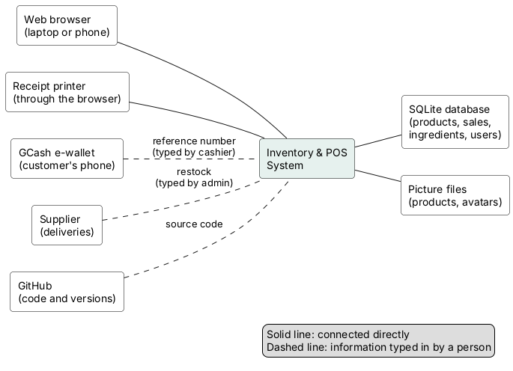
Why GCash and the supplier are dashed: the system does not talk to them directly. A person reads the GCash reference or the delivery note and types it in. A direct GCash connection would need a merchant account (see known limitations).
All UML diagrams in this report were drawn with PlantUML, a tool that turns a short text description into a UML picture, from the code of v0.20.4 and checked against v0.21.2. Each picture is in diagrams/ as a .png, with the .puml text it was made from next to it.

7.2 Process model (item 13, Lecture 5 p. 12)
A process model shows the steps of a real-world job and who does each step. The columns are called swimlanes: each one belongs to one participant (here the Customer, the Cashier and the System). Reading top to bottom, you follow one sale at the café counter from order to receipt. The diamond shapes are decisions (for example "Enough?"), where the flow splits into two paths.
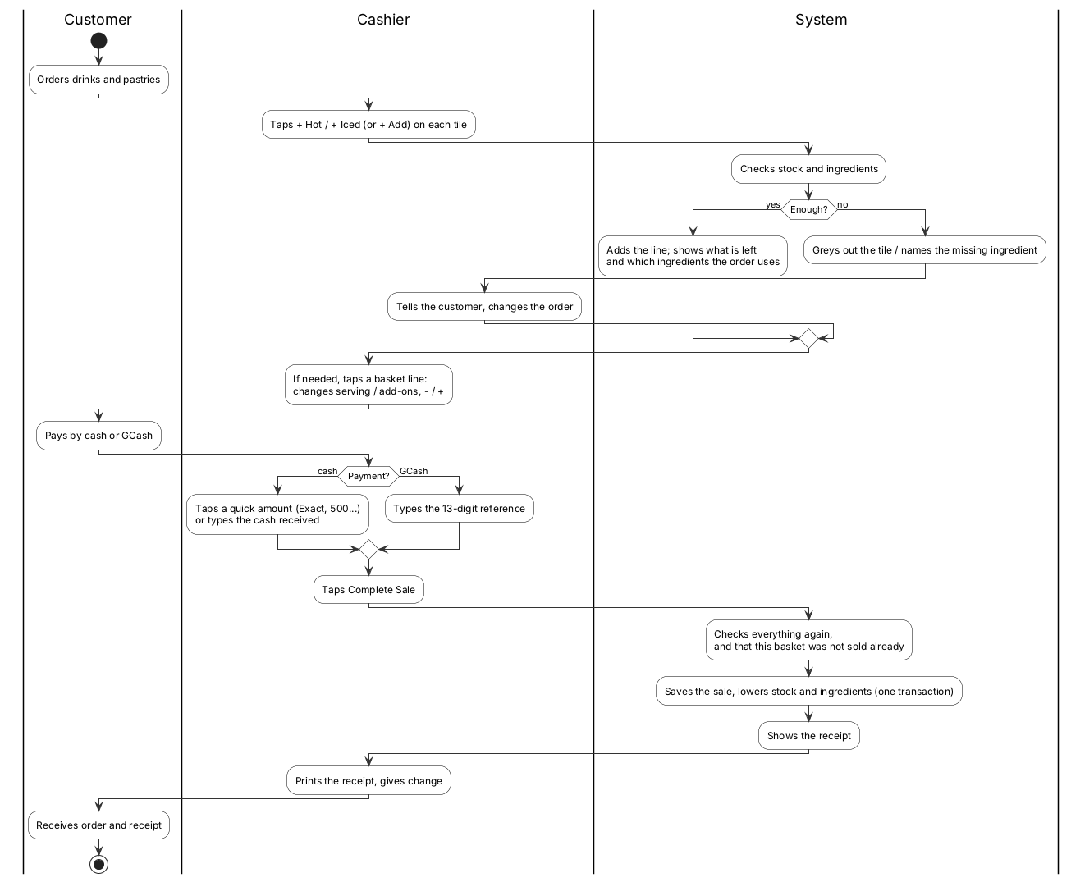
What it shows about our design: the System checks stock twice: once when a line is added to the basket and again when the sale is completed. This is because another till may sell the last item in between (see DEF-13, the race condition fixed with an atomic update). Since v0.20.0 a drink is added with one tap and changed afterwards on its basket line only if needed, so the common order is the shortest path; since v0.20.4 the final check also makes sure this basket was not already sold.

7.3 Use case diagrams (items 11 and 14, Lecture 4 p. 65 and Lecture 5 p. 15)
A use case is one thing a person can do with the system, written from their point of view ("Process sale"). An actor (the stick figure) is a type of user. Lines join actors to what they can do. Two kinds of dashed arrows appear:
- «include»: the use case always runs another one. "Add product" always runs "Check permission (role)".
- «extend»: the use case sometimes adds to another one. "View low-stock warning" only appears inside "View product list" when stock is low.
The use cases
ID | Use case | Primary actor | Status
UC-01 | View home page | Visitor | Built (v0.1.0)
UC-02 | Log in | Visitor → becomes User | Built (v0.6.0)
UC-03 | Log out | User | Built (v0.6.0)
UC-04 | View product list | User (Admin and Cashier) | Built (v0.3.0)
UC-05 | Add product | Admin | Built (v0.4.0)
UC-06 | Edit product | Admin | Built (v0.5.0)
UC-07 | Delete product | Admin | Built (v0.5.0)
UC-08 | Process sale | Cashier and Admin | Built (v0.8.0, fixed v0.8.1)
UC-09 | View low-stock warning | Admin and Cashier | Built (v0.9.0, fixed v0.9.1–v0.9.2)
UC-10 | View sales report | Admin | Built (v0.10.0, fixed v0.10.1–v0.10.2)
UC-11 | Change profile picture | User (Admin and Cashier) | Built (v0.12.0)
UC-12 | Switch light/dark theme | Visitor and User | Built (v0.13.0)
UC-13 | Change password | User (Admin and Cashier) | Built (v0.13.5)
UC-14 | Manage servings and add-ons | Admin | Built (v0.16.0)
UC-15 | Manage ingredients and recipes | Admin | Built (v0.17.0)

Relationships between use cases:
- UC-05, UC-06, UC-07, UC-08 and UC-10 all «include» a hidden step, Check permission (role). «include» means "always happens as part of". The @admin_required decorator in app.py is exactly this.
- UC-09 «extend»s UC-04: the low-stock warning appears on the product list only when some stock is low. «extend» means "sometimes adds extra behaviour, under a condition". Since v0.20.0 it also extends UC-08 (the "Running low" banner on New Sale).
- (v0.20.0–v0.20.4) UC-08 is extended by Change a basket line and See the ingredients the order uses, and includes One receipt per basket (sale ticket). UC-02, UC-03 and UC-13 include Start / end a login record.
All use cases together (item 11):
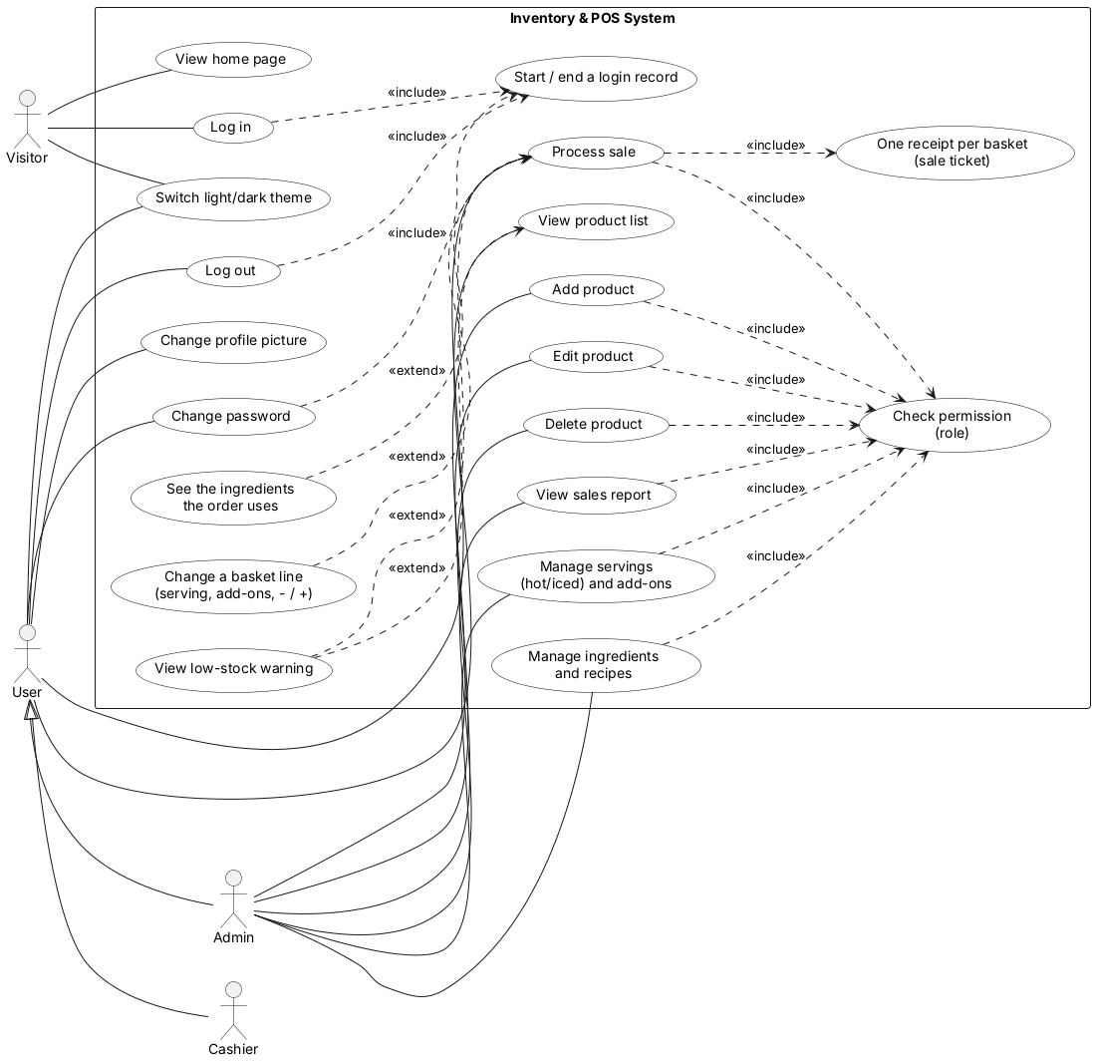
Since v0.20.0–v0.20.4: "Change a basket line" and "See the ingredients the order uses" «extend» Process sale; "View low-stock warning" also extends Process sale (the banner on New Sale); Process sale «include»s "One receipt per basket"; Log in, Log out and Change password «include» "Start / end a login record".
The arrow with a hollow triangle from Cashier and Admin to User means "a Cashier is a kind of User" (generalization, §7.8). Whatever a User can do, a Cashier and an Admin can do too.
One diagram per use case (item 14). The note on each diagram gives the main rule; the full description is in the tables in §7.4.
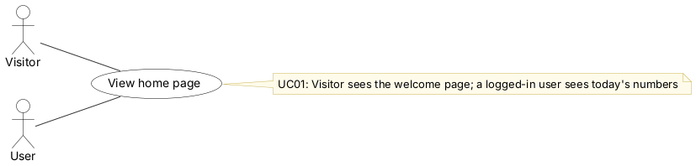
Figure: UC-01 View home page
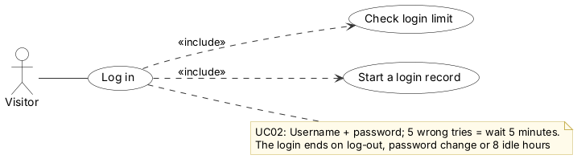
Figure: UC-02 Log in
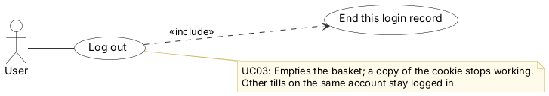
Figure: UC-03 Log out
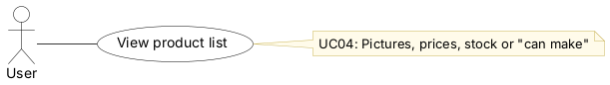
Figure: UC-04 View product list
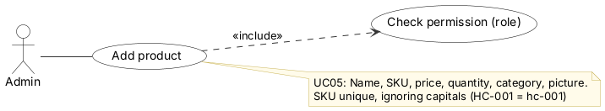
Figure: UC-05 Add product
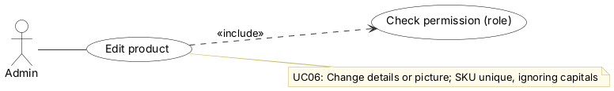
Figure: UC-06 Edit product
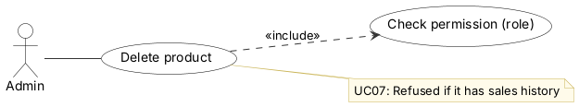
Figure: UC-07 Delete product
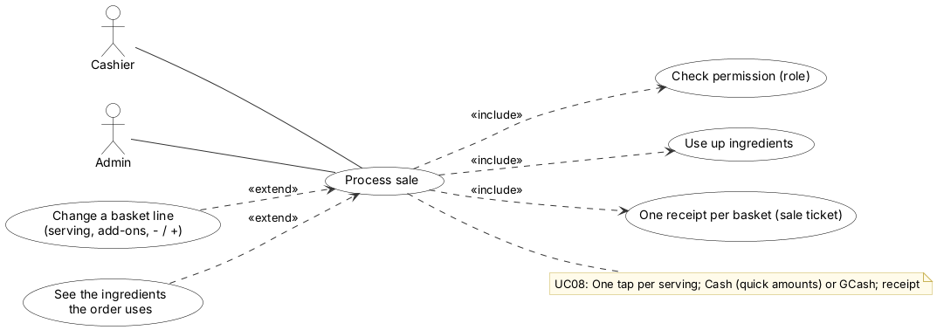
Figure: UC-08 Process sale
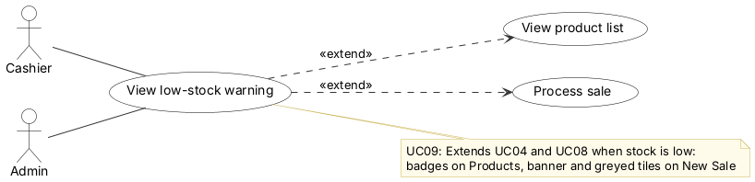
Figure: UC-09 View low-stock warning
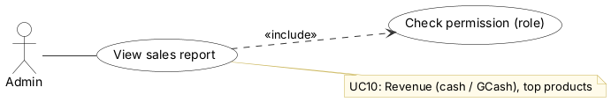
Figure: UC-10 View sales report
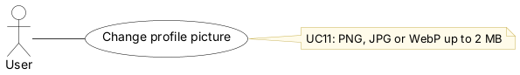
Figure: UC-11 Change profile picture
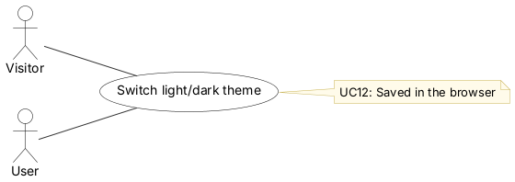
Figure: UC-12 Switch light/dark theme
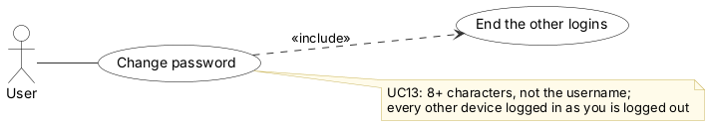
Figure: UC-13 Change password
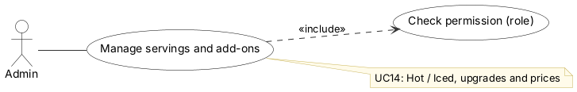
Figure: UC-14 Manage servings and add-ons
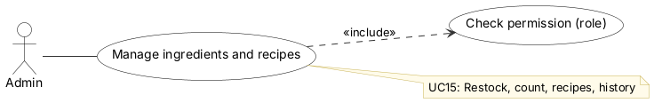
Figure: UC-15 Manage ingredients and recipes

7.4 Tabular use case descriptions (item 15, Lecture 5 p. 16)
Each use case in Sommerville's format: Actors, Description, Data, Stimulus, Response, Comments. UC-01 (view the home page) is left out because it has no rules beyond showing the page.
UC-02 Log in
Actors | Visitor (becomes Admin or Cashier)
Description | A person enters a username and password to gain access according to their role
Data | Username, password; stored User record (username, password hash, role)
Stimulus | The visitor submits the login form
Response | If the details match: a login record is created (since v0.20.3: one row in login_session; the cookie holds only its random token) and the user is sent to the product list, with their name and role in the sidebar. If not: "Invalid username or password" is shown
Comments | The password is checked against a hash and never stored in plain text. The same message is shown for a wrong username or a wrong password, so attackers can't find out which usernames exist

UC-03 Log out
Actors | User (Admin or Cashier)
Description | The user ends their session
Data | The current session
Stimulus | The user clicks Logout
Response | This browser's login record is deleted and the session (with the basket) is cleared; the user is sent to the home page. A copy of the cookie stops working too (v0.20.3). Other tills logged in with the same account stay logged in
Comments | Important on a shared counter computer, so the next person can't act under someone else's account. A login also ends by itself after 8 idle hours (v0.20.3)

UC-04 View product list
Actors | Admin, Cashier
Description | Shows every product with its name, SKU, price, quantity and category
Data | All Product records
Stimulus | The user opens the Products page
Response | A table of products. Admins also see Add, Edit and Delete buttons; cashiers see "View only"
Comments | Not available to visitors who haven't logged in (they are sent to the login page)

UC-05 Add product
Actors | Admin
Description | Creates a new product record
Data | Name, SKU (unique, ignoring capitals since v0.20.2), price, quantity, category (optional)
Stimulus | The admin submits the Add Product form
Response | The product is saved and the admin is returned to the updated list
Comments | Includes Check permission: cashiers get 403. Defects DEF-01 to DEF-04 (crashes and unchecked values) were fixed in v0.7.1

UC-06 Edit product
Actors | Admin
Description | Changes the details of an existing product
Data | Product ID; new name, SKU, price, quantity, category
Stimulus | The admin clicks Edit, changes the pre-filled form and clicks Save Changes
Response | The record is updated and the admin is returned to the list. An unknown ID gives 404
Comments | Includes Check permission. A duplicate SKU (DEF-01) is refused with a message since v0.7.1

UC-07 Delete product
Actors | Admin
Description | Permanently removes a product
Data | Product ID
Stimulus | The admin clicks Delete and confirms the pop-up
Response | The product is removed and the list is shown without it. Since v0.10.2: a product with sales history is kept and a message suggests setting its quantity to 0
Comments | Includes Check permission. Only works as a POST (form submission), not a link, for safety. Keeping sold products protects receipts and reports (DEF-21)

UC-08 Process sale (built v0.8.0)
Actors | Cashier, Admin
Description | Records a customer purchase of one or more products, takes cash, gives change and lowers stock
Data | Basket (in the session): product IDs and quantities. Saved: Sale (date and time, user, total, cash received, change due) and one SaleItem per line (product, name and unit price at the time of sale, quantity)
Stimulus | The user adds items to the basket, enters the cash received and clicks Complete Sale
Response | Stock and cash are checked; the sale and its items are saved and stock reduced in one transaction; the basket is emptied; a printable receipt is shown. Invalid input → message, nothing saved
Comments | Includes Check permission (must be logged in) and, since v0.20.4, One receipt per basket (a one-time sale ticket). Stock can't go negative through normal use; simultaneous sales of the last item are DEF-13 (v0.8.2). Receipts keep a snapshot of names and prices, so old receipts stay correct. Since v0.20.0 each tile has one button per serving (+ Hot / + Iced, or + Add) that adds one with a single tap; two optional steps «extend» this use case: Change a basket line (serving, add-ons, − / +) and See the ingredients the order uses. Payment has quick cash buttons

UC-09 View low-stock warning (built v0.9.0)
Actors | Admin, Cashier
Description | Highlights products whose quantity is at or below the threshold
Data | Product quantities; LOW_STOCK_THRESHOLD = 5 (one value for all products)
Stimulus | Opening the product list when at least one product is low
Response | Yellow box listing the 5 most urgent (lowest first) plus "and N more"; red "Out of stock" badge at 0, yellow "Low" badge at 1–5
Comments | «extend»s UC-04 View product list and, since v0.20.0, UC-08 Process sale (a "Running low" banner and greyed tiles naming the missing ingredient on New Sale). Updates automatically after sales and restocking

UC-10 View sales report (built v0.10.0)
Actors | Admin
Description | Summarizes sales over a chosen period
Data | Sale and SaleItem records; From and To dates (default today; allowed 2000–2100)
Stimulus | The admin opens Sales Report and optionally chooses a date range
Response | Revenue, number of sales, items sold, top 5 products by units (grouped per product), and every sale with a link to its receipt
Comments | Includes Check permission (admin only, 403 for cashiers). Depends on UC-08. Uses the price snapshot in each SaleItem, so later price changes don't alter past revenue

UC-11 Change profile picture (built v0.12.0)
Actors | Admin, Cashier
Description | Lets a user replace the initials circle with a round photo, or remove it
Data | An image file (PNG, JPG or WebP, at most 2 MB); stored in static/avatars/ under a random name; the file name is saved in the user's avatar column
Stimulus | The user clicks their avatar in the sidebar and chooses Change picture
Response | The new picture appears on every page; the previous file is deleted. Wrong type or size gives a message instead
Comments | The file's content (first bytes) is checked, not just its name. Random file names stop users from overwriting each other's pictures

UC-12 Switch light/dark theme (built v0.13.0)
Actors | Visitor, Admin, Cashier
Description | Switches the look between "Warm cream" (light, caramel; "Clean counter" white and teal before v0.21.0) and "Night shift" (dark, amber)
Data | The choice, saved in the browser's localStorage
Stimulus | Clicking the sun / moon icon beside the user's name (or on the login page)
Response | Every page changes colour at once; the choice is kept after reloading. Printing always uses light
Comments | Runs entirely in the browser; the server and database are not involved

UC-13 Change password (built v0.13.5)
Actors | Admin, Cashier
Description | Replaces the user's password, e.g. the default admin123
Data | Current password, new password typed twice; stored as a hash in user.password_hash
Stimulus | Avatar menu → Change password, fill in the form, click Change password
Response | Password changed with a success message saying how many other devices were logged out (v0.20.3: every other login of this user ends and this browser gets a new token); or a message if the current password is wrong, the two don't match, it equals the username or is shorter than 8 characters
Comments | Includes Check permission (must be logged in) and the CSRF token check

UC-14 Manage servings and add-ons (built v0.16.0, renamed v0.17.2)
Actors | Admin
Description | Keeps the list of servings (Hot / Iced, or sizes; exactly one per drink) and add-ons (any number) with their extra prices
Data | menu_option: kind (size/add-on), name, extra price, offered or hidden, order, recipe scale (sizes)
Stimulus | Admin opens Servings & Add-ons, edits a row or adds one
Response | Saved; hidden options disappear from New Sale (tiles and basket-line panels); baskets holding them lose that line with a message
Comments | Includes Check permission (admin only). Options are hidden, never deleted, because receipts and recipes refer to them

UC-15 Manage ingredients and recipes (built v0.17.0)
Actors | Admin
Description | Records ingredient stock (restock, count) and what each product, size and add-on uses
Data | ingredient (name, unit, on hand, warn at; group and full level since v0.18.0), recipe_item (ingredient, amount, product or option), ingredient_movement (history)
Stimulus | Admin opens Ingredients or a product's / option's Recipe page
Response | Stock and recipes saved; the menu's "left" counts follow; low ingredients are flagged on Home. Since v0.18.0 the page is grouped and searchable, with stock bars, an Update window and a History tab
Comments | Includes Check permission. UC-08 Process sale now uses ingredients up, so UC-08 depends on this use case

7.5 Each actor's use cases (item 16, Lecture 5 p. 17)
The same use cases again, grouped by who uses them. This makes it easy to check permissions: everything on the Admin diagram that is not on the Cashier diagram must be refused (403 Forbidden) when a cashier tries it. Test cases TC-6.x in §5 check exactly this.
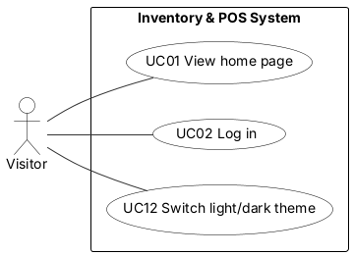
Figure: Visitor
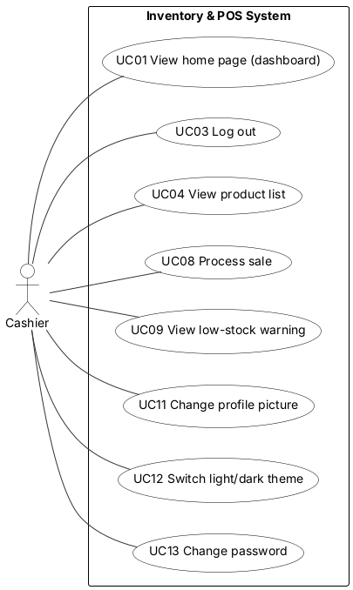
Figure: Cashier
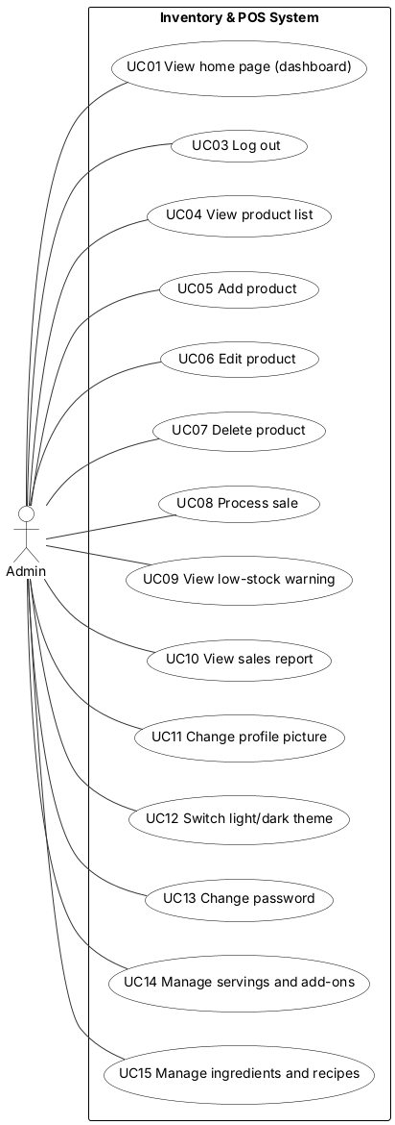
Figure: Admin

7.6 Sequence diagrams (item 17, Lecture 5 p. 19–20)
A sequence diagram shows the messages passed between the parts of the system, in time order from top to bottom. Each part has a dashed vertical line (its lifeline). A solid arrow is a request; a dashed arrow is the reply. Boxes marked alt mean "only one of these paths happens" (like an if/else), and loop means "repeat for each". The names in brackets, like login() in app.py, are the real function names, so each step can be found in the code.
# | Action | What to notice
a | Log in | The login limit is checked before the password, so a guesser is stopped even with the right password after 5 tries. Since v0.20.3 a correct login creates a record whose random token is the only thing the cookie holds.
b | Add a drink to the basket | One tap on "+ Iced" (v0.20.0). Ingredients are checked for the whole basket plus the new line, not just the new line. The first item gives the basket its one-time sale ticket.
c | Complete a sale | A break box comes first: if this basket's ticket is already on a receipt, that receipt opens and nothing else happens (v0.20.4). Each stock subtraction only succeeds if enough is still there; if any fails, everything is rolled back (undone).
d | Restock an ingredient | One database step adds the amount and writes the history line.
e | View the sales report | Dates are checked to be real and between 2000 and 2100 before the database is asked.
f | Add a product | The picture is checked by its first bytes, not its file name, and saved under a random name.
g | Change password | Four checks; if any fails, nothing changes. Since v0.20.3 every login of the user ends and this browser gets a new token, so a stolen copy of the cookie dies too.
h | Upload a profile picture | The old picture file is deleted so the folder does not fill up.
i | Change a basket line (v0.20.0) | The changed basket is checked as a whole; identical lines are joined. The − / + buttons follow the same path.
j | Every request, and log out (v0.20.3) | Each request looks up the login record; no record or 8 idle hours → log-in page. Log out deletes only this browser's record.

a. Log in
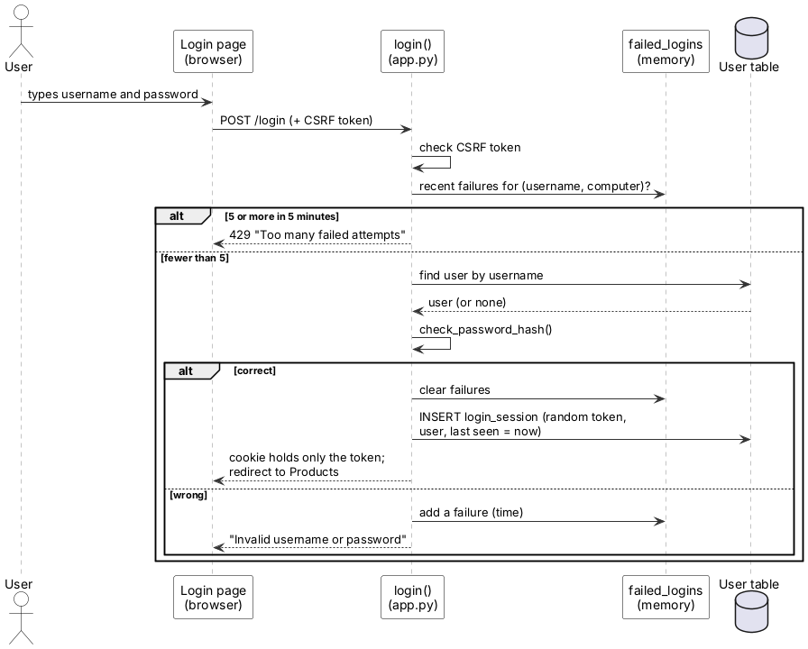
b. Add a drink to the basket
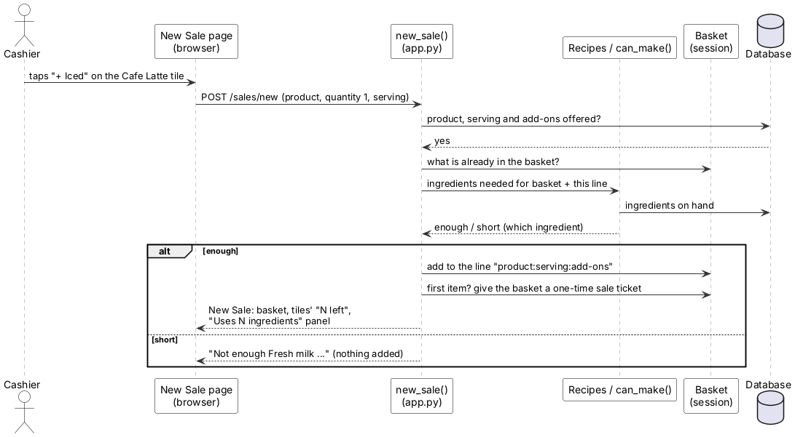
c. Complete a sale
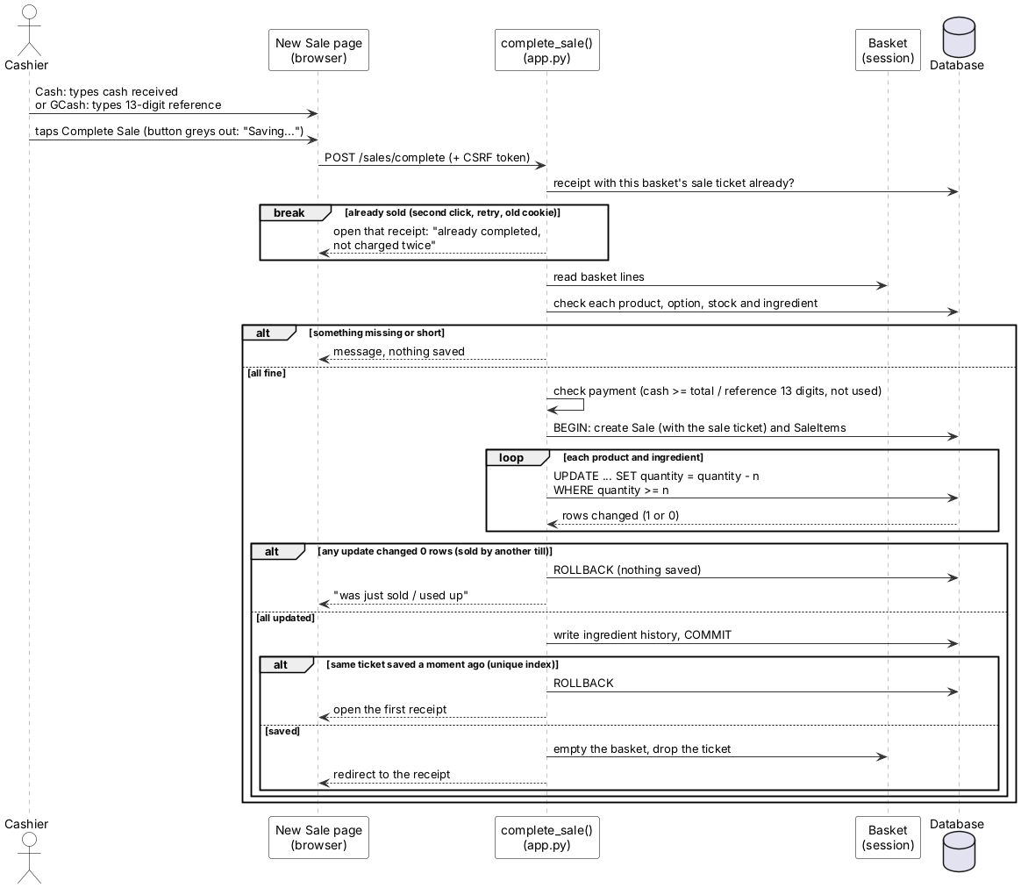
d. Restock an ingredient
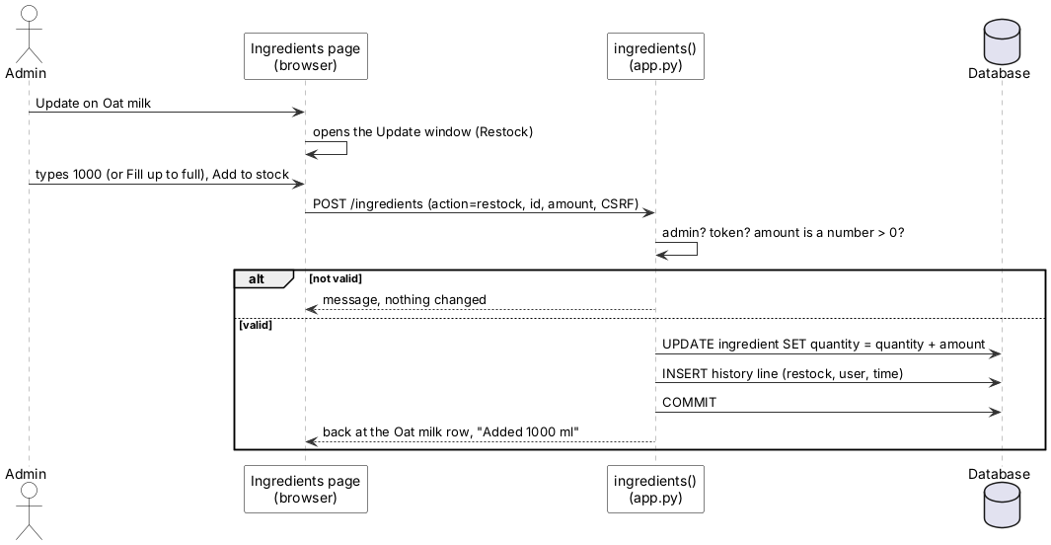
e. View the sales report
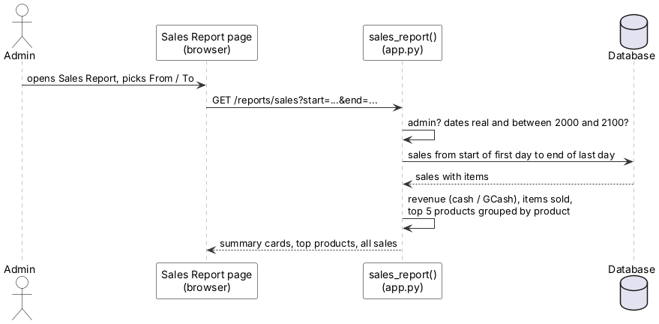
f. Add a product
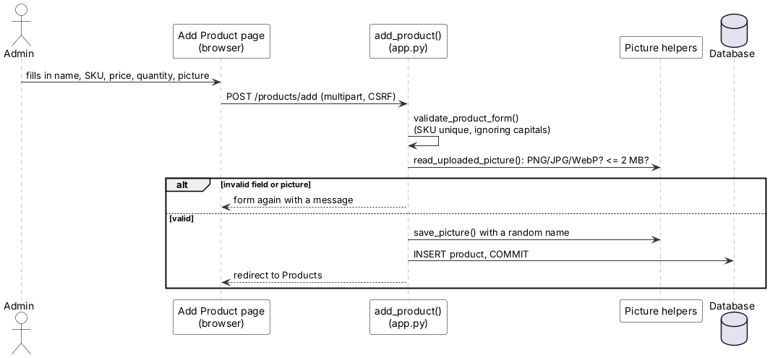
g. Change password
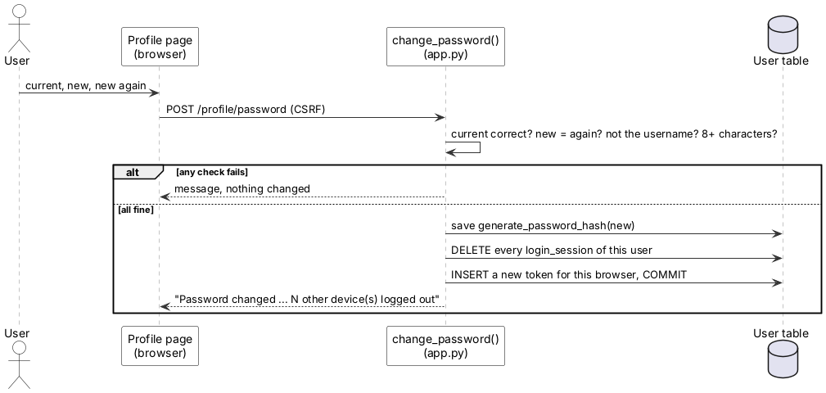
h. Upload a profile picture
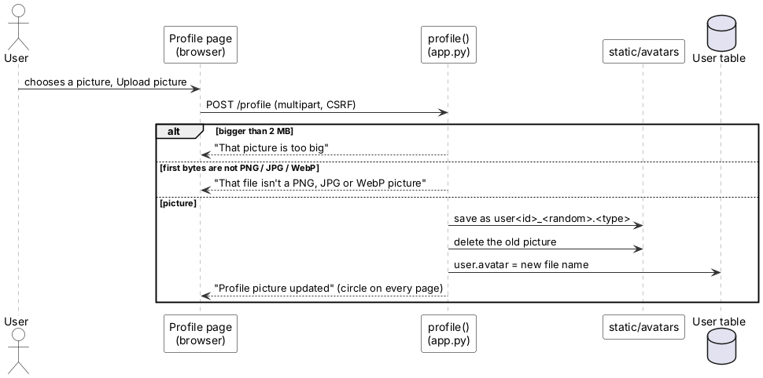
i. Change a basket line (design 6a)
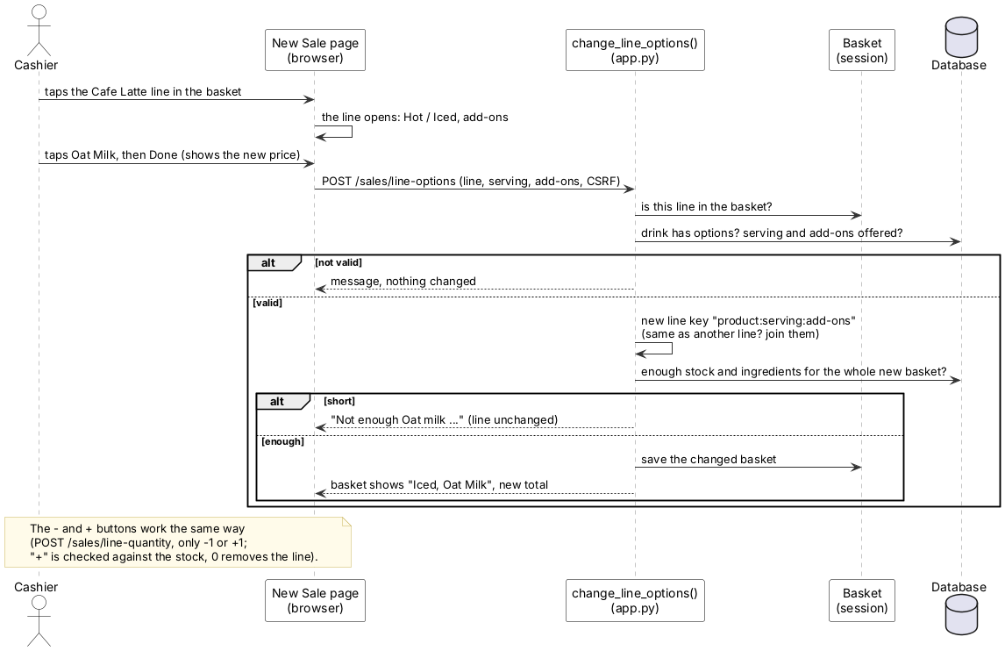
j. Every request of a logged-in browser, and log out
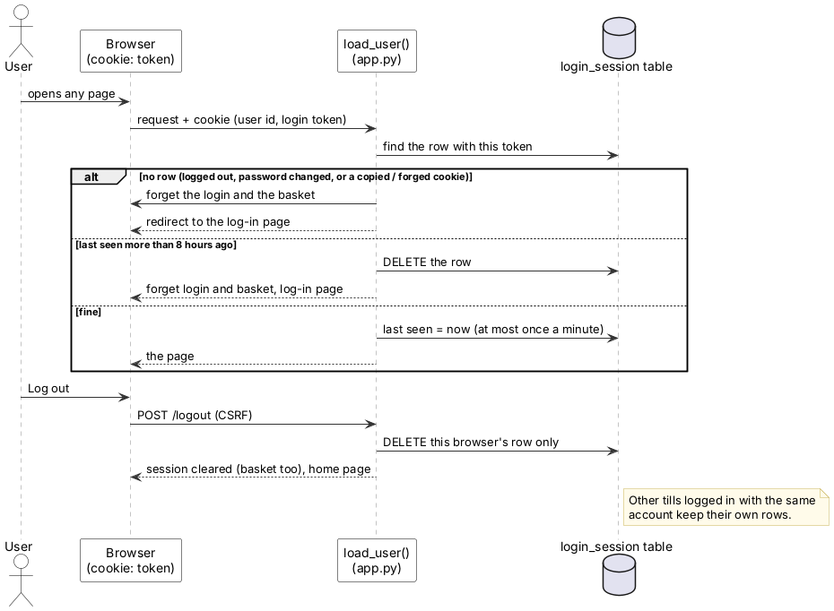
Smaller actions (edit and delete product, switch theme) follow the same pattern as (f) and are not drawn separately: page → function in app.py → checks → database → redirect with a message.

7.7 Class associations and class model (items 18 and 19, Lecture 5 p. 23–25)
A class is a type of thing the system stores, for example a Product. In our code each class is also a database table (in models.py). An association is a line saying two classes are related. The numbers at the ends are the multiplicity, meaning "how many":
- 1: exactly one · 0..1: none or one · 0..*: any number, including none · 1..*: at least one
So User "1" — "0..*" Sale reads: one user makes any number of sales, and each sale is made by exactly one user.
Item 18, associations only (names, no details):
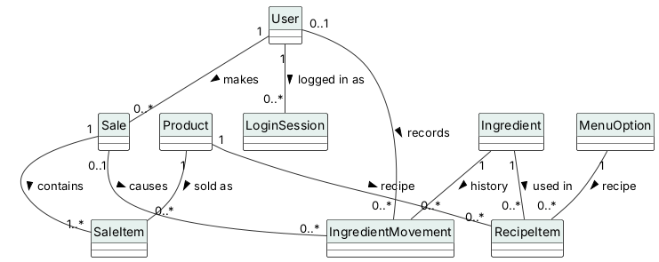
Item 19, the full class model with each class's attributes (the data it stores, the columns of its table) and the important operations (what it can do):
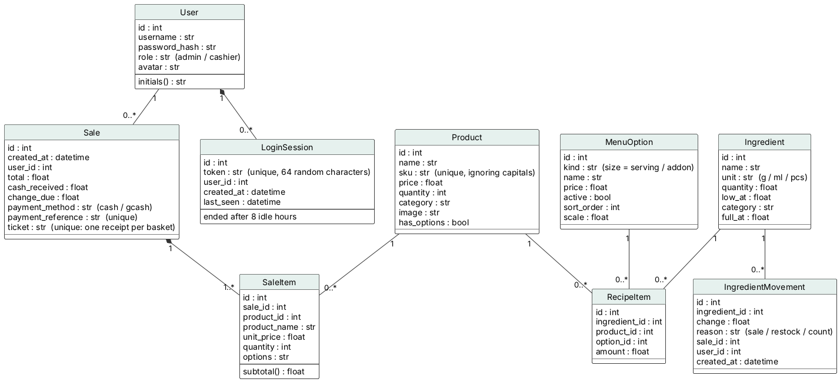
New in v0.20.2–v0.20.4: LoginSession (one row per logged-in browser, joined to User by a filled diamond because a login record can't exist without its user), Sale.ticket (unique, so one basket makes one receipt) and the SKU rule "unique, ignoring capitals". Attributes with a note in brackets are marked {field} in the .puml source so PlantUML keeps them in the attribute box.
Why SaleItem copies the product name and price: if the admin later renames a product or changes its price, old receipts must still show what the customer actually paid. Copying them at the time of sale keeps history true (the same reason UC-07 refuses to delete a product with sales history; see DEF-21).

7.8 Generalization hierarchy (item 20, Lecture 5 p. 30–31)
Generalization means "is a kind of". The arrow with a hollow triangle points from the specific class to the general one. The specific class inherits (automatically gets) everything the general class has and adds its own. Example: a Cashier is a User, so a Cashier has a username and password like every user.
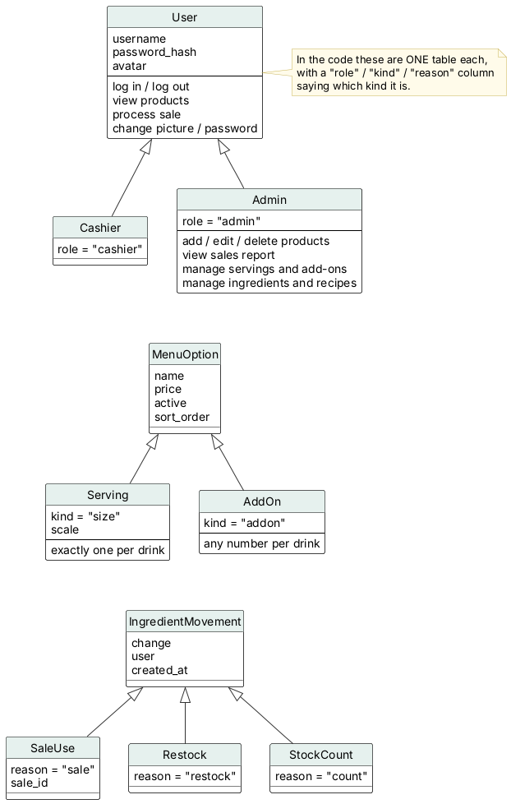
Note: in the code these are not separate classes. Each is one table with a column saying which kind it is (User.role, MenuOption.kind, IngredientMovement.reason). This is a common, simpler way to store a hierarchy in a database (called single-table inheritance). The diagram shows the idea; the code chooses the simpler storage.

7.9 Aggregation (item 21, Lecture 5 p. 33)
Aggregation is a "has-a / is-part-of" relationship. UML has two strengths of it:
- Composition (filled diamond ◆): the part cannot live without the whole. A SaleItem only exists inside its Sale; a receipt line without a receipt makes no sense.
- Aggregation (hollow diamond ◇): the parts can exist on their own. A recipe is made of recipe lines, and each line points to an Ingredient that exists even if no recipe uses it.
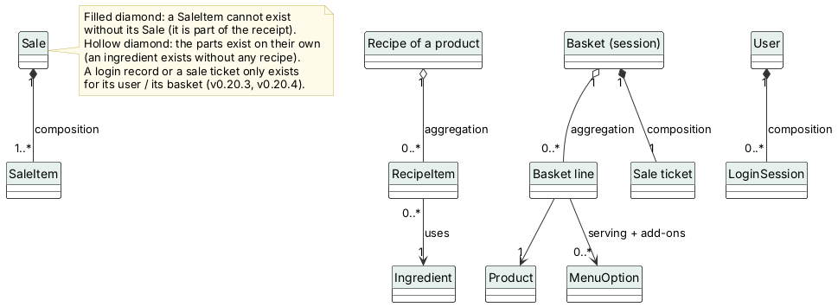
Two compositions were added for v0.20.3–v0.20.4: a basket owns its sale ticket, and a user owns their login records (deleting either the basket or the user leaves no ticket or record behind).

7.10 Activity model (item 22, Lecture 5 p. 36)
An activity diagram is a flowchart of one activity: the rounded boxes are actions, the diamonds are decisions, the black dot is the start and the circled dot is the end. This one shows every check the system makes when the cashier taps Complete Sale, in the order the code (complete_sale() in app.py) makes them. Every "stop" on the side is an error message where nothing is saved. The two sale-ticket decisions (v0.20.4) are why a double click or a retry can never make a second receipt.
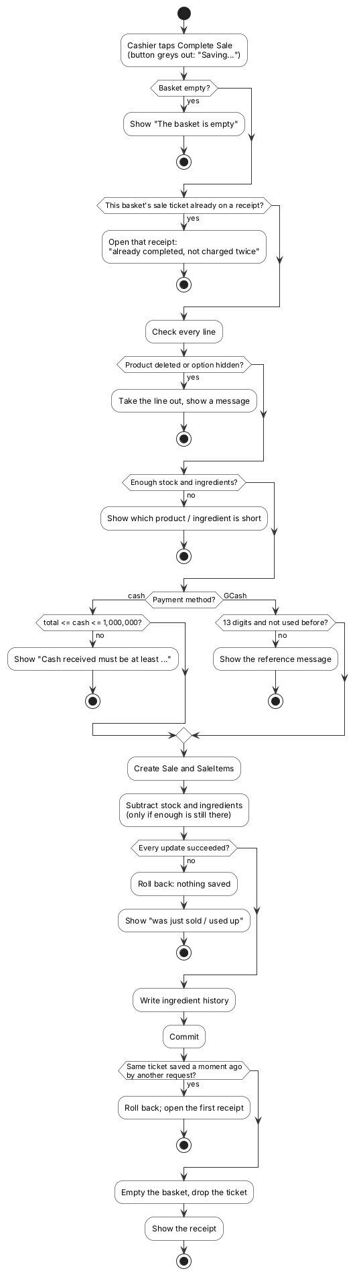

7.11 Application process (item 23, Lecture 5 p. 37)
An application process model shows how the system fits into a business process that goes beyond the software. Here: ingredients run low because of sales, the admin counts and orders, a supplier (outside the system) delivers, and the admin records the delivery. The swimlanes show which steps the software does and which a person does.
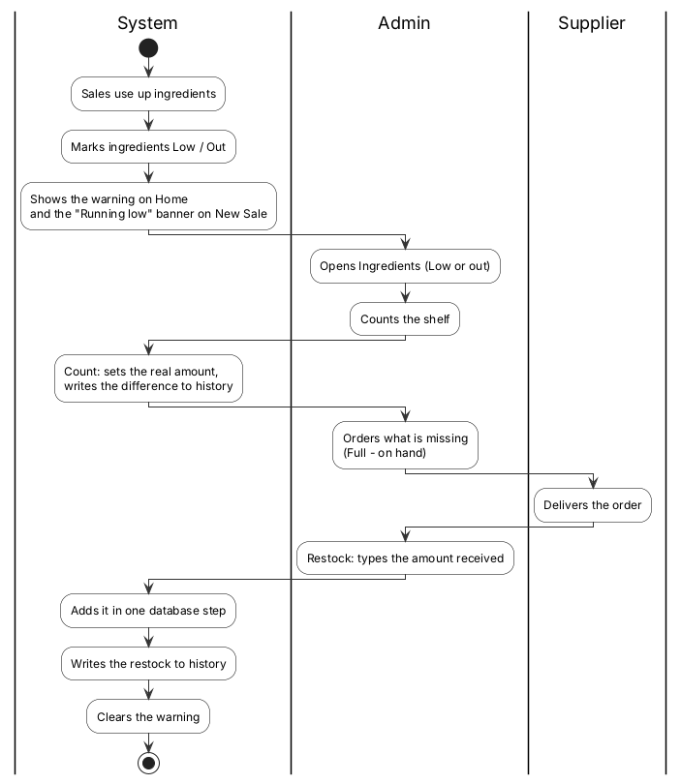

7.12 State diagrams (item 24, Lecture 5 p. 40)
A state is a situation something can be in (for example "Low" or "Out"). A state diagram shows all the states and the transitions (arrows) between them. The label on each arrow is the stimulus, the event that causes the change. The black dot is where it starts; the circled dot is where it ends.
a. A sale, from empty basket to receipt. This shows why a sale is either saved completely or not at all: the Saving state can only end in Completed (committed) or go back to Building (rolled back), never halfway.
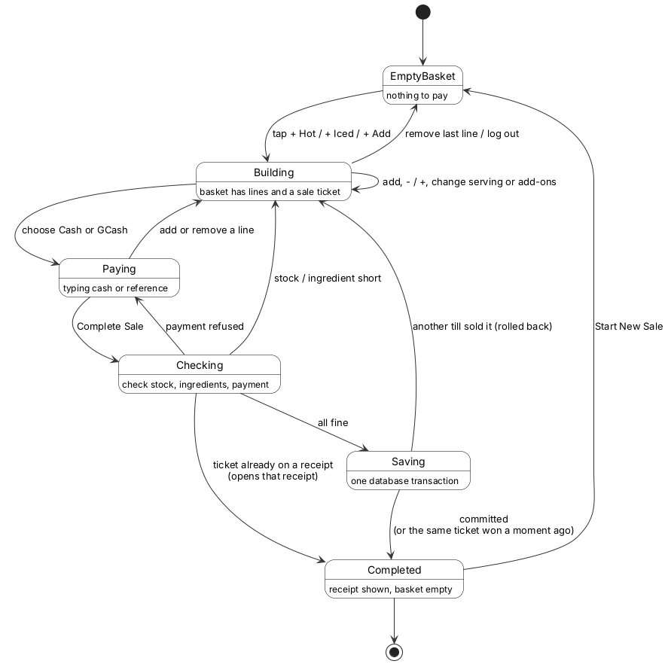
b. An ingredient's stock level. "Warn at" is the low-stock level the admin sets for each ingredient (low_at in the code; see stock_status() in app.py).
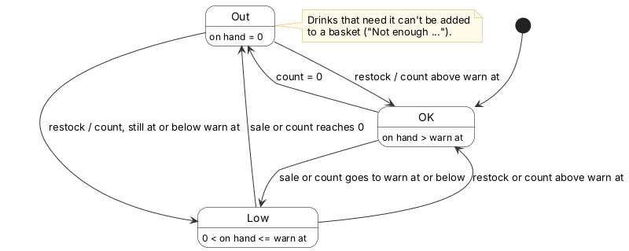
c. A login (v0.20.3). "Ended" is the state a copied cookie falls into as soon as its owner logs out: the browser still has the cookie, but the server no longer has the record, so the next request goes to the log-in page.
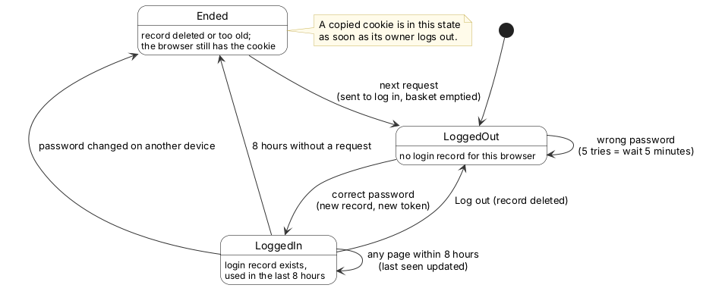

7.13 Structured forms of states (item 25, Lecture 5 p. 41–42)
The same two state diagrams written as tables, the way Lecture 5 shows them: one table describing each state, and one describing each stimulus.
a. Sale: states
State | Description
Empty basket | The New Sale page is open and nothing has been added. The total is ₱0 and Complete Sale does nothing useful.
Building | The basket has one or more lines and a one-time sale ticket (v0.20.4). The cashier can add lines with one tap, use − / +, change a drink's serving and add-ons on its line (stock and ingredients are checked each time) or remove lines.
Paying | The cashier has chosen Cash and is typing the cash received, or chosen GCash and is typing the 13-digit reference.
Checking | The system re-checks every line (product still exists, option still offered, enough stock and ingredients) and the payment.
Saving | One database transaction is open: the Sale and SaleItems are created and stock and ingredients are subtracted.
Completed | The transaction is committed, the basket is emptied and the receipt is shown.

a. Sale: stimuli
Stimulus | Description
Add product | The cashier taps + Hot / + Iced / + Add on a tile, or uses Add several at once. Moves Empty basket → Building.
Add, − / +, change serving or add-ons | The cashier changes the basket. Stays in Building (or goes back to Building from Paying).
Remove last line / log out | The basket becomes empty. Building → Empty basket. Logging out always empties the basket.
Choose Cash or GCash | The cashier picks the payment method. Building → Paying.
Complete Sale | The cashier taps Complete Sale. Paying → Checking.
Payment refused | Cash is less than the total or over ₱1,000,000, or the GCash reference is not 13 digits or was used before. Checking → Paying.
Stock / ingredient short | A product or ingredient no longer has enough. Checking → Building, with a message naming it.
Ticket already on a receipt | This basket was sold a moment ago (second click, retry, old cookie). Checking → Completed, showing that receipt (v0.20.4).
All fine | Every check passed. Checking → Saving.
Another till sold it | A stock update changed 0 rows because another sale took the last item first. The transaction is rolled back. Saving → Building.
Committed | The database confirmed the save (or another request with the same ticket was saved first; this one is rolled back and shows that receipt). Saving → Completed.
Start New Sale | The cashier taps Start New Sale on the receipt. Completed → Empty basket.

b. Ingredient: states
State | Description
OK | On hand is more than the "warn at" level. Shown with a green bar.
Low | On hand is above 0 but at or below "warn at". Shown in amber, counted on the Home page and listed under Low or out.
Out | On hand is 0. Shown in red. Drinks that need it cannot be added to a basket ("Not enough …").

b. Ingredient: stimuli
Stimulus | Description
Sale | A completed sale subtracts the recipe amounts. Can move OK → Low, Low → Out (or OK → Out in one big sale).
Restock | The admin adds the amount delivered. Can move Out → Low, Out → OK or Low → OK.
Count | The admin types the real amount on the shelf; the system saves the difference in history. Can move to any state.
Edit "warn at" | The admin changes the warning level. The state is recalculated at once (for example OK → Low if the level is raised).

c. Login: states
State | Description
Logged out | This browser has no login record. Only the home page and the log-in page open.
Logged in | A login_session row with this browser's token exists and was used in the last 8 hours.
Ended | The row was deleted (log-out elsewhere with a copied cookie, a password change on another device) or is older than 8 idle hours. The browser still holds the cookie, but it no longer works.

c. Login: stimuli
Stimulus | Description
Correct password | A new row and a new random token are created. Logged out → Logged in.
Wrong password | Counted by the login limit (5 tries, then wait 5 minutes). Stays Logged out.
Any page within 8 hours | "Last seen" is updated (at most once a minute). Stays Logged in.
Log out | This browser's row is deleted and the basket emptied. Logged in → Logged out.
Password changed on another device | Every row of the user is deleted. Logged in → Ended.
8 hours without a request | The row is too old. Logged in → Ended.
Next request | The server finds no valid row: the login and basket are forgotten and the log-in page opens. Ended → Logged out.

Source for all six tables: stock_status(), complete_sale() and load_user() in app.py (v0.20.4), and test cases TC-7.x, TC-15.x, TC-17.x, TC-18.x and TC-23.x in §5.

8. Architecture and design (items 26–30)

8.1 Software architecture (item 26, Lecture 6 p. 42 and 49)
Words used: the architecture of a system is its overall structure: which big parts it has and how they talk to each other. An architectural pattern is a well-known structure that has worked before, like a floor plan that builders reuse.
The system uses two patterns from Lecture 6 at the same time:
a. Model–View–Controller (MVC), the pattern for web applications. Each request from the browser goes to a controller (a route in app.py), which reads or changes data through the model (the classes in models.py) and then asks a view (a template in templates/) to build the page. Flask, SQLAlchemy and Jinja2 are built for exactly this split.
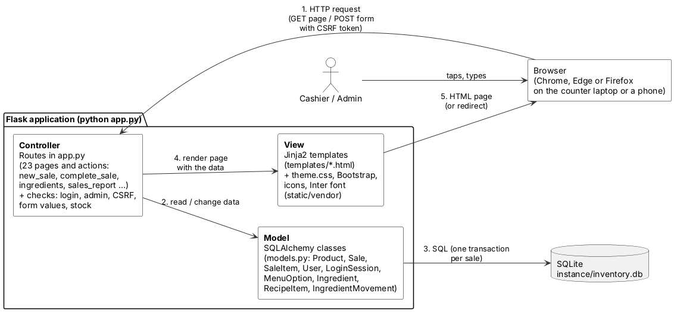
MVC part | In this project | Example: completing a sale
Model | models.py: 9 classes, one table each, kept in SQLite (instance/inventory.db) | Sale, SaleItem, Product.quantity, Ingredient.quantity, IngredientMovement
View | templates/*.html (Jinja2) + static/css/theme.css + Bootstrap, icons and font in static/vendor/ | new_sale.html (basket, payment), receipt.html
Controller | the 23 routes in app.py, with their checks | complete_sale(): checks the ticket, stock and payment, saves everything in one transaction, then redirects to the receipt

b. Layered architecture. Each layer offers services to the layer above and uses only the layer below. In the code the layers are logical: layers 2 and 3 are both in app.py, separated into commented blocks, because the course keeps the app in one file (AGENTS.md, §2). Splitting app.py into Flask blueprints is listed as a future-goal risk in the security audit (§4 there).
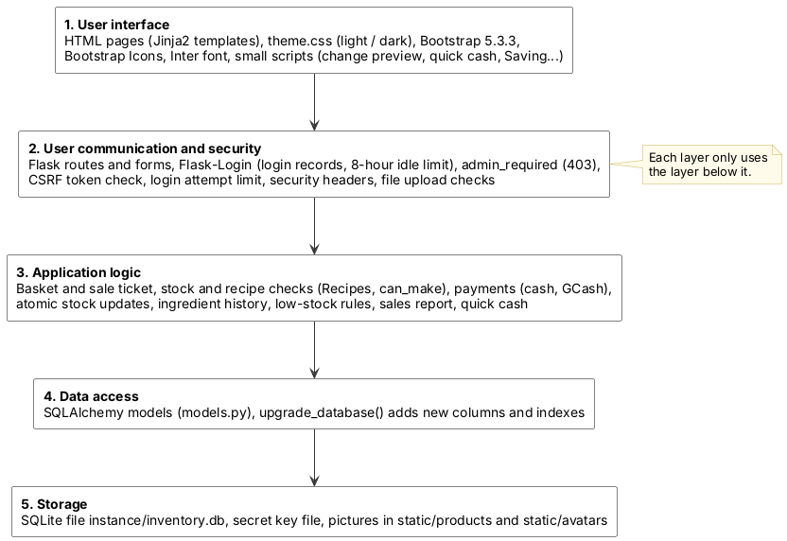
Why these patterns? MVC keeps the look (templates) apart from the rules (routes), so v0.13.0 and v0.20.0 could change the whole look without touching the database. The layers put every security check in one place (layer 2), before any business rule runs. Client–server is also present: the browser is the client and the Flask app the server; several tills (browsers) can use one server at the same time, and SQLite lets one of them write at a time.

8.2 System context (item 27, Lecture 7 p. 9)
Lecture 7 draws the context as boxes joined by associations with multiplicities (how many of each: 1, 0..n, 1..n). It complements the Lecture 5 context model in §7.1, which shows the data that flows.
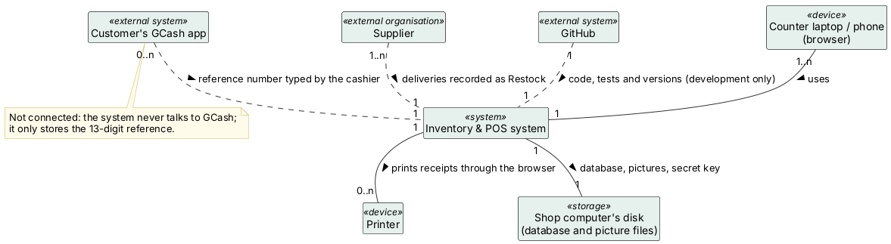
Other system | Multiplicity | Relationship
Counter laptop / phone (browser) | 1..n tills use 1 system | Every page is used through a browser; nothing is installed on the till
Printer | 0..n | Receipts are printed with the browser's Print; the receipt page hides the menus when printing
Customer's GCash app | 0..n | Not connected (dashed line): the cashier types the 13-digit reference from the customer's screen
Supplier | 1..n | Not connected: a delivery is entered by the admin as a Restock
Shop computer's disk | 1 | The database, the secret key and the picture files live here; backing it up is the owner's job
GitHub | 1 | Only for development: code, tests, versions. The running shop does not need GitHub or the internet

8.3 High-level architecture (item 28, Lecture 7 p. 13)
Like the weather station's subsystems joined by a communication link, the system has seven subsystems joined by Flask's request handling.
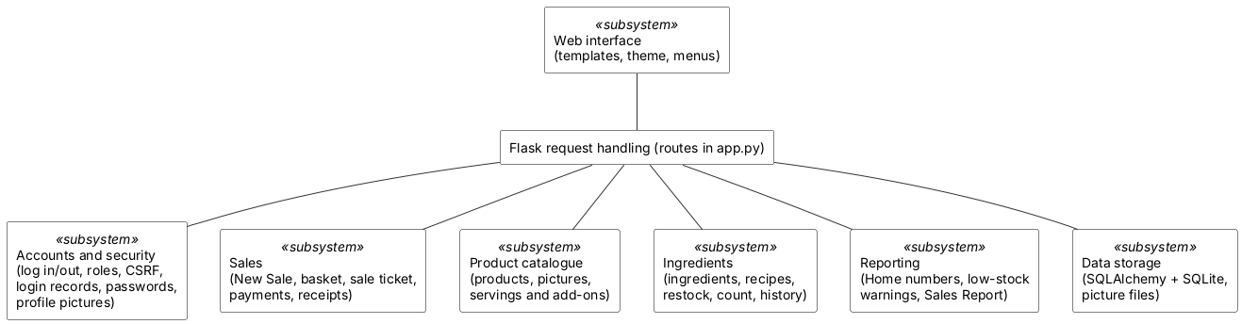
Subsystem | Routes / functions in app.py | Data (models.py)
Web interface | base.html and the page templates, theme.css | —
Accounts and security | login, logout, profile, remove_avatar, change_password, load_user, start_login_session, check_csrf_token, admin_required, add_security_headers | User, LoginSession
Sales | new_sale, change_line_quantity, change_line_options, remove_from_basket, remove_line, complete_sale, receipt | Sale, SaleItem (basket in the session)
Product catalogue | products, add_product, edit_product, delete_product, manage_options | Product, MenuOption
Ingredients | ingredients, ingredient_detail, ingredients_history, edit_recipe, Recipes, can_make | Ingredient, RecipeItem, IngredientMovement
Reporting | home, sales_report, low-stock box on products, banner on New Sale | reads Sale, Product, Ingredient
Data storage | upgrade_database, load_secret_key, save_picture | SQLite file and picture folders

8.4 Object classes (item 29, Lecture 7 p. 19)
Lecture 7's object classes show each class with its attributes (what it knows) and operations (what it can do). The attributes are the real database columns. The operations are the real functions in app.py, grouped by the object they work on: Flask code is mostly functions, not methods, so this is the design view of the code. Basket and SalesReport have no table: the basket lives in the browser's signed session cookie, and the report is calculated each time.
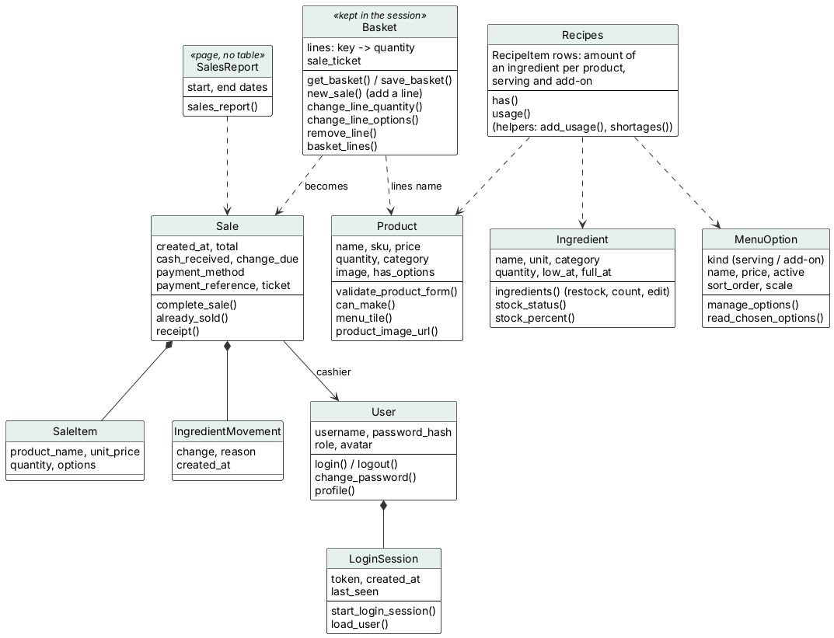
The full class model with every column and association is in §7.7.

8.5 Detailed usage scenario (item 30, Lecture 8 p. 53)
Lecture 8 uses a usage scenario for scenario testing: a realistic story is played through the system, and every feature it touches is tested at once. Each step below is covered by the test cases in the table; the security steps were also tried by hand in my attack drill (2026-10-13).
Scenario: a busy Saturday afternoon. Maria owns a small café; Jun is her cashier. At 3 PM Jun logs in on the counter laptop. The New Sale page shows a "Running low: Iced cups" banner. A customer orders two iced lattes, one with oat milk, and an ensaymada. Jun taps + Iced on the Cafe Latte tile, taps the new basket line, ticks Oat Milk and taps Done; the line now shows the extra ₱40. He taps + Iced again for the plain latte (a second line, because its add-ons differ) and + Add on the ensaymada. The "Uses N ingredients" panel has opened by itself because the iced cups will go low. The customer hands over a ₱500 bill; Jun taps the ₱500 quick-cash button, the change appears, and he taps Complete Sale. The laptop is slow, so he taps it again; the button already says "Saving…", and only one receipt is made. He prints it.
At 4 PM the Wi-Fi drops. Nothing changes on screen, and Jun keeps selling. At 5 PM Maria's supplier delivers iced cups; on her phone she opens Ingredients, filters Low or out, and adds the delivery with Restock. The banner on Jun's screen disappears at his next tap. At closing, Maria opens the Sales Report for today and compares the cash total with the drawer, then changes her password, which logs out the other phone she had used. Jun logs out; the next morning a new cashier finds an empty basket.
Feature tested by the scenario | Where it is specified and tested
Log in, login record, log out empties the basket | UC-02, UC-03; TC-5.x, TC-23.4–23.9
Running-low banner, stock bars on tiles | UC-09; TC-22.1, TC-22.2, TC-22.9
One-tap serving buttons, − / + on a line, equal lines merged | UC-08; TC-22.1, TC-22.3
Change add-ons on the basket line, live price | UC-08, UC-14; TC-22.4, TC-16.x
"Uses N ingredients" panel opens when something goes low | TC-22.5
Quick cash, change preview | TC-22.6, TC-22.7, TC-7.x
One receipt per basket, "Saving…" | TC-23.11–23.14
Works without internet | TC-21.1–21.5
Restock adds safely, history line | UC-15; TC-17.x, TC-18.x
Sales Report: cash vs GCash | UC-10; TC-9.x, TC-15.x
Password change ends other logins | UC-13; TC-23.6

9. Dependability and security (items 31–39)
This chapter applies the dependability and security ideas of Lectures 11 and 12 to the system. It draws on the defect list (Chapter 10), the security audit of 11 October 2026 and my attack drill of 13 October 2026.
To be clear about scope: this is not a safety-critical system like Sommerville's insulin pump. Nobody is physically hurt if it fails; the harm is mostly to money, stock records and personal data. One hazard can reach a customer's health, though: if a drink's Oat Milk option were lost between the basket and the barista, a customer who cannot have dairy might be served the wrong milk. The tables below use Sommerville's terms with café examples like this one.

9.1 Reliability terminology (item 31, Lecture 11 p. 25)
Term | Description | Example in this system
Human error or mistake | Human behaviour that results in a fault being put into the system | When v0.20.0 was written, the New Sale tile bars were given the class name stock-bar, which the Ingredients page already used (DEF-58)
System fault | A characteristic of the software that can lead to a system error | The new style rules for stock-bar (overflow: hidden) also matched the Ingredients bars
System error | An erroneous system state that can lead to behaviour the user does not expect | The Ingredients page was drawn with the warn-level tick clipped to a 6 px green speck
System failure | An event that occurs when the system does not deliver a service as expected by its users | I could no longer see how close an ingredient was to its warning level (reported 2026-10-13; fixed in v0.20.5)

A second example of the same chain: mistake — the stock check and the stock update were written as two steps; fault — another sale could run between them; error — two sales both saw "1 left"; failure — the last item was sold twice and stock showed −1 (DEF-13, fixed in v0.8.2 with an atomic update).

9.2 Safety terminology (item 32, Lecture 11 p. 35)
Term | Definition | Example in this system
Accident (or mishap) | An unplanned event that results in human death or injury, damage to property or to the environment | A customer with a milk allergy is served dairy milk; or the café loses a day's sales records
Hazard | A condition with the potential to cause or contribute to an accident | A drink line loses its Oat Milk option between the basket and the receipt; the only copy of the database is on one laptop
Damage | A measure of the loss resulting from an accident | From a refund and an apology (wrong change) to a customer's health (allergen) or a day of lost records
Hazard severity | An assessment of the worst possible damage that could result from a hazard | Allergen: high (health). Lost database: high (business). Wrong change: low
Hazard probability | The probability of the events occurring which create a hazard | Option lost: very low (options are copied as text onto each receipt line, TC-16.x). Laptop disk failure: low
Risk | The probability that the system will cause an accident: hazard probability × hazard severity × chance the hazard leads to an accident | Allergen: low (very low probability, high severity, barista also asks the customer). Lost database: medium, because there is no automatic backup yet

9.3 Security terminology (item 33, Lecture 11 p. 42)
Term | Definition | Example in this system
Asset | Something of value which has to be protected | The sales and stock records (inventory.db), the users' accounts, the secret key that signs cookies, the GCash reference numbers on receipts
Attack | An exploitation of a system's vulnerability, usually from outside and on purpose | Copying the admin's session cookie into another browser (my attack drill, round 3)
Control | A protective measure that reduces a system's vulnerability | Login records (v0.20.3): log-out or a password change deletes the record, so the copied cookie stops working
Exposure | Possible loss or harm to a computing system | Someone with a copied admin cookie could read every sale and change prices
Threat | Circumstances that have the potential to cause loss or harm | A cashier, or anyone who uses the counter laptop, tries the admin pages or a copied cookie
Vulnerability | A weakness in a system that may be exploited to cause loss or harm | Before v0.20.3: a cookie kept working after log-out (DEF-51, audit A6)

Full list of attacks tried and their results: §10.3 and the security audit report (docs/security_audit_2026-10-11.md).

9.4 Vulnerability avoidance techniques (item 34, Lecture 11 p. 45)
Sommerville names three ways to make a system secure. All three are used:
a. Vulnerability avoidance (design the weakness out, so it can't be attacked):
Technique | How | Version
Passwords never stored | Only scrypt hashes (Werkzeug); minimum 8 characters, not the username | v0.6.0, v0.13.5
Secret key not in the code | Made once and kept in instance/secret_key.txt (not in Git), or set with SECRET_KEY | v0.13.1
Every value checked on the server | Numbers must be finite and between 0 and 1,000,000; ids too big for the database count as "not found"; text fits the columns | v0.7.1, v0.8.3–v0.8.6, v0.19.3
SQL injection impossible | All database access goes through SQLAlchemy with parameters; no SQL text is built from user input | v0.2.0
Script injection impossible | Jinja2 escapes every value shown on a page | v0.3.0
Uploaded pictures can't be run | Checked by their first bytes (PNG, JPG, WebP), at most 2 MB, saved under a random name, sent with nosniff | v0.12.0, v0.14.0
No outside code | Bootstrap, icons and font are stored in the project; nothing loads from the internet | v0.19.4
Only the needed packages, kept up to date | Exact versions in requirements.txt; Werkzeug updated for a known weakness | v0.19.3
Changes can't remove a protection by accident | AGENTS.md rules + tests/check_contract.py (58 rule checks) run on every pull request | v0.19.0

b. Attack detection and elimination (notice an attack and stop it):
Technique | How | Version
Wrong-password limit | 5 wrong passwords for a username from one computer → that computer waits 5 minutes | v0.13.3, v0.19.3
Forged form requests | Every form carries a random CSRF token; a POST without it is refused (400) | v0.13.2
Forged or copied cookies | The user only counts as logged in if the cookie's token has a login record on the server | v0.20.3
Wrong role | Admin pages answer 403 to cashiers, even when the address is typed | v0.7.0
Same basket sent twice | The sale ticket is unique in the database; the second request opens the first receipt | v0.20.4

c. Exposure limitation and recovery (if an attack works, keep the damage small and recover):
Technique | How | Version
Logins end | Log-out, a password change (ends every other login of the user) or 8 idle hours | v0.20.3
Least privilege | Cashiers can sell and see receipts only; the shared "cashier" account cannot change data | v0.7.0
All-or-nothing sales | A sale and all its stock changes are one transaction; if one part fails, nothing is saved | v0.8.2
History of every ingredient change | Who changed what, when, and on which receipt | v0.17.0
Debug console off | The in-browser Python console of debug mode can't be reached unless FLASK_DEBUG=1 | v0.13.4
Nothing is deleted when starting over | --fresh renames the old database instead of deleting it | v0.14.0
Clickjacking blocked | X-Frame-Options: DENY; Referrer-Policy: same-origin | v0.13.4

9.5 Risk classification (item 35, Lecture 12 p. 15)
The same columns as Sommerville's insulin pump table. Acceptability: Intolerable = must be fixed before use; ALARP = "as low as reasonably practical", reduce it if the cost is reasonable; Acceptable = no action needed.
Identified hazard | Hazard probability | Accident severity | Estimated risk | Acceptability
1. The last item sold twice by two tills (stock −1) | Medium before v0.8.2; now very low (atomic update, TC-7.26) | Medium | Low | Acceptable
2. One basket charged twice (double-click, retry) | Medium before v0.20.4; now very low (sale ticket, TC-23.11–23.13) | Medium | Low | Acceptable
3. Wrong change given (cash below total or nan accepted) | Very low (server checks, DEF-14) | Low | Low | Acceptable
4. A drink's milk option lost on the way to the barista (allergen) | Very low (options copied onto each receipt line) | High | Medium | ALARP: the barista should still read the receipt and ask
5. Database lost (disk failure, file deleted) | Low | High | Medium | ALARP: no automatic backup yet; the owner should copy instance/ regularly
6. Someone uses an admin login copied from the till | Low (login records, 8-hour limit, v0.20.3) | High | Medium | ALARP: use separate accounts, log out, change the demo passwords (done 2026-10-12)
7. Stock count overwrites a sale made at the same second | Low | Low | Low | Acceptable (known limitation; Restock adds safely)
8. GCash reference recorded but the money was never received | Low | Medium | Medium | ALARP: the cashier checks the customer's screen; automatic checks would need a GCash merchant account
9. Server error page (HTTP 500) during a sale | Very low (0 crashes in 6,417 fuzzing requests) | Low (nothing is saved half-way) | Low | Acceptable
10. Using this system as the shop's official cash register | Medium (it looks like a POS) | High (tax penalties: not BIR-registered) | High | Intolerable: receipts are order slips only; official invoices must come from the café's registered POS

9.6 Software fault tree (item 36, Lecture 12 p. 18)
A fault tree starts from one bad event at the top and asks "what could cause this?" until it reaches basic causes at the bottom. An OR gate means any one of the causes below is enough. In italics under each basic cause: the code or test that now prevents it, or why it can't be prevented by code.
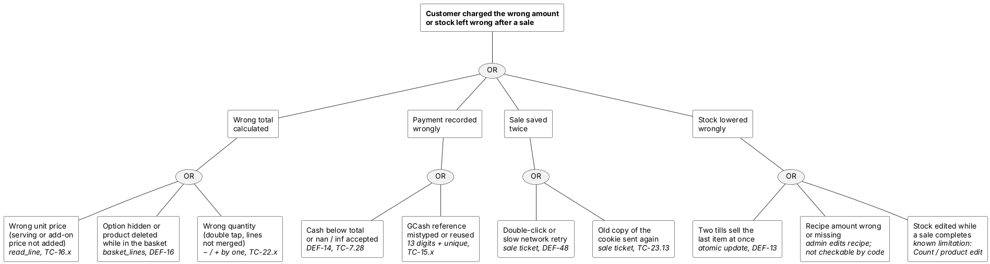
Reading the tree: of the ten basic causes, eight are blocked by code and tested; a wrong recipe amount can only be prevented by the owner checking the recipes (they are still estimates, §10.4), and a stock edit at the same moment as a sale is a known limitation (Restock is safe; Count and the product Edit form overwrite).

9.7 Safety requirements (item 37, Lecture 12 p. 23)
Written like Sommerville's insulin pump requirements (SR1–SR6), from the hazards in §9.5. ✅ = met by v0.21.2 and tested; ⏳ = not yet met.
ID | Requirement | Status
SR1 | The system shall not complete a sale for which there is not enough stock or ingredient at the moment of saving. | ✅ atomic updates, TC-7.26, TC-17.11
SR2 | The system shall not save the same basket as more than one sale. | ✅ sale ticket, TC-23.11–23.13
SR3 | The system shall not accept a cash amount below the total, or a value that is not a finite number. | ✅ TC-7.28
SR4 | The system shall print every chosen serving and add-on on the receipt line of the drink it belongs to, and shall keep it unchanged if options are later renamed or hidden. | ✅ TC-16.x
SR5 | The system shall save a sale and all its stock and ingredient changes together, or none of them. | ✅ one transaction, rollback, TC-7.27
SR6 | The receipt shall not be presented as an official sales invoice. | ⏳ the receipt does not yet say "Not an official receipt"; small template change for a later version
SR7 | The owner shall be able to restore the sales and stock records after the computer fails. | ⏳ manual only (copy instance/); an automatic backup is a future increment

9.8 Functional reliability requirements (item 38, Lecture 12 p. 39)
Like Sommerville's RR1–RR4. In brackets, the type of requirement: checking, recovery or redundancy.
ID | Requirement | Status
RR1 | A pre-defined range shall be set for every number a user types (prices, quantities, cash: 0 to 1,000,000; GCash reference: exactly 13 digits; dates: 2000 to 2100), and the server shall check every input against it. (Checking) | ✅ TC-2.7, TC-7.28, TC-15.x, TC-20.1
RR2 | The system shall check stock and ingredients again at the moment of saving a sale, even if they were checked when the item was added. (Checking) | ✅ TC-7.24–7.27
RR3 | When the database refuses a change (stock too low, duplicate ticket or GCash reference), the system shall roll back the whole sale and show a message instead of an error page. (Recovery) | ✅ TC-15.x, TC-23.11
RR4 | When a new version starts with a database made by an older version, it shall add the missing columns and indexes by itself without losing data. (Recovery) | ✅ TC-23.15, test_avatar.py
RR5 | Starting over with demo data shall keep the old database under a new name instead of deleting it. (Recovery) | ✅ test_seed.py
RR6 | Every change to the code shall pass the automatic tests (20 files, 452 checks + 58 rule checks) before it is merged. (Checking) | ✅ GitHub Checks on every pull request
RR7 | A copy of the database shall be kept on a second device. (Redundancy) | ⏳ not yet (see SR7)

9.9 Threat and control analysis (item 39, Lecture 12 p. 46)
As in Sommerville's preliminary risk assessment for the MHC-PMS: each threat, how likely it is, the control, and whether the control is feasible (cost and effort).
Threat | Probability | Control | Feasibility
Unauthorised user gets in as the admin by guessing the password | Low | Passwords hashed; 5-try limit per username and computer; demo passwords changed | Done (v0.13.3, v0.19.3, 2026-10-12). Low cost
Someone copies a logged-in cookie from the till | Low | Login records; log-out and password change end it; 8 idle hours end it | Done (v0.20.3). Low cost
A cashier opens admin pages by typing the address | Medium | 403 on every admin page; contract check makes sure every page is listed as public, user or admin | Done (v0.7.0, v0.19.0)
Another website makes the browser submit a form (CSRF) | Low | Random token on every form; SameSite=Lax cookie | Done (v0.13.2)
Someone guesses the current password on the change-password page with a stolen login | Low | Not yet: reuse the login attempt limit there (audit A7) | Feasible, small change
Someone finds which usernames exist by timing the login | Low | Not yet: check a dummy hash for unknown users (audit A8) | Feasible, small; low value (2 accounts)
A malicious file uploaded as a picture | Low | Content check, 2 MB limit, random names, nosniff | Done (v0.12.0, v0.14.0)
Script injected through a product name | Low | Jinja2 escaping; later: Content-Security-Policy (audit A10) | Escaping done; CSP needs the inline scripts moved to files
Any logged-in user opens another cashier's receipt by number | Medium | Decision for the owner: normal in a small café, or limit cashiers to their own receipts (audit A12) | Feasible if wanted
The database file is copied off the laptop | Low | The file is not on GitHub (.gitignore, rule P1); passwords are hashed | Done; disk encryption is the owner's choice (Windows BitLocker)
Laptop lost or broken: records gone | Low | Not yet: automatic backup to a second device (RR7) | Feasible; a copy of instance/ to a USB drive each week costs nothing

Words used in §9: atomic update — a database change that happens completely or not at all; rollback — undoing every change of an unfinished transaction; scrypt — a slow hashing method that makes guessing passwords expensive; CSRF — Cross-Site Request Forgery, another website making your browser send one of our forms; Content-Security-Policy (CSP) — a header that tells the browser which scripts it may run.

10. Defects, lessons learned and known limitations

10.1 Defects found and fixed
Testing found 60 defects over the life of the project. Every one of them is fixed in v0.21.2, and from v0.19.0 onwards each fix came with an automated test that fails on the old code and passes on the new one. The table records where each defect was found and how it was fixed.
ID | Severity | Description | Found by | Fix | Status / target
DEF-01 | High | Adding or editing a product with an SKU that already exists crashes the server (500) instead of showing a message | TC-2.3, TC-3.4 | Before saving, check Product.query.filter_by(sku=...) (excluding the product being edited); if found, show the form again with an error | ✅ Fixed v0.7.1
DEF-02 | Medium | Non-number price/quantity crashes the server if the browser check is bypassed | TC-2.4 | Wrap float() / int() in try/except ValueError and show an error | ✅ Fixed v0.7.1
DEF-03 | High | Negative price and negative quantity are accepted | TC-2.5 | Server check: price >= 0, quantity >= 0; also add min="0" to the form inputs | ✅ Fixed v0.7.1
DEF-04 | Medium | Empty name/SKU accepted if the browser check is bypassed | TC-2.6 | Server check: .strip() the value and reject if empty | ✅ Fixed v0.7.1
DEF-05 | Low | Prices display with a $ sign, but the store is in the Philippines | Code review; confirmed by hand | Change the $ in products.html to ₱ | ✅ Fixed v0.7.1
DEF-06 | Low | After logging in, the user is always sent to Products instead of the page they first asked for | TC-5.8 | Read request.args.get('next') and redirect there (only if it is a page within this site: one leading /, never // or / + backslash) | ✅ Fixed v0.20.6
DEF-07 | Critical (security) | SECRET_KEY is written directly in app.py and pushed to a public GitHub repository. Proven on 2026-10-09: a cookie built with it opened the Sales Report as admin without a password | Code review; attack test TC-13.1 | Key from the SECRET_KEY environment variable, else a random key created once in instance/secret_key.txt (not uploaded) | ✅ Fixed v0.13.1
DEF-08 | High (security) | Forms have no CSRF protection (CSRF = Cross-Site Request Forgery: another website tricking a logged-in user's browser into submitting a form). Proven: a product was added by a request without any token | Code review; TC-13.3 | Own small CSRF check: a random token per session in a hidden field of every form, compared with secrets.compare_digest; no new library needed | ✅ Fixed v0.13.2
DEF-09 | High | Logging out did not empty the basket, so on a shared counter computer the next user saw the previous cashier's items | Testing during development (TC-7.17) | session.pop('basket', None) in logout() | ✅ Fixed before v0.8.0 release
DEF-10 | Medium (usability) | The New Sale dropdown showed database stock, ignoring items already in the basket, so it looked like more could be sold | My own hand testing (TC-7.4) | Dropdown shows available = stock − basket; products fully in the basket are hidden; message says how many more can be added | ✅ Fixed before v0.8.0 merge
DEF-11 | High (deployment) | After upgrading the code, Complete Sale crashed: "table sale has no column named cash_received". db.create_all() creates missing tables but never adds columns to existing ones | My own hand testing (TC-7.23) | One-time migration script add_cash_columns_once.py (SQL ALTER TABLE … ADD COLUMN), database backed up first. The crashed sale saved nothing, because the save is one transaction | ✅ Fixed 2026-10-08 (database change, no code change)
DEF-12 | Low | Receipts for sales made before cash tracking showed "Cash ₱0.00 / Change ₱0.00", which looks like a real but impossible payment | Hand testing (TC-7.21) | receipt.html shows "Cash and change not recorded…" when cash is 0; no data invented | ✅ Fixed v0.8.1 (PR #3)
DEF-13 | Medium (reliability) | Race condition: two cashiers completing a sale for the last item at the same moment could both pass the stock check, leaving stock at −1 | Design review; reproduced by tests (TC-7.24–7.27) | Atomic update: subtract stock only if enough is left, in one database step; roll back the sale otherwise | ✅ Fixed v0.8.2
DEF-14 | High | nan, inf and huge numbers in cash, price or quantity crashed the server or were saved as "infinite" | Exploratory testing (TC-7.28, TC-2.7) | Limits of 1,000,000 + math.isfinite() | ✅ Fixed v0.8.3
DEF-15 | Medium | Ids too big for SQLite in an address or form crashed the server | v0.8.x exit check (TC-7.29) | find_by_id() treats them as "not found" (404) | ✅ Fixed v0.8.4
DEF-16 | High (usability) | A product deleted while in a basket left the basket stuck: hidden line, sale could never complete | v0.8.x exit check (TC-7.30) | Deleted products are taken out of the basket with a note | ✅ Fixed v0.8.5
DEF-17 | Low | Text longer than the database columns (e.g. 5,000-character name) was accepted | Fuzz testing (TC-2.8) | Length check + maxlength (100 / 50 / 50) | ✅ Fixed v0.8.6
DEF-18 | Medium (usability) | With many low products the low-stock box filled the screen | v0.9.x stabilization (TC-8.8) | 5 most urgent + "and N more" | ✅ Fixed v0.9.1
DEF-19 | Low | Empty category displayed as the word "None" (since v0.3.0) | v0.9.x stabilization (TC-8.9) | Dash for empty categories | ✅ Fixed v0.9.2
DEF-20 | Medium | A product renamed after being sold appeared twice in Top products, giving a wrong ranking | v0.10.x stabilization (TC-9.7) | Group by product id; show the latest name | ✅ Fixed v0.10.1
DEF-21 | Medium (data integrity) | Deleting a sold product: SQLite may give its id to the next new product, which then "inherits" its sales | v0.10.x stabilization (TC-9.8) | Products with sales history can't be deleted (set quantity to 0 instead) | ✅ Fixed v0.10.2
DEF-22 | Low | Demo data: receipt numbers not in time order | v0.11.x stabilization (TC-10.3) | Sort each day's sale times before creating them | ✅ Fixed v0.11.1
DEF-23 | Low | Amounts ≥ ₱1,000 shown without thousands separator | v0.11.x stabilization (TC-10.4) | peso template filter used everywhere | ✅ Fixed v0.11.2
DEF-24 | Medium | Sales report with end date 9999-12-31 crashed (no next day exists) | Pre-release testing of v0.10.0 (TC-9.5) | Dates limited to 2000–2100 | ✅ Fixed before v0.10.0 release
DEF-25 | Medium | With the web font loading normally, a slow or blocked font server held up the New Sale script, so the change preview stayed at ₱0.00 (browsers wait for stylesheets before running scripts) | Pre-release testing of v0.13.0 (TC-12.6) | Font stylesheet loads in the background (media="print" switched to all when loaded) | ✅ Fixed before v0.13.0 release
DEF-26 | Low | "Please log in to access this page." (from Flask-Login) shown as unstyled text, because its category message has no Bootstrap colour | v0.13.0 restyle (TC-12.8) | Category message shown as info | ✅ Fixed v0.13.0
DEF-27 | High (security) | No limit on wrong passwords: 200 guesses in a row, then the right password still worked | Security review (TC-13.7) | 5 wrong passwords per username + IP address → wait 5 minutes (429) | ✅ Fixed v0.13.3
DEF-28 | Low (security) | Logout worked as a plain link, so any website could log a user out | Security review (TC-13.5) | Logout only as a POST button with token | ✅ Fixed v0.13.2
DEF-29 | Medium (security) | No browser security headers: pages could be framed by other sites (clickjacking) | Security review (TC-13.9) | X-Frame-Options, X-Content-Type-Options, Referrer-Policy on every response | ✅ Fixed v0.13.4
DEF-30 | Medium (security) | app.run(debug=True): on a crash, the debugger console can run Python code | Security review (TC-13.10) | Debug only with FLASK_DEBUG=1 | ✅ Fixed v0.13.4
DEF-31 | Medium (security) | Default passwords (admin123) could not be changed | Security review | Change password on the profile page | ✅ Fixed v0.13.5
DEF-32 | Low | A long name without spaces spilled out of its menu tile over the basket | v0.14.x stabilization (TC-14.13) | Wrap anywhere, max 3 lines in tiles | ✅ Fixed v0.14.1
DEF-33 | Low (usability) | Menu tiles sorted A–Z, mixing drinks and pastries | v0.14.x stabilization (TC-14.14) | Order by category, then name | ✅ Fixed v0.14.2
DEF-34 | Medium (usability) | Each tap reloaded the menu back to "All", so the cashier had to choose the category again for every item | v0.14.x stabilization (TC-14.14) | Chosen category remembered for the browser tab | ✅ Fixed v0.14.2
DEF-35 | Medium (usability) | On phones the basket and Pay button were below the whole menu | v0.14.x stabilization (TC-14.15) | Bottom bar with item count and total that jumps to the basket | ✅ Fixed v0.14.3
DEF-36 | Medium (regression from v0.14.1) | On phones, basket names were squeezed to one letter per line | v0.14.x stabilization (TC-14.16) | Table cells wrap only long words; names kept 8–22rem wide | ✅ Fixed v0.14.3
DEF-37 | Medium (usability) | Between about 990 and 1360 px wide, the basket's Remove (×) button was cut off | Screenshot review while testing v0.15.0 (TC-14.19) | Quantity under the name, tighter cells, side-by-side only from 1200 px | ✅ Fixed v0.14.4
DEF-38 | Medium | Unticking "sizes and add-ons" on a product left basket lines that were then sold with the size price | v0.16.x stabilization (TC-16.11) | Such lines are taken out with a message | ✅ Fixed v0.16.1
DEF-39 | Low | Many long add-on names gave options text longer than the 200-character column | v0.16.x stabilization (TC-16.12) | Shortened with "…" | ✅ Fixed v0.16.1
DEF-40 | High (data integrity) | Deleting a never-sold product left its recipe; SQLite gave the id to the next product, which inherited the recipe | v0.17.x stabilization (TC-17.13) | Recipe deleted with the product; start-up removes leftovers | ✅ Fixed v0.17.1
DEF-41 | Low (usability) | The café sells drinks Hot or Iced, but the screens said "Size", so "Size: Iced" read wrongly | My decision for the café (TC-16.14) | The choose-one group is called a serving on every screen; tiles list the servings ("Hot / Iced") | ✅ Fixed v0.17.2
DEF-42 | Medium (demo data) | With the café's menu every product gets its stock from ingredients (quantity 0), so the demo sales found no product to sell and created only empty ₱0.00 receipts | Screenshot review of v0.17.2 (Home: 8 sales, ₱570.00) (TC-17.14) | Demo sales pick products that can be made (stock_levels()); no sales are created if nothing can be sold; new test_seed.py checks both menus | ✅ Fixed v0.17.3
DEF-43 | Medium | Number boxes were filled with "2,000", which a number box can't read, so they showed up empty; the Edit form of Fresh milk (warn at 2,000 ml) could not be saved | Screenshot review while redesigning (TC-18.1) | plain_amount filter (no separator) for every number box | ✅ Fixed v0.17.4
DEF-44 | Low (usability) | After each Restock / Count / Edit the list reloaded at the top with the search and filter cleared | v0.18.x stabilization (TC-18.12) | Return to the row (#ing-<id>), remember search and filter for the tab | ✅ Fixed v0.18.1
DEF-45 | Low (cosmetic) | In the Products table SKUs broke after the dash ("HC-" / "001") and "100 can make" took two lines | Screenshot review for the documentation (TC-18.15) | SKU and count cells keep their text on one line | ✅ Fixed v0.18.2
DEF-46 | Low (cosmetic) | Avatar menu: "Change picture" and "Change password" ran past the menu's right edge and "Signed in as Admin" took two lines. Side effect of v0.19.1: the menu was set to the name button's width (w-100), and the button became narrower when the theme icon moved into its row | My own hand testing (screenshot), confirmed by measuring in Chromium at 100 %, 110 %, 125 % and phone width (TC-12.13) | Menu is at least the button's width but grows to fit its longest line (min-width: 100%; width: max-content), lines never wrap | ✅ Fixed v0.19.2
DEF-47 | Medium | A 309-digit quantity for a drink made from a recipe crashed New Sale (500, OverflowError in Recipes.usage); neither quantity box has a maximum | Security audit 2026-10-11 (fuzzing, audit A1) | Refuse quantities above MAX_QUANTITY before calculating | ✅ Fixed v0.19.3
DEF-48 | Medium | Two Complete Sale requests sent at the same moment with the same basket both succeed: two receipts, stock taken twice (the basket is in the cookie both carry) | Security audit 2026-10-11 (audit A2; a real double-click in Chromium made only 1 sale) | One-time sale ticket per basket, stored on the receipt with a unique index (same idea as the GCash reference); the second request opens the first receipt with a message. Complete Sale greys out after the first click | ✅ Fixed v0.20.4
DEF-49 | Medium (Windows) | Werkzeug 3.1.8 has CVE-2026-102598: on Windows a static-file request for a device name like NUL: hangs | pip-audit, security audit 2026-10-11 (audit A3) | Werkzeug==3.1.9 (all 17 test files pass with it) | ✅ Fixed v0.19.3
DEF-50 | Medium | The login limit keeps every wrong username in memory, at full length, and never forgets untried ones: 50 tries with 450 KB usernames kept 33 MB | Security audit 2026-10-11 (audit A4) | Cut usernames to 80 characters before counting; clear old entries for everyone | ✅ Fixed v0.19.3
DEF-51 | Medium | A copied session cookie still works after log-out and after a password change; sessions never time out while the browser is open | Security audit 2026-10-11 (audit A6) | New login_session table (one row per logged-in browser, the cookie holds only its random token): log-out deletes the row, a password change ends all of the user's logins and gives this browser a new token, 8 idle hours end a login. Chosen over a per-user "session version" so that logging out on one till doesn't log out another till sharing the same account | ✅ Fixed v0.20.3
DEF-52 | Low | SKUs that differ only in capitals (HC-001, hc-001) are both accepted | Security audit 2026-10-11 (audit A9) | Compare SKUs ignoring capitals (lower() on both sides); a product keeping its own SKU is not re-checked, so pairs saved earlier stay editable | ✅ Fixed v0.20.2
DEF-53 | Medium (demo) | Without internet the pages lost their layout, icons and font, and the avatar and phone menus stayed open, because Bootstrap, its icons and Inter loaded from jsDelivr and Google Fonts | Offline test in Chromium with the internet blocked (2026-10-10); security audit R4 | Store the three in static/vendor/ with their licences; AGENTS.md rule D2 changed | ✅ Fixed v0.19.4
DEF-54 | Low | New Sale v0.20.0 (before release): product names broke in the middle of a word ("Cappuccin / o") because the picture took space beside the name | Screenshot review, TC-22.9 | Picture and price on the top row, the name across the whole tile, wrapping only at spaces | ✅ Fixed before v0.20.0 was published
DEF-55 | Low | New Sale v0.20.0 (before release): on phones "₱1,000" spilled out of its quick-cash button | Measured in Chromium at 390 px, TC-22.9 | Buttons at least 3.9 rem wide; a fifth button wraps to the next row instead | ✅ Fixed before v0.20.0 was published
DEF-56 | Low | New Sale v0.20.0 (before release): on phones the basket line squeezed the name beside the − / + buttons ("1 ×" and "₱140.00" on two lines) | Screenshot review at 390 px, TC-22.9 | On phones the name gets its own row; − / + and the subtotal go below it | ✅ Fixed before v0.20.0 was published
DEF-57 | Low | New Sale v0.20.0 kept the 1180 px page width of the other pages, so on a wide screen about 200 px stayed empty on each side, the menu stopped at 3 tiles per row, and each tile kept a blank line under one-line names | My own check, on my laptop with the café's menu (2026-10-12) | New Sale only: no width limit; auto-fill tile grid; basket 380–460 px; bar and "N left" on one line | ✅ Fixed v0.20.1
DEF-58 | Low | v0.20.0 named the New Sale tile bars stock-bar, a class the Ingredients page already used. The new rules clipped the Ingredients warn-level tick to a 6 px green speck, so it was hard to see how close a full shelf was to its warning level (side effect of v0.20.0, like DEF-46 was of v0.19.1) | My own check, on my laptop (2026-10-13); measured in Chromium against v0.19.4 | New Sale bars renamed (tile-stock, tile-bar, tile-note); TC-22.13 now fails if any New Sale style name is used on another page. Lesson: the v0.20.0 browser check measured only New Sale; a style added for one page must be checked on the pages that share the style sheet | ✅ Fixed v0.20.5
DEF-59 | Low | Folded sidebar: the light/dark icon sat on the right edge, not under the avatar (the row's margin-left: auto still applied after the row became a column in v0.21.0) | My screenshot (2026-10-23); measured in Chromium | margin-left: 0 for the folded sidebar; TC-25.8. Lesson: a rule written for one layout (a row) must be checked when the layout changes (a column) | ✅ Fixed v0.21.2
DEF-60 | Medium | Phone: the "New ingredient" panel was 100 % of the screen wide but started at the button, so its right part was cut off (made worse by v0.21.0's bigger padding) | Layout audit of all pages at 375 px (2026-10-23) | On phones the panel floats under the top bar with 1 rem margins and scrolls if tall; TC-25.9 | ✅ Fixed v0.21.2

10.2 Lessons learned
Looking back over the 60 defects, a few patterns stand out:
- Never trust the browser. The first four defects (DEF-01 to DEF-04) were all values the browser would normally stop but the server accepted. Every form value is now checked again on the server.
- "Check, then write" is not safe when two people work at once. Two tills could both see "1 left" and both sell it (DEF-13). The fix was to let the database do the check and the subtraction in one step.
- A change to one page can break another. DEF-46, DEF-58 and DEF-59 were side effects of a style change made for a different page. Since v0.20.5 a test makes sure New Sale's style names are not shared with other pages, and the last version ended with an audit of every page.
- Screenshots find bugs that tests miss. Looking carefully at each screenshot for this report found DEF-25, DEF-32, DEF-36, DEF-42, DEF-43 and DEF-45.
- Real users find the rest. Seeing the system on my own laptop with the café's real menu found DEF-57, DEF-58 and DEF-59, which no automated test had caught.
Note on the test tools (v0.16.0): two race tests (TC-7.24–7.26) found the "other cashier" moment by counting database look-ups, which changed when the basket code changed, so they briefly reported false failures. They now step in right before the stock update itself, and pass on both the old and the new code. Lesson: a test should depend on what the code does, not on how it is written.
How the v0.7.1 fix works. All checks live in one function, validate_product_form() in app.py, used by both Add and Edit (the DRY principle: Don't Repeat Yourself). It returns either clean data or an error message; on error the form is shown again with a red Bootstrap alert and nothing touches the database. The browser checks (required, min="0") are a convenience; the server check is the real protection.
Lesson from DEF-11: changing the shape of an existing database (adding a column) needs a migration: a small, deliberate script run once, after a backup. Real projects use a migration tool (e.g. Flask-Migrate) to keep these in order.

10.3 Security audit and security review
On 11 October 2026 the whole of v0.19.2 went through a vulnerability and debugging review; the full report is in docs/security_audit_2026-10-11.md. In short:
- Method: dependency check (pip-audit), code scanner (bandit), manual review of all 21 routes, fuzzing of 39 forms with 6,417 hostile requests, 11 targeted attacks and live server probes.
- What held up: no SQL injection, no script injection, no way past the login or admin checks, no crash from the 6,417 fuzzing requests.
- What it found: 1 crash (DEF-47), a duplicate-sale risk (DEF-48), an outdated package (DEF-49), memory growth in the login limit (DEF-50), sessions that can't be cancelled (DEF-51), case-different SKUs (DEF-52), public demo passwords, and 11 risks for future goals (time zone, money as decimals, migrations, splitting app.py, user management).
Security review (2026-10-09): threats and controls
Each threat below was tested as an attack, not just assumed. Chapter 9 builds on this table.
Threat (what an attacker tries) | Asset at risk | Control in the system | Tested by | Status
Steal the database and read passwords | User accounts | Passwords stored as scrypt hashes | Code review | ✅ since v0.6.0
SQL injection in the login form | Whole database | SQLAlchemy sends input as data, never as SQL | TC-13.13 | ✅
Cross-site scripting (XSS) through a product name | Other users' browsers | Jinja escapes everything shown | TC-13.14 | ✅
Forge a login cookie | Admin access | Secret key not in the code | TC-13.1 | ✅ v0.13.1
Cross-site request forgery (CSRF) | Products, sales, passwords | Token in every form; SameSite cookie | TC-13.3–13.6 | ✅ v0.13.2
Guess passwords (brute force) | User accounts | 5 tries then 5 minutes wait; change default passwords | TC-13.7, 13.8, 13.11 | ✅ v0.13.3, v0.13.5
Clickjacking / content sniffing | User actions | Security headers | TC-13.9 | ✅ v0.13.4
Run code through the debugger console | The computer | Debug off by default | TC-13.10 | ✅ v0.13.4
Cashier uses admin pages | Products, reports | @admin_required → 403 | TC-6.x | ✅ since v0.7.0
Upload a harmful file as a "picture" | Server, other users | Content check (PNG/JPG/WebP bytes), 2 MB limit, random names, nosniff | TC-11.5–11.7, TC-14.3, TC-14.9 | ✅
Two sales take the last item at once | Stock accuracy | Atomic conditional update | TC-7.24–7.26 | ✅ since v0.8.2
Two tills use the same milk at once | Ingredient stock | Same atomic update for every ingredient; whole sale cancelled otherwise | TC-17.10, 17.11 | ✅ v0.17.0
Reuse one GCash payment for two purchases | Café's money | Reference number must be unique (checked + unique index) | TC-15.6, 15.7 | ✅ v0.15.0
Untraceable stock changes | Ingredient stock | Ingredient history: every sale, restock and count with user and time | TC-17.2, 17.3, 17.8 | ✅ v0.17.0

Words used: threat (something that could cause harm), vulnerability (a weakness it can use), control (the protection), attack (an attempt to exploit a vulnerability).

10.4 Known limitations
These are things the system does not do yet, or does in a simple way on purpose. They are candidates for future increments.
- Browser tests are not automatic yet: tests/ covers the server; clicking through pages in a real browser is still done before each release (needs Playwright).
- Ingredient groups are a fixed list (Coffee, Milk & cream, Syrups & sauces, Toppings, Bakery, Cups & packaging, Other); a new group needs a code change.
- Recipe amounts are estimates (e.g. 18 g beans per shot, 150 g ice for Iced) until the café owner confirms them; the admin can edit them. If a shop uses sizes instead, a size's scale also multiplies add-ons (an extra shot in a 16oz counts 1.33 shots).
- GCash is recorded, not verified: the cashier checks the amount on the customer's screen. Automatic checking needs a GCash merchant account.
- Count (stock count) overwrites an ingredient's amount on purpose; a sale at that exact moment would be overwritten (Restock adds safely).
- The shop name on receipts is fixed ("Inventory & POS").
- Product pictures and avatars are files on disk, so backing up the database alone does not back them up.
- The login limit is kept in memory, so restarting the app clears it, and nobody can reset a forgotten password except by changing it in the database. Fix: an admin "reset password" page.
- No Content-Security-Policy header yet, because the pages use inline scripts (the CDN files are gone since v0.19.4).
- The light/dark choice is saved per browser, not per user account.
- No "undo" for a tap: a wrong tap is fixed with − on the basket line (one more tap), not an undo button.
- No refunds or voids. To be handled by a void with admin approval flow (Completed → Void requested → Voided / Rejected).
- Editing a product's stock overwrites it with the number typed in (products without a recipe). Ingredients already have Restock-by-amount and a history (v0.17.0); products could get the same.
- Sold products can't be deleted, only set to 0, so they stay in the list with an "Out of stock" badge. Fix: an "archive" option.
- One low-stock threshold (5) for every product. Fix: a per-product threshold (needs a database column, i.e. a migration).
- Money stored as Float, rounded to centavos. Real POS systems store whole centavos or Decimal.
- SQLite allows one writer at a time. Fine for a small shop; many tills would need a server database.
- Not a BIR-registered POS. In the Philippines a machine that issues official sales invoices must use software from a BIR-accredited supplier (RMO 24-2023), each machine needs a Permit to Use, and invoices must follow RR 7-2024. This system's receipts are order slips for the shop's own records, not official invoices.
- No senior citizen / PWD discount and no X- or Z-reading (end-of-shift and end-of-day sales summaries), which Philippine cafés are expected to have. Found while comparing with the café's own subscription POS (2026-10-14).
- Dark theme: a normal tile bar and a Low tile bar are the same amber colour (since v0.18.0); the "N left" text and the Low badge still tell them apart. Cosmetic, not fixed yet.
- No tab icon (favicon): the browser asks for /favicon.ico and gets "404 Not Found" in its console. Harmless.

11. Conclusion
The project set out to replace a café's notebook and calculator with a system that records every sale correctly, keeps stock accurate on its own, and tells the owner how the day went. Version 0.21.2 does that:
- A cashier can ring up a typical order in a few taps, take cash or GCash, and print a receipt that never changes.
- Stock and ingredients go down with every sale, inside the same transaction, so the system never sells what it does not have, even with several tills selling at the same moment.
- The owner sees low stock as it happens, can explain every ingredient change from the history, and reads revenue split into cash and GCash for any range of dates.
- Cashiers cannot reach admin pages, passwords are stored only as hashes, forms are protected against forgery, logins can be ended, and the whole system works without the internet.
Building it in small increments meant there was always a working version to show and test. It also meant that every defect had a version it was found in and a version it was fixed in, which made the 265 test cases and 60 defects in this report possible to trace one by one.
What I learned. The biggest lesson was that most problems were not where I expected them. The features themselves were rarely the hard part; the hard parts were two cashiers pressing a button at the same moment, a customer typing something strange, a style meant for one page changing another, and the gap between "the test passes" and "it looks right on a real screen". Testing on purpose for those cases, writing the rules down in AGENTS.md and letting the automated checks enforce them is what made the later versions stable.
What comes next. The known limitations in 10.4 point to the next increments: an automatic backup to a second device (SR7, RR7), a "Not an official receipt" line on every receipt (SR6), voids with admin approval, senior citizen and PWD discounts, end-of-day X and Z readings, and moving money from floating-point to whole centavos. Using the system as a café's official register would also require BIR accreditation, which is outside the scope of a course project.

Appendix A. Version history
Each version is marked with an annotated tag in Git, which stores a message, a date and who made it. The tag message summarizes what the increment added. From v0.8.2 the Commit column shows the commit with the change; the tag itself sits on the GitHub merge commit of that pull request.
Version numbers follow semantic versioning, MAJOR.MINOR.PATCH: MINOR goes up for a new feature (v0.20.0 → v0.21.0), PATCH goes up for a fix (v0.21.1 → v0.21.2), and MAJOR goes from 0 to 1 when the system is declared complete. Documentation-only changes get no tag.
Tag | Date | Commit | Tag message (what was added)
— | 2026-08-12 | 2cf8b49 | (no tag) Initial commit: add README
v0.1.0 | 2026-08-12 | cb95116 | Walking skeleton: Flask running, GitHub connected
v0.2.0 | 2026-08-12 | d3ca52b | Walking skeleton plus working database layer (Product model)
v0.3.0 | 2026-08-12 | e6ceedb | Product list view with Bootstrap-styled templates
v0.4.0 | 2026-08-12 | e2f3947 | Add product creation via form
v0.5.0 | 2026-08-12 | 51f0ecc | Full product CRUD: create, read, update, delete
v0.6.0 | 2026-08-12 | 2d1a6ae | User authentication (login/logout, no role restrictions yet)
v0.7.0 | 2026-08-13 | 6f552f9 | Role-based access: Admin can manage products, Cashier is view-only
— | 2026-10-03 | e76f4a1 | (no tag) Add documentation draft, test results and use case diagram
v0.7.1 | 2026-10-04 | 6043cdb | Product validation fixes: duplicate SKU, negative values, peso sign (first feature branch + pull request #1)
— | 2026-10-04 | 1d1dd0e | (no tag) Update documentation for v0.7.1: test results and fixed defects
v0.8.0 | 2026-10-08 | 1343236 | Sale processing: basket checkout, cash and change, stock deduction, printable receipt (pull request #2)
v0.8.1 | 2026-10-08 | 538ce09 | Receipt fix: show 'not recorded' for sales made before cash tracking (pull request #3)
— | 2026-10-08 | bf7dc7d | (no tag) Add v0.8.0 hand-test screenshots to documentation
v0.8.2 | 2026-10-09 | caf360f | Safe stock: atomic deduction prevents overselling when sales overlap (pull request #4)
v0.8.3 | 2026-10-09 | 1a15679 | Number limits: reject nan, infinity and unrealistic prices, quantities and cash (pull request #5)
v0.8.4 | 2026-10-09 | 2f94325 | Not found instead of crash for ids too big for the database (pull request #6)
v0.8.5 | 2026-10-09 | 9dbb8b0 | Deleted products are taken out of the basket instead of blocking the sale (pull request #7)
v0.8.6 | 2026-10-09 | decb8f0 | Text limits: name 100, SKU and category 50 characters (pull request #8)
v0.9.0 | 2026-10-09 | d27efd5 | Low-stock warning: badges and reorder alert for 5 units or fewer (pull request #9)
v0.9.1 | 2026-10-09 | 403bd7b | Low-stock box: 5 most urgent shown, count of the rest (pull request #10)
v0.9.2 | 2026-10-09 | a7b4c9c | Empty category shows a dash instead of 'None' (pull request #11)
v0.10.0 | 2026-10-09 | aa07bb2 | Sales report: revenue, sales count, items sold and top products by date range (pull request #12)
v0.10.1 | 2026-10-09 | 96b6682 | Top products: a renamed product counts once (pull request #13)
v0.10.2 | 2026-10-09 | d095cd9 | Products with sales history can't be deleted (pull request #14)
v0.11.0 | 2026-10-09 | 9c0bbac | Demo data: seed script with shop products and a week of sales (pull request #15)
v0.11.1 | 2026-10-09 | e02353c | Demo data: receipt numbers follow the clock (pull request #16)
v0.11.2 | 2026-10-09 | 16c6c7a | Money shown with thousands separators (₱6,904.50) (pull request #17)
— | 2026-10-09 | — | Documentation update for v0.8.2–v0.11.2 (pull request #18, no tag)
v0.12.0 | 2026-10-09 | 5f3648e | Profile pictures: round avatar (initials until a picture is uploaded), avatar menu, automatic database upgrade (pull request #19)
v0.13.0 | 2026-10-09 | ea368ff | Modern theme: left sidebar with icons, light "Clean counter" / dark "Night shift" switch, dashboard home, card layout (pull request #20)
— | 2026-10-09 | — | Documentation update for v0.12.0–v0.13.0 (pull request #21, no tag)
v0.13.1 | 2026-10-09 | b9e44a8 | Secret key out of the code (environment variable or instance/secret_key.txt) (pull request #22)
v0.13.2 | 2026-10-09 | 9da53af | CSRF tokens on every form; logout is a button; SameSite cookie (pull request #23)
v0.13.3 | 2026-10-09 | 9134e6a | Login attempt limit: 5 wrong passwords → wait 5 minutes (pull request #24)
v0.13.4 | 2026-10-09 | aed2017 | Debug mode off by default; browser security headers (pull request #25)
v0.13.5 | 2026-10-09 | 7893486 | Change password on the profile page (pull request #26)
v0.14.0 | 2026-10-09 | 59c6d54 | Product pictures with icon tiles, tap-to-add menu on New Sale, café demo menu (--fresh) (pull request #27)
v0.14.1 | 2026-10-09 | 2795482 | Very long names wrap on the menu and in tables (pull request #28)
v0.14.2 | 2026-10-09 | afea681 | Menu in category order; chosen category kept after each tap (pull request #29)
v0.14.3 | 2026-10-09 | e598e88 | Phone basket bar; table columns stay readable (pull request #30)
— | 2026-10-09 | — | Documentation update for v0.13.1–v0.14.3 (pull request #31, no tag)
v0.14.4 | 2026-10-09 | 8a34326 | Basket Remove button always visible; menu and basket side by side from 1200 px (pull request #32)
v0.15.0 | 2026-10-09 | aa44988 | Cash or GCash payment with a 13-digit reference; receipt and report show the method (pull request #33)
v0.16.0 | 2026-10-09 | 40555c0 | Sizes and add-ons: admin page, drink window on New Sale, options on receipts (pull request #34)
v0.16.1 | 2026-10-09 | 2f97c8d | Sizes/add-ons edge cases: unticked product, very long add-on list (pull request #35)
v0.17.0 | 2026-10-09 | 4492d92 | Ingredients, recipes, can-make counts, ingredient history; sales use ingredients up (pull request #36)
v0.17.1 | 2026-10-09 | 63f9d53 | A deleted product's recipe is deleted too (no inherited recipes) (pull request #37)
v0.17.2 | 2026-10-09 | da4a932 | The one-of choice is called a serving, so the café's Hot / Iced reads naturally (sizes still possible) (pull request #38)
v0.17.3 | 2026-10-09 | a7cd2e5 | Demo sales include products whose stock comes from ingredients (no more ₱0 demo receipts) (pull request #39)
— | 2026-10-09 | — | Documentation update for v0.14.4–v0.17.3 (pull request #40, no tag)
v0.17.4 | 2026-10-09 | c985356 | Number boxes show 2000, not 2,000 (which they can't read) (pull request #41)
v0.18.0 | 2026-10-09 | 9689751 | Ingredients page: groups, Full level and stock bars, search and filters, Needs attention, Update window, ingredient page, History tab (pull request #42)
v0.18.1 | 2026-10-09 | 11e33e7 | Ingredients page keeps the search, filter and row after an update (pull request #43)
— | 2026-10-09 | — | Documentation update for v0.17.4–v0.18.1 (pull request #44, no tag)
v0.18.2 | 2026-10-09 | 4f1ca90 | Products table keeps SKUs and stock counts on one line (pull request #45)
— | 2026-10-09 | — | Documentation: screenshots and how each version was tested (pull request #46, no tag)
— | 2026-10-09 | — | Documentation: requirements chapter (Lecture 4) and context model (pull request #47, no tag)
— | 2026-10-09 | — | Documentation: Lecture 5 system models, 35 UML diagrams (pull request #48, no tag)
v0.19.0 | 2026-10-09 | cf2894e | AGENTS.md rules, automated tests in tests/ and GitHub checks on every pull request (pull request #49)
v0.19.1 | 2026-10-09 | b6b9090 | Light/dark switch is an icon only: sun in the light theme, moon in the dark theme, beside the user's name (pull request #50)
v0.19.2 | 2026-10-09 | 57527bb | Avatar menu grows to fit its words; each line on one line (DEF-46) (pull request #51)
— | 2026-10-11 | — | Documentation: security audit of v0.19.2 (docs/security_audit_2026-10-11.md, DEF-47–DEF-52) (pull request #52, no tag)
v0.19.3 | 2026-10-11 | 1318ec3 | Security audit patch: quantity limit on New Sale, login limit remembers at most 50 characters and forgets old entries, Werkzeug 3.1.9 (DEF-47, DEF-49, DEF-50) (pull request #53)
v0.19.4 | 2026-10-11 | 4821094 | Pages work without internet: Bootstrap 5.3.3, Bootstrap Icons 1.11.3 and Inter stored in static/vendor/ (DEF-53) (pull request #54)
v0.20.0 | 2026-10-12 | 6f42f1e | New Sale redesign "Rush Hour + Stock Aware": + Hot / + Iced on each tile, stock bar and the missing ingredient, running-low banner, − / + and add-ons changed on the basket line (design 6a), "Uses N ingredients" panel, quick cash (pull request #55). A feature chosen by the student before the open patches DEF-48/51/52: a recorded exception to the stabilization rule
v0.20.1 | 2026-10-12 | 9e183f2 | New Sale uses the whole screen: no 1180 px limit on that page, as many tiles per row as fit, basket 380–460 px, bar and "N left" on one line, "Other" cash button replaced by an "Other amount" box (DEF-57) (pull request #56)
v0.20.2 | 2026-10-12 | 6b2b4f5 | SKUs are compared without regard to capitals, so hc-001 can't be added next to HC-001; an unchanged SKU stays editable (DEF-52) (pull request #57)
v0.20.3 | 2026-10-12 | 6a726b9 | Logins can be ended: new login_session table, the cookie carries only a random token; log-out deletes it, a password change ends every login of that user, 8 idle hours end a login. Everyone logs in once more after the upgrade (DEF-51) (pull request #58)
v0.20.4 | 2026-10-12 | f2eda4d | One sale per basket: each basket gets a one-time sale ticket, the receipt stores it and the database allows it once; a second click, a retry or an old cookie opens the first receipt instead; Complete Sale greys out after the first click (DEF-48) (pull request #59)
— | 2026-10-12 | — | Documentation: README.md written (what the app does, quick start, demo accounts, tests, folders, security, contributing); Python version in Section 1 corrected (pull request #61, no tag)
v0.20.5 | 2026-10-13 | efb87ec | Ingredients page: the warn-level tick on each stock bar is a full line again; the New Sale tile bars got their own class names (tile-bar) instead of reusing stock-bar, and a test stops New Sale style names from being shared again (DEF-58) (pull request #62)
— | 2026-10-13 | — | Documentation: new guide docs/run_on_another_computer.md (set the app up on another computer such as a school lab: with or without Git, without activating the venv, with an optional USB copy of the shop's own menu, no-internet install, troubleshooting, cleaning up a shared computer); README wording fixes and a link to the guide; security audit A5 closed (demo passwords changed on the demo laptop) (pull request #63, no tag)
— | 2026-10-14 | — | Documentation check against v0.20.5: actors, requirements (UR-1, 2, 3, 5, 8; NFR-12 offline; parts S5, S6, U4), structured specifications (sale ticket, login record), two new computation tables (quick cash, tile stock bar), scenario 1 with the one-tap flow, metrics measured again on v0.20.5, known limitations (BIR registration, senior/PWD discount, X/Z reading, dark-mode bar colour, tab icon), checklist and AGENTS.md folder list (pull request #64, no tag)
— | 2026-10-14 | — | Report items 26–39 written from the v0.20.5 code: §8 architecture (MVC, layers, system context, subsystems, object classes, usage scenario) and §9 dependability and security (reliability, safety and security terminology, vulnerability avoidance, risk classification, fault tree, safety and reliability requirements, threat and control analysis); 6 new diagrams (pull request #65, no tag)
— | 2026-10-14 | — | Generic names: the café's own add-on and drink names that had slipped into the code comments, tests, test menu, report and one diagram were replaced with generic ones (Oat Milk, Sweetener, Honey Latte, Mocha), and erased from 8 screenshots, because the owners' consent covers only their photos and prices (pull request #66, no tag)
v0.20.6 | 2026-10-23 | — | Login goes back to the page the user first asked for, but only a page on this site (page_after_login()); a link to another website, //host or / + backslash is ignored. Last open defect closed (DEF-06). Short comments added above the 11 older routes (v0.3–v0.20) that had none; new docs/defense_preparation.md (demo script and question list for the one-to-one session) (finishing touches, branch docs/finishing-touches)
v0.21.0 | 2026-10-23 | — | Cozy layout (F20): new warm palette (cream and caramel in the light theme, espresso and amber in the dark theme), bigger text, softer corners and wider gaps on every page, roomier New Sale tiles and basket, and a Fold menu button that shrinks the sidebar to an icon strip on wide screens (choice saved in the browser, like the theme). Only theme.css, base.html and a new test; no database or server change (branch feature/cozy-layout)
v0.21.1 | 2026-10-23 | — | The fold button moved to the top row, as an icon beside the system name (requested after seeing v0.21.0); folded, the logo and the icon sit one above the other. No "Fold menu" words any more; the tooltip and screen-reader label stay (branch fix/fold-button-beside-brand)
v0.21.2 | 2026-10-23 | — | Layout audit of every page (14 pages, light and dark theme, phone 375 px and desktop, open and folded sidebar). Two defects fixed: the theme icon of the folded sidebar sat to the right of the avatar (DEF-59), and the "New ingredient" panel ran off the right edge of a phone (DEF-60). No page had sideways page scrolling (branch fix/rail-alignment-audit)

From v0.8.2 the Commit column shows the commit with the change; the tag sits on the GitHub merge commit of that pull request. Pull request numbers assume the versions were published in order in one session.
— | 2026-10-23 | — | Final report: final_report.md and final_report.docx, written from this draft, with a new tour of v0.21.2, cleaned-up tables and the last two open hand tests closed (TC-4.4, TC-19.14) (branch docs/final-report, no tag)

Appendix B. Automated test suite
Since v0.19.0 the tests live in the project's tests/ folder, so anyone can run them with one command. Each file runs in a temporary copy of the project, so the real database is never touched, and GitHub runs the same command on every pull request (.github/workflows/checks.yml). Browser tests are not in tests/ because they need extra software; they are run by hand before each release.
python tests/run_tests.py # the rule check, then every test file
python tests/run_tests.py sales # only test files whose name contains "sales"
python tests/check_contract.py # only the project rules marked [checked] in AGENTS.md
On v0.21.2 the run ends with "All 22 passed (contract check + test files)."
Test file | Covers | Checks
check_contract.py | The AGENTS.md rules marked [checked] (58 checks since v0.20.0): every page protected, CSRF tokens, no debug or secret in code, allowed packages and CDN files, no private files in Git | 58 rule checks
test_products.py | F1–F6: product forms, login, roles, DEF-01–DEF-04 | 40
test_sales.py | F7: basket, cash and change, receipts, upgrade from v0.7.1, DEF-09, DEF-10, DEF-21 | 40
test_race.py | DEF-13: two tills at once; 20 cashiers on a real server (products and ingredients); DEF-48 (v0.20.4): the same basket sent 2 and 5 times at once, an old cookie | 11
test_limits.py | DEF-14, DEF-15, DEF-17, DEF-47: nan, infinity, huge numbers and ids, long text, huge drink quantities | 23
test_low_stock.py | F8, DEF-18 | 8
test_report.py | F9: dates, midnight, totals, top products | 11
test_avatar.py | F10 / TC-11.x | 18
test_security.py | F12 / TC-13.x, TC-20.3–20.5: secret key, CSRF, login limit (incl. DEF-50), headers, passwords, Werkzeug version (DEF-49) | 42
test_product_pictures.py | F13 / TC-14.x | 25
test_payment.py | F14 / TC-15.x | 19
test_options.py | F15 / TC-16.x | 34
test_ingredients.py | F16 / TC-17.x | 38
test_ingredients_page.py | F17 / TC-18.x | 34
test_number_boxes.py | DEF-43, 5 pages | 5
test_seed.py | Demo data: both menus, run twice, photos, --fresh backup, DEF-42 | 6
test_theme.py | F11 / TC-12.10–12.13 (v0.19.1–v0.19.2): icon-only switch on 3 pages, label, position; avatar menu width (DEF-46) | 16
test_offline.py | DEF-53 / TC-21.1 (v0.19.4): no outside addresses, every asset and font file exists | 11
test_new_sale.py | F19 / TC-22.1–22.8, TC-22.11, TC-22.13 (v0.20.0–v0.20.5): tiles, banner, − / +, change on the basket line, ingredient panel, quick cash, login and token on the new pages, full-width layout, no shared style names (DEF-58) | 55
test_sessions.py | DEF-51 / TC-23.4–23.10 (v0.20.3): copied cookie after log-out and password change, two tills on one account, cookie made with the real key, 8 idle hours, table clean-up | 16
test_layout.py | F20 / TC-25.1–25.9 (v0.21.0–v0.21.2): fold icon beside the name, saved choice before drawing, tooltips, wide screens only, warm palette, centred folded icons, phone panel | 12
test_login_next.py | DEF-06 / TC-5.8, TC-24.1–24.4 (v0.20.6): back to the requested page; other-website links ignored | 6
22 files |  | 470 checks + 58 rule checks

Appendix C. Where each Section B item is answered
# | Item | Lecture | Section
1 | Process model and why | L2 | 3
2 | Full story of each feature | L3 p. 21 | 4
3 | Detailed test case of each feature | L3 p. 31 | 5
4 | Requirements definition: user and system requirements | L4 p. 7 | 6.1
5 | Nonfunctional requirements | L4 p. 18 | 6.2
6 | Nonfunctional requirements metrics | L4 p. 21 | 6.3
7 | Requirements of each part | L4 p. 39 | 6.4
8 | Structured requirements | L4 p. 42–43 | 6.5
9 | Tabular computation | L4 p. 45 | 6.6
10 | Detailed scenarios | L4 p. 62–63 | 6.7
11 | Use case diagram | L4 p. 65 | 7.3
12 | Context model | L5 p. 10 | 7.1
13 | Process model | L5 p. 12 | 7.2
14 | Every use case's UML diagram | L5 p. 15 | 7.3
15 | Tabular use case descriptions | L5 p. 16 | 7.4
16 | Each actor's use cases | L5 p. 17 | 7.5
17 | Sequence diagrams | L5 p. 19–20 | 7.6
18 | Class associations | L5 p. 23–24 | 7.7
19 | Class model | L5 p. 25 | 7.7
20 | Generalization hierarchy | L5 p. 30–31 | 7.8
21 | Aggregation | L5 p. 33 | 7.9
22 | Activity model | L5 p. 36 | 7.10
23 | Application process | L5 p. 37 | 7.11
24 | State diagrams | L5 p. 40 | 7.12
25 | Structured forms of states | L5 p. 41–42 | 7.13
26 | Software architecture | L6 p. 42, 49 | 8.1
27 | System context | L7 p. 9 | 8.2
28 | High-level architecture | L7 p. 13 | 8.3
29 | Object classes | L7 p. 19 | 8.4
30 | Detailed usage scenario | L8 p. 53 | 8.5
31 | Reliability terminology | L11 p. 25 | 9.1
32 | Safety terminology | L11 p. 35 | 9.2
33 | Security terminology | L11 p. 42 | 9.3
34 | Vulnerability avoidance techniques | L11 p. 45 | 9.4
35 | Risk classification | L12 p. 15 | 9.5
36 | Software fault tree | L12 p. 18 | 9.6
37 | Safety requirements | L12 p. 23 | 9.7
38 | Functional reliability requirements | L12 p. 39 | 9.8
39 | Threat and control analysis | L12 p. 46 | 9.9

Appendix D. Running the system
You need Python 3.11 or newer. On Windows, from the project folder:
python -m venv venv
.\venv\Scripts\python -m pip install -r requirements.txt
.\venv\Scripts\python seed_demo_data.py
.\venv\Scripts\python app.py
Then open http://127.0.0.1:5000 in a browser. The demo accounts are admin / admin123 and cashier / cashier123; change them on the Profile page before using the system for real. python seed_demo_data.py --fresh starts again with only the demo data, after renaming the old database so nothing is lost. Step-by-step instructions for another computer, including one without internet, are in docs/run_on_another_computer.md.

