Milestone 5 Pseudocode Algorithm Design Standards
Naming Standards
1.11.3-ALG calculateMatchScore() Algorithm
Purpose:
Computes 0-100 composite score across four weighted sub-scores: skill match (40pts, delegated to compareSkills(), experience (30pts), education (20 pts), and location/remote (10 pts). Score is clamped at 100 before returning. 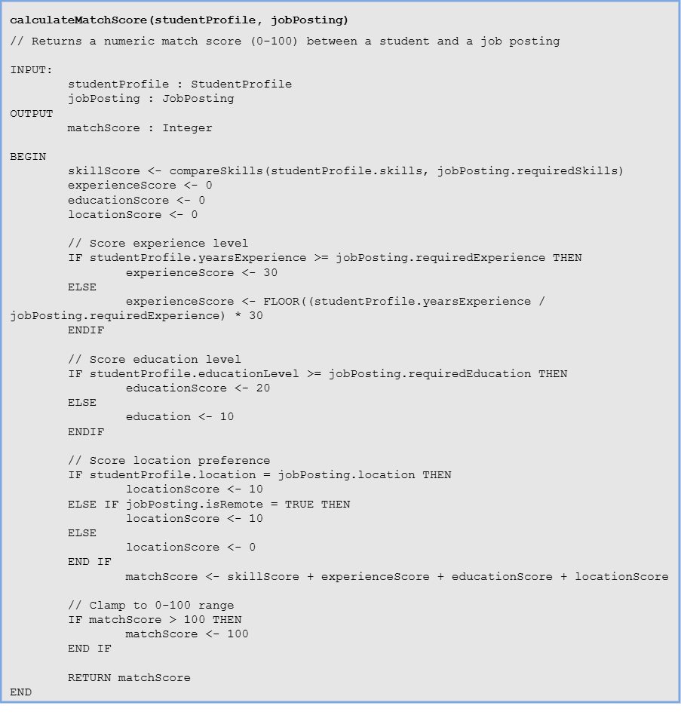
Local Data:
skillScore: Integer
experienceScore: Integer
educationScore: Integer
locationScore: Integer
matchScore: Integer

1.11.3-ALG compareSkills() Algorithm
Purpose:
Iterates every required skill against the student’s skill list using a case-insensitive name match, then scales the match ratio to 40 points. Called as a sub-routine by Algorithm 1.

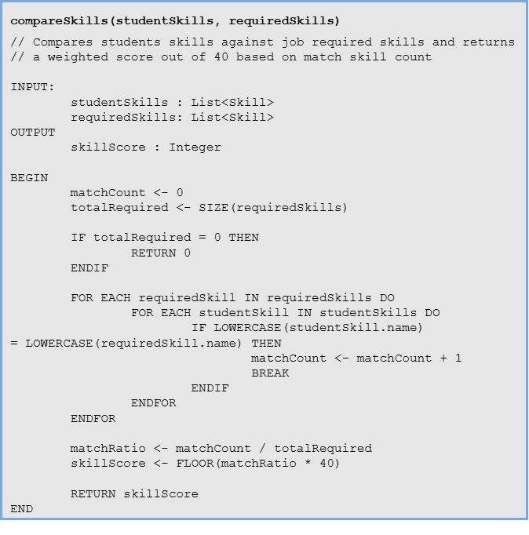
Local Data:
matchCount: Integer
totalRequired: Integer
matchRatio: Float
skillScore: Integer
requiredSkill: Skill
studentSkill: Skill

