1.10.4-ALG formatNotification() Algorithm
Purpose:
Formats a notification job into notification content and prepares the message content needed for delivery.
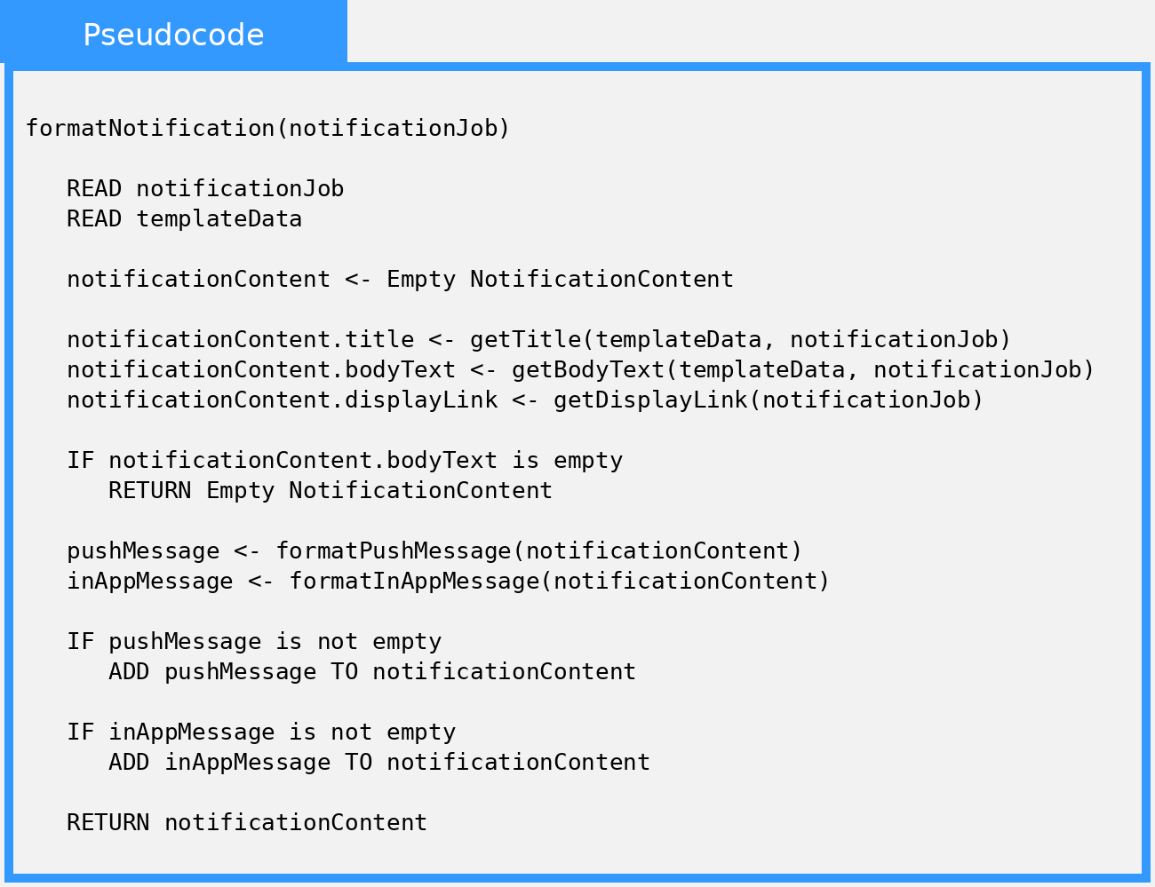

Local Data:
templateData : NotificationTemplate
notificationContent : NotificationContent
pushMessage : NotificationContent
inAppMessage : NotificationContent

