1.10.5-ALG saveNotification() Algorithm
Purpose:
Stores notification content for the resolved recipients and creates notification records for later use.
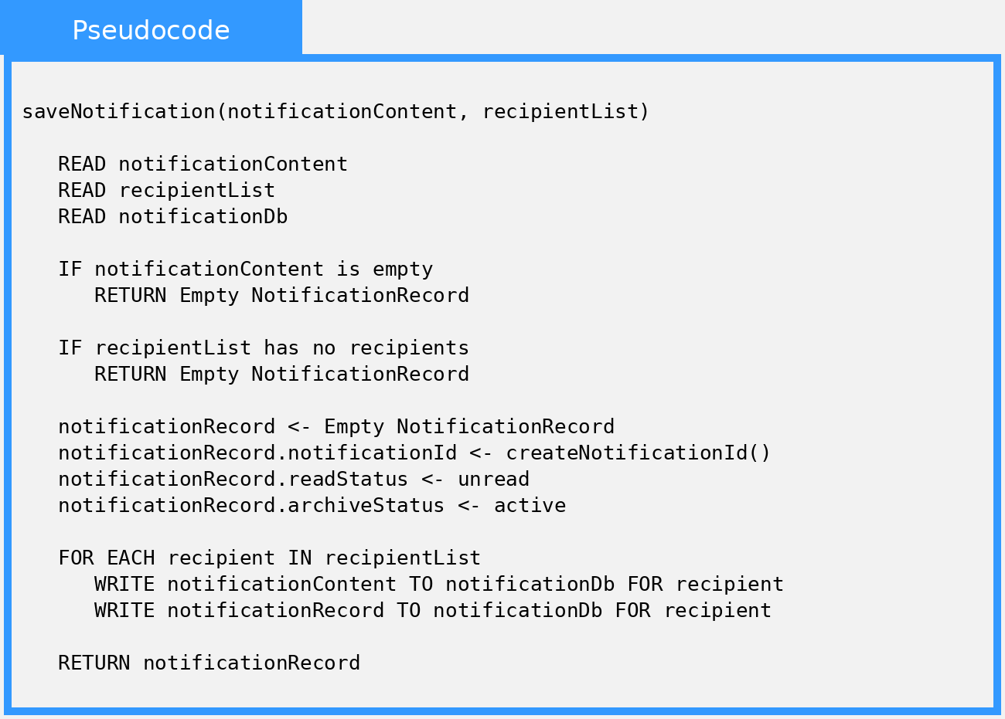

Local Data:
notificationDb : NotificationDb
notificationRecord : NotificationRecord
recipient : Recipient

