1.10.6-ALG resolveRecipients() Algorithm
Purpose:
Determines which users should receive a notification by applying recipient rules and removing muted users.
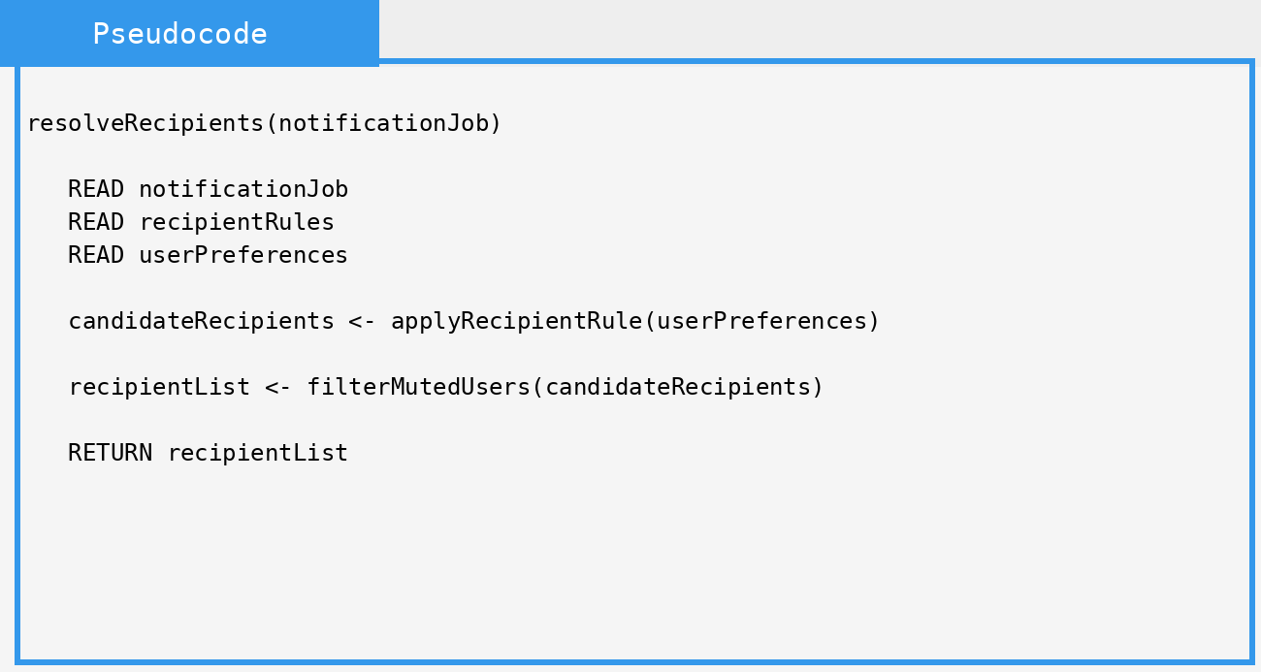

Local Data:
userPreferences : UserPreferences
recipientRules : RecipientRules
candidateRecipients : RecipientList
recipientList : RecipientList

