2.5 Job Detail Screen

Desktop View

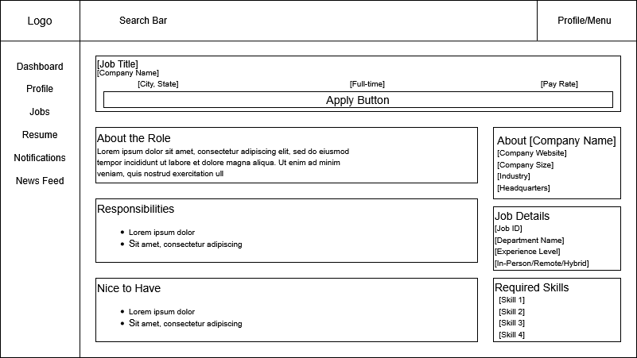

Mobile View
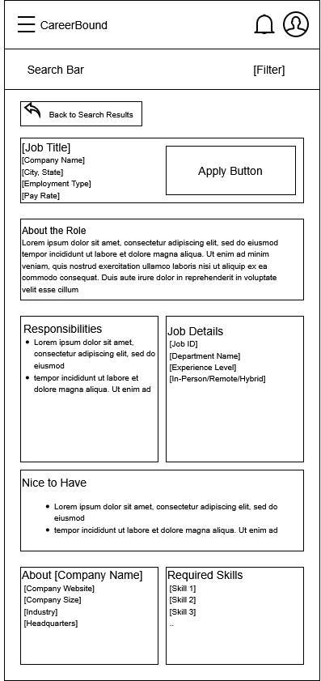

Design Information

Field | Description / Purpose
View Name & Number | 2.5 – Job Detail Screen
Purpose / Design Concern | Allows students to get more information for Job Postings.
Description | Displays all information relevant to a given Job Postings.
Requirements | SRS 2.5.2, SRS 2.5.7, SRS 2.5.9
Elements | Back Button
 | Job Data
Inputs | Tap/Click on Apply Button
Outputs | Application Submission Confirmation, Updated Application Status
Navigation / References | Job Search Screen, Company Profile, Student Dashboard
Viewpoint | UI Wireframe / Mockup (Desktop & Mobile)

