2.4 Job Search Screen

Desktop View
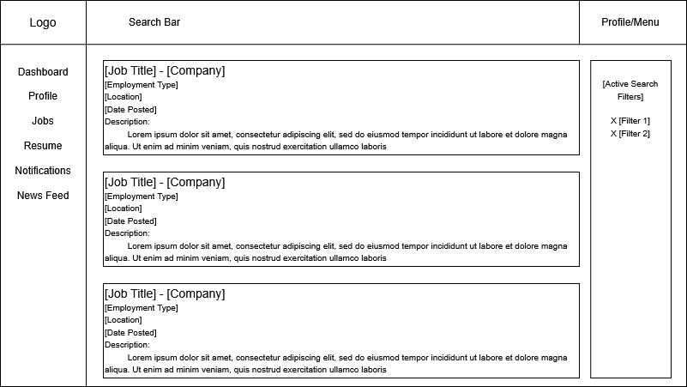
Mobile View
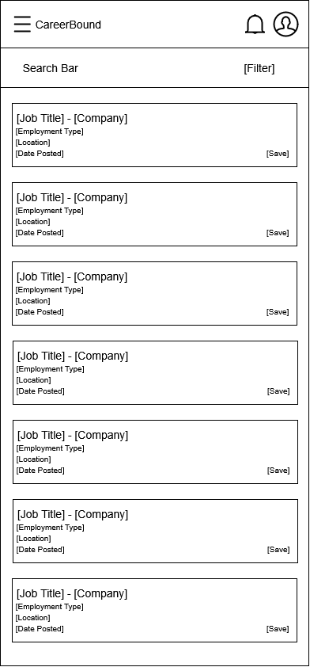
Design Information

Field | Description / Purpose
View Name & Number | 2.4 – Job Search Screen
Purpose / Design Concern | Allows students to search for jobs and companies.
Description | Displays searchable job listings with filters and detailed results.
Requirements | SRS 2.3 Search Features, 3.3 Student Search Features
Elements | Search bar
 | Filters
 | Results list
 | Save/apply buttons
Inputs | Search terms, filter selections, wildcard search
Outputs | Matching job postings and company search results
Navigation / References | Job Details Screen, Company Profile, Student Dashboard
Viewpoint | UI Wireframe / Mockup (Desktop & Mobile)

