Name: Architectural Design Class Members,
Class: CSE 430 Architectural Design,
Teacher: Linwood Jones,
May 9, 2026

Career Bound System
Software Design Description (SDD)

Table of Contents
Milestone 1 Design Overview ............................................... 2
Figure 1.1 – Career Bound System Master Component Diagram (UML 2.0) ....... 2
Interface Glossary – Career Bound System Master Component Diagram ......... 3
SRS Requirements Mapping .................................................. 4
Figure 1.2 – Web Client ................................................... 5
Figure 1.3 – Mobile Client ................................................ 6
Figure 1.4 – API Gateway / Orchestrator ................................... 7
Figure 1.5 – Authentication Service ....................................... 8
Figure 1.6 – Profile Management Service ................................... 9
Figure 1.7 – Resume Service .............................................. 10
Figure 1.8 – Job Posting Service ......................................... 11
Figure 1.9 – Search Service .............................................. 12
Figure 1.10 – Communication Services (Notifications + News Feed) ......... 13
Figure 1.11 – Recommendation Service ..................................... 14
Figure 1.12 – External Services .......................................... 15
Figure 1.13 – Analytics Service .......................................... 16
Figure 1.14 – Database ................................................... 17
Figure 1.15 – File / Blob Storage ........................................ 18

Milestone 1 Design Overview

Figure 1.1 – Career Bound System Master Component Diagram (UML 2.0)
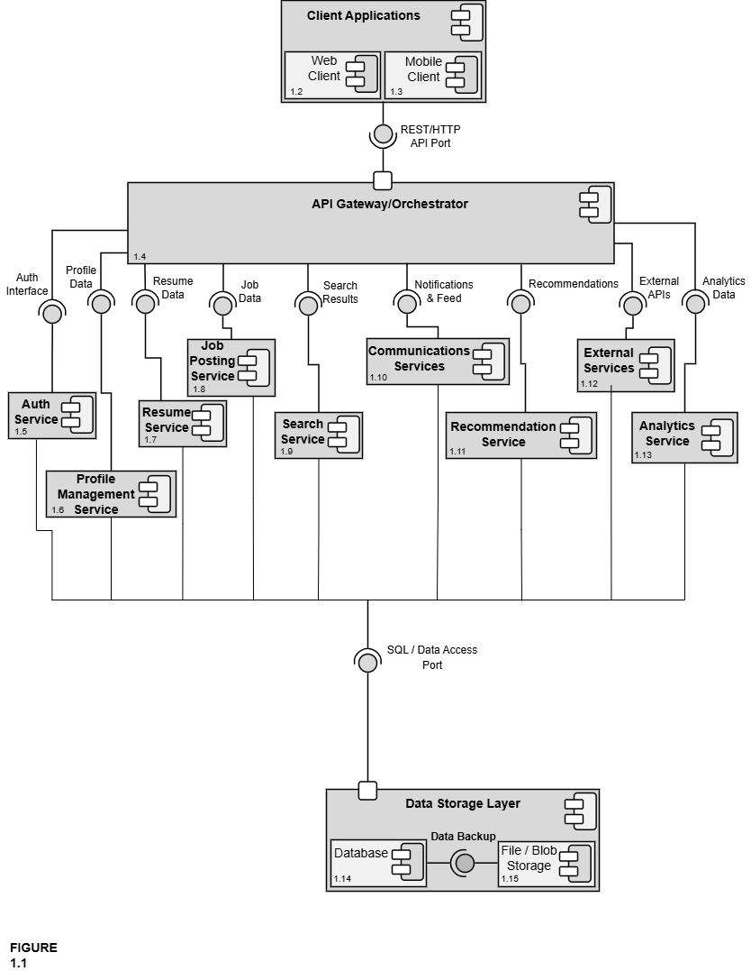
(See Figure 1.2 – Web Client Detail)
(See Figure 1.3 – Mobile Client Detail)
(See Figure 1.4 – API Gateway / Orchestrator Detail)
(See Figure 1.5 – Authentication Service Detail)
(See Figure 1.6 – Profile Management Service Detail)
(See Figure 1.7 – Resume Service Detail)
(See Figure 1.8 – Job Posting Service Detail)
(See Figure 1.9 – Search Service Detail)
(See Figure 1.10 – Communication Services (Notifications + News Feed) Detail)
(See Figure 1.11 – Recommendation Service Detail)
(See Figure 1.12 – External Services Detail)
(See Figure 1.13 – Analytics Service Detail)
(See Figure 1.14 – Database Detail)
(See Figure 1.15 – File / Blob Storage Detail)

Interface Glossary – Career Bound System Master Component Diagram

Interface Name | Description | Provided By | Required By
REST/HTTP API Port | Formal, well-defined entry point for all client (Web + Mobile) communication | API Gateway / Orchestrator | Client Applications (Web Client + Mobile Client)
Auth Interface | Login, registration, role management, and session handling | Authentication Service | API Gateway
Profile Data | Read/write access to company and student profiles (locations, following, skills, GPA, etc.) | Profile Management Service | API Gateway, Search Service, Recommendation Service
Resume Data | Resume creation, submission, storage, retrieval, and access control | Resume Service | API Gateway, Search Service, Company profiles
Job Data | Job posting creation, editing, deletion, required skills, and job details | Job Posting Service | API Gateway, Search Service, Recommendation Service
Search Results | Candidate and job search results, filters, autocomplete, and wildcards | Search Service | API Gateway
Notifications & Feed | In-app notifications, push notifications, news feed posts, and updates | Communication Services | API Gateway
Recommendations | Job and candidate recommendations based on profiles, resumes, and job data | Recommendation Service | API Gateway
External APIs | Integration with third-party services (USPS address validation, autocomplete APIs, push notification providers, etc.) | External Services | API Gateway
Analytics Data | System usage metrics, reporting, and analytics data | Analytics Service | API Gateway
SQL / Data Access Port | Formal port — the single standardized interface through which all services access persistent data (the only way any service talks to the database or file storage) | Data Storage Layer | All services

SRS Requirements Mapping
Component | SRS Sections / Requirements It Directly Supports
Client Applications  (Parent) | • 1.2 Application Scope (web and mobile interfaces that share the same features)  • Overall client-side architecture, shared UI patterns, role-based views, and coordination between web and mobile clients
Web Client | • Primary web-based user interface (browser UI)  • Implements all web UI elements for Company and Student features (sections 2.x and 3.x)  • Profile pages, search bar, forms, news feed display, notifications display, resume form, job browsing, etc. (1.2.1)
Mobile Client | • Mobile application user interface  • Implements the same features and characteristics as the Web Client (per SRS 1.2.1)  • Mobile-optimized UI for all features in sections 2.x and 3.x (profiles, search, news feed, notifications, resume form, job browsing, etc.)
API Gateway / Orchestrator | • Cross-cutting orchestration for all client–service communication (implicit in 1.2 and all functional requirements in 2.x / 3.x)
Authentication Service | • Foundational requirement for all logged-in features (profiles, following, notifications, job postings, resume access, etc.)  • Required for every section under 2.x and 3.x
Profile Management Service | • 2.1 Company Profile Page (2.1.1–2.1.3.10)  • 3.1 Student User Profile (3.1.1–3.1.3.3)
Resume Service | • 3.5 Resume (3.5.1–3.5.5.2)  • Referenced in 2.1.2, 2.2.5, 2.3.3, 2.3.5, 2.5.6, 3.1.3.1–3.1.3.3
Job Posting Service | • 2.5 Job Postings (2.5.1–2.5.7)  • Referenced in 3.3.1, 3.4.1, 2.2.5
Search Service | • 2.3 Search Features (2.3.1–2.3.8)  • 3.3 Search Features (3.3.1–3.3.2)
Communication Services (Notifications + News Feed) | • 2.2 Notifications (2.2.1–2.2.5)  • 2.4 News Feed (2.4.1–2.4.6)  • 3.2 Notifications (3.2.1–3.2.7)  • 3.4 News Feed (3.4.1–3.4.2)
Recommendation Service | • Job and candidate recommendations based on profiles, resumes, and job postings  • Supports 2.3 Search Features, 2.5 Job Postings, 3.3 Search Features, and 3.1/3.5 profile/resume data
External Services | • External integrations (USPS address validation in 2.1.3.9, autocomplete API in 2.3.6, push notification services in 2.2, etc.)  • Any third-party APIs referenced throughout the SRS
Analytics Service | • Provides reporting and analytics on job posting performance (views, applications, 2.5), candidate search effectiveness (filters, results, 2.3), profile and resume engagement (2.1, 3.1, 3.5), and notification / news feed activity (2.2, 2.4, 3.2, 3.4)  • Monitors key performance metrics (e.g., search results returned within 3 seconds per 2.3.5)  • Supports data-driven platform improvements, usage insights, and overall system monitoring
Data Storage Layer  (Parent) | • Provides the single unified SQL / Data Access Port used by every service in the system  • Acts as the central enclosing component that coordinates Database and File/Blob Storage  • Manages system-wide data concerns (transactions, consistency, backups, scalability, reliability)  • 4. Hardware requirements (implicit backend storage, servers, infrastructure)
Database | • All persistent data storage for profiles, resumes, job postings, notifications, news feed, authentication, etc.  • Referenced in every “Data X.X.X” entry throughout the SRS
File / Blob Storage | • Storage of uploaded resumes, profile images, attachments, and other binary files  • Supports 3.5 Resume submission and any file-related requirements

Figure 1.2 – Web Client & Figure 1.3 – Mobile Client
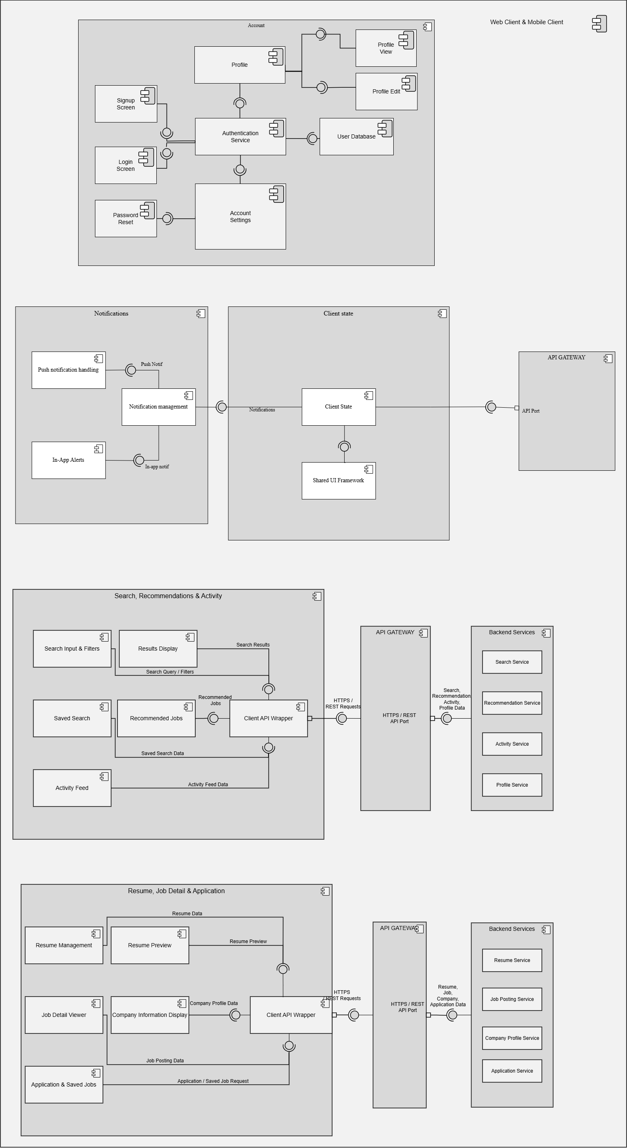

Figure 1.4 – API Gateway / Orchestrator
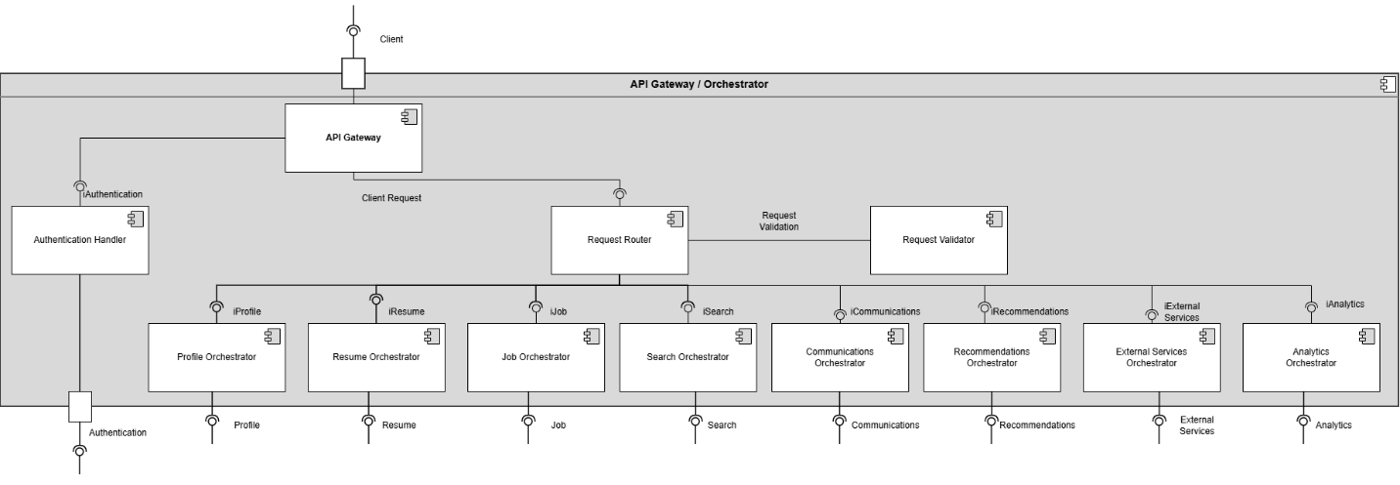Figure 1.5 – Authentication Service
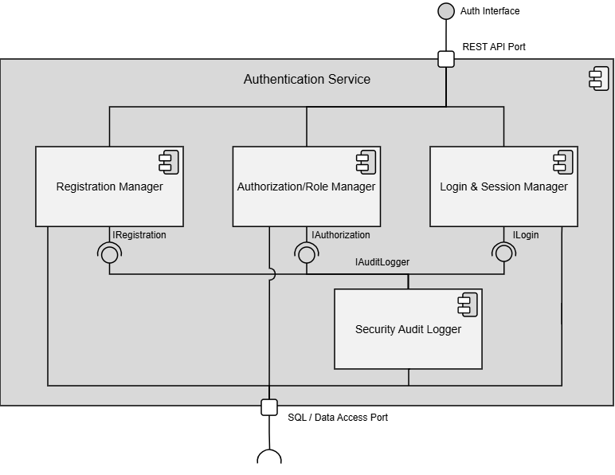

Figure 1.6 – Profile Management Service
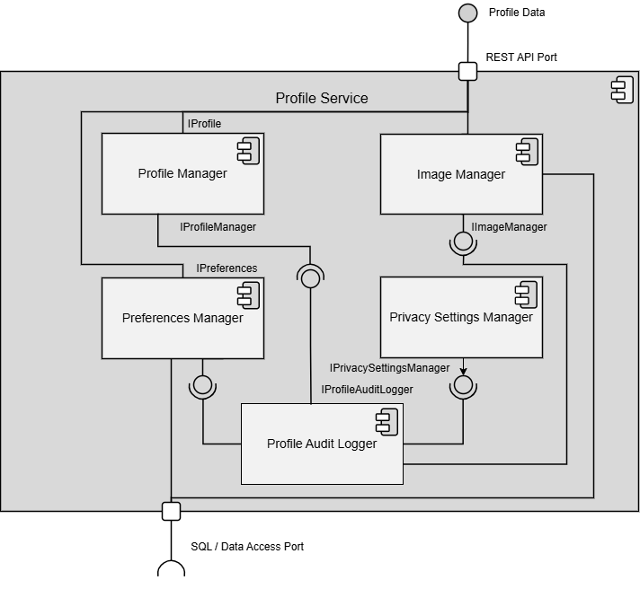

Figure 1.7 – Resume Service
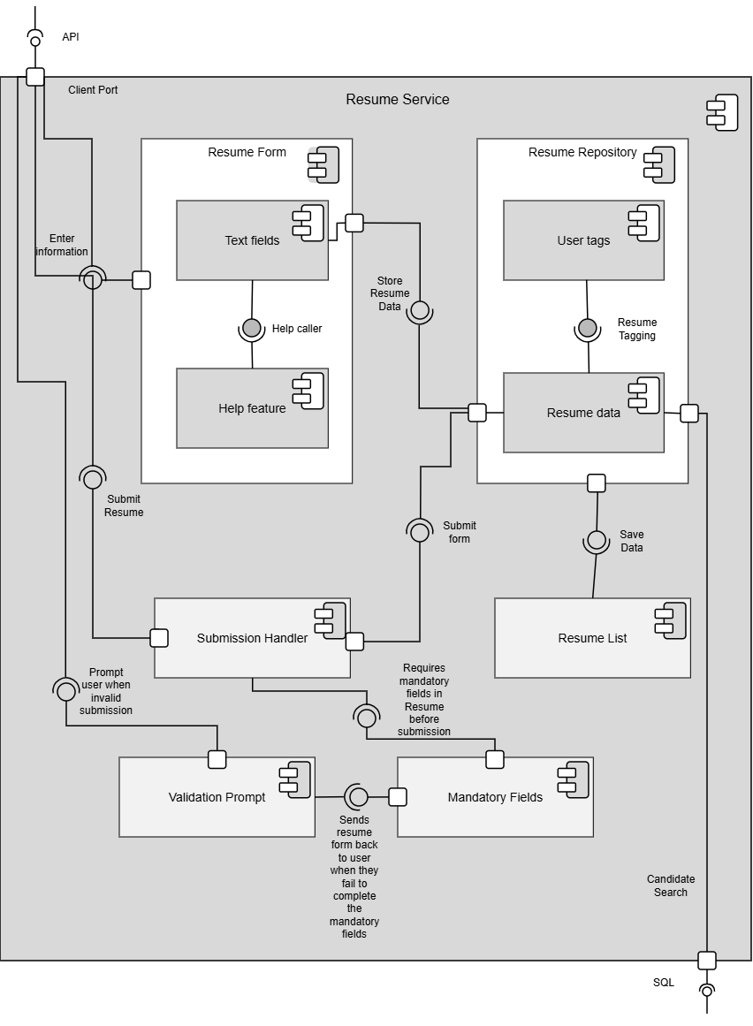

Figure 1.8 – Job Posting Service
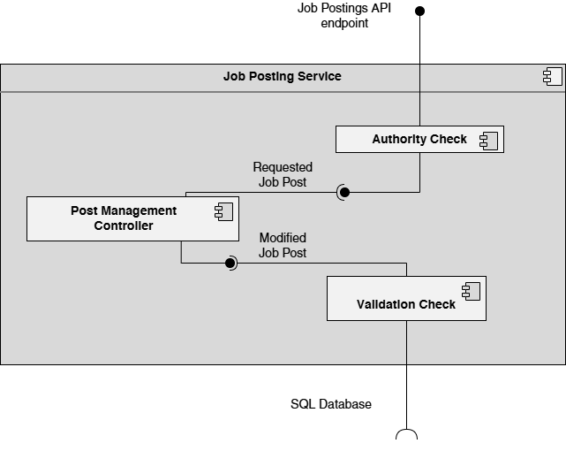

Figure 1.9 – Search Service

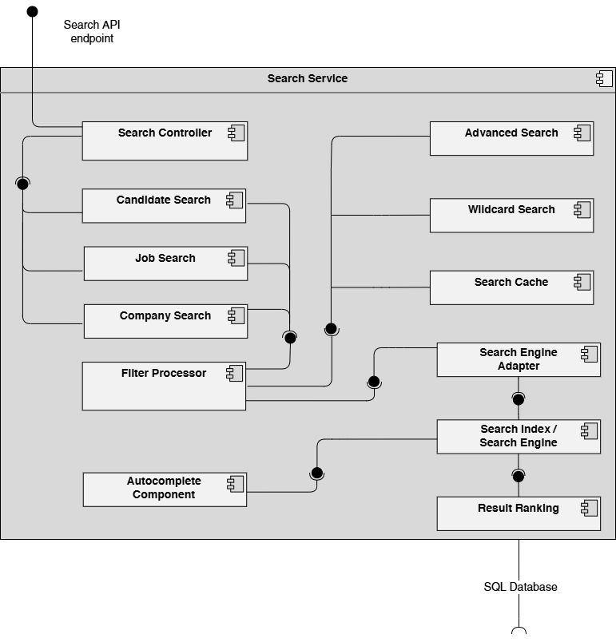

Figure 1.10 – Communication Services (Notifications + News Feed)
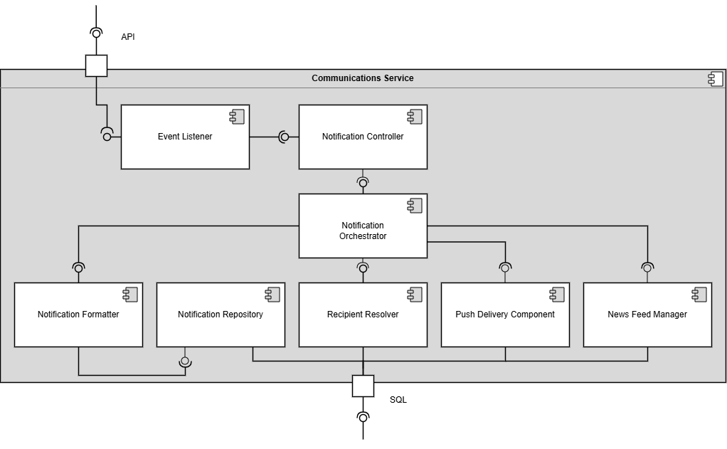

Figure 1.11 – Recommendation Service
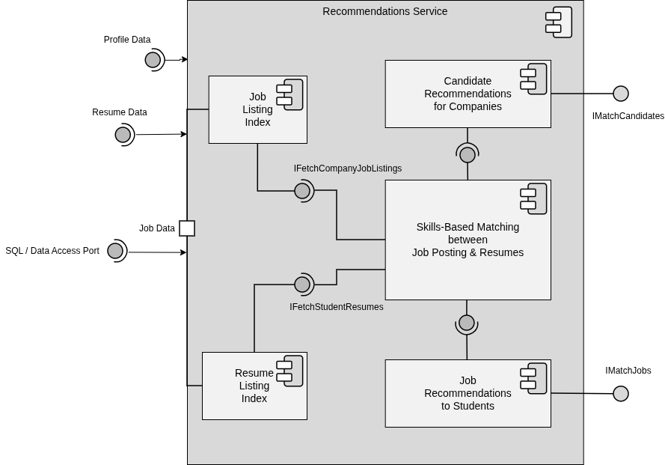

Figure 1.12 – External Services
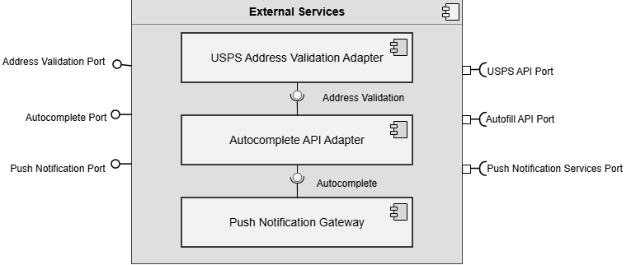

Figure 1.13 – Analytics Service
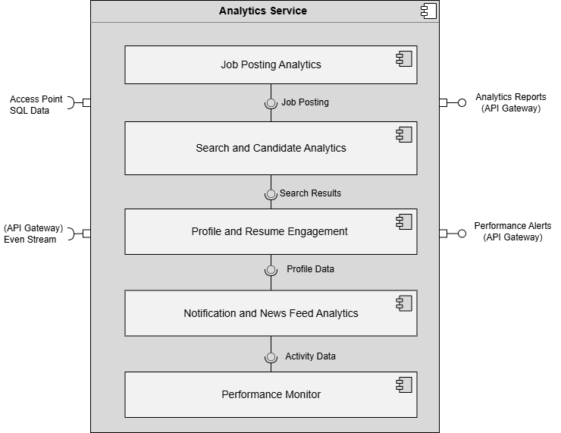

Figure 1.14 – Database
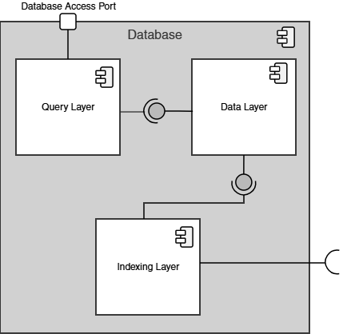

Figure 1.15 – File / Blob Storage
