SWDD- [obtain number from Conduct of Engineering Document Numbering SharePoint site]

CSE 430 Architectural Design
Career Bound

Software Design Document

Name (s): Jeremy Troy Suchanski, Robert Anderson, Danny Capps, Savannah Harvey, Spencer Beals, Kimberly Uresti, Adam Sheridan, Marco Quintero, Corbin Probasco, Nathan Lipovich, Abraham Moreno-Sanchez, Kaleb Swertfeger, Mike Olson, Kyle Jones, Yat Lam, Ernesto Quispe Cajan, Jacob Mychal Kertesz, Pavel Shvets, Peyton Markus, Carson Roberts, Joe Allen, Sam Evans, Zach Crittenden, Caleb Schmid, Jackson Aden, Scott Shumway, Zachary Humphreys, Braulio Garcia Gonzalez, Ethan Houser, Wessly Green Contreras, William Torman, Ethan Seegmiller, Sergey Tsybenko, Sergio Bravo Bravo Moran, Dallin Stephens, Sunseehray Tirazona, Teph Milford
Section: BYUI
Workstation: Online

Date: 05/13/2026

Revision History
Version | Date | Author | Change Description
1.0 | 5/14/26 | Jeremy Troy Suchanski | Filled in work done for Milestone 1 and started filling in sections relevant to Milestone 2 for Initial SWDD draft

TABLE OF CONTENTS
1.0 INTRODUCTION 4
1.1 Purpose 4
1.2 Scope 4
1.3 Overview 4
1.4 Reference Material 4
1.5 Definitions and Acronyms 4
2.0 SYSTEM OVERVIEW 4
3.0 SYSTEM ARCHITECTURE 4
3.1 Architectural Design 4
3.2 Decomposition Description 5
3.3 Design Rationale 5
4.0 DATA DESIGN 5
4.1 Data Description 5
4.2 Data Dictionary 5
5.0 COMPONENT DESIGN 5
6.0 HUMAN INTERFACE DESIGN 5
6.1 Overview of User Interface 5
6.2 Screen Images 6
6.3 Screen Objects and Actions 6
7.0 REQUIREMENTS MATRIX 6
8.0 APPENDICES 6

INTRODUCTION

Purpose
This Software Design Document (SWDD) describes the architecture, subsystem breakdown, data design, component structure, and human interface design of the Career Bound system. The document provides the design foundation necessary for implementation and integration of the Career Bound software platform.
The intended audience of this document includes:
- Developers
- Designers
- QA reviewers
- Project managers
- Instructors
- Stakeholders
This document serves as the primary design reference for the Career Bound project and establishes standardized architecture, interface, workflow, and UI design patterns used throughout the system.

Scope
Career Bound is a web and mobile application for career networking and job searching designed to connect students and employers through profiles, resumes, job postings, notifications, and search capabilities.
The system supports:
- Student profile management
- Company profile management
- Resume creation and submission
- Job posting management
- Candidate and job search
- Notifications and news feed updates
- Responsive desktop and mobile interfaces
The goals of the project are to:
- Simplify finding jobs and candidates
- Improve communication between students and employers
- Provide a centralized career development platform
- Support scalable and modular software architecture
- Demonstrate standardized software engineering practices
The project delivers the following key benefits:
- Improved organization of career-related information
  - All student profiles, resumes, job postings, company information, news, and notifications are centralized in one easy-to-access platform instead of being scattered across emails, spreadsheets, and multiple websites.
- Streamlined resume and application workflows
  - Students can create, update, and submit resumes quickly and efficiently, while companies can easily review candidates and manage job postings, which reduces the manual work and speeds up the entire hiring process.
- Improved accessibility on desktop and mobile devices
  - Students and companies can access all features (profiles, search, notifications, resumes, etc.) conveniently from any device. The platform provides consistent, high-quality experiences whether on a desktop computer, laptop, tablet, or mobile phone.
- Modular architecture supporting maintainability and scalability
  - The system is built using well-defined and independent components (as shown in the component diagram). This modularity makes the application easier to maintain, update, and expand in the future without disrupting the entire system.

Overview
This document is organized into the following major sections:
- Introduction and project overview
- System architecture and subsystem decomposition
- Data design and storage structure
- Component design
- Human interface design and screen views
- Requirements traceability
- Supporting appendices and standards
The SWDD combines architectural diagrams, interface views, workflow standards, and UI design patterns to provide a complete description of the Career Bound software system.

Reference Material
The following references were used in the design of Career Bound:
- Software Requirements Specification (SRS)
- IEEE 1016 Software Design Description guidance
- Course textbook Chapter 4.1 – Design Description
- GitHub CareerBound-SDD Repository Standards and Workflow Documentation
- Career Bound Component Diagram Standards
- Career Bound UI and Wireframe Standards

Definitions and Acronyms

Term / Acronym | Definition
API | Application Programming Interface
UI | User Interface
UX | User Experience
QA | Quality Assurance
IC | Individual Contributor
SWDD | Software Design Document
SRS | Software Requirements Specification
REST | Representational State Transfer
Wireframe | Simplified UI layout representation
Component Diagram | Diagram representing major system components and interfaces
Responsive Design | UI design adapting to multiple screen sizes

SYSTEM OVERVIEW

Career Bound is designed as a modular career networking platform that supports interaction between students and employers. The system provides profile management, resume handling, job posting functionality, notifications, and advanced search features.

The system is divided into multiple major services and interface layers in order to improve maintainability, scalability, and separation of responsibilities.

The primary system users include:
- Students
- Employers / Companies
- Administrators

The system supports both desktop and mobile user interfaces through responsive UI design patterns.

Major functional areas include:
- Authentication and user management
- Profile management
- Resume services
- Job posting services
- Search services
- Communication services
- Data storage services

SYSTEM ARCHITECTURE

Architectural Design

The Career Bound system is designed using modular, component-based architecture to clearly separate concerns and thus enable scalability and maintainability. The overall system is decomposed into well-defined, replaceable components that communicate through explicit interfaces and ports.

Figure 1.1 below shows the high-level component diagram for the Career Bound system. This diagram shows how the system responsibilities have been partitioned into major subsystems and how those subsystems collaborate to deliver the complete functionality required by the SRS.

Figure 1.1 – Career Bound System Master Component Diagram (UML 2.0)
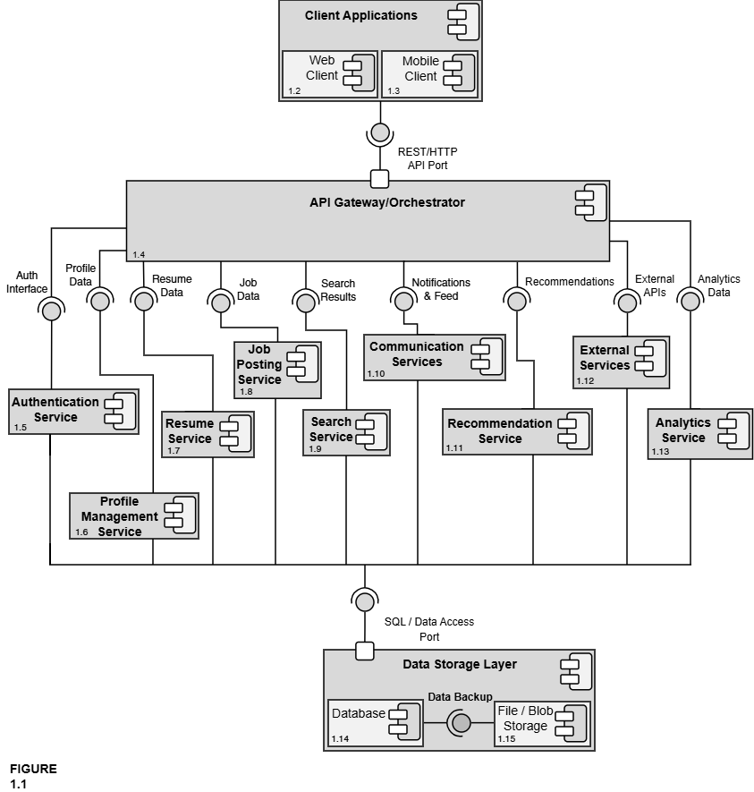
The interfaces and ports shown in Figure 1.1 are formally defined in the Interface Glossary below. All components communicate exclusively through these explicit interfaces, ensuring low coupling and high replaceability.

Interface Glossary – Career Bound System Master Component Diagram

Interface Name | Description | Provided By | Required By
REST/HTTP API Port | Formal, well-defined entry point for all client (Web + Mobile) communication | API Gateway / Orchestrator | Client Applications (Web Client + Mobile Client)
Auth Interface | Login, registration, role management, and session handling | Authentication Service | API Gateway
Profile Data | Read/write access to company and student profiles (locations, following, skills, GPA, etc.) | Profile Management Service | API Gateway, Search Service, Recommendation Service
Resume Data | Resume creation, submission, storage, retrieval, and access control | Resume Service | API Gateway, Search Service, Company profiles
Job Data | Job posting creation, editing, deletion, required skills, and job details | Job Posting Service | API Gateway, Search Service, Recommendation Service
Search Results | Candidate and job search results, filters, autocomplete, and wildcards | Search Service | API Gateway
Notifications & Feed | In-app notifications, push notifications, news feed posts, and updates | Communication Services | API Gateway
Recommendations | Job and candidate recommendations based on profiles, resumes, and job data | Recommendation Service | API Gateway
External APIs | Integration with third-party services (USPS address validation, autocomplete APIs, push notification providers, etc.) | External Services | API Gateway
Analytics Data | System usage metrics, reporting, and analytics data | Analytics Service | API Gateway
SQL / Data Access Port | Formal port — the single standardized interface through which all services access persistent data (the only way any service talks to the database or file storage) | Data Storage Layer | All services
The architecture is organized into four primary layers:
- Client Applications (parent) – Encloses the Web Client and Mobile Client. These components provide the unified user interface for both students and companies, supporting all features described in SRS sections 2.x and 3.x.
- API Gateway / Orchestrator – Serves as the single, centralized entry point for all client requests. It routes traffic to the appropriate backend services and enforces cross-cutting concerns such as authentication and request orchestration.
- Core Services Layer – Contains the business logic components:
      - Authentication Service
      - Profile Management Service
      - Resume Service
      - Job Posting Service
      - Search Service
      - Communication Services (Notifications + News Feed)
      - Recommendation Service
      - External Services
      - Analytics Service
Each service is responsible for a cohesive set of related functions and exposes well-defined interfaces to the rest of the system.
- Data Storage Layer (parent) – Acts as the single source of truth for all persistent data. It encloses the Database and File / Blob Storage components and exposes the formal SQL / Data Access Port used by every service in the system.

All communication between the Client Applications and the backend services flows through the REST/HTTP API Port provided by the API Gateway. Every service communicates with the Data Storage Layer exclusively through the SQL / Data Access Port. This design ensures reduced dependencies between components, clear separation of responsibilities, and makes individual components replaceable and maintainable. Detailed views of each major component are provided in Figures 1.2 through 1.15.This modular architecture directly supports the system’s requirements for accessibility, scalability, and maintainability while providing a clear roadmap for implementation and future extension.

Decomposition Description

The master component diagram (Figure 1.1) provides a high-level view of the overall system architecture. This section presents the detailed decomposition of each major component identified in the master diagram. Each sub-diagram shows the internal structure of the component, its sub-components, and the interfaces through which it interacts with the rest of the system. All sub-diagrams maintain the same interface names and ports as defined in the master diagram and the Interface Glossary to ensure consistency.

The following figures provide the detailed decomposition of each major component shown in the master diagram (Figure 1.1):
- Figure 1.2 & 1.3 – Web & Mobile Client Detail

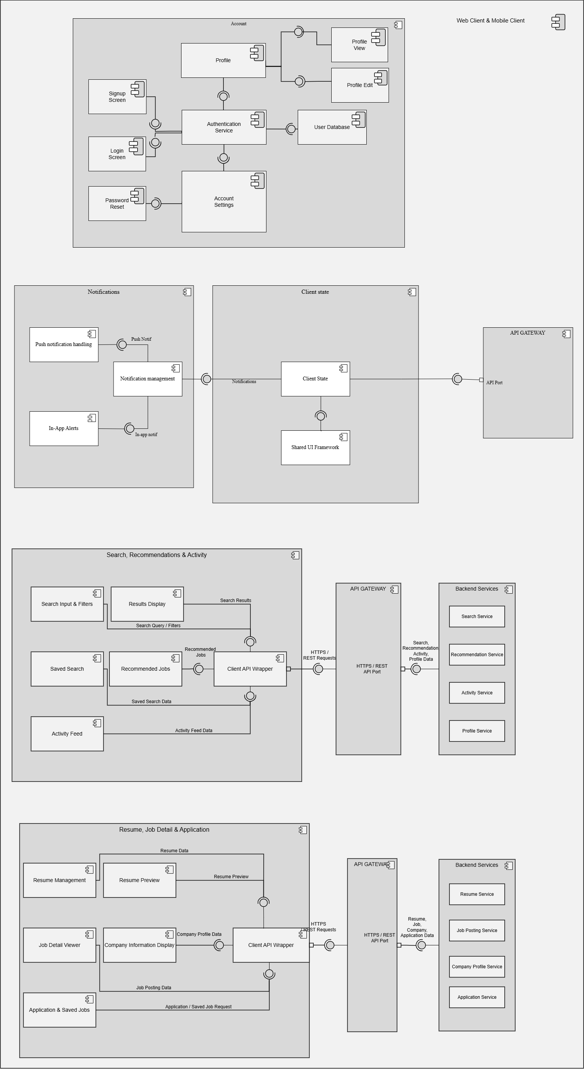
- Figure 1.4 – API Gateway / Orchestrator Detail
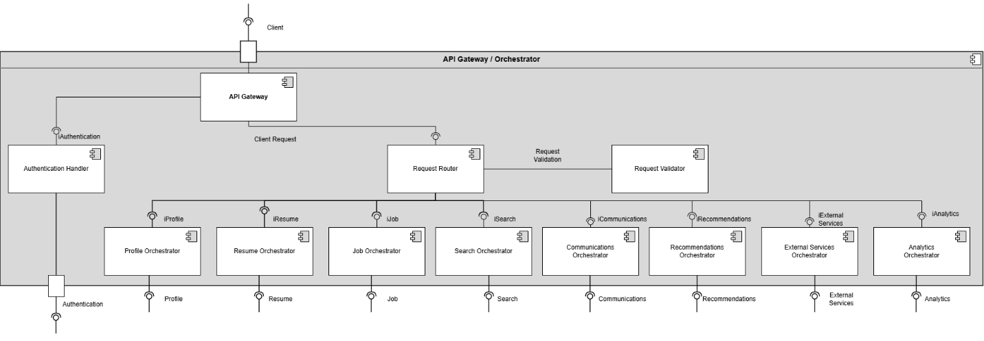
- Figure 1.5 – Authentication Service Detail
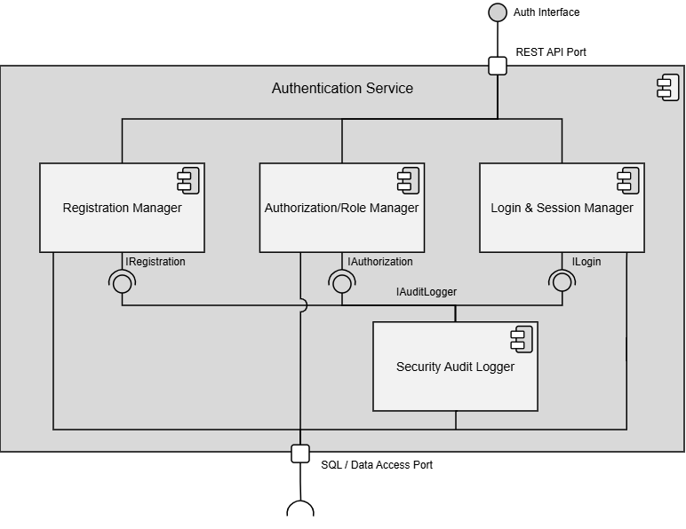
- Figure 1.6 – Profile Management Service Detail
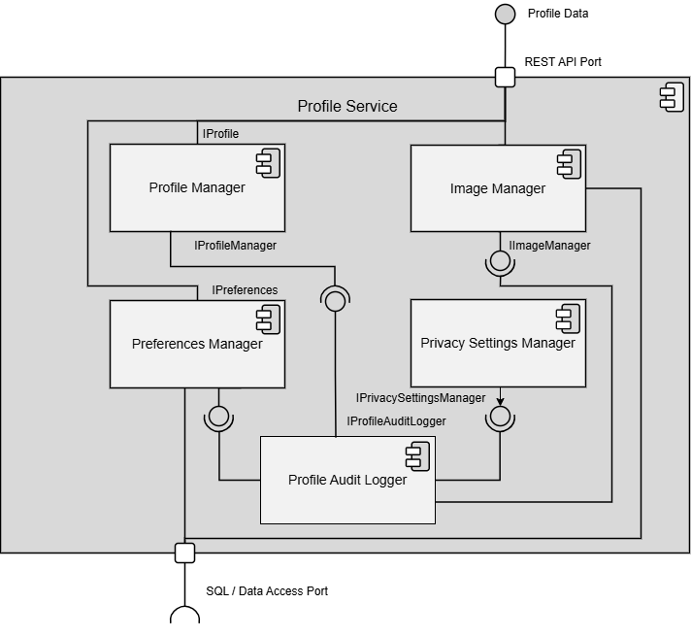
- Figure 1.7 – Resume Service Detail
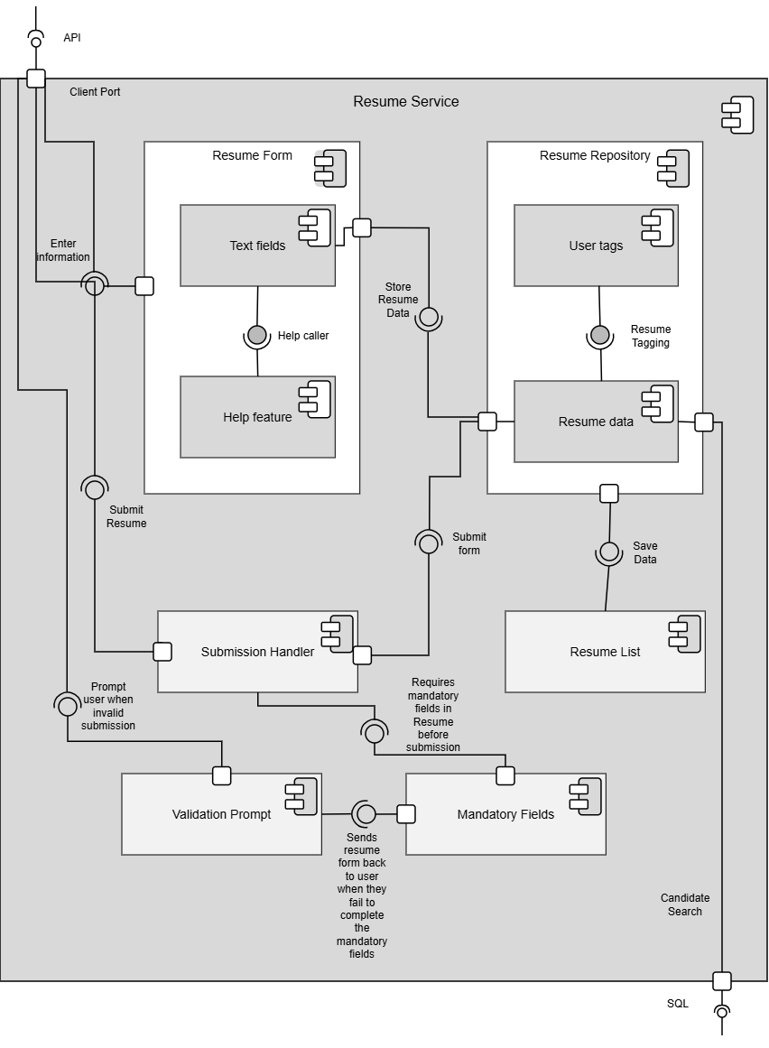
- Figure 1.8 – Job Posting Service Detail
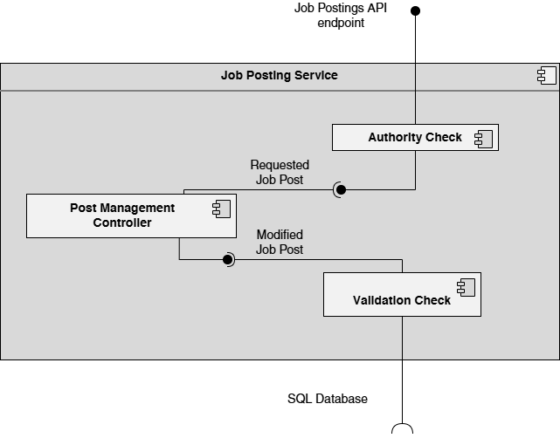
- Figure 1.9 – Search Service Detail
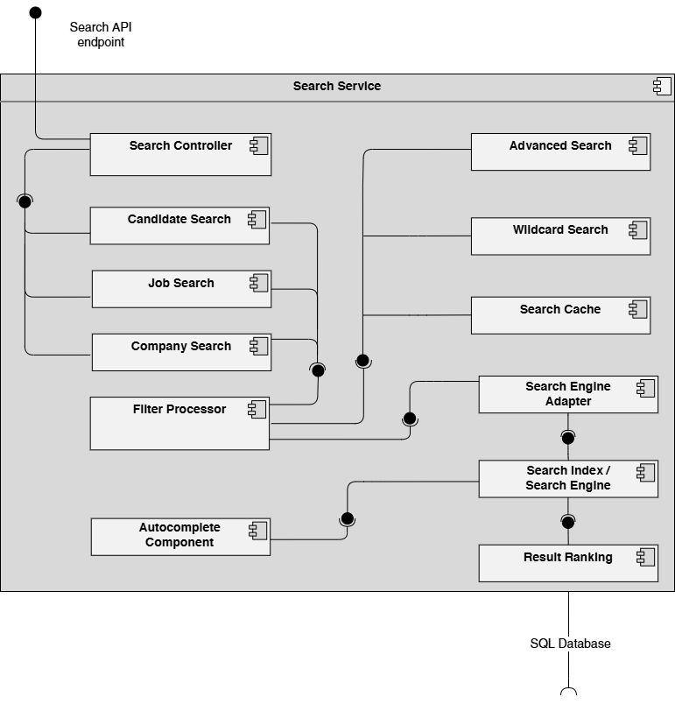
- Figure 1.10 – Communication Services (Notifications + News Feed) Detail
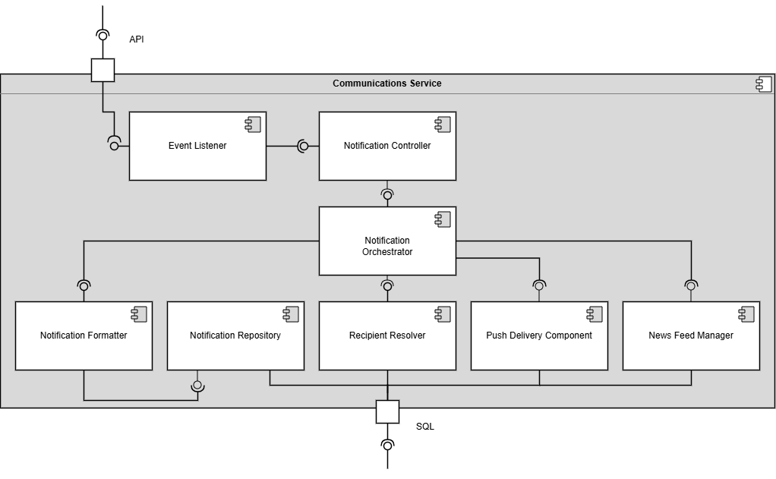
- Figure 1.11 – Recommendation Service Detail
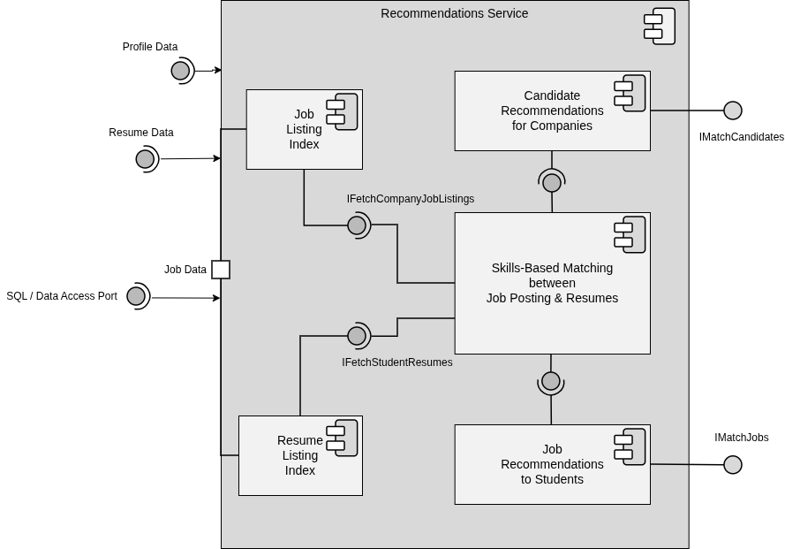
- Figure 1.12 – External Services Detail
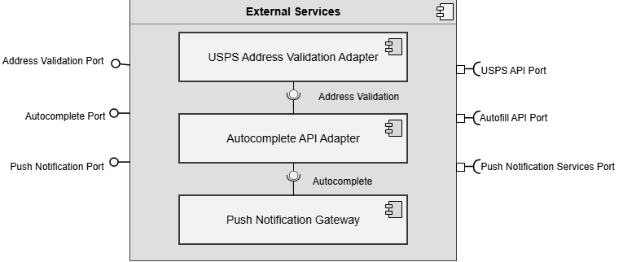
- Figure 1.13 – Analytics Service Detail
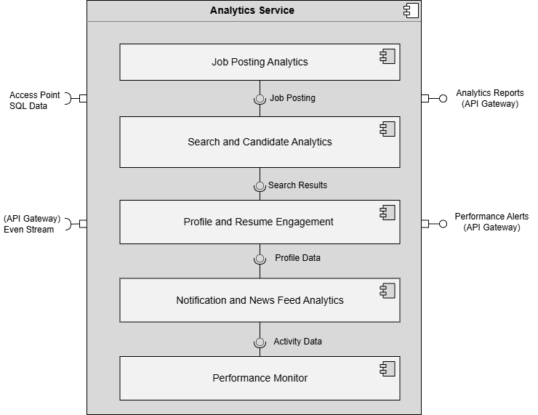
- Figure 1.14 – Database Detail
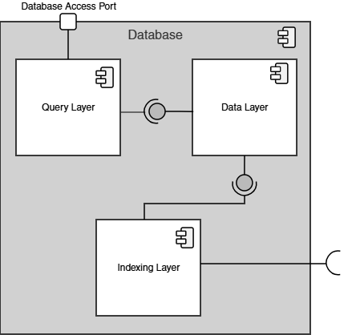
- Figure 1.15 – File / Blob Storage Detail
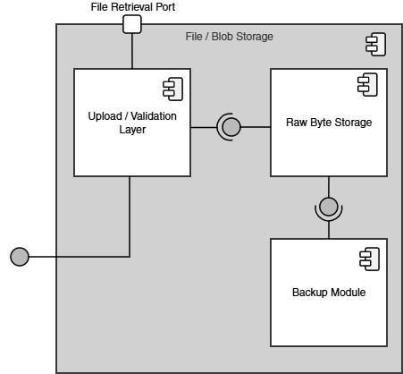

These sub-diagrams illustrate how each major component has been further decomposed into smaller, cohesive sub-components while preserving the explicit interfaces and ports defined at the system level. This decomposition supports modular design principles and enables independent development and maintenance of each subsystem.

Design Rationale
Discuss the rationale for selecting the architecture described in 3.1 including critical issues and trade/offs that were considered. You may discuss other architectures that were considered, provided that you explain why you didn’t choose them.

DATA DESIGN

Data Description
Explain how the information domain of your system is transformed into data structures. Describe how the major data or system entities are stored, processed and organized. List any databases or data storage items.

Data Dictionary
Alphabetically list the system entities or major data along with their types and descriptions. If you provided a functional description in Section 3.2, list all the functions and function parameters. If you provided an OO description, list the objects and its attributes, methods and method parameters.

COMPONENT DESIGN

In this section, we take a closer look at what each component does in a more systematic way. If you gave a functional description in section 3.2, provide a summary of your algorithm for each function listed in 3.2 in procedural description language (PDL) or pseudocode. If you gave an OO description, summarize each object member function for all the objects listed in 3.2 in PDL or pseudocode. Describe any local data when necessary.

HUMAN INTERFACE DESIGN

Overview of User Interface

Describe the functionality of the system from the user’s perspective. Explain how the user will be able to use your system to complete all the expected features and the feedback information that will be displayed for the user.

Screen Images
Display screenshots showing the interface from the user’s perspective. These can be hand­ drawn or you can use an automated drawing tool. Just make them as accurate as possible. (Graph paper works well.)

Screen Objects and Actions

A discussion of screen objects and actions associated with those objects.

REQUIREMENTS MATRIX
The following table provides a cross-reference that traces each major component in the system architecture to the specific SRS requirements it fulfills. Below this SRS Requirements Mapping Table you will find Requirements Traceability Matrices for quick visual SRS Requirements tracing.

SRS Requirements Mapping Table

Component | SRS Sections / Requirements It Directly Supports
Client Applications  (Parent) | • 1.2 Application Scope (web and mobile interfaces that share the same features)  • Overall client-side architecture, shared UI patterns, role-based views, and coordination between web and mobile clients
Web Client | • Primary web-based user interface (browser UI)  • Implements all web UI elements for Company and Student features (sections 2.x and 3.x)  • Profile pages, search bar, forms, news feed display, notifications display, resume form, job browsing, etc. (1.2.1)
Mobile Client | • Mobile application user interface  • Implements the same features and characteristics as the Web Client (per SRS 1.2.1)  • Mobile-optimized UI for all features in sections 2.x and 3.x (profiles, search, news feed, notifications, resume form, job browsing, etc.)
API Gateway / Orchestrator | • Cross-cutting orchestration for all client–service communication (implicit in 1.2 and all functional requirements in 2.x / 3.x)
Authentication Service | • Foundational requirement for all logged-in features (profiles, following, notifications, job postings, resume access, etc.)  • Required for every section under 2.x and 3.x
Profile Management Service | • 2.1 Company Profile Page (2.1.1–2.1.3.10)  • 3.1 Student User Profile (3.1.1–3.1.3.3)
Resume Service | • 3.5 Resume (3.5.1–3.5.5.2)  • Referenced in 2.1.2, 2.2.5, 2.3.3, 2.3.5, 2.5.6, 3.1.3.1–3.1.3.3
Job Posting Service | • 2.5 Job Postings (2.5.1–2.5.7)  • Referenced in 3.3.1, 3.4.1, 2.2.5
Search Service | • 2.3 Search Features (2.3.1–2.3.8)  • 3.3 Search Features (3.3.1–3.3.2)
Communication Services (Notifications + News Feed) | • 2.2 Notifications (2.2.1–2.2.5)  • 2.4 News Feed (2.4.1–2.4.6)  • 3.2 Notifications (3.2.1–3.2.7)  • 3.4 News Feed (3.4.1–3.4.2)
Recommendation Service | • Job and candidate recommendations based on profiles, resumes, and job postings  • Supports 2.3 Search Features, 2.5 Job Postings, 3.3 Search Features, and 3.1/3.5 profile/resume data
External Services | • External integrations (USPS address validation in 2.1.3.9, autocomplete API in 2.3.6, push notification services in 2.2, etc.)  • Any third-party APIs referenced throughout the SRS
Analytics Service | • Provides reporting and analytics on job posting performance (views, applications, 2.5), candidate search effectiveness (filters, results, 2.3), profile and resume engagement (2.1, 3.1, 3.5), and notification / news feed activity (2.2, 2.4, 3.2, 3.4)  • Monitors key performance metrics (e.g., search results returned within 3 seconds per 2.3.5)  • Supports data-driven platform improvements, usage insights, and overall system monitoring
Data Storage Layer  (Parent) | • Provides the single unified SQL / Data Access Port used by every service in the system  • Acts as the central enclosing component that coordinates Database and File/Blob Storage  • Manages system-wide data concerns (transactions, consistency, backups, scalability, reliability)  • 4. Hardware requirements (implicit backend storage, servers, infrastructure)
Database | • All persistent data storage for profiles, resumes, job postings, notifications, news feed, authentication, etc.  • Referenced in every “Data X.X.X” entry throughout the SRS
File / Blob Storage | • Storage of uploaded resumes, profile images, attachments, and other binary files  • Supports 3.5 Resume submission and any file-related requirements
The following Requirements Traceability Matrices map the requirements defined within the Software Requirements Specification (SRS) to the CareerBound system architecture components responsible for supporting, implementing, or interacting with those requirements.
These matrices are intended to:
- verify that all documented requirements are addressed within the system design,
- demonstrate traceability between requirements and architectural components,
- support validation and quality assurance activities, and
- ensure consistency between the SRS and the Software Design Description (SDD).
An “X” within a matrix cell indicates that the corresponding component directly supports, implements, manages, or participates in fulfilling the specified requirement.
The matrices are organized by major SRS requirement sections for improved readability and maintainability.

APPENDICES

This section is optional.

Appendices may be included, either directly or by reference, to provide supporting details that could aid in the understanding of the Software Design Document.

