1.4.11-CD ExternalServicesOrchestrator Class Diagram
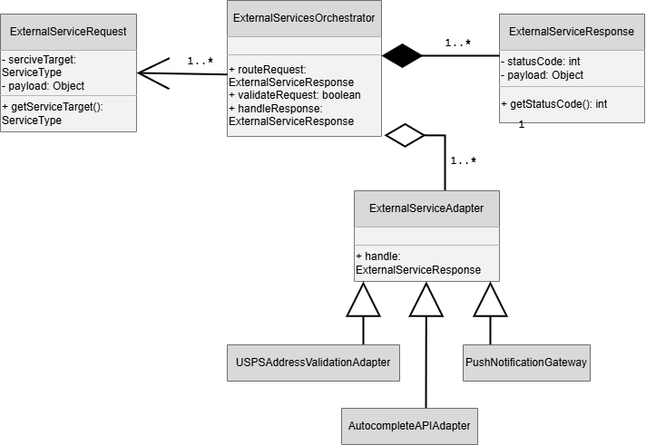

1.13.5-CD Performance Monitor Class Diagram
