Free Tool Stack
- draw.io → diagrams (Website Link: https://app.diagrams.net/)
- SharePoint → Word doc (Website Link: https://webmailbyui-my.sharepoint.com/. Click on the link. Click on your BYU IDAHO account. Sign in.)
- GitHub → structure + backup (You will need to accept the collaborator invite to the project repository. Link: https://github.com/JmmonJeremy/CareerBound-SDD)
- VS Code → interactions with the GitHub repository. (You can use whatever tool you normally would use for pushing and pulling from GitHub for this.)
- Trello → assignments + status tracking (Click the Link. Sign in using your BYUI email. Link: https://trello.com/b/TZn4KFEu/careerbound-sdd - For this to work you must accept the invite I sent you in your BYUI email)
- Teams → communication (Link: https://teams.microsoft.com/v2/, sign in with your BYUI email, from the Teams listed choose CSE 430 - 2026 - Spring or this is the direct link to our team - General | CSE 430 - 2026 - Spring. You can right-click on the link, copy the Hyperlink, and paste it in your web browser. I have trouble using the Microsoft Teams app, so I choose "Use the web app instead" - see additional information below about signing in below)
(What I get from app) (Screen for choosing web app)
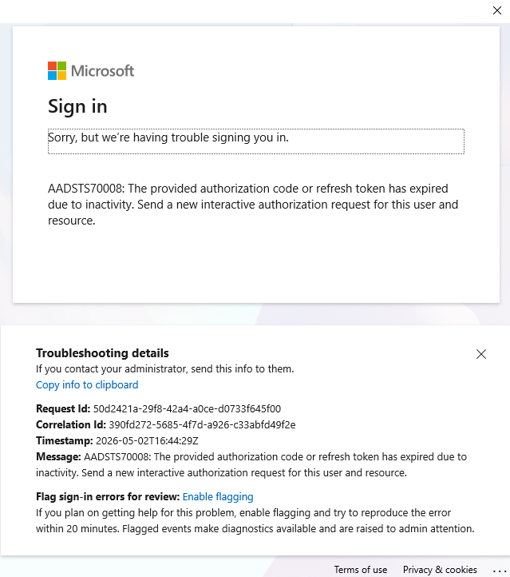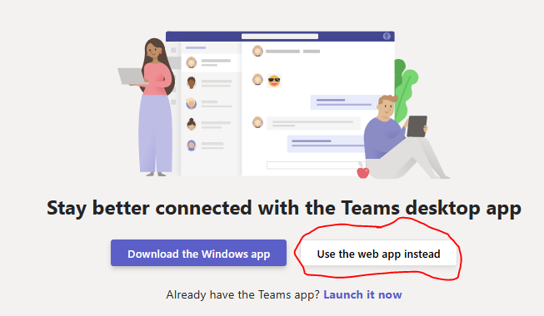
If you're able to sign into the app on your computer that's great! I would love help troubleshooting why it doesn't work for me. The app signs in and connects to our team fine on my iPad & phone - just not on my computer - where I do most of my work.

Tool Instructions & Workflow

GitHub/ VS Code
- Accept the invite as a collaborator to the CareerBound-SSD repository. One has been sent using your BYUI email. If you use a different email address for your GitHub account, contact me with that email and I can send an invite using that email address.
- Once you have accepted the invitation as a collaborator for the repository on GitHub, clone the repository for use on your local system.
- Steps for Cloning:
  - On your GitHub repo page click Code (green button) and copy the HTTPS URL for the Repository - https://github.com/JmmonJeremy/CareerBound-SDD.git
  - Create/choose a folder to house the repo locally on your system (I would give the folder the same name as the repo, but that's up to you)
  - In VS Code press Ctrl + Shift + P, type: Git: Clone
  - In the window that pops up on top, paste the repo URL and select the folder to clone the project into it.
- Every day after you work on your assigned file you will do the following to back up your work:
- First, pull from the repository to download any changes by:
  - Clicking on the Source Control icon in VS Code
  - Clicking on the three dots next to the CareerBound-SDD repository name under the REPOSITORIES section
  - Clicking on the Pull option from the pop-up list
- Second, commit your work to the repository by:
  - Clicking on the Commit button above your changes
- Pull Requests will only be used for anything going into the 04_QA_Review/Approved folder and 05_Final_SDD folder by the Chief of Q/A after the Chief of Q/A has approved it. To make the Pull Request the Chief of Q/A, Chief Reviewer, Assistant PM or PM will do the following:
- Open the Repository in VS Code
- Pull any changes by going to the Source Control, clicking on the 3 dots next to the Repository name, and selecting Pull from the dropdown menu.
- Click the branch name "main" located on the bottom-left corner
- In the dropdown menu than appears at the top of the screen select Create new branch... and enter the appropriate branch name following the naming rules
- VS Code will automatically switch to that newly created branch
- Add the files to be added or integrated into the appropriate folder
- Go to Source Control by clicking on the Source Control icon and type in a commit message explaining what is happening and click the Commit button
- Click the Publish Branch prompt that appears
- Right after publishing go to the Repository on GitHub and you should see a banner saying, “Compare & pull request,” click on it to go to the Pull Request page. If you do not see the banner, click on the Pull requests tab located on the top left of the toolbar to get to the Pull Request page.
- Click on the green "New pull request" button located on the right of the page.
- At the top on the left set the base: box to main and the compare: box to the new branch
- Add an appropriate title and description
- Click on the green "Create pull request" button located on the right of the page.
- The pull request is now created and will need approval from the assigned approver to be merged into the main branch.

draw.io
- You will use this tool to create any diagrams, like the Component Diagram
- Your work as an individual contributor will be submitted as a .drawio file
- After a team's work has been integrated into their team's assignment and placed in the Final_Integrated file for your team a PNG will be made by the assigned person by:
- Clicking File from the top menu and selecting Export from the dropdown menu
- Selecting PNG as they type
- Clicking on the Export button in the window that pops up
- In the next window that pops up under the Where section select one of 2 optioins
  - Option 1 select Download and click the OK button
    - On your local system move the downloaded file from your Downloads folder to the appropriate folder in the project
    - Commit the changes to the repository
  - Option 2 select GitHub - Pick a folder ...
    - In the window that pops up click on Authorize button with Remember me selected (ONLY REQUIRED THE FIRST TIME)
    - In the new tab that opens up click the Authorize button (ONLY REQUIRED THE FIRST TIME)
    - [SKIP] Select JmmonJeremy/CareerBound-SDD and then the folders until you reach the appropriate PNG folder and then click the Authorize button. In the window that pops up click the Authorize button. Then in the new tab that opens up click on the Install button, then change to the selection to Only select repositories & select the JmmonJeremy/CareerBound-SDD repository. Finally, click on the Install button and then enter the password, select the Verify button and close the window. (THIS WAS ALREADY DONE BY ME FOR THE REPOSITORY)
    - Select JmmonJeremy/CareerBound-SDD and then the folders until you reach the appropriate PNG folder and then click the OK button (THIS FOLDER WILL PERMANENTLY BE ADDED AS AN OPTION IN THE DROPDOWN LIST AFTER THE FIRST TIME)
    - In the window that pops up click the Save button.
    - In the window that pops up add your commit message and click the OK button
- The PNG will be pasted into the final document.

SharePoint
- The OneDrive with our BYUI SharePoint account will be used to store Word documents you are working on.
- To create a folder to store documents for our CareerBound SDD project in this class:
- Click on the blue button with rounded corners that says + Create or upload located in the top right-hand corner.
- Select the Folder option at the top of the dropdown menu.
- Name and color your folder as desired and click the Create button.
- To access the folder for our CareerBound SDD project in this class:
- Click on the My files link located on the right-hand side of the page.
- Click on the folder you created.
- To add a document from your local computer:
- Go into the folder you want the file uploaded to in your OneDrive in SharePoint.
- Click on the blue button with rounded corners that says + Create or upload located in the top right-hand corner.
- Select the Files upload option at the top of the dropdown menu.
- Select the Word document from the pop-up window and click on the Open button.
- To download a document from your OneDrive folder in SharePoint:
- Go to your folder in your OneDrive in SharePoint.
- Select the Download option from the top ribbon menu.
- Move the file from your local Downloads folder to your desired location for the file.
- To start a new Word document in SharePoint:
- Go into the folder you want the documents to be located in SharePoint.
- Click on the blue button with rounded corners that says + Create or upload located in the top right-hand corner.
- Select the Word document option from the dropdown menu.
- In the new tab that opens up with a Word document name the document by clicking on the word Document located in the top right corner and replace Document with the desired name for the file.
- It is automatically saved in the folder, and you will see it after you refresh the browser while in the folder.
- Changes made to the document will now automatically be saved in your folder.
- To see the history version of your Word document in SharePoint
- Go to your folder location and click on the document to open it.
- In the new window with the open document click on the Catch up button located on the top left-hand side of the window.
- Click on the Version History link that is listed in the pop-up window.
- Click on the point you version time stamp you want to see.
- You can also select at the top of the Version History to Show Edits by turning on the Show edits button
- To work on the same Word document at the same time and see edits as you work:
- Option 1 - from the Word document:
  - While in the Word document window select the Share dropdown menu located on the top left-hand side of the window.
  - Click the Share option from the dropdown list.
  - Then proceed with the steps below.
- Option 2 - from the Folder containing the Word document:
  - Select the document or documents you want to collaborate on by checking the white dot that appears next to the document on the left when you hover over the document.
  - Then click on the share button located on the top tool ribbon.
  - Then proceed with the steps below.
- In the pop-up window enter the BYUI email address of the person you want to collaborate with.
- Click on the Settings symbol next to the Copy link in the same popup window and make sure that under the link works for heading People you choose is selected and under the More settings heading Can edit is selected. If you have to change the settings, click the Apply button, otherwise if the settings are correct, you can X out of the settings.
- Copy the link to the document and paste it into the Add a message window.
- Hover over the pencil icon next to the email you entered and make sure it says Can edit (If it doesn't click on the dropdown arrow and select Can edit)
- Click on the Send button
- Now you can both open the document and work on it together and you will see each other's names at the top, colored cursors, and edits will appear in real time.

Trello
- You will need to accept the Join request invitation that was sent to your BYUI email. https://trello.com/invite/b/69f51da0530397d9ac372de7/ATTId09c87151397902b20b8940ec84bda8bDACAF0F2/careerbound-sdd Then you will be able to access and work on the Trello board.
- To create a new card:
- Click on the Add a card at the bottom of the list or click on the three dots at the top of the list next to the name and select Add card.
- Enter your team's name in parenthesis and then a title describing the task to be accomplished and click on Add card.
- Click on the newly created card and click on the Members button and click on the person it is assigned to. The click on Labels and type t into the search and select the matching team label.
- To quickly find your card in the list:
- Click on the three dots at the top of the list.
- From the dropdown menu select Sort by
- From the dropdown menu select Card name (alphabetically)
- Scroll to the list of your teams cards and find your assigned cards.
- To get notified when a change in status is made to a card:
- Click on the three dots at the top of the card.
- From the dropdown menu select Watch
- An eye will appear on the card to show it is being watched and you will get notifications for each change.
- To stop getting notifications click on the card and click on the eye at the top right.
- When assigned a card, move it to the appropriate list status as it makes progress and reassign it to the Chief of Q/A or the Chief Editor when it is passed to them.

Teams
- All communication will be done through Teams. You are responsible for communicating on a daily basis with you Team Leader. You will meet at least once a week through the Meet now video conferencing option located at the top right side.

