1.5.1-ALG hashPassword() Algorithm
Purpose:
Acts as a wrapper for a password hashing function from a certified cryptography library, and returns the hashed password.
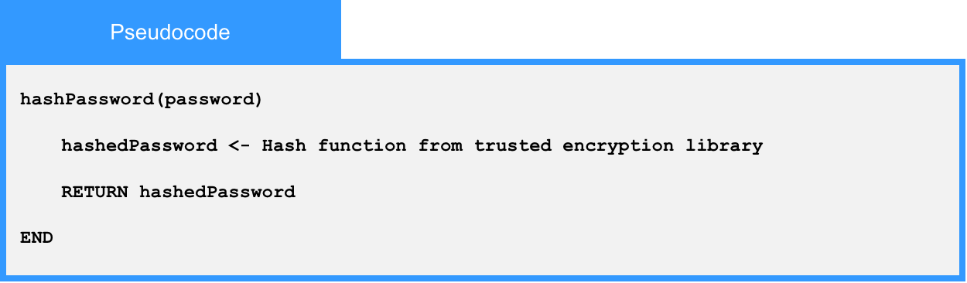
Local Data:
hashedPassword : String

