1.5.1-ALG validateEmail() Algorithm
Purpose:
To ensure that the email is in the correct format and doesn’t extend past 254 characters according to the RFC 5321 section 4.5.3.1.3 standards. NOTE: This does not confirm that the email actually exists.
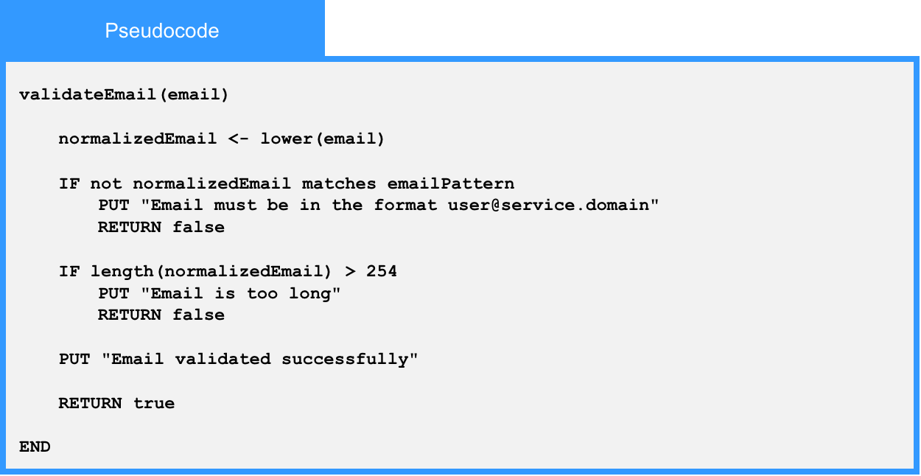
Local Data:
normalizedEmail : String
emailPattern : Regular Expression

