1.5.1-ALG validatePassword() Algorithm
Purpose:
To ensure that the password is compliant with NIST SP 800-63B section A password standards.
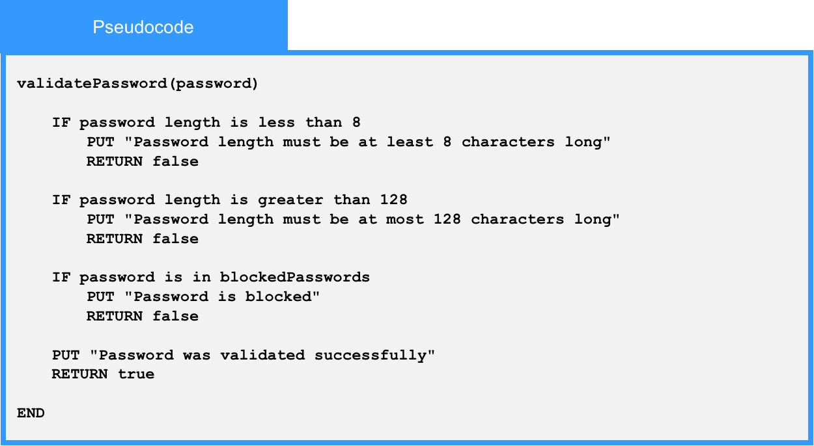
Local Data:
blockedPasswords : List of Strings

