1.8.2-CD JobPosting Class Diagram
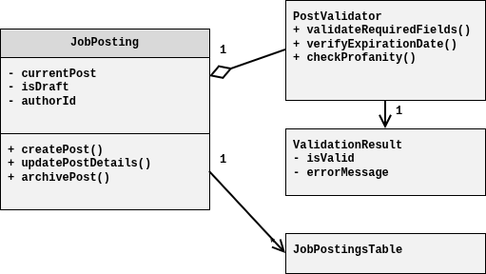

1.8.2-CD PostManagementController Class Diagram
