1.8.3-CD PostValidator Class Diagram
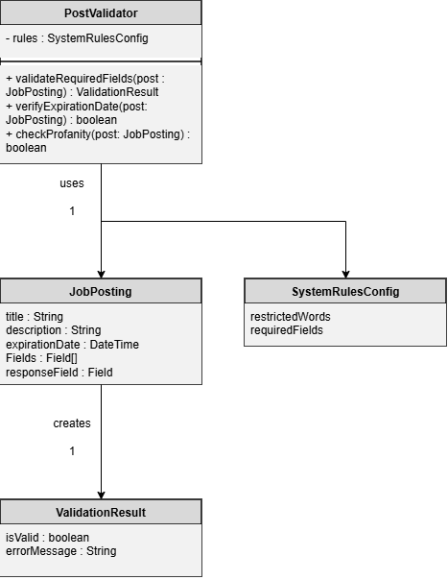

1.8.3-CD ValidationResult Class Diagram
