1.2.4 & 1.3.4-CD State Class Diagram
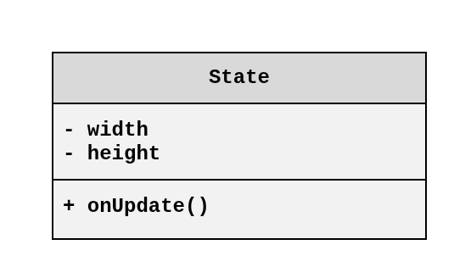

1.2.4 & 1.3.4-CD Dynamic UI Class Diagram
