- DATA DESIGN

Class Design

Class Diagrams – 1.8 Job Posting Service

1.8.1-CD AuthorizationService Class Diagram
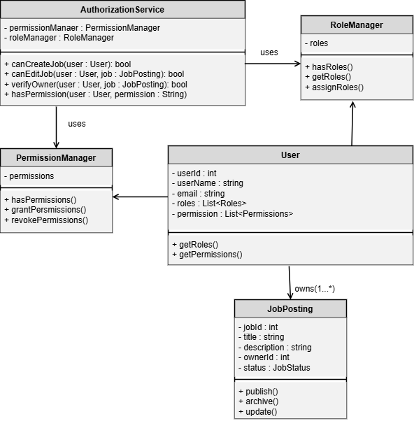

1.8.1-CD PermissionManager Class Diagram

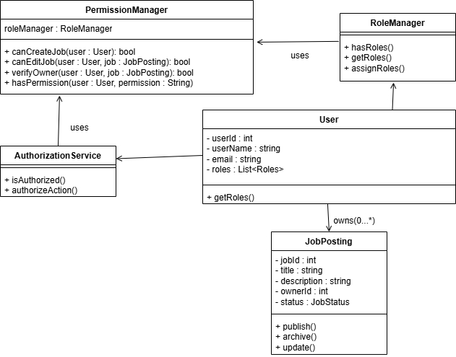

1.8.2-CD JobPosting Class Diagram
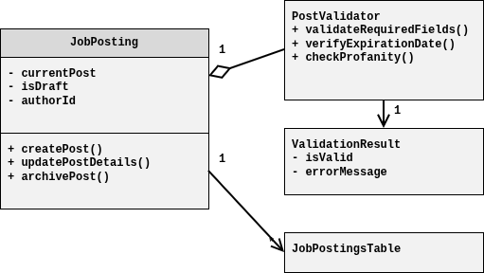

1.8.3-CD PostValidator Class Diagram
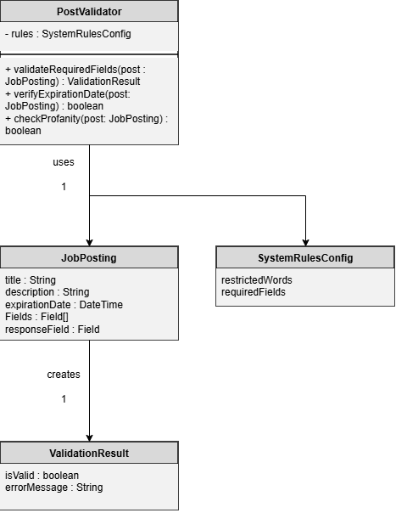

1.8.3-CD ValidationResult Class Diagram
