1.4.4-ALG validate() Algorithm

Purpose:
Validates an incoming request by cleaning the request body, retrieving route rules, verifying the user, checking the request requirements, and returning either a valid request result or a validation error.
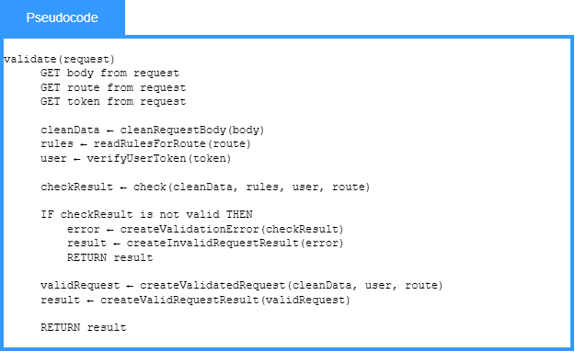

Local Data:
cleanData: Sanitized Request Data
rules: Validation Rules
user: User
checkResult: Check Result
error: Validation Error
validRequest: Valid Request
result: Validation Result

1.4.4-ALG check() Algorithm

Purpose:
Checks request data against user authentication, route permissions, required fields, and validation rules to determine whether the request is valid.
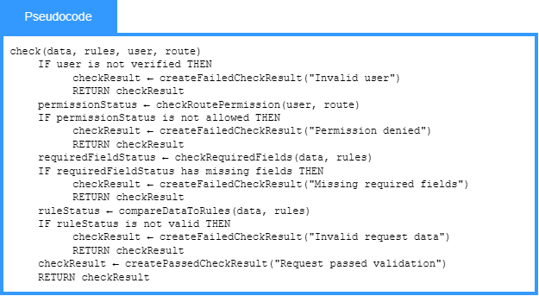

Local Data:
permissionStatus: Permission Status
requiredFieldStatus: Required Field Status
ruleStatus: Rule Status
checkResult: Check Result

1.4.4-ALG run() Algorithm

Purpose:
Runs the service request by finding the correct service route, returning an error if the route is missing, and building a response from the service result.
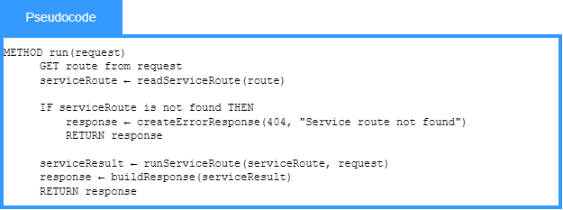
Local Data:
serviceRoute: Route Definition
serviceResult: Service Result
response: Response

