Daily Standup Standards

Team Lead is to Post to the Team Channel every morning containing the following:
- Post this image
- Click the announcement megaphone symbol and paste in image
  - Click on the upload image symbol and upload shared file
  - The shared file can be found in the repository under Templates
Example:
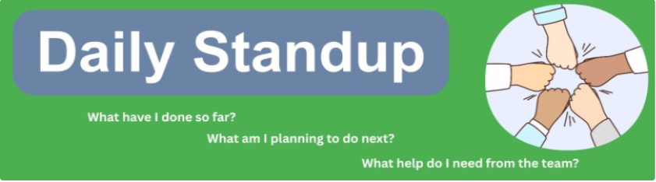
- Put Date in Subject
- Enter Daily Standup <Day> <Date> in the "Add a subject" line
Example:
  - Daily Standup - May 27, 2026 - Wednesday
- Do your Daily Standup
- Start with an @mention to notify the Team
- Type in bold the bullet points and answer the questions
Example:
  - @Team 1
  - What I did: I sketched out my diagram
  - What I'm planning to do: Finish my diagram
  - Help I need from the Team: I need to know where to put my finished diagram
- Message Team members
- If a Team member does not reply with their daily standup, message them directly, and ask them to put their response in the post
Example:
  - Chat Direct Message: Hi Jon Doe - I noticed that you have not responded to the Daily Standup post. Can you please respond with your answers to #1 What you did: #2 What you're planning to do and #3 What help you need from the Team? Thanks!

Daily Team Lead Reports Standards
Team Lead is to Fill out the Daily Team Leads Report every day:
- Go to the "All Leaders" channel
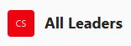
- Select the "Daily Team Leads Report" tab

- Click on "Add new item" & fill out the report for the day

or

Click on "Edit in grid view" and "Add new item" to enter column by column


CareerBound SDD Task Tracker Standards
- Team Lead is to Create "Task Cards" for every Team Member's assigned Tasks.
- Team Lead is to have Team members move their "Task Card" to the list that represents where the Task is in the workflow.

- Create "Task Cards" at the beginning of the Milestone
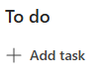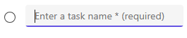
- Assign the "Task Cards" to a Team Member with an assigned Due Date
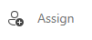
- Inform the Team Member of their "Task Cards" and instruct them to move them to the appropriate list as the work progresses
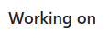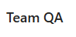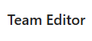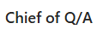
- Remind Team Members daily to update their Task Cards to the appropriate list


If a Team Member is not updating their Task Card status despite posting reminders, message them directly.


