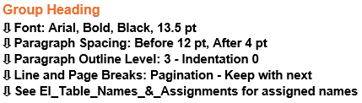
Entity Identification Table Standards

Visual Reference for Standard
Heading Pattern
(<> contains generic item to be replaced with specifics)

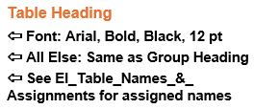
Entity Identification Tables — <Component Name>

EI Table <Figure #>.<Inner Component #> — <Inner Component Name>
[table]

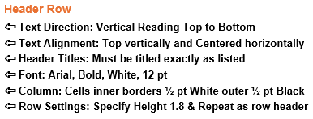
Entity Identification
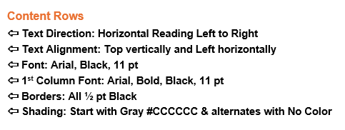
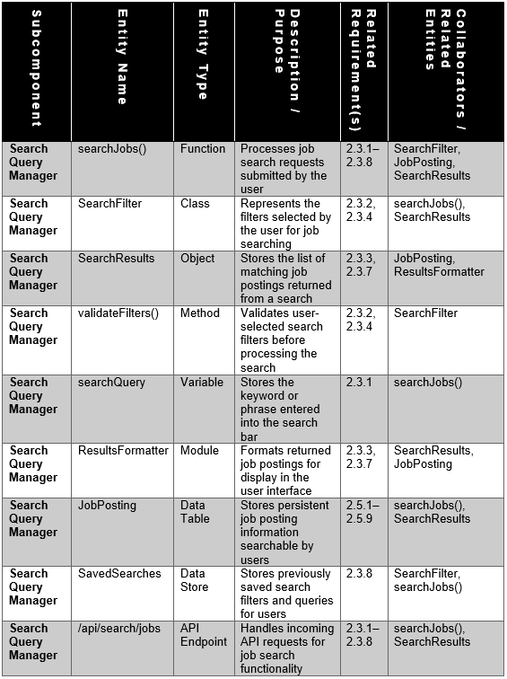
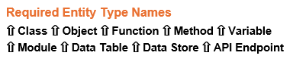
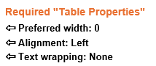
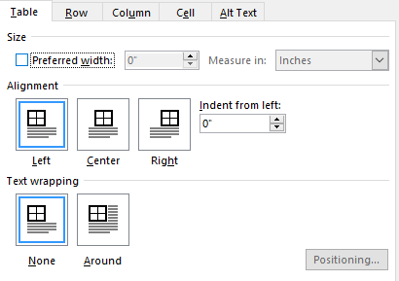
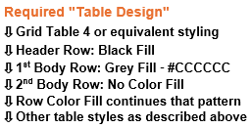
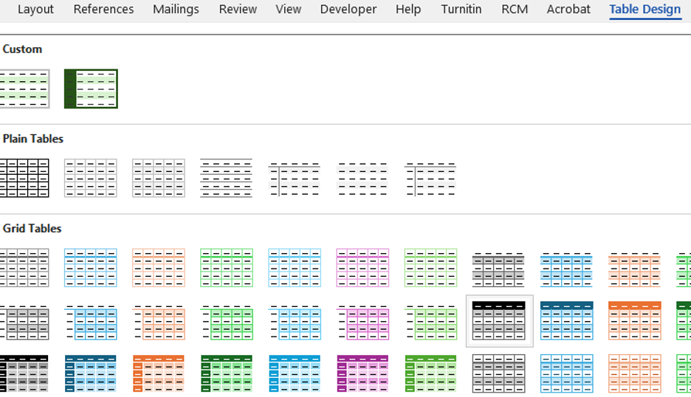

Column Explanations
Column | Purpose
Subcomponent | The internal module/subsystem where the entity belongs
Entity Name | Name of the class, function, object, variable, etc.
Entity Type | Class, Function, Object, Data Store, Variable, Module, etc.
Description / Purpose | Brief explanation of what the entity does
Related Requirement(s) | SRS requirements tied to the entity
Collaborators / Related Entities | Other entities this item interacts with

Fictional Table Example
Subcomponent | Entity Name | Entity Type | Description / Purpose | Related Requirement(s) | Collaborators / Related Entities
Search Query Manager | searchJobs() | Function | Processes job search requests submitted by the user | 2.3.1–2.3.8 | SearchFilter, JobPosting, SearchResults
Search Query Manager | SearchFilter | Class | Represents the filters selected by the user for job searching | 2.3.2, 2.3.4 | searchJobs(), SearchResults
Search Query Manager | SearchResults | Object | Stores the list of matching job postings returned from a search | 2.3.3, 2.3.7 | JobPosting, ResultsFormatter
Search Query Manager | validateFilters() | Method | Validates user-selected search filters before processing the search | 2.3.2, 2.3.4 | SearchFilter
Search Query Manager | searchQuery | Variable | Stores the keyword or phrase entered into the search bar | 2.3.1 | searchJobs()
Search Query Manager | ResultsFormatter | Module | Formats returned job postings for display in the user interface | 2.3.3, 2.3.7 | SearchResults, JobPosting
Search Query Manager | JobPosting | Data Table | Stores persistent job posting information searchable by users | 2.5.1–2.5.9 | searchJobs(), SearchResults
Search Query Manager | SavedSearches | Data Store | Stores previously saved search filters and queries for users | 2.3.8 | SearchFilter, searchJobs()
Search Query Manager | /api/search/jobs | API Endpoint | Handles incoming API requests for job search functionality | 2.3.1–2.3.8 | searchJobs(), SearchResults

Entity Identification Expectations
- Teams should identify meaningful entities only.
- Avoid trivial helper functions or unnecessary variables.
- Focus on entities directly related to the assigned components and SRS requirements.
- Entity identification should support later structure chart & DFD creation.
- Keep the explanations SHORT -1 sentence maximum.
- Each Entity Identification Table shall represent only ONE subcomponent and contain all entities directly related to that subcomponent.

Identify Entities
Using the noun identification process from Chapter 2.7, teams shall identify:
- classes,
- objects,
- functions,
- methods,
- variables,
- data stores,
- and major collaborators
related to their assigned components & thinking about how their components help to cause the UI views we created to happen.
Teams should identify:
- nouns → classes/objects/data
- verbs → functions/methods
based directly on the SRS requirements.

Envison How Entities Create UI Views with UI to Component Traceability
UI View | Primary Components Involved | How the View Helps Identify Functions / Data
1.1 Login / Logout | Authentication Service; API Gateway / Orchestrator; Database | Identifies functions for login, logout, credential validation, session handling, and user account lookup.
1.2 Registration | Authentication Service; Profile Management Service; API Gateway / Orchestrator; Database | Identifies functions for creating accounts, selecting roles, validating registration input, and creating initial student/company profile records.
2.1 Student Dashboard | API Gateway / Orchestrator; Profile Management Service; Resume Service; Job Posting Service; Search Service; Communication Services; Recommendation Service | Identifies functions for loading student summary data, recent jobs, notifications, resume status, recommendations, and dashboard widgets.
2.2 Student Profile | Profile Management Service; Resume Service; API Gateway / Orchestrator; Database; File / Blob Storage | Identifies functions and data for student profile display/editing, GPA, skills, accolades, experience, profile image, and resume hyperlink access.
2.3 Resume Builder | Resume Service; Profile Management Service; API Gateway / Orchestrator; Database; File / Blob Storage | Identifies functions for resume form fields, help features, validation, saving, uploading, submitting, storing metadata, and retrieving resume files.
2.4 Job Search | Search Service; Job Posting Service; Recommendation Service; API Gateway / Orchestrator; Database | Identifies functions for search input, filters, autocomplete, wildcard search, ranking, job result display, and saved job actions.
2.5 Job Details | Job Posting Service; Resume Service; Search Service; API Gateway / Orchestrator; Database | Identifies functions for retrieving job details, showing required skills, displaying company/job data, applying, and linking resume/application data.
3.1 Company Dashboard | API Gateway / Orchestrator; Profile Management Service; Job Posting Service; Search Service; Communication Services; Analytics Service | Identifies functions for company summary data, active postings, candidate activity, notifications, news feed items, and analytics widgets.
3.2 Candidate Search | Search Service; Profile Management Service; Resume Service; Recommendation Service; API Gateway / Orchestrator; Database | Identifies functions for candidate filters, candidate matching, viewing profiles, viewing resumes, ranking candidates, and returning candidate search results.
3.3 Job Posting Creation | Job Posting Service; Profile Management Service; API Gateway / Orchestrator; Database | Identifies functions for creating/editing/deleting job postings, validating required fields, adding required skills, saving job data, and publishing postings.
4.1 Notifications | Communication Services; API Gateway / Orchestrator; Authentication Service; External Services; Database | Identifies functions for creating notifications, retrieving notifications, marking read/unread, notification preferences, and push notification delivery.
4.2 News Feed | Communication Services; Profile Management Service; Job Posting Service; API Gateway / Orchestrator; Database; File / Blob Storage | Identifies functions for loading feed posts, creating updates, displaying company/student activity, attaching media, and storing/retrieving feed data.

Entity Identification Table (EIT) QA Checklist

1. Group Heading QA

Group Heading Formatting
- Font is Arial
- Font is Bold
- Font color is Black
- Font size is 13.5 pt

Paragraph Settings
- Paragraph spacing is 12 pt Before
- Paragraph spacing is 4 pt After
- Outline Level is set to Level 3
- Indentation is set to 0

Pagination
- “Keep with next” is enabled

Naming
- Heading name matches assigned name in EI_Table_Names_&_Assignments

2. Table Heading QA

Table Heading Formatting
- Font is Arial
- Font is Bold
- Font color is Black
- Font size is 12 pt

Other Settings
- All other formatting matches Group Heading requirements
- Heading name matches assigned name in EI_Table_Names_&_Assignments

3. Header Row QA

Header Formatting
- Text Direction is Vertical (Top to Bottom)
- Text Alignment is Top Vertically and Centered Horizontally
- Header titles match the required column names exactly
- Font is Arial
- Font is Bold
- Font color is White
- Font size is 12 pt

Borders
- Inner cell borders are ½ pt White
- Outer borders are ½ pt Black

Row Settings
- Row height is set to Exactly 1.8
- “Repeat as Header Row” is enabled

4. Content Rows QA

Content Formatting
- Text Direction is Horizontal Left to Right
- Text Alignment is Top Vertically and Left Horizontally
- Font is Arial
- Font color is Black
- Font size is 11 pt

First Column Formatting
- First column font is Arial
- First column font is Bold
- First column font color is Black
- First column font size is 11 pt

Borders & Shading
- All borders are ½ pt Black
- Row shading starts with Gray #CCCCCC
- Alternating row pattern is maintained throughout table

5. Table Structure & Table Properties QA

Required Table Properties
- Preferred Width is set to 0
- Table Alignment is set to Left
- Text Wrapping is set to None

6. Table Design QA

Required Table Styling
- Uses Grid Table 4 or approved equivalent styling
- Header Row has Black Fill
- First body row has Gray Fill (#CCCCCC)
- Second body row has No Fill
- Alternating row shading pattern continues correctly throughout table
- Other table styling matches project standards

7. Column Validation QA

Required Columns Present
- Subcomponent
- Entity Name
- Entity Type
- Description / Purpose
- Related Requirement(s)
- Collaborators / Related Entities

8. Required Entity Type QA

Valid Entity Types Only
- Class
- Object
- Function
- Method
- Variable
- Module
- Data Table
- Data Store
- API Endpoint

9. Entity Identification QA

Noun / Verb Identification
- Nouns were identified as:
  - Classes
  - Objects
  - Data Structures
  - Data Stores
- Verbs were identified as:
  - Functions
  - Methods
  - Processes

Source Validation
- Entities were identified directly from SRS requirements
- Entities support assigned component responsibilities
- Entities support related UI workflows/views
- Entities support future Structure Chart creation
- Entities support future DFD creation

Entity Expectations
- Only meaningful entities are included
- Explanations are concise (1 sentence maximum)

Subcomponent Scope
- Table represents ONLY ONE subcomponent
- All listed entities belong directly to that subcomponent

11. Final QA Review

Final Validation
- Table numbering matches assigned EI Table numbering
- Table placement matches assigned component section
- Alternating row shading is consistent
- No merged formatting issues exist
- Table fits properly within page margins
- No text wraps incorrectly within words
- Document formatting matches project standards
- Spelling and capitalization are consistent
- Acronyms and abbreviations match project conventions
Top of Form

Bottom of Form

