Standards Documentation for the Structure Charts
Item Numbering
Artifact Type | Numbering Logic
EI Tables | Directly tied to inner subcomponents
Structure Charts | Sequential starting at <Figure #>.0.1
DFDs | Sequential starting at <Figure #>.0.0.1

Find what number your item should be in the following document:
01_Standards/MIlestone_3_components/Component_Numbers_for_Teams.pdf
Heading Structure
Heading Pattern (<> contains generic item to be replaced with specifics)

Figure <Figure #> — <Component Name> Detail

<diagram>

Design Information — <Component Name>

[table]

Entity Identification Tables — <Component Name>

EI Table <Figure #>.1 — <Inner Component Name>

[table]

With the numbering system matching the inner component number.

Data Flow Diagrams — <Component Name>

DFD Figure <Figure #>.0.0.1 — <Primary Workflow Name>

[new DFD]

With the numbering system starting with the containing component number - then starting at .0.0.1 and incrementing by one for each additional Structure Chart - as shown below

DFD Figure <Figure #>.0.0.2 — <Secondary Workflow Name>

[new DFD]

Example Headings

Data Flow Diagrams — Fictitious Service

DFD Figure 1.16.0.0.1 — Primary Workflow

[new DFD]

DFD Figure 1.16.0.0.2 — Secondary Workflow

[new DFD]

More On Data Flow Diagrams
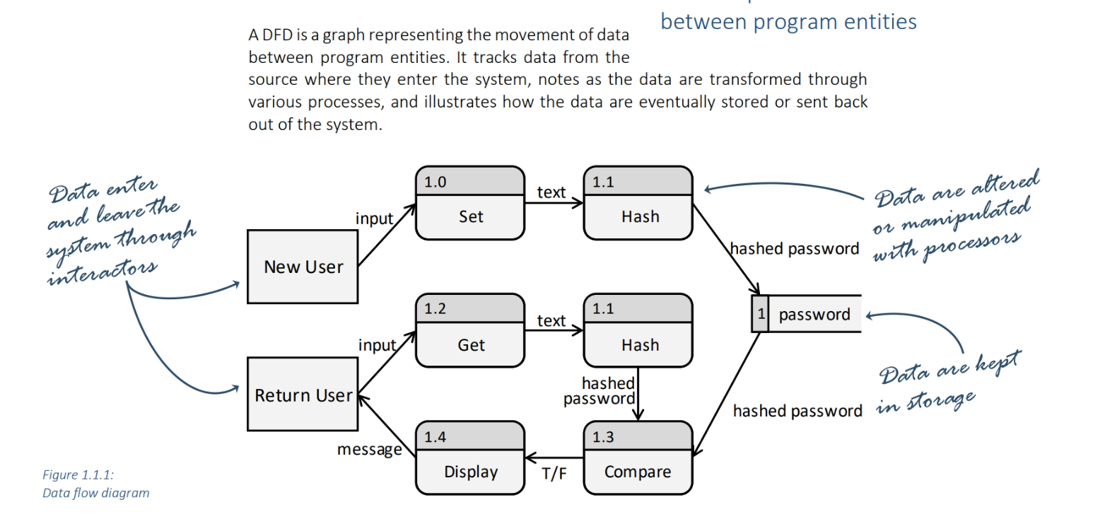

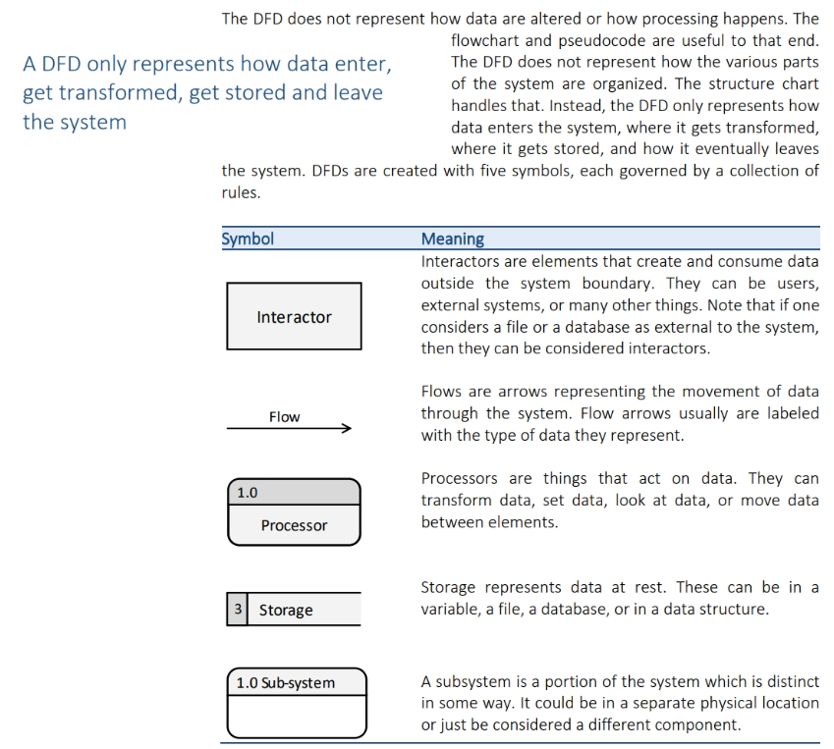

Style guide
In drawio: Click on More Shapes, then look for Data Flow Diagram (DFD) and select the box.
You will use general shapes, Data Flow Diagram shapes, and entity relation shapes
Interactors:
General “Rectangle”, Arial bold 14pt
Background Fill: light gray #D9D9D9
Flow arrows:
General “Directional Connector”, Arial bold 12pt
Processors:
Entity Relation “Entity”
Top section background fill: Dark gray #D1D1D1
Bottom section background fill: light gray #D9D9D9
Arial bold 14pt
Storage:
Data Flow Diagram “Data Store with ID”
Left section background fill: Dark gray #D1D1D1
Right section background fill: Light gray #D9D9D9
Sub System:
Entity Relation “Entity”
Top section background fill: light gray #D9D9D9
Bottom section background fill: White
Arial bold 14pt

QA Checklist

1. Headings
- Structure Matches format outlined above.
- Numbers correct as seen in 01_Standards/MIlestone_3_components/Component_Numbers_for_Teams.pdf
- Heading is Arial Bold 14pt
- Subheadings are Arial Bold 12pt

2. DFDs

Content
- All required documents and components are present
- Elements are correctly use (Interactors are are interactor parts of program, storage is in a storage block, processing happens in processor block)
- Data flows in the correct direction
- All necessary elements are present

Fonts/Format
- Correct fonts, sizes, format and spelling is used within diagrams and outer document
- Colors of elements are correct as outlined in this document
- Style matches style guide

3. File Naming
- Standard file naming convention is followed
- Version is up to date

