Standards Documentation for the Structure Charts
Item Numbering
Artifact Type | Numbering Logic
EI Tables | Directly tied to inner subcomponents
Structure Charts | Sequential starting at <Figure #>.0.1
DFDs | Sequential starting at <Figure #>.0.0.1

Find what number your item should be in the following document:
01_Standards/MIlestone_3_components/Component_Numbers_for_Teams.pdf

Heading Structure
Heading Pattern (<> contains generic item to be replaced with specifics)

Figure <Figure #> — <Component Name> Detail

<diagram>

Design Information — <Component Name>

[table]

Entity Identification Tables — <Component Name>

EI Table <Figure #>.1 — <Inner Component Name>

[table]

With the numbering system matching the inner component number.

Structure Charts — <Component Name>

SC Figure <Figure #>.0.1 — <Function Name from Top of Your Chart>()

[chart]

With the numbering system starting with the containing component number - then starting at .0.1 and incrementing by one for each additional Structure Chart - as shown below

SC Table <Figure #>.0.2 — <Function Name from Top of Your Chart>()

[chart]

Example Headings

Structure Charts — Fictitious Service

SC Figure 1.16.0.1 — primaryFunction()

[new chart]

SC Figure 1.16.0.2 — primaryFunction()

[new chart]

SC Figure 1.16.0.3 — primaryFunction()

[new chart]

SC Figure 1.16.0.4 — primaryFunction()

[new chart]

More On Structure Charts
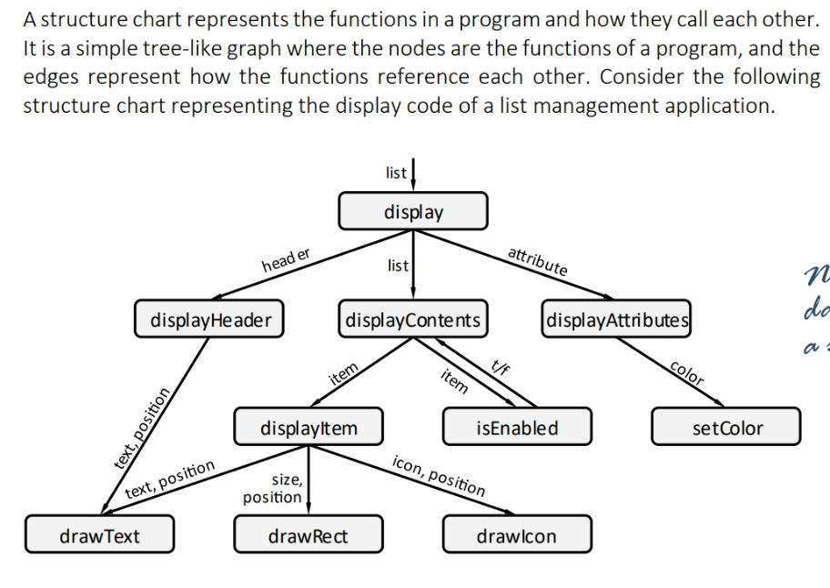

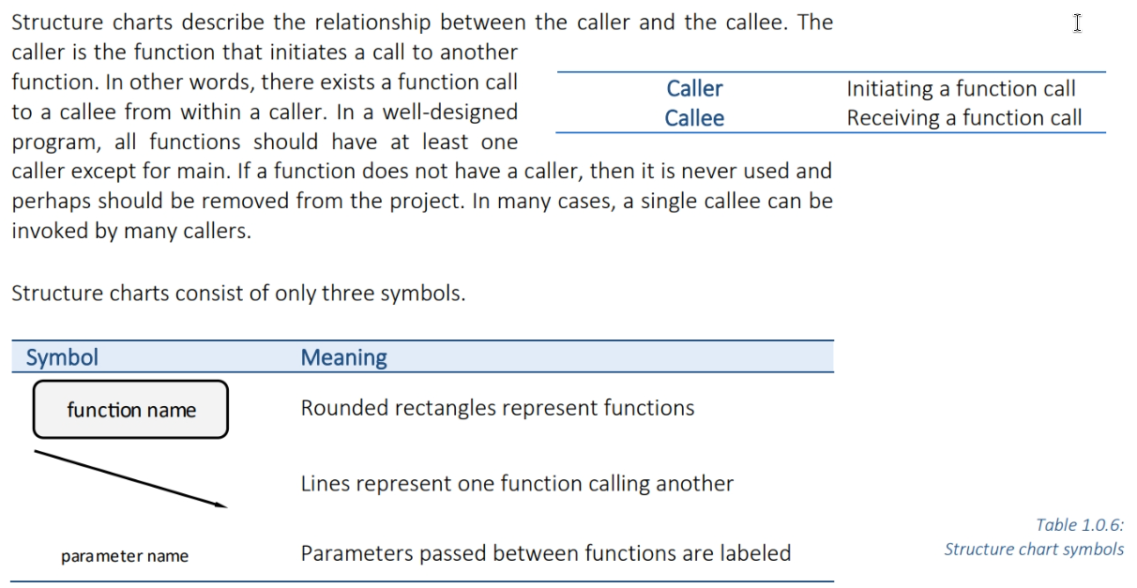

Lines are used in structure charts to indicate that one function calls another. By convention, the caller is on top and the callee is on the bottom. These lines correspond to the edges in the structure chart graph.

Style guide
Function block fill: light grey #D9D9D9
Lines/Arrows: Black
No decorative colors
Font: Arial, bold
Font sizes:
Function names 14pt
Labels: 12pt
Arrows: “Directional Connector” in drawio
Function Block: “Rounded Rectangle” in drawio

QA Checklist

1. Headings
- Structure Matches format outlined above.
- Numbers correct as seen in 01_Standards/MIlestone_3_components/Component_Numbers_for_Teams.pdf
- Heading is Arial Bold 14pt
- Subheadings are Arial Bold 12pt

2. Structure Charts

Content
- All required documents and components are present
- Function names are coherent
- Functions match what real requirements would be for component
- Labels Correctly Identify parameters being passed between functions
- Arrows correctly show caller vs callee relationship
- Top Down structure is followed

Functions
- Font is Arial
- Font is Bold
- Font color is Black
- Font size is 14 pt
- “Rounded Rectangle” block is used

Labels
- Font is Arial
- Font is Bold
- Font color is Black
- Font size is 12 pt

Arrows
- Color is black
- “Directional Connector” is used

3. File Naming
- Standard file naming convention is followed
- Version is up to date

