Standards

For each API message, use this format:

Heading Requirements
<Inner Component Number>-API <Message Name>
(Arial 13.5 Bold, Outline Level 3 Header, Keep with next)

API Message Specification Table Requirements
(Table Design: Grid Table 4, Font: Arial, Header Row: 12pt Bold, Body 1st Column 11pt Bold, Rest of table rows and columns 11pt, Headings as shown below)
Field | Data Type | Required | Description
fieldName | DataType | Yes/No | Description of the field

Examples:

1.5.3-API LoginRequest
Field | Data Type | Required | Description
email | String | Yes | User email address
password | String | Yes | User password

1.5.3-API LoginResponse
Field | Data Type | Required | Description
userId | UUID | Yes | Unique user identifier
token | String | Yes | Authentication token
role | String | Yes | User role
The goal is to define what data is sent into and returned from each assigned service.

Suggested API Messages by Team

Team 2 — Job Posting & Search

Suggested API messages:
- CreateJobPostingRequest
- CreateJobPostingResponse
- UpdateJobPostingRequest
- UpdateJobPostingResponse
- JobSearchRequest
- JobSearchResponse
- CandidateSearchRequest
- CandidateSearchResponse

Team 2 — Subcomponent Numbers Job Posting Service
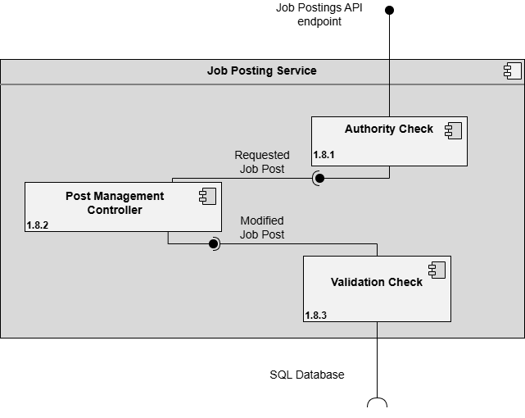


Team 2 — Subcomponent Numbers Search Service
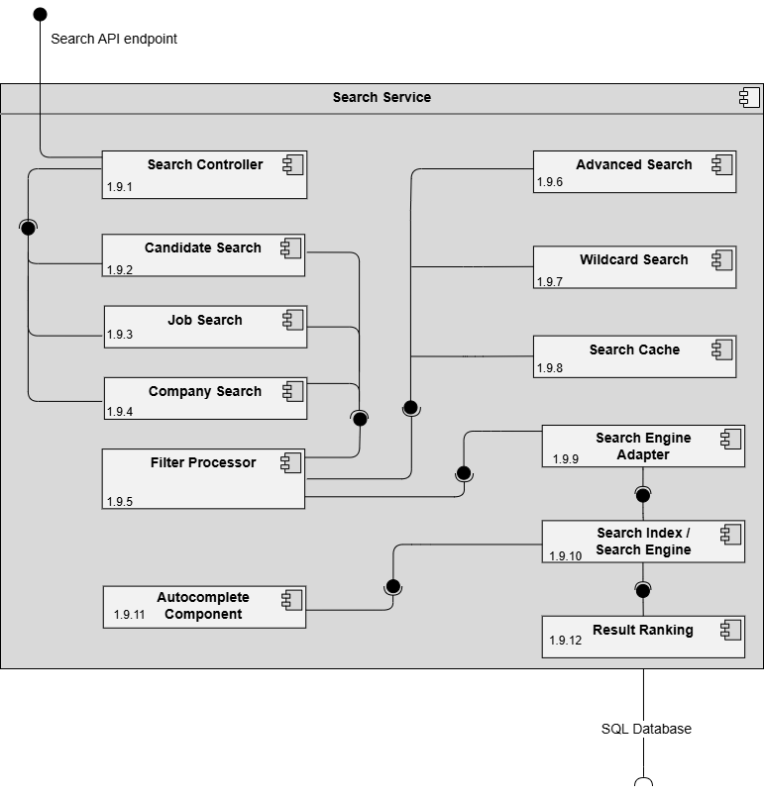


Team 3 — API Gateway & Communication Services

Suggested API messages:
- GatewayRequest
- GatewayResponse
- NotificationRequest
- NotificationResponse
- NewsFeedPostRequest
- NewsFeedPostResponse
- MessageRequest
- MessageResponse

Team 3 — Subcomponent Numbers API Gateway / Orchestrator
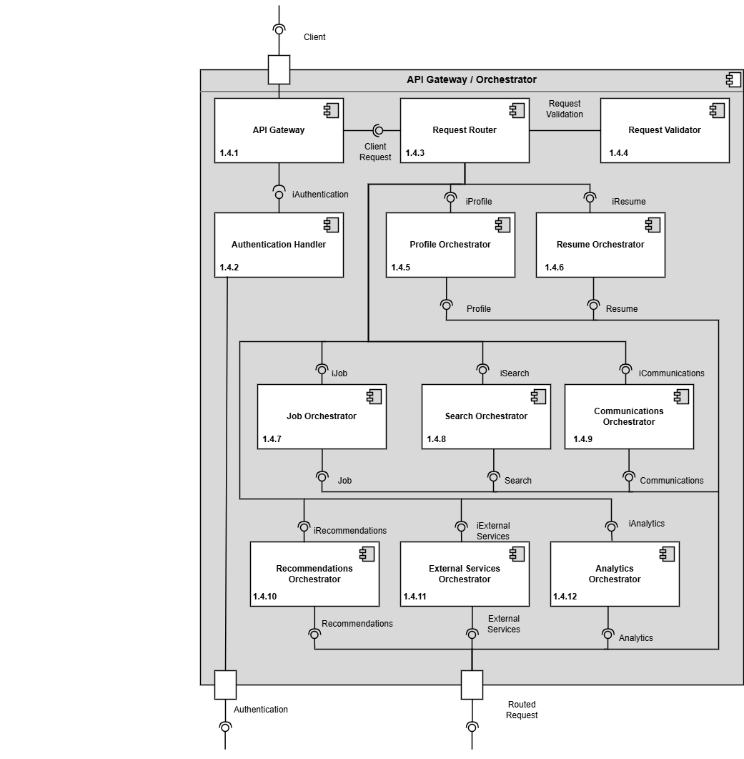


Team 3 — Subcomponent Numbers Communication Services
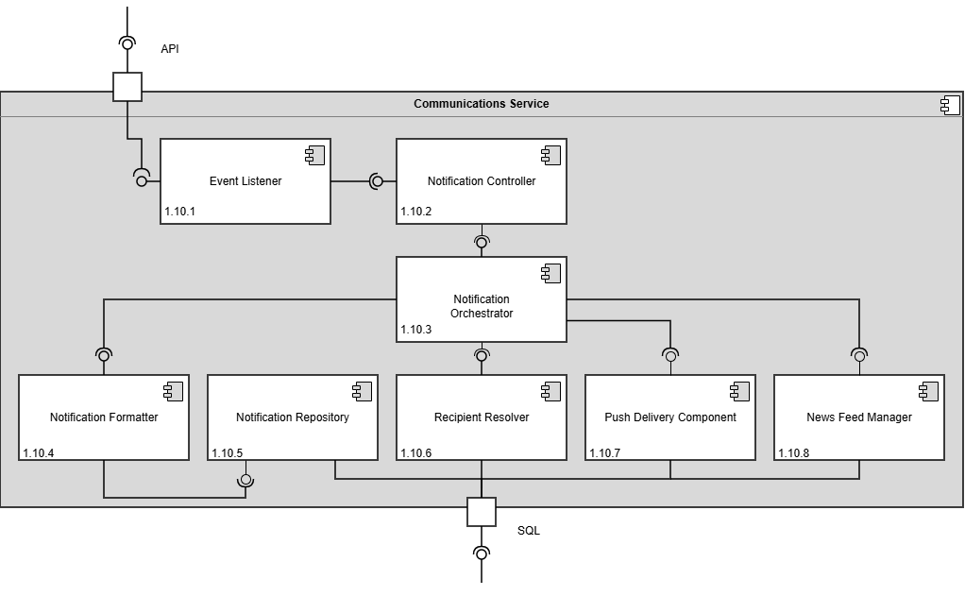

Team 4 — Authentication & Profile

Suggested API messages:
- LoginRequest
- LoginResponse
- RegisterUserRequest
- RegisterUserResponse
- UpdateStudentProfileRequest
- UpdateStudentProfileResponse
- UpdateCompanyProfileRequest
- UpdateCompanyProfileResponse

Team 4 — Subcomponent Numbers Authentication Service
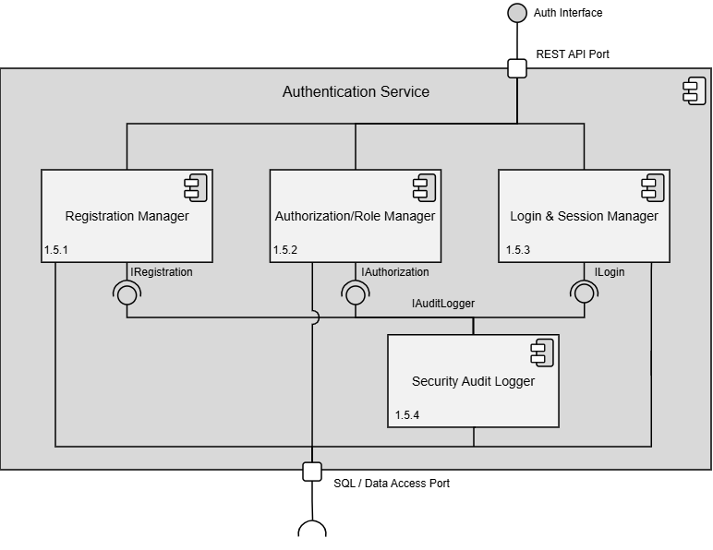

Team 4 — Subcomponent Numbers Profile Management Service
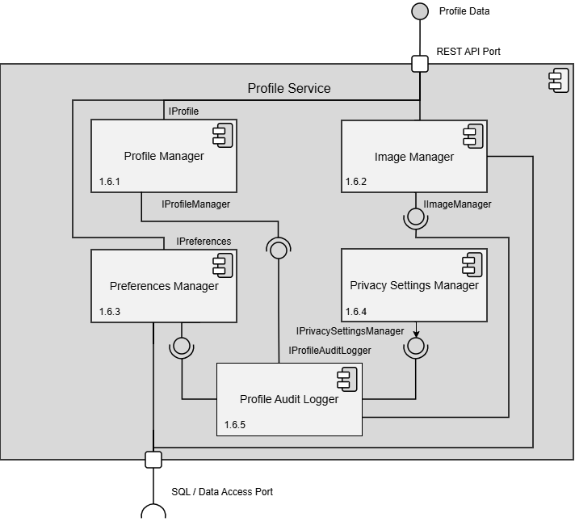

Team 5 — External Services & Analytics

Suggested API messages:
- AddressValidationRequest
- AddressValidationResponse
- AutocompleteRequest
- AutocompleteResponse
- AnalyticsEventRequest
- AnalyticsEventResponse
- PerformanceMetricRequest
- PerformanceMetricResponse

Team 5 — Subcomponent Numbers External Services
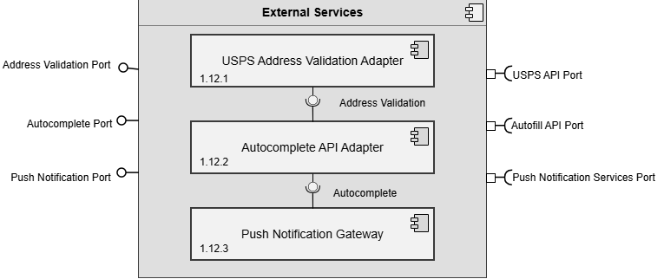

Team 5 — Subcomponent Numbers Analytics Service
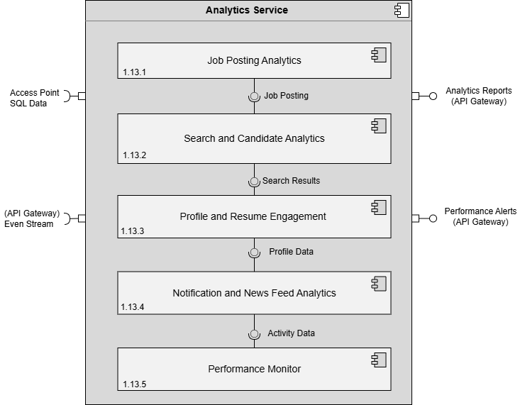


Team 6 — Resume & Recommendation

Suggested API messages:
- CreateResumeRequest
- CreateResumeResponse
- UpdateResumeRequest
- UpdateResumeResponse
- JobRecommendationRequest
- JobRecommendationResponse
- CandidateRecommendationRequest
- CandidateRecommendationResponse

Team 6 — Subcomponent Numbers Resume Service
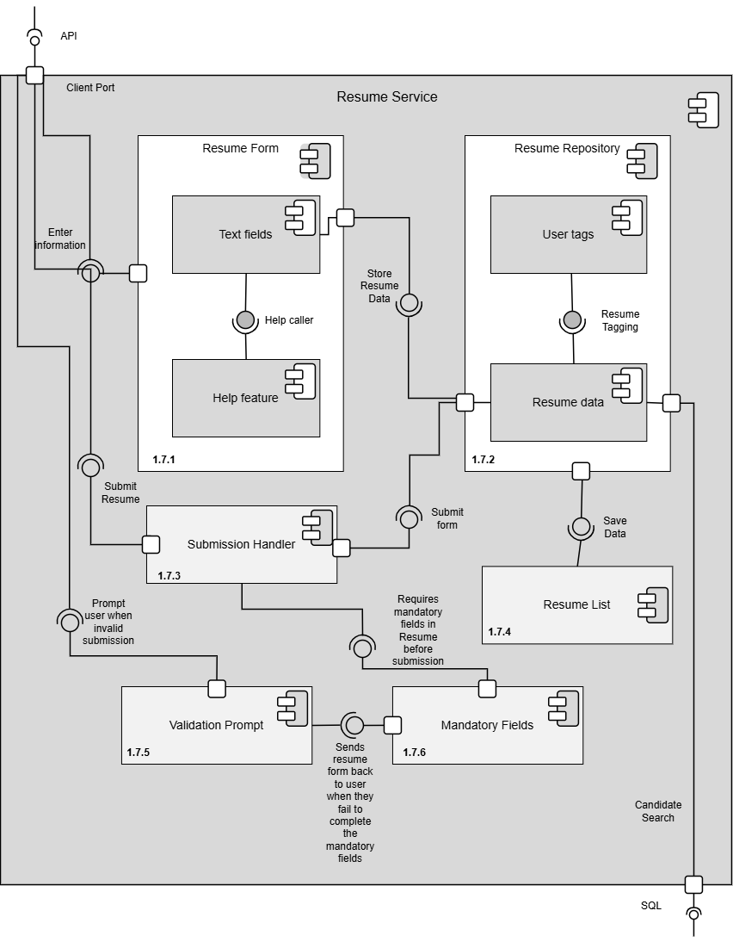


Team 6 — Subcomponent Numbers Recommendation Service
