Milestone 4 Class Diagram QA Checklist

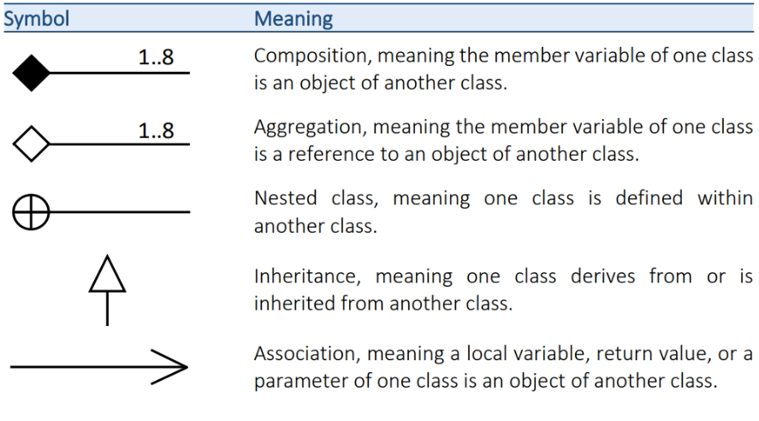

1. Diagram Content
- 10 class diagrams are present
- Each diagram has exactly one primary class
- Each primary class has a Title box (2-row table with Title)
- Supporting / related classes use the no-title 1-box format
- Attributes are listed in the top content row
- Methods are listed in the bottom content row
- No attribute or method line is missing its visibility symbol
- All relationships shown are one of: Composition, Aggregation, Nested Class, Generalization, Association
- Related classes shown are logically relevant to the primary class

2. Class Table Formatting
- Primary class title box fill color is #D9D9D9 (light gray)
- Primary class content rows fill color is #F2F2F2 (off-white)
- Supporting class boxes use no title and fill color is #F2F2F2
- Font is Arial 12 px Bold throughout all class boxes

3. Relationship Connectors
- Composition — uses "Composition 1" UML symbol, Arial 12 pt Bold
- Aggregation — uses "Aggregation 1" UML symbol, Arial 12 pt Bold
- Nested Class — uses "Inner Class" UML symbol, Arial 12 pt Bold
- Inheritance — uses "Generalization" UML symbol, Arial 12 pt Bold
- Association — uses "Association 3" UML symbol, Arial 12 pt Bold
- No other connector types used
- All connectors use straight lines (not curved)

4. Word Document Structure
- Each diagram has a heading: "<Subcomponent Number>-CD <Primary Class Name> Class Diagram" formatted Arial Bold 13.5 pt
- Diagram image appears directly below the heading

5. File Naming
- Standard file naming convention is followed
- Version number is correct and up to date

