Use drawio (https://app.diagrams.net/) to Create your Class Diagrams

Class Table

Use a 2-row table with a Title for the primary Class
Click on the table icon at the top,check "Title" box, and hover over 2 single boxes and click on the second to create a table shape. (No Title & 1 box for supporting Classes)
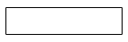
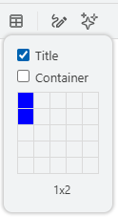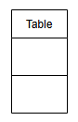
Replace Table with Class name, expand table to needed size.
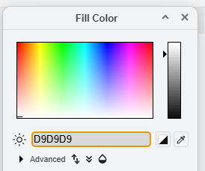
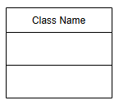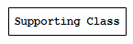
Select Title box and color it to #D9D9D9 Gray.
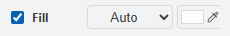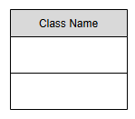
Select the 2 lower rows and color them to #F2F2F2 Light Gray.
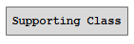
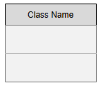
Put the attributes (data members / fields / properties) in the top row and the methods (operations / behaviors) in the bottom row.

UML Visibility Symbols in front of the attributes & methods
Symbol | Meaning | Equivalent
+ | Public | Accessible by other classes
- | Private | Accessible only within the class
# | Protected | Accessible within the class and derived classes
~ | Package | Accessible within the same package/module

Use "New Courier" 12px Bold Monospaced Font.
Make the text left aligned.
Put a space before the Class Name.
Put a space before & after the Symbols.
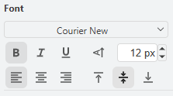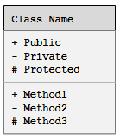

Drawio UML Symbols
If UML isn't shown on the Left Toolbar enable it under + More Shapes.
On the Left Toolbar under UML use the following:

Composition 1 UML Symbol
Select the "Composition 1" UML symbol for Composition Class relationships.
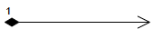
Click on the arrow edge and change to straight line & delete the number.
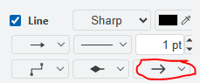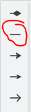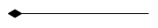
Change line thickness to 2pt, the symbol size to 40pt, add the multiplicity via text box with the same "New Courier" 12px Bold Monospaced Font, & place between Classes.
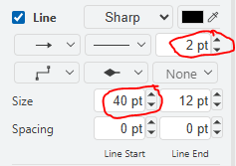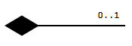

Aggregation 1 UML Symbol
Select the "Aggregation 1" UML symbol for Aggregation Class relationships & follow the same steps used for Composition.
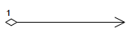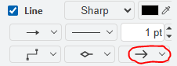
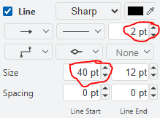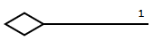

Inner Class UML Symbol
Select the "Inner Class" UML symbol for Nested Class relationships & follow the same steps used for Composition, except the symbol size is 17 not 40 & no multiplicity.
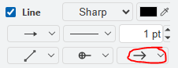
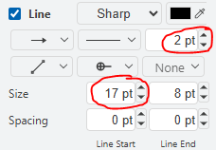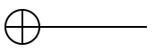

Generalization UML Symbol
Select the "Generalization" UML symbol to use for Inheritance Class relationships.
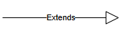

Delete the Extends word, enlarge the line thickness to 2pt, the symbol size to 34pt, rotate the arrow up, and place between Classes.
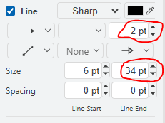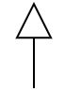

Association 3 UML Symbol
Select the " Association 3" UML symbol to use for Association Class relationships.
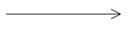
Change line thickness to 2pt, the symbol size to 32pt, add the multiplicity via text box with the same "New Courier" 12px Bold Monospaced Font, & place between Classes.
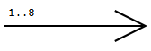

Class Relationship Elements
Symbol | Meaning
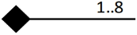 | Composition, meaning the member variable of one class is an object of another class.
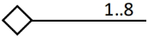 | Aggregation, meaning the member variable of one class is a reference to an object of another class.
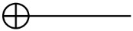 | Nested class, meaning one class is defined within another class.
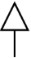 | Inheritance, meaning one class derives from or is inherited from another class.
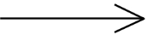 | Association, meaning a local variable, return value, or a parameter of one class is an object of another class.

Multiplicity
Though not required, it is helpful to include the number of instances of the attribute, called multiplicity. This can be a single number or a range. We can also indicate an indefinite number of instances with an asterisk. Sometimes the multiplicity can be inferred from the rest of the class diagram, so adding multiplicity information is not helpful. Most often, however, explicitly stating multiplicity adds clarity.

5 | A fixed number of five instances
0 ... 1 | Zero or one instance
6 ... 10 | Between six and ten instances
* | Zero or more instances
Table 3.0.6: Different forms of multiplicity

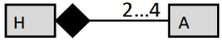
Figure 3.0.7: Composition with multiplicity

Word Document Deliverable
Use the class name as the heading:

<Subcomponent Number>-CD <Primary Class Name> Class Diagram (Arial 13.5 Bold, Outline Level 3 Header, Keep with next)
[Diagram]

