Standard Font & Sizes
Element | Standard Font | Standard Size
Header | Arial Bold | 13.5 pt
Table Header Row | Arial Bold | 12 pt
Design Information Tables | Arial | 11 pt
First Column (“Column” entries) | Arial Bold | 11 pt
Remaining Columns (“Data Type, etc.” entries) | Arial | 11 pt

Database Table Standards
- Use the Microsoft Word table style “Grid Table 4” for all design information tables.
- Tables shall span the full document text width using Preferred Width 6.5" table format.
- For header row "Repeat as header row at the top of each page"
- Table header rows shall use Arial Bold 12 pt formatting.
- First-column field labels shall use Arial Bold 11 pt formatting.
- Table content/descriptions shall use Arial 11 pt formatting.
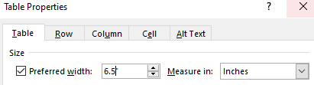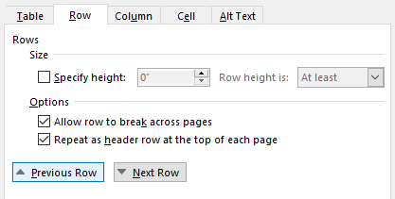

Standardized Table for "Database Column Definitions"
Column | Description / Purpose
Column Name | Name of the database field or attribute stored within the table.
Data Type | Type of data stored in the field (e.g., UUID, VARCHAR, INT, DATE, BOOLEAN, TEXT).
Required | Indicates whether a value must be provided (Yes or No).
Key | Identifies whether the field is a Primary Key (PK), Foreign Key (FK), or neither.
Description | Explains the purpose of the field and what information it stores.

Database Table Heading Standards
Use the table name as the heading:

< Table Name> Database Table (Arial 13.5 Bold, Outline Level 3 Header, Keep with next)
[Column Definition Table]

Table Format Example - Including Heading:

StudentProfile Database Table
Column | Data Type | Required | Key | Description
StudentId | UUID | Yes | PK | Unique student identifier
UserId | UUID | Yes | FK | Associated user account
FirstName | VARCHAR(50) | Yes |  | Student first name
LastName | VARCHAR(50) | Yes |  | Student last name
Email | VARCHAR(255) | Yes |  | Student email address
GPA | DECIMAL(3,2) | No |  | Student GPA
Skills | TEXT | No |  | Student skills
PortfolioUrl | VARCHAR(255) | No |  | Portfolio link

