Milestone 5 Pseudocode Algorithm Design Standards

Naming Standards

<Component #>-ALG <Method>() Algorithm
Purpose:
Brief sentence explaining what the algorithm does.

[Pseudocode Figure]

Local Data:
variableName : Type
variableName : Type

Top Pseudocode Heading Requirements
(Use assigned names that are given in the format above)
(Arial 13.5 Bold, Outline Level: 3 Header, Keep with next)

Purpose & Local Data Heading Requirements
(Arial 11 Bold, Outline Level: Body Text, Keep with next)

Document text below Purpose & Local Data headings
(Times New Roman 11, Outline Level: Body Text, Spacing Before .3 pt, Spacing After: 0, Line Spacing: Single Line)

Pseudocode Standards
Use the template found in the Repository (The inner text is example code to be replaced with the pseudocode for your method.):

Template Location: "CareerBound-SDD\01_Standards\Templates\Milestone_5_Algorithms\Pseudocode_Template.drawio.png"

Below is an Example of the inserted Template:

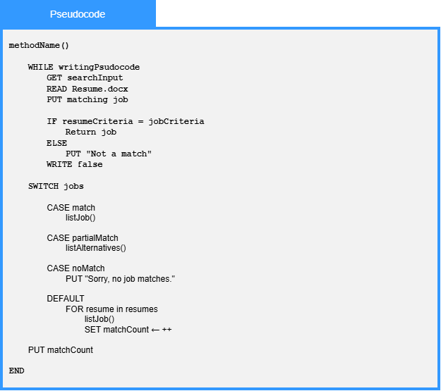

Top Pseudocode Heading Requirements
(Label = Pseudocode)
(Arial 14, White, Centered, Background Fill: 3399FF)

Pseudocode Container Requirements
(Width: 620 pt = 6.5"; Background Fill: F2F2F2, Border Line: 4pt thickness, 3399FF color)

Pseudocode Text Requirements
(Courier New 12)

Pseudocode should:
- Start with method at the top.
- Be language independent.
- Use actual variable names.
- Use meaningful function names.
- Use indentation for IF statements and loops.
- Be written from top to bottom.
- Focus on the algorithm rather than programming language syntax.

Use Common Pseudocode Keywords
GET, READ, PUT, WRITE, IF, ELSE, FOR, WHILE, RETURN &
the arrow operator () to assign values to variables

Each algorithm should clearly show:
- Inputs
- Processing
- Decisions
- Outputs

Keep algorithms at a design level rather than implementation level.
Do not write production source code.

Local Data Standards
Complex algorithms: include Local Data if it helps understanding.

What Counts as a Type for Local Data?
Use simple descriptions rather than programming-language types:
- candidateList : List of StudentProfile
- filteredCandidates : List of StudentProfile
- validationErrors : List of String
- matchScore : Number
- jobPosting : JobPosting
- resumeData : Resume
- notification : Notification
- recipientList : List of User
- routeDefinition : Route

Example of Local Data being Helpful:

1.11.3-ALG calculateMatchScore() Algorithm
Purpose:
Calculates a compatibility score between a student's resume and a job posting by evaluating skills, experience, and education criteria and combining the results into a weighted match percentage.
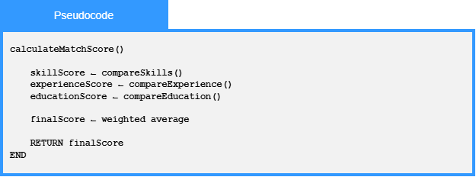
Local Data:
skillScore : Number
experienceScore : Number
educationScore : Number
finalScore : Number

In this example the variables help explain the algorithm.

Examples of things worth listing:
- candidateList
- filteredCandidates
- matchScore
- validationErrors
- currentUser
- routeDefinition
- notificationQueue

Examples of things not worth listing:
- email
- password
- jobId
- userId
unless they are being transformed or manipulated in a significant way.

Local Data is optional:
Include only when the algorithm introduces temporary variables, accumulators, counters, score calculations, collections, or other intermediate data that are important to understanding the logic. Do not list parameters, class attributes, database tables, or variables that are obvious from the pseudocode itself.

