For the Best Guidance
Structure Charts: Assigned Reading - Chapter 1.0 - Structure Chart
Data Flow Diagrams (DFDs): Assigned Reading - Chapter 1.1 - Data Flow Diagram

Here is the Relationship Between the Artifacts
SRS (Requirements)
↓
Entity Identification Table (WHAT exists)

↓
Structure Chart (WHO calls WHO)
↓
DFD (WHAT data moves WHERE)

The EIT is the source material. The Structure Chart and DFD are simply two different views of the same component.

To create a Structure Chart
Look in the EIT for:
- Functions
- Methods

and ask:
Who calls who?
What data or parameters are passed between them?

To create a Data Flow Diagram (DFD)
Look in the EIT for:
- Interactors (users, external systems, external services)
- Processes (functions, operations, managers, handlers, adapters, controllers)
- Data Stores (repositories, databases, files, storage locations)
- Data Structures (records, requests, responses, messages, documents)

and ask:
What data moves where?

The DFD models the movement of data between interactors, processes, and data stores. It shows where data originates, how it is transformed, where it is stored, and where it ultimately flows.

Example 1 — Structure Chart from an EIT
Using a fictional component:

EI Table — User Registration Manager
Entity Name | Entity Type
RegistrationManager | Class
validateRegistration() | Function
createUser() | Function
sendWelcomeEmail() | Function
registerUser() | Function
User | Class
UserRepository | Data Table
EmailService | Module

Step 1: Identify the Parent Function
According to the Structure Chart rules, nodes should be functions. The first step is to identify the primary function performed by the component. In this example:
From the EIT:
registerUser()
- Becomes the root of the Structure Chart.

Step 2: Identify Helper Functions
From the EIT:
validateRegistration()
createUser()
sendWelcomeEmail()
- These functions support the parent function and become child nodes.

Step 3: Identify Parameters Passed Between Functions
Review the EIT and determine what data each function needs to receive or return.

Example parameters:
registrationData
validatedUser
newUser
- These become the labels on the Structure Chart connections.

Structure Chart (This is a quick thrown together sketch representation not a diagram that meets all of the standards)
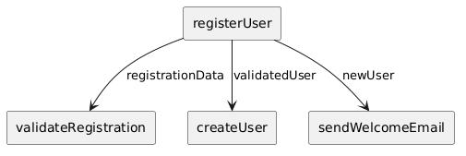

What the Structure Chart Shows
registerUser()
calls
validateRegistration()
registerUser()
calls
createUser()
registerUser()
calls
sendWelcomeEmail()

The labels on the connections identify the parameters being passed between the caller and callee functions.

Structure Charts show:
- Function organization
- Function calling relationships
- Parameters passed between functions

Example 2 — DFD from the Same EIT

When creating DFDs from an EIT, start by identifying:
- External entities (users, other services, third-party systems)
- Storage elements (repositories, databases, files)
- Processes that act on the data
- The data moving between them

The DFD should answer the question:
"Where does the data come from, where does it go, and what transforms it along the way?"

Using the same EIT:
Entity | Type
User | Class
RegistrationManager | Module
UserRepository | Data Store
EmailService | Module

Interactors
- Student User
- Email Service

Processor
- Register User

Storage
- User Repository

Flows
- Registration Data
- User Record
- Stored User
- Welcome Email Request
- Email Status (or Delivery Confirmation)
- Registration Confirmation

DFD (This is a quick thrown together sketch representation not a diagram that meets all of the standards)
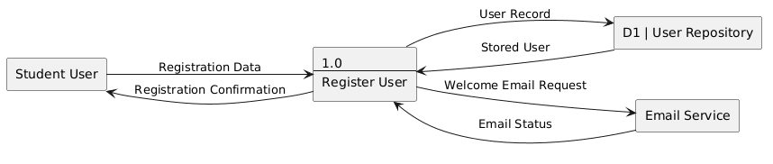

What the DFD Shows
The DFD is showing:
data movement
NOT:
function hierarchy

